**4th year Lect Prosthodontics Dr. Mohammed M A**

**Occlusal Relationship for Removable Partial Denture**

**And Recording Jaw Relationship of RPD**

The fourth phase in the treatment of patients with removable partial dentures is the estab­lishment of a functional and harmonious occlusion. Occlusal harmony between a removable partial denture and the remaining natural teeth is a major factor in the preservation of the health of their surrounding structures**.**

In removable partial dentures, occlusal stresses can be transmitted directly to the abutment teeth and other supporting structures because of the attachment of the removable partial denture to the abutment teeth.

Failure to provide and main­tain adequate occlusion on the removable partial denture is primarily a result of:

1. Lack of support for the denture base,
2. The fallacy of establishing occlu­sion to a single static jaw relation record.
3. An unacceptable occlusal plane.

In establishing occlusion on a removable partial denture, the influence of the remaining natural teeth is usually such that the occlusal forms of the teeth on the removable partial denture must be made to conform to an already established occlusal pattern. Occlusal adjustment or restoration may have altered this pattern. However, the pattern present at the time the removable partial denture is made dictates the occlusion on the removable partial denture.

In order to successfully build an artificial occlusion that will fulfil the needs of the patient, the needs must be determined during the diagnostic phase of treatment.

Objective in RPD occlusion is harmony between natural and artificial dentition. Stable RPD will cause fewer undesirable changes in its supporting structures. Occlusion is one of the most important factors in developing a stable RPD.

**The** **establishment of satisfactory occlusion for RPD should include:**-

1. Analysis of the existing occlusion.
2. Correction of the existing occlusal disharmony.
3. Recording of centric relation or an adjusted centric occlusion.
4. Harmonizing of eccentric jaw movements for a functional eccentric occlusion.
5. Correction of occlusal discrepancies created by the fit of the framework and during processing of the removable partial denture.

**Desirable occlusal contact relationships for various RPD:**

The following occlusal arrangements are recom­mended to develop a harmonious occlusal relation­ship among removable partial dentures and to enhance stability of the removable partial dentures:

1. Simultaneous bilateral contacts of opposing pos­terior teeth must occur in centric occlusion.
2. Occlusion for tooth-supported removable partial dentures may be arranged similar to the occlusion seen in a harmonious natural dentition, since sta­bility of such removable partial dentures results from the effect of the direct retainers at both ends of the denture base
3. Bilateral balanced occlusion in eccentric posi­tions should be formulated when a maxillary complete denture opposes the removable partial denture. This is accomplished primarily to promote the stability of the complete denture. However, simultaneous contacts in a protrusive relationship do not receive priority over appearance, phonetics, and/or a favorable occlusal plane.
4. Working side contacts should be obtained for the mandibular distal extension denture. These contacts should occur simultaneously with working side contacts of the natural teeth to dis­tribute the stress over the greatest possible area. Masticatory function of the denture is improved by such an arrangement.
5. Simultaneous working and balancing contacts should be formulated for the maxillary bilateral distal extension removable partial denture when­ever possible. Such an arrangement will compensate in part for the unfavorable posi­tion the maxillary artificial teeth must occupy in relation to the residual ridge, which is usually lat­eral to the crest of the ridge. Working side contacts can be obtained without resorting to excessively steep cuspal inclinations.
6. Only working contacts need to be formulated for either the maxillary or mandibular unilat­eral distal extension removable partial denture. Balancing side contacts would not enhance the stability of the denture because it is entirely tooth supported by the framework on the balancing side.
7. In the Kennedy Class IV removable partial denture configuration, contact of opposing anterior teeth in the planned intercuspal position is desired to prevent a continuous eruption of the opposing natural incisors, unless they are otherwise prevented from extrusion by means of a lingual plate, auxiliary bar, or by splinting. Con­tact of the opposing anterior teeth in eccentric positions can be developed to enhance incisive function but should be arranged to permit bal­anced occlusion without excursive interferences.
8. Balanced contact of opposing posterior teeth in a straightforward protrusive relationship and func­tional excursive positions is desired only when an opposing complete denture or bilateral distal extension maxillary removable partial denture is placed.
9. Artificial posterior teeth should not be arranged far­ther distally than the beginning of a sharp upward incline of the mandibular residual ridge or over the retromolar pad. To do so would have the effect of shunting the denture anteriorly.

A harmonious relationship of opposing occlusal and incisal surfaces alone is not adequate to ensure stability of distal extension removable partial den­tures. In addition, the relationship of the teeth to the residual ridges must be considered.

Bilateral eccentric contact of the mandibular distal exten­sion removable partial denture need not be formu­lated to stabilize the denture. The buccal cusps, however, must be favorably placed to direct stress toward the buccal shelf, which is the primary sup­port area in the mandibular arch. In such positions the denture is not subjected to excessive tilting forces.

**Occlusion in RPD’s (Requirements):**

1. Whatever is the treatment of choice, it must be capable of function within the pattern of the patient’s own functional requirements.
2. The combined occlusal patterns of natural and artificial teeth must be adjusted to function harmonically with other parts of the masticatory system.
3. When posterior teeth of one jaw are brought into contact with their antagonists in centric occlusion, they should touch simultaneously with no deflective occlusal contacts,
4. Opposing, contacting teeth should glide freely and without cuspal interference throughout the functional range of occlusal movement.
5. Attempts to create artificial occlusal surfaces should be preceded by the elimination of any occlusal discrepancies in the natural teeth.
6. Artificial posterior teeth should be smaller bucco-lingualy than the natural teeth which they replace.
7. Artificial teeth should be arranged so the tongue will not be inhibited nor will the shape of the palatal vault be substantially altered.
8. The horizontal jaw position to which the RPD’s will be constructed-centric relation or centric occlusion, when these factors do not coincide in the remaining natural teeth – is an important decision which must be made prior to the construction of the restorations.

**Methods for establishing occlusal relationship**

a) Direct apposition of cast.

b) Interocclusal records with posterior teeth remaining.

c) Occlusal relations using occlusion rims on record base.

d) Jaw relations records made entirely on occlusion rims.

e) Establishing occlusion by the recording of occlusal pathways.

Five methods of establishing occlusal relationships for RPDs, vary from simple apposition of opposing casts by occluding sufficient remaining natural teeth to the recording of jaw relations (vertical and horizontal) in the same manner as for completely edentulous patient. It is necessary that the use of face-bow for mounting of maxillary cast in relation to the condylar axis of articulating instrument are acceptable for a RPD when needed.

The horizontal jaw relation (planned intercuspal position or centric relation) in which the restoration is to be fabricated should have been determined during diagnosis and treatment planning.

***Recording Jaw Relationships for RPD***

For the purpose of jaw relationships and their registration partially dentate patients can be divided into two categories:-

1. Patients without an occlusal stop to indicate the correct intercuspal position or vertical dimension of occlusion.
2. Patients with occlusal contact in the intercuspal position.

**A. Direct apposition of casts**

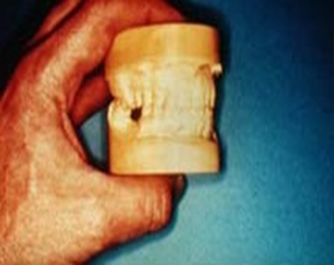The first method is used when sufficient opposing teeth remain in contact to make the existing jaw relationship obvious, or when only a few teeth are to be replaced on short denture bases and no evidence of occlusal abnormalities is found. With this method, opposing casts may be occluded by hand. The occluded casts should be held in apposition with rigid supports attached with sticky wax to the bases of the casts until they are securely mounted in the articulator.

**B. Interocclusal records with posterior teeth remaining**

A second method, which is a modification of the first, is used when sufficient natural teeth remain to support the removable partial denture (Kennedy Class III or IV) but the relation of opposing natural teeth does not permit the occluding of casts by hand. In such situations, jaw relations must be established as for fixed restorations with some type of interocclusal record.

The least accurate of these methods is the interocclusal wax record. The bulk, consistency, and accuracy of the wax will influence the successful recording of centric relation. Therefore a definite procedure for making interocclusal wax records is given as follows:

A uniformly softened, metal-reinforced wafer of baseplate or set-up wax is placed between the teeth, and the patient is guided to close in centric relation. The wax then is removed and immediately chilled thoroughly in room-temperature water. It should be replaced a second time to correct the distortion that results from chilling and then again chilled after removal.

Any excess wax is removed, in these cases a contact between upper and lower natural teeth occurs at acceptable vertical dimension.

A wax record can be further corrected with a freely flowing occlusal registration material, such as a metallic oxide paste, which is used as the final recording medium. The occlusal registration material then is mixed and applied to both sides of the metal-reinforced wax record. It is quickly placed, and the patient is assisted to close into centric relation, which will be guided by the previous wax record. After the occlusal registration material has set, the corrected wax record is removed and inspected for accuracy. Some of the advantages of using a metallic oxide paste over wax as a recording medium for occlusal records include:

1. Uniformity of consistency.
2. Ease of displacement on closure.
3. Accuracy of occlusal surface reproduction.
4. Dimensional stability.
5. The possibility of some modification in occlusal relationship after closure, if it is made before the material sets.
6. Reduced likelihood of distortion during mounting procedures.

C. **Occlusal relations using occlusion rims on record base:**

**Indications:-**

1. When one or more distal extension areas are present.
2. When a tooth- supported edentulous space is large.
3. When opposing teeth do not meet.

In these instances occlusion rims on accurate bases are used where the occlusal surface of a rim opposes standing teeth, a layer of modelling wax approximately 2mm depth is added to occlusal surface of the rim, and the wax is thoroughly softened by using a hot wax knife. The rim is seated in the mouth and the mandible guided carefully into closure until maximal intercuspal contact for natural teeth occurs.



**D. Jaw relation records made entirely on occlusion rims**

**Indications**:-

1. When an opposing maxillary complete denture is to be made concurrently with a mandibular removable partial denture.
2. Used in those rare situation in which the few remaining teeth do not occlude and will not influence eccentric jaw movements.
3. When either arch has only anterior teeth present.

In any of these situations, jaw relation records are made entirely on occlusion rims. The occlusion rims must be supported by accurate jaw relation record bases. Here, the choice of method for recording jaw relations is much the same as that for complete dentures. Either some direct inter- occlusal method or a stylus tracing may be used. As with complete denture fabrication, the use of a face bow, the choice of articulator, the choice of method for recording jaw relations, and the use of eccentric positional records are optional, based on the training, ability, and desires of the individual dentist.



Summary of desirable contacts relationship for various RPD

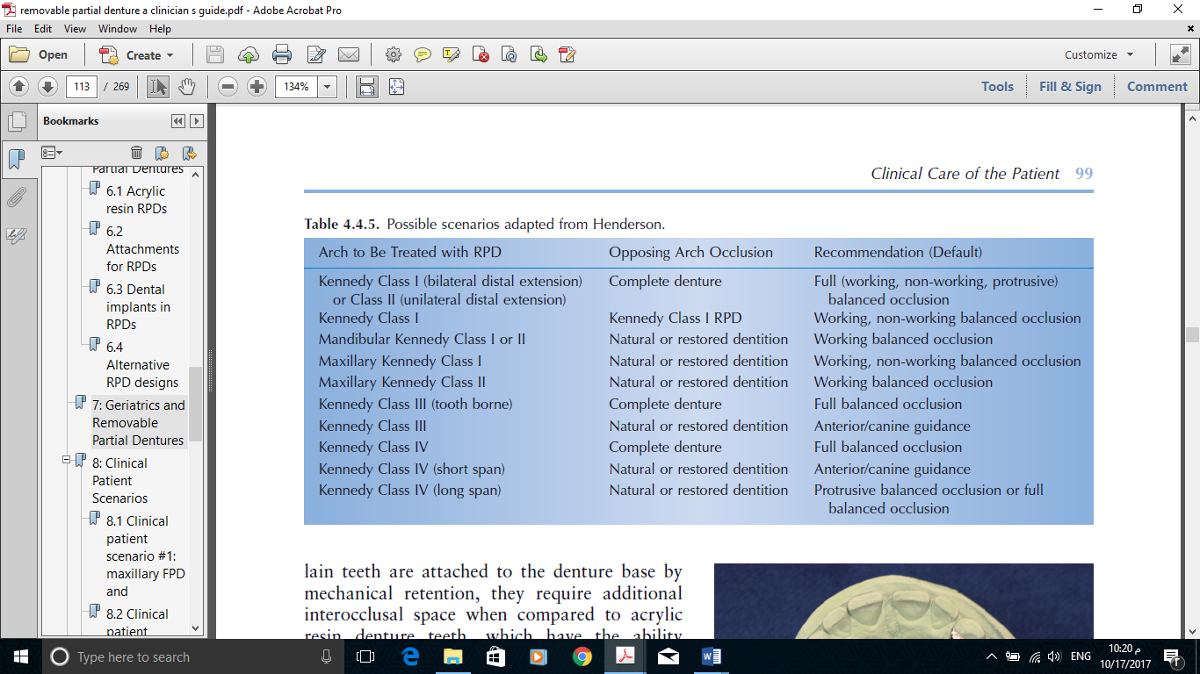

**E. Establishing Occlusion by the Recording of Occlusal Pathways**

The fifth method of establishing occlusion on the removable partial denture is the registration of occlusal path- ways and the use of an occluding template rather than a cast of the opposing arch. When a static jaw relation record is used, with or without eccentric articulatory movements, the prosthetically supplied teeth are arranged to occlude according to a specific concept of occlusion. On the other hand, when a functional occlusal record is used, the teeth are modified to accept every recorded eccentric jaw movement. These movements are made more complicated by the influence of the remaining natural teeth. In the partially edentulous arch in which RPD is to be fabricated, a hard inlay wax is placed over the stable denture base and patient is asked to carry out all extremes of mandibular movement. Inform the patient that the occlusion rim must be worn for 24 hours or longer. It should be worn constantly, including at nighttime, except for removal during meals. With wearing and biting into a hard wax occlusion rim, a record is made of all extremes of jaw movement.

**Advantages of functionally generated pathways**

1. Harmonious occlusion.
2. No recording of complex mandibular movement required.
3. Recovery of lost vertical dimension of occlusion.
4. Errors in occlusion are minimized.
5. 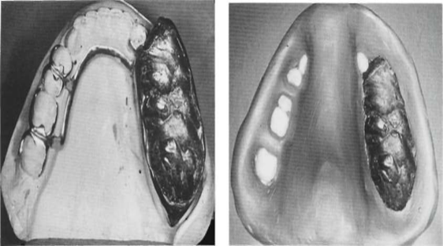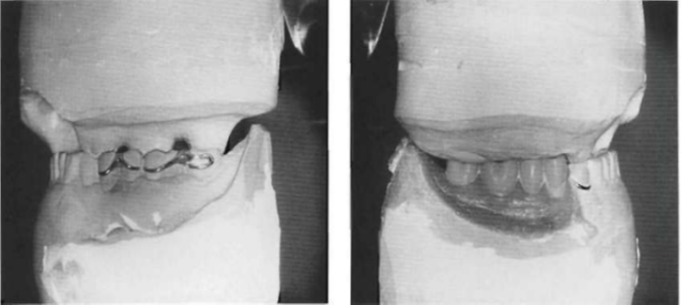Eliminate the need of complex articulator (simple hinge articulator is enough).

***(Functional pathways and uses occluding template rather than a cast of opposing arch for teeth arrangement).***

**Interocclusal records**

An interocclusal record or occlusal registration is usually necessary to orient the maxillary and mandibular diagnostic or master casts to each other properly.

Three widely separated tripod points of occlusal contact are necessary to relate the two casts accurately. These contact points may be tooth-to-tooth or tooth-to-interocclusal recording material. A stable orientation of the opposing casts may exist if suﬃcient teeth remain, and in these patients no interocclusal relation recording is necessary. It is suggested, however, that orientation lines be drawn on the casts to guarantee proper cast alignment in the future. An interocclusal recording will be necessary if insuﬃcient teeth remain to allow a stable cast-to-cast relationship. Some mention must be made of the ridge on which the record bases are formed. If the prosthesis is to be tooth supported or if a distal extension base is to be made on the anatomic ridge form, the bases will be made to fit that form of the residual ridge. But if a distal extension base is to be supported by the functional form of the residual ridge, it is necessary that the recording of jaw relations be deferred until the master cast has been corrected to that functional form.

When a recording is necessary, a record base, occlusion rim, and occlusal recording material are needed to make the recording accurately. It has been suggested that the record base be fabricated using auto-polymerizing acrylic resin, although they often are fabricated of light polymerized resin. The record base must be made on the cast to be attached to the articulator. The occlusion rims most often are made using hard baseplate wax.

**Excellent occlusal recording materials include**:

1. zinc oxide eugenol impression material,
2. plaster impression material,
3. modeling compound,
4. polyether,
5. Polyvinyl siloxane.
6. Wax records made in edentulous areas with or without the support of record bases may not be suﬃciently stable to be acceptable.

The interocclusal recording is most often made after fabrication of the removable partial denture framework. Following the ﬁtting of the framework and the making of a corrected cast impression (if indicated), the record base is fabricated on the edentulous areas of the framework/master cast. Occlusion rims are added, and an occlusal recording material is used to make the record. The cast is oriented to the opposing cast with the recording, and desired denture teeth are selected. This fabrication is followed by a trial insertion appointment.