د. احمد حامد علي
Lecture (10)
Operative Dentistry

Defense Mechanisms of the Pulp and Dentin against Injury

The reaction of the pulp and dentin to injury is mainly related to the activity of the odontoblast cells. A variety of reactions to injury could be seen which include:

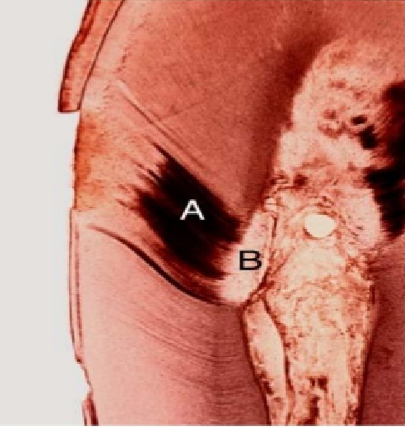
- Dead Tracts
These are regions of empty tubules in primary dentin that result from degeneration of the odontoblastic process found under most carious cavities.
At the proximal end of the tubules (near the pulp), the dead tract has been sealed off by a layer of impermeable calcified tissue protecting the pulp.

- Sclerotic Dentin
This type of dentin result from either aging or mild irritation (such as slowly advancing caries) and causes a change in the composition of the dentin. The peritubular dentin become wider and thicker as the tubules being filled and obliterated with calcifying minerals. Continued intratubular mineralization of dentin may result in complete obturation of the tubules. These areas of dentin are harder, denser, less sensitive, and more protective of the pulp against subsequent irritations.
Sclerosis resulting from aging is called physiologic dentin sclerosis, while sclerosis resulting from irritation is called reactive dentin sclerosis.
Clinically, sclerotic dentin is shiny, darkly colored, and feels hard to explorer tip, while the freshly cut normal dentin lacks the shiny reflective surface and allows some penetration by the sharp explorer tip (softer than sclerotic dentin). It is not uncommon to find sclerotic dentin under old restoration which usually shows a great amount of discoloration.
The apparent function of sclerotic dentin is to wall off the lesion by blocking (sealing) the tubules. The permeability of this type of dentin is greatly reduced in comparison to normal dentin because of the decrease in the tubule lumen diameter.

- Reparative Dentin (Tertiary D., Reactionary D., or irregular secondary D.)
This type of dentin is the outcome of odontoblastic response to irritation occurring mainly during secondary dentinogenesis and is caused by dental abrasion, attrition, cavity preparation, erosion or dental caries.
Caries advancing at a moderate rate with high acid production results in degeneration and death of the odontoblasts and their processes in the tubules, as well as mild inflammation of the pulp.
In about 15 days, new odontoblasts are differentiated from mesenchymal cells of the pulp, and these replacement odontoblasts lay down the reparative dentin that is confined to the localized irritated area of the pulp cavity wall.
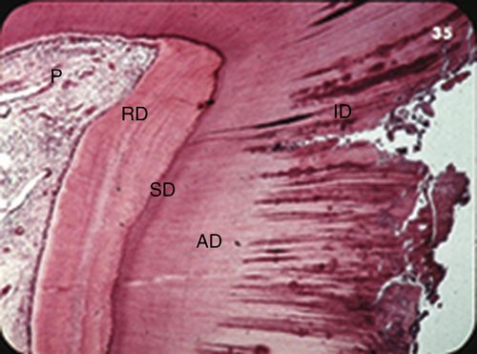
The structure of reparative dentin is more often irregular, atubular dentin depending on the severity of the stimulus. Reparative dentin is a defense reaction localized to the area of injury.
(reactionary dentin is the result of irritation of postmitotic odontoblasts, whereas reparative dentin is formed by odontoblasts or odontoblast-like cells which differentiate from pulp cells after the cell death of primary odontoblasts).

- Infected Dentin
It is softened and contaminated with bacteria. It includes the superficial necrotic dentin tissue or zone. Clinically, necrotic dentin is wet mushy, easily removable mass. Histologically, this dentin is structureless with granular appearance and contain mass of bacteria. Remnant of distorted dentinal tubules filled with bacteria may be seen. The deeper infected dentin is dry and leathery. It is easily removed by hand instrument and flake off in layers parallel to the DEJ.
If the lesion is progressing slowly, there will be a zone of sclerotic dentin subjacent to the demineralized dentin. When this occurs, it represents the ideal excavation depth, since the sclerotic dentin is a natural barrier that blocks the penetration of toxin and acids.

- Affected Dentin
It is softened dentin that still not invaded by bacteria and has intact tubules containing odontoblastic processes that have porous surface and contain crystalline material. This dentin is capable of remineralization, provided the pulp remains vital.
In slowly advancing lesion, we should remove all softened dentin down to the identificationable zone of sclerotic dentin. In rapidly advancing lesion, there is little clinical evidence by texture and color change to indicate the limit of the infected dentin. Caries indicator could be helpful to distinguish between infected and affected dentin.

- Inflammation of the pulp.
Inflammatory Conditions of the Pulp
In order to select the proper choice of treatment, the status of the pulp must be determined with accuracy. Sufficient irritation induces injury; incites inflammation. Histologically and physiologically, the inflammation is similar to that occurring in other connective tissues. However, the long term response of the pulp to severe irritation is different than in other tissues. In contrast to most soft tissues, the pulp has no room in which to swell. This inability to swell may well lead to increasing cell death in an ever widening area. It is generally the coronal pulp that is injured and it lacks collateral blood supply; extra nutrition and defenses cannot be marshaled quickly to the area. Another factor working to the detriment of the injured pulp is inflammation itself. Inflammation is a protective response. The immune response may destroy normal cells as well as foreign substances. Again, the pulp, with its compromised blood supply is unable to cope with this increasingly severe damage.
The most severe reaction occurs at the time of actual pulp exposure. In progressive order the status of the pulp in the response to caries are as follows:
1- Healthy pulp.
2- Hyperemia.
3- Acute pulpitis.
4- Chronic partial pulpitis (without necrosis).
5- Chronic partial pulpitis (with necrosis).
6- Chronic total pulpitis with partial necrosis.
7- Total necrosis of the pulp.
8- Acute pulpitis superimposed on chronic pulpitis.
Pulpal diseases are broadly divided into reversible and irreversible pulpitis and are based on the ability of the inflamed dental pulp to return to a healthy state or not.
1-Healthy Pulp
Normal pulp, free of disease, or healthy, may show a wide variation in it histological structure according to its age and function. There are no inflammatory cells.
2- Hyperemia
Hyperemia is a physiologic term meaning an increase in blood flow through tissue. In histology, dilated and congested vessels were seen. Pulp could not be inflamed. About 41% of the carious teeth did have hyperemia, suggesting that frequently this may be an early sign of inflammation. Because the early vascular events of hyperemia precede or are an early component of inflammation, the removal of the precipitating cause of hyperemia should revert the microcirculation to its normal state.
3- Acute Pulpitis
This occurs as a sequent to various operative procedures including mechanical pulp exposure also following deep scaling and curettage. Always an acute reaction develops beneath the affected dentinal tubules. Acute infection could superimpose itself on an existing chronic inflammatory reaction e.g. the operative manipulation will induce an acute reaction on an already existing chronic reaction due to the previous restoration.
Histologic changes associated with inflammation: The odontoblast cells may be destroyed or irrupted by edema. Often evidenced by increased eosinophilia of the connective tissue. Marked dilatation of lymphatics and of blood vessels is accompanied by packing of erythrocytes and pavementing of leukocytes along the vessel walls, and within capillaries. Infiltrate of leukocytes, is soon evident around the dilated vessels. This reaction lasts 3 days and it either disappears and resolves into a repair process or it changes into a chronic inflammatory reaction depending on the irritant “if it persists”.
The clinical manifestation is mild pain during hot and/ or cold application, the pain remain as long as the stimulus remains.

4- Chronic Partial Pulpitis (without Necrosis)
This develops from deep dental caries, pulp exposure, operative procedures, deep periodontal lesion, and orthodontic tooth movement. The inflammation is confined to the coronal portion of the pulp. Histologically the chronic form usually dominated- small Lymphocytes, Monocytes, Macrophages, and plasma cells are abundant.
In children and young adults, the hyperplastic tissue reaction occurs because the young dental pulp has a rich blood supply and favorable immune response that is more resistant to bacterial infection. This is known as pulp polyp, also known as chronic hyperplastic, is an uncommon and specific type of inflammatory hyperplasia that is easy to bleed by touch. The pulp polyp is usually an incidental finding that occasionally mimics reactive and neoplastic diseases of the gingiva and adjacent periodontium, it's easy to be differentiated from gum polyp by follow the origin of each by using a probe. The pulp polyp is the result of both mechanical irritation and bacterial invasion into the pulp of a tooth that exhibits significant crown destruction due to trauma or caries. Usually, the entire dentinal roof is exposed with the crown of a carious tooth. The large exposure of pulpal tissue to the oral environment and bacterial invasion results in a chronic inflammatory response that stimulates granulation tissue reaction. Treatment of a pulp polyp includes: The more conservative vital pulpotomy treatment has been successful in selected cases when only the coronal pulp is affected (there's no necrosis in the pulp). Or either root canal therapy or extraction of the tooth when there is necrosis in the pulp.

5- Chronic Partial Pulpitis with Partial Necrosis
It develops from the same irritant as above but with the persistence of such irritant. This causing area of liquefaction or coagulation necrosis with the inflammatory lesion has extended to deeper pulp tissue.
Painful symptoms may occur, these areas of liquefaction necrosis are called “pulp abscess” since they are surrounded by disintegrated polymorphonuclear leukocytes, collagen fibers and chronic inflammatory cells. The pain is spontaneous and is due to the pressure of the abscess on the nerve surrounding it. Sometimes the pain may last for ½ hr, and it doesn’t disappear with analgesics.
Radiograph should be taken when the tooth in such condition. It could be exposed (the caries has gone to the pulp- chronic open pulpitis) or it could be closed (the effected caused by bacterial toxins or sever irritant that the pulp can't recover).
The available treatment for this type of pulpitis is either endodontic (root canal treatment) or tooth extraction.

6- Chronic Total Pulpitis with Partial Necrosis
This develops with the extension of the inflammation to involve the entire pulp tissue (coronal and radicular) due to the persistence of the irritant and the development of liquefaction necrosis within the inflammatory area or coagulation necrosis. We get severe pain, sometimes lasting for many hours or when the patient sleeps this will increase the pressure inside the pulp and cause throbbing pain. The available treatment for this type of pulpitis is either endodontic (root canal treatment) or tooth extraction.

7- Total Necrosis of the Pulp
Pulp in which the cells have died as a result of coagulation or liquefaction. histologically, coagulation cell means is still recognizable but the intracellular details have disappeared. While liquefaction necrosis, the entire outline of the cell has disappeared, and liquefied area. There is a dense zone of polymorphonuclear leukocytes with cells of chronic inflammation.

8- Acute Pulpitis Superimposed on Chronic Pulpitis
There's severe pain especially at night till the abscess is formed then there's slight relief but not complete relief unless we do drainage through the tooth (access opening) or surgical incision with antibiotic cover, we should see the patient within few days and then treatment is continue by root canal treatment or extraction.

