**Dr. Zainab H AlGhurabi**

**Fundamentals of Radiography**

* **Introduction:-**
* Dental radiography: is a process of production a photographic image for an object through the use of **x – radiation**, and by this process the dentist can examine the internal tissues like (roots of teeth and alveolar bone) which are not able to be seen by the naked eye due to over soft tissues.
* X – Ray was discovered by (Roentgen) in 1895, it travels in a form of pure energy and the basic unit is x – ray photon or (quantum).
* X – Ray photons travel with a wave motion called (sine – wave) and the distance between the crests of these waves called (wave – length) which measured by a unit (A˚). The X – ray photons wave length used in diagnostic radiography is ranged between 0.1 – 0.5 A˚ and the amount of energy contained in each photon called (photon energy) which depend on

1. Wave length

2. Frequency of x – ray

The high frequency of X – ray the shorter wave length photons this shorter wave length photon has more energy than a low frequency long wave length type of X – ray photons.

**Similarities between x – ray and light:-**

1. Both belong to the same electro – magnetic

radiation family.

2. Both travel in straight lines at the same speed

Which is 186,000 miles per seconds.

3. Both affected the photograph films and made

them black.

4. Both not affected by magnetic fields objects in the same manner

5. X – ray and light cast the shadows of the objects in the same manar.

**Differences:-**

1. X – ray has the ability to penetrate objects that the light can't pass through.

2. X– ray has the ability to ionize atoms

3. X – ray has the ability to produce light (blue light) when it hits some objects and this phenomena called (fluorescence).

4. X – ray is invisible

**The components of x – ray machine:-**

A dental X– ray machine is used to generate X – ray, this machine composed of:-



1.X–ray tube:- it’s a vacuum tube so that the electrons are free to travel inside the tube without interaction with air molecules.

The glass tube is leaded to prevent (the generated X – ray) from escaping in all directions. While the window is of unleaded glass so that X – ray exist out through this window.

**X – ray tube consists of 2 ends:-**

A – (-ve) electrode (cathode) end.

B – (+ve) electrode (anode) end.

**Cathode end:-**

It consist of focusing cup made of molybdenum in which a tungsten filament is set this filament is the source of electrons that are used to generate X – ray.

**Anode end:-**

Here was have a thin tungsten button set in a rod of copper this rod surrounded by an oil bath which used to absorb heat that created during generation of X– ray

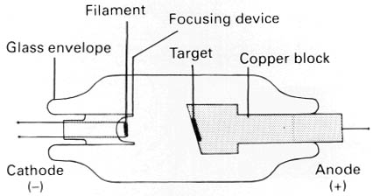

* 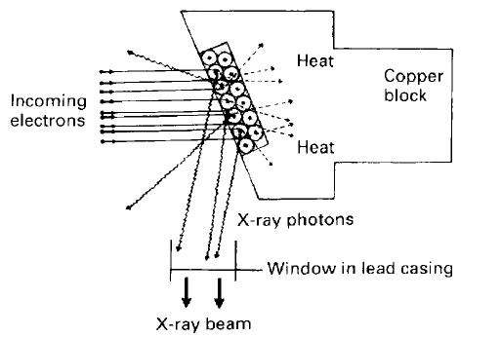
* 2. Step up transformer: - it consist of 2 coils of electrical wire and it used to increase the incoming voltage from 240 Volts to 60 kilovolt or more.

3. Step down trans former: - it used to decrease the incoming voltage to around 10 Volts in order to supply the filament circuit of X – ray tube with low voltage.

4.Autotransformer: - this is made from one coil to do the work of 2 coils. It can be used for making minor change in the voltage.

5.Rheostat :- is a device used to increase the resistance to the passage of electrical current through the wire it reduce the amount of electrical current used in X – ray machine through the circuit to about 10 – 15 milliamp (mA).

6.Timer: - it cause activation of high tension current across the tube and this happened when the timer bottom is pressed.

.

**Selection of target material:-**

Ideal target material must posses the following qualities:-

It should have high thermal conductivity

It should have high atomic number

It should have high melting point

It should have low vapor pressure

 (Tungsten with copper rods is ideal because copper has high thermal conductivity.)