Dr. Zainab H AlGhurabi
Ideal radiographic projection:-
Ideal radiographic demonstrate certain image qualities includes
A – Radiographic image that is
sharp.
B – Radiographic image that is
shaped like the object.
C – Radiographic image that is
same size as the object.
Also there are 5 principles of shadow casting must observed during the film exposure these principles are as follow:
1. Source of radiation should as small as possible.
2. Tube – object distance should be as great as possible.
3. Object – film distance should be as small as possible.
4. Film should be parallel to an easily identifiable plane of the object.
5. Central ray of the beam should be perpendicular to the film.
Now first 3 principles deal with the image sharpness while the last 2 principles required during exposure as a technique
.
Penumbra: - is the amount of unsharpness of the image so penumbra is the area of partial shadow.
Umbra: - is the area of total shadow and it's exist only when the object absorb all of x – rays.
Now penumbra is created by the size of focal spot (source of radiation), the larger the spot size the greater is the penumbra (the amount of unharness).
Also penumbra affected not only by focal spot size but tube – object distance and object – film distance so the closer tube – object distance the greater is the penumbra while the closer object– film distance the lesser is the size of penumbra.

Distortion:-
Is the change in the shape of the image as compared to the object due to improper alignment of the tube film or the object.
Artifacts:-
1. Cone cut:- is clear unexposed area result from positioning fault when the x- ray beam not completely cover the film during exposure
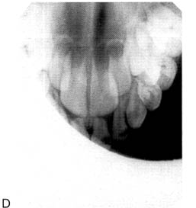

2.Back side exposure:- when the film placed in wrong position making the non exposure side facing the beam, the result is the image with the pattern of the lead foil is evident.
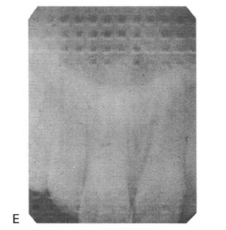

3. Double exposure:- here the same-ray film expose twice to X- ray this result in excessive dense and blurred image.

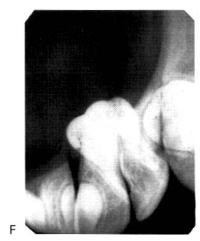
4. Elongated image:- vertical angulation of x- ray tube was too shallow

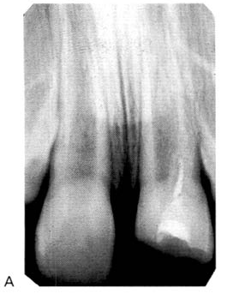

5. Shortened image:- vertical angulation was too steep.

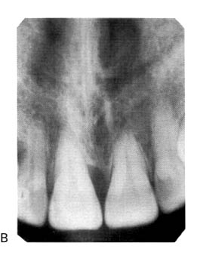

6. Over lapping of adjacent structures:- when horizontal angulation was incorrect.

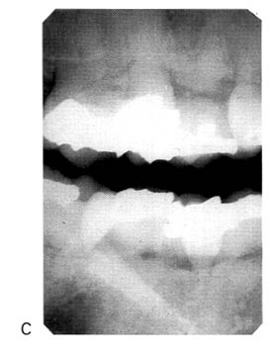

7. Blurred film:- due to excessive bending of the film during exposure.
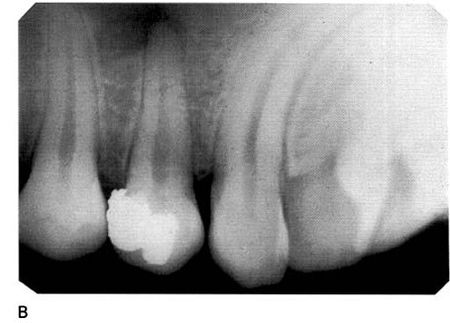
8. Fingernail marks:- resulting black lines when pressure by fingernail as an example put on the film or sometime we have (finger print impression) in the emulsion

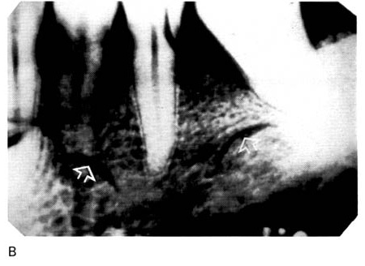
9.Reticulation: - it mean creak of emulsion when subjected to great change in
temperature between different processing solution
( temperature must go from warm to cold.)
10. Undeveloped area:- this appear as clear area caused by incomplete immersion of the film in developer or sticking the film in the developer to the side of the tank.
11. Wet and leaking packets: - when we have black borders due to light entering a poorly sealed film wrapper
12. Completely clear film:- when put the film in fixer before developer

13. to Pale X- ray film:- this due either under exposure, or under developing

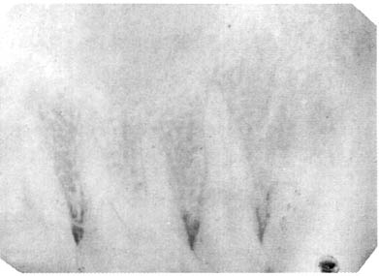
14 . Dark X- ray film:- this is due to either over exposure or overdevelopment

