INTRA ORAL EXAMINATION

The Intraoral Examination
The first step in the intraoral examination is a quick general examination of the cheeks, hard palate, tongue and gingiva looking for any contraindications for continuing the evaluation. If there are none, start the examination.
The examination of the teeth (present in details in power point)

Oropharynx
Examine the oropharynx by placing a mirror or tongue depressor on the dorsal surface of the tongue applying gentle pressure without having the patient stick their tongue out. The dentist should be able to visualize the posterior pharyngeal wall, anterior and posterior pillars and the tonsillar crypt and tonsils, if present These areas are normally not palpated unless there is a need.
Normal anatomy of the oropharyngeal area.
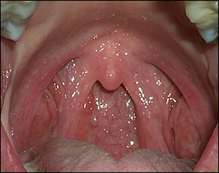

Posterior Pharyngeal Wall
The tissue in this area should appear very vascular but otherwise homogenous in color tending towards reddish pink. The surface may be smooth or appear to have small coral pink to translucent, gelatin-like, homogenous surface prominences which are consistent with normal areas of scattered lymph tissues (lymphoid aggregates). Pathologic findings include:
- Homogenous and non-tender erythema associated with post nasal drip and/or smoking
- Erythema and purulent exudate associated with pharyngitis (infection of the pharynx) may cover portions of the pharyngeal wall
- Ulcers, erosions or noticeable enlargements or growths

Anterior and Posterior Pharyngeal Pillars
The anterior and posterior pillars should appear vascular, smooth and symmetrical Atypical findings one may encounter include lymphoid aggregates (as found on the posterior pharyngeal wall), areas of pale scarring in a radial or stellate pattern from tonsillectomy, or torn or absent pillars also a result of this surgery. Pathologic findings include:
- Asymmetry, unless due to tonsillectomy
- Lesions of any kind
- Erythema associated with tenderness or exudates

Tonsillar Crypt
The tonsils are examined using direct visualization. dentist will observe rough, lobular, and coral to light pink tissue of varying amounts between the anterior and posterior pharyngeal pillars Atypical presentations include excessively large or asymmetrical tonsils, cratered surfaces without evidence of erythema or exudates. Occasionally, individuals have large crypts in the tonsils that collect food debris, bacteria and hardened material. Patients with this type of cryptic tonsil often complain of halitosis(those patients attend to the dentist complaining from bad odor in the mouth) , be very suspicious looking so it is essential to be vigilant. After a tonsillectomy one may observe residual tonsil tissue or a regrowth of lymph tissue in the area. Pathologic findings include:
- Dysphagia (painful or difficult swallowing)
- Swelling, asymmetry, erythema and/or surface exudates
- Erythema and/or dysphagia may also be associated with mouth breathing and may indicate a nasal obstruction.
Streptococcal infection of the tonsils.
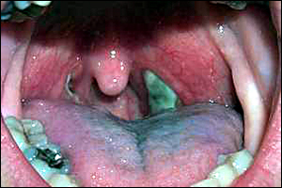

Soft Palate and Uvula
This area is examined using direct vision and is normally not palpated unless necessary. If palpation is necessary a topical anesthetic should be used by the dentist and the tissues should be palpated from the mid line out towards the lateral surfaces. Normally, this area is slightly less vascular than the oropharynx and is usually reddish pink in color .Observe the area as the patient says “ah.” The tissue should appear loose, mobile and symmetrical during function. The tissue will have a homogenous, spongy consistency on palpation. Atypical observations include yellowish coloring due to increased adipose tissue (especially in older patients), excessively long or short uvulas and uvulas that appear slightly asymmetrical at rest. Occasionally one will discover a bifid (cleft) uvula. Pathologic findings include:

- Lesions of any kind
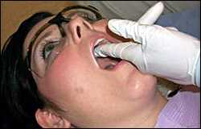
- Loss of function or lack of symmetry during function.

Use firm pressure and try not to slide the fingers along the tissue of the hard palate
- In general, the tissue is a homogenous pale pink color, firm to palpation towards the anterior and lateral to the midline while more compressible towards the posterior and medial to the apices of the teeth. The normal structures of the hard palate should be identified:
- Incisive papilla – protuberance of soft tissue lingual to the maxillary central incisors which covers the incisive foramen and normally appears redder than the surrounding tissues
- Raphe – slightly elevated line extending from the incisive papilla to the soft palate)
- Rugae – corrugated ridges radiating laterally from the raphe
- Normal structures of the anterior hard palate.
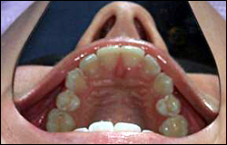

Vault – relates to the depth and width of the palate
Normal structures of the posterior hard palate.
Maxillary tuberosities – area distal to the last molars the tissue should be a homogenous pink color and firm to palpation:
The torus palatinus is the most common atypical finding in the hard palate. These tori may range have a smooth surface texture. Often the larger tori will have traumatic ulcers or other traumatic lesions on their surfaces.
Extreme example of a multilobulated torus palatinus.
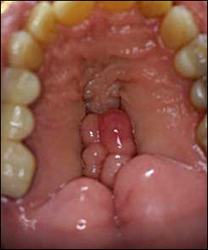

Tori are not usually considered a problem unless prosthetic appliances are being considered. Tori also make it difficult to expose intraoral radiographic films. while Pathologic findings include:
Pigmented macules – pigmented lesions of any type should be identified to rule out melanoma. The palate is also a common area for unintentional tattoos resulting from pencil leads being jabbed into the tissues while playing with a pencil or holding it in the mouth.
Thermal burns – the anterior palate is the most common area for this type of traumatic injury
Nicotine stomatitis – whitening and fissuring of the attached gingiva of the hard palate and inflammation of the minor salivary gland ducts
Papillary hyperplasia – development of finger-like projections usually under a poorly fitting full or partial denture
Other traumatic lesions – abrasions and lacerations resulting from eating injuries
Systemic related lesions – lesions related to lupus are commonly found in the palate and the palate is a prime location for the blue nevus

Buccal Mucosa

The buccal mucosa is examined using direct and indirect vision followed by bi-digital palpation of the entire area. Be sure to pull the tissues away from the retromolar area and stretch the mucosa away from the mucogingival junction

The buccal mucosa should be bidigitally palpated pressing the tissue between the index finger and thumb of one hand
Palpating the buccal mucosa.
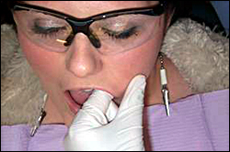

Normal tissues of the buccal mucosa appear moist and pink/dark pink. They are soft and pliable on palpation with no discernible indurations. Stensen’s duct should be identified with or without the presence of a parotid papilla. Linea alba, Fordyce’s granules and leukoedema are common atypical findings on the buccal mucosa. feeling small papules within the tissues usually indicative of sclerotic or fibrotic minor salivary glands. Varicosities may often present on the buccal mucosa of older patients. The buccal mucosa is also a prime area for stress related habits such as cheek chewing (morsicatio buccarum). Assisting the patient in stress reduction techniques and providing awareness of the habit is helpful. Pathologic findings associated with the buccal mucosa include:
- Traumatic injuries – thermal burns, cheek bites, ulcers, traumatic fibroma
- Leukoplakia associated with spit tobacco
- Neoplastic changes – erythroplakia, speckled leukoplakia and pigmented lesions
- Systemic disease – oral lichen planus, lupus, lipomas, aphthous ulcers, erythema multiforme, and Crohn’s disease.
Leukoplakia associated with spit tobacco.
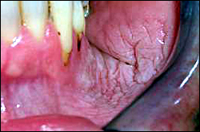

Labial Mucosa
The labial mucosa is examined using direct vision by averting the tissues over the fingers or thumbs followed by bidigital palpation of the tissues of the lips.

Visual examination of the upper labial mucosa.
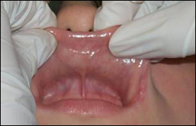

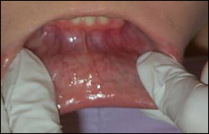
Visual examination of the lower labial mucosa.

Move the tissues from side to side and visualize the frena. Normal lip tissues are a homogenous deep pink color which changes gradually to a deep red color with more prominent vascularity near the mucolabial vestibule. The tissues should be moist and have uniform consistency and thickness when palpated
Bidigital palpation of the upper labial mucosa.
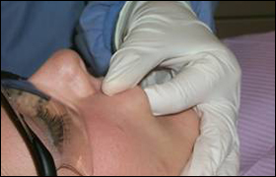

Sclerotic minor salivary glands are common atypical findings as are Fordyce’s granules. Pathologic findings include the following:
- Traumatic injuries – abrasions, lacerations
- Dry, cracked lips
- Angular cheilitis – human herpes virus, Candida Albicans
- Aphthous ulcers
- Neoplastic changes

Mandible
The body of the mandible will be examined using direct and indirect vision followed by digital palpation of the entire structure. The tissues of the floor of the mouth should be stretched away from the inferior border of the mandible with a mouth mirror
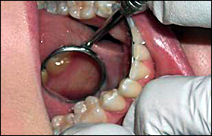
Use the mirror to stretch the tissue away from the inferior border of the mandible.

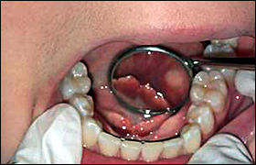
The mirror is used to visualize the anterior lingual portion of the mandible

Digitally palpate the body of the mandible along the lingual and facial surfaces Normal tissues will be a homogenous coral pink and have a firm consistency with no visible or palpable lesions. Mandibular tori and exostoses are the most common atypical findings in this area. The retromolar area may present with partially erupted third molars or scarring from third molar extraction. This area is also prone to hyperkeratosis from constant friction from masticatory function. Pathologic findings include:
- Traumatic lesions – ulcers, abrasions
- Infections – pericoronitis
- Neoplastic growths
- Leukoplakia associated with spit tobacco
Use digital palpation pressing the tissues against the body of the mandible for both the lingual and the facial aspects.
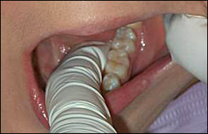

Painful pericoronitis surrounding partially erupted tooth
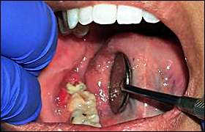

Floor of the Mouth
The floor of the mouth is examined using direct and indirect vision followed by bimanual palpation of the entire area. The patient should be asked to raise the tongue making direct visual examination of the tissues toward the midline of the floor of the mouth possible
Visual examination of the floor of the mouth. Note the normal structures of the area.
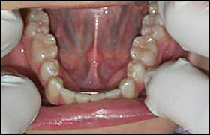

The mirror should be used to examine the areas near the inferior border of the mandible. The tissues should appear moist and very vascular. The normal anatomy of the area should be identified including:
- Sublingual caruncle – small rounded projection at the base of the lingual frenum which houses Wharton’s duct from the submandibular salivary gland
- Sublingual folds – two oblique elevations found radiating laterally away from the lingual frenum on either side of the caruncle which house the ducts from the sublingual salivary gland
- Lingual frenum – muscle attachment from the ventral surface of the tongue to the floor of the mouth. This attachment varies in length from person to person.
Bimanual intraoral palpation with the index finger of the nondominant hand supported extraorally by the fingers of the dominant hand will allow the clinician to feel the structures of the area between the fingers as they are compressed together gently
Extraoral view of proper palpation technique.
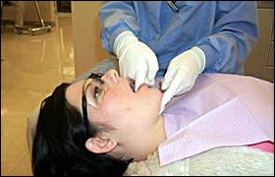

The tissue will be soft on palpation with firmer areas noted in the area of the suprahyoid muscles (digastric, geniohyoid, mylohyoid). The sublingual folds will feel ridge-like and mobile. Varicosities are the most common atypical observation in this area. Other atypical findings are enlarged lingual folds and caruncle and a short lingual frenum (ankyloglossia). Ankyloglossia is only considered a problem if it begins to affect the speech development of the individual. Pathologic findings include:
- Traumatic injuries – ulcers mucoceles
- Salivary gland pathology – ranula, sialoliths, enlargement
- Neoplastic changes
- Ankyloglossia – this is considered pathologic only if it interferes with the normal development of proper speech

Tongue
The tongue is examined using both direct and indirect vision. The most common place for cancer to occur on the tongue is the lateral border. Grasp the tip of the tongue with a gauze square and roll the tongue over on one side to observe the lateral border then repeat for the other side Use the mirror to examine the posterior lateral borders if necessary.

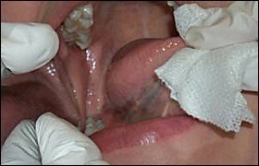
Examination of the lateral borders of the tongue.

Proper use of the mirror to aid in the visual examination of the tongue.
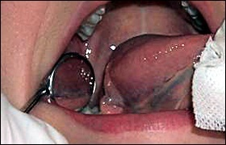

Have the patient raise the tongue to the roof of the mouth to observe the ventral surface
Visually examine the ventral surface of the tongue.
The tissues should appear pink in color with a rough surface texture on the dorsal surface and a smoother surface texture on the ventral surface. The tongue should be symmetrical in shape and in function.
Use a bidigital technique to palpate the entire tongue between the finger and thumb of one hand
Grasp the tip of the tongue with gauze while palpating the body of the tongue.

The tissues of the tongue should feel soft and resilient with no palpable indurations or masses. The clinician should identify the normal anatomy of the tongue including:
- Dorsal surface – papillae (filiform, fungiform, circumvallate), median sulcus, sulcus terminalis
- Lateral borders – foliate papillae
- Ventral surface – lingual veins, plicafimbriata, lingual frenum
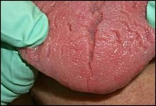
Atypical findings on the dorsal surface of the tongue are common. They include: fissuring scalloping, benign migratory glossitis ,and enlarged papillae, among others. A lingual thyroid may rarely be found on the posterior dorsal surface at the foramen cecum. Lingual varicosities are a common finding on the ventral surface of the tongue, especially in older patients. The Glands of Blandin-Nuhn (minor salivary glands found on the ventral surface of the tongue) may become enlarged prompting the need for a referral or diagnostic procedure to confirm the origin.
Fissured tongue.

Scalloped tongue.

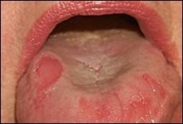

Benign migratory glossitis.

The tongue is the most common intraoral site for oral cancer. Therefore, any sign of pathology should be investigated thoroughly. Some of the pathological findings that are found on the tongue include:
- Hairy tongue – filiform papilla become elongated due to a variety of reasons from overuse of mouth rinses to not cleaning the tongue adequately.
- Candidiasis – fungal infection of the tongue often associated with deeply fissured tongues.
- Glossitis – inflammation of the tongue due to anemia, nutritional deficiencies and others.

It is also important to note if the tongue is coated with dental biofilm. The tongue is home to the highest number of bacteria found anywhere in the oral cavity. Bacteria located on the tongue have been associated with halitosis, increased pH of the saliva, and periodontal disease. Tongue cleaning and methods of cleaning the tongue should be stressed during patient education.
The patient raise the tongue to the roof of the mouth to observe the ventral surface
Visually examine the ventral surface of the tongue.
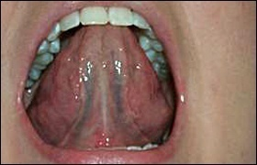

The tissues should appear pink in color with a rough surface texture on the dorsal surface and a smoother surface texture on the ventral surface. The tongue should be symmetrical in shape and in function.

Neurological examination of the tongue
Note any atrophy or fasciculations (spontaneous quivering movements caused by firing of muscle motor units) of the tongue while it is resting on the floor of the mouth. Ask the patient to stick their tongue straight out and note whether it curves to one side or the other. Ask the patient to move their tongue From side to side and push it forcefully against the inside of each cheek.
Fasciculations and atrophy are signs of lower motor neuron lesions. Unilateral tongue weakness causes the tongue to deviate toward the weak side.
Tongue weakness can result from lesions of the tongue muscles, the neuromuscular junction, the lower motor neurons of the hypoglossal nerve (CN XII), or the upper motor neurons originating in the motor cortex. Lesions of the motor cortex cause contralateral tongue weakness.
So there is a statement which said that the tongue is the mirror of the body.

Attached Gingiva
The attached gingiva of the maxillary and mandibular arches is visually examined using both direct and indirect vision. The tissues should appear pale pink and homogenous in color and texture Following the visual examination, the attached gingiva is palpated using a digital technique.
The tissue should feel firm to touch and tightly attached to the bone. The most common atypical finding in the area of the attached gingiva is exostoses
Extensive exostoses on the maxillary facial surfaces.
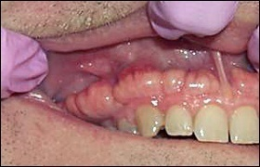

Pathologic findings include:
- Inadequate zones of attached gingiva – the clinician should determine the presence of adequate amounts of attached gingiva in all areas. Less than 1 mm of attached gingiva is considered to be inadequate in most cases and the patient should be referred to a periodontist for evaluation of the affected area.
- Mucogingival involvement – areas with no attached gingiva or areas of extreme recession
- Frena problems – tight frenum attachments or pulls
- Traumatic lesions – ulcers, abrasions, burns
- Mucosal disease such as lichen planus, pemphigus vulgaris, mucous membrane pemphigoid, lupus, and allergic type responses

Salivary Flow and Consistency
Salivary flow and consistency will vary with each patient. Some abnormal findings must be noted such as frothy saliva or thick ropy saliva. the actual flow of saliva appears normal. The mixture of serous and mucous saliva affects the perception of dryness as well. When problems arise with the parotid gland, the flow from Stensen’s duct will be diminished. Milking the salivary glands from the tail toward the mid line assists the clinician in visually assessing the Stensen’s duct orifice found next to the maxillary first molar.
Gauze should be used to dry the floor of the mouth and visually asses the flow from the Wharton’s duct orifice and other ducts of both the sublingual and submandibular glands

Normal structures that may be mistaken for lesions
- Stensen's duct is the duct of the parotid gland. It opens into the mouth on the posterior buccal mucosa opposite the maxillary molars. The duct opening may be flat or slightly raised.
- The circumvallate papillae form a V-shaped row of rounded papillae at the junction of the anterior 2/3s and the posterior 1/3 of the tongue.
- The lingual tonsils are found on the posterior-lateral aspect of the oral tongue. They may become enlarged with viral infections.
- Plicafimbriata are folds of mucosa on the ventral surface of the tongue on either side of the lingual frenum. The folds may looked fringed due to mucosal tags.

Variations of Normal
- Fissured tongue is a common condition. Multiple grooves are seen on the dorsum or occasionally the lateral tongue. This is reported in 2% to 5% of the population
- Fordyce granules are ectopic sebaceous glands that occur on the oral mucosa. They are commonly seen on the buccal mucosa or the lateral vermillion of the upper lip. They appear as groups of yellowish-beige slightly raised areas (papules) measuring 1 to 3 mm diameter.
- Varicosities are enlarged veins, commonly seen on the ventral tongue. These are usually seen in older patients. Varicosities blanch on pressure. A glass slide or glass test tube can be used to press on the varicosity. The pressure causes collapse of the vein with disappearance of the purple color. On releasing the pressure, the blood flows back into the vein, and the purple color returns.

Common oral pathology
- Geographic tongue a common benign condition seen in 1% to 3% of the population. The eitiology is unknown. The classic features are multiple pink or red circular or semicircular well-demarcated areas on the dorsum or lateral aspect of the tongue. The erythema is partially surrounded by a slightly raised yellowish-white rim or border. It may be seen in association with fissured tongue.
- Linea Alba (white line) appears as a white (hyperkeratotic) horizontal line along the buccal mucosa at the level of the occlusal plane. This is a common condition and is often bilateral. It is due to frictional irritation or sucking trauma.
- Benign vascular lesions appear as red or purple areas on the oral mucosa. These are usually seen in older patients. They blanch on pressure. A glass slide or glass test tube can be used to press on the varicosity. The pressure causes collapse of the blood vessels with disappearance of the purple color. On releasing the pressure, the blood flows back into the blood vessels, and the purple color returns.
- Morsicatio buccarum or cheek biting appears as a ragged slightly translucent area on the buccal mucosa. Most patients, when asked, will admit that they bite their cheek repeatedly.

