Operative Dentistry
د. احمد حامد علي
Lecture (9)

Restorative Dentistry and Pulpal Health

Teeth are vital organs; they should be treated with consideration when subjected to operative procedures. The pulp responds very quickly to external stimuli, and the response depends on the severeity of the stimuli. The effects of different operative procedure on the pulp can be subdivided into:

A-Effect of Local Anesthetic on the Pulp
Vasoconstrictors of LA potentiate and prolong anesthetic effect by reducing blood flow in the area. Reduction in blood flow during a restorative procedure could lead to an increase in the concentration of irritants accumulating within the pulp.

B-Effect during cavity and crown preparation (cutting procedures)
Pulpal responses to cutting procedure depend on many factors:

- Thermal injury (frictional heat)
In spite of low thermal conductivity of dentin, the heat generated by grinding procedures of tooth structure has often been considered as being the greatest single cause of damage, if high temperatures are produced in deep cavity by continuous cutting without proper cooling, the underlying pulp may be severely damage. If the damage is extensive and the cell-rich zone of the pulp is destroyed, reparative dentin may not be formed resulting in generalized cellular degeneration and localized abscess may develop.

Basic factors in rotary instrumentation that cause temperature rise in the pulp:
- Force applied by the operator is directly proportional with heat generation.
- Revolutions per minute (speed of rotation):
The development of ultra-speed (300,000) RPM and more found to be more traumatic to the pulp than low- speed (6000 RPM) because of increase of frictional heat, but this occur in case if inadequate air water coolant is used. So it is essential that the development of these high-speed hand pieces should be accompanied by adequate cooling mechanisms to dissipate the heat generated by grinding. Water cooling system is better than air-cooling.
The advantages of water cooling system are (1) reduction of temperature rise, (2) removal of debris, and (3) clean vision.
- Size, shape and the condition of cutting tools:
Tungsten carbide much harder than stainless -steel, once the bur dull, there is a decrease in cutting efficiencies and increase in heat and vibration.
Diamond bur has full surface contact with the tooth surface so is more heat generation. Bur with longitudinal serration or with cross cut its better because water can get to the cutting blades easily and this will reduces the heat generation.
- Duration of actual cutting time:
Intermittent cutting at intervals of a few seconds can reduce the heat generation.

2-Transection of the odontoblastic processes
Amputation of the distal segment of odontoblast processes is a consequence of cavity preparation, but this quickly followed by repair of the cell membrane. While if amputation of odontoblast process occur close to the cell body, this will lead to irreversible injury. Also during cutting procedure there is a distrubs of tight junction between adjacent odontoblasts, thus increasing the permeability of the odontoblast layer and could increase the potential for entry of toxic substances into the subjacent pulp tissue.

3-Dehydration
When the surface of freshly cut dentin is dried with a jet of air there is a rapid out ward movement of fluid through the dentinal tubules. According to theory of dentin sensitivity, this movement result in stimulation of the sensory nerve of the pulp and drawing odontoblasts up into tubules, these displaced odontoblasts soon die and disappear as they under go autolysis result in an inflammatory response.

4-Remaining dentin thickness (RDT)
Dentin permeability increases with increasing cavity depth due to the differences in size and number of dentinal tubules. Permeability of dentin is of great importance in determining the degree of pulp injury resulting from the restorative procedures and materials. The distance between the floor of the cavity preparation and the pulp greatly influences the pulpal response to operative procedures and materials. Conservation of the remaining tooth structure is more important to pulpal health than is replacement of lost tooth structure with cavity liner and base.

5-Pulpal exposure
Exposure of the pulp during cavity preparation occurs in the process of removing carious dentin. Accidental mechanical exposure may result during the placement of pins or retention points in dentin (large pulp chamber, extensive pulp horn even with shallow cavity).injury to the pulp appears to be due to bacterial cavity contamination, so carious exposure result in much more bacterial contamination than dose mechanical exposure, occasionally a pulp exposure is made unknown to the dentist because there is no bleeding. The first indication of a problem is the patient complaint of pulpalgia when anesthesia wears off. Radiographic revels the exposure and cement force into the pulp.

6-Pin insertion
Since the advantages of pin placement into dentin is to support amalgam and composite restoration or as a fram work for building up badly broken teeth for full crown construction, increase in pulp inflammation and death has been noted. Pin insertion result in
-Heat generation and this will increase the incidence of pulp damage.
-Pins may have been inadvertently inserted directly into the pulp or so close to it that they acted as severe irritant.
-Craze and stress in dentin during insertion.

C-Effect of lining materials and procedure
- ZPC: the initial cement mixture is highly acidic because of phosphoric acid, although the PH approaches neutrality in a short period of time, newly mixed phosphate cement is highly irritant to the pulp and produce irreversible pulpal damage.(acidity will decrease of blood flow and cause pulpal death).
- Polycarpoxylat cement less irritant than ZPC, the lower level of irritation may be due to the large molecular size of polyacrylic acid which restricts penetration through dentin.adapted well to dentin and has bacteriocidal effect.
- ZOE apalliative effect, PH (7), bacteriostatic and cidal, has good marginal seal. Eugenol, a phenol derivative, is known to be toxic, its capable of producing thrombosis of blood vessels when applied directly to pulp tissue. Because eugenol injures cells, there is a question whether should be used in very deep cavity preparation where there is a risk of pulp exposure.
- GIC it has been found that GIC has no irritating effect upon living pulp.

-Lining materials should not place on the wall and margins because it dissolves in oral fluid leaving a wide gap between the restoration and tooth and this consider as a source of irritant.
-Thickness of base materials should be (1-2mm) is an effective barrier against both hot and cold stimuli in deep cavity.
-Force of cementation: the patient complains of pulp pain when an inlay or crown is finally cemented with ZPC due to chemical irritation of the cement liquid as a factor. But on the other hand the hydraulic pressure exerted during cementation could not help but drive the fluid toward the pulp that result in separation of the odontoblast layer from the dentin and cause irritation to the pulp.

D-Effect of filling materials and procedure
In resin restoration the initial toxic shock is so severe, that extensive use of mouth curing plastic as filling and temporary crown might be related to great number of pulp death.
Composite resins: they give off irritant component, over along time than cold cure, the composite contain acrylic monomers in their catalyst system and it can be assumed that the monomers could be the cause of damage as in case of cold- curing resin.
Acid etching: there is no significant effect of the acid on the pulpal microvascular vessels. But the acid etching widens the opening of dentinal tubules that increase the dentin permeability, and enhance bacterial penetration of dentin.
Dental amalgam: high mercury content amalgam may exert a cytotoxic effect on the pulp, the mercury penetrates into the dentin and pulp beneath an amalgam restoration. Patient some time report hypersensitivity following insertion of dental amalgam and this may be related to 1-force of insertion 2-possibility to the expansion of amalgam after insertion.
The pulp may be injured from severe temperature changes induced by thermal energy passing through the metallic restoration. Thus wherever the cavity preparation is deep and inadequate thickness of dentin is present for thermal isolation, protection by a cement base must be provided.
No permanent filling material has been shown to provide a perfect marginal seal. So leakage and bacterial contamination are always threat to the integrity of the pulp. Bacteria growing beneath restoration will produce toxic products that diffuse through the dentinal tubules and cause inflammatory reactions. adequate liner or cement base should be employed to seal the dentinal tubules before inserting restorative materials, and its better that these cement have ability to inhibit bacterial growth (eg;ZOE, GIC).

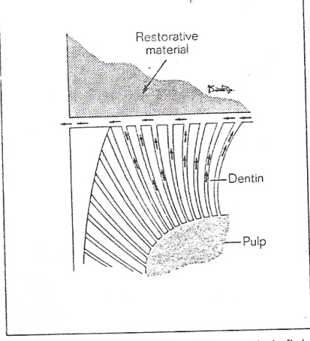
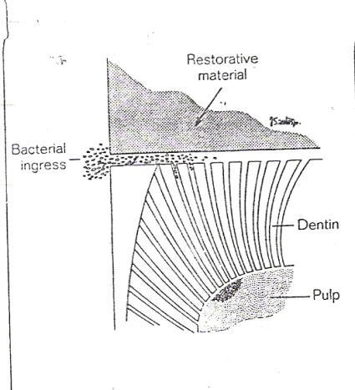

Two important factors affecting marginal adaptation: 1-temperature changes, 2- masticatory forces. If a material has different coefficient of thermal expansion than tooth structure, temperature change is likely to produce gaps between the material and the cavity. In composite filling, marginal seal has been improved by acid etching of beveled enamel and the use of the bonding agent or primer. But it has been shown that the initial marginal seal tends to decrease as the etched composite restoration ages.

E-Accumulative effect: is the whole irritation that the tooth is subjected to during all this time (carious process, cavity preparation, lining and filling procedure, secondary caries) so the pulp in a continuous process of irritation and inflammation. If there is a small inflammatory process it may be get worse till the whole pulp involved and become necrotic. This may occur very fast or slowly depending on the severity of irritation, and this may occur without any discomfort to the patient.

Heat of polishing: the pulp damage caused by polishing restoration must be considered, especially if we use dry powder. Polishing burs made of rubber created higher temperatures than cup brushes. Continuous polishing using high speed of rotation is associated with greater heat production than intermittent polishing with low speed.

