Dr. Zainab H AlGhurabi

INTRAORAL RADIOGRAPHIC TECHNIQUES
1. Periapical radiographic techniques
The periapical view is taken of both anterior and posterior teeth. The objective of this type of view is to capture the tip of the root on the film. This is often helpful in determining the cause of pain in a specific tooth, because it allows a dentist to visualize the tooth as well as the surrounding bone in their entirety. This view is often used to determine the need for endodontic therapy as well as to visualize the successful progression of endodontic therapy once it is initiated. It can be used in case of detection hyperdontia (supernumerary teeth) & impacted teeth. The name periapical is derived from the Greek peri, which means "around," and apical, which means "tip."
Indications:
1. Detection of apical infection.
2. Assessment of periodontal status after trauma to the teeth and alveolar bone
3. Assessment of presence and position of un erupted teeth.
4. Assessment of root morphology.
5. During endodontic.
6. Pre surgical implant insertion bone evaluation
---------------------------------------------------------.
There are two Periapical radiographic techniques:
a. Bisecting technique:-
Is the older of the two procedures it
. consider to be the easier of the two
b. Parallel technique:-
It was originally developed by MC Cormack. The result of this technique is superior to those of bisecting one.

Theory of parallel technique:-
It called so because film and the tooth must be parallel to each other. The requirements of this technique are:-
1. It requires the target object distance as long as possible and practical.
2. It requires the X-ray strike the object (tooth) and the film at right angle (90˚).
3. It requires the film to be placed in apposition parallel with the plane passing through the long axis of all teeth being examined.
The last requirement necessitates fairly wide separation of the tooth and the film.
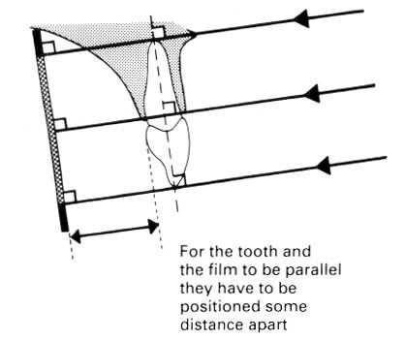
In parallel technique generally the separation between the film and the tooth would produce considerable distortion if the short target – object distance were employed.
However, the use of extended long cone of 16 inches will increase the target – object distance and compensates for the distortion and un sharpness that result from increasing object – film distance.
In the parallel technique, the film is placed in the mouth so that the long axis of the film parallel to the long axis of the tooth being radiographed. Paralleling instruments with an aiming ring is normally used to orient the film, teeth and ring in a parallel relationship. When the x-ray beam is a ligand with the ring, the x-ray beam will be perpendicular (right angle ) to the teeth and the film.

Theory of bisecting technique:-
1. Operator envision an imaginary bisector of the angle formed by the
long axis of the tooth and the long axis of the film,
where the film contacts the tooth this angle is formed
crown
2. Operator direct the central ray of the
beam through the apex of the tooth
so central ray strikes the bisector at
90˚ such angulations if properly
employed results in a tooth image
that is exactly the length of the
object.
In the bisecting angle technique, the x-ray beam is directed a perpendicular to an imaginary line which bisects (divided in half) the angle formed by the long axis of the tooth and the long axis of the film .
90

tooth
film

Horizontal angulation
The horizontal angulation is adjusted so that a line connecting the front and back edge of PID is parallel with the line connecting the buccal surfaces of the premolars and molars, the x-ray then will be perpendicular to the film.
In this technique, as a result of lack of parallelism between the tooth and the film since the film is contact with the tooth crown, we have all the areas below the apex of the tooth as well as above are distorted and the degree of distortion can reduced by the use of long cylinder because the longer distance between the source of radiation and the object the more is the parallel will be the rays.
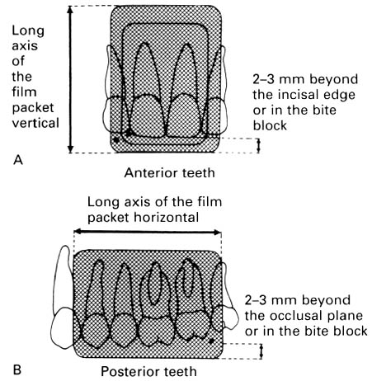

Horizontal and vertical angulations:-
1. Horizontal angulations:- refers to the X-ray beams direction in horizontal plane.
2. Vertical angulations:- is the angle of X-ray beam in a vertical plane.
Plus vertical angulations:- when the beam is tipped down ward
Minus vertical angulations:- when the beam is tipped upward.

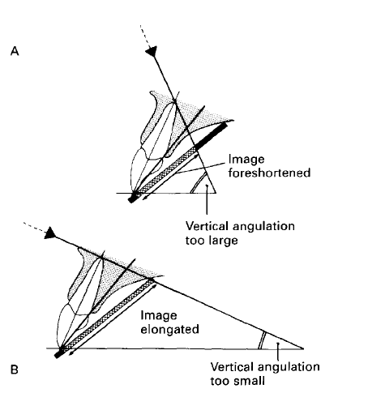
Diagrams showing the effects of incorrect vertical
Tube head positioning. A Foreshortening of the image.
B Elongation of the image
.

2.Film placement and angulations for bitewing films:-
Bitewing X-ray film used to show the inter proximal caries and visualize the periodontal condition in adult we need 2 bitewing films on each sides of the jaw at premolar and molar area while in children of 12 years old we need one film on each side.
Here in this type of X-ray film we have tab that positioned on the middle of film packet.
Patient is positioned with the occlusal plane horizontal and the tab
of the film placed on the occlusal
surfaces of lower teeth ask the patient to close the
teeth firmly together on the tab the beam is aimed
directly through the contact areas at right angels
to the teeth and film in horizontal plane and at
approximate 5˚ - 8˚ downward in vertical plane.

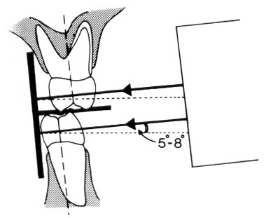
Diagram showing the ideal film packet position and
the approximate 5°-8° downward vertical angulations of the
X-ray beam compensating for the curve of Monson.

Occlusal technique
3.Occlusal film projection
The occlusal view is indicated when there is a desire to reveal the skeletal or pathologic anatomy of either the floor of the mouth or the palate. The occlusal film, which is about three to four times the size of the film used to take a periapical or bitewing, is inserted into the mouth so as to entirely separate the maxillary and mandibular teeth, and the film is exposed either from under the chin or angled down from the top of the nose. Sometimes, it is placed in the inside of the cheek to confirm the presence of a sialolith in Stenson's duct, which carries saliva from the parotid gland. The occlusal view is not included in the standard full mouth
series.
Occlusal film:
Occlusal film is used to:
1- Identify the extent of lesions in buccolingual direction.
2-Identify of buccolingual location of impacted teeth and other abnormalities
3- Show the location of developing teeth in children
4-Imaging patients with trismus that have limited mouth opening
- *Occclusal film projection:-
  - Maxillary occlusal projections include:-
A- Upper standard occlusal
B- Upper oblique occlusal
C- Vertex occlusal
-------------------------------------
A- Upper standard occlusal:-
- This projection shows the anterior part of maxilla and upper anterior teeth.
The technique involve:-
1. Patient position where the occlusal plane horizontal and parallel to the floor.
2. Film placed on to the occlusal surfaces of lower teeth and patient asked to bite together gently the film place centrally in the mouth (the long axis crossways).
3. X-ray tube positioned above the patient in the midline directed downward through the bridge of the nose at 65˚ - 70˚ to the film packet. 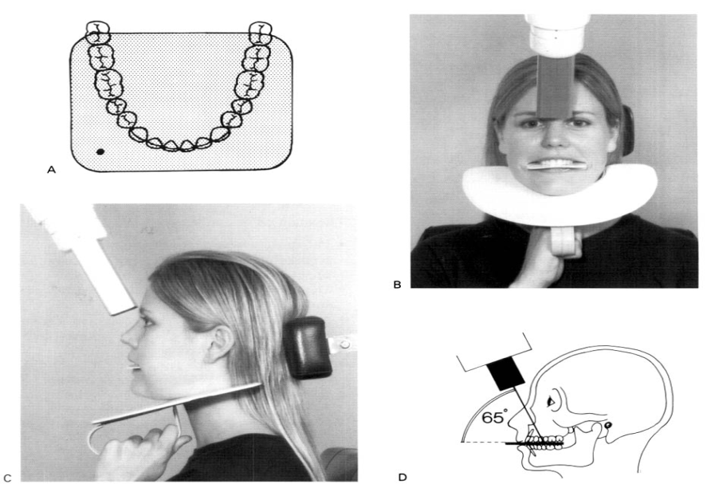

B – Upper oblique occlusal :-
- This projection shows the posterior part of maxilla and the upper posterior teeth.
- * The technique involve:-
1. Patients position where the occlusal plane horizontal and parallel to the floor.
2. Film placed on the occlusal surfaces of lower teeth with long axis anteroposteriorly placed to the side of the mouth under examination and patient asked to bite gently.
3. X-ray tube positioned at the side of patients face directed downwards through the cheek at 65 - 70˚ to the film.
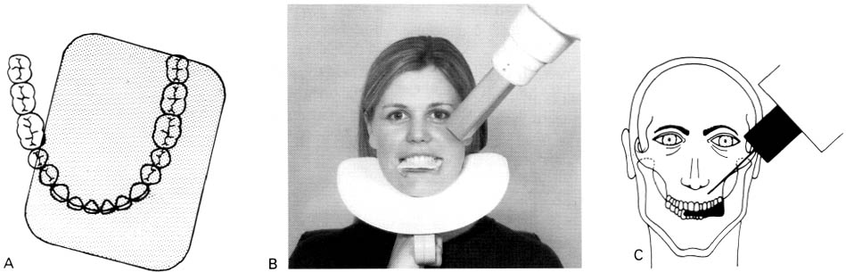
C- Vertex occlusal:-
- This projection shows a plan view of teeth bearing area of maxilla from above to assess the bucco - palatal position of un erupted canines.
* The technique involve:-
1. The patient is seated with occlusal plan horizontal
and parallel to the floor.
2. The film placed on the occlusal surfaces
of lower teeth with its long axis
anteroposteriorly and patient asked to
bite on to it.
3. X-ray tube is positioned above the patient in the midline directed downwards through the vertex of the skull.

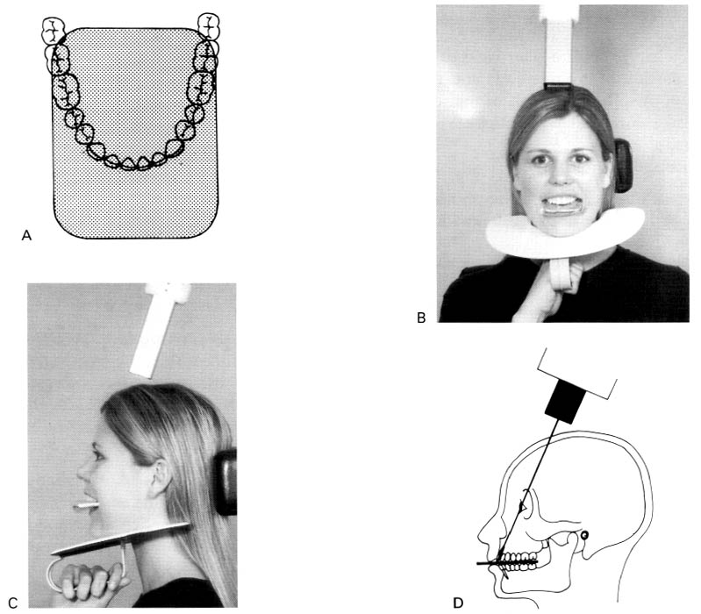
Mandibular occlusal projection:-
a/ Lower 90˚ occlusal (true occlusal).
b/ Lower standard occlusal.
c/ Lower oblique occlusal.
----------------------------------
a/ Lower 90˚ occlusal (true occlusal):-
- This projection used to show a plan view of the tooth bearing area of mandible and the floor of the mouth.
The technique:-
1. Patient tips his head backward as far as comfortable, where it is supported.
2. The film placed centrally into the mouth on the occlusal surfaces of lower teeth with long axis crossways and patient bite gently on the film.
3. X-ray tube placed below the patients chin in midline centering on imaginary line joining the first molar at 90˚ to the film.
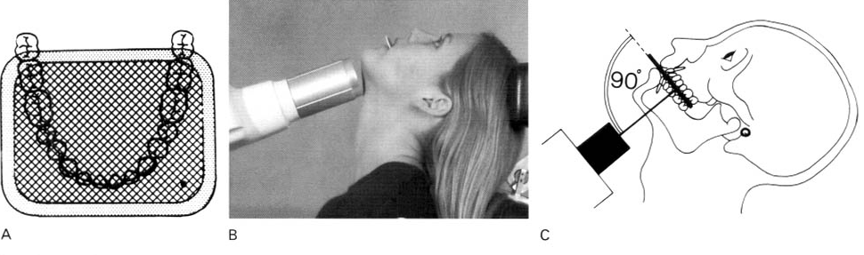
b/ Lower standard occlusal :-
This projection is taken to show lower anterior teeth and anterior part of mandible.
* Technique :-
1. Patient is seated with the head supported and occlusal plane horizontal and parallel to the floor.
2. Film placed centrally into the mouth
and the long axis
anteroposterior
then ask him to bite on the film gently.
3. X-ray tube positioned in midline centering through the chin point at 45˚ to the film.
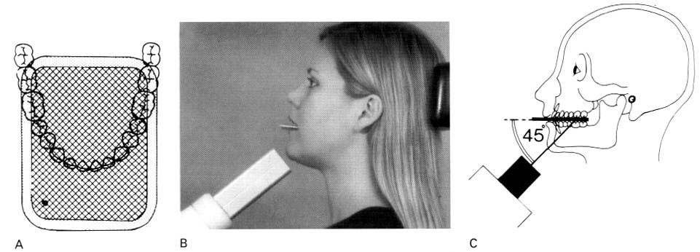

C / Lower oblique occlusal:-
This projection shows the submandibular salivary gland on the side of interest.
* The technique:-
1. Patients head is supported and rotated
away from the side under investigation and the head is raised.
2. The film placed on occlusal surfaces of
lower teeth over to the side under
investigation with long axis anterior
posteriorly then he bite on the film
gently.
3. X-ray tube directed upwards and forwards
toward the film from below and behind
the angle of mandible and parallel to the
lingual surface of the mandible.
