Periodontal instruments Dr. Raghad
Periodontal instruments are designed for specific purposes, such as removing calculus, planning root surfaces, curetting the gingival wall or removing disease tissues.
Periodontal instruments composed of:
- Blade
- Shank
- handle
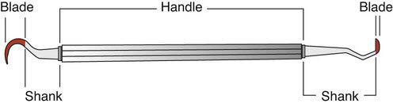

classification of periodontal instruments
- diagnostic instruments
- dental mirrors used for Specific uses
- Indirect vision
- Indirect illumination
- Transillumination
- Retraction
Nonspecific uses
Handles can be used for checking mobility, percussion.

- Periodontal probes used to locate, measure and mark pockets as well as determine their course on individual tooth surfaces.
A typical probe is a tapered rod-like instrument calibrated in millimeters with a blunt, rounded tip. Periodontal probes are used to measure the depth of the pocket and to determine their configuration. Types of periodontal probes
• Color-coded
• Noncolor-coded

a. The Marquis color-coded probe: The calibrations are in 3 millimeter sections.

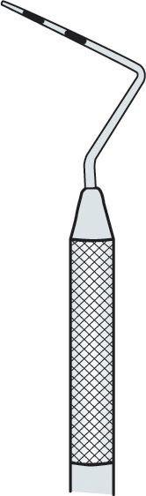
b. Williams probe: Has both color and non-color coding with markings at 1,2,3,5,7,8,9 and 10 mm.
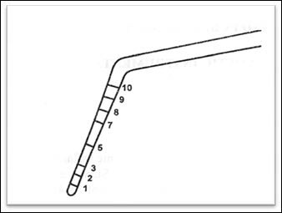

c.The Michigan “O” probe with markings: At 3, 6,and 8 mm.
d. The WHO probe: It has a 0.5 mm ball at the tip and millimeter marking at 3.5, 8.5 and 11.5 mm and color coding from 3.5 to 5.5 mm
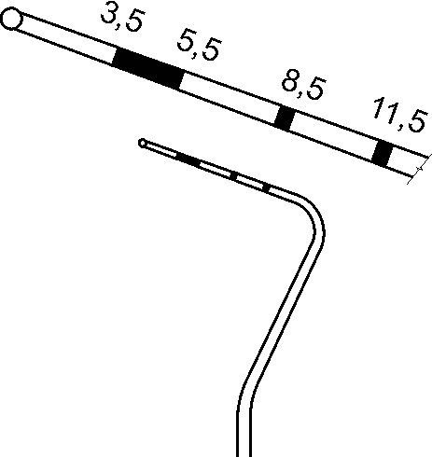

- Explorers : are used to locate calculus deposits and caries They are also used to locate subgingival deposits in various areas, and to check the smoothness of the root surfaces after root planing. Explorers are designed with different shapes and angles for a variety of use.

- Scaling ,root planing, and curettage instruments
They are classified as follows:
- For supra gingival scaling which include : Sickle scalers, cumine , push scalers
- Sickle scalers have a flat surface and two cutting edges that converge in a sharply-pointed tip. The arch-shape of the instrument makes the tip so strong that it will not break off during use. They appear triangular in cross-section. The sickle scaler is inserted under ledges of calculus no more than 1 mm below the gingival sulcus. It is used with a pull stroke. Sickles with straight shanks are designed for use on anterior teeth and premolars.Sickle scalers with contra-angled shanks adapt to posterior teeth.

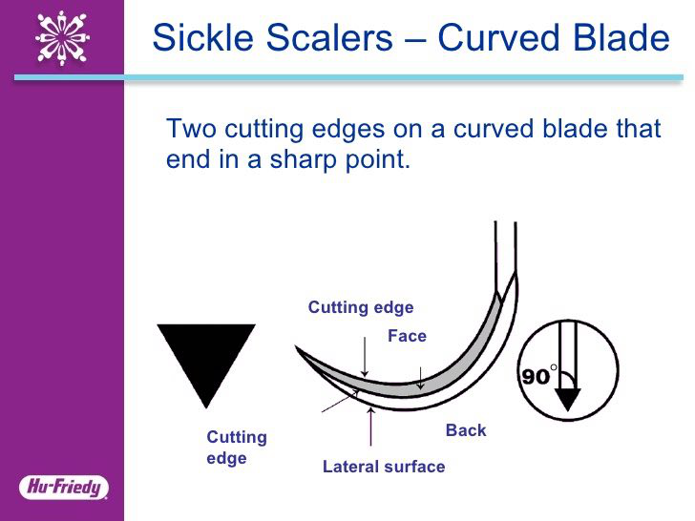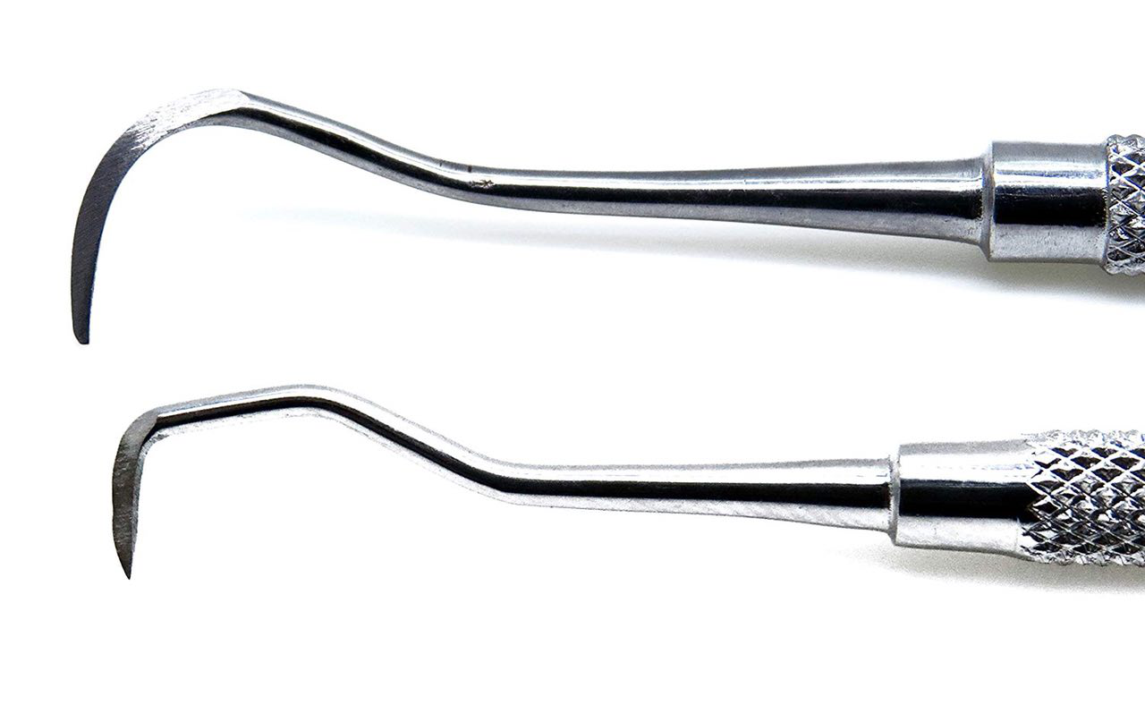
- Cumine : A hybrid (double ended) instrument – one end is a “spoon” curette -the other is a heavy duty tooth scaler. It is hook-like having a simple curved shape without offset which tapers to a sharp point.
Uses
Both ends can be used to dislodge thick calculus deposits to allow visualization of the crown or prior to further scaling.
Scaler end; to remove heavy supragingival calculus deposits from interproximal area.
Curette end or spoon end ; gentle curettage of large sockets to remove the granulation tissue (if present), removal of soft tissues from sites of bony pathology e.g. to clean out the bony defect in debridement of bone cyst lesions.also used to clean labial and lingual surfaces from calculus

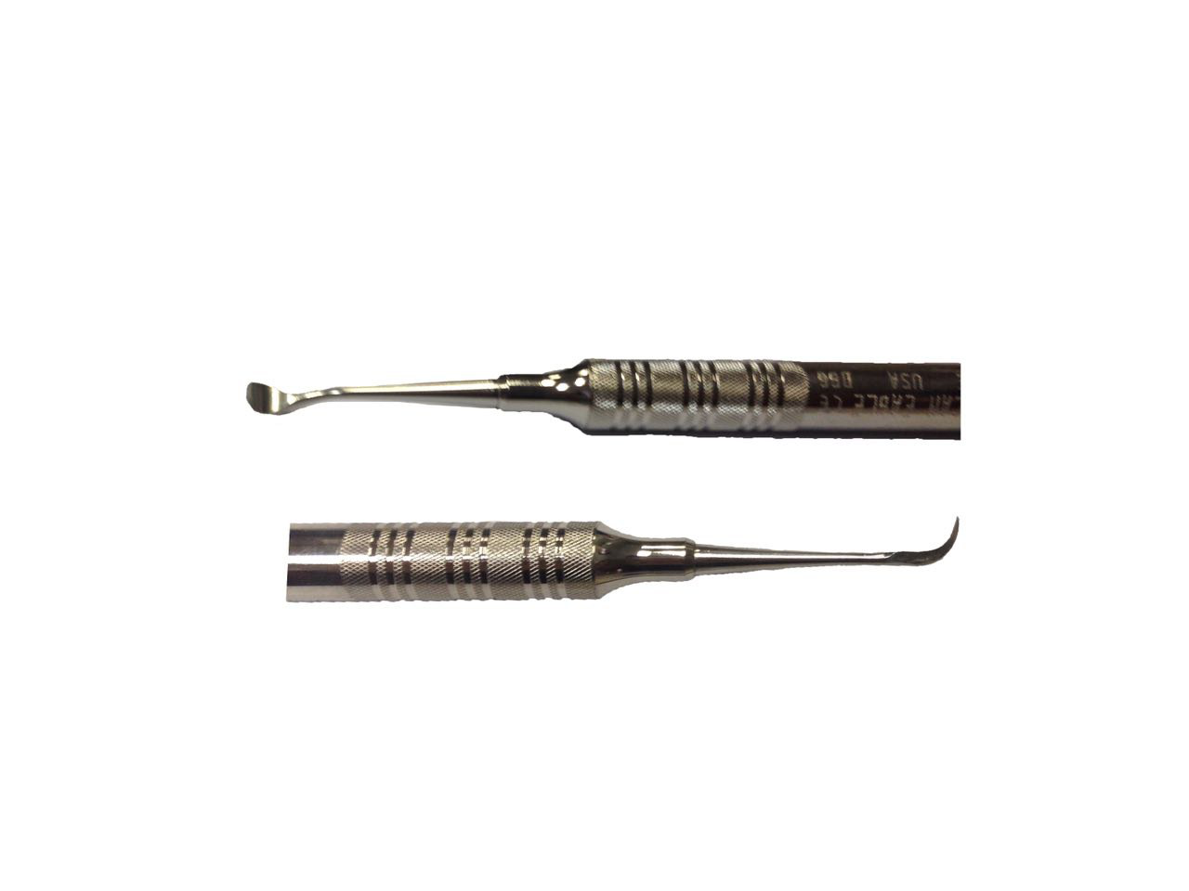
- Pushing scaler :These have been designed for the proximal surfaces of teeth and primarily used in the anterior areas. Push stroke through interproximal contact while maintaining contact with tooth surface. Needs sufficient interproximal space and care with surrounding tissues

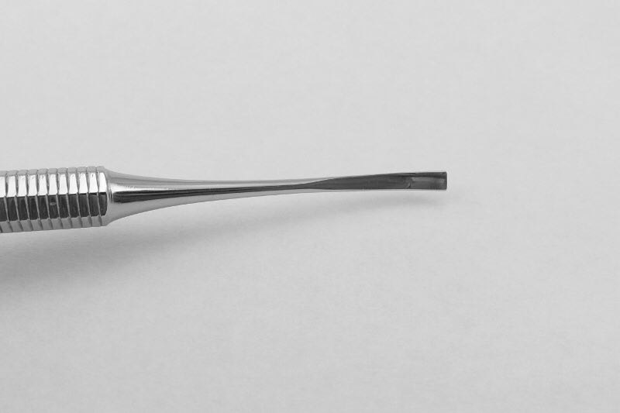

- For subgingival scaling :
- Hoe scaler ,are used to remove tenacious subgingival deposits, Hoe scalers are used for scaling of ledges or rings of subgingival calculus. The blade is bent at a 99-degree angle; the cutting edge is formed by the junction of the flattened terminal surface with the inner aspect of the blade.The blade has been reduced to minimal thickness to permit access to the roots without interference from the adjacent tissues.
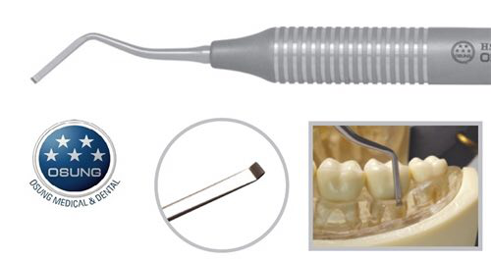

Hoe scalers are used in the following manner:
1. The blade is inserted to the base of the periodontal pocket so that it makes twopoint contact with the tooth. This stabilizes the instrument.
2. The instrument is activated with a firm pull stroke toward the crown, pull action parallel to the long axis of the tooth. Must be fully engaged with every effort being made to preserve the two point contact with the tooth
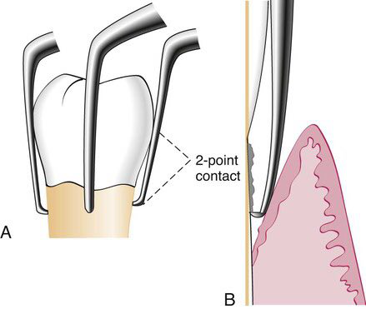

- Curettes are used to plane the root surface by removing altered cementum and also , for scraping the soft tissue wall of the periodontal pockets Curette can be adapted to provide good access to deep pockets, with minimal soft tissue trauma.There are cutting edges on both sides of the blade.
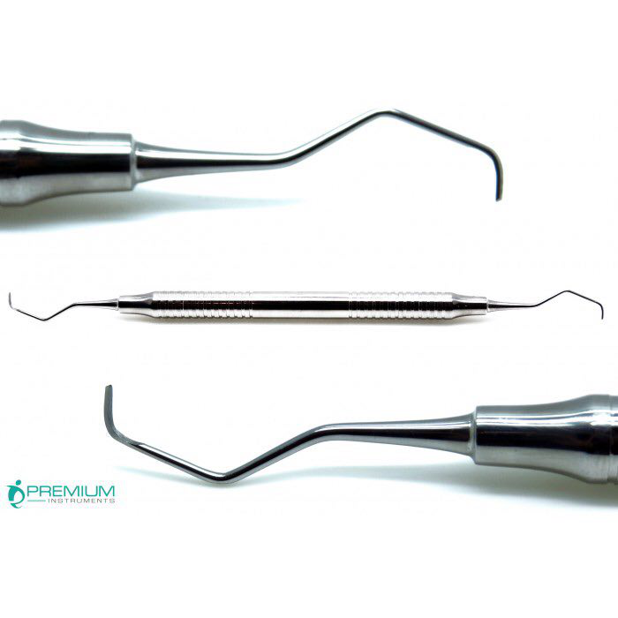

Sonic and ultrasonic instruments. Used for removing plaque, scaling, curetting and removing stains
Two types of ultrasonic units are:
• Magnetostrictive: Vibration of the tip is elliptical; hence all the sides can be used.
• Piezo-electric: Pattern of vibration of the tip is linear;only two sides of the tip are active.
Ultrasonic vibrations range from 20,000 to 45,000 cycles/second. They operate in a wet field and have attached water outlets. Ultrasonic instrument tip must be cooled by fluid to prevent overheating of the vibrating instrument tip. They have been shown to be as effective as hand instruments in subgingival calculus removal, removal of attached and unattached subgingival plaque, removal of toxins from root surfaces, and in reduction and maintenance of pocket depth.The water lavage from ultrasonic instruments has three benefits on the treatment site.
• Flushing action–flushes calculus, blood, bacteria ,plaque from treatment site.
• Cavitation.
• Acoustic streaming.
As the water exits from instrument tip, it forms a spray of tiny bubbles that collapses and releases shock waves in a process known as cavitation. It causes disruption of bacterial microflora.
Advantage of ultrasonic over hand Ins:
1- Less effort, pressure, trauma and time.
2- Simple manipulation.
3- Water sprays clean debris.
Disadvantage of sonic & ultrasonic instrumentations:
1- Lack of tactile sensation because of light pressure during manipulation.
2- Heat generation, required coolant system.
3- Impair of visibility because of water spray.
4- Aerosol contamination.
5- Damage restorative materials (porcelain, amalgam, gold, composite & Titanium implant abutments.(
Contraindication of ultrasonic device:
1- Infectious diseases.
2-Cardiac pacemaker & hearing aids.
3- Gag reflex
4- young children
5- pain.
Plastic and Titanium Instruments for Implants:
Several different companies are manufacturing plastic and titanium instruments for use on titanium and other implant abutment materials. It is important that plastic or titanium instruments be used to avoid scarring and permanent damage to the implants
- Cleansing and polishing instruments
Rubber cups, brushes, dental tapes
Rubber cups
Rubber cups consist of a rubber shell with or without webbed configurations in the hollow interior. They are used in the handpiece with a special prophylaxis angle. The hand piece, prophylaxis angle must be sterilized after each patient use, or a disposable plastic prophylaxis angle and rubber cup may be used and then discarded. A good cleansing and polishing paste that contains fluoride should be used and kept moist to minimize frictional heat as the cup revolves. Polishing pastes are available in fine, medium, or coarse grits and are packaged in small, convenient, single-use containers.Aggressive use of the rubber cup with any abrasive may remove the layer of cementum, which is thin in the cervical area.
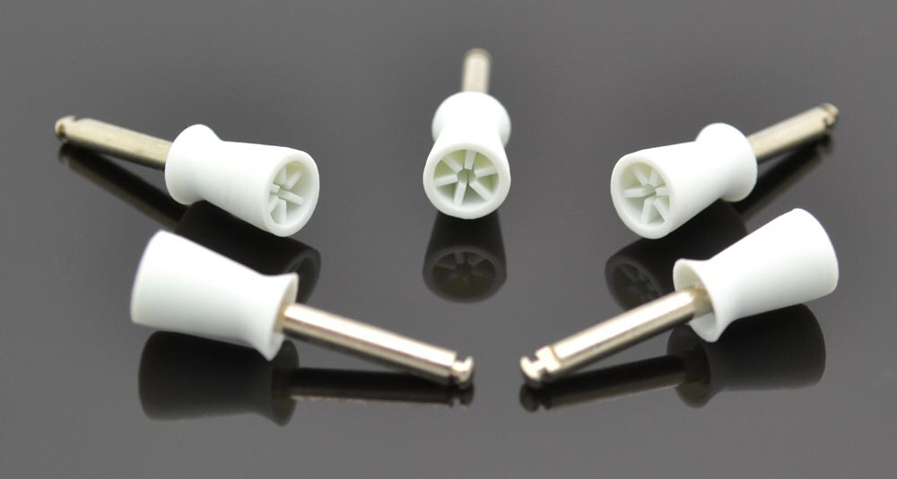

Bristles brush
Bristle brushes are available in wheel and cup shapes. The brush is used in the prophylaxis angle with a polishing paste. Because the bristles are stiff, use of the brush should be confined to the crown to avoid injuring the cementum and the gingiva.
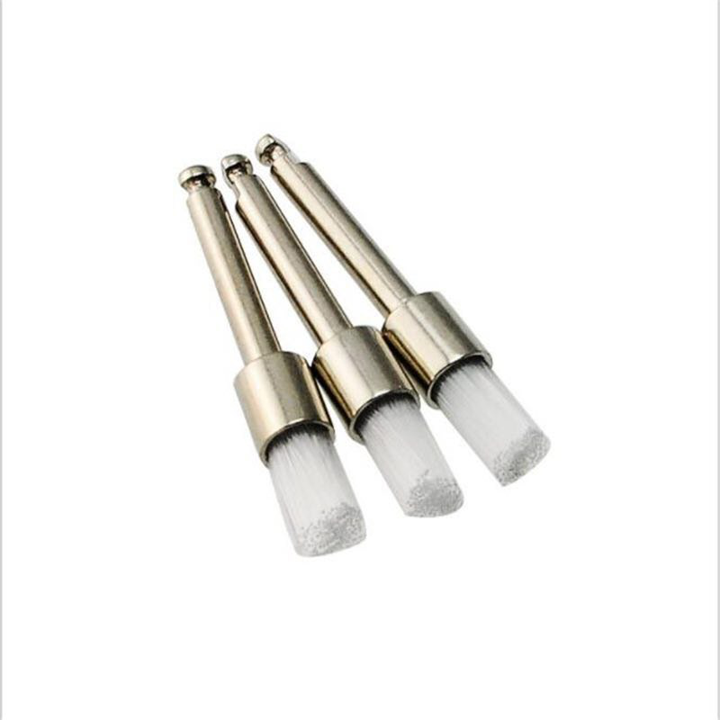
Dental tape
Dental tape with polishing paste is used for polishing proximal surfaces that are inaccessible to other polishing instruments. The tape is passed interproximally while being kept at a right angle to the long axis of the tooth and is activated with a firm labiolingual motion. Particular care is taken to avoid injury to the gingiva. The area should be cleansed with warm water to remove all remnants of paste..
D.surgical instruments
Excisional and incisional instruments, surgical curettes and periodontal elevators scissors and nippers
Knives are basic instruments and can be obtained with both fixed and replaceable blades.
- Kirkland knifes typically used for gingivectomy.These knives are kidney shaped and can be obtained as either double- ended or single-ended instruments.
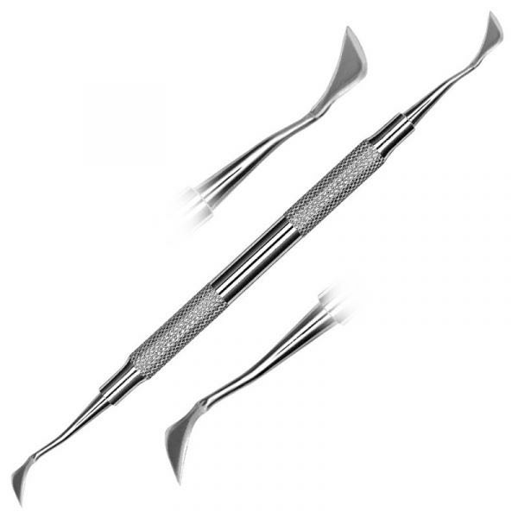

- Interdental knives eg: Orban knife These spear-shaped knives having cutting edges on both sides and are designed with either double-ended or single-ended blade. useful for excising interproximal tissue.
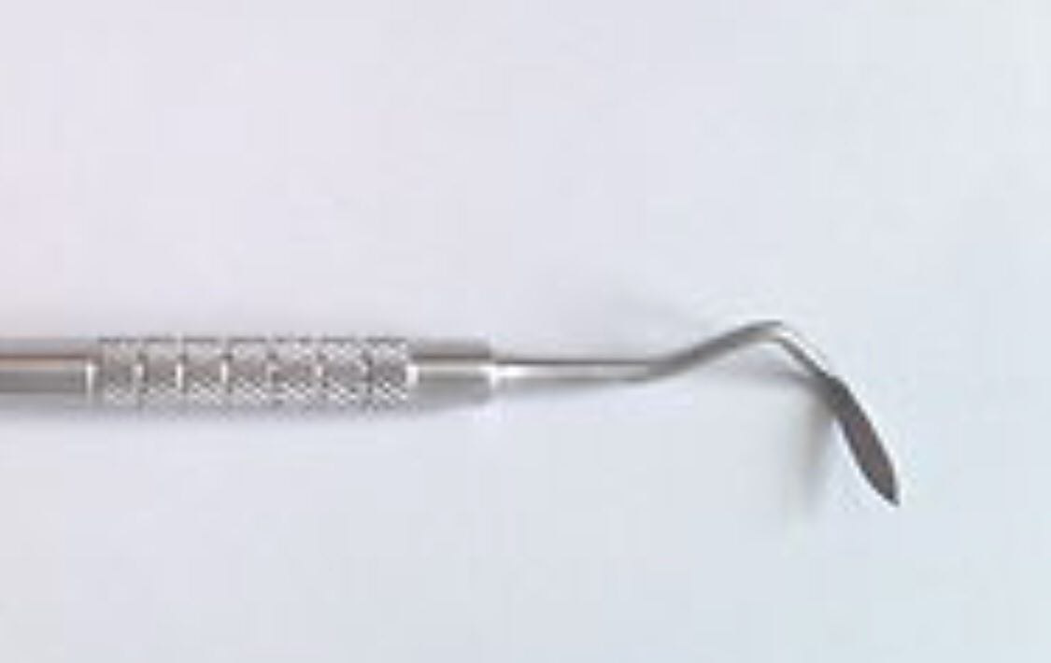

3. Surgical blades eg:#12D,15,11.
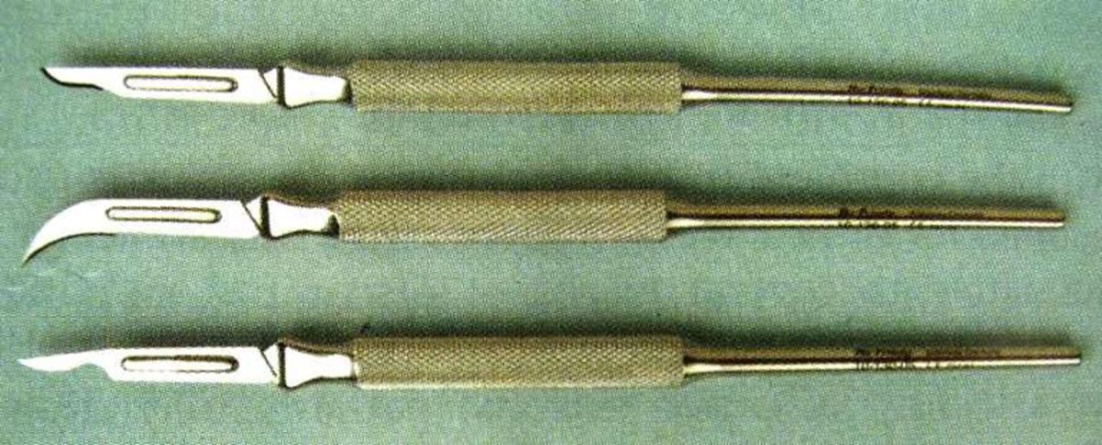

Periodontal elevators These are needed to reflect and move the flap after the incision has been made for flap surgery.
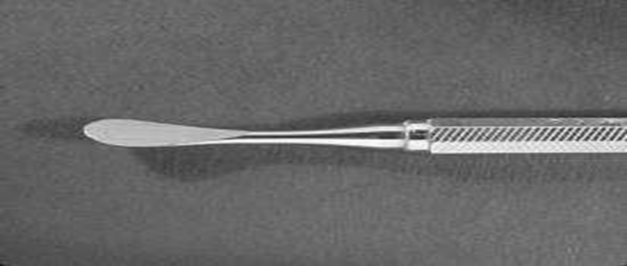
Tissues forceps: used to hold the flap during suturing and used to position and displace the flap after reflection.
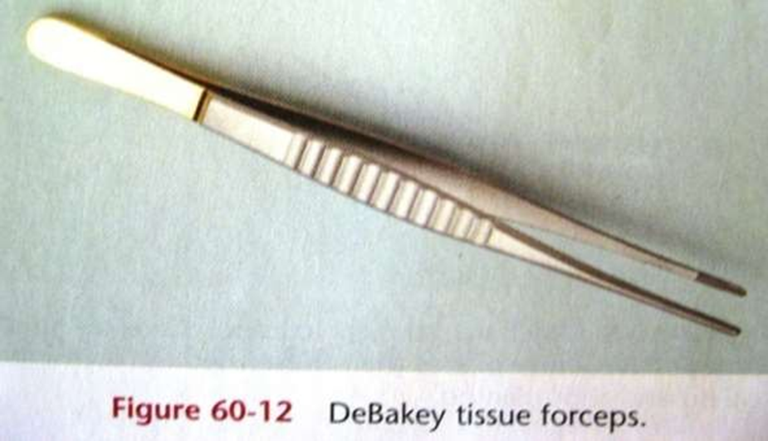
Scissors are used in periodontal surgery for such purposes as removing tags of tissue during gingivectomy, trimming the margins of flaps, enlarging incisions in periodontal abscesses, and removing muscle attachments in mucogingival surgery.
Surgical nippers: Serve same purpose as Scissors and they are also used for contouring the architectural form and for forming interdental sluiceways
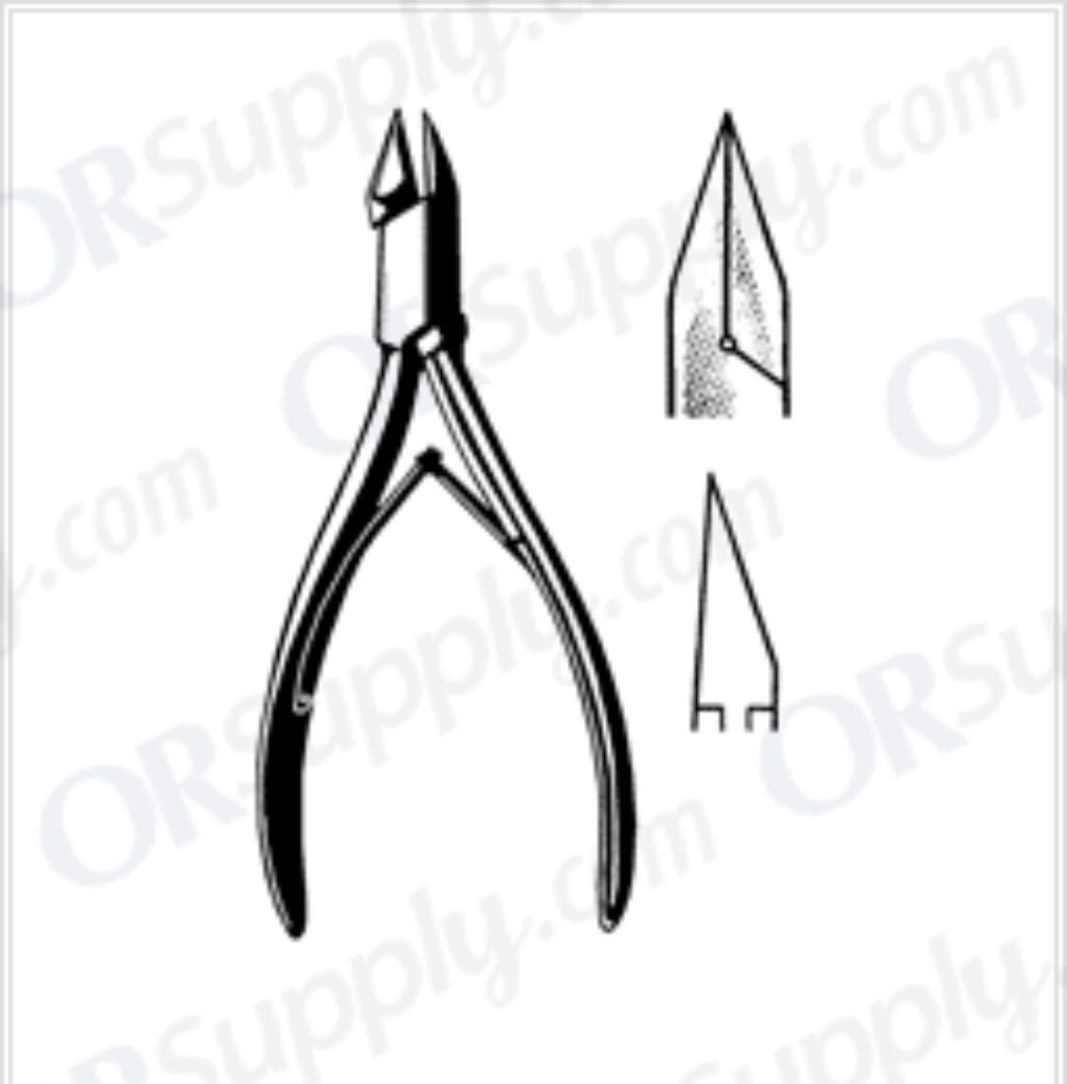
Needle holders: Used to suture the flap at the desired position after surgical procedure has been complete.

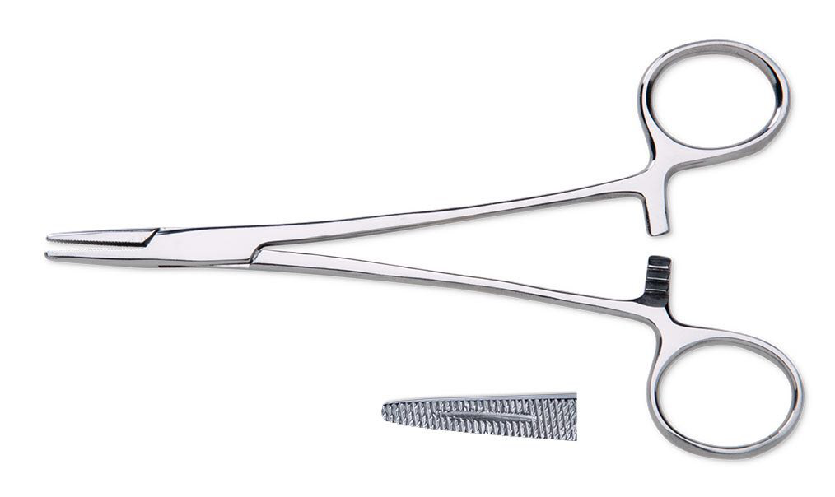
Effective instrumentation is governed by a number of general principles that are common to all periodontal instruments. Proper position of the patient and the operator, illumination and retraction for optimal visibility ,instrument stability and sharp instruments are the fundamental pre-requisites
INSTRUMENT STABILIZATION
Stability of the instrument and the hand is the primary requisite for controlled-instrumentation, stability and control is essential for effective instrumentation and to avoid injury to the patient or clinician. The two factors that provide stability are, instrument grasp and finger rest
Instrument Grasp :grasping can be divided in to
- pen grasp : Index finger and thumb hold instrument, middle finger under instrument.usually provide less tactile sensitivity & flexibility of movement so it is not recommended during periodontal instrumentation.

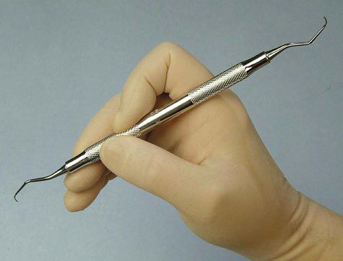

- modified pen grasp :Index finger and thumb hold instrument. Middle finger guides instrument,as it rest on the pad of middle finger so this will provide tactile sensitivity. The ring-finger acts as fulcrum/finger rest while the little finger relaxed beside ring finger.so it is recommended for all periodontal instruments. This grasp allows precise control of the working end, permits a wide range of movements and facilitates good tactile conduction.
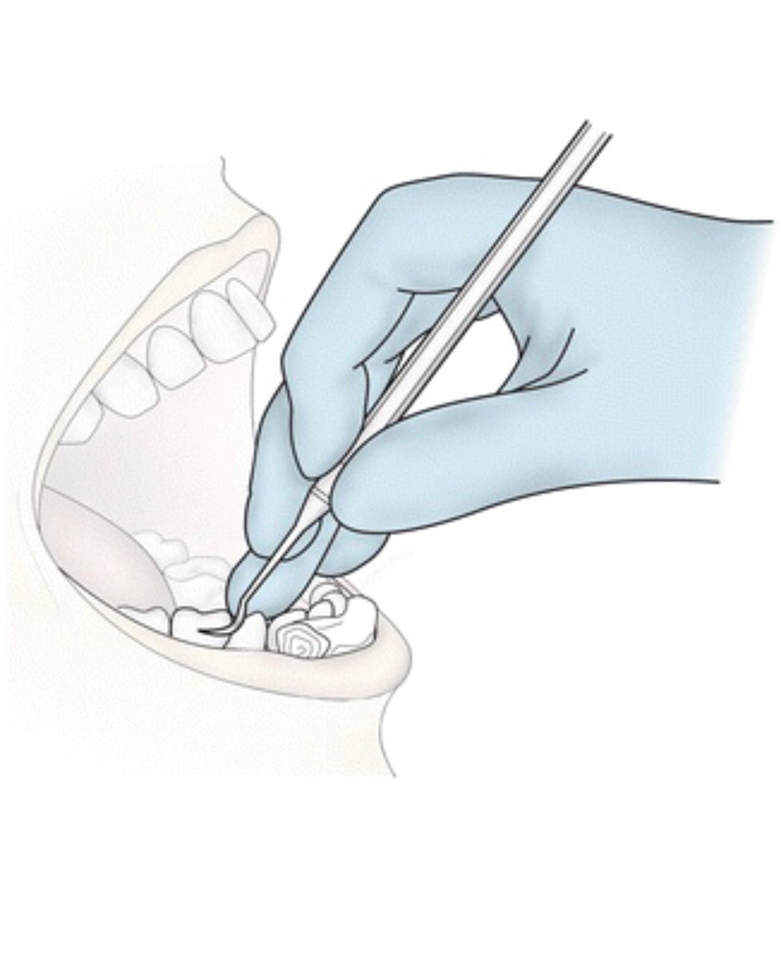
- palm and thumb grasp: Fingers wrapped around handle, thumb used to stabilize instrument. The palm and thumb grasp is useful for stabilizing instruments during sharpening and for manipulating air and water syringes
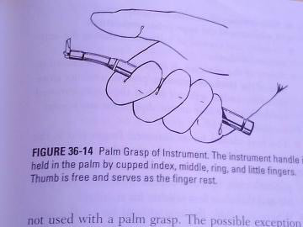

Correct grasp provides:
• Maximized stability during instrumentation.
• Minimized patient trauma and operator fatigue.
• Improved tactile sensitivity.
Finger Rest
The finger rest serves to stabilize the hand and the instrument by providing a firm fulcrum, as movements are made to activate the instrument. A good finger rest prevents injury and laceration of the gingival and surrounding tissues. The ring finger is preferred by most clinicians for the finger rest. Maximal control is achieved
when the middle finger is kept between the instrument shank and the fourth finger. This built-up fulcrum is an integral part of the wrist-forearm action that activates the powerful working stroke for calculus removal. Finger rests may be generally classified as intraoral finger rests or extraoral fulcrums.
CONDITION OF INSTRUMENTS)SHARPNESS(
Prior to any instrumentation, all instruments should be inspected to make sure that they are clean, sterile and in good condition. The working ends of pointed or bladed instruments must be sharp to be effective.
Advantages of Sharpness
1. Easier calculus removal.
2. Improved stroke control
3. Reduced number of strokes.
4. Increased patient comfort.
5. Reduced clinician fatigue.
Ideally, it is best to sharpen your instruments after autoclaving and then re-autoclave them prior to patient treatment. Dull instruments may lead to incomplete calculus removal and unnecessary trauma because of excess force applied.
For all instruments, the instrument is held in the non-dominant hand using a palm grasp. The index finger and thumb should be near the junction of the functional shank and the top of the handle such that they will counter balance the force produced at the opposite end of the instrument once the stone is activated. For all stones, the lower half is held in the dominant hand with the thumb on the edge closer to the operator and the fingers on the edge farther. The entire arm will work in one fluid motion so the grasp is intended to stabilize the stone and make such a motion comfortable to accomplish. The difference between the instruments is found at the working end. These differences make sharpening technique a little different for each instrument type.

