**4th year Lect Prosthodontics Dr. Mohammed M A**

**Try-in of removable partial denture**

(This may be at the fourth visit or according to clinical requirements).

This is the last stage at which modifications can be made before the wax is replaced by acrylic. A careful routine must be followed to prevent any mistakes continuing through to the finished dentures. The replacement of anterior teeth often represents an important event in the life of an individual.

Although many patients identify improved function as the primary reason for seeking treatment, a sense of esthetics always remains. A patient may be dissatisfied with a prosthesis even if it meets all functional and biologic requirements. Therefore, if anterior teeth are to be replaced, an esthetic try-in is essential. A try-in appointment allows the patient to view the prosthesis and provide feedback. This appointment also allows the practitioner to evaluate the esthetic and phonetic characteristics of the prosthesis and to make appropriate changes in the arrangement of teeth.

An additional indication for the appointment is to verify the accuracy of jaw relation records made during the previous appointment. If there is any doubt regarding the accuracy of the articulator mounting, a try-in appointment should be scheduled.

**The trial dentures should firstly be examined on the mounted casts in respect of:-**

1. Adaptation of partial dentures on the casts.
2. Occlusion.
3. Position of artificial teeth with regard to adjacent natural ones.
4. The arrangement of anterior teeth.
5. Extension and contouring of wax flanges.

**In the mouth the trial dentures should be examined in respect of:-**

1. Adaptation of the dentures. Comfort, and function of the appliance.
2. Vertical dimension including the vertical dimension of occlusion and rest.
3. Occlusion, check centric jaw relation and centric occlusion. Prove the centric record and take new occlusal registration.
4. Evaluate the shade, mold, and arrangement of the teeth. (Esthetic and phonetic).
5. Appearance. Modify positions of teeth and incisal edges of anterior teeth to achieve a pleasing result.
6. Ask for patient's comments on appearance. Show the patient the dentures in the mirror and ensure that they are satisfied.
7. Note any changes on the laboratory prescription.

**Esthetic try-in**

The patient should be seated in a treatment room that provides a quiet, relaxed atmosphere. This helps to alleviate the tension that may develop as the patient views the tooth arrangement for the first time.

The dentist should evaluate the positions of anterior teeth and assess lip support. There is a tendency to position the artificial teeth lingual to the positions occupied by the natural teeth. If anterior teeth have been missing for 6 months or more, the patient may report a sensation of abnormal fullness at the upper lip. A short period of accommodation usually will eliminate this problem.

A. Teeth length:

Tooth length should be carefully evaluated. If all anterior teeth are being replaced and the upper lip is of normal length, the edges of the central incisors should be visible when the lip is relaxed. When the lip is drawn upward (e.g., in an exaggerated smile), the gingival contours of the denture base should be minimally evident.

B. Short space:

If an anterior edentulous space has been decreased by drifting of the teeth, a decreased number of teeth should not be placed. This technique usually results in an abnormal appearance. Instead, attempts should be made to rotate or overlap the denture teeth in order to achieve an acceptable esthetic result.

C. Large space:

If the anterior edentulous space is relatively large, diastemata may be incorporated into the tooth arrangement. If this is to be accomplished, the patient should be informed of potential difficulties associated with interdental spacing. Spacing complicates oral hygiene procedures, increases the likelihood of food impaction, and may create difficulties with phonetics.

D. Overlap of the anterior teeth:

Attention should be paid to the horizontal and vertical overlap of the anterior teeth. If some natural anterior teeth remain, the overlap should be duplicated. If no natural teeth remain, care should be taken to avoid excessive vertical overlap without accompanying horizontal overlap. This could result in the application of undesirable forces to the artificial teeth and associated soft tissues.

E**.** Vertical alignment of the teeth:

Vertical alignment of the teeth also should be evaluated. A slight deviation from the vertical can produce an acceptable esthetic result, but a significant deviation can create esthetic difficulties. The practitioner should pay particular attention to the maxillary midline. This midline must be examined for its vertical alignment and for its midface position. Any error in the position of the maxillary midline can be extremely distracting.

F. Tooth shade:

Verification of tooth shade should be accomplished during the evaluation process. The presence of natural teeth makes shade selection and patient acceptance a critical component of removable partial denture therapy. To ensure selection of an appropriate shade, the prosthesis should be viewed using a variety of light sources (e.g., natural, fluorescent, and incandescent).

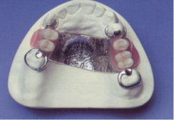Tooth position: The positioning of any posterior is compare with the position of the remaining natural teeth.

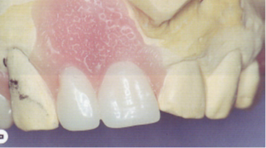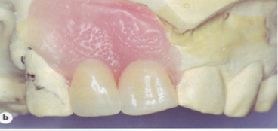The arrangement of the anterior should be harmonize with the abutment. The appearance may need to be modified, if incisal wear is present on the natural teeth it should be simulated on the denture.

The shade, mould and arrangement of the artificial teeth should harmonize with the natural teeth. The incisal edges of the natural anterior teeth tend to follow the curve formed by the lower lip when smiling. Reproduction of this relationship when positioning artificial anterior teeth can contribute significantly to a pleasing appearance.

(The incisal edges of the natural anterior teeth tend to follow the curve formed by the lower lip when smiling). 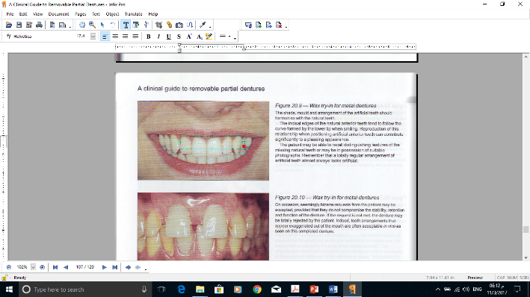

**Denture base consideration**

A. Wax flanges should be of a thickness and extension corresponding to the amount of bone resorption in the area so that they only replace the tissue that has been lost, restoring the former contour of the alveolar ridge. Mesial and distal borders should be thin so that the flange blends with the adjacent mucosa, thus avoiding food trapping and promoting patient comfort.

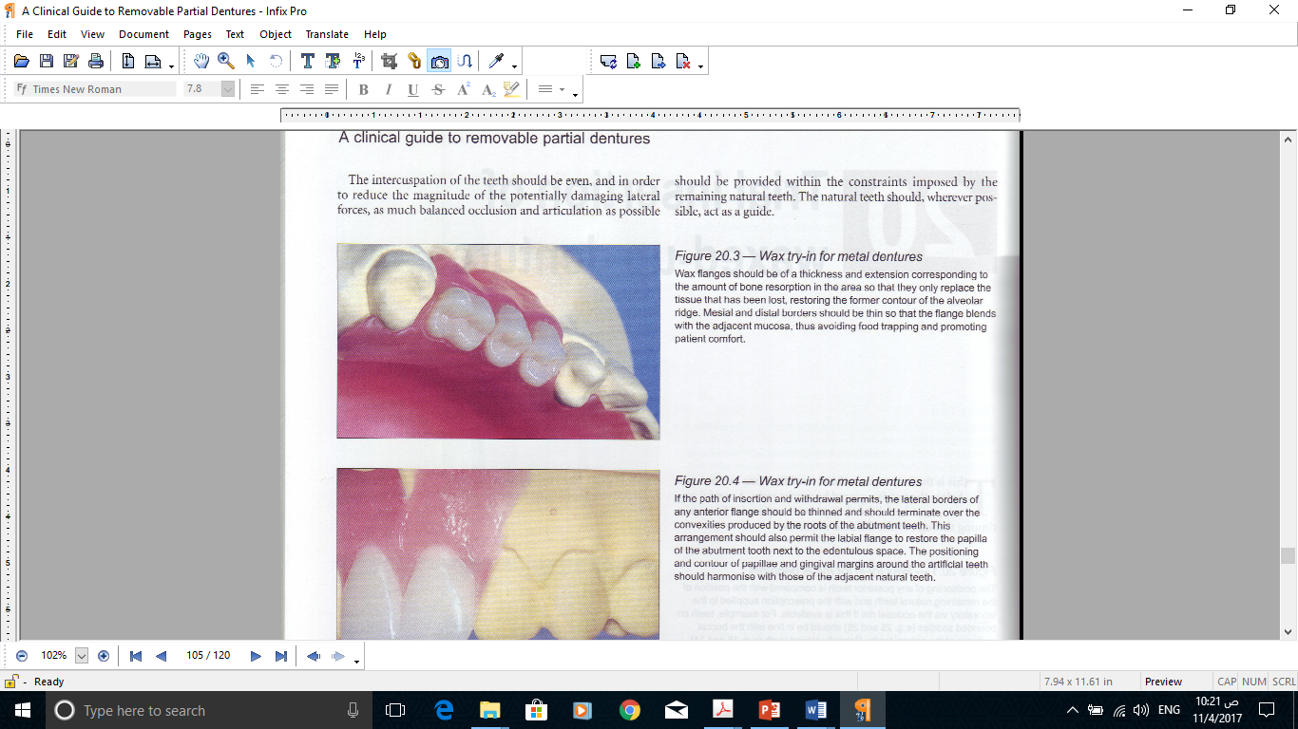

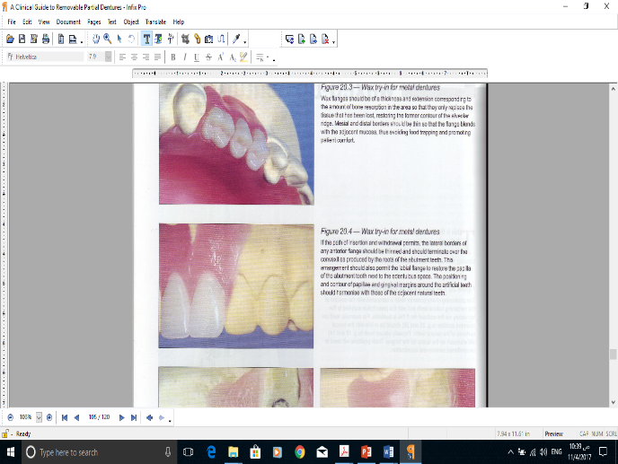B. If the path of insertion and withdrawal permits, the lateral borders of any anterior flange should be thinned and should terminate over the convexities produced by the roots of the abutment teeth. This arrangement should also permit the labial flange to restore the papilla of the abutment tooth next to the edentulous space. The positioning and contour of papillae and gingival margins around the artificial teeth should harmonise with those of the adjacent natural teeth.

C. A common error, which creates a poor appearance, is to place the gum margin of the artificial maxillary premolars at a lower level than that of the adjacent natural teeth . This may be overcome by careful waxing up and by the selection of an artificial tooth of appropriate crown length .

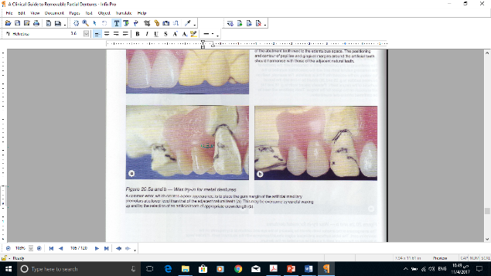

D. The borders of mucosa, or partially mucosa-supported saddles, should extend to the full depth of the sulci recorded on the cast. This is so that the occlusal forces may be distributed as widely as possible and so that the adjacent musculature may be utilized to reinforce the retention and stability of the prosthesis.

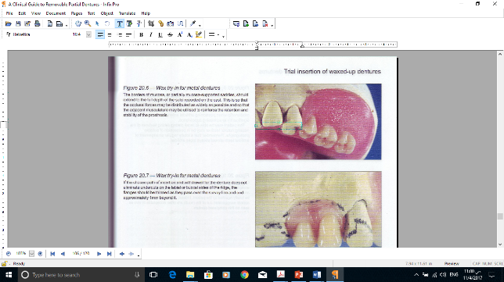

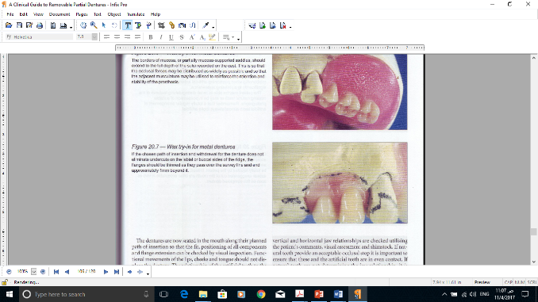E. If the chosen path of insertion and withdrawal for the denture does not eliminate undercuts on the labial or buccal sides of the ridge, the flanges should be thinned as they pass over the survey line and end approximately 1mm beyond it.

**The patient evaluation**

The patient should stand several feet from a wall mirror to examine the teeth critically. The use of a hand mirror should be discouraged because the patient’s attention will be focused on individual teeth and not on the

overall effect of the prosthesis. The patient’s remarks should be noted, and required changes should be made. Arrival at mutual acceptance by the patient and dentist frequently demands a high level of communicative skill combined with psychological insight.

**Phonetics evaluation**

Although wearing a new prosthesis will likely require some speech adaptation, it is wise to perform a speech evaluation when multiple anterior

teeth will be replaced. As fricative ( “ f ” and “ v ” ) sounds are made by the patient, the maxillary incisors touch the wet - dry line of the lower lip. As the patient makes the “ s ” sound, the maxillary and mandibular incisors should just miss contact (less than 1 mm is ideal). However, in some instances, patients are able to provide the proper air escape at slightly greater distances. These patients are generally skeletal Class II patients.



**(Maxillary incisors contact wet - dry line of lower lip when making the “ f ” sound).**

**(In making the “ s ” sound, the maxillary and mandibular incisors are out of direct incisal contact, with generally less than 1 mm of space between incisal edges).**

**Verification of Jaw Relation**

The jaw relation only needs to be verified in limited instances:

1. If problems were encountered during jaw relation procedures and there is any doubt regarding the accuracy of the articulator mounting.
2. If the partial denture is opposed by a complete denture.
3. If all posterior teeth in both arches are being replaced.
4. If there are no opposing natural teeth in contact and verification of the occlusal vertical dimension is necessary.

A dentist should never complete a prosthesis without confidence in the accuracy of the jaw relation records and the articulator mounting. A considerable amount of unnecessary work can be avoided if the practitioner pays close attention to detail throughout these procedures. To ensure accuracy, it is essential that the practitioner evaluate the mounting using additional jaw relation records . As a result, the importance of a face-bow transfer becomes particularly evident at this stage of treatment. For a mounting to accept additional jaw relation records, the arc of rotation for the articulator must be the same as the arc of rotation for the patient’s mandible.

**Making a polyvinylsiloxane verification record**

The patient is instructed to open the mouth moderately. The fingers of one hand are positioned to permit visualization of the dental arches . The polyvinylsiloxane registration material is mixed and introduced into the patient’s mouth . The operator’s remaining hand is then positioned on the

facial surfaces of the mandibular anterior teeth, and the patient is guided into the prescribed closure . This position is maintained until the polyvinylsiloxane material has reached a suitable consistency.

When the recording medium has set, the patient is instructed to open the mouth. The record and removable partial denture (or dentures) are removed from the oral cavity. The record is carefully examined to determine its acceptability. There should be no signs of penetration through the record. If the record is acceptable, it is properly trimmed using a surgical scalpel.

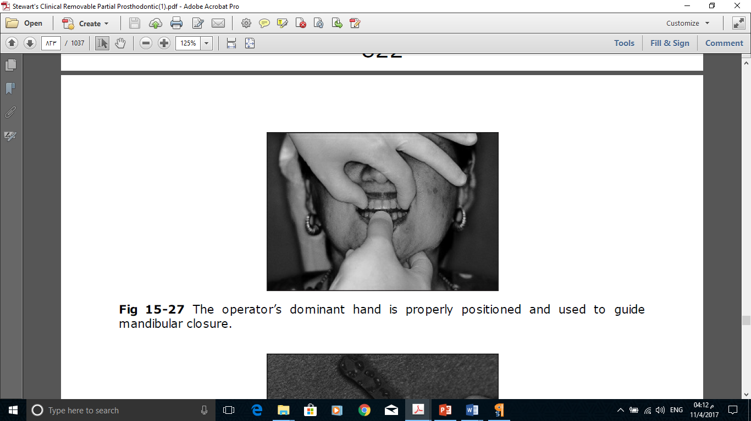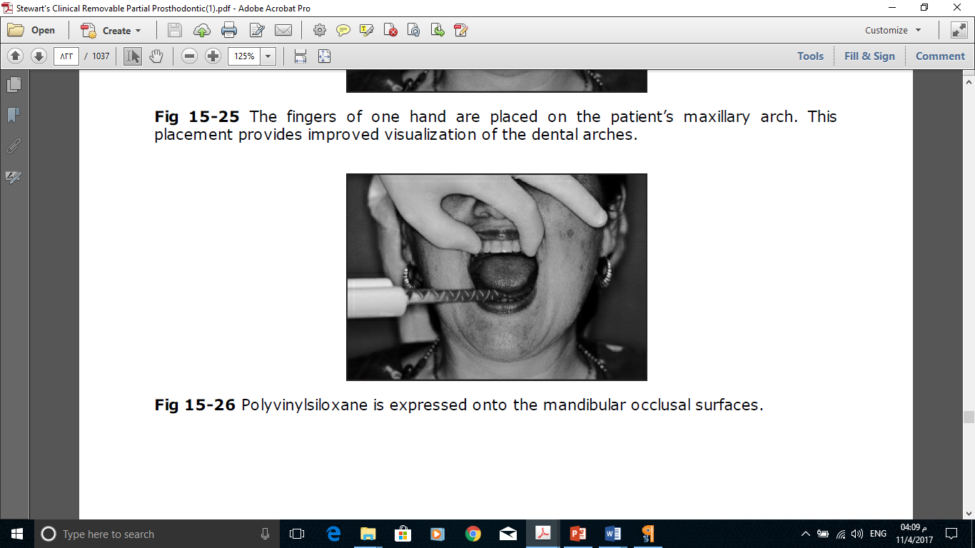

The operator’s dominant hand is properly positioned and used to guide mandibular closure.

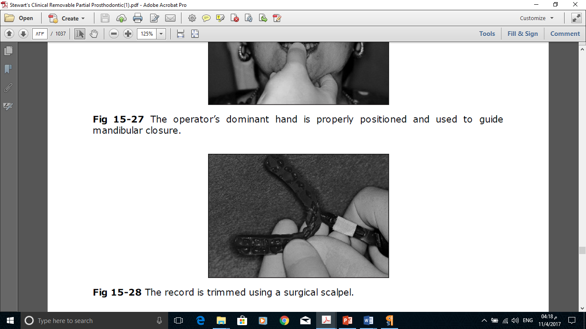

**Choice of tooth materials**

Acrylic resin pontics are the teeth of choice for most patients. Current cross - linked polymers resist abrasion and are compatible with opposing occlusal surfaces of enamel or metal. However, if the RPD pontics oppose porcelain restorations, consideration should be given to more wear - resistant materials such as metal occlusal surfaces or porcelain denture teeth. Since porcelain teeth are attached to the denture base by mechanical retention, they require additional interocclusal space when compared to acrylic resin denture teeth, which have the ability to bond to the denture base. Some patients also report unnatural sounds — for example, “clacking” — when porcelain denture teeth oppose each other. Other, recommend that custom glass ceramic occlusal surfaces be fabricated and cemented to prepared acrylic resin denture teeth in order to reduce the wear caused by opposing ceramic occlusal surfaces.