**GENERAL PATHOLOGY L5&L6**

**Dr. Ban AL Drobie**

**INFLAMMATION**

**Inflammation:-**

It is Complex biological response of vascularized living tissues to local injury or harmful stimuli, such as pathogens, damaged cells, or irritants. Inflammation is induced by chemical mediators that are produced by host cells in response to injurious stimuli.

**Terminology**

Inflammatory conditions are termed by adding the suffix (-itis) to the affected organ or tissue

For example:-

Pulpitis : inflammation of pulp

Gingivitis: inflammation of gingiva

Hepatitis: inflammation of liver

Appendicitis: inflammation of appendix

**Significance of inflammation**

1-Destroy, dilute, or wall off the injurious agent, Inflammation is fundamentally a protective response, the ultimate goal of which is to rid the organism of both the initial cause of cell injury (e.g., microbes, toxins) and the consequences of such injury (e.g., necrotic cells and tissues).

2- It sets into motion a series of events that try to heal and reconstitute the damaged tissue.

**Note:** *Without inflammation, infections would go unchecked, wounds would never heal*.

**Inflammation may have harmful effects:**

1- It can cause life-threatening hypersensitivity reaction.

2- It can cause progressive organ damage from chronic inflammation and subsequent fibrosis like rheumatoid arthritis and atherosclerosis.



**The components of acute and chronic inflammatory responses: circulating cells and proteins, cells of blood vessels, and cells and proteins of the extracellular matrix.**

**Components of inflammation:**

Many tissues and cells are involved in the inflammatory reaction, including

1- plasma fluid proteins.

2- circulating leukocytes,( neutrophils, monocytes, eosinophils, lymphocytes, basophils, in addition to platelets).

3- blood vessels.

4-The connective tissue cells are mast cells, fibroblasts, macrophages, and lymphocytes.

5-The extracellular matrix consists of structural proteins (collagen, elastin), adhesive glycoproteins (fibronectin, laminin), and proteoglycans.

**Inflammation is divided into**

1- Acute inflammation

2-Chronic inflammation

|  |  |
| --- | --- |
| **Acute inflammation** | **Chronic inflammation** |
| Early onset (sec. – min) | Later onset (days) |
| Short duration (min. – days) | Longer duration (wks – yrs) |
| Fluid exudation (edema( | Inducing B.V. proliferationand scarring |
| Polymorph nuclearleukocyte emigration. (neutrophils) | Involving lymphocytes and macrophages infiltration |

**The cardinal signs of inflammation**

The classical signs of inflammation are:

1-Redness

2- Swelling

3--Heat

4-Pain

5-loss of function

These signs are typically more prominent in acute inflammation than in chronic inflammation

**General characters of inflammation:-**

A- Inflammation is generally characterized by two main component:

1- Vascular wall response.

2- Inflammatory cell response.

B- The effects of inflammation are mediated by inflammatory mediators which are:

1- Circulating plasma proteins

2- Factors produced locally by vessel wall or inflammatory cells.

C- Termination: Active anti-inflammatory mechanism begins when:

1- The causative agents is eliminated

2- The secreted mediators are removed

.

**ACUTE INFLAMMATION**

Acute inflammation is a rapid response to an injurious agent that serves to deliver mediators of host defense—leukocytes and plasma proteins—to the site of injury.

**Causes of inflammation**

1- Infections (bacterial, viral, fungal, parasitic).

2-Trauma (blunt and penetrating)

3-Physical and chemical agents (thermal injury, such as burns or frost bite, irradiation, toxicity from certain environmental chemicals)

4-Immune reactions (hypersensitivity reactions) against environmental substances or against self tissues.

5-Tissue necrosis that result from ischemia as in myocardial infarction.

6-forign bodies (dirt ,suture).

**Acute Inflammation has Two Major Components**

**I-VASCULAR CHANGES:** the main vascular reactions are increased blood flow secondary to vasodilation and increased vascular permeability, both designed to bring blood cells and proteins to site of injury

**A-change in vascular caliber and flow**

1- Initial transient vasoconstriction, followed by

2- Vasodilation causing increasing in blood flow to the area of injury. (this is the cause of heat and redness)

.

B- Increased Vascular Permeability (Vascular Leakage)

increased vascular permeability leading to the escape of a protein-rich fluid **(exudate)** into the extravascular tissue. The loss of protein from the plasma reduces the intravascular osmotic pressure and increases the osmotic pressure of the interstitial fluid. results in **edema( which is the cause of swelling)**

**The most common mechanism of vascular leakage**

1-endothelial cell contraction leading to the formation of endothelial gaps in venules which is elicited by histamine, bradykinin, leukotrienes, , and many other classes of chemical mediators.

2- Direct endothelial injury as by burns or infections

**Edema** Excessive fluid in the interstitial tissue or body cavities which may be either exudates or transudate

|  |
| --- |
|  |

**Exudate** is an inflammatory extravascular fluid that has a high protein concentration, cellular debris,. It implies significant alteration in the normal permeability of small blood vessels in the area of injury.

**Transudate** is a fluid with low protein content that results from increase hydrostatic pressure as a consequence of reduced venous return. transudate is accumulate in non inflammatory conditions

**Purulent exudates**, is an inflammatory exudates rich in leukocytes (mostly neutrophils), the debris of dead cells and, in many cases, microbes.

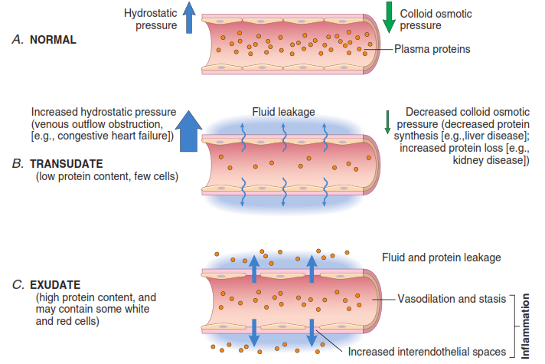

Formation of transudates and exudates. *,* A transudate is formed when fluid leaks out because of increased hydrostatic pressure or decreased osmotic pressure. *C,* An exudate is formed in inflammation because vascular permeability increases as a result of the increase in interendothelial spaces.

**II-CELLULAR CHANGES:**

**LEUKOCYTE RECRUITMENT AND ACTIVATION**

A critical function of inflammation is to deliver leukocytes to the site of injury and to activate the leukocytes to perform their normal functions in host defense. Leukocytes ingest offending agents, kill bacteria and other microbes, and get rid of necrotic tissue and foreign substances.

The sequence of events in the recruitment of leukocytes from the vessel lumen to the extravascular spaces consist of:-

|  |  |
| --- | --- |
|  | 1-**Margination and rolling**  2-**Adhesion** |
|  | 3-**Transmigration** across the endothelium (also called diapedesis) |

4. **Chemotaxis** :Migration in interstitial tissues toward a chemotactic stimulus

**1-Margination and rolling**

blood flow slows early in inflammation (stasis), more white cells assume a peripheral position and accumulate along the endothelial surface. This process is called **margination.**

If endothelial cells are activated they express adhesion molecules to which leukocyte attach loosely they bind and detach and thus beggin to tumble **(a process called rolling),** The weak and transient interactions involved in rolling are mediated by **selectin** family of adhesion molecule

**2-Adhesion**

The second step in leukocyte reaction is **Firm adhesion** to endothelial surfaces which is mediated by **integrins** expressed on leukokocyte cell surfaces interacting with their ligands on endothelial cells

3-Transmigration

Leukocyte migrate through the vessel wall primarily by squeezing between cells at intercellular junctions this extravasation of leukocyte called diapedesis. Migration of leukocyte is driven by chemokines produced in extravascular tissues

**4-Chemotaxis**

After extravasation, leukocytes emigrate in tissues toward the site of injury by a process called **chemotaxis**, defined most simply as locomotion oriented along a chemical gradient. All granulocytes, monocytes and, to a lesser extent, lymphocytes respond to chemotactic stimuli with varying rates of speed. Both **exogenous** and **endogenous** substances can act as chemoattractants. The most common exogenous agents are bacterial products.

Endogenous chemoattractants, include several chemical mediators:

(1) components of the complement system, particularly C5a;

(2) products of the lipoxygenase pathway, mainly leukotriene B4 (LTB4);

(3) cytokines, particularly those of the chemokine family (e.g., IL-8).

***The type of emigrating leukocyte varies with the age of the inflammatory response and with***

***the type of stimulus****. In most forms of acute inflammation,* ***neutrophils predominate*** *in the*

*inflammatory infiltrate during the first 6 to 24 hours, and then are* ***replaced by monocytes*** *in 24*

*to 48 hours. After entering tissues, neutrophils are short-lived; they undergo apoptosis (self*

*destruction) and disappear after 24 to 48 hours*

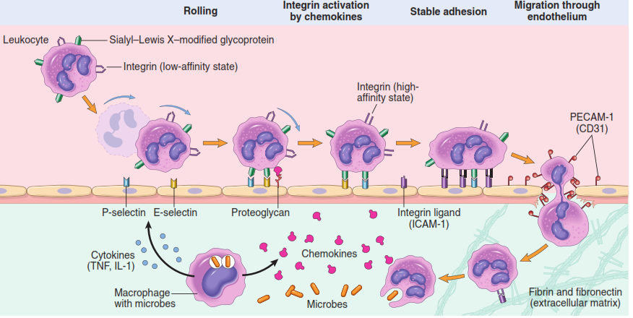**Mechanisms of leukocyte migration through blood vessels**. The leukocytes (neutrophils shown here) first roll, then become activated and adhere to endothelium, then transmigrate across the endothelium, pierce the basement membrane, and migrate toward chemoattractants emanating from the source of injury. Different molecules play predominant roles in different steps of this process: selectins in rolling; integrins in firm adhesion.

**Leukocyte Activation**

Once leukocytes have been recruited to the site of infection or tissue necrosis, they must be activated to perform their functions. Stimuli for activation include microbes, products of necrotic cells, and several mediators

**Phagocytosis**

**Phagocytosis**: Is the engulfment and degradation of the bacteria and cellular debris by **neutrophils** and **macrophages**.

**Phagocytosis involves three distinct but interrelated steps:-**

**(1)** Recognition and attachment of the particle to be ingested by the leukocyte (adherence and opsonization).

**(2)** Its engulfment, with subsequent formation of a phagocytic vacuole.

**(3)** Killing or degradation of the ingested material. .*(reactive oxygen and nitrogen species and lysosomal enzyme)*

1-Recognition and Attachment (adherence and opsonization)

Phagocytosis of microbes and dead cells is initiated by recognition of the particles by receptors expressed on the leukocyte surface; these receptors recognize microbes and host protein (opsonins). Contact of the bacteria or antigen with the phagocyte cell membrane is essential for trapping the agent and triggering the final steps of phagocytosis. The efficiency of phagocytosis is greatly enhanced when microbes are opsonized by specific proteins (opsonins) for which the phagocytes express high-affinity receptors.

**Opsonization**: it is coating the antigen with antibody or complement. This coating enhances or increases the binding of the antigen to the leukocyte cell membrane.

The major opsonins are IgG antibodies, the C3b breakdown product of complement, and certain plasma lectins, all of which are recognized by specific receptors on leukocytes

2-Engulfment

During engulfment, extensions of the cytoplasm (pseudopods) flow around the particle to be engulfed, eventually resulting in complete enclosure of the particle within a **phagosome** created by the plasma membrane of the cell. The limiting membrane of this phagocytic vacuole then fuses with the limiting membrane of a lysosome resulting in discharge of the granule's contents into the phagolysosome.

3-Killing and Degradation:

The ultimate step in the elimination of infectious agents and necrotic cells is their killing and degradation within neutrophils and macrophages of the. Microbial killing is accomplished largely by oxygen-dependent mechanisms.*(reactive oxygen and nitrogen species and lysosomal enzyme)*

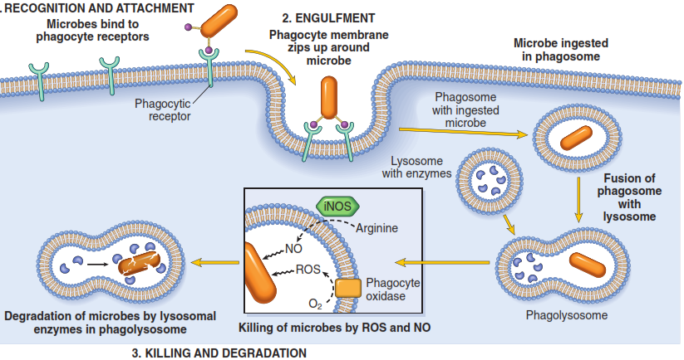

Phagocytosis. Phagocytosis of a particle (e.g., a bacterium) involves (*1*) attachment and binding of the particle to receptors on the

leukocyte surface, (*2*) engulfment and fusion of the phagocytic vacuole with granules (lysosomes), and (*3*) destruction of the ingested particle.iNOS, inducible nitric oxide synthase; NO, nitric oxide; ROS, reactive oxygen species.

**Outcomes of Acute Inflammation depends on**:-

1-The nature and intensity of the injury.

2-The site and tissue affected.

3-The responsiveness of the host.

**Outcomes of acute inflammation**

1-**Resolution** : Regaining normal histological & functional tissue. It occurs when there is:

a- Limited or short lived injury.

b. Minimal or no tissue damage.

c. Tissue which is capable of replacing any irreversibly injured cells.

**2- Progression to chronic inflammation:** Occur if

a. The offending agent is not removed.

b. There is continuing tissues injury.

c. There is decreased capacity of the affected tissue to regrow.

Chronic inflammation may be followed by restoration of the normal structure and function or may lead to scarring.

**3-Suppuration** : means pus formation

**Pus**: A purulent inflammatory exudate caused by pyogenic bacteria

**Pus is a mixture of:-**

1. Living & dead neutrophils.

2. Bacteria.

3. Cellular debris.

4. edema fluid

**Abscesses** are focal collections of pus, typically have a central, largely necrotic region rimmed by a layer of preserved neutrohils with a surrounding zone of dilated vessels and fibroblast

**4- Scarring and fibrosis**

It means replacement of the injured tissue by fibrous connective tissue. This occurs

if we have large tissue destruction as in abscess or if the inflammation occur in tissue that do not regenerate.

|  |
| --- |
| **1.** |
| **2.** |

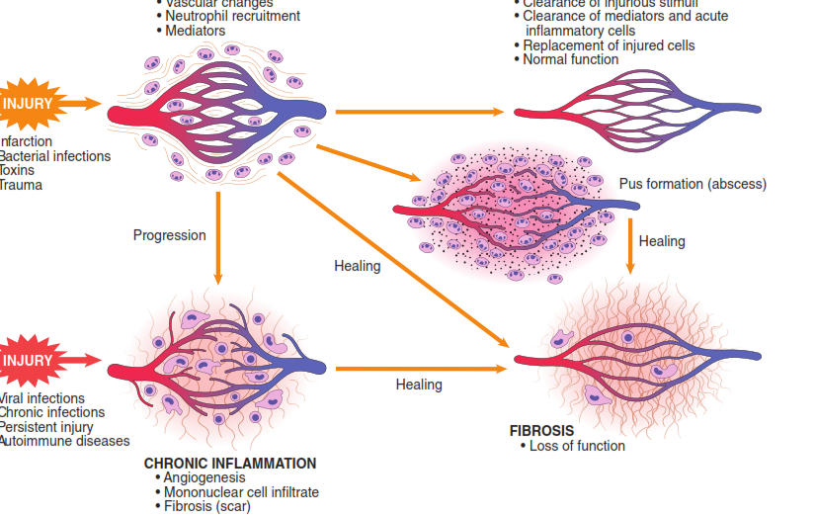

**Outcomes of Acute Inflammation**