**Muscular tissue**

Muscle tissue is composed of fundamental units of muscles are called muscle fiber (sarcomere) which form of special elongated cells, the cell membrane of these muscle fibers is known a sarcolemma and the cytoplasm called sarcoplasm, while the contractile elements called myofibrils and myofilaments. These cells arranged in parallel array that have the primary role of contraction. Most muscle cells are mesodermal origin. Muscle tissue is responsible about movement of the body.

**Structure:** Sarcomere contains [myofibrils](https://en.wikipedia.org/wiki/Myofibrils). The myofibrils are composed of myofilaments which are two types, thin element called [actin](https://en.wikipedia.org/wiki/Actin) and thick element called [myosin](https://en.wikipedia.org/wiki/Myosin) filaments. The arrangement of myofibrils near each other shows transverse striations, the transverse striations in the muscle fibers are due to presence of alternating dark and light bands on each myofibril. The dark bands called A-Bands, each dark band is further subdivided by a pale area in its center called H-Band. Bisecting the H band is the M-line, a region at which lateral connections are made between adjacent thick filaments. The major protein of the M-line is creatine kinase, while the light bands are called I-Bands and each light band is also further subdivided by a darkly-stained zone present at its center and is called Z-line.

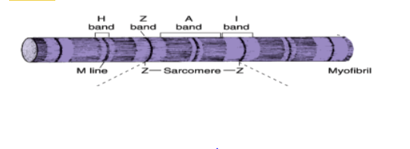

**Classification of muscle tissue:**

According to their structure**,** muscles were classified to striated muscle which include (skeletal and cardiac) muscles and non-striated (smooth) and according to their movement, muscles were classified to voluntary (skeletal muscle) and involuntary (cardiac and smooth muscles).

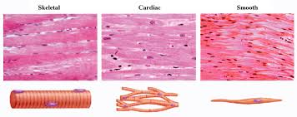

**1-Skletel muscle**

Skeletal muscle consists of muscle fibers, bundles of long cylindrical multinucleated cells, the oval nuclei are usually found at the periphery of the cell under the cell membrane. Muscle fibers are arranged in regular bundles surrounded by the **epimysium**, from which, thin septa of connective tissue extend inward and surrounded the bundles of fibers within a muscle called the **perimysium**, so, the each muscle fiber in itself surrounded by a delicate layer of connective tissue called **endomysium.** In the connective tissue of the muscles, blood vessels, nerves and lymph vessels are present.

The main function of skeletal muscles are contraction and relaxation, supporting, also it help in homeostatic regulation of body temperature (Homeostasis is the maintenance of a relatively constant internal environment). Skeletal muscles are attached to the skeleton (except the muscle of tongue may not be attached to the skeleton). They are present in the tongue, face, eye, pharynx and upper third of esophagus. Skeletal muscles are voluntary (except in the upper third of esophagus and pharynx)

**2-Cardiac muscle**

Cardiac muscle is the type of muscle found in the walls of heart and vena cava. Cardiac muscle exhibits striations because it also has actin and myosin filaments arranged into sarcomeres. Generally these striations do not appear as well-defined as in skeletal muscle. Cardiac muscle cells have only one or two nuclei, which are centrally located. As in skeletal muscle, individual muscle fibers are surrounded by delicate connective tissue. Numerous capillaries are found in the connective tissue around cardiac muscle fibers. Unique and distinguishing characteristic of cardiac muscle is the presence of dark transverse lines that cross the chain of cardiac cells at irregular intervals called intercalated disks, for highly specialized attachment sites between adjacent cells. Unlike skeletal muscle, cardiac muscles are not normally subject to voluntary control.

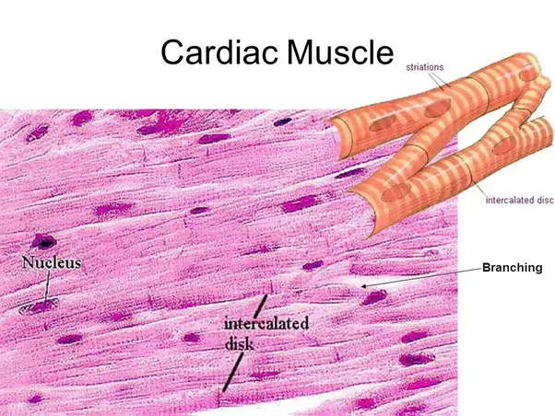

**3- Smooth muscles**

Smooth muscles cells are elongated, fusiform shape, non-striated, not branch, generally, they are arranged in bundles or sheets, and they are largest at their midpoints and taper toward their ends. Each cell has a single nucleus located in the center of the broadest part of cell. So the narrow part of one cell lies adjacent to the broad parts of neighboring cells.

Smooth muscles fibers are found in the walls of digestive tract and blood vessels, urinary bladder and other internal organs. Smooth muscles under involuntary nervous control.

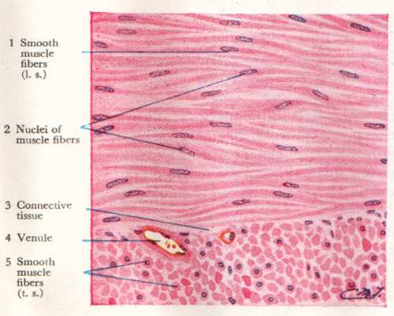

**Nervous tissue**

The human nervous system is complex system in human body and is formed by network of more than 100 million nerve cells (neuron), which show numerous long processes and other type of cell which called glial cells or glia or neuroglia which have short processes, support and protect neurons, participate in neural activity, neural nutrition and the defense processes of the central nervous tissue.

Nervous system is divided to:

* Central nervous system (CNS) which include brain and spinal cord.
* Peripheral nervous system (PNS) which include nerve fibers and ganglia.

**Neurons**

Neurons respond to environmental changes (stimuli) by altering electrical potentials that exist between the inner and outer surfaces of their membranes. Thus, the nerve cells are responsible for the reception, transmission and processing of stimuli, triggering of certain cell activities and release of neurotransmitters.

Most neurons consist of three parts:

**Cell body (Perikaryon) :** It is the trophic center for the whole nerve cell and is also receptive to stimuli, it contain large nucleus which surrounding by cytoplasm, cell body also contain granular area called Nissl bodies, these granules are of rough endoplasmic reticulum (rER), and are the site of protein synthesis

**Dendrites**: are multiple elongated processes specialized in receiving stimuli from other neurons or from the environment, dendrites have greater diameter than axons, are un-myelinated and tapered, it branched as tree for increase the receptor surface area of neuron.

**Axon:** Is a single process specialized in generating or conducting nerve impulses to other cells such as nerve muscle and gland cells, but the main function of the axons is to convey information away from the cell body to specialized terminal (synapse), this synapse makes contact with other neuron or an effector cell. Most neurons have only one axon, the myelin-sheath gaps is occur along a myelinated [axon](https://en.wikipedia.org/wiki/Axon), this is called, Nodes of Ranvier which participate in the exchange of ions.

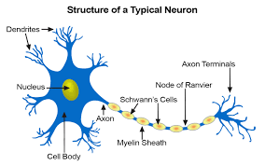

Neurons are classified according to its functions to:

* **Sensory (afferent) neurons**: Carry the signal from the body to the brain and spinal cord (input), they respond to one particular type of stimuli such as touch, sound, or light and all other stimuli affecting the cells of the sensory organs.
* **Motor (efferent) neurons**: Carry the signal away from the brain and spinal cord to cause everything from [muscle contractions](https://en.wikipedia.org/wiki/Muscle_contraction) and affect glandular (output).
* **Interneurons**: are communicating and integrating network between the sensory and motor neurons.

Also the neurons are classified according to the number of processes which extended from the cell body.

**1- Unipolar neurons:** in which, single short process emerging from cell body, This single process gets divided into two branches and functions as the axon, as well as the dendrites.

**2- Bipolar neurons:** With one dendrite and one axon.

**3- Multipolar neurons:** Which have more than two cell processes, one process being the axon and the others dendrites.

**4- Pseudounipolar neurons:** Which have a single process that is close to the cell body and divides into two branches, the process then form T-shape, with one branch extending to a peripheral ending and the other toward the central nervous system.

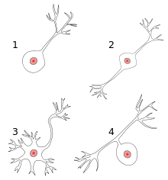

**Glia cells:**

They are other type of cell found in nervous tissue which consider as supporting cells and surround both cell bodies and their axonal and dendrites processes that occupy the interneuronal space. There are six types of glia cells, four of them are found in the CNS and two are found in the PNS.

Glia cells of CNS which include the following:

**1- Oligodendrocytes:** These large glial cells produce the myelin sheath for surround the axon and provides the electrical insulation of neurons in CNS.

**2- Microglia:** Small elongated cells with short irregular processes; they are derived in bone marrow, their function as macrophages in CNS.

**3-Astrocyte:** They are star-shaped cells with multiple radiating processes, astrocyte with few long processes are called fibrous astrocyte and are located in the white matter, while the astrocyte with many short-branched processes are found in gray matter. Astrocyte bind neurons to capillaries and to the pia matter for the controlling of the transfer molecules and ions from the blood to the neurons.

**4- Ependymal cells:** They are columnar epithelial cells lining the ventricles of the brain and central canal of the spinal cord, ependymal cells facilitates the movement of cerebrospinal fluid.

Glia cells of PNS which include the following:

**1- Schwann cells**: These cells have the same function as oligodendrocytes but are located around axon in the PNS. Schwann cell forms myelin around a segment of one axon, in contrast to the ability of oligodendrocytes to branch and serve more than one neuron and its processes.

**2- Satellite cells:** They are found in sensory ganglia, their function similar to astrocyte expect in CNS.

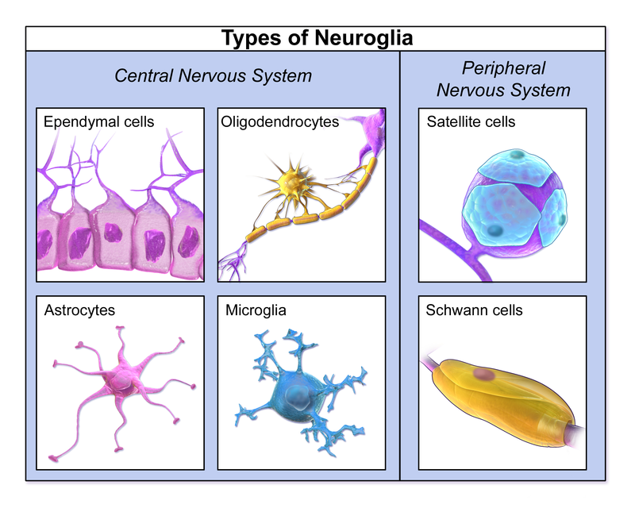

**Spinal cord**

* The cross section of spinal cord show regions of white matter in peripheral and gray matter in the central, assuming H-shape.
* Posteriorly, the cord is divided partially into right and left halves by the dorsal septum, while, anteriorly, there is longitudinal cleft which called anterior median fissure. The central canal, which is a remnant of the lumen of the embryonic neural tube and line by ependymal cells.
* The gray matter consists of neuronal bodies and abundant cell processes (axons and dendrites), while the white matter consists mainly of nerve fibers whose myelin sheath. The spinal cord (and brain) is protected by three layers of tissue or membranes called meninges.
* Gray matter has a gray color because of the gray nuclei that comprises the cells, and myelin is responsible for the white appearance of the white matter.

**Meninges**

The skull and the vertebral column protect the central nervous system. It is also encased in membranes of connective tissue called the meninges. From the outer layer dura mater, arachnoid and pia matter.

**Dura matter:** It envelops the spinal cord and separated it from the periosteum of the vertebrate.

**Arachnoid:** It has two components, a layer in contact with dura matter and a system of trbeculae connecting the layer with the pia matter.

**Pia matter:** It internal layer, which closely invests the brain and spinal cord, it contain many blood vessels.

