Dental Waxes

Dental waxes are mixture of natural wax, synthetic wax, & additives. Chemically waxes are polymers consisting of hydrocarbon & their derivatives like ester & alcohol. The primary use of the waxes in dentistry is to make Pattern of appliances prior to casting as many dental restorations are made by the lost – wax technique, in which a pattern is made in wax and put in mold {investment material}. After setting, the wax is burnt out and the space is filled with molten metal or plastic – acrylic.
Requirements of dental waxes:
- Must conform to the exact size and shape and contour of the appliance which is to be made.
- Should have enough flow when melted to reproduce the fine details.
- No dimensional change should takes place once it's formed.
- Boiling out of the wax without any residue.
- Easily carved and smooth surface can be produce.
- Definite contrast in color to facilitate proper finishing of the margin.
Classification of waxes according to origin.
- Mineral: Paraffin wax: Refined from crude oil, has relatively low melting point (50-70) C and relatively brittle.
- Ceresin wax (microcrystalline): refined from petroleum, has medium melting range (60-90) C.
- Plants:
- Carnauba: obtained from palm trees it is hard tough, and has high melting point (80-85) C.
- Candelilla: it is hard, tough, and has high melting point (80-85) C, used to increase the melting point and reduce flow at mouth temperature.
- Animal:
- Sterain: obtained from beef fat, has low melting point(50 C).
- Bees wax: obtained from hony – comb, consist of partially crystalline natural polyester. It is brittle, has medium melting temperature (60-70) C.
- Synthetic waxes:
They are used to modify some properties of natural waxes like polyethylene.
Classification of waxes according to use1-pattern wax:
- Inlay casting wax: Should be hard and brittle in order to fracture rather than to distort when removed from under – cut areas. The wax is mostly blue in color. They are used to make inlays crowns and pontic replicas. They are mostly paraffin with carnauba wax. There are 2 types.
- Type 1: for direct technique
- Type 2: for indirect technique
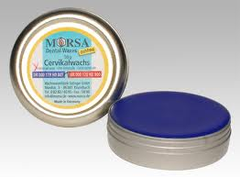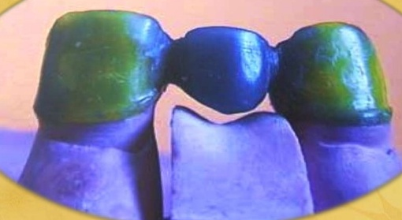
- Denture casting wax: used to produce the metal components of cobalt – chromium partial denture. It is based on paraffin wax with bees wax to give softness necessary for molding and stickiness necessary to ensure adhering to an investment material. It is mostly green sheet.
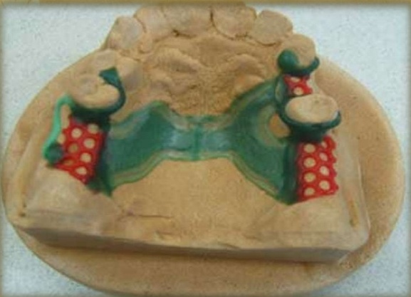
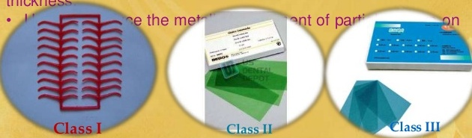
- Denture base plate wax (modeling wax, sheet wax):
It is used to form the base of the denture and in setting of teeth. pink sheet.
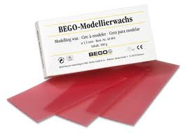

Processing wax: used during processing an appliance like:
- Beading wax: used to make beading around the impression before pouring gypsum to protect the margins.
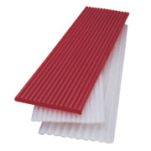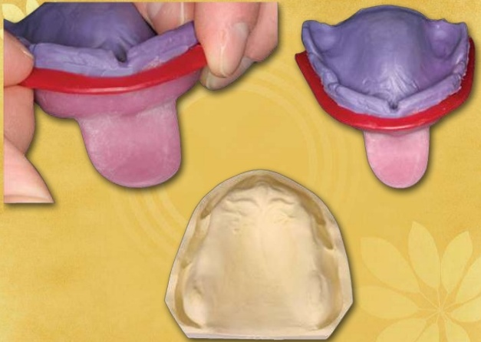

- Boxing wax: used to make box around the impression to make pouring gypsum into the impression easier and more perfect.
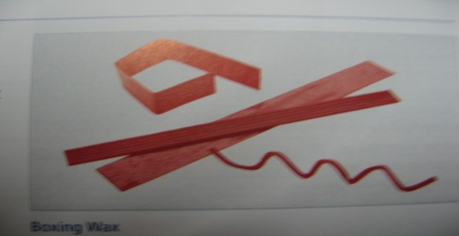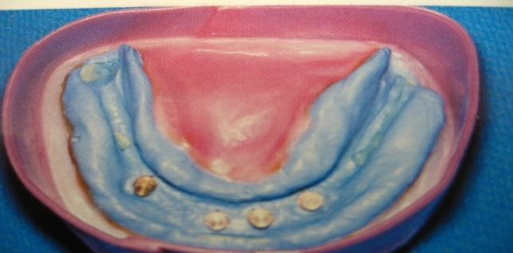

- Block – out wax: to block – out undercut areas on cast during processing of co/cr metal frame work.
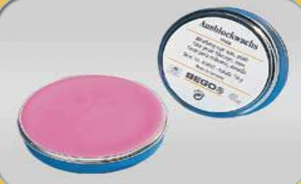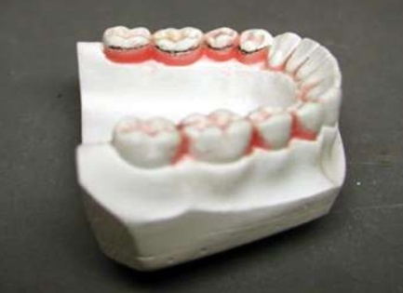
- White wax: to make pattern simulate veneer facing in crowns.
- Sticky wax: to join the broken pieces of the denture before repair.
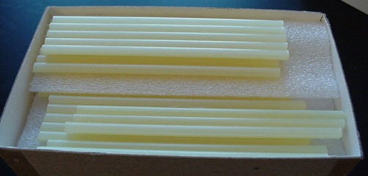

Impression wax: They are previously used to make impression but distort when removed from undercut, they have high flow.
- Impression wax: used to make the impression
- Corrective wax: used to record selected areas of soft tissues in edentulous arches.
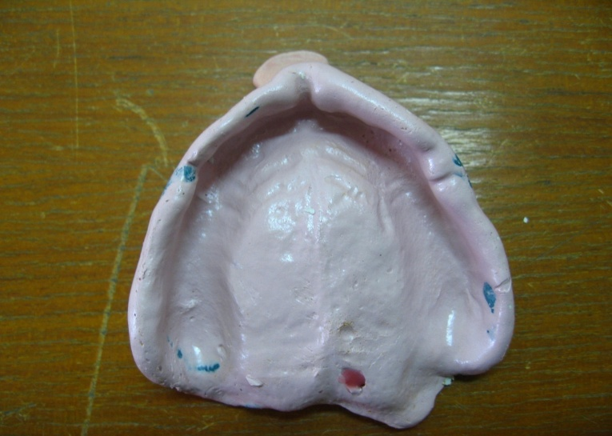

Properties:
- They are thermoplastic materials that are soft when heated and are solid at room temperature.
- High coefficient of thermal expansion and contraction it is the highest of dental materials.300*10-6-1000*10-6 cm/cm C shrinkage of wax from liquid to solid at room temp. is 0.4% thermal contraction of wax is compensated by expansion of investment.
- Poor thermal conductivity after softening of the wax it is allowed to cool, which is accompanied by contraction. because of poor thermal conductivity only the outer layer solidify and the inner solidify later which will produce internal stress. Relief of the stresses accrues later especially when temp. increases, greater stresses may be incorporated if the wax is not properly softened. The best way to soften the wax is to be held in the warm raising air above the flame and not in the flame itself.
The ideal way for softening the wax is to use annealer which is thermo statically controlled oven, keeping the wax just above the softening temp. and ready to use.
- Flow: should have high flow when softened but should have little or no flow at room temp. or mouth temp. in order not to distort.
- Brittleness: inlay wax should be brittle in order to fracture rather than distort when removed from undercut of the cavity.

Distortion of wax:
The wax distorted by:
1-If the wax is not at uniform temperature when used .Some parts of the wax pattern may thermally contracted more than others when stresses are introduced.
2-If the wax is not held under uniform pressure during cooling.
3-If the wax is melted and added in an area of deficiency, the added wax will introduce stresses during cooling.
4-During carving some molecules of wax will be disturbed and stresses will result.
To avoid distortion:
1-Minimal carving and change in temperature.
2-Minimal storage of pattern . Invest immediately.3-Use warm instruments for carving.4-Store in fridge if necessary.

