General pathology Dr. Layla Sabri

Diseases of the Immune System

I. Hypersensitivity reaction (Allergy)

II. Transplantation immunopathology:
Transplantation of solid organs (e.g., liver, kidney,heart) and bone marrow become nearly routine with the greater understanding of humoral and cellular immune response,the development of immunosuppressive drugs such as cyclosporine, and understanding of the role of the major histocompatibility complex (MHC) antigens (human leukocyte antigen =HLA) which is cell surface antigens that determine whether transplanted tissue is recognized as foreign or not.

Transplanted tissue canbe categorized as:
1- Allogeneic if the donor and recipient are related or unrelated
but share similar HLA types.
2- Syngeneicif the donor and recipient are identical twins.
3- Autologous if donor and recipient are the same person.

Immune Recognition of Allografts

Rejection of allografts is a response to MHC molecules, which are so polymorphic that no two individuals are likely to express exactly the same set of MHC molecules (except twins). There are two main mechanisms by which the host immune system recognizes and responds to the MHC molecules on the graft:

Direct recognition. Host T cells directly recognize the allogeneic (foreign) MHC molecules that are expressed on graft cells. Because DCs in the graft express high levels of MHC, they are the most likely APCs in direct recognition.
1-Host CD4+ helper T cells are triggered into proliferation by recognition of foreign MHC molecules and produce cytokine causing delay type hypersensitivity (DTH).
2-CD8+ T cells recognize foreign MHC and differentiate into cytotoxcic T cells (TCLs) which kill the cells in the graft.

Indirect recognition.
1-Host CD4+ T cells recognize donor MHC molecules after these molecules are picked up, processed, and presented by the host's own APCs activating DTH reaction.
2-Production of antibodies by host B cells against graft alloantigens. Helper T cells, stimulate antibody responses.

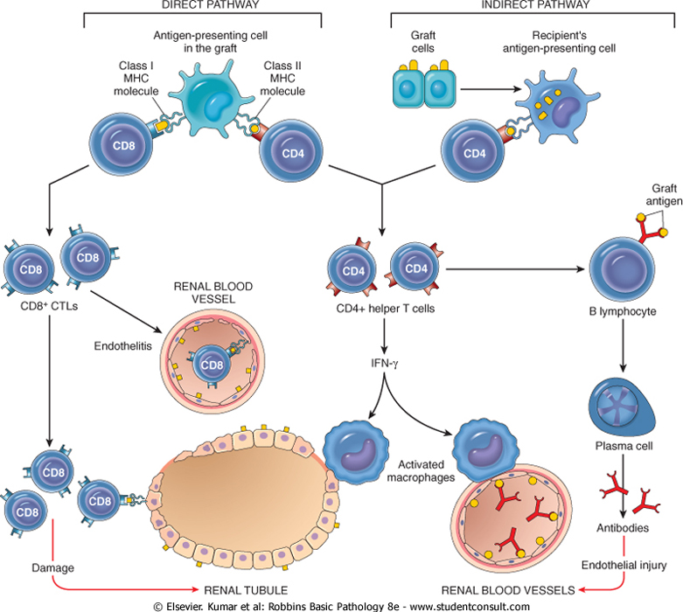

Host-Versus-Graft Disease: (HVGD)

If the transplanted graft bearing foreign MHC antigens, the recipient’s immune system, attack the donor cells of the transplanted organ. Rejection involves T cell-mediated and circulating antibodies.The initial target of the recipient antibodies is graft vasculature.

There are three basic patterns of transplant rejection:

1-Hyperacute reaction occurs immediately after transplantation; in kidney transplants, as soon as blood flow from the recipient to the donor organ begins, it takes on a cyanotic, mottled appearance.

2-Acute rejection usually occurs within the first few months after transplantation and it is evidenced by signs of organ failure.

3-Chronic HVGD occurs over a prolonged period. It is manifest by dense fibrosis of the intimal layer of blood vessels in the transplanted organ.

Graft-Versus-Host Disease(GVHD):

In GVHD, the cellular immune systemof the transplanted graft (donorT cells)recognizes and attacks the unrelated recipient HLA. Occurs mainly in:
- Bone marrow transplant.
- Severely immuno-compromised patients, who have received blood products containing HLA-incompatible lymphocytes.
- After transplantation of solid organs rich in lymphoid cells (e.g., the liver).

III. Autoimmune disorders

They are caused by a breakdown in the ability of the immune system to differentiate between self and nonself antigens. Normally, there is a high degree of immunologic tolerance to self-antigens, which prevents the immune system from destroying the host.Autoimmune diseases can affect almost any cell or tissue inthe body. Some autoimmune disorders are tissue specific; others affect multiple organs and systems.
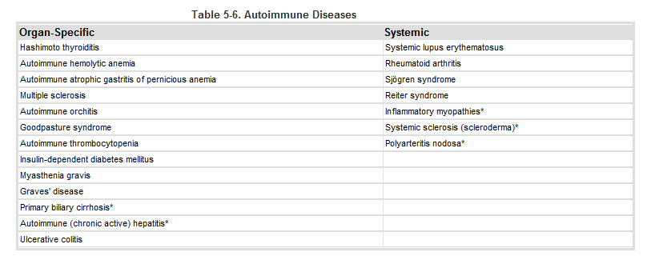
Mechanisms of Antibody-Mediated Diseases (Type II)
Opsonization and phagocytosis.

When circulating cells, such as erythrocytes or platelets, are coated(opsonized) with autoantibodies, with or without complement proteins, the cells become targets for phagocytosis by neutrophils and macrophages. Opsonized cells are usually eliminated in the spleen, and this is why splenectomy is of some benefit in autoimmune thrombocytopenia and hemolytic anemia.

Inflammation. Antibodies bound to cellular or tissue antigens activate the complement system, recruiting neutrophils and monocytes, triggering inflammation in tissues, opsonize cells for phagocytosis, and lyse cells, especially erythrocytes.

Antibody-mediated cellular dysfunction. In some cases, antibodies directed against cell surface receptors impair or dysregulate cellular function without causing cell injury or inflammation. In myasthenia gravis, antibodies against acetylcholine receptors in the motor end plates of skeletal muscles inhibit neuromuscular transmission, with resultant muscle weakness.
Antibodies can also stimulate cell function inappropriately. In Graves' disease, antibodies against the thyroid-stimulating hormone receptor stimulate thyroid epithelial cells to secrete thyroid hormones, resulting in hyperthyroidism.

Immunologic Tolerance:Self-tolerance
The ability of the immune system to differentiate self from
Nonself antigens by the presence of HLA antigens which serve as recognition markers. Autoimmune diseases results from loss of immune tolerance.

Central tolerance: It is the elimination (deletion or death) of autoreactive T cells in the thymus and B cells in the bone marrow. Clonal deletion of autoreactive lymphocytes is not perfect because many self antigens may not present in the thymus so these lymphocytes bearing receptors for those auto- antigens may escape into the periphery causing autoimmune diseases.

Peripheral tolerance: It is the deletion or inactivation of autoreactive T cells or B cells that escaped elimination in the central lymphoid organs. Autoreactive B cells are deleted in the spleen and lymph nodes. Autoreactive T cells may undergo activation, induced cell death, or be rendered inactive so that they cannot recognize self antigens.

Several mechanisms in the peripheral tissues that silence such autoreactive T cells have been identified:

1-Anergy: It is functional inactivation (rather than death) of
lymphocytes.
2-Suppression of the response of T lymphocytes by
regulatory T cells
3-Activation-induced cell death: It involves apoptosis of
mature lymphocytes as a result of self-antigen recognition.

4- Antigen sequestration:Some antigens are hidden from the immune system because the tissues, in which these antigens are located, do not communicate with blood and lymph; these organs are also called immune-privileged sites because it is difficult to induce immune responses to antigens in these sites.

Mechanisms of Autoimmune Disease

The breakdown of self-tolerance and the development of autoimmunity are probably related to the inheritance of various susceptibility genes and changes in tissues, often induced by infections or injury, that alter the display and recognition of self-antigens.

Genetic Factors in Autoimmunity

Genetic susceptibility plays an important role in the development of autoimmune diseases. Autoimmune diseases have a tendency to run in families, and are linked with the HLA locu.
Role of Infections and Tissue Injury

A variety of microbes, including bacteria, mycoplasmas, and viruses, are considered as triggers for autoimmunity. This is because viruses and other microbes, particularly certain bacteria such as streptococci and Klebsiella organisms, may share cross-reacting epitopes with self-antigens, so the body responses to the microbial antigen may attack self-tissues. This phenomenon is called molecular mimicry. It is the probable cause of a few diseases, like rheumatic heart disease, in which an immune response against streptococci cross-reacts with cardiac antigens.

Failure of Self-tolerance
Autoimmune disorders can result from loss of one or more mechanisms of self-tolerance. Among them are:

- Failure of T-cell–mediated suppression.
- Breakdown of T-cell anergy.
- Disorders of MHC–antigen receptor/ complex interactions.
- Release of sequestered antigens.
- Molecular mimicry.

Examples of autoimmune diseases:

1- Systemic Lupus Erythematosus

SLE is caused by autoantibodies, some of which are directed against nuclear antigens and the formation of circulating immune complexes.Other autoantibodies directed against erythrocytes, platelets, and various complexes of phospholipids with proteins.
Disease manifestations include nephritis, skin lesions like “butterfly” rash on the face and arthritis (caused by the deposition of immune complexes), and hematologic and neurologic abnormalities.

2- Rheumatoid Arthritis

RA is a chronic inflammatory disease caused by an autoimmune response against an unknown self antigen(s), which leads to T-cell reactions in the joint with production of cytokines that activate phagocytes that damage tissues and stimulate proliferation of synovial cells (synovitis). The cytokine plays a central role; antibodies may also contribute to the disease.
3-Sjögren Syndrome
Sjögren syndrome is an autoimmune disease in which there are autoantibodies against the ductal epithelial cells of the exocrine gland, characterized by dry eyes (keratoconjunctivitis sicca) and dry mouth (xerostomia), resulting from immune-mediated destruction of the lacrimal and salivary glands.

It occurs as: 1-Isolated disorder (primary form), also known as the sicca syndrome.
2- In association with another autoimmune disease (secondary form, RA is the most common, but some patients have SLE, polymyositis, systemic sclerosis, vasculitis, or thyroiditis.

Morphology

- Lacrimal and salivary glands are the primary targets, but other secretory glands, including those in the nasopharynx, upper airway, and vagina, may also be involved.
- Involved tissues show an intense lymphocyte (primarily activated CD4+ T cells) and plasma-cell infiltrate, occasionally forming lymphoid follicles with germinal centers. There is associated destruction of the native architecture.

- Lacrimal gland destruction results in a lack of tears, leading to drying of the corneal epithelium, with subsequent inflammation, erosion, and ulceration (keratoconjunctivitis).
- Similar changes may occur in the oral mucosa as a result of loss of salivary gland output, giving rise to mucosal atrophy, with inflammatory fissuring and ulceration (xerostomia).
5-Dryness and crusting of the nose may lead to ulcerations and even perforation of the nasal septum.
6- When the respiratory passages are involved, secondary laryngitis, bronchitis, and pneumonitis may appear.

Clinical features:

Dry mouth, Lack of tears, Salivary glands enlargement as a result of lymphocytic infiltrates. Extraglandular manifestations include synovitis, pulmonary fibrosis, and peripheral neuropathy.

IV- Immune deficiency diseases

Caused by inherited defects affecting immune system development, or they may result from secondary effects of other diseases (e.g., infection, malnutrition, aging, immunosuppression, autoimmunity, or chemotherapy). Clinically, patients present with increased susceptibility to infections as well as to certain forms of cancer.
We have two type of immune deficiency diseases:
- Primary immune deficiencies.
- Secondary immune deficiency.(AIDS)
(Acquired immunodeficiency syndrome)

Primary (Congenital) Immune Deficiency Diseases:
Caused by mutations in genes involved in lymphocyte maturation or function, or in innate immunity. They have increased susceptibility to infections in early life

Secondary Immune Deficiencies

Immune deficiencies secondary to other diseases or therapies are much more common than the primary (inherited) disorders. It occurs in patients with malnutrition, infection, cancer, renal disease, or sarcoidosis. However, the most common cases of immune deficiency are therapy-induced suppression of the bone marrow and of lymphocyte function.

The most important is Acquired Immunodeficiency Syndrome
(AIDS).
Acquired Immunodeficiency Syndrome

AIDS is a retroviral disease caused by the human immunodeficiency virus (HIV), characterized by infection and depletion of CD4+ T lymphocytes, and by immunosuppression leading to opportunistic infections, secondary neoplasms, and neurologic manifestations.

The major routes of HIV infection are:
- Sexual contact.
- Intravenous drug abusers.
- Hemophiliacs receiving factor VIII or IX concentrates.
- Random recipients of blood transfusion.
- Passage of the virus from infected mothers to their newborns.

Pathogenesis:
The two major targets of HIV infection are the immune system and the CNS.

Virus entry into cells: Requires CD4 and co-receptors, which are receptors for chemokines; involves binding and fusion of the virus with the cell; main cellular targets are CD4+ helper T cells, macrophages, and DCs.

Viral replication: Provirus genome integrates into host cell DNA; viral gene expression is triggered by stimuli that activate infected cells (e.g., infectious microbes, cytokines produced during normal immune responses)

Progression of infection: Acute infection of mucosal T cells and DCs; viremia with dissemination of virus; latent infection of cells in lymphoid tissue; continuing viral replication and progressive loss of CD4+ T cells.

Mechanisms of immune deficiency:
Loss of CD4+ T cells occurs due to :
- T-cell death during viral replication and budding.
- Apoptosis as a result of chronic stimulation.
- Decreased thymic output.
- Defects in macrophage and DC functions
- Destruction of architecture of lymphoid tissues (late).

Clinical Features

The clinical manifestations of HIV infection range from a mild acute illness to severe disease. The typical adult patient with AIDS presents with fever, weight loss, diarrhea, generalized lymphadenopathy, multiple opportunistic infections, neurologic disease, and secondary neoplasms.

Amyloidosis:
It is systemic disease that may involve components of the immune system. It is characterized by the extracellular deposits of misfolded proteins that aggregate to form insoluble fibrils.
Amyloid deposits cause tissue injury and impair normal function by causing pressure on cells and tissues. They do not evoke an inflammatory response.
Amyloidosis may be localized or systemic. It is seen in association with a variety of primary disorders, including:

- Monoclonal B-cell proliferations in which the amyloid deposits
consist of immunologlobulin light chains.
- Chronic inflammatory diseases such as rheumatoid arthritis
(deposits of amyloid A protein, derived from an acute-phase
protein produced in inflammation).
- Alzheimer disease (amyloid β protein).
- Familial conditions in which the amyloid deposits consist of
mutants of normal proteins
- Amyloidosis associated with dialysis (deposits of β2-
microglobulin, whose clearance is defective).

Histological appearance:
With the light microscope and standard tissue stains, amyloid appears as an amorphous eosinophilic hyaline extracellular substance that with progressive accumulation will produce pressure atrophy of the adjacent cells. To differentiate between amyloid and other hyaline deposits like collagen and fibrin, a special stain can be used which is, Congo red that give amyloid a pink or red color.

