**Lec 2Dr. Zainab Salih**

**MECHANICAL PROPERTIES:**

One of the most important properties of dental material is the ability to withstand the various mechanical forces placed during their use as a restoration, impression, Models appliances and tools.

**STRESS:** is the force per unit area induced in a body in response to some externally applied force .It is force measured in kg/Cm2 or pound /inch2or Pascal.

STRENGTH: is the measure of the resistance of the material to the externally applied force. There are many types of stresses according to the direction of the applied force. Each type of stress is accompanied by the same type of strain.

STRAIN: is the change in dimension per unit dimension caused by externally applied force.

Strain =final length - original length/ Original length.

Percentage of elongation=strainX100%. Examples: acrylic: 1.5%, Co/Cr:4%, stainless steel: 35%.

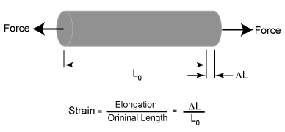

**TYPES OF STRESS:**

1. Tensile stress: It is the force per unit area induced in the body in response to externally applied force which tends to elongate or stretch the body; it is accompanied by tensile strain.

Examples: enamel: 10Mpa, dentin: 106Mpa, amalgam: 32Mpa.

1.png

1. Compressive stress: It is the force per unit area induced in the body in response to externally applied force which tend to compress or shorter the body.lt is accompanied by compressive strain.

Examples: enamel: 384Mpa, dentin: 297Mpa, amalgam: 388Mpa.

Investment material, restorative materials and models should have high compressive strength.

2.png

1. Shear stress: It is the force per unit area induced in the body in response to external force, which is applied to one part of the body in one direction, and the rest is being pushed in the opposite direction.

Examples: enamel: 90Mpa, dentin: 138 Mpa, amalgam: 188Mpa.

Shear force: is the force which causes tearing a paper or a card. If one part of the crown is in occlusion while the rest is not, shear stress will develop. It is accompanied by shear strain.

Usually three types of stresses occur at the same time. If a piece of metal is being bending it will exhibit tensile stress on the outer surface, compressive on the inner and shear stress in the middle.

Transverse strength: It is the strength of the middle of a beam, which is supported only at its ends. It is important in dental bridges.

Examples: composite: 139Mpa, amalgam: 124Mpa.

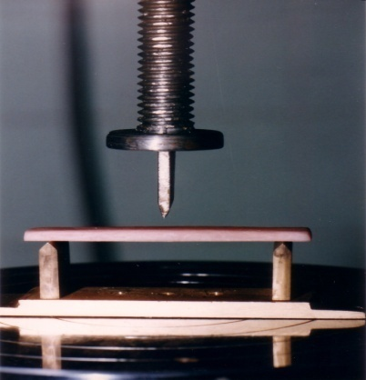  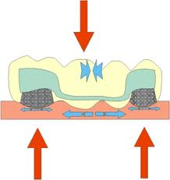

Fatigue strength: It is when the material is constantly subjected to change in shape due to frequent application of force like clasp arm of partial denture.



Impact strength: It is the ability of the material to break on sudden impact. Low impact strength means brittle material, like dropping of the denture.

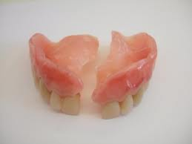  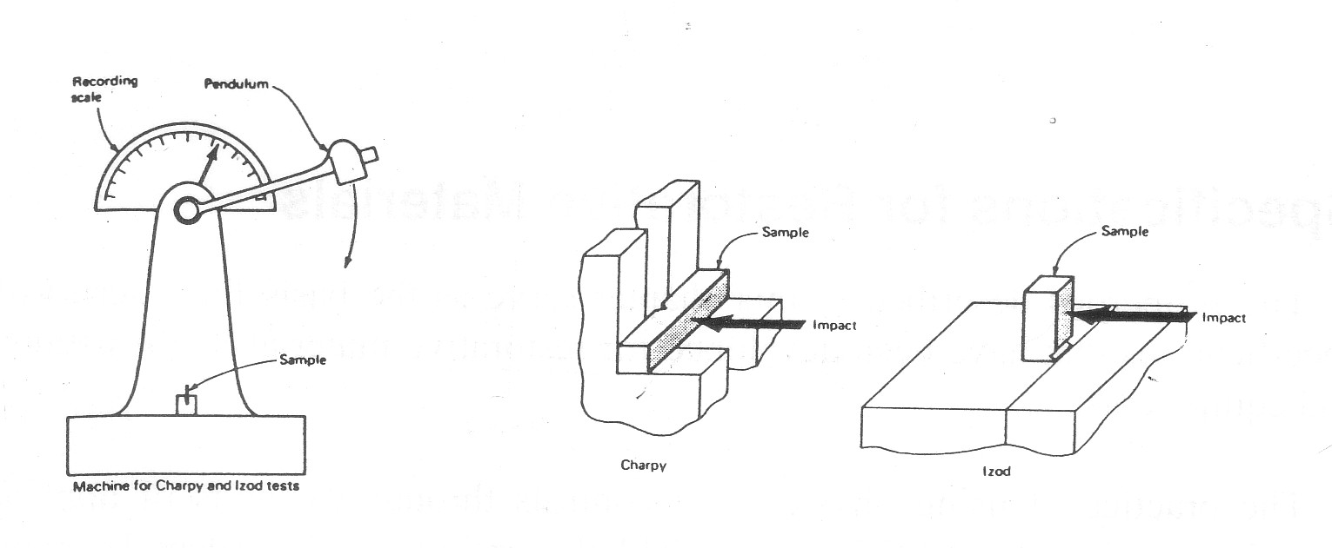

**STRESS —STRAIN CURVE**

**Proportional limit:**

When a stress is applied to a material, the material will tend to deform (change in shape and dimension) in an amount proportional to the magnitude of applied stress. The greatest stress, which may be produced in the material such that the stress is directly proportional to the strain.

**Elastic deformation (elastic limit):** The greatest stress to which the material can be subjected such that it will return to its original shape and dimension when the stress is removed.



If the stress is increased beyond the elastic limit or the proportional limit, the material will deform and if we remove the stress the material will not return to its dimension. This is called plastic deformation. If the stress is increased more and more, the material will break.



**ULTIMATE STRENGTH:** It is the greatest stresses which break the material. is the maximum stress that a material can withstand before failure

Fracture strength: The stress at which a material fracture. The fracture strength is not necessarily the ultimate stress at which the material will fracture.

**MODULUS OF ELASTICITY:** It is the constant of proportionality. It is when any stress value equal or less than the proportional limit is divided by it is corresponding strain value.

Modulus of elasticity=stress/Strain, kg/Cm2 or pound /inch2or Pascal.

Examples: enamel: 84Gpa, dentin: 17Gpa.

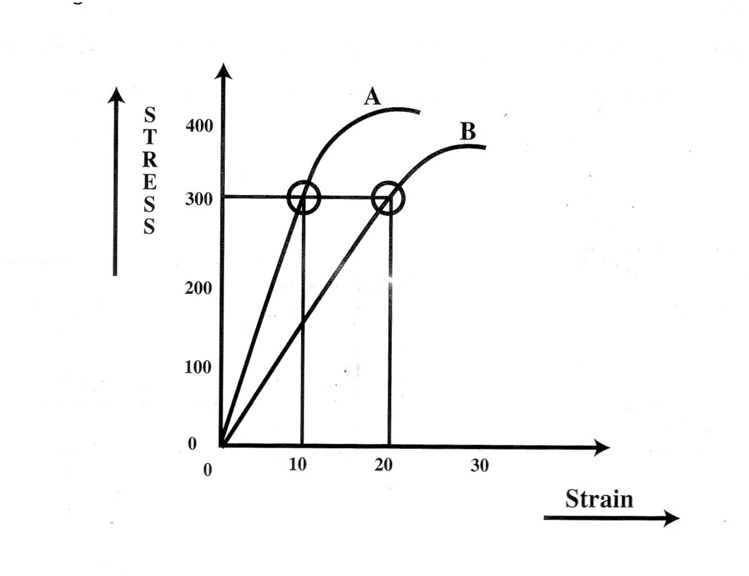

**DUCTILITY:** It is the ability of the material to withstand permanent deformation under tensile stress without fracture; it depends on plasticity and tensile strength. It's the ability of the material to be drawn into a fine wire.

Examples: gold: most ductile.

**MALLEABILITY:** It is the ability of the material to withstand permanent deformation under compressive stress without fracture. It's the ability of the material to be drawn into a sheet.

Examples: gold: most malleable.



**TOUGHNESS:** It is the total work or energy required to break the material. It's the total area under the stress-strain curve. It requires strength and plasticity.



BRITTLNESS: It is the opposite of ductility; it requires lack of plasticity.

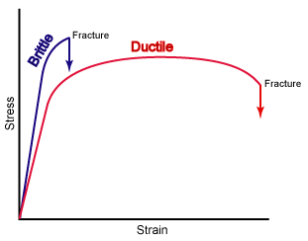 

**FLEXIBILITY:** The higher strain which accuse when the material is stressed to its proportional limit.

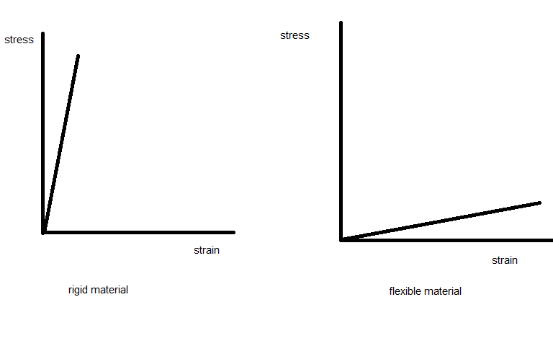

RESILIENCE: The amount of energy absorbed by a structure when it is stressed within the proportional limit.



HARDNESS: It is the resistance of the material to deformation caused by penetrating or scratching the surface .It is done either by using steal ball (Brinell or Rocwell test) or using diamond (Vickers and Knoop test). The higher the number, the harder the material.

Examples: Brienell hardness number: acrylic: 22, dentin:65, gold: 250.

Knoop hardness number: enamel: 343, dentin:68, Co/Cr: 391.Kg/mm2.

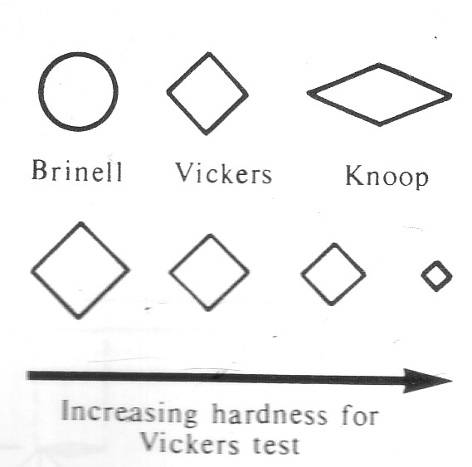

Properties of stress strain curve: The shape of stress –strain allows classifications of materials according to their general properties.

