Periodontics
Lec.3
Effects & sequelae of the incorrect use of mechanical plaque
removal devices:
Tooth brushing can cause damage both to soft & hard tissues.
Trauma to the soft tissues results in gingival erosion & gingival
recession. Trauma to hard tissues leads to cervical abrasion of
the tooth surface which is mainly caused by the abrasives in the
dentifrice. These lesions have been associated with toothbrush
stiffness, the method of brushing, brushing frequency/time,
excessive brushing force, and improper use of both manual and
powered tooth brushing.
The use of dental floss, interproximal brushes & wood sticks
may also induce soft tissue damage; however, in most cases
this damage is limited to acute lesions, such as lacerations and
gingival erosions.
Scaling & Root Planing (S + RP):
Scaling is the process by which plaque &calculus are removed
from both supragingival & subgingival tooth surfaces.
Root planing is the process by which residual embedded
calculus and softened cementum are removed from the roots
to produce smooth, hard & clean root surfaces.

The supragingival scaling is the initial phase of debridement of the dentition in patient with periodontal disease in order to facilitate the
subsequent subgingival scaling, so supragingival
calculus and gross overhang or metal crown should be
removed first, then the dentition are polished so that
the patient can start self performed plaque control
program.
Subgingival S&RP, although they are considered as two
separated procedures with different objectives but in
clinical work they always carried out together and can
be carried out in sessions, the number of teeth included
in each session for RP depends on the skills of the operator
and the severity of the case, usually (4-6)teeth.At the
beginning the area is probed to identify:
- The probing pocket depth ( PPD).
- Anatomy of the root surface.
- Location of the deposits.

Scaling & root planing aims to:
- Restore gingival health by the removal of bacterial plaque
(which is responsible for periodontal tissue destruction),
calculus & the superficial layer of cementum however,
calculus & plaque grow in surface irregularities of
cementum furthermore, bacterial products (such as
endotoxin) penetrate into the cementum surface.
- The creation of a clean & hard root surface that is as smooth
as possible (which inhibits further plaque retention) must be
achieved to promote tissue healing possibly with the
formation of a long junctional epithelium and aids soft tissue
reattachment.
Subgingival scaling & root planing are performed as either
closed or open procedures under local anesthesia. The closed
procedure implies subgingival instrumentation without
displacement of the gingiva, thus less trauma, pain, bleeding
and minimal recession (which is important for esthetics,
especially anteriorly) were achieved. In addition, wound healing
occurs more rapidly following closed procedures. Closed
therapy is the definitive treatment for mild & moderate
periodontitis and represents the initial therapeutic approach
prior to surgical intervention for complex & severe cases.
Closed therapy limitations include its performance without
direct vision & good access for the instruments, thus its success
is dependent on tactile sensation & knowledge of root
morphology. Even the experienced hygienist will not always
effectively treat all root surfaces, nor completely remove all

plaque & calculus from all surfaces, e.g. S+RP of poorly
accessible, irregular root surfaces, in deep, narrow or distal
pocket and substantial furcation involvement, even in patients
with minimal mouth opening capacity & with expansively
progressive disease.
Open procedure calls for exposure of the affected root
surface by the displacement of the gingival tissue, thus gingiva
is incised and reflected to facilitate access for the instrument
and visibility for the operator.
Instruments used for scaling & root planing are classified as
- Hand instruments.
- Ultrasonic & sonic instruments.
- Motor driven devices incorporating diamond-coated tips
(reciprocating instruments).
- Rotating instruments.
- Laser instruments.
Reciprocating instruments: a special designed hand piece will give 20000-30000 strokes per min. with a 1.2mm reciprocating motion of a specially designed working tips for
S & RP (e.g. a set of PER-IO-TOR instruments), its use is less time consuming than hand instrument , results in less root surface loss and produce equivalent clinical outcome compared to hand, sonic or ultrasonic scalers.
Rotating instruments: used to debride root furrows, furcation areas and root surface in deep narrow pockets because in these situations
cannot be properly debride with hand inst. A fine grained diamond bur is usually used with great care to avoid excessive removal of tooth substances.

Laser: recently laser devices been introduced to
be used in different aspects of periodontal
therapy including S&RP.
Removal of Plaque retentive factors
Epidemiological studies had document the relation
between faulty dentistry (overhang filling, defective crown margin & improperly situated clasp of P.D.) and periodontal disease
due to its plaque retentive property .Such conditions should be corrected either by correction or replacement of the prostheses &
restorations to prevent accumulation of plaque & facilitate self-performed tooth cleaning to maintain good periodontal health. overhang restorations can be removed using diamond stone
mounted on a hand piece

Evaluation of the effect of the initial, cause-related therapy:
Reevaluation of the patients periodontal conditions & caries
activity should be performed no earlier than 6-8 weeks
following the last session of the S+ RP procedures, in order to
provide time for the tissues to heal by the formation of a long
junctional epithelium & sufficient practice with oral hygiene
skills. The initial phase of the therapy is completed with a
thorough analysis of the results obtained with respect to
- Improvement of the self-performed plaque control.
- Reduction in plaque level (plaque index).
- Resolution of gingival inflammation include less bleeding,
redness & swelling ( gingival index and bleeding on probing).
- Shrinkage of the gingival soft tissue (recession).
- Increased resistance to probe tip penetration by the tissues
at the base of the pocket
- Reduction of probing pocket depth, and if possible
changes in probing attachment level as a result of
gingival shrinkage and formation of long junctional epi.

Clinical attachment level (CAL): is the distance from the cementoenamel junction (CEJ) to the location of inserted periodontal probe tip(bottom of gingival crevice or periodontal pocket).
- reduced tooth mobility.
The Pockets should not be probed sooner than 4-6 weeks
after S&RP as this may interfere with healing process.
When we evaluate the results of our treatment
according to these points we can see one of the
following conditions :-

- Patient with improved oral hygiene, no gingival
inflammation, no bleeding on probing with marked
reduction in probing pocket depth, in such situation no
further periodontal treatment is required and the
patient directly advanced to maintenance phase of
periodontal therapy.

- Patient with proper standard of oral hygiene but having
some sites of bleeding on probing with no significant
reduction in probing depth. Such patient may need to be
advanced to corrective phase including the periodontal
surgery.

- Patient with inadequate oral hygiene due to lack of
motivation or lack of ability to do proper home care, such
patient should be remotivated and reinstructed to
improve their oral hygiene because if the oral hygiene
not improved the periodontal disease will recurrent even
if we conduct periodontal surgery.

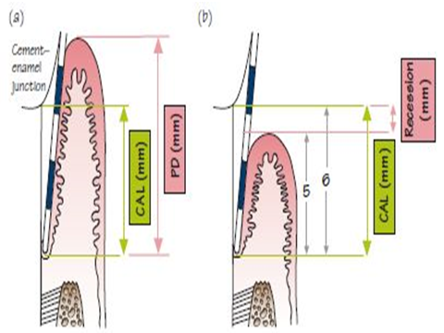

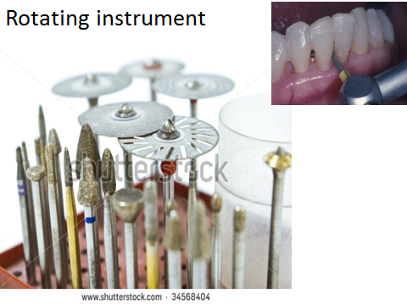

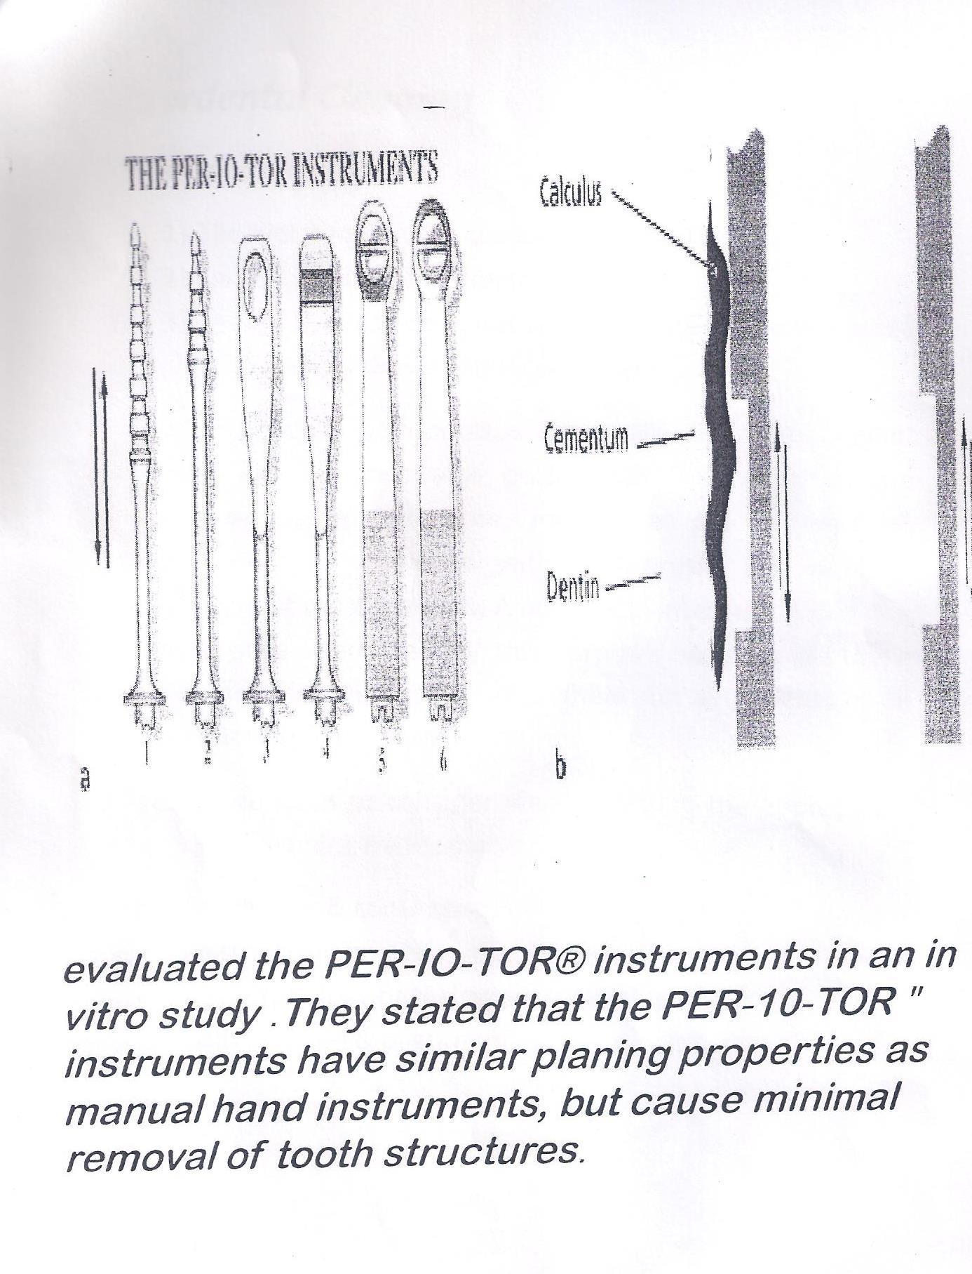

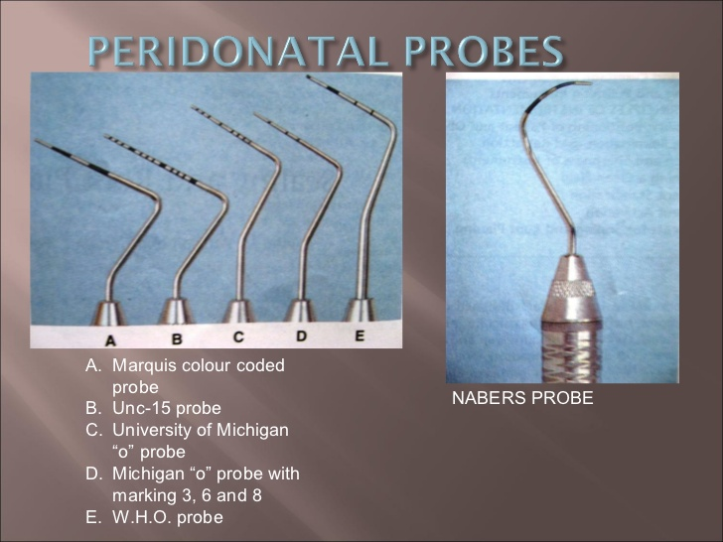
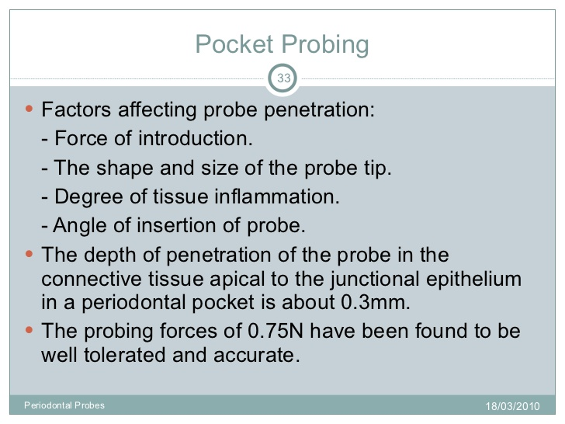

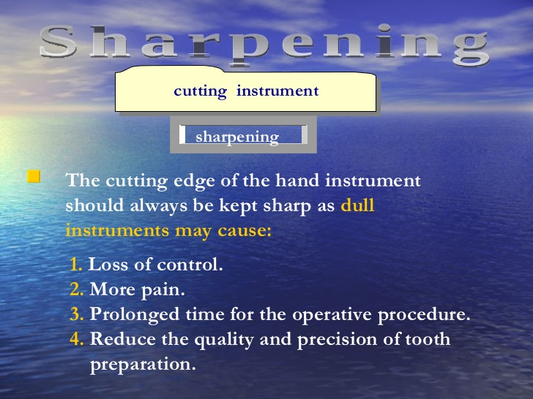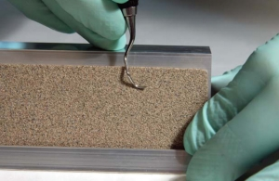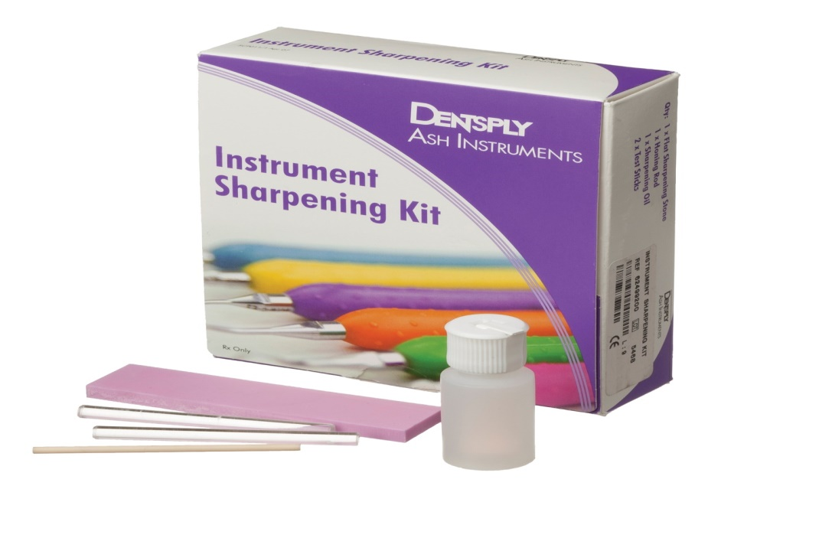Kit includes sharpening stone,lubricating oil,test stick and honing rod