Lec.4
Periodontics
Chemical plaque control
Gingivitis and periodontitis are highly prevalent diseases and prevention of occurrence or recurrence is dependent on supra -gingival plaque control. Tooth cleaning is largely influenced by the compliance and dexterity of the individual thus the concept of using chemical plaque control is just an adjunctive mean to overcome inadequacies of mechanical cleaning.
The action of these chemical could fit into four categories:
1. Anti-adhesive
2. Antimicrobial
3. Plaque removal.
4. Anti-pathogenic.
Anti-adhesive agents
They would act at the pellicle surface to prevent the initial attachment of the primary plaque forming bacteria and development of biofilms, although the amine alcohol, delmopinol, which appears to interfere with bacterial matrix formation and therefore fits between the concepts of anti-adhesion and plaque removal, has been shown effective against plaque and gingivitis.

Antimicrobial agents:
They could inhibit plaque formation through one of two mechanisms alone or combined. The first would be the inhibition of bacterial proliferation therefore could exert their effects either at the pellicle coated tooth surface before the primary plaque formation bacteria attach or after attachment but before division of these bacteria, this effect would be bacteriostatic in type while, the second effect could be bactericidal, whereby the antimicrobial agent destroys all of the microorganisms either attaching or already attached to the tooth surface.
Plaque removal agents:
Such agents contained in a mouth rinse to reach all tooth surfaces and act in an identical manner to a tooth brush and remove bacteria from the tooth surface have attracted the terminology of the chemical tooth brush e.g. Hypochlorite's.

Anti-pathogenic agents:
These agents might inhibit the expression of plaque microorganisms' pathogenicity without necessarily destroying them and directly approaches to alter plaque ecology to a less pathogenic flora, e.g. Antimicrobial agents with bacteriostatic effect.

Vehicles for the delivery of chemical agents
Tooth paste-mouth rinses-spray-irrigators-chewing gum-varnishes,
gel,chips.
These agents should have persistent action (substantivity) measured in hours which depend on
- Adsorption and prolonged retention on oral surface including
pellicle-coated teeth.
- Maintenance of antimicrobial activity once adsorbed.
- Slow release from the oral tissues.
After many studies and clinical trials it was found that the
chlorhexidine (CHX) is the best chemical supra-gingival plaque control
agent.

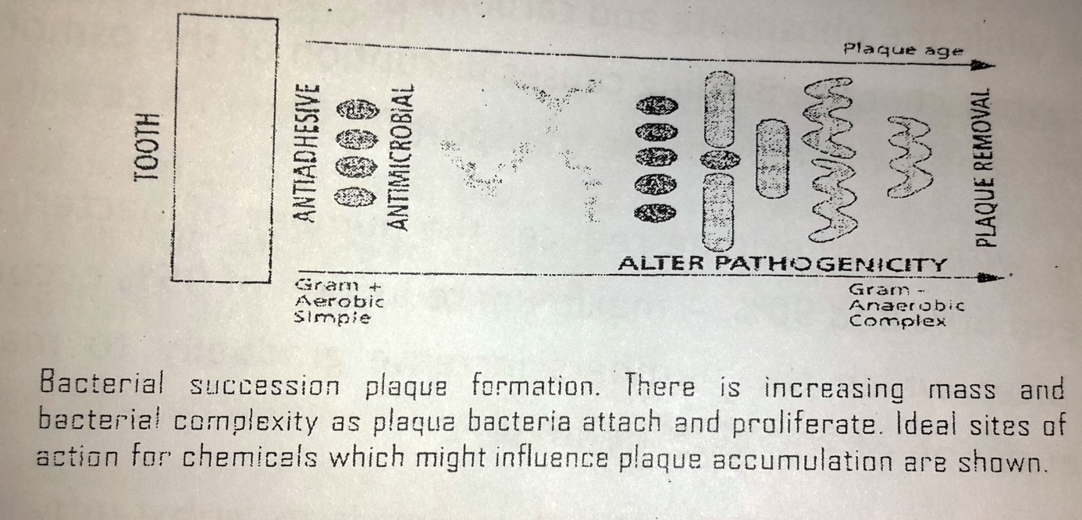

Chemical supra-gingival plaque control :
Chemical agents have been incorporated into mouth rinses and
tooth pastes with the objective of inhibiting the formation of plaque
and calculus. Antiplaque agents may also have a significant clinical
effect of resolving an established gingivitis.
Chlorhexidine digluconate:
CHX is frequently used as a mouth rinse (o. 2% or 0.12% w/v). The compound can also be applied as a gel, spray, varnishes and has been incorporated into tooth paste, chewing gum, slow release vehicles (perio chip), periodontal packs and sub-gingival irrigation.
At low concentrations, chlorhexidine is bacteriostatic, at high concentrations, it is bactericidal. The mode of action of chlorhexidine in killing bacteria is dependent upon the drug having access to cell walls. This is facilitated by electrostatic forces, since chlorhexidine is positively charged, while the phosphate and carboxyl groups of bacterial cell walls carry negative charges. Binding causes disruption of the osmotic barrier and interference with membrane transport.
Rinsing with chlorhexidine reduces the number of bacteria in saliva
by between 50% and 90%. A maximum reduction of 95% occurs around 5 days, after which the numbers of bacteria increase gradually to maintain an overall reduction of 70%-80% at 40 days.
An important property of chlorhexidine is its substantivity, that is, the retention in the mouth and subsequent release from oral structures, After a 1 minute oral rinse of 10ml chlorhexidine 0.2% approximately 30% of the drug is retained, within 15 seconds of rinsing, half will have bonded to receptor molecules.

Clinical uses of chlorhexidine
1. As an adjunct to oral hygiene and professional prophylaxis.
2. Post oral surgery including periodontal surgery or root planing.
3. For patients with jaw fixation.
4. Medically compromised individuals predisposed to oral infections.
5. High risk caries patients.
6. In denture stomatitis.
7. Oral mal odor.
8. Recurrent oral ulceration.
9. Removable and fixed orthodontic appliance wearers.
10. Immediate preoperative chlorhexidine rinsing and irrigation.
11. Reduced salivary flow.
12. For oral hygiene and gingival health benefits in the mentally and physically handicapped.
In oral use as a mouth rinse chlorhexidine has been reported to have
a number of local side effects, thus it is only used for a few weeks at a
time when it is not possible to carry out other oral hygiene procedures.
These side effects are:
1. Brown discoloration of the teeth and some restorative materials
and the dorsum of the tongue.
2. Taste perturbation where the salt taste appears to be preferentially affected to leave food and drinks with a rather
bland taste.
3. Enhanced supra-gingival calculus formation.
4. Unilateral or bilateral parotid swelling.
5.Oral mucosal erosion.
6. Chlorhexidine also has a bitter taste which is difficult to mask
completely.
CHX is nontoxic even if digested or topically applied and has a broad antimicrobial action including wide range of gram positive & gram
negative m.o.; it is also effective against fungi and yeast including
Candida and some viruses (HBV and HIV). No report of bacterial
resistance even after prolong use of CHX were recorded.
It was demonstrated that rinsing for 60 seconds twice per day with
l0 ml of a 0.2% CHX gluconate solution in the absent of tooth cleaning
inhibited plaque regrowth and development of gingivitis, after that the patient should not eat or drink anything for up to 30min. With tooth brushing by using tooth paste, CHX mouth wash should be used after 30min. of brushing otherwise cross reaction may occur and reduce the plaque inhibition of CHX.
Studies suggest a slow release of CHX from surface to produce a
persistent bacteriostatic action lasting for about 12hours that's why it
should be used twice a day.
Nonprescription Essential Oil Rinse
Essential oil mouthrinses contain thymol, eucalyptol, menthol, and methyl salicylate. These preparations have been demonstrated plaque biofilm reductions of 20% to 35% and gingivitis reductions of 25% to 35%. This type of oral rinse has had a long history of daily use and safety . These products also contain alcohol (up to 24% depending on the preparation), which must be a consideration for some patients not to use these products.

Other Products
A preparation containing triclosan has shown some effectiveness in reducing plaque biofilm and gingivitis. It is available in toothpaste form . Other oral rinse products on the market have shown some evidence of plaque biofilm reduction. These include stannous fluoride, cetylpyridinium chloride (quaternary ammonium compounds), and sanguinarine. Evidence suggests that these and other available mouthrinse products do not possess the antimicrobial potential of either chlorhexidine products or essential oil preparations.
One type of agent has been marketed as a prebrushing oral rinse to improve the effectiveness of toothbrushing. The active ingredient
is sodium benzoate.
It has been reported that chemical plaque biofilm control has been effective for both plaque biofilm reduction and improved wound healing after periodontal surgery. Both chlorhexidine and essential oil mouthrinses have significant positive effects when prescribed for use after periodontal surgery for 1 to 4 weeks.
Antimicrobials
The use of systemic antimicrobials in the management of periodontal disease should be restricted to the following conditions
1. Severe necrotizing ulcerative gingivitis.
2. Multiple or sever periodontal abscesses with involvement of regional lymph nodes.
3. Some cases of aggressive periodontitis.
4. Refractory periodontitis.

Routs of administration
Two disadvantages of the nonspecific mechanical treatment which repeated at recall visits are the irreversible and ever increasing damage to tooth hard structure especially roots within pockets as well as gingival recession. In addition, it is impossible to mechanically remove plaque completely from narrow grooves, narrow furcation's and other bacterial reservoirs within the pockets. Thus it is appropriate to combine mechanical plaque control with antimicrobials. Since only a few bacterial species are potentially periodontal pathogenic, it is reasonable to eliminate these groups specifically. These groups contain bacteria can invade periodontal tissues, making mechanical therapy alone in-effective.
This situation can be effectively combated using systemic or topically applied antimicrobials to achieve, within the periodontal environment a concentration of the drug that is sufficient either to kill (bactericidal) or arrest growth(bacteriostatic) of pathogenic microorganisms.
Systemically ingested antimicrobials, whereby the drug enters the
crevicular fluid and able to bathe sub-gingival flora, capable of
Advantages
- Eliminating pathogens, not only from periodontal lesions but also from the oral cavity. (Reach widely distributed microorganisms).
- Such an action may have prophylactic benefits and reduce the risk of reinfection of the periodontal sites.
- Broad spectrum of activity.

Disadvantages
- Systemic side effects.
- The possible elimination of non-pathogenic "beneficial" bacteria.
- Low concentration within the tissues.
- BacteriaI resistance.
- Requires good patient compliance.
- Interaction with other medications.
- Allergic reactions.
- Super infections of opportunistic bacteria.
- High doses of antimicrobials are administered.
Antimicrobials have also been incorporated into formulation that
can be applied locally into periodontal pockets.
Advantages of local route of administration
- Lower dose of antimicrobials are administered.
- High local concentrations of the drugs are achieved locally in
periodontal pockets so better effect against biofilms.
- Minimal or no side effects.
- Administration is not dependent upon patient compliance.
- Placement is site specific.
- When the matrix (vehicle) biodegrades to release the drug (controlled slow release device), an antimicrobial sustain its
localized concentration of effective levels for a sufficient time.

Disadvantages:
- Narrow, limited spectrum of efficacy,
- Possible reinfection of non-treated sites.
- The placement can be time consuming when the treatment of
multiple sites is indicated.
- The extent to which the drug penetrates the connective tissues
may be less predictable than when systemic dosing is
undertaken.
Choice of antimicrobial agent :
The choice depends upon the presence and sensitivity of so called
periodontal pathogens and the risks of adverse reactions that can arise from antimicrobial usage. The Tetracycline and metronidazole are the drugs that have been evaluated most expensively in the treatment of periodontal disease as an adjunct to mechanical therapy.
Tetracycline:
Tetracycline is a group of related bacteriostatic antimicrobials. They
provide a board spectrum of activity against both gram-positive and
gram-negative microorganisms. Tetracycline is effective against most
spirochetes and many anaerobic and facultative bacteria. Additional
properties of Tetracycline that may be valuable in the management of periodontal disease are
- Inhibition of collagenase (inhibit tissue destruction).
- Anti-inflammatory actions.
- Enhancement of fibroblast attachment to root surfaces.

- Inhibition of bone resorption and may aid bone regeneration.
- High drug concentration to be delivered into pocket
(concentration in gingival sulcus 2-10 times that in serum) ·
In chronic periodontitis, systemic tetracycline has little advantage when used as an adjunct to other procedures. systemic Tetracycline is valuable in the management of localized aggressive periodontitis and refractory periodontitis. In localized aggressive periodontitis, the prime pathogen is Aggregatibacter actinomycetem comitans(A.a), which is very susceptible to tetracycline.

This microorganism is difficult to eliminate from patients with
aggressive periodontitis by mechanical debridement alone, presumably because of its ability to invade the gingival connective tissues. A 3-6 week course of tetracycline of 1g per day will halt the progression of aggressive periodontitis, although it is more usual to give the tetracycline in a 2 week course as an adjunct to non-surgical or surgical management. Tetracycline medication should be continued for 1 week after obtaining negative culture results for A.a. this minimizes the chance of recolonization.
Sub-antimicrobial dose of doxycycline 20 mg (periostat) 2/d for 3 months for a maximum of 9 months approved and indicated as an adjunct to S+RP in the treatment of periodontal diseases, e.g. refractory periodontitis,which act by a mechanism called host modulation that refers to the concept of modulating the host response to the presence of bacteria with methods such as inhibiting collagen destructive enzymes hence, this regimen create no bacterial resistance.

Tetracycline has been incorporated into slow release devices for
adjunctive local treatment following S+ RP. e.g. Minocycline ointment, Minocycline in biodegradable powder (Arestin), doxycycline hyclate in a biodegradable polymer gel(Atridox) and tetracycline in a non-resorbable fiber(Actisite) have also been available for local application.
Metronidazole:
Antibacterial activity against anaerobic-cocci, gram-negative and gram-positive bacilli has led to the use of metronidazole in the
treatment of periodontal disease.
The microbial effects of the drug depend upon its selective reactivity,which is achieved through the actions of electron transport proteins of susceptible bacteria. Once in the cell, metronidazole binds and disrupts DNA synthesis leading to cell death. This process results in rapid killing of anaerobic microorganisms (Bactericidal). It is effective against porphyromonas gingivalis.

In periodontal treatment, metronidazole has been used systemically; common dosage is 200mg three times a day for 3-5 days. For more severe infections the dose is increased to 400mg twice daily for 3-5 days.
Metronidazole is effective in controlling necrotizing ulcerative
gingivitis. Gingival ulceration, bleeding, pain and halitosis usually resolve rapidly within about 48-72 hours of starting therapy. The dosage and duration of metronidazole therapy used will depend upon the severity of the disease.
Systemic metronidazole appears to be useful as an adjunct to non- surgical management in advanced or refractory periodontitis.
Metronidazole has been found to be very effective when combined
with amoxicillin in the treatment of refractory localized aggressive
periodontitis that has not responded to conventional periodontal
treatment and tetracycline therapy. A 7 days (250mg of each drug)
regimen three times a day, combined with further sub-gingival
debridement results in almost total elimination of A.a. In addition this
combination used for treatment of periodontal abscess. Efficacies
studies suggest that two applications of 25% metronidazole gel (1 week apart)in periodontal pocket are as effective as conventional non-surgical management in reducing probing depths and bleeding on probing.
Amoxicillin:
Had extended antimicrobial spectrum that includes gram positive and gram negative bacteria by inhibiting bacterial cell wall production and therefore are bactericidal,hence may be useful in the management of patients with aggressive periodontitis,the dosage is 500 mg 3/d for 8 days.
Augmentin(Amoxicillin with clavulanate),this combination makes it resistant to penicillinase enzymes produced by some bacteria,hence may be useful in the management of patients with refractory or localized aggressive periodontitis.The Augmentin with Metronidazole combination have an additive effect regarding suppression of A.a in localized aggressive periodontitis.
Nonsteriodal Antiinflammatory Drugs (NSAID):
May be of therapeutic value in treating periodontal disease because of their ability to inhibit the inflammatory process, drugs such as flurbiprofen ,ibuprofen ,mefenamic acid and naproxen.

