**Periodontics**

Lec.5

**Corrective phase**

In this phase the following procedures may be performed

1-periodontal surgery

2-placement of implants

3-endodontic treatment

4-definitive restorative and prosthetic treatment

**Periodontal surgery**

Successful cause-related therapy (by the removal of plaque and calculus) will reduce gingival inflammation (edema, hyperemia and flabby tissue) there by making assessment of true gingival contour and pocket depth possible. In addition the soft tissue will be more fibrous and thus firmer, which facilitate surgical handling of the   
soft tissues. The propensity for bleeding is reduced, making the inspection of the surgical field easier.

The effectiveness of the patient's home care which is of decisive importance for the long term prognosis must be properly evaluated; lack of effective self performed plaque control will often mean that the patient should be excluded from surgical treatment.

Transient root hypersensitivity and recession of the gingival margins frequently accompany the healing process following close and open S+ RP, thus the patient should be awarned that these results may happen.

**Objectives of periodontal surgery**

1-Accessibility and direct vision for proper S+ RP

2-Reduction or elimination of plaque retentive area especially periodontal pockets that have not responded to initial therapy.

3-Eliminate inflamed periodontal tissue

4-Enhancing the regeneration of periodontal tissue

5-Create a physiologic morphology of the dentogingival area that will facilitate efficient self performed plaque control

6-Correct mucogingival defect and improve periodontal aesthetic

7-Provide access to correct bony defects

**Surgical treatment include**

1-Gingivectomy for the removal of the over growth gingival tissues   
2-Flap surgery

3-Distal wedge procedure

4-Mucogingival surgery for correction of mucogingival and aesthetic defect

5-Crown lengthening to increase clinical crown length

6-Guided tissue regeneration (GTR) to regenerate periodontal supporting structures

**Gingivectomy**  
This surgical procedure aimed at the excision of the soft tissue wall of a pathologic periodontal pocket and this pocket elimination was usually combined with recontouring of the diseased gingiva to restore physiologic form(e.g. Drugs induced gingival enlargement and the resulting false pocket can be removed by this method).

**Indication**   
1-Gingival enlargement or over growth

2-Idiopathic gingival fibromatosis.

3-Shallow suprabony pocket

4-Minor corrective procedure

**Contraindication**   
1-Infrabony pocket

2-Thickening of marginal alveolar bone and the need for bone surgery   
3-Attached gingiva is narrow or absent

**Advantage**   
1-Technically simple, good visual access

2-Complete pocket elimination

3-Restoration of a physiologic gingival contour

**Disadvantage**

1-Gross wound, post operative pain

2-Healing by secondary intention

3-Danger of exposing bone

4-Loss of attached gingiva

5-phonetics and aesthetic problem in the anterior area with sensitivity due to exposure of the cervical area of tooth

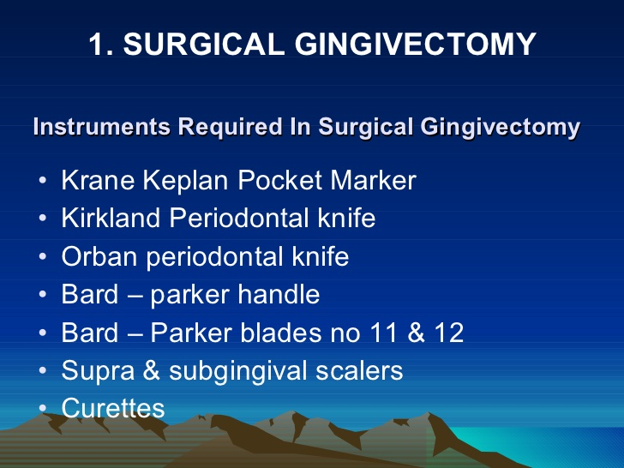

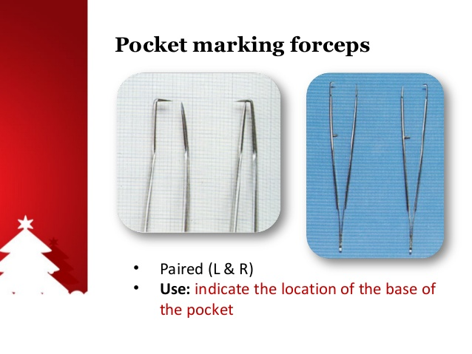

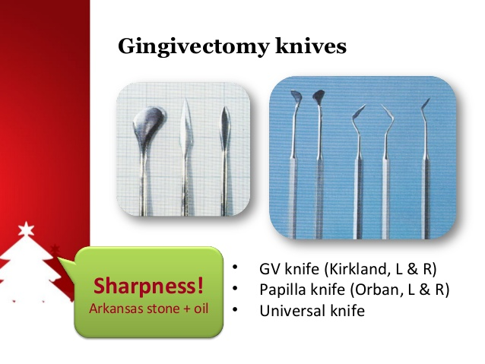

C:\Users\hppc\Desktop\New folder (11)\gingivectomy-10-638.jpg

**Goldman gingivectomy procedure**

**-giving local anesthesia**

**-marking the pocket depth: the straight arm of pocket depth marker forceps is guided into buccal pocket, when the base of pocket is encountered,the forceps is pinched together causing the horizontal forceps tip to mark depth of pocket, by repeating this procedure at each tooth surface ,a series of bleeding points is created, which are used subsequently as a guide for incision**.

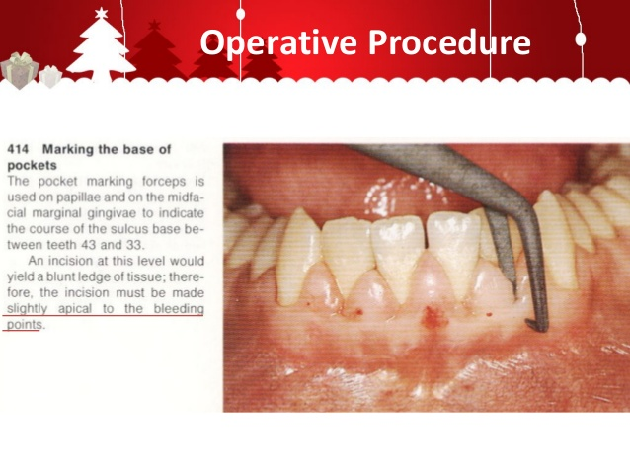

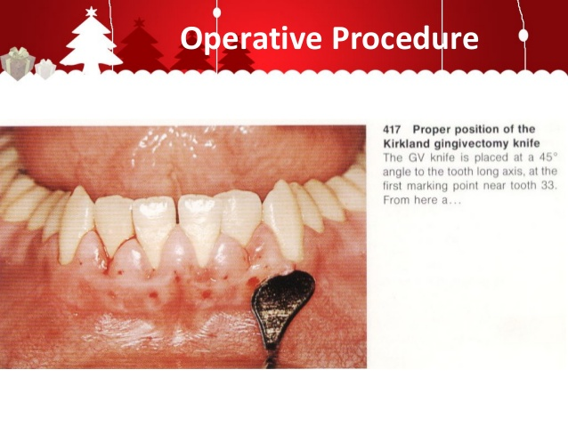

**Primary beveled incision which carried out 1 mm apical to bleeding points by Kirkland knife.**

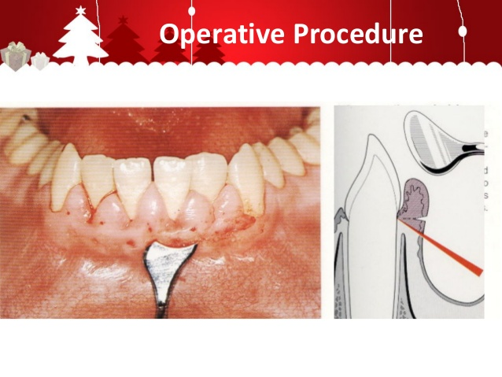

**Continuous incision or interrupted , straight or scalloped is made.**

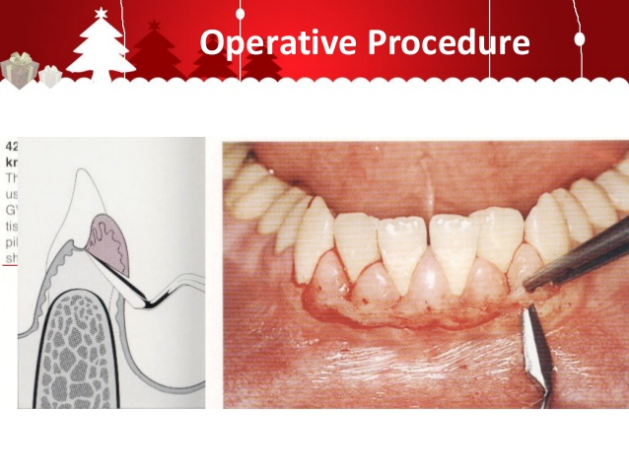

**Secondary incision to separate the interproximal soft tissues from the interdental periodontium by Orban knife.**

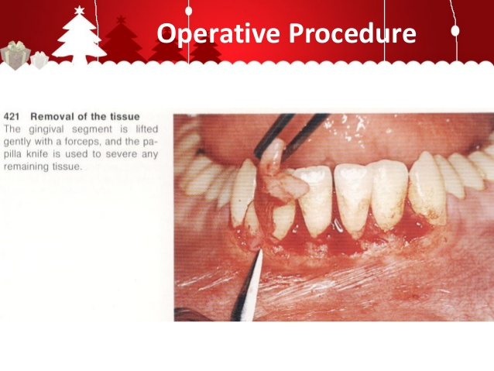

Careful removal of the incised tissues by a currete or a cumine.

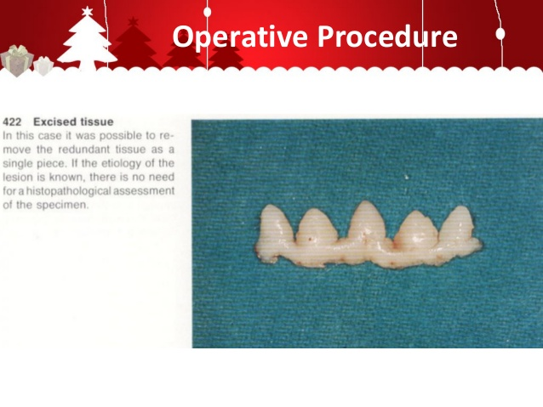

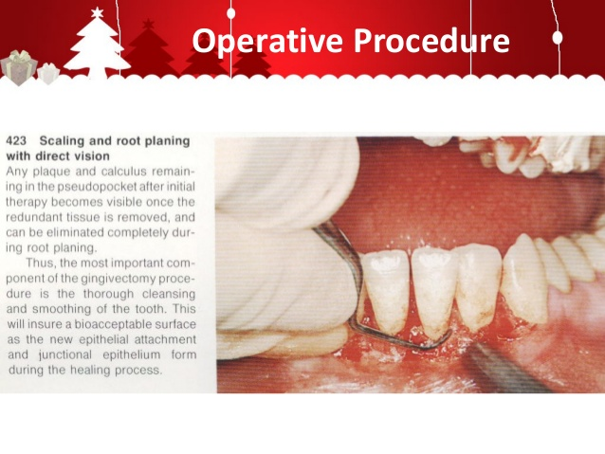By curette remove plaque, calculus and granulation tissues then smoothing teeth surfaces.

.

**Use Kirklaned knife for gingivoplasty(minor alterations in gingival morphology without tissue excision)by shaving wound margin to create thin margin.**

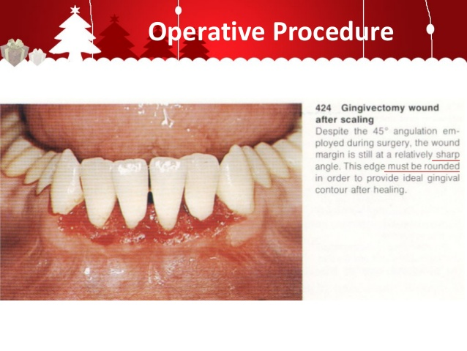

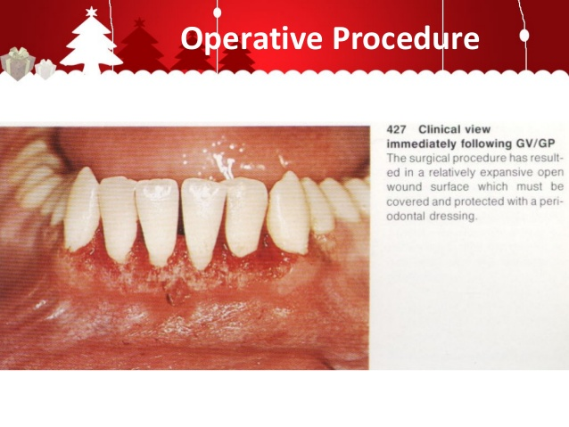**Control bleeding by placing gauze packs 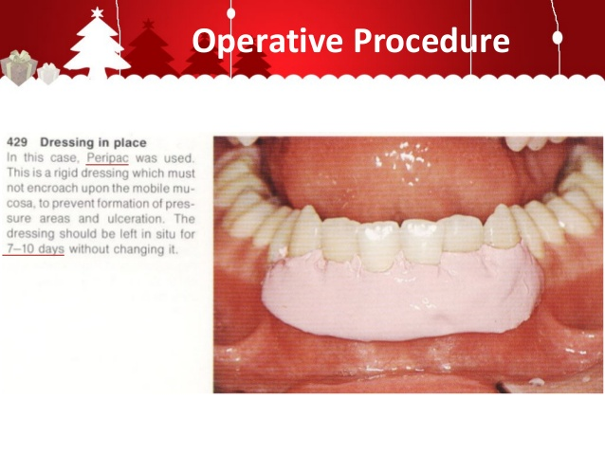Put dressing to cover the wound with pressure to prevent the bleeding with consequence formation of granulation tissue under dressing and**

**without interference with occlusion or mobile mucosa**

C:\Users\hppc\Desktop\New folder (11)\gingivectomy-40-638.jpg