Periodontics
Lec.6
Flap surgery
Indications
1-In treatment of infrabony pockets
2-When the gingivectomy will lead to an unacceptable aesthetic results
3-Osseous recontouring (elimination of bony defect)

The Modified Widman flap Advantages
1-good access to root surface to facilitate S+ RP as well as the removal of the pocket epithelium and the inflamed connective
tissue.
2-width of keratinized gingiva is maintained
3-replacement of the flap at presurgical location leads to less exposure of the root surfaces thus minimizes problem of
aesthetic (especially anteriorly) and root hypersensitivity.
4-cause minimal amount of trauma to the periodontal tissues and discomfort to the patient.
5-the possibility of obtaining a close adaptation of the soft tissues to the root surfaces.

6-provides better access to re-establish proper contour of the alveolar bone as well as the potential for bone regeneration in
sites s with angular bony defect.
7-furcation areas can be exposed.
Following flap procedures and the removal of plaque, calculus and chronically inflamed granulation tissue, healing occurs by the formation of a Long junctional epithelium, this lead to reduced probing depth but that epithelium is more
susceptible to plaque induced breakdown than the original connective tissue attachment and consequently post operative plaque control must be a very high standard, a new connective tissue
attachment may form following flap procedures, although this cannot be predicted with certainty.
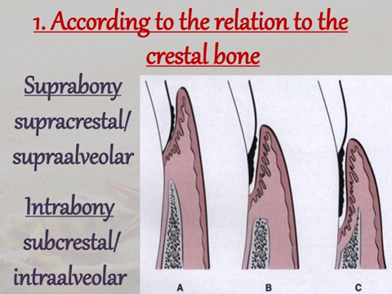
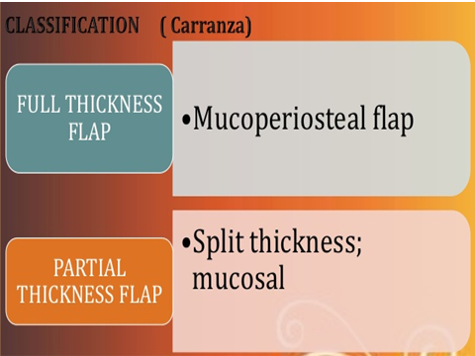
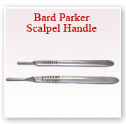
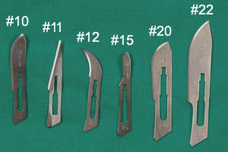
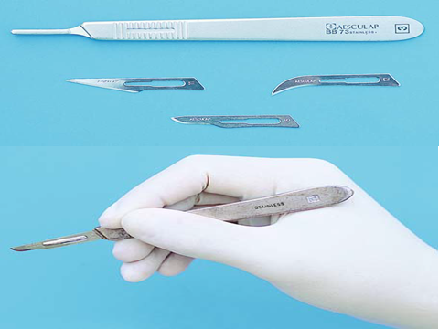
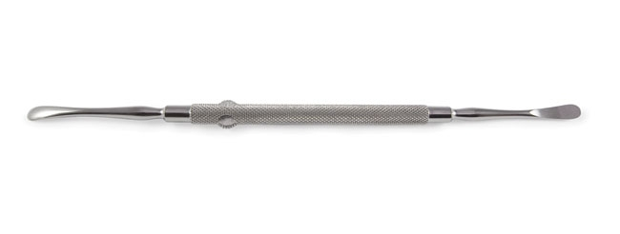
Periosteal elevator
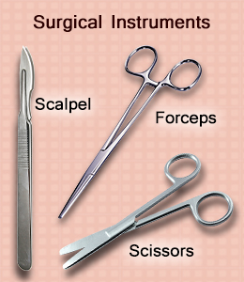
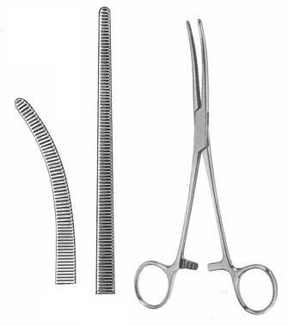
Hemostatic forceps, tissue forceps
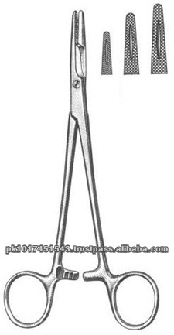
Needle holder
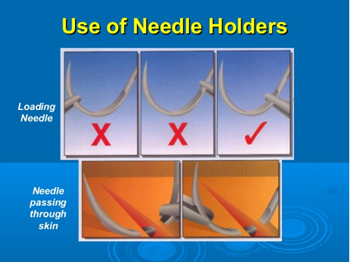

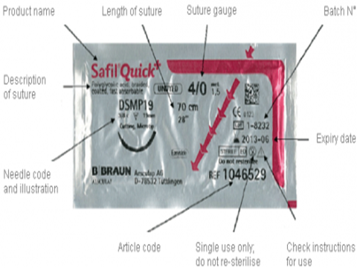
Suture
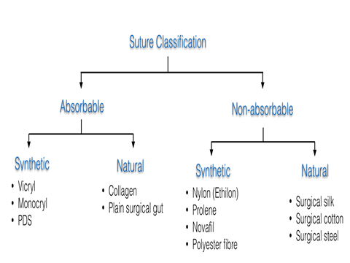

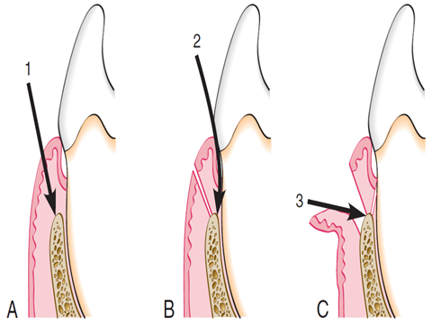
Three incisions of Modified widman flap
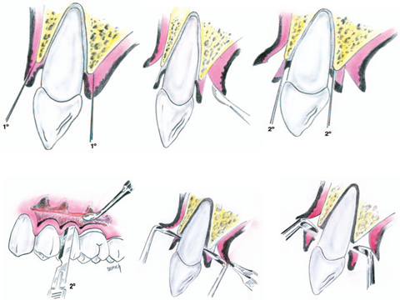
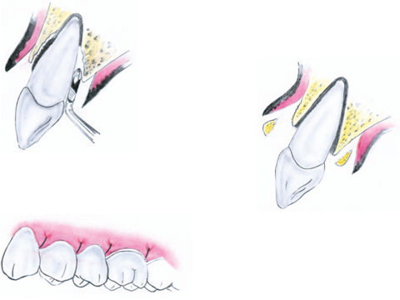
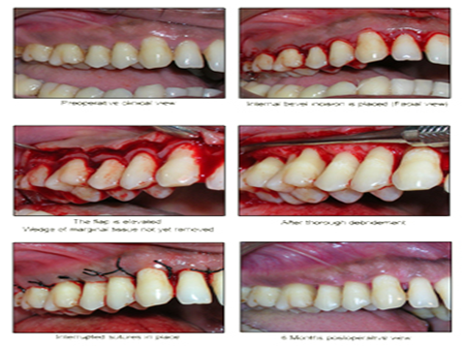

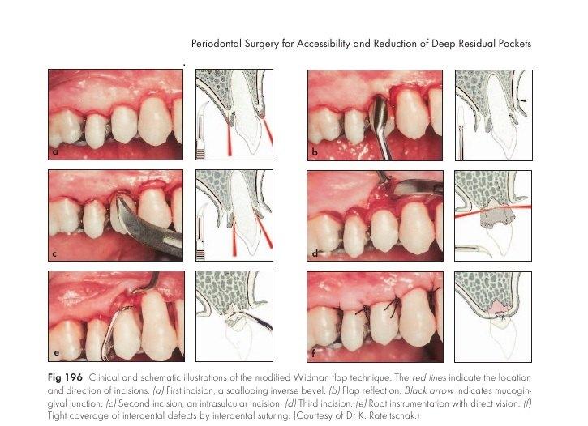

Modified widman flap ; reported in 1974 by Ramfjod and Nissle,it is a replaced flap.There are three incisions in this flap,it is usually conducted as following:
Primary incision:
a:First incision-scalloping
The scalloped incision is performed on both labial and palatal aspects,using the double-edge 12B scalpel.It is an inverse bevel incision extending to the alveolar crest.This incision thins the gingival tissue and permits complete closure of the interdental osseous defects postoperatively.The distance of the incision from the gingival margin may vary from 0.5 to 2mm.In this case,the incision rather far from the gingival margin in most cases,this incision is made much closer to the free gingival margin
Flap retraction:
b:Flap reflection
An elevator is used to raise a full thickness mucoperiosteal flap as atraumatically as possible.The flap is reflected only to permit direct visualization of the root surface and the alveolar crest.In most cases it is possible to stay within the boundaries of the attached gingiva,without extending beyond the mucogingival line.
Secondary incision:
C:Second incision-crevicular
This incision is carried around each tooth,between the hard tooth structure and the diseased pocket epithelium,to the depth of the junctional epithelium.The 12B scalpel is used.
Third incision:
d:Third incision-horizontal
The horizontal incision is carried along the alveolar crest thus separating the infiltrated tissue from healthy supporting connective tissue,specially in the interdental area.The incision also permits atraumatic removal of the diseased tissue.
Direct root planing:
e:Root planing with direct vision
Fine curettes are used to remove remnants of pocket epithelium and granulation tissue,calculas necrotic cementum to obtain smooth, hard, clean surface.Root planing is performed with repeated rinsing.Root planing is the most important part of both the modified Widman procedure and all other periodontal surgical procedures.
Suturing:
f:Complete coverage of interdental defects
The labial and palatal flaps are closed over the interdental areas without tension,using interrupted sutures.The flaps should be adapted to the underlying bond and the necks of the teeth.New papillae where created by the scalloped form of the initial incision.These make it possible to cover interdental defects(e.g.bony defects)even when the interdental space is wide.For this reason,placement of a periodontal dressing is not absolutely necessary.

