Periodontics
Lec.7
Mucogingival surgery
Periodontal treatment involving procedures for correction of defects in morphology,position and/or the amount of soft tissue (gingiva and alveolar mucosa) and underlying bone support at teeth and implants.
These procedures are varied from simple *gingivectomies or *crown lengthening procedures ( e.g. To increase the clinical crown length if there is a gummy smile with
a high lip line), to complex gingival grafting procedures. In patients with bone defects *GTR and *bone grafting (Guided bone regeneration, GBR) may also be employed to increase the bulk of available alveolar bone, grafting procedures generally aim Io cover exposed roots, to increase the bulk of the width of keratinized gingiva and to prevent further gingival recession.
Grafting procedures include
- Free gingival graft (epithelium + connective tissue)
- The pedicle sliding graft (Lateral repositioned graft)
- The sub epithelial connective tissue graft (connective tissue)
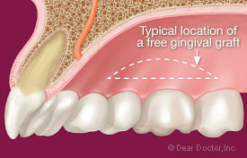
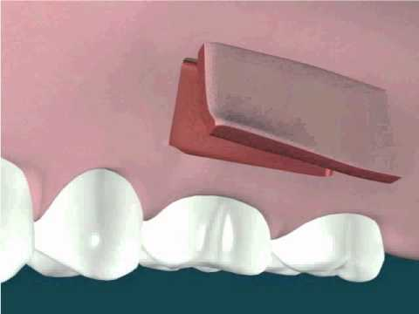

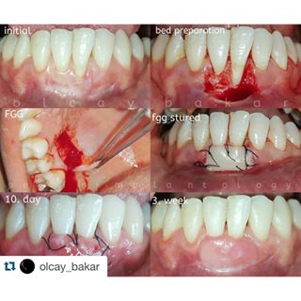Free gingival graft
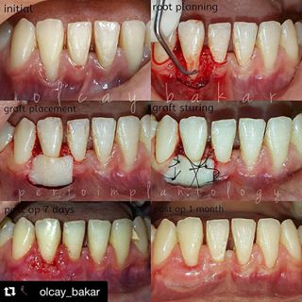
Free gingival graft
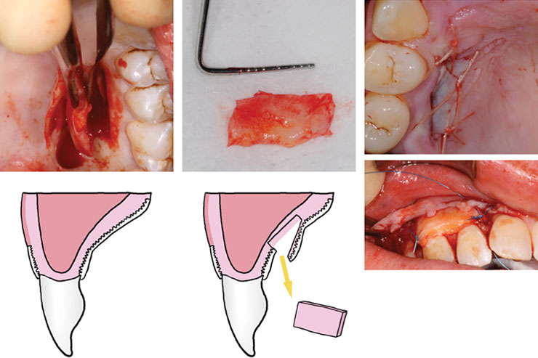Sub epithelial connective tissue graft
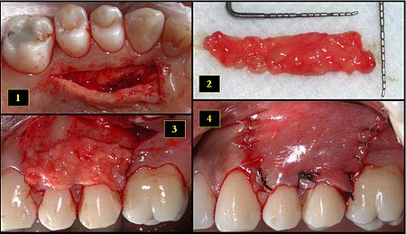
Sub epithelial connective tissue graft

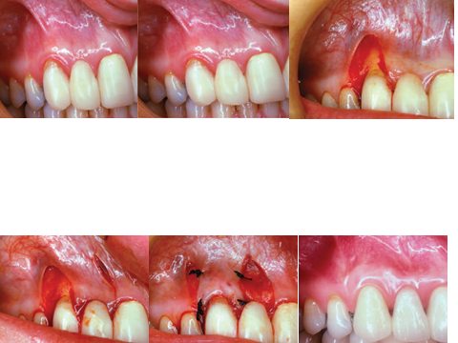
Lateral repositioned graft
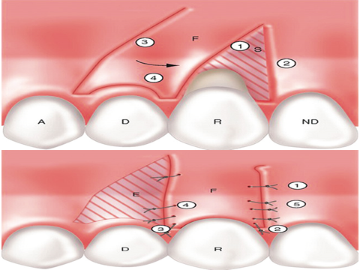
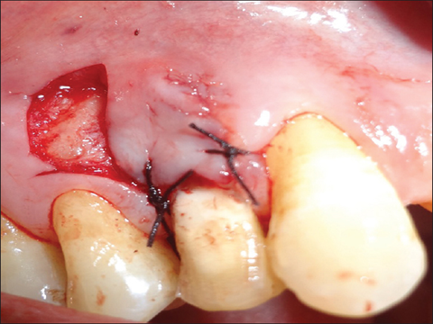
Lateral repositioned graft
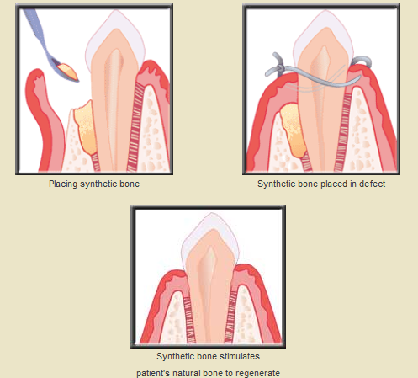
Bone graft (GBR)

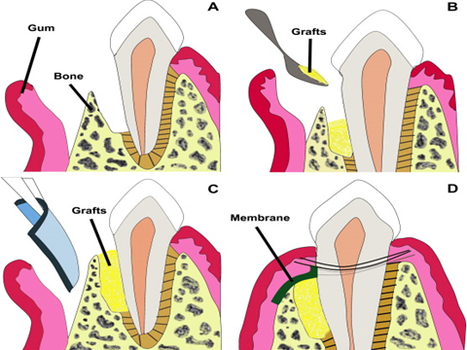
GTR + GBR graft

Guided tissue regeneration GTR
Following periodontal surgery, the instrumented root surface is colonized by gingival epithelial cells to form a long junctional epithelium which prevent the formation of new connective tissue attachment to the root surfaces, thus GTR is achieved by placing barrier membrane over periodontal defect to exclude gingival epithelium and connective tissues cells, and to create a space into which the proliferating cells from periodontal ligament and bone can migrate into healing area. These cells have the
capability to differentiate into fibroblast, cementoblast and osteoblast and thus can produce new periodontal ligament fibers, cementum and bone to regenerate the lost connective tissue attachment to the root surface. Membranes are either non-
resorbable which require removal 4-6 weeks after placement or resorbable which biodegrade within the tissue over 12 months
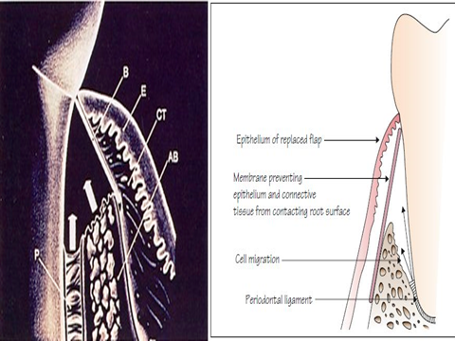
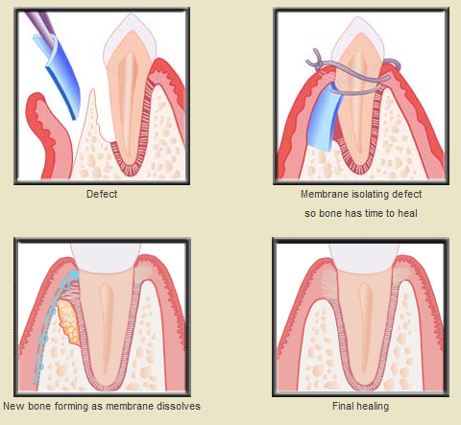
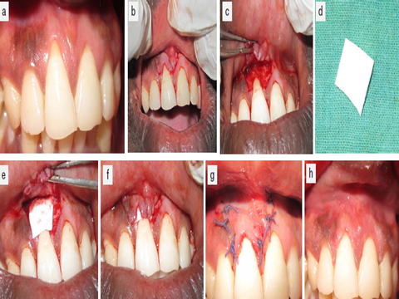

Crown lengthening
Indication
1-Short clinical crown require increased retention for placement of full coronal restoration (including cases of gross tooth wear requiring full mouth rehabilitation)
2-Deep subgingivally located crown preparation margins, resulting in difficulty finishing margins and taking impressions also encroachment on the biologic width
3-Sub gingival caries
4-Root fractures or root resorption in the cervical third of the tooth root
5-Aesthetic improvement of anterior teeth with short clinical crowns and high lip line
