Oral Histology
Lec.14 Dr. Nada AL-Ghaban
Oral mucosa-2
Masticatory mucosa:
General features of masticatory mucosa: Masticatory mucosa covers those areas of the oral cavity such as the hard palate and gingiva that are exposed to compressive and shear forces and to abrasion during the mastication of food. The dorsum of the tongue has the same functional role as other masticatory mucosa, but because of its specialized structure, it is considered separately.
The epithelium of masticatory mucosa is moderately thick and frequently is orthokeratinized, although normally parakeratinized areas of the gingiva and occasionally of the palate do occur. Both types of epithelial surface are inextensible and well adapted to withstanding abrasion. The junction
between epithelium and underlying lamina propria is convoluted, and the numerous elongated papillae probably provide good mechanical attachment and prevent the epithelium from being stripped off under shear force. The lamina
propria is thick, containing a dense network of collagen fibers in the form of large, closely packed bundles.
1-Hard palate:
In the hard palate there are grooves and ridges, all appeared to be adaptation to resist the force of mastication .The m.m. of the hard palate is fixed tightly to the underlying periosteum ,so its immovable and its color is pink.. The epith. is thick, firm and stratified squamous keratinized or parakeiratinized with numerous long papillae.
The lamina properia is thicker in the anterior than in the posterior parts of the hard palate. Various regions in the hard palate differ because of the varying structure of the submucous layer, so the following zones can be distinguished:
1-Gingival part: This part is adjacent to the teeth.
2-Palatin raphe: The median area of the hard palate, extends from incisive papilla posteriorly.
3- Anterolateral area: Between median palatin raphe and gingiva till the second premolar area (fatty sub mucosa).
4- Posterolateral area: Between gingiva and median palatin raphe posterior to second premolar area (glandular sub mucosa).
The first areas have mucoperiosteal junctions which mean that the lamina properia attached directly to the periosteum of underlying bone without submucosa , while the last two layers have distinct submucosa.
2-Gingiva or gum:
Thick (250 µm), either orthokeratinized or parakeratinized stratified
squamous epithelium with a stippled surface. It extends from dentinogingival junction to the alveolar mucosa. It subjected to the friction and pressure of mastication. Gingiva is divided clinicallyinto 3 parts which are free gingiva, attached gingiva and interdental papilla.
Free gingiva (marginal gingiva):
It’s the terminal border of gingiva surrounding the tooth in a collar-like fashion, demarcated from the adjacent attached gingiva by a depression called free gingival groove.
Attached gingiva:
Its firm, resilient and tightly bound to underlying periosteum of alveolar bone, it extends to alveolar mucosa from which its demarcated by mucogingival junction . Attached gingiva is characterized by a surface that appears stippled(i-e depretion and elevation which correspond to epith. ridges and connective tissue papillae) , they’re functional adaptation to mechanical impact. It’s a feature of healthy gingiva and its reduction or loss is common singe of gingival disease beside it varies with age and sex.
Interdental papillae: Its occupies the gingival embrasure (which is the interproximal space between two adjacent teeth). Its surface is triangular in 3 dimention.Gingiva appear slightly depressed between adjacent teeth corresponding to depression from vertical folds called intrerdental grooves. The color of the gingiva is pale pink but it becomes red in inflammation, sometimes its brown because of increase melanin pigmentation.
Lamina properia of the gingiva consist of dense c.t. dose not contain large vessels, small number of lymphocytes, plasma cells, macrophages are present in c.t. Collagen fibers arranged in strong bundles arise from the cervical area of cementum and from the outer surface of alveolar process (gingival groups of PDL).
Histologically we can exist three areas of epithelium which covers the gingiva. its thick stratified squamous epith. (keratinized) in 15% , (parakeratininized) in 75% and (nonkeratinized) in 10%.:
1-Oral or outer epith.: which covers the free and attached gingiva, its either keratinized or parakeratininized stratified squamous epith.. The epith. ridges are long , slender-like and numerous, lacks separating submucosa layer so its immovably attached to bone and teeth by coarse collagen fibers and has no glands.
2-Sulcular epith.: Its that epith. which lines the gingival sulcus, which is thin, nonkeratinized stratified squmous epith. without epith. ridges.
3-Junctional epith :which formed the dentino gingival junction and start from the bottom of gingival junction cervically and its non keratinized epith.
lining mucosa
1-Alveolar mucosa: Its red, shiny and covering the alveolar bone separating from attached gingiva by mucogingival junction. Its movable (loosely attached to periosteum by a loose well-defined sub mucosa contain minor salivary glands). The epith.is thin, stratified squamous non keratinized and the papillae are low and often entirely missing.
2-Soft palate
Non keratinized stratified squamous epith. ,Highly vascularized so more pink than hard palate. Submucosa contains minor salivary glands and muscles of soft palate.
3-Lip : Oral Mucosa of the lip covered by non keratinized stratified squamous epithelium .Minor salivary glands are present in the sub mucosa and fibers of orbicularis oris muscle are noted also.
MUCOCUTANEOUS JUNCTION(vermilionzone)
The skin, which contains hair follicles and sebaceous and sweat glands, is continuous with the oral mucosa at the lips .At the mucocutaneous junction is a
transitional region where appendages are absent except for a few sebaceous glands (situated mainly at the angles of the mouth). The epithelium of this region is keratinized but thin, with long connective tissue papillae containing capillary
loops. This arrangement brings the blood close to the surface and accounts for the strong red coloration in this region, called the red (or vermilion) zone of the lip. The line separating the vermilion zone from the hair-bearing skin of
the lip is called the vermilion border. In young people this border is demarcated sharply, but as a person is exposed to ultraviolet radiation, the border becomes diffuse and poorly defined.
Specialized mucosa: The mucosa of the dorsal surface of the tongue is unlike that anywhere else in the oral cavity because, although covered by what is functionally a masticatory mucosa, it is also a highly extensible lining and in addition has different types of lingual papillae. Some of them possess a mechanical function, whereas others bear taste buds and therefore have a sensory function.
The mucous membrane of the tongue is composed of two parts, with different embryologic origins and is divided by the V-shaped groove, the sulcus terminalis The anterior two thirds of the tongue, where the mucosa is derived from the first pharyngeal arch, often is called the body, and the posterior third, where the mucosa is derived from the third pharyngeal arch, the base. The mucosa covering the base of the tongue contains extensive nodules of lymphoid tissue, the lingual tonsils.
FUNGIFORM PAPILLAE
The anterior portion of the tongue bears the fungiform (funguslike) and filiform (hairlike) papillae .Single fungiform papillae are scattered between the numerous filiform papillae at the tip of the tongue. The fungiform papillae are smooth, round structures that appear red because of their highly vascular connective tissue core, visible through a thin, nonkeratinized covering epithelium. Taste buds normally
are present in the epithelium on the superior surface.
FILIFORM PAPILLAE
Filiform papillae cover the entire anterior part of the tongue and consist of cone-shaped structures, each with a core of connective tissue covered by a thick keratinized epithelium. Together they form a tough, abrasive surface that is involved in compressing and breaking food when the tongue is apposed to the hard palate. Thus the dorsal mucosa of the tongue functions as a masticatory
mucosa. Buildup of keratin results in elongation of the filiform papillae in some patients. The dorsum of the tongue then has a hairy appearance called hairy tongue.The tongue is highly extensible, with changes in its shape accommodated by the regions of nonkeratinized, flexible epithelium between the filiform papillae.
FOLIATE PAPILLAE
Foliate (leaflike) papillae sometimes are present on the lateral margins of the posterior part of the tongue, although they are seen more frequently in mammals other than human beings. These pink papillae consist of parallel ridges that
alternate with deep grooves in the mucosa, and a few taste buds are present in the epithelium of the lateral walls of the ridges.
CIRCUMVALLATE PAPILLAE
Adjacent and anterior to the sulcus terminalis are 8 to 12 circumvallate (walled) papillae, large structures each surrounded by a deep, circular groove into which open the ducts thick submucosa. Elastic fibers in the lamina propria of these
regions tend to restore the mucosa to its resting position after distention. By contrast, mucosa of the underside of the tongue is bound firmly to the underlying muscle. The soft palate is flexible but not highly mobile, and its mucosa is
separated from the loose and highly glandular submucosa by a layer of elastic fibers.
Salivary
Taste Buds : Unique sense organs that contain the chemical sense for taste.
Microscopically visible barrel-shaped bodies found in the oral epithelium.
Usually associated with papillae of the tongue (circumvallate, foliate and
fungiform). Also seen in epiglottis, larynx, and pharynx referred to as neuroepithelial structures. Each taste bud has 10 -14 cells. Majority are taste cells with elongated microvilli that project into the taste pore.
4 taste sensations: Sweet, salty, sour and bitter . Sweet and salt: anterior tongue, Sour: lateral tongue, Bitter: region of circumvallate papillae.

Age changes in oral mucosa
Clinically, the oral mucosa of an elderly person often has a smoother and dryer surface than that of a youngster and may be described as atrophic or friable, but these changes likely represent the cumulative effects of systemic disease, medication use, or both, rather than an intrinsic biologic aging process of the mucosa.
Histologically, the epithelium appears thinner, and a smoothing of the epithelium-connective tissue interface results from the flattening of epithelial ridges. The dorsum of the tongue may show a reduction in the number of filiform
papillae and a smooth or glossy appearance, such changes being exacerbated by any nutritional deficiency of iron or B complex vitamins. The reduced number of filiform papillae may make the fungiform papillae more prominent, and patients erroneously may consider it to be a disease state. Aging is associated with decreased rates of metabolic activity, but studies on epithelial proliferation and rate of tissue turnover in healthy tissue are inconclusive. Langerhans cells become fewer with age, which may contribute to a decline in cell-mediated immunity.
In the lamina propria a decreased cellularity occurs with an increased amount of collagen, which is reported to become more highly cross-linked. Sebaceous
glands (Fordyce’s spots) of the lips and cheeks also increase with age, and the minor salivary glands show considerable atrophy with fibrous replacement.

Hard palate Gingiva
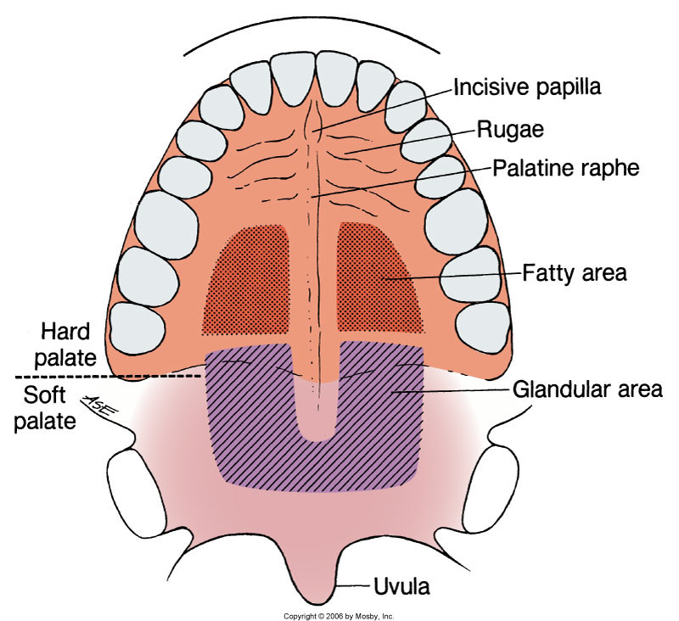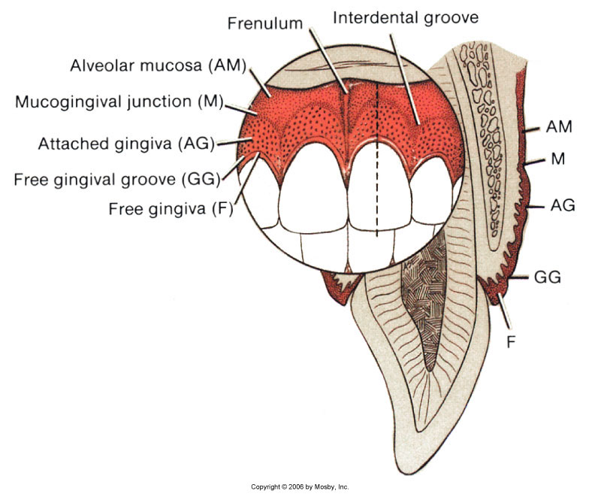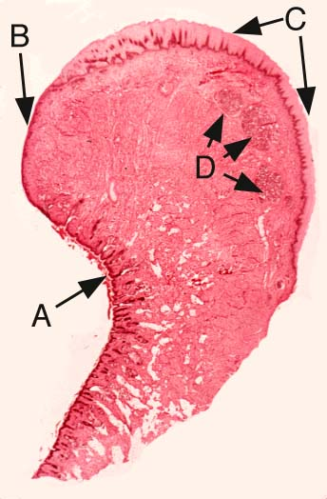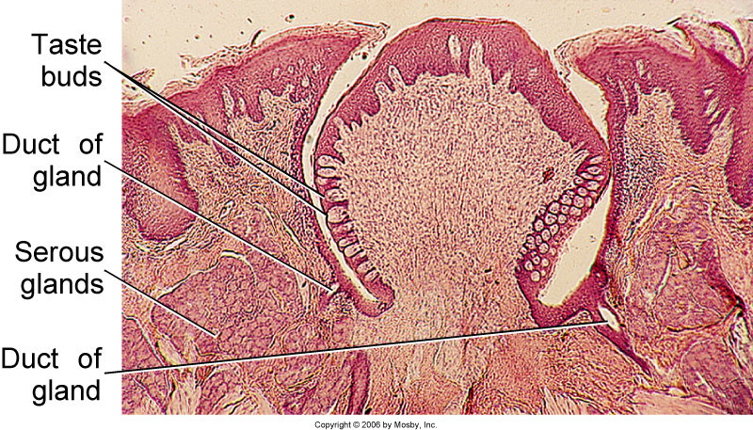
Lip Foliate papillae
A-skin part, B-Vermilion part
C-Mucous part, D-salivary gland

