Republic of Iraq
Ministry of High Education
and Scientific Research
University of Baghdad
College of Dentistry

Relationship of Fovea Palatinae to the Vibrating Line

A project submitted to College of Dentistry, University
of Baghdad in partial fulfillment of the requirement for a
B.D.S. degree
By:
Marwa Ghassan Abdulameer
Supervised by:
Assist. Lect. Dr.Zainab A. Azeez
B.D.S., M.Sc. Prosthodontics

2018 A.D. 1439 A.H

Acknowledgment
First, I would like to thank Allah who paved my way with his blessings and only by His will everything can be achieved.
Our deep appreciation to Prof. Dr. Hussain Al-Huwaizi, the dean of College of Dentistry /University of Baghdad.
I would like to express my thanks, deepest respect and sincere gratitude to Prof. Dr.Nidhal Hussain and Prof. Dr.Raghad Al- Hashimi , the dean assistants of College of Dentistry /University of Baghdad.
I would like to express my thanks, deepest respect and sincere gratitude to Prof. Dr. Raghdaa Kareem Jassim, Head of Department of Prosthodontics, and Asst. Lect. Dr. Mustafa Saadi Ali , for their unwavering support and mentorship throughout this project.
With grateful heart, I would like to thank my supervisor Asst. Lect. Dr. Zainab A. Azeez who help me during the course of my project. I cannot find enough word to express my thanks for all her support, attention and encouragement. I cannot say thank you enough for her tremendous teaching and motivation. I felt motivated and encouraged throughout the course of study. Without her advises and guidance, this project would not have materialized. I am grateful for her constant support and help.
Finally, I would like to thank my family for all support and encouraging me always during University study.

Abstract
Background: Retention is one of the prime factors for successful delivery of denture to the completely or partially edentulous patient .Fovea palatine and vibrating line my aid in determining for the posterior extension of complete denture.
Statement of problem: For the extent of maxillary denture to be decided, fovea palatine can be used as a guideline for the placement of posterior palatal seal. The posterior palatal seal contributes for the retention of the maxillary complete denture. However, reasons responsible for the lack of denture retention have diverted dentist’s interest in these anatomic landmarks.
Material and methods: A clinical examination was carried out on 140 patients with partially or completely edentulous maxillary arch, attending to the College of Dentistry, University of Baghdad. Each patient was examined for the number of fovea palatinae, and the location of fovea palatinae whether in anterior, at or posterior to the vibrating line and marked by an indelible pencil.
Result and discussion: From 140 patients, only 116 (82.86 %) have visible fovea palatinae ; between them 13(9.28 %) patients have one fovea palalinae, 101 (72.41%) of them have two fovea palatinae , and 2(1.42 %) of them have multible fovea palatinae. By using Chi-square test, there was a significant relation between number of fovea palatinae and gender (P=0.003 ),age (P=0.004) . Regarding to vibrating line 68.9% of patients had their fovea palatinae posterior to their vibrating line, 15.5 % had it anterior and 15.5% at their vibrating line .By using Chi-square test, there was no significant relation between position of fovea palatinae to vibrating line with gender( P=0.319 ) and age (P=0.977 ).
Conclusion: The study concluded that fovea palatinae is a reliable anatomical land mark that helps in determining the posterior palatal seal (post dam).
List of contents
Tital no. | Tital | Page no.
 | Acknowledgment | I
 | Abstract | II
 | List of contents | III
 | List of figures | V
 | List of tables | VI
 | Introduction | 1
 | Aims of the study | 2
Chapter One Review of Literature
1.1 | Retention | 3
1.1.1 | Definition | 3
1.1.2 | Factors of denture retention | 3
1.2 | Posterior palatal seal area | 4
1.2.1 | Definition | 4
1.2.2 | Functions of posterior palatal seal | 4
1.3 | Parameters of posterior palatal seal | 5
1.3.1 | Size | 5
1.3.2 | Location | 5
1.3.3 | Shape | 5
1.4 | Classification of soft palate | 7
1.5 | Vibrating line | 8
1.5.1 | Definition | 8
1.5.2 | Type of vibrating line | 8
1.5.2.A | Anterior vibrating line | 8
1.5.2.B | Posterior vibrating line | 9
1.6 | Limiting structure that use in determining the vibrating line | 9
1.6.1 | Fovea palatinae | 9
1.6.2 | Hamular notch | 9
1.7 | Locating of posterior palatal seal area | 10
1.8 | Location of vibrating line in relation to fovea palatinae | 10
Chapter Two Materials and Metho
2.1 | Materials and equipment | 11
2.2 | Sample criteria | 11
2.3 | Method | 12
Chapter Three Result
3.1 | Gender distribution of patients | 14
3.2 | Age distribution of patients | 14
3.3 | Gender distribution of patients in age groups | 15
3.4 | Relation between number of fovea palatinae with gender, and age groups. | 16
3.5 | Relationship between gender and age with position of fovea palatinae relation to vibrating line. | 19
Chapter Four Discussion
4.1 | Relation between number of fovea palatinae and gender | 22
4.2 | Relation between position of fovea palatinae to vibrating line and gender | 22
4-3 | Relation between position of fovea palatinae to vibrating line and age groups | 23
Chapter Five Conclusion
 | Conclusion | 24
References |  | 25

List of figures
Page no. | Tital | Figure no.
6 | Different shapes of posterior palatal seal | 1-1
7 | Class I soft palate. | 1-2
7 | Class II soft palate. | 1-3
8 | Class III soft palate. | 1-4
11 | Materials and equipment use during patient examination | 2-1
12 | Case sheet for taking information from people | 2-2
13 | Determine fovea palatinea by an indelible pencil | 2-3
13 | Determine vibrating line by an indelible pencil. | 2-4
16 | Gender distribution of the patients in age groups | 3-1
17 | Relation between number of fovea palatinae and gender. | 3-2
20 | Relation between number of fovea palatinae with gender, and age groups. | 3-3
20 | Relationship between gender and position of fovea palatinae relation to vibrating line. | 3-4

List of tables
Table no. | Tital | Page no.
3-1 | Gender distribution of patients | 14
3-2 | Age distribution of patients | 15
3-3 | Gender distribution of the patients in age groups | 15
3-4 | Relation between number of fovea palatinae with gender, and age groups | 18
3-5 | Relation between position of fovea palatinae to vibrating line with gender, and age groups | 21

Introduction
One of the problems in complete denture service is the provision of retentive dentures. In order to gain good retention of the maxillary complete denture an adequate seal must be obtained along the posterior border [ Akhtar et al. ,2017].
The vibrating line and fovea palatinae considered as the useful limiting structures of the posterior border of the denture [Pompa et al. , 2017].
For past 20 century many authors have evaluated techniques relating to the location of the posterior border of the maxillary denture in which the most easiest and practical methods is using the anatomical land marks fovea palatine and hamular notches. Fovea palatine position influence the extension of posterior border of the denture [Adiguzel,2008 ; Rahn et al. ,2009].
In our study we classified patients according to gender and age groups to find relation between fovea palatinae and vibrating line with age and gender. This study was based on phonation of the"ah" sound technique, for determining the vibrating line and the fovea palatinae. We started to collect data from Dec/2017 to March/2018.
Through this study we investigate the reliability of fovea palatinae for determining the posterior border of the maxillary denture and found relation between number and position of fovea palatinae to vibrating line with age, and gender.

Aims of the study
The present study was carried out to study the number of fovea palatinae, whether it had one, two, or multiple fovea palatinae and position of fovea palatinae in relation to vibrating line in an Iraqi patients whether it lie anterior, at, or posterior to vibrating line with gender and age differentiations.

Chapter One Review of Literature

1.1. Retention
1.1.1. Definition
Denture retention has been defined as resistance of a denture to vertical movement away from the tissues and as that quality inherent in the prosthesis acting to resist the forces of dislodgement along the path of insertion [GPT. , 2017].

1.1.2. Factors of denture retention
The retention in denture is dependent upon many factors:
1-The forces of adhesion
2-The forces of cohesion
3-Interfacial surface tension
4-Gravity
5-Intimate tissue contact
6-Peripheral (border seal)
7-Atmospheric pressure
8-Neuromuscular control [Chetan, 2010] .

Adhesion, and cohesion, viscosity of saliva and interfacial surface tension, although may have been recognized as forces that aid in retention of a denture, resist only those forces that act perpendicular to the denture base. But atmospheric pressure plays a role to counteract those lateral torque and tipping thrusts which tend to dislodge the denture. A partial vacuum is formed between the denture base and the supporting tissues that will resist lateral torque and therefore prevents displacement of the denture [ Powers et al.,2006; McCabe and Wells ,2008].
The border seal defined as the contact of the denture border with the underlying or adjacent tissues to prevent the passage of air or other substances. The peripheral borders of the denture are so formed to bring them into contact with adjacent oral tissues. This will establish an effective valve seal, which in turn will exclude the air from between the denture and the supporting mucosa [GPT. ,2017].
For maxillary arch the most important single factor on which retention depends is the border seal [Simrat , 2016].

1.2. Posterior palatal seal area
1.2.1. Definition
The soft tissue area limited posteriorly by the distal demarcation of the movable and nonmovable tissues of the soft palate and anteriorly by the junction of the hard and soft palates on which pressure, within physiologic limits, can be placed; this seal can be applied by a removable complete denture to aid in its retention [GPT. ,2017].

1.2.2. Functions of posterior palatal seal
(1) To provide retention.
(2) Prevents ingress of fluid, air, and food between denture and tissue.
(3) Diminishes gagging reflex.
(4) Provides embedded sunken distal border which is less conspicuous to tongue.
(5) Supplies a thick border to counteract denture warpage due to dimensional changes during the polymerization shrinkage of methyl methacrylate resin.
(6) Adds confidence and comfort to the patient by enhancing retention.
(7) Establishes a positive contact posteriorly, and therefore prevents the final impression material from sliding down into the pharynx [Behanoush and Petropoulous ,2003].

1.3. Parameters of posterior palatal seal
Posterior palatal seal has specific characteristics with different parameters, it is variable in its size, shape location, and depends on anatomical configuration of soft and hard palatal, their relationship, muscle coordination, and amount of tissue displaceability [Goyal et al. ,2014]. .
1.3.1.Size
The dimension of posterior palatal seal was 2 mm at the midpalatal region and hamular notch and 4 mm at the greatest curvature region of posterior palatal seal, But wide range of variation was also found [Goyal et al. ,2014]. .
1.3.2.Location
Location of posterior palatal seal is not consistent and show a lot of variation but on an average anterior vibrating line is 1.31 mm distal to fovea palatine [Goyal et al. ,2014].

1.3.3. Shape
There are five different shape of posterior palatal seal were commonly used[Figure1-1]:
a. Single bead scribed on the posterior vibrating line.
b. Double line scribed in the anterior and posterior vibrating line.
c. Butterfly shaped posterior palatal seal.
d. Butterfly shaped posterior palatal seal with notching of posterior vibrating line.
e. Butterfly shaped posterior palatal seal with notching of hamular notch.
f. Variations used with different shaped soft palate based on the classification:
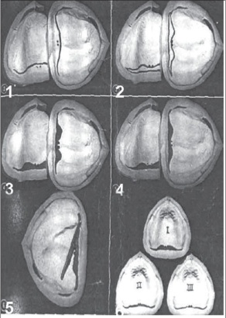
Class 1: A butterfly shaped posterior palatal seal with 3-4 mm wide.
Class 2: Posterior palatal seal is narrow with 2-3 mm of width.
Class 3: A single beading made on the posterior vibrating line [Lye, 1975].
Figure 1-1: Different shapes of posterior palatal seal [Lye, 1975].

1.4. Classification of soft palate
There are three classes of soft palate configuration that are commonly used. The House Classification (named after M. M. House) is also customarily used to designate the shape of the soft palate, and it describes the amount of posterior tissue that will be covered by the PPS (or in other words, the amount of posterior tissue that will accept the PPS).
Class I: the soft palate is horizontal, makes 10° angle with hard palate, more than 5 mm of movable tissues available for post damming. Ideal for retention and allow wide PPS.
Figure 1-2: Class I soft palate [Goyal et al., 2014].

Class II: soft palatal contour lies somewhere between class I and class III classes, makes 45° angle with hard palate, 1- 5mm of movable tissues available for post-damming. Good retention is usually possible.
Figure 1-3: Class II soft palate [Goyal et al., 2014].
Class III: the soft palate is more acute in relation to the hard palate, makes 70° angle with it, Less than 1 mm of movable tissue available for post-damming. Retention is usually poor. Usually seen in conjunction with a high V-shaped palatal vault .
Figure 1-4: class III soft palate [Goyal et al., 2014].

1.5. Vibrating line
1.5.1. Definition
Imaginary line across the posterior part of the soft palate marking the division between the movable and immovable tissues; this line can be identified when the movable tissues are functioning [GPT. ,2017].
1.5.2. Type of the vibrating line
There are two vibrating lines anterior and posterior vibrating lines, in which PPS area lies between them [Goyal et al., 2014].

1.5.2.A. Anterior vibrating line
The anterior vibrating line demarcates the zone of transition between no movement of the tissues overlying the hard palate and some movement of the tissues of the soft palate [Goyal et al., 2014].
The anterior vibrating line can be visualized by asking the patient to say 'ah' in short vigorous bursts or by asking the patient to perform the Valsalva maneuver [Goyal et al., 2014].

1.5.2.B. Posterior vibrating line
The posterior vibrating line lies in the area of the junction of the aponeurotic portion of the soft palate and the muscular portion of the soft palate [Goyal et al. ,2014].
The posterior vibrating line can be visualized by instructing the patient to say 'ah' in a normal unexaggerated fashion [Goyal et al. ,2014].

1.6.Limiting structure that use in determining the vibrating line
1.6.1. Fovea palatinae
Two small pits or depressions in the posterior aspect of the palatal mucosa, one on each side of the midline, near the attachment of the soft palate to the hard palate [GPT.,2017].
Fovea palatine position also influence the extension of posterior border of the denture [Adiguzel et al. , 2008].
In some patients with thick saliva, fovea palatine should be left uncovered as it causes denture displacement due to increase hydrostatic pressure. In other cases, denture may extent across 1-2mm [Goyal et al. ,2014]

1.6.2. Hamular notch
It is a narrow cleft of loose connective tissue which is approximately 2mm in extent anteroposteriorly. Located by using T-burnisher Constitutes the lateral boundary of posterior palatine seal area in maxillary foundation [Navad, 1994].

The notch or fissure formed at the junction of the maxilla and the hamular process of the sphenoid bone, just beyond the distal end of the alveolar process [Liao et al. ,2018] .
1.7. Locating of posterior palatal seal area .
Locating posterior palatal seal region as tissues of this area are displaceable, the seal area can be identified when the movable tissues are functioning, methods that can be employed are as follows:
1. Palpation method using a "T" burnisher , The palpatory method locates the junction of hard and soft palate.
2. Nose blow method or valsalva maneuver-closing both nostrils of the patient and asking him to blow gently through the nose. This method distinguishes the movable and immovable portion of the soft palate.
3. Phonation method-visualizing the vibrating lines as the patient says 'ah'.
4. Anatomical landmark-using fovea palatinae to identify vibrating area [Vernie et al. ,2008].

1.8. Location of vibrating line in relation to fovea palatinae

Many study related this subject, one of them that take 200 patients found that only 110 had fovea palatinae and from them 50.9% had their vibrating line laying directly on the fovea palatinae and 44.5% had their fovea palatinae posterior to their vibrating line and 6.4% had fovea palatinae laying anterior to their vibrating line [ Alousi , 2009].
Other study found that take 150 patients found that fovea palatinae was present in about 109 (73%) of the study sample only. In the remaining 41 (27%) of the subjects, the presence of fovea palatinae could not be confirmed by the investigators. From 109 about 44.9% of the sample had their vibrating line at level with the position of the fovea palatinae , and more than 43.1% patients exhibited vibrating line laying posterior to the fovea palatinae, and only 11.9% subjects had their vibrating line located anterior to the fovea palatinae [Akarar et al. , 2017].

Chapter Two Materials and Method

2.1. Materials and equipment
Here some of the materials use during this research:
- An indelible pencil
- Alcohol
- Cotton
- Digital camera
- Gloves
- Mask
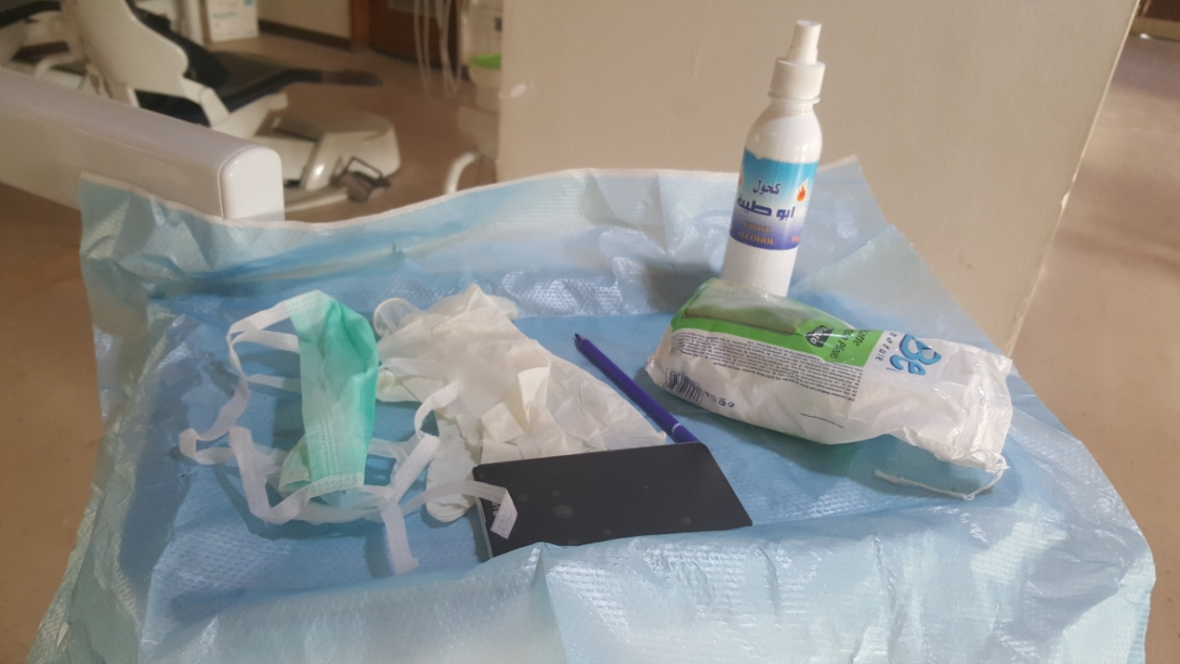
.
Figure 2-1: Materials and equipment use during patient examination

2.2. Sample criteria
Patients with completely or partially edentulous maxillary arch, were randomly selected from patients in the College of Dentistry University of Baghdad University, with of age groups ranging from (25-84) years from both male and female. We started collected informations from December/2017 to March/2018.

2.3. Method
In dental clinic 140 patients were examine clinically to their palate by ask the patient to sit on the dental chair in rest position , and after take the informations about name ,age ,and gender according case sheet in figure 2-2. Palate of each patient was examine for evidence of pathological change, for visibility of fovea palatinae plus vibrating line.
By asking the patient to open mouth and after drying the area with cotton, fovea palatinae were marked by using an indelible pencil, then photo were taken as shown in Figure 2-3.
Vibrating line were marked by using an indelible pencil by asking the patient to open wide and pronounce "ah" sound repetitively and then take photo as shown in Figure 2-4.
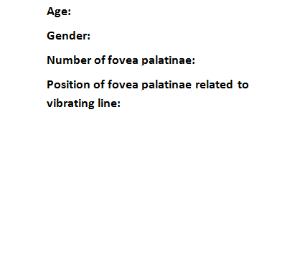
Figure 2-2: Case sheet for taking information from people.
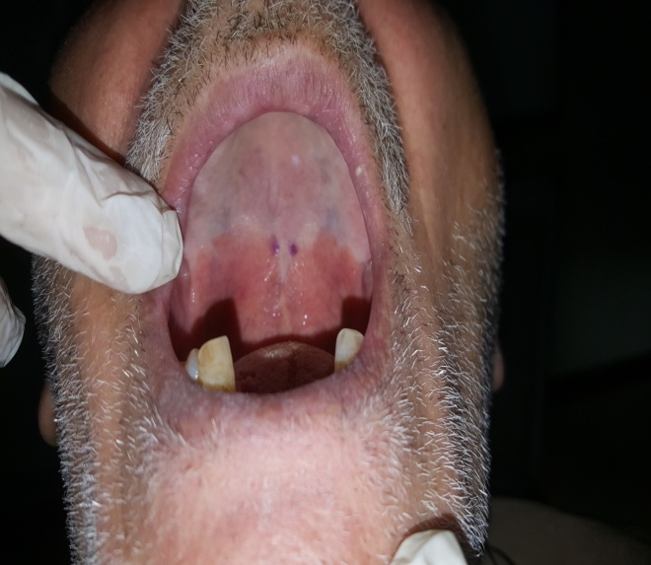
Figure 2-3: Determine fovea palatinae by an indelible pencil
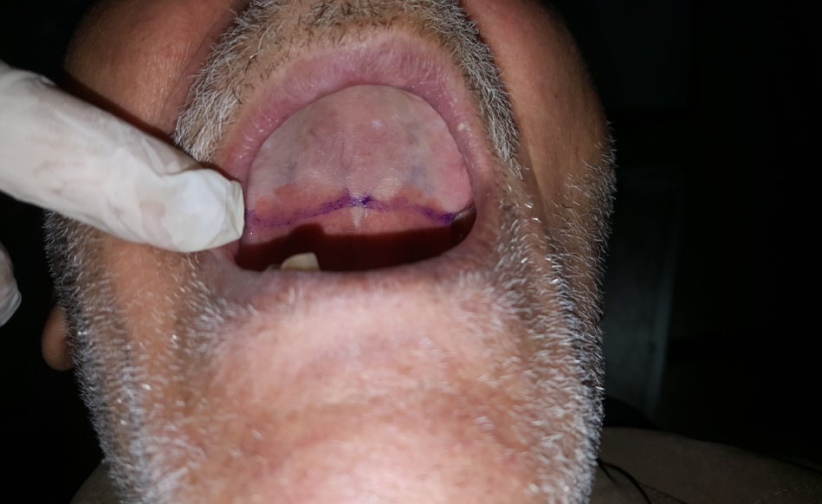

Figure 2-4: Determine vibrating line by an indelible pencil.

Chapter Three Result

Statistical analyses were performed using SPSS statistical program. Data are presented as mean ± SD for quantitative variables and as number and percentage for qualitative variables.
Chi-square test was used for qualitative variables.
P value of <0.05 was considered statistically significant.

3.1. Gender distribution of the patients
From 140 patients we have 70 male (50%) and 70 female (50%), with a male to female ratio is 1:1 as shown in table 3-1.

Table 3-1: Gender distribution of the patients

Gender |  | Frequency | Percent %
 | Male | 70 | 50.0%
 | Female | 70 | 50.0%
 | Total | 140 | 100.0%

3.2. Age distribution of the patients
A total of 140 patients were included in the present study. As shown data from table 3-2 indicated that the number and percentage of patients with age groups (55-64 and 65-74) years were higher [37 (26.4%) and 33 (23.6 %)], respectively, than other age group (25-34) years was [29(20.7%)], (45-54) years was [19(13.6%)], (35-44) years was [15(10.7%)], and (75-84) years was [7(5%)].

Table 3-2: Age distribution of the patients

Age |  | Frequency | Percent%
 | 25-34 year | 29 | 20.7%
 | 35-44 year | 15 | 10.7%
 | 45-54 year | 19 | 13.6%
 | 55-64 year | 37 | 26.4%
 | 65-74 year | 33 | 23.6%
 | 75-84 year | 7 | 5.0%
 | Total | 140 | 100.0%

3.3. Gender distribution of the patients in age groups
By using Chi-square test as shown in table 3-3 and figure 3-1, there was a significant relation between age and gender (females are predominant in young age groups while males are predominant in older age groups).

Table 3-3: Gender distribution of the patients in age groups .
 | Age |  | Gender
 |  |  | Male |  | Female
 |  |  | Count | % | Count | %
 |  | 25-34 year | 1 | 3.4% | 28 | 96.6%
 |  | 35-44 year | 3 | 20.0% | 12 | 80.0%
 |  | 45-54 year | 9 | 47.4% | 10 | 52.6%
 |  | 55-64 year | 24 | 64.9% | 13 | 35.1%
 |  | 65-74 year | 28 | 84.8% | 5 | 15.2%
 |  | 75-84 year | 5 | 71.4% | 2 | 28.6%

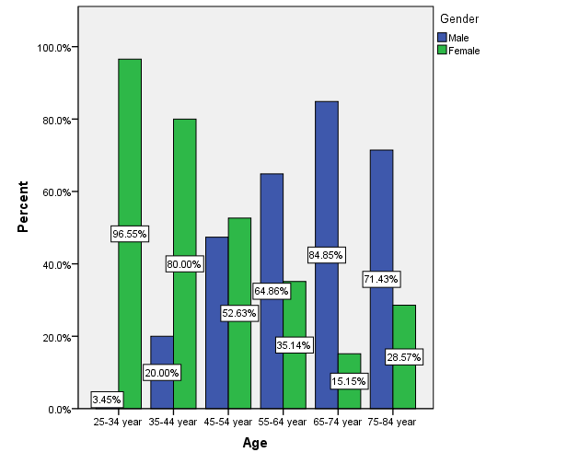
Figure 3-1: Gender distribution of the patients in age groups.

3.4. Relation between number of fovea palatinae with gender, and age groups.
From the 140 subjects screened 116 showed the presence of fovea palatinae of the palate as shown in table 3-4 and figure 3-2, 3-3. No fovea palatinae were found in 24 subjects [10(14.3%)] male and [14 (20.0%)] female. Fifteen subjects [2(2.9%)] male and [13 (18.6%)] female had one fovea palatine located on one side of the palate. Ninety nine subjects [58(182.9%)] male and [41 (58.6%)] female had two fovea palatinae present. Two subjects from female (2.9%) only had multiple fovea palatinae.
Relationship between age of patients and number of as we shown in table 3-4 , which observed in age group between (25-34) years that fovea palatinae not present in 6 persons (20.7 % ), in 10 persons (34.5%) had one fovea palatine, in 12 persons (41.4 %) had two fovea palatinae, and in 1 person (3.4 %) had multiple fovea palatinae .
Between (35-44) years fovea palatinae not present in 5 persons (33.3 % ), and in 10 persons (66.7 %) had two fovea palatinae.
Between (45-54) years fovea palatinae not present in 2persons (10.5 % ), in 1 person (5.3%) had one fovea palatine, in 15 persons (78.9 %) had two fovea palatinae, and in 1 person (5.3 %) had multiple fovea palatinae.
Between (54-64) years fovea palatinae not present in 6 persons (16.2 % ), in 3 persons (8.1%) had one fovea palatine, and in 28 persons (75.7 %) had two fovea palatinae.
Between (65-74) years fovea palatinae not present in 5 persons (15.2 % ), in 1 person (3.0%) had one fovea palatine, and in 27 persons (81.8 %) had two fovea palatinae.
Between (75-84) years in 7 persons (100.0 %) had two fovea palatinae.
By using Chi-square test, there was a highly significant relation between number of fovea palatinae with gender (P<0.01, P= 0.003), and age groups (P<0.01, P= 0.004).

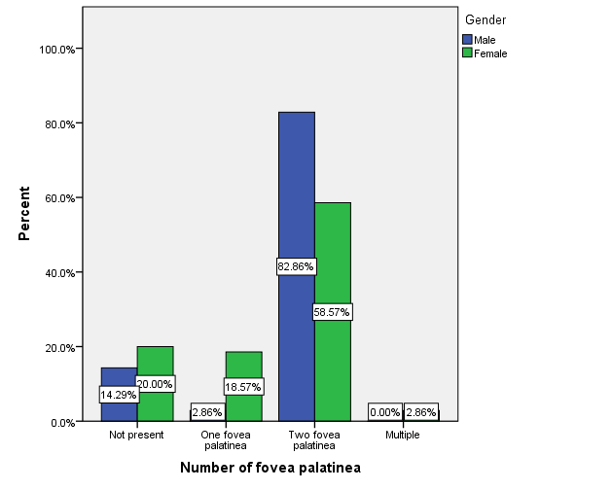
Figure 3-2: Relation between number of fovea palatinae and gender.
Table 3-4: Relation between number of fovea palatinae with gender, and age groups.

 |  | Number of fovea palatinea
 |  | Not present |  | One fovea palatinea |  | Two fovea palatinea |  | Multiple fovea palatinea
 |  | Count | % | Count | % | Count | % | Count | %
Gender | Male | 10 | 14.3% | 2 | 2.9% | 58 | 82.9% | 0 | 0.0%
 | Female | 14 | 20.0% | 13 | 18.6% | 41 | 58.6% | 2 | 2.9%
Age | 25-34 | 6 | 20.7% | 10 | 34.5% | 12 | 41.4% | 1 | 3.4%
 | 35-44 | 5 | 33.3% | 0 | 0.0% | 10 | 66.7% | 0 | 0.0%
 | 45-54 | 2 | 10.5% | 1 | 5.3% | 15 | 78.9% | 1 | 5.3%
 | 55-64 | 6 | 16.2% | 3 | 8.1% | 28 | 75.7% | 0 | 0.0%
 | 65-74 | 5 | 15.2% | 1 | 3.0% | 27 | 81.8% | 0 | 0.0%
 | 75-84 | 0 | 0.0% | 0 | 0.0% | 7 | 100.0% | 0 | 0.0%
*p= 0.004 HS for age.
*p = 0.003 HS for gender.
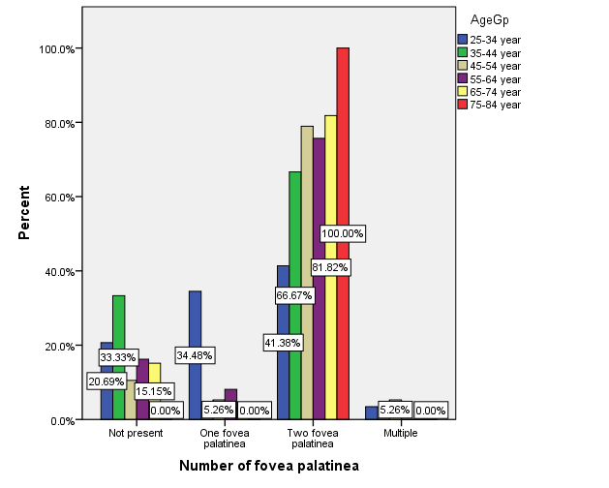
Figure 3-3: Relation between number of fovea palatinae with gender, and age groups.

3.5. Relationship between gender and age with position of fovea palatinae relation to vibrating line.
From our result as shown in table 3-5 and figure 3-4 , we found that majority of subject (38 male 63.33% and 42 female 75.5%) had fovea palatinae laying posteriorly to vibrating line , while located anteriorly to vibrating line about (12 ,20%) in male and (6 ,10.71%) in female, and located at level to vibrating line about (10 ,16.67%) in male and (8 ,14.29%) in female .
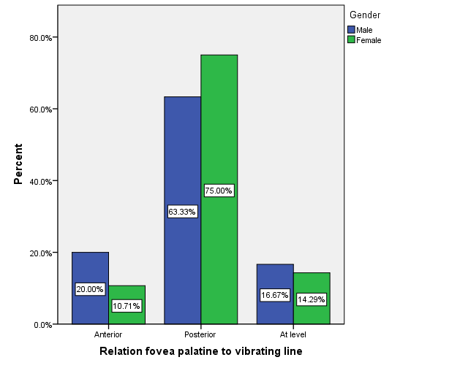
Figure 3-4: Relationship between gender and position of fovea palatinae relation to vibrating line.

Relationship between age of patients and position of fovea palatinae as shown in table 3-5 , which observed that fovea palatinae in age group between (25-34) years lie anteriorly in 3 persons (13 % ), posteriorly in 17persons (73.9%), and at level in 3 persons (13 %).
Between (35-44) years lie anteriorly in 1 person (10% ), posteriorly in 7 persons (70 %), and at level in 2persons (20 %).
Between (45-54) years lie anteriorly in 2 persons (11.8%) ,posteriorly in 12 persons (70.6 %), and at level in 3 persons (17.6%).
Between (54-64) years lie anteriorly in 5 persons (16.1%) ,posteriorly in 20 persons (64.5 %), and at level in 7 persons (19.4%).
Between (65-74) years lie anteriorly in 5 persons (17.9%) ,posteriorly in 19 persons (67.9 %), and at level in 4 persons (14.3%).
Between (75-84) years lie anteriorly in 2 persons (28.6%) ,posteriorly in 5 persons (71.4 %), and no person had fovea palatinae lie at level to vibrating line.

Table 3-5: Relation between position of fovea palatinae to vibrating line with gender, and age groups.

 |  |  | Relation fovea palatine to vibrating line
 |  |  | Anterior |  | Posterior |  | At level
 |  |  | Count | % | Count | % | Count | %
Gender | Male |  | 12 | 20.0% | 38 | 63.3% | 10 | 16.7%
 | Female |  | 6 | 10.7% | 42 | 75.0% | 8 | 14.3%
Age | 25-34 |  | 3 | 13.0% | 17 | 73.9% | 3 | 13.0%
 | 35-44 |  | 1 | 10.0% | 7 | 70.0% | 2 | 20.0%
 | 45-54 |  | 2 | 11.8% | 12 | 70.6% | 3 | 17.6%
 | 55-64 |  | 5 | 16.1% | 20 | 64.5% | 6 | 19.4%
 | 65-74 |  | 5 | 17.9% | 19 | 67.9% | 4 | 14.3%
 | 75-84 |  | 2 | 28.6% | 5 | 71.4% | 0 | 0.0%
*p= 0.319 NS for gender.
*p= 0.977 NS for age.

By using Chi-square test, there was no significant relation between position of fovea palatinae to vibrating line with gender (p= 0.319), and age(p= 0.977 )groups.

Chapter Four
Discussion

4.1. Relation between number of fovea palatinae and gender.
The results in table 3-3 showed that from 140 of the examined patients 116 patients had fovea palatinae and 24 patients had no fovea palatinae. The absent of fovea palatinae in the examined patients was also reported by Alousi in 2009 who stated that fovea palatinae not found in 90 patients from 200 study patients, also Nageen in 2017 found that the fovea palatinae absent in 41(about 27%) from 150 study sample .
The other 116 patients showed wide range of variation on number of fovea palatinae along with gender majority of male 96.66% that had two fovea palatinae , about 3.33% had one fovea palatinae and no one of them had multiple fovea palatinae. While in female that had two fovea palatinae about 73.21%, about 23.21% had one fovea palatinae and 3.57% of them had multiple fovea palatinae. This could be due to gender differentiation .

4.2. Relation between position of fovea palatinae to vibrating line and gender.
The result shown in table 3-5 about 63.33% of male and 75% of female that had fovea palatinae posterior to vibrating line ,which differed from the results of Alousi in 2009 that found 44.7% of male and 44.1% from female had fovea palatinae posterior to vibrating line without gender prevalence.
The percentage of male that had fovea palatinae at level to vibrating line about 16.67% and 14.29 % in female , while Alousi in 2009 that found 47.4% of male and 52.9% from female had fovea palatinae at level to vibrating line.
The percentage of male that had fovea palatinae anteriorly to vibrating line about 20% and 10.71 % in female , while Alousi in 2009 stated that 7.9% of male and 2.9% from female had fovea palatinae anteriorly to vibrating line , the different due to different in sample size and population.
The result from Chi-square test, there was no significant relation between position of fovea palatinae to vibrating line and gender (P=0.319) this could be due to the gender had no impact on this anatomical landmark.

4.3. Relation between position of fovea palatinae to vibrating line and age groups.
As shown in table 3-5 majority of the young patients in age groups between (25-34)and ( 35-44) years had fovea palatinae located posteriorly to vibrating line in about (73.9%, and 70%) respectively. The second highest percentage for this age groups was fovea palatinae located at level of vibrating line (13%, 20%) respectively.
Majority of the middle age patients in age groups between (45-54)and(55-64) years in about had fovea palatinae located posteriorly to vibrating line in about (70.6%, 64.5%) respectively. The second highest percentage for this age groups was fovea palatinae located at level of vibrating line (17.6%, 19.4%) respectively.
Majority of the old patients in age groups between (65-74) years had fovea palatinae located posteriorly to vibrating line in about (67.9%, 71.4%) respectively. The second highest percentage for this age groups was fovea palatinae located anteriorly to vibrating line (17.9%, 28.6%) respectively.these results indicate that there was no impact of age on the relation between fovea palatinae and vibrating line. .

Chapter Five
Conclusion

Conclusion
- Within the limitations of the present study, it can be concluded that foveae palatinae occupy a variable in number according to age and gender. As we shown there is highly significant relation between the number of fovea palatinae with age and gender .They may be one, two, or multible in number.
- Foveae palatinae occupy a highly variable relation with the vibrating line according to age and gender. As we shown there is no significant relation between the position of fovea palatinae to vibrating line with age and gender. If present they may be located either at, posterior to or anterior to the vibrating line. Hence, foveae palatinae cannot be considered a very reliable landmark for determining the position of the vibrating line in order to judge the posterior extent of the maxillary complete dentures.

References

References
A
- Adiguzel O, Sadullah KA, Yavuz I, Atakul F ,(2008) :”Oral Findings of Ectodermal Dysplasia and Literature Review”, Journal Of International Dental And Medical Research, 1(1);43-9.

- Akhtar N, Tanveer S, Chaudhary MA, Ahmad S,( 2017):” The reliability of foveae palatinae in determining the location of vibrating line in edentulous patients”,Pakistan Oral & Dental Journal ,37(2);368-70.

- Avant WE,( 1973):” A comparison of the retention of complete denlure base having different type of posterior palatal seal”, J Pristhe Dent ,29;484-93.

- Alousi Y.( 2009):” Reliability of fovea palatinea in determining the posterior palatal seal”, Journal of Baghdad College of Dentistry , 21(1);41-55.

B
- Behanoush Rashedi, petropoulous Vicki C,( 2003) :“Current concepts for determine postpalatal seal in compelet denture”, J. prosthodont , 12(4);265-70.

C
- Chetan, ( 2010) :“Objectives of Impression making in complete denture”, J Prosthet Dent,43;133-7 .

G
- Goyal S, Goyal MK, Balkrishanan D, Hegde V, Narayana AI,( 2014):” The posterior palatal seal: Its rationale and importance: An overview”, European Journal of Prosthodontics ,2(2);41.47.

- "glossary of prosthodontic terms”, 9 ^{th} ed . (2017),J Prosthet Dent , 5S, 117;77.

- “glossary of prosthodontic terms”, 9 ^{th} ed . (2017) ,J Prosthet Dent , 5S, 117;70.

- “glossary of prosthodontic terms”, 9 ^{th} ed . (2017),J Prosthet Dent , 5S, 117;17.

- “glossary of prosthodontic terms”, 9 ^{th} ed . (2017),J Prosthet Dent , 5S, 117;90.

- “glossary of prosthodontic terms”, 9 ^{th} ed (2017).,J Prosthet Dent , 5S, 117;41.

H
- Hardy IR, Kapoor KK,( 1987):” Improved adhesion of denture acrylic resin to base metal alloys”. J Prosthet Dent , 57;520-4 .

J
- Jacobson, T. E. and Krol A. J,( 1983): “A contemporary view of the factors involved in complete denture .retention, stability, and support.Part I: Retention”, J Prosthet Dent ,49;5-15.

K
- Kumar B, Naz A, Rashid H, Butt AM,( 2016):” Location of the Vibrating Line with Respect to Fovea Palatini in Class I, Class II and Class III Soft Palate Types”, JPDA , 25(02);60-66.

L
- Lye TL,( 1975):” The significance of the fovea palatini in complete denture prosthodontics”, J Prosthet Dent, 33;504.

- Laney WR, Gonzalez JB,( 1967):” The maxillary denture: its palatal relief and posterior palatal seal”, J Am Dent Assoc,75;1182-8.

- Liao D, Lv G, Wang T, Min J, Wang Y, Liu S,(2018) :”PTC Dental Dictionary “,Mar 27,18;47.

M
- McCabe JF, Wells AWG , (2008):”Applied Dental Materials”. 9th edition. Oxford, UK: Blackwell.

N
- Nikoukari H,( 1975):” A study of posterior palatal seals with varying palatal forms”. J Prosthet Dent , 34;605-13.

- Navad A,(1994):“Ten Cate`s Oral histology : development, structure, and function “4th ed. 33-39, 373-82.

P
- Pompa G., Brauner E., Jamshir S., De Angelis F., Giardino R., Di Carlo S.,( 2017):” Quality of Life in Patients Rehabilitated with Palatal Obturator without Reconstruction Versus Fixed ImplantProsthesis after Reconstruction of Maxillectomy Defects”,J Int Dent Med Res,10; (1), pp. 1-8.

- Powers JM, Sakaguchi RL, editors,(2006): “Craig’s Restorative Dental Materials”, 12th edition. St Louis, Mo, USA: Mosby-Elsevier.
S
- Schwarz WD,( 1991):” The post dam”,Dental Update, 18;26-30.

- Simrat , Kusum Datta, S. K. Gupta, and Neelam Suman,( 2016):” Comparative analysis of the retention of maxillary denture base with and without border molding using zinc oxide eugenol impression paste“, Indian J Dent v.7(1); Jan-Mar.

- Singhal MK,(2010):” An excellence towards a perfect ness, in the
complete denture prosthesis - a clinical approach”, Indian Journal of Dental Sciences,(2);2.

V
- Vernie FA , Vidhya Ch , Meena A,(2008):” A study to determine whether the anterior and posterior vibrating can be distinguished as two separate lines of flexion by unbiased observers: A pilot study”. Indian J Dent Res, 19;335-39.

