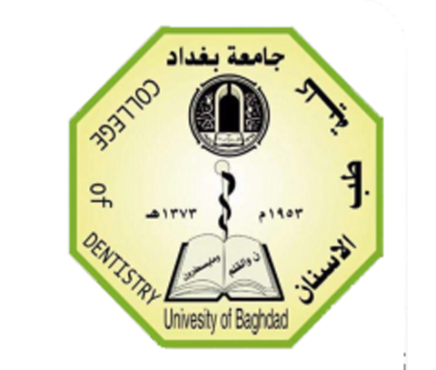
Republic of Iraq
Ministry of Higher Education
And scientific Research
University of Baghdad
College of Dentistry

Immediate denture

A project
Submitted to Collage of Dentistry, University of Baghdad. Department of Orthodontic in fulfillment for the requirement to award the degree B.D.S

Done by
Baidaa Imad Mohammad
5th Grade

Supervisor
Dr. Ban Saad Jasim

B.D.S, M.SC. Prosthodontics

Baghdad Iraq

2018 A.D 1439 A.H

