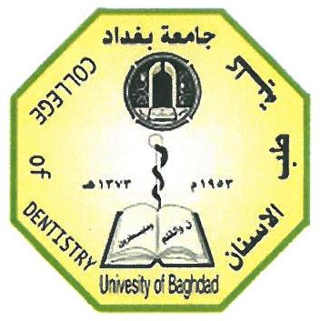**Ministry of Higher Education**

**& Scientific Research**

**University of Baghdad**

**College of Dentistry**

**Impression Technique for CLI Removable Partial Dentures**

**A project**

**Submitted to Collage of Dentistry, University of Baghdad. Department of Prosthodontics in fulfillment for the requirement of B.D.S Degree**

**By**

**Mohammed Waleed**

**Supervisor**

**Dr. Ghazwan Adnan Abbood**

**B.D.S. M.Sc. Prosthodontics**

**Baghdad – Iraq**

**2018**

Supervisor Declaration

This is to certify that the organization and preparation of this project have been made by the under graduated student " **Mohammed Waleed** " under my supervision at the College of Dentistry, University of Baghdad in a partial fulfillment of requirements of the degree of B.D.S in Prosthodontic Dentistry.

Signature

Supervisor

**Lecturer Dr. Ghazwan Adnan Abbood**

**B.D.S., MSc. Prosthodontic.**