C.V.

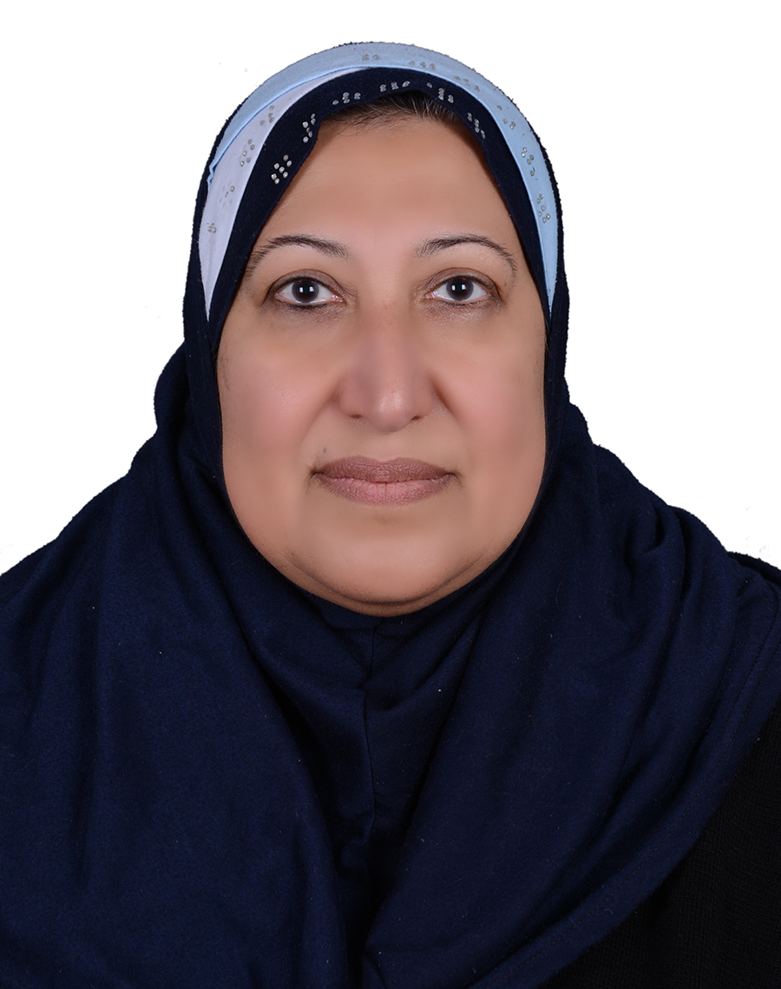

Photo

Name: alaa omran ali al mosawi
Date of Birth: 11feb 1963
Religion: Muslim
Martial statues: mareid
No. of children: one
Specialization: dentist
Position: asst proph
Scientific Degree: .BDS, MSc
Work Address: Baghdad University/College of dentistry university of baghdad .
Work Phone:
Mobile: 07901276790
E-mail: alaa_ali1973@yahoo.com
- First, Scientific Certification:
Date | College | University | Degree science
1985 | dentistry | baghdad | B.DS.
1991 | dentistry | Baghdad | M.Sc.
 |  |  | Any other

From -To | Workplace | Career | No.
1986-1989 | College of dentistry | Dentist | 1
1989-1991 | College of dentistry | Master student | 2
1991to now | College of dentistry | lecturer | 3
 |  |  | 4
 |  |  | 5
 |  |  | 6
- Second, Career:

- Third, University Teaching.
From -To | The (Institute / College) | University | No.
1991to now | dentistry | Baghdad | 1
 |  |  | 2
 |  |  | 3
 |  |  | 4
 |  |  | 5
 |  |  | 6
 |  |  | 7

- Fourth, Courses Which You Teach:

Year | Subject | Department | No.
 | periodontology | periodontology | 1
 |  |  | 2
 |  |  | 3
 |  |  | 4

- Fifth, Thesis which was supervised by :

Year | Department | Thesis Title | No.
2019 | periodontology | Estimation of antiphosphyl coline in serum of atherosclerotic patient | 1
 |  |  | 2
 |  |  | 3
 |  |  | 4
 |  |  | 5
 |  |  | 6
 |  |  | 7

- Sixth, Conferences which you participated:
Type of Participation  And  lecturer | Place  Iraq | Year  1991 to  2019 | Conferences Title  College of dentistry  All years | No.  ( بحث / بوستر حضور)
 |  |  |  | 1
 |  |  |  | 2
 |  |  |  | 3

- Seventh, Scientific Activities:
Outside the College | Within the College

- Eighth, Research Projects in The Felid of Specialization to The Environment and Society or the Development of Education:
No. | Research Title | Place of Publication | Year
1 | Reliability of family history report among relatives of aggressive periodontists patients. | . college of dentistry journal | 2008
2 | Evaluation of the effect of low energy laser on gingivitis. | College of dentistry journal | 2008
3  4  5  6  7  8 | Comparing the effect of probiotic and chlorhexidine as a mouth rinses in bacterial  The Iraqi Method of Natural Liquorice as a Mouth Rinse and Its Effect in Patient with Chronic Periodontitis.  The effect of chewing gum on periodontal disease  Diode LASER versus scalpel gingivictomy  Probiotic chewing gum treatment of periodontal disease | College of dentistry journal  Iraqi dental association journal  International J of science and research.  Biomedical and pharmacology journal  Inter national journal of advance research | 2012  2016  2017  2017

- Ninth, Membership:

- Tenth, Awards and Certificates of Appreciation:

Year | Donor | Name of Awards and Certificates | No.
 |  |  | 1
 |  |  | 2
 |  |  | 3
 |  |  | 4
 |  |  | 5
 |  |  | 6
 |  |  | 7
 |  |  | 8

- Eleventh, Scientific literature:

Year of The Publication | Scientific Literature Title | No.
 |  | 1
 |  | 2
 |  | 3
- Twelfth, languages:
- Arabic
- English

*Note: - Make a copy on CD.

