**Ministry of Higher Education**

**and Scientific Research**

**University of Baghdad**

**College of Dentistry**

**Bite raising appliance**

A Project

Submitted to the Council of the College of Dentistry at the University of Baghdad Department of Prosthodontics Dentistry in Partial Fulfillment of the Requirements for the B.D.S. Degree

By

**Mays Nazik Lahmod**

Supervised by

**Dr. Ban Saad Jasim**

B.D.S., M.Sc.

2018 A.D. 1439 A.H.

بسم الله الرحمن الرحيم

(وعنده مفاتيح الغيب لايعلمها الاهو ويعلم مافي البر والبحر وماتسقط من ورقه الا يعلمها ولاحبه في ظلمت الارض ولا رطب ولايابس الا في كتب مبين)

صدق الله العظيم

الانعام 59

Dedication

This work is dedicated to my family, my father and mother and my friends for their great support and for always believing in me.

To my supervisor for her guidance and Support

Thank you from all my heart.

**Certification of the Supervisor**

I certify that this thesis entitled “**Bite raising appliance”** was prepared by **Mays Nazik Lahmod** under my supervision at the College of Dentistry/ University of Baghdad in partial fulfilment of the requirements for the for the B.D.S. Degree.

Signature

**Dr. Ban Saad Jasim**

B.D.S., M.Sc.

(The supervisor)

**Acknowledgement**

Thanks and praise to **Allah Almighty** for inspiring and giving me the

strength, willingness and patience to complete this work.

My thankfulness and gratitude goes to **Prof. Dr. Hussain F. Al-Huwaizi**, the Dean of the College of Dentistry, University of Baghdad.

I am also expressing my thanks and gratitude to **Prof. Dr. Nidhal H. ttGhaib**, Assistant Dean for Scientific Affairs, for her help and support.

My sincere appreciation to **Prof. Dr. Raghdaa Kareem Jasim** , head of department of prosthodontics .

I would like to express my deepest gratitude and special appreciation to my supervisor **Dr.Ban Saad Jasim** for her phenomenal knowledge, invaluable guidance, efforts and continuous encouragement which gave me the confidence to finish work successfully.

**List of content**

|  |  |
| --- | --- |
| Subject | Page No. |
| Acknowledgment | **I** |
| List of contents | **II** |
| List of figures | **IV** |
| List of abbreviations | **V** |
| Introduction | **1** |
| Chapter one: Review of Literature | **3** |
| 1.1.General terms related to literature | **4** |
| 1.2. Causes of loss vertical dimension | **5** |
| 1.3.Clinical assessment of vertical dimension | **6** |
| 1.3.1 Pre-extraction records in determining vertical dimension | **6** |
| 1.3.2 Using physiologic rest position as a guide to determine the vertical | **7** |
| 1.3.3Facial dimensions in establishing vertical dimension | **7** |
| 1.3.4 Phonetics in establishing the vertical dimension | **8** |
| 1.3.5 Deglutition in establishing vertical dimension | **9** |
| 1.3.6 Aesthetic appearance in establishing vertical dimension | **10** |
| 1.4.Clinical evaluation | **11** |
| 1.4.1 Facial Aesthetic | **11** |
| 1.4.2 Temporomandibular joint status | **12** |
| 1.4.3 Intraoral considerations: | **13** |
| 1.4.3.1 Remaining tooth structure | **13** |
| 1.4.3.2 Occlusion | **14** |
| 1.5. Bite Raising in Full Occlusal Rehabilitation | **15** |
| 1.6.Functional Adaptation | **15** |
| 1.7. Principles behind increasing vertical dimension | **16** |
| 1.8.Bite collapse | **17** |
| 1.9.The indications for bite raising | **18** |
| Chapter two : Material and method | **19** |
| 2.Material and method | **20** |
| 2.1.Clinical examination | **20** |
| **2.2. Treatment plan** | **22** |
| **2.3 Making partial denture** | **24** |
| **2.4 Constrution of composite filling** | **25** |
| **Chapter three: Discussion** | **27** |
| Discussion | **28** |
| Chapter four: Conclusion | **29** |
| **Conclusion** | **30** |
| **Reference** | **31** |

**List of figures**

|  |  |
| --- | --- |
| Figure title | Page No. |
| Figure 1: Occlusal vertical dimension and rest vertical dimension | **4** |
| Figure 2: Using profile silhouettes to determine vertical dimension. | **7** |
| Figure 3: Facial dimensions in establishing vertical dimension. | **8** |
| Figure 4: Silverman closest speaking space. | **9** |
| Figure 5: Remaining tooth structure | **14** |
| Figure 6: Loss of posterior tooth support | **14** |
| Figure 7 :Patient profile before treatment A:facial profile ,B :lateral profile. | **20** |
| Figure 8 : Patient occlusion show attrition of anterior teeth | **21** |
| Figure 9 : lower arch shown attrition of teeth | **21** |
| Figure 10 :Upper arch shown attrition of teeth | **21** |
| Figure 11 :Take face bow of patient . | **23** |
| Figure 12 : After insertion the RPD that was made to open the bite 2 mm | **24** |
| Figure 13:Lower arch after insertion. | **25** |
| Figure 14:Upper arch after insertion . | **25** |
| Figure 15 :Construction of composit filling | **26** |

**List of Abbreviations**

|  |  |
| --- | --- |
| Abbreviations | Meaning |
| CLS | **Crown Lengthening Surgery** |
| OVD | **Occlusal Vertical Dimention** |
| RPD | **Removable Partial Denture** |
| TMDs | **Temporomandibular Joint Disorders** |
| TMJ | **Temporo-mandibular Joint** |
| VD | **Vertical Dimension** |
| VDR | **Vertical Dimension at Rest** |

**Introduction**

The Glossary of Prosthodontic Terms defines the vertical dimension as the distance between two selected anatomic points .The vertical dimension when the mandibular teeth are occluding with the maxillary teeth is defined as the occlusal vertical dimension (OVD). The OVD for dentate individuals is mainly determined by the remaining dentition, hence loss of tooth substance might influence the OVD. A loss of OVD can significantly affect patient function, comfort and aesthetics (Turner et al., 1984).

Tooth wear is accompanied by compensatory growth of the alveolus, termed alveolar compensation, that maintains the OVD but leaves little, or no interocclusal space for replacing the lost enamel and dentine. One method for gaining interocclusal clearance is using a bite raising appliance for assessing whether the patient can tolerate an increase in the OVD, before providing reparative restorations.( Irfan Ahm ad., 2012).

The common fears of opening vertical are that the patient will develop joint or muscle pain. Based on the scientific research there is very little risk of either of these happening. Another common risk is difficulty adapting to the new vertical and phonetic issues. When open a patient’s vertical do not to consume all of their freeway space, and the change must be tested prior to making it in final restorations. Unfortunately, using a removable appliance is a poor way to test a patient’s ability to adapt to opening their vertical. A true test requires using direct composite overlays or restorations or provisional, something the patient cannot remove and must function in all of the time. If challenges with phonetics or adaptation are encountered, the vertical or tooth contacts must be corrected to alleviate them. (Brady, 2013).

The last risk is that the change will not be long lasting and the vertical will return to its previous amount through tooth movement or osseous adaptation. This risk is often does not have an impact on the function or Aesthetics of the patient so is not clinically relevant. One way to manage this risk is to follow the patient in their provisional restorations for 6-9 months prior to completing the case. (Brady, 2013).

All treatment procedures in dentistry revolve around a few basic, firm set of laws. Based on investigations and evidence, it is confirmed that these principles should never be violated. Establishing the occlusal vertical dimension (OVD) to the pre-treatment levels is been accepted over the years. It is advocated that any alteration in the OVD during restorative procedures is unsafe to the stomatognathic system. But as an exemption, the OVD is increased or altered in full occlusal rehabilitation for gaining space for the planned restorations. Stuart reported that this procedure leads to TMJ related problems. contradicting opinions exist regarding the justification, validity and applicability of the procedure. ( Stuart.,1960)**.**

This research will analyzes the indications, principles, methods, functional adaptation and the effects of altering the OVD of patient with reduce OVD due to attrition.

**Chapter one**

**Review**

**Of**

**Literature**

**Chapter one**

**Review of literature**

**1.1.General terms related to literature**

**Vertical dimension of occlusion**: the distance between two selected anatomic or marked points (usually one on the tip of the nose and the other on the chin) when in maximal intercuspal position(Glossary of Prosthodontic Terms, 2017).

**Vertical dimension at rest**: the postural position of the mandible when an individual is resting comfortably in an upright position and the associated muscles are in a state of minimal contractual activity(Glossary of Prosthodontic Terms, 2017).

**Interocclusal rest distance:** the difference between the rest vertical dimension and the occlusal vertical dimension, as in Figure 1 (Glossary of Prosthodontic Terms, 2017)

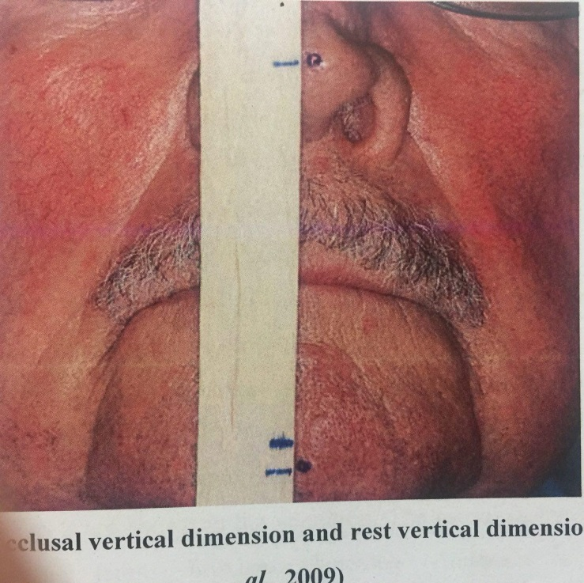

**Figure 1: Occlusal vertical dimension and rest vertical dimension, (Patel et al., 2009)**

**1.2.** **Causes of loss vertical dimension**

A few of the causes of a loss in vertical dimension are: tooth wear, loss of all of the teeth, loss of molar support on either or both sides, and the early loss of six- year molars which allows the teeth to drift(Schopper, 1959).

**1**. Tooth wear is a general term describing the loss of dental hard tissues from the surfaces of the teeth caused by factors other than dental caries, trauma, and developmental disorders (Litonjua et al., 2003; Lussi, 2006). Attrition, erosion, and abrasion usually cause alterations of the tooth surface and manifest as tooth wear. These processes act by distinct progressions and exhibit unique clinical characteristics (Hanif, et al., 2015.).

**a. Abrasion:** Both patient and material related factors influences the prevalence of this condition. The brushing technique, brushing frequency, and the force applied while brushing are common patient-related factors. The type of bristle material of toothbrush, stiffness of toothbrush bristles, the abrasiveness, and pH of dentifrice used are factors related to material (Imfeld,. 1996).

**b. Attrition** mainly results from contact between opposing teeth and well- defined wear facets are shown in the condition. The causal factors for attrition are parafunctional habits, bruxism, clenching(Anderson et al., 1993) developmental defects (Licht et al., 1980), coarse diet, and natural teeth opposing porcelain. It is caused not only by diet or the habits, but a class III incisal relationship and lack of posterior support also lead to attrition (Chu, et al., 2002).Attrition occurs almost entirely on occlusal and incisal surfaces, although it may also affect the buccal and palatal sides of the maxillary and mandibular anterior teeth in deep vertical overlap occlusal relationships (Smith, 1991).

**2**. The edentulous patient suffers a constant change in the vertical dimension, and, in order to maintain health, happiness, comfort, and beauty, new complete dentures that restore the lost vertical dimension of occlusion should be constructed at regular intervals (Schopper, 1959).

**3**. The loss of molar support, either unilateral or bilateral, not only causes a loss of vertical dimension, but also causes an asymmetry of the facial contour. When the molar loss is unilateral, the muscles of mastication function on one side, while on the other side there is only the attempt at function. This produces an overdevelopment of one side of the face and an underdevelopment of the other side (Schopper, 1959).

**4**. The loss of a first molar at any age has not been a serious consideration in the past. However, more destruction of a natural dentition can be generated from the postponement of such a replacement than by any other dental neglect. By the loss of this tooth, an incredible amount of change takes place throughout the dental arch

**1.3.Clinical assessment of vertical dimension**

Although advances in techniques and materials are being made in prosthodontics, still no accurate method of assessing the vertical dimension of occlusion in partially edentulous patients is available to dentists. Clinical judgment plays a major role in the assessment of this important component in the construction of dentures (Turrell, 1955).

**1.3.1 Pre-extraction records in determining vertical dimension**

Various pre-extraction records like profile photographs, profile silhouettes, radiographs, articulated casts and facial measurements can be used to record the vertical dimension at occlusion. These records give an idea about the vertical dimension at occlusion of the patient when the teeth were present, (Nallaswamy, 2008) Profile photographs are made before extraction. They should be taken in maximum occlusion as the patient can easily maintain this position during photographic procedures. The photographs should be enlarged to the actual size of the patient and the distance between the anatomical landmarks should be measured and compared with that of the patient to avoid errors. The measurements are recorded so that they can be used later. While measuring the jaw relation, the measurements from the profile photographs are used to determine the vertical dimension at occlusion as in Figure 2 (Nallaswamy, 2008).

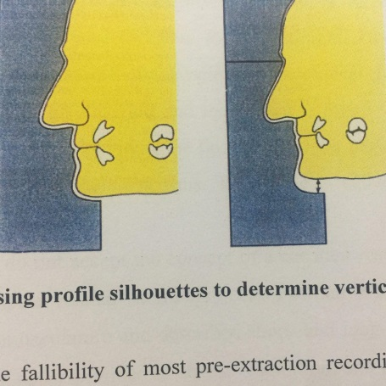

**Figure 2: Using profile silhouettes to determine vertical dimension** **(Nallaswamy, 2008)..**

**1.3.2 Using physiologic rest position as a guide to determine the vertical Dimension of occlusion**

This method is not considered as an accurate method because it requires patient’s cooperation, which is variable, and alterations in jaw position can occur during this procedure. In this method the patient is asked to sit upright with his head unsupported and the eyes looking straight. Upper and lower occlusal rims which were modified according to the clinical guidances (refer occlusal rim fabrication) are inserted and the patient is asked to swallow and relax. When the relaxation is obvious, the lips are carefully parted to reveal the space present between the occlusion rims. This space is called the Free-way space (Nallaswamy, 2008).

**1.3.3Facial dimensions in establishing vertical dimension**

The distance between the pupil of the eye and the rima oris (corners of the mouth) and the distance between the anterior nasal spine and the lower border of the mandible should be measured using a Willis guide. If both these distances are equal, the jaws are considered at rest. Its accuracy is questionable in patients with facial asymmetry, as seen in Figure 3(Nallaswamy, 2008).

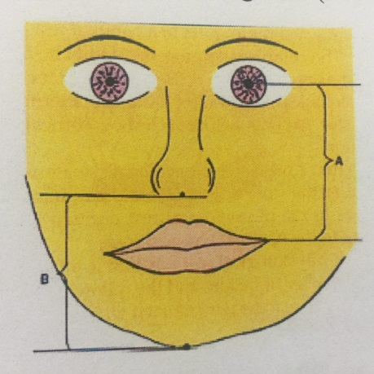

**Figure3 : Facial dimensions in establishing vertical dimension (Nallaswamy, 2008).**

**1.3.4 Phonetics in establishing the vertical dimension**

Phonetics to check an arbitrary vertical dimension of occlusion and rest. This theory is dependent upon a correlation during speech of the interocclusal distances, the position of the occlusal plane, and the position of the tongue relative to the occlusion rims or teeth. The most popular sound used as an aid in determining rest position is the labial m sound which can be said without the use of teeth. However, the m sound often leaves the lips in contact. As soon as they are parted by the dentist to observe the space between the occlusion rims, the mandible is depressed and the rest position is lost. To overcome this difficulty the sound m is often extended to the word emma or followed by the labial p sound which leaves the lips apart; hence, the popularity of the word Mississippi. Some patients depress the mandible when pronouncing p sound (Pound, 1957).

The methods used to guide the mandible into rest position vary. Some dentists prefer the m sounds in conjunction with complete relaxation. addition to the m sound, prefer to engage the patient in conversation. The measurements are repeated after the patient has stopped talking. When the vertical dimension of rest position has been measured between the triangles of tape on the face, the occlusion rims are built up until the vertical dimension of occlusion equals this measurement. Then, the height of the lower occlusion rim is reduced 2 to 4 mm. according to the beliefs of the dentist (Pound, 1957).

Phonetics used to establish the closest speaking space. maintains that it is easier and more accurate to record a measurement which relies upon muscular phonetic enunciation when the patient loses voluntary muscular control of the mandible than to record a measurement which relies upon relaxation. Thus, he records the closest speaking space before the teeth are extracted as seen in Figure 4 (Silverman, 1953).

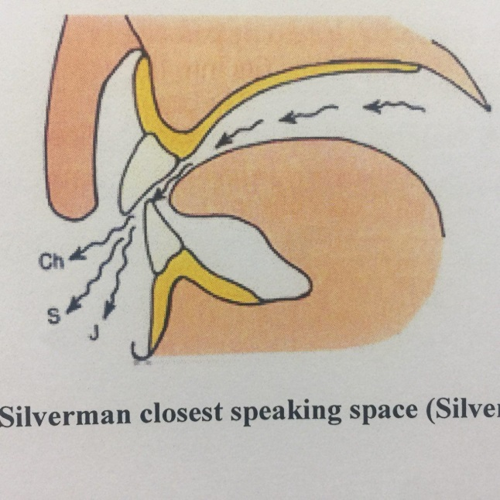

**Figure 4 : Silverman closest speaking space (Silverman, 1953)**

**1.3.5 Deglutition in establishing vertical dimension**

Shanahan (1956) indicated that the mandibular pattern of movement during deglutition is the same for the edentulous infant as it is for the edentulous adult. He maintained that eruption of teeth is held at the occlusal plane by the act of swallowing which establishes the vertical dimension of occlusion. When constructing compete dentures, the advocates of the swallowing technique believe that soft wax on the occlusion rim is reduced during deglutition to give the correct vertical dimension of occlusion (Shanahan, 1956).

**1.3.6 Aesthetic appearance in establishing vertical dimension**

The estimation of vertical dimension by appearance is based on the aesthetic harmony of the lower third of the face relative to the rest of the face, upon the contour of the lips and the appearance of the skin from the margin of the lower lip to the lower border of the chin, and also the labiomental angle. With the lips in contact, the elevation of the mandible and the compression of the lips should be just discernible on mandibular closing from rest position to the vertical dimension of occlusion. This guide applies to normal young patients or middle-aged patients with good tonus of the skin. Difficulties arise when the tonus of the skin is poor, when resorbed denture-bearing tissues preclude full restoration of the contour of the lip (Turrel, 1972).

The following facial features indicate that the jaw is in its physiological rest position:

* 1. Skin around the eyes and chin should be relaxed. It should not be stretched, shiny or excessively wrinkled.
  2. The nostrils are relaxed and breathing should be unobstructed.
  3. The upper and lower lips should have a slight contact in a single plane. If the mandible is protruded, the lower lip will be in front and without contact. If the mandible is retruded, the upper lip will be in front. (Nallaswamy, 2008).

**1.4.Clinical evaluation**

In contemporary dentistry, emphasis should be placed on conservative management strategies (Mount, 2007). Since increasing the OVD by restorative means involves multiple teeth in at least one arch, it is regarded as an extensive, costly and time-consuming procedure. Prevention strategies and conservative measures should be the clinician’s main priority. Conservative management for patients with reduced vertical tooth height includes dietary counselling, fluoride application, exclusion of dietary disorders, controlling parafunctional habits and management of gastro-esophageal reflux disorder (Lee et al., 2012).

**1.4.1** **Facial Aesthetic**

The determinants of facial Aesthetic are the sagittal profile, facial tissues appearance, lip morphology and teeth display (Tjan et al., 1984). Sagittal assessment of the face can reveal mandibular pseudo-prognathism which might be a sign of OVD loss and overclosure of the mandible (Kaidonis, 2008).

The severity of mandibular pseudoprognathism can be subjectively assessed by reviewing an old photograph of a patient’s facial profile (Crothers, 1992). From the frontal view, several facial implications can manifest after loss of OVD including altered facial contour, narrowed vermillion borders and an overclosed commissure. These implications are exacerbated by increased mandibular pseudo-prognathism(Crothers, 1992). As long as the lip competence is not compromised, it is thought that increasing the OVD might reverse the consequence of OVD loss and restore facial morphology(Toolson et al., 1982; Kois et al., 1997).

The upper lip position in relation to the incisal edges of maxillary anterior teeth determines the teeth display while smiling and at rest (Tjan et al., 1984). Insufficient display of the maxillary anterior teeth can be improved by lowering the occlusal surface of the maxillary teeth. Further, increasing the OVD allows the establishment of an incisal overjet that can augment the support of the maxillary lips. Subsequently, an overbite can be incorporated which can allow the maxillary incisal edge to be placed parallel to the lower lip, rendering a more Aesthetic appearance (Tjan et al., 1984). On the contrary, excessive display of the gingival tissues will not be improved by increasing OVD. Rather, Aesthetic crown lengthening surgery (CLS) should be considered(Jorgensen et al.,2001; Wang et al., 2001).

**1.4.2 Temporomandibular joint status**

The prevalence of temporomandibular joint disorders (TMDs) has been reported to be 7–10% within the population (LeResche, 1997; List T. et al., 1999) Therefore, it is not uncommon to encounter patients with signs and symptoms of TMD seeking routine dental care. However, TMD has been found to primarily affect young and middle aged adults(LeResche, 1997; Magnusson et al., 2005).

Considering that this group of patients might not suffer from significant loss of OVD (Van’t Spijker, 2009), it could be speculated that the development of TMD is not associated with the loss of OVD. This assumption is supported by the clinical observation that attrition is not associated with an increased prevalence of TMD (Seligman et al., 1988).

Through routine clinical assessment, it is critical to assess the status of the temporomandibular joint (TMJ) before intervention therapy. TMJ evaluation is comprised of assessment of joint and muscle pain, mandibular movement and associated sounds (Johansson A. et al., I 1994; Johansson A. et al., 2009).

Therefore, for patients with TMD, the occlusal appliance has a dual purpose: stabilizing the TMD and increasing OVD. The intended permanent increase in the OVD can be incorporated into the occlusal appliance. On the basis of patient adaptation to the occlusal appliance, permanent restoration at the increased OVD can then be performed (De Boever et al., 2000; Davies et al., 2001).

**1.4.3 Intraoral considerations:**

Intraoral assessment involves examining the following parameters: remaining tooth structure and occlusion(Lee et al., 2012).

**A. Remaining tooth structure**

The prognosis of a dental restoration is directly determined by the amount of remaining tooth structure, figure 5 (Goodacre CJ et al., 2001). For generalized loss of vertical tooth height, the clinician is faced with the dilemma of limited remaining tooth structure that is necessary for adequate retention and resistance of the restoration. The original tooth height determines the active preparation height, which can be defined as the vertical distance between the preparation margin and the occlusal-axial line angle. In order to avoid compromising the preparation height, increasing the OVD should be considered to provide adequate space to accommodate the restorative material. The merit behind this technique is more prominent in generalized loss of tooth height manifested from tooth wear. As a result of this approach, the teeth will be subjected to less pulpal trauma. In addition, by utilizing the available vertical height of the tooth, the indication for adjunctive crown lengthening surgery is minimized. (Lee et al., 2012).

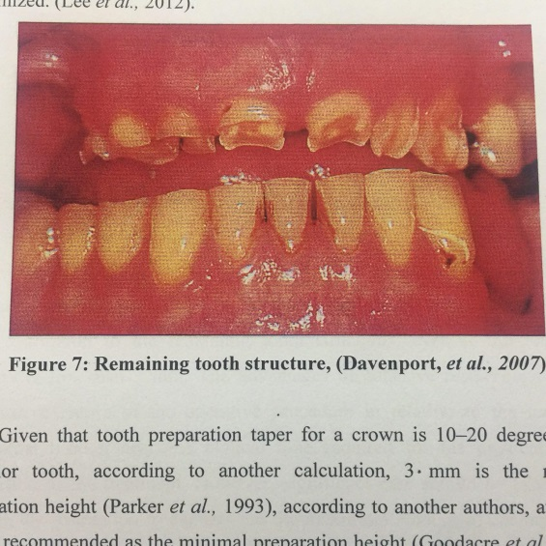

**Figure 5 : Remaining tooth structure, (Davenport, et al., 2007)**

**B. Occlusion**

Clinically, unopposed teeth have been reported to be prone to overeruption, which can create occlusal interferences (Craddock et al.,2007). For some patients, increasing OVD facilitates occlusion reorganization and the achievement of an even occlusal plane. Subsequently, an invasive sacrifice of tooth structure can be avoided (Keough, 2003). Loss of posterior tooth support has been cited as probably the main cause for loss of OVD in dentate individuals, Figure 6 (Turner, et al., 1984).

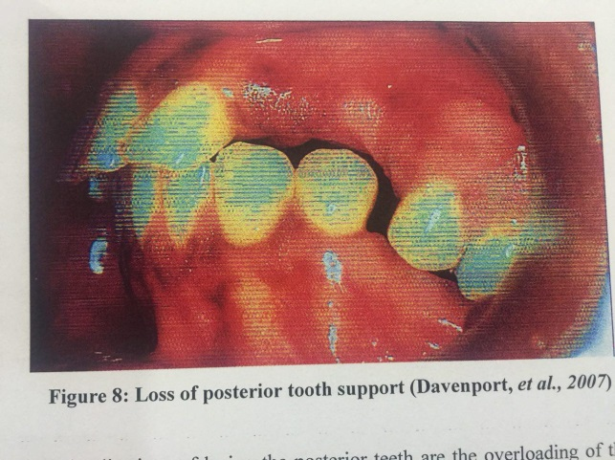

**Figure 6 : Loss of posterior tooth support (Davenport, et al., 2007)**

Patients with a worn anterior dentition suffer from a loss of clinical crown height and the possibility of development of an edge-to-edge incisal relationship(Crothers et al., 1993; Johansson et al., 2008).

**1.5. Bite Raising in Full Occlusal Rehabilitation**

It is a widely accepted notion that it is mandatory to increase OVD in all full occlusal rehabilitation cases. From the critical reviewing, it is ascertained that restoring OVD to original level rather than increasing is needed and patient’s response should be tested during each stage of increase in OVD.

By exploring the various controversies and myths regarding vertical dimension and its alteration, discarding the erroneous beliefs and accepting the essentials, two logical hypotheses can be arrived, they are:

OVD is not altered following tooth wear (except in case of amelogenesis/dentinogenesis imperfecta). Any method to restore OVD will result in increased OVD.

Free way space can be manipulated and new VDR will get established if OVD is not increased beyond pre-existing rest position

The decisive statement that can be made from the above deductions is that OVD is almost always preserved. For better outcome, it is advisable to proceed with the existing OVD in excessively worn dentitions. But in cases with serious lack of space for the planned restoration, OVD can be raised but only within the VDR **(** Stuart: 1960.).

**1.6. Functional Adaptation**

Following an alteration in OVD, adaptive responses occur within three components: TMJ, periodontium, and occlusal morphology.The fluid compartments within TMJ periodontium are the first to respond to the strain. Under strain, there is a shift fluids within temporo-mandibular joint disc and retrodiscal tissues away from force. Once the strain is removed, the fluid returns to position and tissue morphology is thus preserved ( Harper ,.2000).

Under prolonged strain as in of an increase in OVD collagen and other case proteins in the soft tissues get altered and tissue morphology is changed. Strains beyond adaptive capacity of soft tissues will result in adaptive changes in bone and cartilage. If strains are beyond the adaptive capacity they will lead to degeneration of tissues. Clinically, it can be related as: OVD increase within VDR will get adapted only if occlusion is stable without interferences and stabilized in new OVD position ( Carlsson et al.,1979).

**1.7. Principles behind increasing vertical dimension**

It is obligatory that two principals have to be pursued during the increase OVD:

(1) Starting point for reconstruction/increase in OVD must be with in centric relation.

(2) Reconstruction to be within the range of the patient's neuromuscular adaptation.

In accordance with **first principle**, the centric reference points must be accurately recorded and this must be transferred to a mechanical instrument in order to reproduce the patient's functional occlusion.

Alteration of OVD must be initiated from the centric position In accordance with **second principle** intervening modalities such as occlusal splints, removable dentures, etc., must be tried before definitive restoration so that neuro-muscular adaptive capacity is not exceed (. Rivera-Morales.,1992).

The classification (Tomer .,1984) for patient with worn dentition can be re categorized on the space availability and treatment options.In patients with worn dentitions were adequate space available for restoration (type I), conventional fixed removable restorative treatments towards full occlusal rehabilitation can be done without altering OVD.

If the demand aesthetic enhancement is present then crown lengthening can be performed. In situation with worn dentition and lack of space occlusal (type II), bite raising with OVD not encroaching can be made followed by full rehabilitation.

In conditions with a loss of OVD like in amelogenesis imperfecta (type occlusal III), exact location of OVD must be identified and restored by full rehabilitation

**1.8. Bite collapse**

Bite collapse is a medical condition that is characterized by a change in the structure of the patient’s teeth, facial features, and jaw position because of tooth loss or severe wearing down of the teeth.(Peck et al., 2017). This condition is brought about as a result of excessive undermining of the teeth, missing teeth, and periodontal disease. All these conditions are implicated in bite collapse, which is manifested through visible loss of tooth structure, reduced facial height, and the precipitation of TMJ disorders. (Peck et al., 2017).

Patients that are diagnosed with bruxism are more likely to develop bite collapse because of the constant rubbing, grinding, and friction of the teeth that adds to the wearing down of their surfaces. Periodontal disease also plays a significant role in bite collapse because as the gum tissues deteriorate, they will be unable to support the teeth and hold them in place. Both of these cases ultimately lead to tooth loss, which further aggravates the patient’s tendency to incur the condition. (Peck et al., 2017).

**1.9. The indications for bite raising**

1. Inadequate space for the restoration.
2. For temporarily relieving the symptoms in intra-capsular TMJ disorders**(** Harper .,2000).

**Chapter two**

**Case**

**Report**

**2.Case report**

A 35 years old female presents to the department of prosthodontics of collage of dentistry, Baghdad uiversity, for general dental care.

The patient chief complaint was chewing deficiency and speech problems.

2.1.Clinical examination:

The patient’s medical history has no contraindications to dental treatment. The patient had history of endodontic and restorative treatment. The patient had no asymmetry, competent lips,had decreased vertical dimention due to attrition and no signs or symptoms (pain, limited range of jaw opening, or clicking) of temporomandibular joint disorder (TMD) were detected.

Initial evaluation of the patient revealed Para functional habits of bruxism and clenching.

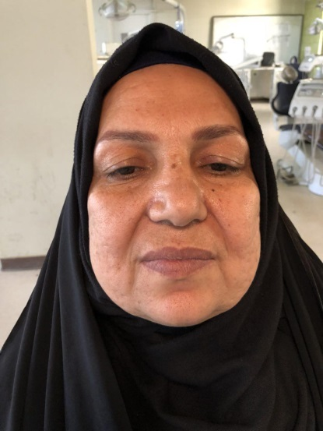 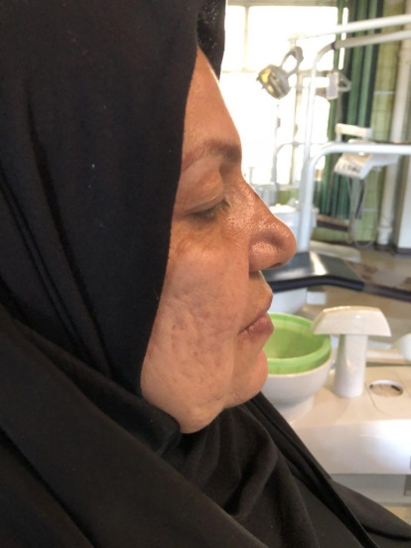

A:frontal profile of the patient B:lateral profile of the patient

**Figure 7 :Patient profile before treatment A:facial profile ,B:lateral profile.**

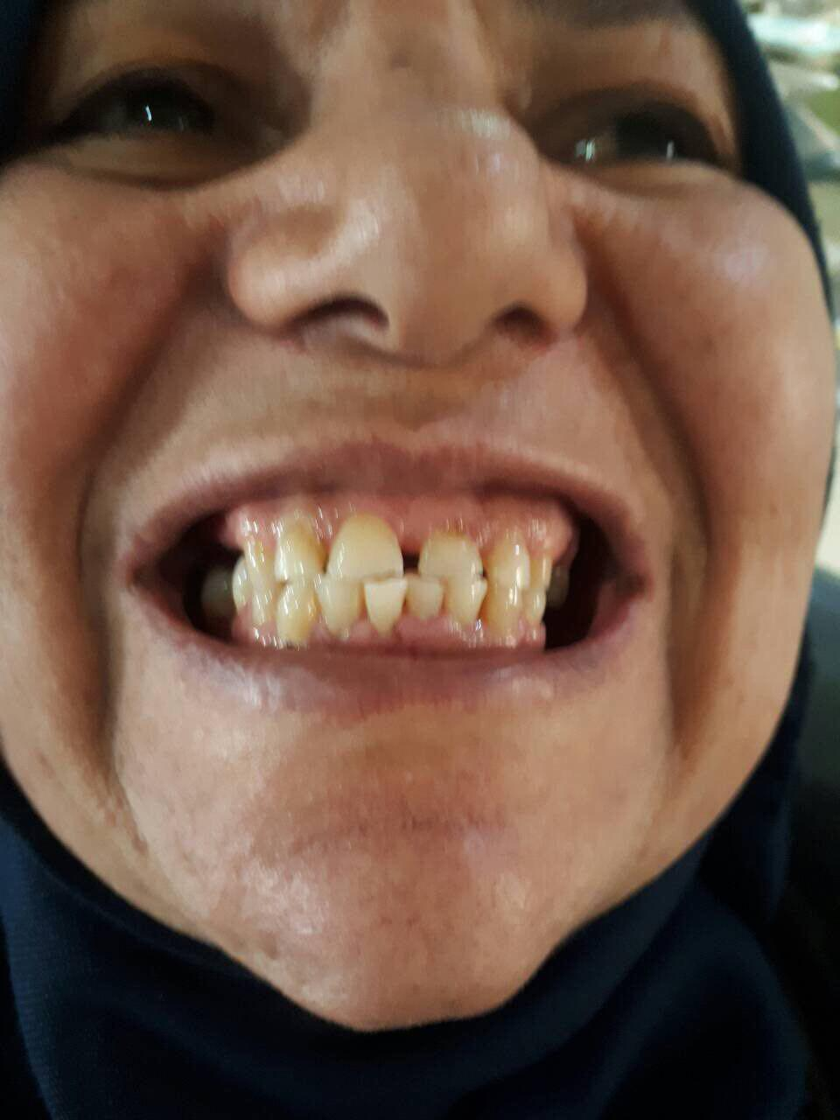

**Figure 8 : Patient occlusion show attrition of anterior teeth**

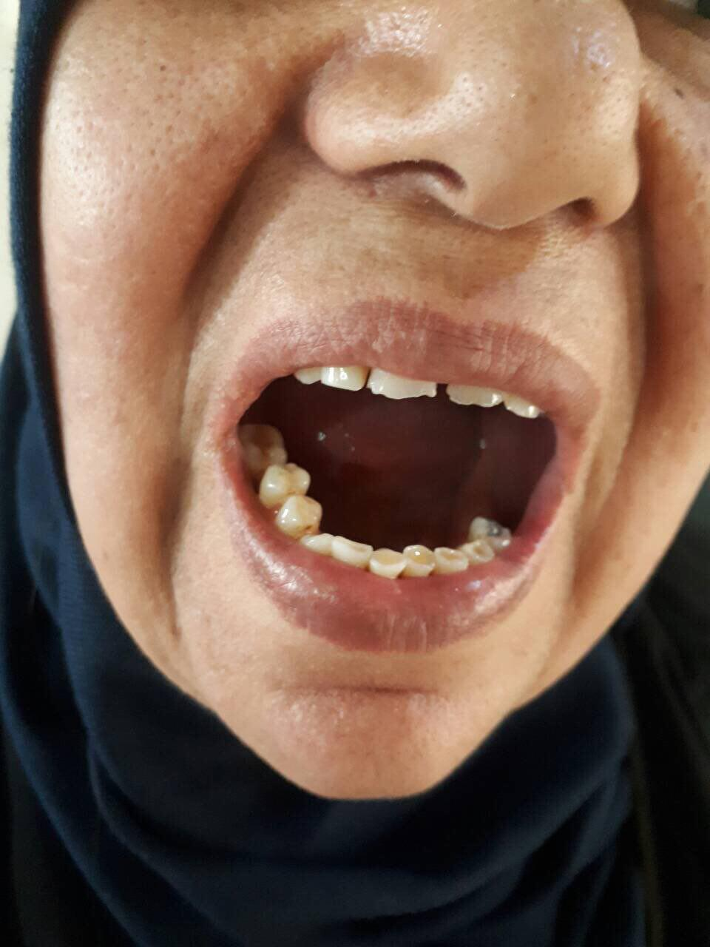

**Figure 9 : Lower arch shown attrition of teeth.**

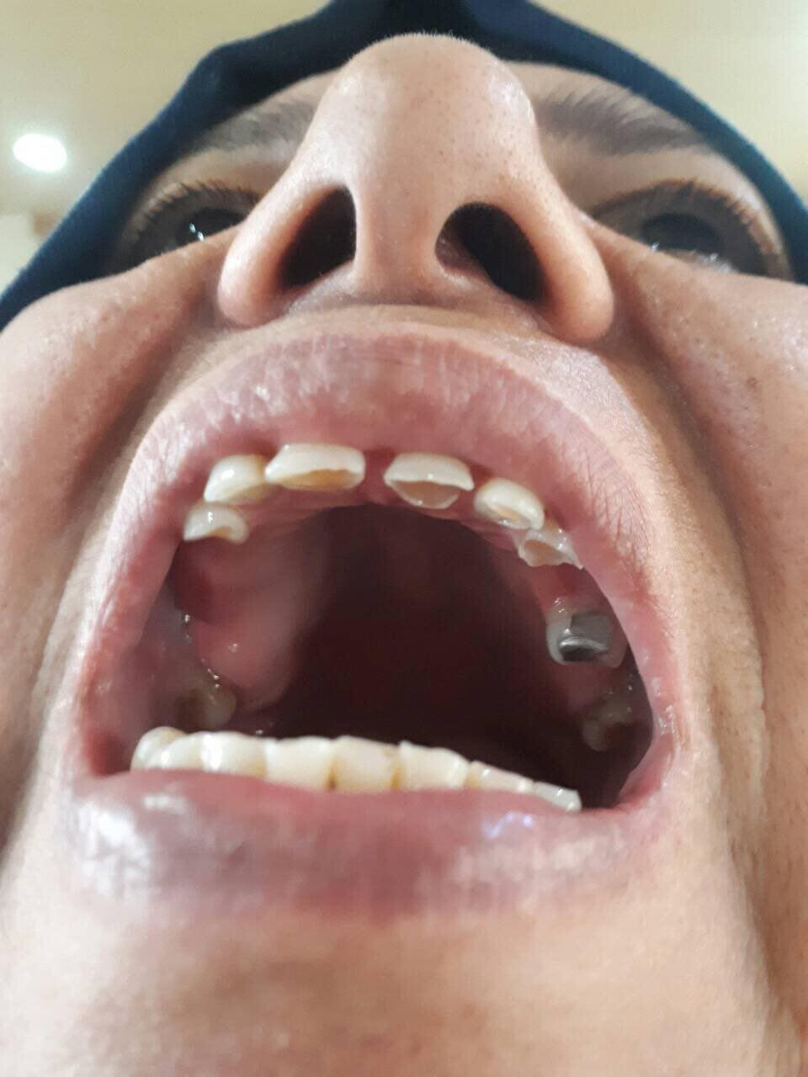

**Figure 10 :Upper arch shown attrition of teeth**

The patient presented in partially edentulous state; maxillary Kennedy Class III modification I, and mandibular Class II, modification I, with loss of occlusal vertical dimension (OVD) and severs attrition of her maxillary anterior teeth and mild attrition of her mandibular anterior teeth.

Vertical dimension of occlusion measurement result was: 58 mm, by selected two anatomic or marked points (usually one on the tip of the nose and the other on the chin) when in maximal intercuspal position.

And in rest position was 67 mm. by the postural position of the mandible when an individual is resting comfortably in an upright position and the associated muscles are in a state of minimal contractual activity.

The measurement result showed loss of vertical dimension. Based on the estimation, rest position occlusion was 67-58 mm=9 mm, freeway space was=9mm (VDR-OVD=FWS).

After the vertical dimension was clinically assessed, physiologic rest position was determined by facial measurements between nose tip and chin and confirmed by phonetics.

The interocclusal distance was found to be approximately 4mm, and the OVD could be restored by approximately increasing it by 5mm in addition the patient upper anterior teeth was having short crown due to attrition , by doing gingivectomy this problem was resolved.

2.2. Treatment plan:

A treatment plan was developed with the aim of improving occlusion, restoring masticatory function, and improving the patient’s appearance. It was decided to increase occlusion vertical dimension about 5mm gradually by 2 steps to restorative correct vertical dimension and compensate the loss vertical dimension due to attrition of anterior teeth , then make bridge for anterior teeth according to new occlusion vertical dimension.

The diagnostic plaster casts were obtained from alginate impressions for upper and lower arch using stock tray. Diagnostic casts were made and mounted on a semi-adjustable articulator with facebow record and centric relation record.

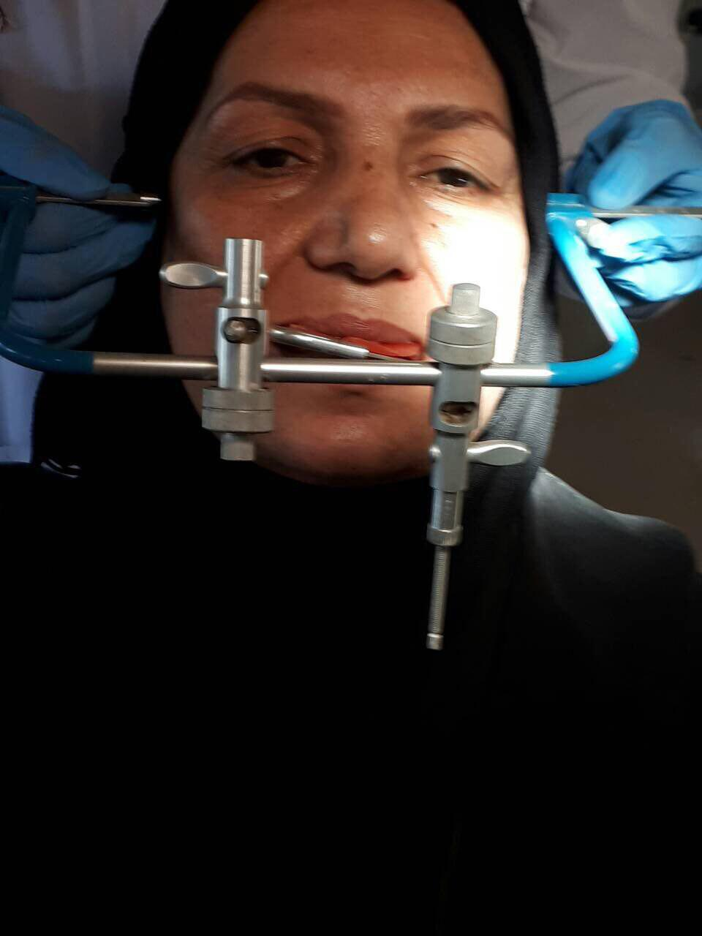 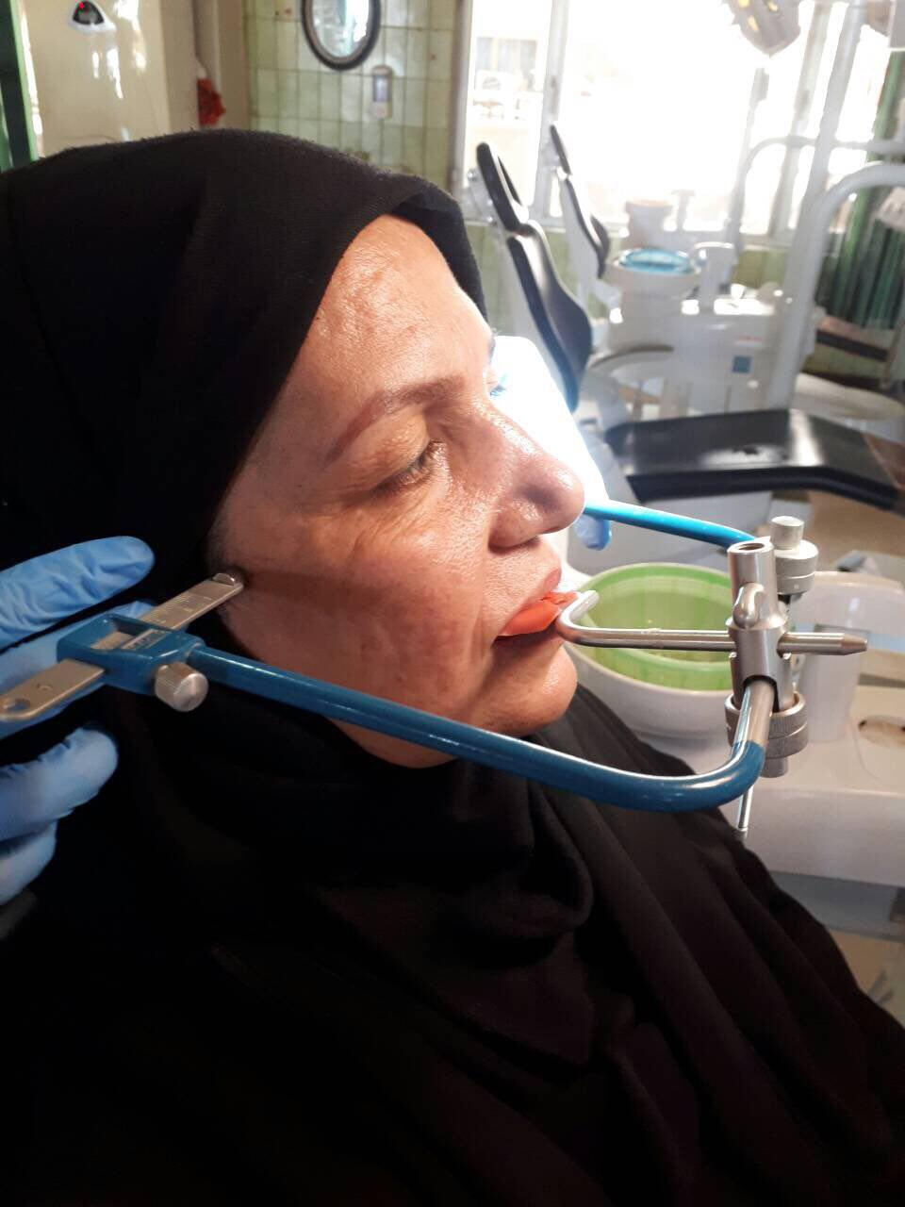

**Figure 11:Take face bow of patient** **.**

Take facebow by use posterior reference point (Gysi point) 13 mm in front of the most upper part of the external auditory meatus on line passing to the outer canthus of the eye) is measured and marked so that the condylar earpiece is positioned on it, then transmitted and mounted casts to articulator. after mounting the cast on articulator using face bow , use interocclusal registration material (heavy body condensation silicone) to record the relationship between teeth.

**2.3 Making partial denture**

The mandibular removable partial denture was constructed. The patient was instructed to wear this denture 8 hours a day, because of difficulty in eating while wearing it, therefor during eating he was wearing his previous RPD. After opening the bite 2 mm the freeway space become 7mm**.**

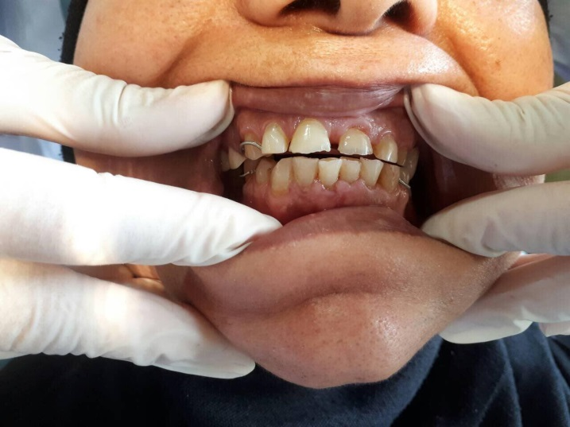

**Figure 12: after insertion the RPD that was made to open the bite 2 mm**

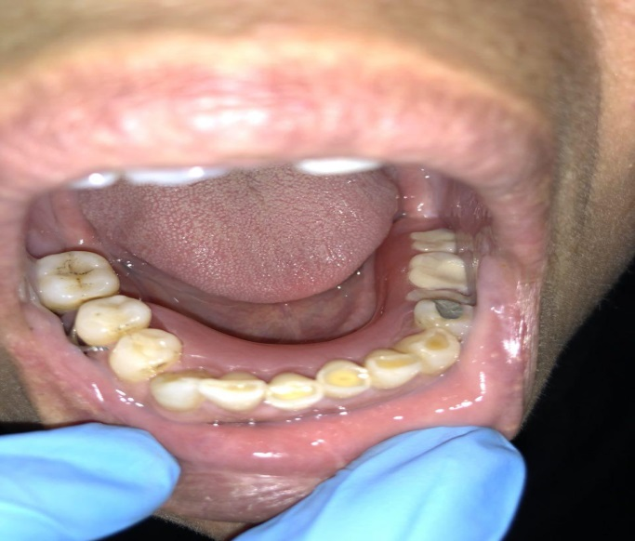

**Figure 13:Lower arch after insertion.**

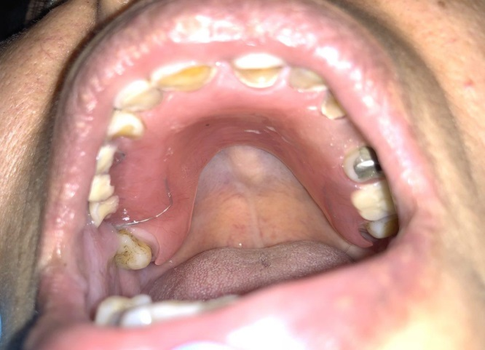

**Figure 14:Upper arch after insertion .**

**3.2.Construction of composite filling**

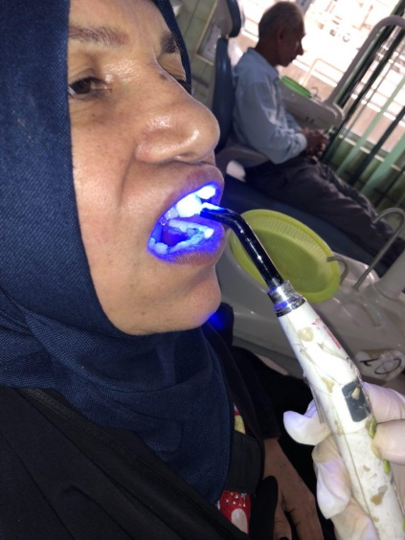 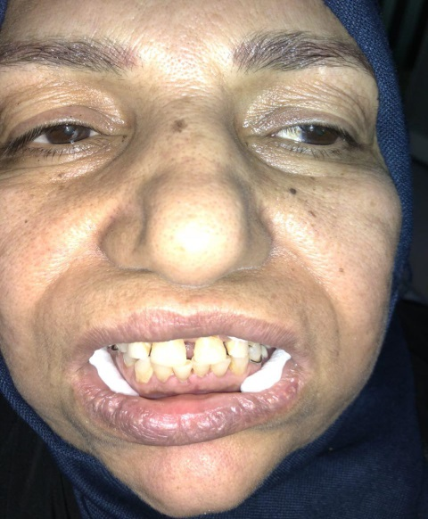

**Figure 15 :Construction of composit filling**

**Chapter three**

**Discussion**

**Discussion**

Full mouth rehabilitation is a treatment modality which not only focuses on the esthetics and functional aspect of the dentition but also improves upon the health of the whole stomatognathic system.

VD is defined as the distance between the two selected anatomical or marked points. For dentate individuals, VD of occlusion (OVD) is largely determined by occluding dentition. Subsequently, loss of tooth substance will directly affect the OVD leading to alteration in facial morphology, function, comfort, and esthetics. The dynamic nature of stomatognathic system is considered by several authors to be an adaptation mechanism of the masticatory system in response to progressive loss in tooth substance. Increasing the OVD is often held to be a hazardous procedure in prosthetic treatment. But modem practice of renewing and reorganizing the teeth by prosthesis began with the idea of "raising the bite" to rectify closure resulting from excessive wear of the occlusal surfaces.

A moderate increase in the VDO does not seem to be a hazardous procedure. provided that occlusal stability is established, which by improving the relationship of teeth, improves condition and health of the supporting structures. In the present case, the bite was collapsed due to attrition, leading to loss of VD. The task of rehabilitating this patient includes restoration of missing and attrited teeth, by increasing the VD.

**Chapter five**

**Conclusion**

**Conclusion**

* The evaluation of the concepts and bite raising procedure affirms that OVD is preserved in all situations by the adaptive mechanisms of alveolus, periodontium.
* TMJ and teeth. Bite raising can be done to rehabilitate an extremely worn dentition with lack of space for restoration and as a temporary symptom reliever in intra-capsular TMJ problems.
* Any attempt to restore OVD in worn dentition will always result in its increase.
* Any increase in OVD within the VDR will get accommodated and a new VDR will get established without any unfavorable symptoms

**References**

**Reference**

**(A)**

* Atwood, D. A. (1966). A critique of research of the rest position of the mandible. The Journal of prosthetic dentistry, 16(5), 848-854.
* Anderson GC, Pintado MR, Beyer JP, DeLong R, Douglas WH. Clinical enamel wear as related to bruxism and occlusal scheme. J Dent Res 1993;72:303.

**(B)**

* Bloom, D. P. and Padayachy, J. N. (2006). Increasing occlusal vertical dimension why when and how. Br Dent J. 200 : 251 ‐ 6.
* Brady, L. A. (2013). Altering vertical dimension. Dental practice excellence.
* Brown KE. Reconstruction considerations for severe dental attrition. J Prosthet Dent 1980;44:384–388.

**(C)**

* Carlson, G. E., Ingervall, B. and Kocak, G. (1979). Effect of increasing vertical dimension on the masticatory system in subjects with natural teeth. J prosthet Dent. 41 : 284 ‐ 9.
* Cekic‐Nagas, I. and Ergun, G., 2015. Implant‐Supported Prosthetic Rehabilitation of a Patient with Localized Severe Attrition: A Clinical Report. Journal of Prosthodontics, 24(4), pp.322‐328.
* Cesto, F. M, Domareski, L., Samra, A. P. B., Nepplenboroek, K. H., Campanha, N. H. and Urban, V. M. (2015). Overlay removable partial denture as temporary restoration of vertical dimension of occlusion in a bruxist patient. Vol 63. No. 1.
* Chu FC, Yip HK, Newsome PR, Chow TW, Smales RJ. Restorative management of worn dentition: I. Aetiology and diagnosis. Dent Update 2002;29:162-8.
* Craddock HL, Youngson CC, Manogue M, Blance A. Occlusal changes following posterior tooth loss in adults. Part 1: a study of clinical parameters associated with the extent and type of supraeruption in unopposed posterior teeth. J Prosthodont 2007;16:485–494
* Crothers A, Sandham A. Vertical height differences in subjects with severe dental wear. Eur J Orthod 1993;15:519–525.
* Crothers AJ. Tooth wear and facial morphology. J Dent 1992; 20:333–341.
* Carlsson GE, Ingerwall B, Kosak G. Effects of changing VD on the masticatory system in subjects with natural teeth. J Prosthet Dent. 1979;41:284. doi: 10.1016/0022-3913(79)90008-8. [[PubMed](https://www.ncbi.nlm.nih.gov/pubmed/283228)] [[Cross Ref](https://dx.doi.org/10.1016%2F0022-3913(79)90008-8)]

**(D)**

* Dahl BL, Krogstad O. Long-term observations of an increased occlusal face height obtained by a combined orthodontic ⁄ prosthetic approach. J Oral Rehabil 1985;12:173–176.
* Dahl BL, Krogstad O. The effect of a partial bite raising splint on the occlusal face height. An x-ray cephalometric study in human adults. Acta Odontol Scand 1982;40:17–24.
* Davenport, J.C., Basker, R.M., Heath, J.R., Ralph, J.P., Glantz, P.O. and Hammond, P., 2000. A clinical guide to removable partial denture design (pp. 1-112). British Dental Association.
* Davies SJ, Gray RM, Whitehead SA. Good occlusal practice in advanced restorative dentistry. Br Dent J 2001;191:421–424, 427-430, 433-424.
* De Boever JA, Carlsson GE, Klineberg IJ. Need for occlusal therapy and prosthodontic treatment in the management of temporomandibular disorders. Part II: Tooth loss and prosthodontic treatment. J Oral Rehabil 2000;27:647–659.
* Dawson PE (1989) Evaluation, diagnosis and treatment of occlusal problems, 2 edn. Mosby, St. Louis

**(F)**

* Fava, J. (2016). Altering vertical dimension with bonded composite. Oral health
* Fishman LS. Dental and skeletal relationships to attritional occlusion. Angle Orthod 1976;46:51–63.

**(G)**

* Ganddini MR, Al-Mardini M, Graser GN, Almog D. Maxillary and mandibular overlay removable partial dentures for the restoration of worn teeth. J Prosthet Dent 2004;91:210-4.
* Goodacre CJ, Campagni WV, Aquilino SA. Tooth preparations for complete crowns: an art form based on scientific principles. Journal Prosthet Dent 2001;85:363–376.
* Gross MD, Ormianer Z. A preliminary study on the effect of occlusal vertical dimension increase on mandibular postural rest position. Int J Prosthodont 1994;7:216–226.
* Grossmann Y, Sadan A. The prosthodontic concept of crownto- root ratio: a review of the literature. J Prosthet Dent 2005; 93:559–562.

**(H)**

* Hanif, A., Rashid, H. and Nasim, M., 2015. Tooth surface loss revisited: Classification, etiology, and management. Journal of Restorative Dentistry, 3(2), p.37.
* Harper RP. Indications for altering occlusal vertical dimension. Quintessence Int. 2000;31:275–280.[[PubMed](https://www.ncbi.nlm.nih.gov/pubmed/11203936)].
* Haugen LK. Biological and physiological changes in the ageing dentition. Int Dent J 1992;42:339-48.
* Harper RP. Indications for altering occlusal vertical dimension. Quintessence Int. 2000;31:275–280.[[PubMed](https://www.ncbi.nlm.nih.gov/pubmed/11203936)]

**(I)**

* Imfeld T. Dental erosion. Definition, classification and links. Eur J Oral Sci 1996;104:151-5.
* Irfan Ahmad., 2012, Occlusion: adjustment and splints Chapter 17: 43

**(J)**

* Jaikumar RA, Madhulika N, Kumar RP, Vijayalakshmi K. Prosthetic rehabilitation in a partially edentulous patient with lost vertical dimension: A case report. J Indian Acad Dent Spec Res 2014;1:70-3.
* Johansson A, Johansson AK, Omar R, Carlsson GE. Rehabilitation of the worn dentition. J Oral Rehabil 2008;35:548–566.
* Johansson A, Omar R. Identification and management of tooth wear. Int J Prosthodont 1994;7:506–516.
* Jorgensen MG, Nowzari H. Aesthetic crown lengthening. Periodontol 2000 2001;27:45–58.

**(K)**

* Kaidonis JA. Tooth wear: the view of the anthropologist. Clin Oral Investig 2008;12(Suppl 1):S21–S26.
* Keough B. Occlusion-based treatment planning for complex dental restorations: Part 1. Int J Periodontics Restorative Dent 2003;23:237–247.
* Kiliaridis S, Katsaros C, Karlsson S. Effect of masticatory muscle fatigue on cranio-vertical head posture and rest position of the mandible. Eur J Oral Sci 1995;103:127–132.
* Kois JC, Phillips KM. Occlusal vertical dimension: alteration concerns. Compend Contin Educ Dent 1997;18:1169–1174, 1176-1167; quiz 1180.

**(L)**

* Lee, A., He, H., Lyons, K. and Swain, M.V. (2012)Tooth wear and wear investigations in dentistry. Journal of Oral Rehabilitation. 39; 217–225.
* LeResche L. Epidemiology of temporomandibular disorders: implications for the investigation of etiologic factors. Crit Rev Oral Biol Med 1997;8:291–305.
* Licht WS, Leveton EE. Overdentures for treatment of severe attrition. J Prosthet Dent 1980;43:497-500.
* List T, Wahlund K, Wenneberg B, Dworkin SF. TMD in children and adolescents: prevalence of pain, gender differences, and perceived treatment need. J Orofac Pain 1999;13:9–20.
* Litonjua LA, Andreana S, Bush PJ, Cohen RE. Tooth wear: Attrition, erosion, and abrasion. Quintessence Int 2003;34:435-46.
* Lussi A. Dental erosion. In: Lussi A, editor. Monographs in Oral Science. Vol 20. Basel: Karger; 2006. p. 1-8.
* Lawrence AW. Vertical dimension: a research and clinical analysis. J Prosthet Dent. 1982;47:290. doi: 10.1016/0022-3913(82)90159-7. [[PubMed](https://www.ncbi.nlm.nih.gov/pubmed/6801257)] [[Cross Ref](https://dx.doi.org/10.1016%2F0022-3913(82)90159-7)]

**(M)**

* Magnusson T, Egermarki I, Carlsson GE. A prospective investigation over two decades on signs and symptoms of temporomandibular disorders and associated variables. A final summary. Acta Odontol Scand 2005;63:99– 109.
* McGee, G. F. (1947). Use of facial measurements in determining vertical dimension. The Journal of the American Dental Association, 35(5), 342-350.
* McMillan, D. R., & Imber, S. (1968). The accuracy of facial measurements using the Willis bite gauge. The Dental practitioner and dental record, 18(6), 213-217.
* Mount GJ. A new paradigm for operative dentistry. Aust Dent J 2007;52:264–270; quiz 342.

**(N)**

* Nitzan DW. Intra-articular pressures in the functioning human TMJ and its alteration by uniform elevation of the occlusal plane. J Oral Maxillofac Surg. 1994;52:671–680.doi:10.1016/0278-2391(94)90476-6. [[PubMed](https://www.ncbi.nlm.nih.gov/pubmed/8006730)] [[Cross Ref](https://dx.doi.org/10.1016%2F0278-2391(94)90476-6)]

**(O)**

* Olsen, E. S. (1964). The Dental Clinics of North America, Complete Denture Prosthesis. Philadelphia and London: WB Saunders Company, 611.
* Ormianer Z, Gross M. A 2-year follow-up of mandibular posture following an increase in occlusal vertical dimension beyond the clinical rest position with fixed restorations. J Oral Rehabil 1998;25:877–883.
* Ormianer Z, Palty A. Altered vertical dimension of occlusion: a comparative retrospective pilot study of tooth- and implantsupported restorations. Int J Oral Maxillofac Implants 2009;24: 497–501.

**(P)**

* Parker MH, Calverley MJ, Gardner FM, Gunderson RB. New guidelines for preparation taper. J Prosthodont 1993; 2:61–66.
* Patel, M. B., & Bencharit, S. (2009). A treatment protocol for restoring occlusal vertical dimension using an overlay removable partial denture as an alternative to extensive fixed restorations: a clinical report. The open dentistry journal, 3, 213.
* Peck, D. I., Grillo, Z. T, Oh, V. and Daleo, J. (2017). Bite collapse. Taylor Dental Street.
* Pound, E.: Recapturing Aesthetic Tooth Position in the Edentulous Patient, J. Am. Dent. Assoc. 55: 181-191, 1957.

**(R)**

* Rivera-Morales WC, Mohl ND. Restoration of the vertical dimension of occlusion in the severely worn dentition. Dent Clin North Am 1992;36:651– 664.
* Rugh JD, Drago CJ. Vertical dimension: a study of clinical rest position and jaw muscle activity. J Prosthet Dent 1981;45:670–675.

**(S)**

* Sarita PT, Kreulen CM, Witter DJ, van’t Hof M, Creugers NH. A study on occlusal stability in shortened dental arches. Int J Prosthodont 2003;16:375– 380.
* Schopper, A. F. (1959). Loss of vertical dimension: causes and effects: diagnosis and various recommended treatments. The Journal of Prosthetic Dentistry, 9(3), 428-431.
* Seligman DA, Pullinger AG, Solberg WK. The prevalence of dental attrition and its association with factors of age, gender, occlusion, and TMJ symptomatology. J Dent Res 1988;67:1323–1333.
* Shanahan, T. E. (1956). Physiologic vertical dimension and centric relation. The Journal of Prosthetic Dentistry, 6(6), 741-747.
* Silverman, M. M. (1953). The speaking method in measuring vertical dimension. The Journal of Prosthetic Dentistry, 3(2), 193-199.
* Smith BG. Some facets of tooth wear. Ann R Australas Coll Dent Surg 1991;11:37-51.
* Swenson, M. G.: Complete Dentures, ed. 4, St. Louis, 1959, the C. V. Mosby Company, p. 125.
* Stuart CE, Stallard H. Principles involved in restoring occlusion in natural teeth. J Prosthet Dent. 1960;10(2):304–313. doi: 10.1016/0022-3913(60)90058-5. [[Cross Ref](https://dx.doi.org/10.1016%2F0022-3913(60)90058-5)]

**(T)**

* Tallgren A, Lang BR, Walker GF, Ash MM Jr. Roentgen cephalometric analysis of ridge resorption and changes in jaw and occlusal relationships in immediate complete denture wearers. Journal Oral Rehabil 1980;7:77–94.
* Tallgren, A. (1957). Changes in adult face height due to aging, wear and loss of teeth, and prosthetic treatment.
* Terrell, W. H. (1958). Fundamentals important to good complete denture construction. The Journal of Prosthetic Dentistry, 8(5), 740-752.
* The glossary of prosthodontic terms. J Prosthet Dent 2005;94:10-92
* Thompson, J. R. (1954). Concepts regarding function of the stomatognathic system. The Journal of the American Dental Association, 48(6), 626-637.
* The Glossary of Prosthodontic Terms. J Prosthet Dent 2005;94:10–92.
* The glossary of prosthodontic terms. Ninth edition. The journal of prosthetic dentistry. Vol 117. issue 55.
* Toolson LB, Smith DE. Clinical measurement and evaluation of vertical dimension. J Prosthet Dent 1982;47:236–241.
* Tjan AH, Miller GD, The JG. Some esthetic factors in a smile. J Prosthet Dent 1984;51:24–28.
* Tryde G, McMillan DR, Christensen J, Brill N. The fallacy of facial measurements of occlusal height in edentulous subjects. J Oral Rehabil 1976;3:353–358.
* Turner KA, Missirlian DM. Restoration of the extremely worn dentition. J Prosthet Dent 1984;52:467–474.
* Turner, L. C. (1969). The profile tracer: method for obtaining accurate pre- extraction records. The Journal of prosthetic dentistry, 21(4), 364-370.
* Turrel, A. J. W. (1972). clinical assessment of vertical dimension. J. prosthet. dent. Vol 28. No. 3.
* Turrell, A. J. W. (1955). The pre-extraction recording of the vertical dimension by an intraoral method. Dent Pratt Dent Rec, 6, 68-72.
* Tyas MJ, Burrow MF. Adhesive restorative materials: a review. Aust Dent J 2004;49:112–121.
* Tzakis M, Carlsson GE, Kiliaridis S. Effect of chewing training on mandibular postural position. J Oral Rehabil 1989;16: 503–508.

**(W)**

* Wang HL, Greenwell H. Surgical periodontal therapy. Periodontal 2000 2001;25:89–99.
* Witter DJ, Creugers NH, Kreulen CM, de Haan AF. Occlusal stability in shortened dental arches. J Dent Res 2001;80:432–436.

**(V)**

* Van’t Spijker A, Rodriguez JM, Kreulen CM, Bronkhorst EM, Bartlett DW, Creugers NH. Prevalence of tooth wear in adults. Int J Prosthodont 2009;22:35–42.
* Varrela J. Dimensional variation of craniofacial structures in relation to changing masticatory-functional demands. Eur J Orthod 1992;14:31–36.