**Republic of Iraq**

**Ministry of Higher Education**

**And Scientific Research**

**University of Baghdad**

**College of Dentistry**

**Smile analysis for Iraqi adults of both genders**

A project

Submitted to the Council of the College of Dentistry at

the University of Baghdad, Department of Orthodontic

in Partial Fulfillment of the Requirements for B.D.S degree

By:

**Sama akram salim**

Supervised by:

**Ass.Prof.Dr. Israa salman jasim**

Baghdad- Iraq

**2017 A.D 1438 A.H**

**Acknowledgement**

First of all I would like to present my thanks to **"Allah"** for inspiring me with energy and strength to accomplish this work, and I pray upon his great prophet **Muhammad** (peace be upon him).

I would like to thank **Prof. Dr. Hussain Al- Huwaizi,** dean of college of dentistry, university of Baghdad, for supporting the postgraduate students.

Grateful thanks are expressed to **Prof. Dr.Dhea Jaffar,** Chairman of Orthodontic Department, for his scientific support and encouragement.

My deep thanks to my supervisor **Ass.Prof.Dr. Israa salman jasim,** for her unlimited cooperation, scientific care and to the spirit of high morality thatencourage and advise me always to right way throughout this research.

Finally I would like to express grateful thanks to **my lovely family**, my wonderful **Parent**, for everything.

**List of contents**

|  |  |
| --- | --- |
| Subjects | Page No. |
| Introduction | **4** |
| Aims of the study | **5** |

|  |  |  |
| --- | --- | --- |
| Chapter One: Review of Literature | 6 | |
| 1.1. The smile | **6** | |
| 1.2. Anatomy of smile | **6** | |
| 1.3. Smile components | **7** | |
| 1.4. Muscular basis of smile | **8** | |
| 1.5. Characteristics of the normal smile  1.6. Mini Esthetics consideration | **8**  **8** | |
| 1.6.1. Classification of Smile  1.6.2. Smile arc (Smile curve)  1.6.3. Buccal Corridors | **9**  **11**  **12** | |
| 1.7. WAY‟S TO ASSESS SMILE | **13** | |
| 1.7.1. Tooth component of smile  1.7.2. SOFT TISSUE COMPONENT OF SMILE DESIGN  1.7.3. FACIAL COMPOSITION | **14**  **16**  **17** | |
| 1.8. Esthetic smile  1.8.1. Golden proportions | **18**  **18** | |
|  |  | |
|  |  | |
|  |  | |
| Chapter Two: Materials and Methods | 20 |
| 2.1. Materials | **20** |
| 2.1.1. Sample | **20** |
| 2.1.2. Criteria for Subject Selection | **20** |
| 2.1.3. Instruments and Equipments | **21** |
| 2.2. Methods | **21** |
| 2.2.1.History and Clinical Examination | **21** |
| 2.2.1.1. Skeletal Examination | **21** |
| 2.2.1.2. Dental Examination | **22** |
| 2.2.2. Standardization of the Photographs | **22** |
| 2.2.3. Photographic Exposure | **22** |
| 2.2.4. The Micro-aesthetic Appearance | **23** |
| 2.2.4.1. Soft tissue points | **23** |
| 2.2.4.2. Linear measurement | **23** |
| 2.2.5. The statistical analyses | **24** |

|  |  |
| --- | --- |
| Chapter Three: Results | 25 |
| 3.1. Descriptive statistics for male and female groups. | **25** |
|  |  |
| 3.2. Independent T-test for male and female groups. | **26** |

|  |  |
| --- | --- |
| Chapter four : Discussion | 28 |
|  |  |
| Appendix | **29** |

|  |  |
| --- | --- |
| References | 30 |

|  |  |
| --- | --- |
|  |  |

**INTRODUCTION:**

From the past two decades, interest in esthetics among Orthodontists, Medical Professionals and the general population has increased dramatically &will certainly continue to rise (Nanda, 2005).

The 18th century philosopher Alexander Baumgarten, established esthetics as a distinct field of philosophy and coined the term, “esthetics” which is derived from the Greek word, “aesthesis”, which connotes sensory perception of beauty and the beautiful. The philosopher Immanuel Kant (1790) said, “*Beautiful is that which pleases universally without a concept*” (Naini et al, 2006).

Orthodontics plays a pivotal role in enhancing facial esthetics of an individual. The contours of the face reflect the underlying facial skeleton & inevitably affect the facial soft tissues. There has been a transition in Orthodontic diagnosis & treatment planning towards the soft tissue paradigm in which the primary goal of treatment is to obtain best possibleadaptation & proportions of soft tissues of face and mouth and the secondary goal is functional dental occlusion (Proffit et al ,2007).

One of the major goals of Orthodontics is to enhance anterior tooth display during speech and smiling (Proffit et al, 2003).

Mini and Micro Esthetics in Orthodontics are the considerations carried out during and at the end of orthodontic treatment to enhance the cosmetic appearance by improving the smile of the patient (Proffit et al, 2007)**.**

**Aims of the study**

The present study aimed to:

**1.** To investigate the smile index of posed (social) and unposed smile characteristics among both genders of Iraqi individuals.

**2.** To investigate the correlation between outer commissure width of posed (social) and unposed smile with facial width.

**3.** To verify amount of incisors appearance during social and unposed smile for both genders.

**Review of literature**

**1.1.The smile**

The aesthetic zone is composed of the size, shape, position and color of the displayed teeth, the gingival contour, the buccal corridors and the framing of the lips. The range of the aesthetic zone is defined by the movement of the upper and lower lip during smiling, facial expression and speech and the essentials of the smile involve theinteraction and relationships between:

• The teeth.

• The framework of the lips.

• The gingival scaffold (Garber and Salama, 1996; Ackerman and Ackerman, 2002; Van der Geld et al, 2008).

Smiling involves:

• The development of prominent nasolabial folds.

• Flaring of the nostrils.

• Inferior movement of the nasal tip.

• Display of the teeth.

• Pronounced lip movement.

• Squinting of the eyes.

Squinting of the eyes is the final part of the smiling process and denotes a natural and spontaneous smile; smiles which do not involve squinting of the eyes appear as joyless. (Sarver, 2001).

1.2. Anatomy of smile

Smile emanates from the facial movements and is the clear manifestation of the facial structures. The perioral musculature can be classified into three groups:

* Group I muscles: Buccinator, Orbicularis oris, Elevator angulioris, Depressor angulioris, Risorius, Zygomaticus major
* Group II muscles: Elevator labio-superioris, Elevator labio-superioris alaequenasi, Zygomaticus minor.
* Group III muscles: Depressor labio-inferioris, Mentalis, Platysma.

Group I muscles insert into the modiolus, Group II muscles inserted into the upper-lip, and Group III muscles insert into lower-lip.

The upper and lower lips frame the display zone of the smile. Within this framework, the components of the smile are the teeth and the gingival scaffold. The main effectors of the smile are the zygomaticus major muscles which insert into the Modiolus of the Orbicularis oris at each corner of the mouth.

An external file that holds a picture, illustration, etc.
Object name is JPBS-7-271-g002.jpg

**Figure 1:** The upper and lower lips frame the display zone of the smile

1.3. Smile components

The soft-tissue determinants of the display zone are lip thickness, Interlabial gap, Intercommissure width, Smile index (width/height), Gingival architecture (Ackerman and Ackerman ,2002 ).

**1.4. Muscular basis of smile:**

Rubin *et al (1989)* have identified the nasolabial fold as the keystone of the smiling mechanism. They stated that a smile is formed in two stages:

In the first stage, the elevator muscles contract and raise the upper lip to nasolabial fold.

In the second stage, the elevator labio-superioris, zygomaticus major, and buccinator muscles raise the lips even more superiorly.

The final stage if often characterized by appearance of squinting. It represents the contraction of the periocular musculature to support maximum upper-lip elevation through the fold.

**1.5. Characteristics of the normal smile**

The characteristics of the normal smile are:

* normal incisor show
* Almost all cervico-incisal length of tooth of maxillary anterior teeth displayed.
* Only interproximal gingiva displayed.
* The upper incisors do not touch the lower lip.
* The incisal edges are parallel to the lower lip.
* The smile displays at least the first premolars or the first and second premolars.
* The upper incisors are approximately the width of the philtrumthe upper central incisors, lateral incisors and canines are in the golden proportion (Levin, 1978).
* Midline coincides with harmonious and balanced smile.

1.6. Mini Esthetics consideration

Includes:-

* Smile types.
* Smile arc.
* Buccal corridors.

**1.6.1. Classification of Smile**

Many authors have classified smile into different types.

(Ackerman and Ackerman ,2002 ) classified smile into two basic types:

* The social smile/posed smile which is reproducible, voluntary. The lips part due to moderate muscular contraction of the lip elevator muscles, and the teeth and sometimes, the gingival scaffold are displayed ( Ritter *et al,2006).*
* The enjoyment smile/unposed smile/Duchenne smile, is an involuntary smile and is elicited by laughter or great pleasure and results from maximal contraction of the elevator and depressor muscles causing full expansion of the lips, gingival show, and maximum anterior tooth display ( Ritter *et al,2006).*

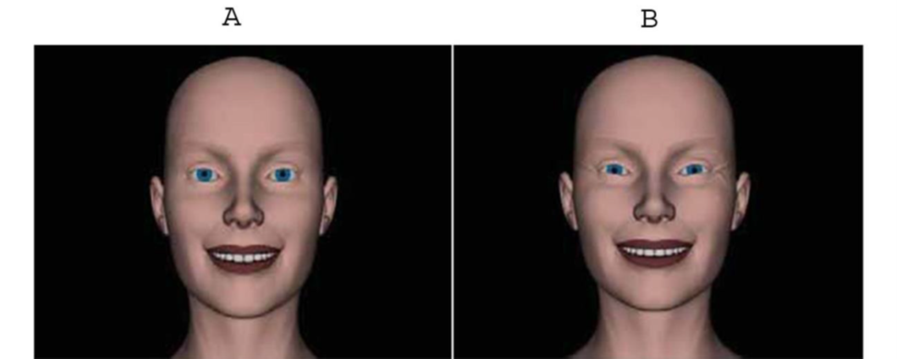

**Figure 2: A) Social smile, B) Enjoyment smile**

(Tjan et al, 1984) classified Smile depending on Incisor & gingival display has been distinguished into 3 types:

1. Low incisor display.
2. Average incisor display.
3. High incisor display.

**Low→** Less than 75% of maxillary incisor is displayed during a full smile. This type is seen in 20% of the population and is not an attractive characteristic of smile.

**Average→** Most frequent type of incisor display. Seen in 70% of young adults Population and reveals 75-100% of upper incisors display. More tooth display gives a more feminine & youthful smile ( Zarricson , 1998).

**High (Gummy Smile)→**Reveals the complete cervicoincisal length of upper incisors with a contiguous band of gingiva, seen in 10% of population.

Dental professionals have been conditioned to see a “gummy smile” as undesirable, but some gingival display is certainly acceptable, and is even considered a sign of youthful appearance. A gummy is often more esthetic than a smile with diminished tooth display.

Gummy smile is usually greater with younger age group which lessens as the person grows older thus decreasing the incisor and gingival display during rest and smile (Sarver and Ackermann, 2003). This is because as age advances upper lip coverage tends to increase.

Excessive gingival exposure during smile can be corrected by orthodontic intrusion, orthognathic surgery to move the maxilla up, & implant anchorage to intrude maxillary teeth. But over-doing intrusion of anterior teeth makes the smile less attractive & patient looks older (Proffit and Sarver, 2003). If the tooth display is inadequate, elongating the upper teeth improves the smile, makes patient look younger. This can be achieved by extrusion mechanics with arch wires, judicious use of class II elastics to take advantage of their tendency to rotate the occlusal plane down anteriorly and anterior vertical elastics. In patients with maxillary deficiency rotating the maxilla down in front as it is advanced surgically can improve smile esthetics (Proffit and Sarver, 2003).

The amount of proclination of maxillary incisors can affect how much they are displayed at rest & on smile. Flared max incisors tend to reduce incisor display & upright maxillary incisor tend to increase incisor display (Sarverand Ackermann, 2003).

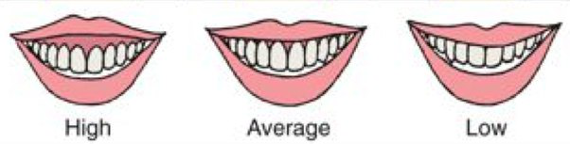

A B C

**Figure 3: A) Average smile, B) Low smile, C) Gummy smile**

(Rubin et al, 1989) classified three styles of smile depending on the direction of elevation and depression of the lips and the predominant muscle groups involved. He stated that in Commissure smile, the zygomaticus major muscles pull the upper-lip like a Cupid's bow. This is referred as the Mona Lisa smile. In the canine smile, the upper-lip is elevated uniformly like a diamond without the corners of the mouth turning upward. In the complex smile/full denture smile, the upper-lip moves superiorly as in the canine smile, but the lower-lip also moves inferiorly.

**1.6.2. Smile arc (Smile curve)**

Smile arc is defined as the relationship of the curvature of the incisal edges of maxillary anterior teeth to the curvature of the lower lip during a social smile (Sarver,2001 ).

Smile arc can be of 3 types:

1. Parallel (Consonant) smile arc.
2. Straight (flat) smile arc.
3. Reverse smile arc.

The parallel smile arc has the curvature of the maxillary incisal edges parallel to the curvature of the lower lip upon smiling and the term consonant (ideal) is used to describe this parallel relationship. (Figure 4A)

Goldstein (1997) referred the consonant smile as “youthful smile”.

A non consonant, or flat smile arc is characterized by the maxillary incisal curvature being flatter than the curvature oflower lip during smile. (Figure 4B)

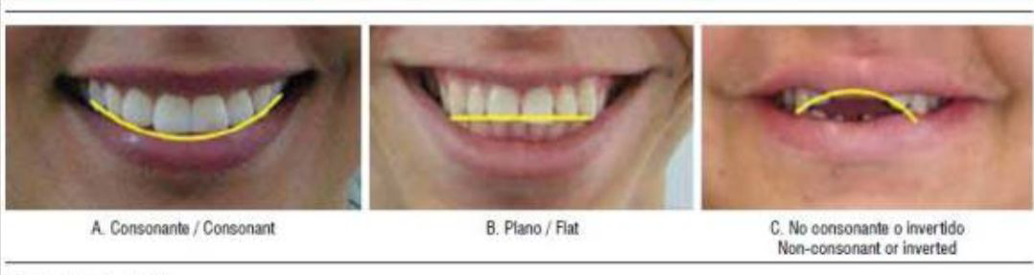**Figure 4: A) Consonent smile arc, B) Flat smile arc, C) Reverse smile arc**

Reverse smile arc is the one where canines are lower than the incisors in the maxillary arch and the arc formed by the maxillary anterior teeth is reverse in relation to lower lip curvature during smile. (Figure 4C)

The characteristics of the smile arc must be monitored during orthodontic treatment because it is surprisingly easy to flatten during orthodontic treatment procedures. Obtaining and maintaining a proper smile arc requires proper bracket positioning during orthodontic treatment. The traditional guideline for placing brackets is based on measurements from the incisal edge, so that the central incisor brackets are placed at the middle of the clinical crown, lateral incisor, 0.5mm closer to incisal edge and canine at the same level as centralincisors (Sarver, 2001) .Flatsmile arc& reverse smile arc can be improved by placing the central incisor brackets more gingivally or by giving astep bend in the archwire, tobring about extrusion of maxillary incisors (Sarver, 2001 ).

**1.6.3. Buccal Corridors**

Buccal corridors refer to the distance between the maxillary posterior teeth (especially premolar) and the inside of the cheek. This is of interest to Prosthodontists & more recently to Orthodontists. This was first introduced by Frush and Fisher (1958) which defines the transverse dimension of the smile and is referred to in terms of “broadness of the smile”. (Figure 5)

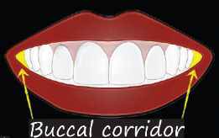

**Figure 5: Buccal corridor**

Excessively wide buccal corridors have been referred to as “negative space”, which can be reduced orthodontically by transverse expansion of the maxilla (Sarver and Ackermann, 2003).

Esthetically, a broad smile is considered to be more attractive than a narrow one, but too broad a smile with no buccal corridor is also un esthetic (Proffit and Sarver, 2003).

1.7. WAY‟S TO ASSESS SMILE:

There are certain vital elements of smile designing which includes the following:

Vital elements of smile designing (Dental composition):

1. Tooth components.

a. Dental midline.

b. Incisal length.

c. Tooth dimensions.

d. Axial inclinations.

e. Zenith points.

f. Incisal embrasures.

g. Interdental contact area and Interdental contact points.

h. Sex, personality and age.

i. Symmetry and balance.

2. Soft tissue components.

a. Gingival health.

b. Gingival level.

c. Smile line.

d. Interdental embrasure.

**1.7.1. Tooth component of smile:**

* **Dental Midline:**

These are least noticed by the patients and dental personnel. As long as the midline is parallel with the long axis of the face, midline discrepancies of up to 4 mm will generally not be perceived as unesthetic. Slight corrections of midline can be corrected by restorative dentistry. The ideal treatment is orthodontics (Edward and Phong, 2009).

* **Incisal Length:**

Published reports have shown that the average 30 year old woman displays about 3.5 mm of maxillary incisor tooth structure when the lips are at rest.

The prosthodontic literature has generally recommended setting denture teeth so that 2 mm of tooth structure is displayed at rest (Vig and Brundo, 1978). If patient displays less than 4 mm of the maxillary centrals at rest, the teeth need to be lengthened and this length will be achieved by adding to the incisal edge.

* **Tooth Dimensions:**

If the incisal display at rest is 3 mm to 4 mm, and it is determined that the teeth are too short, then surgical crown lengthening procedures should be considered (Edward and Phong, 2009).If there is insufficient tooth display at rest, normal lip mobility, the teeth are the correct length, and there is inadequate tooth display during smiling, then this is diagnostic of vertical maxillary insufficiency. This is not a case that should be treated with esthetic tooth lengthening. This is an orthognathic problem and should be referred for proper treatment (Robbins, 1999).

* **Axial inclinations:**

Tooth inclinations compare the vertical alignment of maxillary teeth, visible in the smile line, to central vertical line. The evaluation of axial inclination can be done on a photograph of the anterior teeth in a frontal view. A line is sketched on each tooth from the midline of the incisal edge through the midline of the tooth at its gingival interface (Mohan, 2010).

* **Zenith points:**

The gingival zenith point is the most apical point of the gingival tissues along the long axis of the tooth.

* **Incisal embrasures and contact points:**

From central to canine, an open space is formed between the proximal surfaces of incisal edges from the contact points. These embrasure spaces terminate at the contact points with the adjacent teeth. Failure to provide adequate depth and variation to the incisal embrasure will make the teeth appear too uniform and contact areas too long which gives box like appearance of the dentition(Mohan,2010).

* **Sex :**

Minor differences in the length, shape and positioning of the maxillary teeth allow for dramatic differences.

* For Female, the maxillary incisors should be round smooth, soft delicate and for male, should be cuboidal, hard and vigorous.
* **age :**
* Youthful teeth: unworn incisal edge, defined incisal embrasure, low chroma and high value
* Aged teeth: shorter; so less smile display, minimal incisal embrasure, high chroma and low value.
* **Symmetry and Balance:**

Lip symmetry involves the mirror image appearance of each lip when smiling. Independent evaluation of upper and lower lip is essential when analyzing both symmetry and fullness. Sometimes plastic surgery is necessary to provide results desired by the patients. Balance is observed as the eyes move distally from the midline, so that both the sides of the smile are well balanced (Mohan, 2010).

**1.7.2. SOFT TISSUE COMPONENT OF SMILE DESIGN:**

* **Gingival health, level and harmony:**

The gingival frame the teeth and add to the symmetry of the smile. The health, color and texture of the gingival tissues are paramount for long term success and the esthetic value of the treatment. Healthy gingiva is usually pale pink in color, stippled, firm and should exhibit a matte surface. A normal healthy gingival sulcus should not exceed 3 mm in depth.

* **Smile Line:**

It's an imaginary line drawn along the incisal edges of the maxillary anterior teeth. In an esthetic smile, the edges of the maxillary anterior teeth follow a convex or gull-wing course matching the curvature of the lower lip (Edward and Phong,2009) .In a reverse smile line, the centrals appear shorter than the cuspids along the incisal plane. Lip line should not be confused with the smile line.

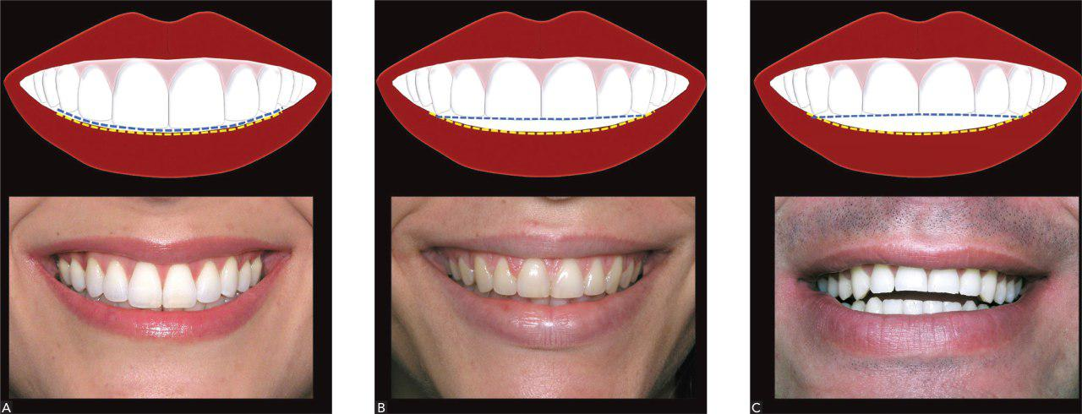

**Figure 6: A) Normal smile line, B) Flat smile line, C) Reverse smile line**

* **Interdental embrasures:**

The darkness of the oral cavity shouldn't be visible in the interproximal triangle between the gingival and the contact area. The black triangles will be avoided if the most apical point of the restoration is 5 mm or less from the crest of the bone. Sometimes this will require long contact area and will be extended towards the cervical. Which encourage the formation of healthy pointed papilla instead of the blunted tissue form that often accomplishes a black triangle (Tarnow et al,1992).

**1.7.3. FACIAL COMPOSITION:**

* **Lip line:**

When smiling, the inferior border of the lip as it relates to the teeth and gingival tissues is the lip line. Dentistry has arbitrarily classified 3 types of smiles that, relating the height of the upper lip relative to the maxillary anterior central incisors which are referred to as presenting a low lip line, middle lip line, high lip line.

Average lip line-exposes the maxillary teeth and only the interdental papilla.

Low lip line: exposes no gingival tissues when smiling.

High lip line: exposes the teeth in full display also gingival tissues above the gingival margins (Patil, 2002).

In cases where there is a high lip line and an excessive gingival display exists, an unwanted „gummy smile‟ become evident. There are many corrective options available. The vertical maxillary excess can be determined with cephalometric analysis. Orthodontics and orthognathic surgery to impact the maxilla are ideal when these conditions are confirmed as skeletal dysplasia‟s in nature (Sabri, 2005).

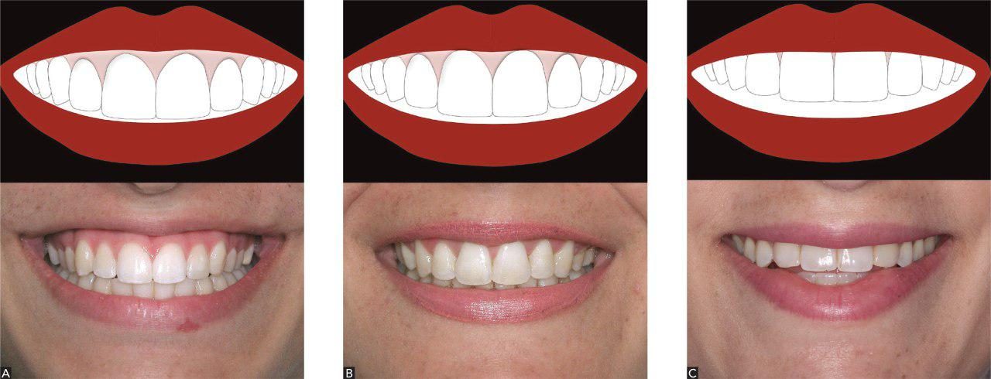

**Figure 7: A) High lip line, B) Average lip line, C) Low lip line**

* **Interpupillary line:**

This should be parallel with the horizon line and perpendicular to the midline of the face. Also it should be parallel with the commeasure line and occlusal plane.

**1.8. Esthetic smile**

**1.8.1. Golden proportions**

The concept of the „golden proportion‟ has often been offered as a cornerstone of smile design theory (Minoo,2004). The term ''golden proportion'' has been used for centuries. The golden proportion mathematically denotes that the ratio of a smaller to a larger length is equal to the ratio of the larger length to the total length. Application of golden proportion to dental esthetics was first documented by Levin in 1978. He explained the association of proportion with an esthetically pleasing dentition and smile. A portion between 2 adjacent parts which is repeated across enhances the unity within the diverse part of the composition (Meenu and Santu, 2013). This ratio is approximately 1.61803:1; that is, the smaller section is about 62% the size of the larger. The uniqueness of this ratio is that the ratio of the smaller part to the larger part is the same as the ratio of the larger part to the whole (Rosenstiel et al, 2001).

Lombardi was the first to propose the application of the golden proportion in dentistry, stating, ‟it has proved too strong for dental use‟ also he defined the idea of a repeated ratio which implies that in an optimized dentofacial composition from the frontal aspect, the lateral to central width and the canine to lateral width are repeated in proportion

(Lombardi ,1973) . Maxillary central incisors, because of their position in front of the arch, should appear to be the widest, whitest, and therefore ,the most predominant teeth when viewed from the frontal aspect.

Clearly, for the golden proportion to be most useful in esthetic dentistry, it must be adapted for easy bilateral analysis of the teeth. Snow has advocated theuse of the ‟golden percentage‟ as a means of applying the golden proportion across the midline to encompass the total canine-canine width(Snow ,1999).

**Materials and method**

**2.1. Materials**

**2.1.1. Sample**

The sample of this study was consisting of 63 students of 5th grade undergraduate students from College of Dentistry/University of Baghdad. After the research purpose was explained to the students and an agreement was obtained from them to participate in this study, 189 extraoral photographs were taken (three photographs for each student).

All the participants in the project were examined clinically.

**2.1.2.Criteria for Sample Selection**

**a. Inclusion criteria:**

1. All are Iraqi with an age ranged between 21-23 years.
2. All have full permanent dentition regardless the third molars.
3. Normal overjet and overbite (2-4 mm).
4. Bilateral Class I buccal segments "molar and canine" **(Angle, 1899).**
5. Skeletal Class I relationship determined clinically by two finger method **(Foster, 1985).**
6. No spacing or crowding in the anterior teeth.

**b. Exclusion criteria:**

1. History of facial trauma, orthodontic/orthognathic treatment, dentofacial deformities, surgeries or asymmetry.
2. Presence of anterior or posterior crossbite**.**
3. Presence of dental midline shift.
4. Presence of active periodontal diseases and gingivitis**.**
5. History of bad oral habits like thumb sucking, tongue thrust or mouth breathing.
6. Presence of intruded, extruded or rotated teeth in the anterior region.
7. Presence of signs of attrition and restoration of the maxillary anterior teeth.
8. Presence of proximal caries, developmental anomalies such as supernumerary teeth, prosthesis in the anterior teeth.

**2.1.3. Instruments and Equipments**

* Disposable dental mirrors, cotton, gloves, masks, disinfectant (Desident Cavicide, Spofadental)
* Measuring tape to measure the distance between the participants and the camera lens.
* A digital camera (Nikon D5200, 24.1 Megapixels, Thailand) with (18-55) lens.
* Two rulers variable in size, onefor the extraoral photograph and the other for intra oral examination.
* white background made of a piece of cloth.
* Stool.
* Personal Computer (Sony Vaio CW16FA).
* Analyzing software (AutoCAD, 2007).

**2.2 Methods**

**2.2.1. History and Clinical Examination**

Each participant was seated on the dental chair and information about his/her name, age, medical and dental history was obtained from him/her, then each participant was examined clinically (extraoral and intraoral) to ensure his/her inclusion in the study according to criteria of sample selection.

**2.2.1.1. Skeletal Examination:**

**a. Anteroposterior Relation:** each participant was postured in an upright position with Frankfort plane parallel to the floor, and asked him/her to occlude gently on posterior teeth and look straight forward.

By using the index finger of the right hand to palpate the soft tissue point A (deepest point in the upper lip at midline) and the middle finger to palpate the soft tissue point B (deepest point in the lower lip at midline), the skeletal pattern was assessed **(Roberts-Harry and Sandy, 2003).**

b. Vertical Relation: The vertical relation was measured in terms of facial height, the upper anterior facial height was represented by the distance from the point between the eyebrows “glabella” to the base of the nose “subnasale”, the lower anterior facial height was the distance from the soft tissue menton (base of the chin) to the base of the nose, after marking the points of glabella (Gl), subnasale (Sn), menton (Me) with a marker, the facial heights were measured with a ruler **(Roberts-Harry and Sandy, 2003).**

**c. Horizontal Relation:** This dimension was assessed by looking at the participant head-on and assess whether there was asymmetry in the facial midline **(Roberts-Harry and Sandy, 2003).**

**2.2.1.2. Dental Examination:**

Each participant was examined intraorally to ensure that all permanent teeth were present according to the previously mentioned criteria. Then the relation between the maxillary and mandibular teeth were examined:

**2.2.2. Standardization of the Photographs**

The camera fixed in position and adjusted in height to be at the level of the participant’s eyes according to the participant’s body height. The distance from the camera to the background was fixed at a distance of about 100 cm,The EF-S 18-55mm lens was used, participants were seated on a constant chair in front of a white background which was made from a piece of cloth.

**2.2.3. Photographic Exposure**

Three frontal facial photographs were taken for the participant in rest and tow types of smile.

For the facial photographs, each participant was seated in upright position, and instructed to keep their teeth in maximum intercuspation and gently closed lips in rest position **(Al-Sehaibany F,2011).** The camera lens positioned parallel to the participant’s face and the participant was asked to look at the center of the camera’s lens during taking the photograph with the participant’s hair did not cover any part of the face **(Varjão *et al*., 2006(,** a ruler was placed near the participant’s head to correct the magnification. The digital camera was set on the manual exposure shooting chosen from the model dial that determined the desired function . Each shoot analyzed by AutoCAD 2007 program. The measurements were divided by scale for each picture to overcome the magnification.

**2.2.4. The Micro-aesthetic Appearance Includes:**

**2.2.4.1.** **Soft tissue points** **(Ricketts, 1982; Farkas, 1986):**

**1-Chilion (ch)**: a point located at each angle of mouth and selected to be on same level with stomion, but during smiling located with the level of stomion-superius **(Ricketts, 1982; Farkas, 1986)** .

**2- Stomionsuperius (stos)**: The lower most point on the vermilion border of the upper lip **(Jacobson, 1995)**.

**3-Stomion inferius (stoi)**: the upper most point on the vermilion border of the lower liP **(Jacobson, 1995)**.

2**.2.4.2. Linear Measurements (Ackerman and Ackerman, 2002):**

**1. Outer-commissural width (OCW):** It is the distance between right and left Chilion points **(Moore *et al.*, 2005 and Isksal *et al*., 2006)** **.**

**2. Inter-labial gap (ILG):** It is the distance between stomionsuperius point and stomion-inferius point **(Ackerman and Ackerman, 2002)**.

**3. Smile index (SI):** It represents the smile zone, obtained by dividing the outer commissural width by the inter-labial gap **(Ackerman and Ackerman, 2002)** .

**4. Maximium incisor show (MIS)**: It is the perpendicular distance between the inferior border of the upper lip and the incisal edge of the upper left central incisor in a maximum smile in order to determine the incisor show at smile **(Peck and Peck, 1992 b; Dickens *et al.*, 2002)**.

**2.2.5. The statistical analyses were:**

**1. Descriptive statistics**- include:

**a)** Mean.

**b)** Standard Deviation.

**c)** Maximum and Minimum values.

**2. Inferential statistics**- include:

1. Independent samples t-test: to test for statistical significant differences between genders in the same group for two types of smile.
2. Paired samples t- test: To compare between posed and unposed smile for male, female and total sample.

In the statistical evaluation, the following levels of significance are used:

|  |  |  |
| --- | --- | --- |
| **P > 0.05** | **NS** | **No significant** |
| **0.05 ≥ P > 0.01** | **\*** | **Significant** |
| **0.01 ≥ P > 0.001** | **\*\*** | **Highly significant** |
| **P ≤ 0.001** | **\*\*\*** | **Very highly significant** |

**Results:**

The table (3.1) shows that the SI for posed smile was more than unposed smile and in male more than the female. The same results for OCW where it is higher in male than the female for both types of smile. While ILG and MIS; it is higher in female than the male in posed smile and the same results in unposed smle.

The independent T-test show no significant difference for all measurements except for OCW it is highly significant difference between male and female for both types of smile, and MIS was highly significant difference between male and female in posed smile only as shown in table (3.2).

While paired T-test show very highly significant difference between posed and unposed smile for all variables as shown in table (3.3).

**Table ( 3.1 ): Descriptive statistic**

|  |  |  |  |  |  |  |  |  |  |  |
| --- | --- | --- | --- | --- | --- | --- | --- | --- | --- | --- |
| **Gender** | **Variables** | **Posed smile** | | | | **Unposed smile** | | | | |
| **Min.** | **Max.** | **Mean** | **Std. Deviation** | **Min.** | **Max.** | **Mean** | **Std. Deviation** |
| **Female**  **(No=30)** | **SI** | **4.91** | **15.69** | **9.3323** | **2.72555** | **3.97** | **11.34** | **6.3030** | **1.49107** |
| **OCW** | **55.10** | **72.00** | **61.8370** | **5.03934** | **52.03** | **80.81** | **68.7593** | **6.48964** |
| **ILG** | **3.51** | **12.81** | **7.2230** | **2.01856** | **6.21** | **18.05** | **11.4037** | **2.57239** |
| **MIS** | **3.58** | **10.00** | **6.5783** | **1.59161** | **1.56** | **12.34** | **8.7413** | **2.12408** |
| **Male**  **(No=33)** | **SI** | **7.94** | **13.42** | **10.3482** | **1.82797** | **5.27** | **9.00** | **6.7236** | **1.00110** |
| **OCW** | **57.35** | **75.57** | **67.8882** | **5.20003** | **60.45** | **80.53** | **75.0727** | **5.89137** |
| **ILG** | **5.09** | **8.32** | **6.6982** | **.96074** | **9.03** | **15.24** | **11.2373** | **1.55386** |
| **MIS** | **4.31** | **6.75** | **5.6991** | **.70761** | **6.18** | **11.10** | **8.5727** | **1.43220** |
| **Total**  **(No=63)** | **SI** | **4.91** | **15.69** | **9.8644** | **2.33685** | **3.97** | **11.34** | **6.5233** | **1.26572** |
| **OCW** | **55.10** | **75.57** | **65.0067** | **5.92582** | **52.03** | **80.81** | **72.0663** | **6.90765** |
| **ILG** | **3.51** | **12.81** | **6.9481** | **1.56591** | **6.21** | **18.05** | **11.3165** | **2.08526** |
| **MIS** | **3.58** | **10.00** | **6.1178** | **1.28033** | **1.56** | **12.34** | **8.6530** | **1.78219** |

|  |  |  |  |  |  |  |  |
| --- | --- | --- | --- | --- | --- | --- | --- |
|  | **Table (3.2): Independent T-test (Female= 30, Male =33)** | | | | | |  |
| **Type of smile** | **Variable** | **gender** | **Mean** | **Std. Deviation** | **t** | **Mean Difference** | **P-Value** |
| **Posed smile** | **SI** | **M** | **10.3482** | **1.82797** | **1.752** | **1.01585** | **NS** |
| **F** | **9.3323** | **2.72555** | **1.720** |
| **OCW** | **M** | **67.8882** | **5.20003** | **4.681** | **6.05118** | **\*\*\*** |
| **F** | **61.8370** | **5.03934** | **4.688** |
| **ILG** | **M** | **6.6982** | **.96074** | **-1.337-** | **-.52482-** | **NS** |
| **F** | **7.2230** | **2.01856** | **-1.297-** |
| **MIS** | **M** | **5.6991** | **.70761** | **-2.878-** | **-.87924-** | **\*\*** |
| **F** | **6.5783** | **1.59161** | **-2.786-** |
| **UnPosed smile** | **SI** | **M** | **6.7236** | **1.00110** | **1.325** | **.42064** | **NS** |
| **F** | **6.3030** | **1.49107** | **1.301** |
| **OCW** | **M** | **75.0727** | **5.89137** | **4.048** | **6.31339** | **\*\*\*** |
| **F** | **68.7593** | **6.48964** | **4.029** |
| **ILG** | **M** | **11.2373** | **1.55386** | **-.314-** | **-.16639-** | **NS** |
| **F** | **11.4037** | **2.57239** | **-.307-** |
| **MIS** | **M** | **8.5727** | **1.43220** | **-.372-** | **-.16861-** | **NS** |
| **F** | **8.7413** | **2.12408** | **-.366-** |

**Table (3.3):** **Paired Samples Statistics**

|  |  |  |  |  |  |  |
| --- | --- | --- | --- | --- | --- | --- |
| **Paired Samples Statistics (Total / No.=63)** | | | | | | |
|  | | **Mean** | **Std. Deviation** | **T-test** | **Mean difference** | **P-value** |
| **Pair 1** | **SI1** | **9.8644** | **2.33685** | **15.132** | **3.34111** | **\*\*\*** |
| **SI2** | **6.5233** | **1.26572** |
| **Pair 2** | **OCW1** | **65.0067** | **5.92582** | **13.963-** | **-7.05968-** | **\*\*\*** |
| **OCW2** | **72.0663** | **6.90765** |
| **Pair 3** | **ILG1** | **6.9481** | **1.56591** | **-22.691-** | **-4.36841-** | **\*\*\*** |
| **ILG2** | **11.3165** | **2.08526** |
| **Pair 4** | **MIS1** | **6.1178** | **1.28033** | **-16.242-** | **-2.53524-** | **\*\*\*** |
| **MIS2** | **8.6530** | **1.78219** |
| **Paired Samples Statistics (Female / No.=30)** | | | | | | |
|  | | **Mean** | **Std. Deviation** | **T-test** | **Mean difference** | **P-value** |
| **Pair 1** | **SI1** | **9.3323** | **2.72555** | **7.701** | **3.02933** | **\*\*\*** |
| **SI2** | **6.3030** | **1.49107** |
| **Pair 2** | **OCW1** | **61.8370** | **5.03934** | **-7.653-** | **-6.92233-** | **\*\*\*** |
| **OCW2** | **68.7593** | **6.48964** |
| **Pair 3** | **ILG1** | **7.2230** | **2.01856** | **-11.899-** | **-4.18067-** | **\*\*\*** |
| **ILG2** | **11.4037** | **2.57239** |
| **Pair 4** | **MIS1** | **6.5783** | **1.59161** | **-8.564-** | **-2.16300-** | **\*\*\*** |
| **MIS2** | **8.7413** | **2.12408** |
| **Paired Samples Statistics (Male3No.=33)** | | | | | | |
|  | | **Mean** | **Std. Deviation** | **T-test** | **Mean difference** | **P-value** |
| **Pair 1** | **SI1** | **10.3482** | **1.82797** | **16.621** | **3.62455** | **\*\*\*** |
| **SI2** | **6.7236** | **1.00110** |
| **Pair 2** | **OCW1** | **67.8882** | **5.20003** | **-13.813-** | **-7.18455-** | **\*\*\*** |
| **OCW2** | **75.0727** | **5.89137** |
| **Pair 3** | **ILG1** | **6.6982** | **.96074** | **-24.809-** | **-4.53909-** | **\*\*\*** |
| **ILG2** | **11.2373** | **1.55386** |
| **Pair 4** | **MIS1** | **5.6991** | **.70761** | **-16.578-** | **-2.87364-** | **\*\*\*** |
| **MIS2** | **8.5727** | **1.43220** |

**Note: 1 mean posed smile and 2 mean unposed smile.**

**Discussion:**

The results of this project could be explained as following:

1. Outer commissural width:

The mean value outer commissural width for males was significantly higher than that in females. This may follow the general rule that the males are larger than the females in all dimensions. This finding comes in agreement with Al-Ramahi (2009).

2. Interlabial gap

The mean value of interlabial gap for males was insignificantly smaller than that in females. This may be due to that females smiled more often and more openly than males. These data are congruent with (Maulik and Nanda, 2007) or this may be due to women have more lip elevation than men (Sabri, 2005).

3. Smile index

The mean value of smile index for males was significantly larger than that in females. This may result from an increase in outer commissural width and decrease in inter labial gap for males which will lead to increase in smile index (Ackerman et al, 1998; Ackerman and Ackerman, 2002).

4. Maximum incisor show

The mean value of maximum incisor show for males was insignificantly smaller than that in females. This could be attributed to the feminine round teeth shape for females and masculine square teeth shape for males or may be due to women have more lip elevation than men (Sabri, 2005).This could also be explained on the basis of vertical lip growth which is much more in males than in females as stated by Gunsolus (2003).

**Appendix**

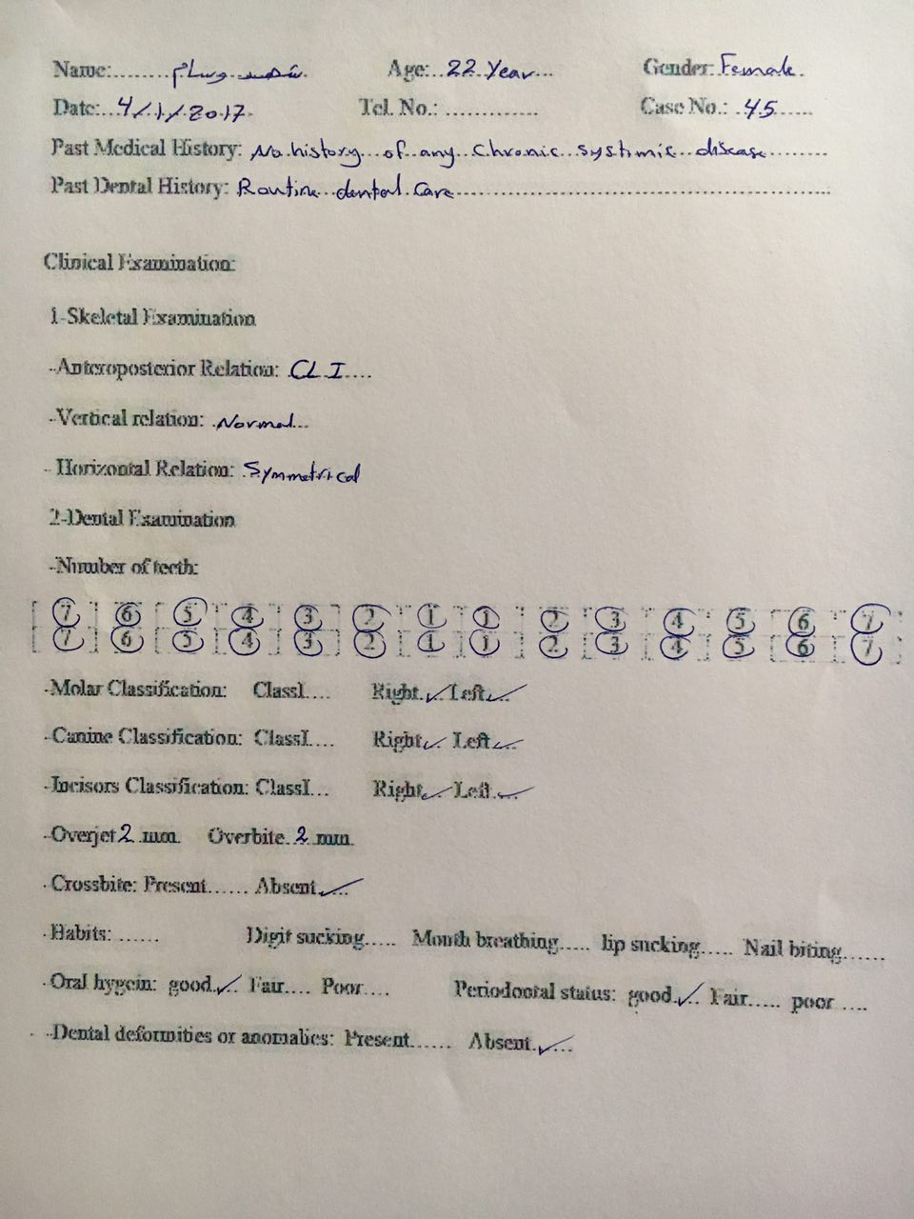

**References**

A.

* **Ackerman MB, Ackerman JL.** Smile analysis and design in the digital era. J Clin Orthod. 2002;36:221–36.
* **Al-Sehaibany F.** Analysis of maxillary anterior teeth and various facial dimensions among adolescents in riyadh, saudi Arabia. JPDA 2011; 20(2): 67-72.
* **Angle EH.** Classification of malocclusion. Dent Cosmos 1899; 41(3): 248-264.

**D.**

*  **Dickens S, Sarver DM, Proffit WR.** The dynamics of the maxillary incisor and the upper lip: A cross-sectional study of resting and smile hard tissue characteristics. World J Orthod 2002; 3(4): 313-20.

**E.**

* **Edward A. McLaren, DDS, MDC : and Phong Tran Cao,** DDS Smile Analysis and Esthetic Design: “In the Zone” INSIDE DENTISTRY JULY/AUGUST 2009.

**F.**

* **Farkas LG.** Anthropometric and art in the aesthetic of women's face. Clin. Plast. Surg. 1986 , 14, 599-615.
* **Foster TD.** A text book of orthodontics. 2nded. Oxford: Blackwell Scientific Publication; 1985. p. 14, 34-36.
* **Frush JO and Fisher RD.** The dynesthetic interpretation of the dentogenic concept. J. Prosth. Dent.1958;8:558-81.

**G.**

* **Goldstein RE.** Change your smile. 3rd ed. Louis: Quintessence pub co,Inc;1997.

**I.**

*  **Isıksal E, Hazar S, Akyalçın S.** Smile esthetics: Perception and comparison of treated and untreated smiles Am J Orthod Dentofacial Orthop 2006; 129:8-16.

**J.**

*  **Jacobson A.** Radiographic cephalometry from basics to videoimaging. 1sted. Chicago: Quintessence publishing Co; 1995. p.43, 240.

**L.**

* **Lombardi R.** The principles of visual perception and their clinical application to dental esthetics. J Prosthet Dent 1973; 29:358-381.

**M.**

* **Meenu Merry C.** Paul and Santu Tom Abraham Golden Propotion In Denture Esthetics Health Sciences 2013; 2(1):JS008.
* **Minoo Mashid, DDS, MS.et al.** Evaluation of “Golden Proportion” in Individuals with an Esthetic Smile. (J Esthet Restor Dent 16:185-193, 2004).
* **Mohan Bhuvaneswaran.** Principles of smile design. J Conserv Dent . 2010 Oct – Dec; 13(4): 225-232.
* **Moore T, Southard KA, Casko JS, Qian F, Southard TE.** Buccal corridors and smile esthetics. Am J Orthod Dentofac Orthop 2005; 127(2): 208-213

**P.**

* **Patil Ratnadeep.** Esthetic dentistry: An artist‟s science . 1st ed.Mumbai:PR Publications;2002.p.16-36.
* **Peck S, Peck HH.** A concept of facial aesthetics. Angle Orthod 1970; 40(4): 284-317.
* **Proffit WR, White RP, Sarver DM.** Contemporary treatment of dentofacial deformity, St Louis:Mosby;2003.
* **Proffit WR, Field HW, Ackerman JL,** Contemporary Orthodontics, 4th ed. St Louis: Mosby;2007.

**R.**

*  **Ricketts RM.** The biologic significance of the divine proportion and Fibonacci series. Am j orthod 1982; 81(5):351-370.
* **Ritter DE, Gandini LG, Jr, Pinto Ados S, Ravelli DB, Locks A.** Analysis of the smile photograph. World J Orthod. 2006;7:279–85.
* **Robbins JW.** Differential diagnosis and treatment of excessive gingival display. Pract Periodontics Aesthet Dent.1999;2:265-272.
* **Roberts-Harry D, Sandy J.** Orthodontics. part 2: patient assessment and examination I. BDJ 2003; 195(9): 489-493.
* **Rosenstiel SF, Land MF, Fujjimoto J.** Contemporary fixed prosthodontics. 3rd ed. St. Louis: CV Mosby ,2001. P. 598-599.
* **Rubin LR, Mishriki Y, Lee G.** Anatomy of the nasolabial fold: The keystone of the smiling mchanism. Plast Reconst Surgery. 1989;83:1–8.

**S.**

* **Sabri R.** The eight components of a balanced smile . J Clin Orthod.2005; 39(3):155-66.
* **Sarver DM.** The importance of incisor positioning in esthetic smile. The smile arc. Am J Orthod Dentofacial Orthop 2001;120: 98-111.
* **Sarver DM and Ackermann MB.** Dynamic smile visualization and quantification Part 2. smile analysis and treatment strategies. Am J Orthod Dentofacial Orthop 2003;124:116-27.
* **Snow, S.R.** Esthetic smile analysis of maxillary anterior tooth width: The golden percentage. J of Esthetic Dentistry, Vol. 11, No. 4, 1999; 177-184.

****

* **Tarnow DP, Manager AW, Fletcher P.** The effect of the distance from the contact point to the crest of the bone on the presence or absence of the interproximal papilla . J Periodontal . 1992; 63:995-6.
* **Tjan A, Miller G, The J.** Some esthetic factors in smile. J. Prosth. Dent. 1984;51:24-28.

**V.**

* **Varjão FM, Nogueira SS, Russi S, ArioliFilho JN.** Correlation between maxillary central incisor form and face form in 4 racial groups. Quintessence Int 2006; 37(10): 767-771.
* **Vig RG, Brundo Gc.** The Kinetics of anterior tooth display. J Prosthet Dent. 1978:39; 502-504.

**Z.**

* **Zarricson BU.** Esthetic factors involved in anterior tooth display and smile: Vertical dimention. J Clin Orthod 1998;32:432-45.