Republic of iraq
Ministry of higher education
Scientific research
University of baghdad
College of dentistry

space creation in orthdotics

A project
Submitted to the college of dentistry, University of baghdad, Department of orthodontics.

By:
Mustafa ali abdul-kader
Suppervised by :
Dr. Sara Mohammed

2017 1438
Dedication

To my parents who were their for me in every step of the way with their love and support
&
To my supervisor DR. Sara for her guidance, help and endless support throughout this project

Mustafa
Acknowledgment
First of all, all thanks and praises to “Allah” for guiding and helping me by giving me the ability, ambition and patience to complete this project.
I would like to express my honest gratitude to the Dean of College of Dentistry, University of Baghdad, Prof. Dr. Hussain F. Al-Huwaizi, for offering me the opportunity to perform my study.
I would also like to express my gratitude to Prof. Dr. Dhiaa, Head of the Department of Orthodontics.
Lastly, I would like to offer my deepest gratitude and appreciation to Dr. Sara Mohammed for her kind support and guidance to make this project possible.

Introduction

for the resolution of majority of malocclusion and For achieving majority of the treatment objectives . space has to be created within the jaws, The modern orthodontic therapy attempts, whenever possible, a nonextraction treatment, with convenient means for the patient, which would allow current activities and it would not affect facial harmony, In this context there is several useful treatment method in obtaining space that each one of them has indication and advantages over the others methods , so i’ll explain each one of them in this project.

Table of contents
No. | Title | Page no.
1 | Literature review | 2
1.1 | Methods of space creation | 3
1.1.1 | Proximal stripping | 3
1.1.1.1 | Indications for proximal stripping | 3
1.1.1.2 | Contraindications for interproximal enamel reduction | 4
1.1.1.3 | Enamel Thickness Available for Reduction | 4
1.1.1.4 | Interproxiaml enamel stripping techniques | 4
1.1.1.5 | Complications of interproximal enamel Reduction | 5
1.1.2 | Maxillary expansion | 7
1.1.2.1 | Rapid maxillary expansion (RME) | 7
1.1.2.1.1 | Indications of RME | 8
1.1.2.1.2 | Contraindication of RME | 8
1.1.2.1.3 | Disadvantages of RME | 8
1.1.2.1.4 | Appliances of RME | 8
1.1.2.1.4.1 | Tooth borne RME appliances | 9
1.1.2.1.4.1.1 | HYRAX expander | 9
1.1.2.1.4.1.2 | Issacson expander | 9
1.1.2.1.4.2 | Tooth and tissue borne rme | 10
1.1.2.1.4.2.1 | Types of Tooth and Tissue Borne | 10
1.1.2.1.5 | Bonded rapid palatal expander | 10
1.1.2.1.6 | IPC Rapid palatal expander | 11
1.1.2.2 | Slow maxillary expansion | 11
1.1.2.2.1 | SME appliances | 12
1.1.2.2.1.1 | Coffin Appliance | 12
1.1.2.2.1.2 | Magnets | 12
1.1.2.2.1.3 | W-Arch | 13
1.1.2.2.1.4 | Quadhelix | 13
1.1.2.2.1.5 | Spring Jet | 13
1.1.2.2.1.6 | NiTi Expander | 14
1.1.2.3 | Surgical Techniques | 14
1.1.3 | Molar Distalization | 15
1.1.3.1 | Types of appliances | 15
1.1.3.1.1 | Headgear | 15
1.1.3.1.2 | Acrylic cervical occipital (ACCO) | 16
1.1.3.1.3 | Transpalatal arch | 17
1.1.3.1.4 | Wilson bimetric distalizing arch (BDA) system | 17
1.1.3.1.5 | Herbst | 18
1.1.3.1.6 | Jasper Jumper | 18
1.1.3.1.7 | Forsus | 19
1.1.3.1.8 | Repelling magnets | 19
1.1.3.1.9 | Jones Jig | 20
1.1.3.1.10 | Ni–Ti wires | 20
1.1.3.1.11 | Distal - Jet | 21
1.1.4 | Extraction | 22
1.1.4.1 | Factors affecting the decision to extract | 22
1.1.4.2 | Extraction of specfic teeth | 22
1.1.4.2.1 | Lower incisors extraction | 22
1.1.4.2.2 | Upper Incisors extraction | 23
1.1.4.2.3 | Canines extraction | 23
1.1.4.2.4 | Premolars | 23
1.1.4.2.5 | First molars | 24
1.1.4.2.6 | Second molars | 24
1.1.5 | Uprighting of tipped molar | 25
1.1.5.1 | Differential diagnosis of tipped molars | 25
1.1.5.2 | Causes of Molar tipping | 26
1.1.5.3 | Indications of uprighting for space gaining | 26
1.1.5.4 | appliance design | 27
1.1.6 | Derotation of posterior teeth | 28
1.1.7 | Proclination of the incisors | 29
List of figures
Name | Page no.
Figure (1) crowdnig | 2
Figure (2) Teeth angulated (bottom) occupy more space in the arch than those upright (top). | 2
Figure (3) overnite reduction | 2
Figure (4) overjet reduction | 2
Figure (5) correction of tooth inclination | 2
Figure (6) modified tuverson technique, using a diamond disk | 5
Figure (7) contra-angle- mounted diamond-coated disks. | 5
Figure (8) ortho-strip with a special holder | 5
Figure (9) Tooth and tisue borne | 8
Figure (10) Tooth borne | 8
Figure (11) HYRAX expander | 9
Figure (12) issacson expander | 9
Figure (13) Haas | 10
Figure (14) Derichweiler | 10
Figure (15) Bonded palatel expander | 11
Figure (16) Ipc rapid palatal expander | 11
Figure (17) Coffin appliance | 12
Figure (18) Magnets | 12
Figure (19) W-arch | 13
Figure (20) Quadhelix | 13
Figure (21) spring jet | 14
Figure (22) NiTi Expander | 14
Figure (23) (a) high-pull headgear. (b)cervical-pull headgear. (c) combi-pull headgear. | 16
Figure (24) Acrylic cervical occipital (ACCO). | 16
Figure (25) Biomechanical force system produced by a unilateral firstorder activation of a statically indeterminate TPA. | 17
Figure (26) Wilson Bimetric Distalizing Arch and lower full- fixed bonded appliance. | 17
Figure (27) Dental effects produced by the Herbst appliance. | 18
Figure (28) Jumper mechanism connected to a SS 0.017” · 0.025”sectional wire. | 18
Figure (29) Forsus appliance. | 19
Figure (30) (a,b) Biomechanical force system produced by repelling magnets – sagittal (30a) and occlusal view (30b). | 19
Figure (31) Biomechanical force system produced by the Jones Jig-sagittal (31a) and occlusal view (3b). | 20
Figure (32) Biomechanical force system produced by Ni–Ti wire. | 21
Figure (33) Biomechanical force system produced by the Distal-Jet- sagittal view. | 21
Figure (34) Center of Resistance. | 26
Figure (35) Mesial drift. | 26
Figure (36) uprighting appliance. | 27
Figure (37)(A,B) Derotation | 28

Introduction

for the resolution of majority of malocclusion and For achieving majority of the treatment objectives . space has to be created within the jaws, The modern orthodontic therapy attempts, whenever possible, a nonextraction treatment, with convenient means for the patient, which would allow current activities and it would not affect facial harmony, In this context there is several useful treatment method in obtaining space that each one of them has indication and advantages over the others methods , so i’ll explain each one of them in this project.

Chapter one
1 Literature Review
Whenever extraction is done or tooth is fallen the adjacent teeth moves into the arch & tries to fill the space of that extracted tooth which may resultin malocclusion. For the prevention of that malocclusion interceptive measures are used. Space may be required in the dental arches to achieve a number of treatment aims relating to the malocclusion: (Cobourne , Dibiase , 2010)
- Relief of dental crowding (Fig. 1 ).
- Correction of tooth angulation (Fig. 2).
- Arch levelling and overbite reduction (Fig. 3).
- Overjet reduction (Fig. 4).
- Correction of tooth inclination or torque (Fig. 5).
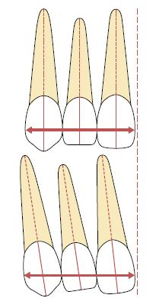
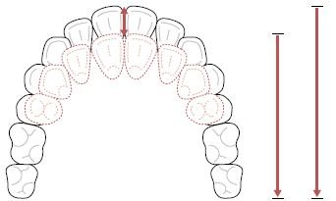
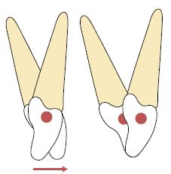
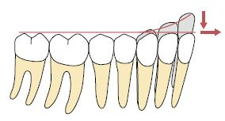
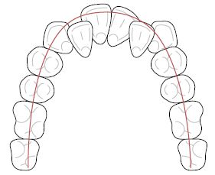
Figure (5) correction of tooth inclination (Cobourne, Dibiase, 2010)
Figure (1) crowdnig (Cobourne ,Dibiase ,2010)
Figure (3) overnite reduction (Cobourne, Dibiase , 2010)
Figure (2) Teeth angulated (bottom) occupy more space in the arch than those upright (top). (Cobourn, Dibiase , 2010)
Figure (4) overjet reduction (Cobourne, Dibiase , 2010)
1.1 Methods of space creation
- PROXIMAL STIPPING.
- ARCH EXPANSION.
- EXTRACTION.
- DISTALIZATION OF MOLAR.
- UPRIGHTING OF TILTED MOLAR.
- DEROTATION OF POSTERIOR TEETH.
- PROCLINATION/FLARING OF ANTERIORS.
1.1.1 Proximal stripping
Interproximal enamel reduction, also known as interdental stripping, enamel approximation or slenderizing, is a well-known technique that is frequently applied during orthodontic treatment. Not only can the clinician achieve better alignment and occlusion of the teeth through this adjunct to overall treatment, but it also simplifie the long-term maintenance of tooth alignment. (Rossouw,Tortorella, 2003)
1.1.1.1 Indications for proximal stripping (Lapenaite,Lopatiene, 2014)
The main indications for IER in the treatment of adults are:
- the ability to safely obtain sufficient space for tooth movement without the need for extractions .
- when the lack of space in the dental arch is 4 to 8 mm .
- Bolton Index discrepancy.
- changes in tooth shape and dental esthetics within the enamel .
- crowding
- Macrodontia .
- correction of the Curve of Spee .
1.1.1.2 Contraindications for interproximal enamel reduction (Lapenaite, Lopatiene,2014)
- crowding more than 8 mm per arch.
- poor oral hygiene, active periodontal diseases .
- Enamel hypoplasia .
- hypersensitivity to cold .
- High caries index, and multiple restorations because there is a risk of causing imbalance in an unstable oral situation (the treatment outcomes and possible complications are difficult to predict).
- rectangular-shaped front teeth–because it is difficult to create appropriate contact point .
- round-shaped premolars and young patients with large pulp chambers .
1.1.1.3 Enamel Thickness Available for Reduction
It has been suggested that approximately 50% of the interproximal enamel can be safely removed . Estimates of the amount of tooth structure that can be removed depend on accurate reference data for enamel thickness, which are currently unavailable. However, reduction of the interproximal surfaces of the anterior teeth has not resulted in increased susceptibility to caries or periodontal disease (Tuverson , 1980) Although Radlanski and others suggested that there was an increase in caries with interproximal reduction of the posterior segment (Radlanski et al , 1988).
1.1.1.4 Interproxiaml enamel stripping techniques
- The air-rotor stripping technique with fine tungsten-carbide or diamond burs and diamond-coated strips (figure 6)
- Hand-piece or contra-angle-mounted diamond-coated disks (figure 7)
- Handheld or motor-driven abrasive metal strips (figure 8) .
The technique of IER depends on the severity of crowding and the segments of the teeth. (Lapenait, lopatiene,2014)
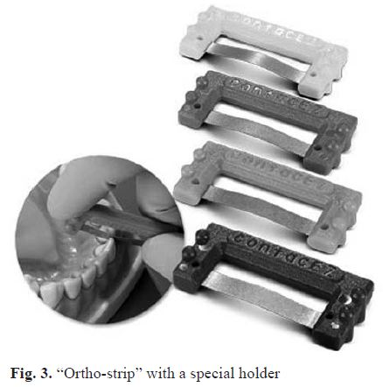
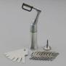
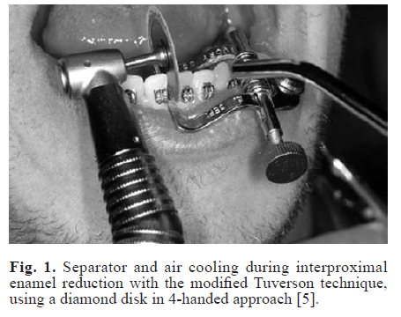

Figure (8) ortho-strip with a special holder (Chudasama,Sheridan , 2007)
Figure (7) contra-angle-mounted diamond-coated disks. (Frindel , 2010 )
Figure (6) modified tuverson technique, using a diamond disk . (Zachrisson et al , 2007)
1.1.1.5 Complications of interproximal enamel Reduction
- Excessive IER can lead to hypersensitivity (Singh, 2007) .
- irreversible damage of the dental pulp (Singh , 2007) .
- increased formation of plaque and caries (Zachrisson et al 2007) .
- risk of periodontal diseases (Phulari ,2011) .
- Hypersensitivity to temperature changes wich depends on :(Lapenaite, Lopatiene , 2014) the age of the patient , the severity of crowding, pathological tooth wear, hypersensitivity before treatment and the amount of the removed enamel .

Instruments used for IER | Manual/Rotary instruments | Advantages | Disadvantages
Thin metal strip with an abrasive material | Manual | Can be used when the teeth are so rotated that a disk is not appropriate. Can be used for re-contouring teeth after IER. | 1- Impractical, unproductive, and time-consuming when used for buccal teeth.  2-Leaves bits of the strip lodged between the teeth.
Diamond discs | Rotary instrument | The smoothest enamel surface is achieved when using with polishing after IER. | - Dangerous using high speed rotating instrument in close proximity to a patient’s tongue, cheeks and lips.  - Using a disc guard to the hand piece to guard against the possibility of cutting into soft tissues reduce visibility.  3-Unpredictable results.  4-Leaves deep cuts on the enamel.
Burs | Rotary instrument | Have deactivated points that will not create ridges in the proximal enamel. Painless and precise. | 1- Leave the roughest enamel surface after IER compared to diamond discs and metal strips.  2- Diamond and carbide burs do not provide enough flexibility.
Ortho strip system | Manual | No risk of cutting into the soft tissue. Enamel surface is smoother than after ARS.Predictable results.One side coated only to protect the adjacent tooth. | Longer procedure time compared to ARS.
Table 1. Comparison of interproximal stripping techniques (Lapenaite, Lopatiene , 2014)
1.1.2 Maxillary expansion
Maxillary expansion treatments have been used for more than a century to correct maxillary transverse deficiency. The earliest common cited report is that of E.C. Angell published in Dental Cosmos in 1860 (Timms, 1999) . The work was discredited at the time, but the technique is now generally accepted as a relatively simple and predictable orthodontic therapy . Three expansion treatment modalities are used today:
- rapid maxillary expansion (RME).
- slow maxillary expansion (SME).
- urgically assisted maxillary expansion.
Practitioners select treatment appliances based on their personal experiences and on the patient’s age and malocclusion (Ficarelli , 1978) . Normal palatal growth is nearly complete by age 6 , and increasing interdigitation of the suture makes separation difficult to achieve after puberty. The clinical conditions indicating maxillary expansion include crossbites, distal molar movement, functional appliance treatment, surgical cases for instance arch coordination or bone grafts, to aid maxillary protraction and mild crowding. (Cleall et al, 1965)
1.1.2.1 Rapid maxillary expansion (RME)
Rapid maxillary expansion was first described by Emerson Angell in 1860 (Timms, 1999) and later repopularized by Haas. The main object of RME is to correct maxillary arch narrowness but its effects are not limited to the maxilla as it is associated with 10 bones in the face and head. Advocates of rapid maxillary expansion believe that it results in minimum dental movement (tipping) and maximum skeletal movement .When heavy and rapid forces are applied to the posterior teeth, there is no enough time for tooth movement to occur and the forces are transferred to the sutures. (Bell , 1982)

1.1.2.1.1 INDICATIONS OF RME (Agarwal, Rinku ,2010)
- protraction in class III treatment by disrupting the system of sutures
- cleft lip and palate patients with collapsed maxillae.
- To gain arch length in patients, who have moderate maxillary crowding.
1.1.2.1.2 Contraindication of RME (Agarwal, Rinku ,2010)
- Patients who have passed the growth spurt or have anterior open bite.
- Have recession on the buccal aspect of the molars.
- steep mandibular plane.
1.1.2.1.3 Disadvantages of RME (Agarwal, Rinku ,2010)
- Dicomfort due to heavy forces used.
- requirement of patient or parent cooperation in activation of appliance
- root resorption and tissue impigment .
1.1.2.1.4 Appliances of RME (Agarwal, Rinku ,2010)
These are banded and bonded appliances. The banded appliance are attached to teeth with bands on the maxillary first molar and first premolars.The banded RME are of two types:
- Tooth and tissue borne (Figure 9)
- Tooth borne ( Figure 10)
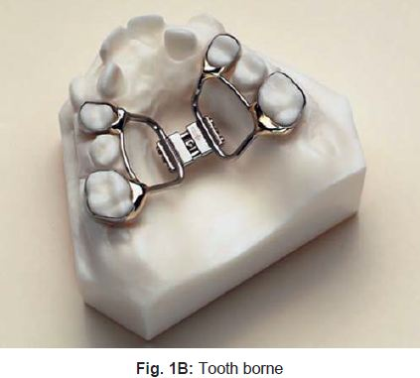
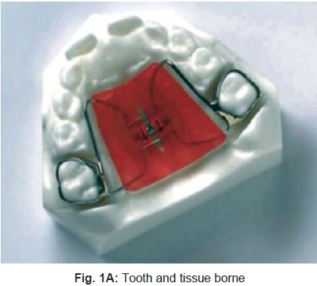

Figure (9)Tooth and tisue borne appliance (Agarwa,Rinku ,2010)
Figure (10) Tooth borne appliance (Agarwa,Rinku ,2010)
1.1.2.1.4.1 Tooth borne RME appliances
They consist of only bands and wires without any acrylic covering
1.1.2.1.4.1.1 HYRAX expander
It is a tooth borne appliance, which was introduced by William Biederman in 1968. This type of appliance makes use of a special screw called HYRAX (Hygenic Rapid Expander). The Hyrax Expander (Figure 11) is essentially a non spring loaded jackscrew with an all wire frame. The screws have heavy gauge wire extensions that are adapted to follow the palatal contours and soldered to bands on premolar and molar. The main advantage of this expander is that it does not irritate the palatal mucosa and is easy to keep clean. (Bishara,Staley , 1987)
1.1.2.1.4.1.2 Issacson expander
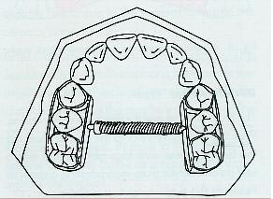
it is a tooth borne appliance without any palatal covering. This expander makes use of a spring loaded screw called Minne expander (Figure 12) (developed by university of Minnesota, dental school), which is soldered directly to the bands on first premolar and molars.The Minne expander is a heavily calibrated coil spring expanded by turning a nut to compress the coil. Two metal flanges perpendicular to the coil are soldered to the bands on abutment teeth. The Minne expander may continue to exert expansion forces after completion of the expansion phase unless they are partly deactivated (Bishara,Staley, 1987) .
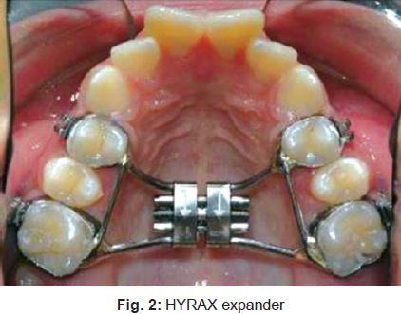

Figure (11) HYRAX expander
(Bishara,Staley , 1987)
Figure (12) issacson expander (Bishara,Staley , 1987)

1.1.2.1.4.2 TOOTH AND TISSUE BORNE RME (agarwal et al ,2010)
They consist of an expansion screw with acrylic abutting on alveolar ridges.
Haas, in 1970, gave the following advantages of tooth and tissue RME:
- Produces more parallel expansion and Less relapse
- More favorable relationship of the denture bases in width and frequently in the anteroposterior plane as well
- Create more mobility of the maxilla instead of teeth.
1.1.2.1.4.2.1 Types of Tooth and Tissue Borne
1- Haas: The basis for the rapid expansion procedure is to produce immediate midpalatal suture separation by disruption of the sutural connective tissue.(Figure 13) The rapid palatal expander as described by Haas is a rigid appliance designed for maximum dental anchorage that uses a jackscrew to produce expansion in 10 to 14 days (Haas , 1965) .
2- Derichsweiler: The first premolar and molars are banded. Wire tags are soldered to these bands and then inserted to the split palatal acrylic, which contains the screw.(Figure 14) (Agarwal,Rinku ,2010)
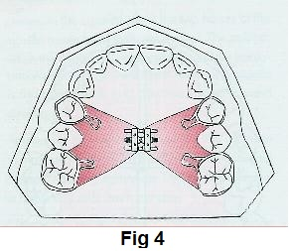
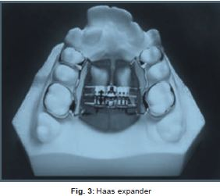

Figure (14) Derichweiler (Agarwal,Rinku ,2010)
Figure (13) Haas appliance (Haas, 1965)

1.1.2.1.5 BONDED RAPID PALATAL EXPANDER
The Bonded RPE were first described by Cohen and Silverman in 1973 (Figure 15). It is similar to the banded version with the exception of the method of attachment to the teeth. This appliance is constructed with an acrylic cap over the posterior segments, which is then bonded directly to the teet (Sarver et al , 1989).The bonded appliance has become increasingly popular because of its advantages:
- It can be easily cemented during the mixed dentition stage, when retention from other appliances can be poor (Sarver, 1989) .
- Number of appointments are reduced (Sarver, 1989) .
- There is reduced posterior teeth tipping and extrusion. (Sarver, 1989) .
- It provides Bite block effect to facilitate the correction of anterior crossbite (McNamara , 1987) .
1.1.2.1.6 IPC Rapid palatal expander
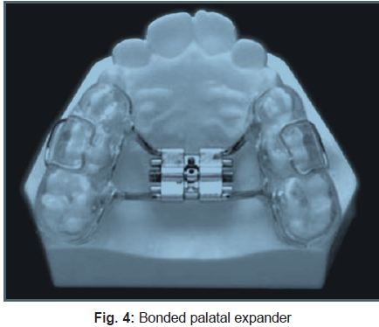
is designed for orthopedic expansion along with labial alignment of incisors (Figure 16). As expansion occurs, the IPC controls the NiTi open coil spring force applied to the lingual surface of the anterior teeth. (Agarwal,Rinku,2010).
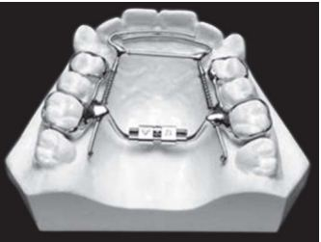

Figure (16) Ipc rapid palatal expander (agarwal et al, 2010).
Figure (15) Bonded palatel expander (Sarver et al , 1989)

1.1.2.2 Slow maxillary expansion
SME procedures produce less tissue resistance around the circum-maxillary structures and,therefore improve bone formation in the intermaxillary suture, which theoretically should eliminate or reduce the limitations of RME.Slow expansion has been found to promote greater post-expansion stability if given an adequate retention period. It delivers a constant physiologic force. The appliance is light and comfortable enough to be kept in place for sufficient retention of the expansion. Prefabrication eliminates extra appointments for impressions and the time and expense of laboratory fabrication (Bell , 1982)
1.1.2.2.1 SME APPLIANCES
1.1.2.2.1.1 Coffin Appliance
Given by Walter Coffin–1875. It is a removable appliance (Figure 17) capable of slow dento alveolar expansion. The appliance consists of an omega-shaped wire of 1.25 mm thickness,placed in the midpalatal region. The spring is activated by pulling two asides apart manually (Gill et al , 2004).
1.1.2.2.1.2 Magnets
Repulsive magnetic forces for maxillary expansion were first described by Vardemon et al 1987.Banded magnets (Figure 18) produced more pronounced skeletal; versus overall expansion effects. The continuous force of 250-500 gm could generate dental and skeletal movements, the degree depending on patients status (age, growth, etc). Disadvantage of magnets is that they tend to be oxidized in the oral environment due to the potential formation of corrosive products but this can be overcome by coating magnets. The advantage of these magnets is that they impart measured continuous force over a long period of time, hence the risk of external root resorption is decreased.(Vardimon,Graber, 1987)
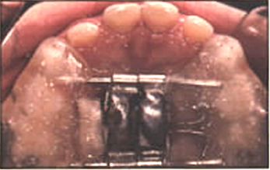
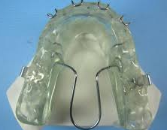

Figure (17) Coffin appliance (Gill et al , 2004).

Figure (18) Magnets (Vardimon,Graber, 1987)

1.1.2.2.1.3 W-Arch
The “W” expansion appliance was originally used by Ricketts and his colleagues to treat cleft palate patients (Figure 19). The W-arch is a fixed appliance constructed of 36 mm steel wire soldered to molar bands. To avoid soft tissue irritation, the lingual arch should be constructed so that it rests 1-1.5 mm off the palatal soft tissue. It is activated simply by opening the apices of W-arch and is easily adjusted to provide more anterior than posterior expansion, or vice versa if this is desired (Ricketts et al , 1979).
1.1.2.2.1.4 Quadhelix
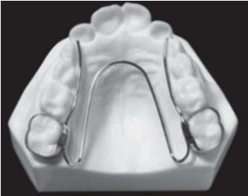
The quadhelix appliance is a modification of Coffin’s W-spring and was described by Ricketts (Figure 20). The incorporation of four helices into the W-spring helped to increase the flexibility and range of activation. The length of the palatal arms of the appliance can be altered depending upon which teeth arch in crossbite. (Bell , 1982).
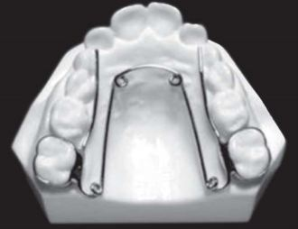

Figure (20) Quadhelix (Bell , 1982)
Figure (19) W-arch (Ricketts et al , 1979)
1.1.2.2.1.5 Spring Jet
The active components of the spring jet are soldered or attached to the molar bands (Figure 21). The telescopic unit is placed upto 5 mm from center of molar tubes so that the forces pass close to the center of resistance of maxillary teeth, but it should be 1.5 mm away from palatal tissue. Activation is done by moving the lock screw horizontally along the telescopic tube. A ball stop on the transpalatal wire allows the spring to be compressed (Agarwal,Rinku,2010).

1.1.2.2.1.6 NiTi Expander
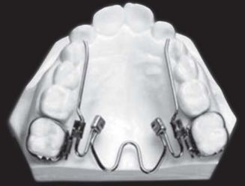
The Nickel Titanium Palatal Expanders were introduced by Wendell V (Fig. 22). It generates optimal, constant expansion forces. The expander may be used simultaneously with conventional fixed appliances, requiring only an additional lingual sheath on the molar bands. The action of the appliance is a consequence of nicket titanium’s shape memory and transition temperature effects. The nickel titanium component has a transition temperature of 94ºF. At room temperature, the expander is too stiff to bend for insertion. Chilling the expander softens the central component allowing easy manipulation. Once placed, stiffens begins to return to its original shape . (Wendell, 1993)
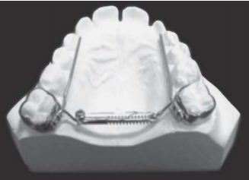

Figure (21) : Spring jet (agarwal et al ,2010)
Figure (22) NiTi Expander ( wendell et al ,1993)

1.1.2.3 Surgical Techniques (Agarwal, Rinku, 2010).
The effect of dental arch on the maxillary base diminishes as age advances so, surgically assisted expansion techniques can be considered . Indications of surgical expansion are:
- To widen the arch .
- To correct posterior crossbite when large amount (>7mm) of expansion is required to avoid the potential increased risk of segmental osteotomies maxillary halves are then separated and retained in the new position.

1.1.3 Molar Distalization
Non-extraction treatment of Class II malocclusion frequently requires upper molar distalization into a final Class I relationship. To achieve this, a variety of treatment modalities have been suggested. For more than 100 years the most common procedure has been the headgear applied to upper molars, and its performance has been reliable . Unfortunately, headgear requires patient compliance to be effective. Often, the patient is not willing to wear the headgear for the recommended 12–14 h per day. To overcome this problem, several alternative methods have been proposed. These new molar distalizing appliances have been possible because of advances in technology especially new materials capable of delivering light and constant forces over a wide range of deactivation, and a better understanding of biomechanics and tissue reaction to orthodontic tooth movement. Consequently, the clinician nowadays can choose among a great variety of devices.(Wieslander , 1963)
1.1.3.1 Types of appliances
1.1.3.1.1 Headgear
In the nineteenth century several devices with extraoral support and extraoral forces were used. Kloehn showed successful results with headgear Class II treatment and invented the facebow design that we use today, attaching the bows to the inner arch with a soldered union in the incisor area (Kloehn,1947) Three different types of extraoral traction have been described depending upon the line of action of the force: high-pull, combi-pull and cervical pull. The high-pull headgear produces mostly intrusion of upper molars with hardly any movement posteriorly (Figure 23a). The combi-pull headgear has principally a sagittal effect (Fig. 23b) whereas, the cervical pull delivers extrusion and posterior displacement of the molar (Figure 23c). (Wieslander, 1963) Advantages of the headgear include extraoral anchorage, ease of application and inexpensiveness. The disadvantages are represented by patient co-operation, discomfort and difficulty in producing bodily tooth movement(Melsen, 1978)
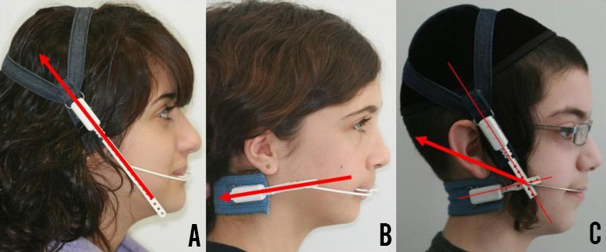

Figure (23) (a) high-pull headgear. (b)cervical-pull headgear. (c) combi-pull headgear. (Melsen, 1978)
1.1.3.1.2 Acrylic cervical occipital (ACCO) (Sfondrini MF et al,2002)
This appliance consists of an acrylic palatal section (1 mm bite plate) to disclude the posterior teeth, modified Adams clasps on the first premolars, a labial bow across the incisors for retention, finger springs against the mesial aspects of the first molars for molar distalization in association with an extraoral traction (Figure 24). With the combined use of ACCO and headgear, molars can be moved distally in a more bodily fashion. The finger springs move the crowns, and the headgear moves the roots (Cetlin et al , 1983). however, it is clinically difficult to monitor the two different force vectors , another disadvantage is anchorage loss. The lower arch anchorage can be augmented by a lip bumper. it’s indicated in Class II growing patients, with deep bite and normal or retroclined upper front teeth. It is contra-indicated in dental and skeletal open bites with high mandibular plane angle, increased lower face height, and proclined upper front teeth (Wieslander et al , 1971).
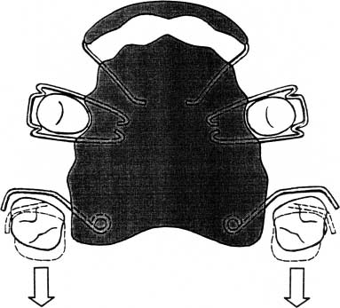

Figure (24) Acrylic cervical occipital (ACCO) (Wieslander, 1971)
1.1.3.1.3 Transpalatal arch
The transpalatal arch (TPA) (Figure 25) consists of a rigid stainless steel 0.9 mm wire, which enables the clinician to gain arch length by rotation, expansion and distalization of molars, and does not rely on patient compliance. Haas and other reported that the TPA is able to correct Class II malocclusions as a result of distobuccal rotation and distal tipping of the activated molar. As it has been shown that the distal movement produced by the TPA is very limited, we believe that it is useful in the correction of a unilateral Class II dental malocclusion or when both molars are very mesially rotated (Haas, cisneros , 2000)
1.1.3.1.4 Wilson bimetric distalizing arch (BDA) system
It consists of a buccal upper arch with an open coil spring pushing against the first molar bands. Anchorage in the lower arch is reinforced by means of a 3-D lower lingual arch contacting the cingulae of the incisors and attached to the lingual of the mandibular first molars. If maximum anchorage is required, a full fixed appliance can be bonded on the lower arch (Figure 26) (Wilson , 1978). Compared with the headgear and ACCO appliance, the Wilson appliance produces less discomfort and requires Less patient compliance. Disadvantages are represented by upper and lower anterior anchorage loss, upper and lower molar tipping and canting of the occlusal plane posteriorly and inferiorly. it’s indicated in Class II growing patients, with retroclined mandibular incisors and it’s is contra-indicated in open bites with high mandibular plane angle and increased lower face height (Sfondrini MF et al,2002) .
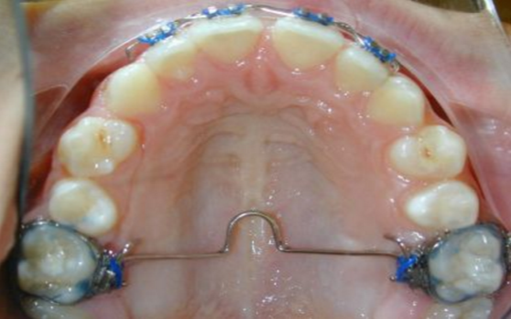
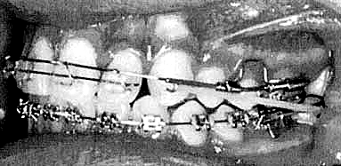

Figure (26) Wilson Bimetric Distalizing Arch.(Sfondrini MF et al,2002) .

Figure (25) Biomechanical force system produced TPA. (Rebellato et al, 1995)
1.1.3.1.5 Herbst
This appliance was introduced in 1909 by Herbst and popularized by Pancherz in 1979 (Pancherz , 1979) . The Herbst appliance (Figure 27) works as an artificial joint between the maxilla and the mandible. A bilateral telescopic mechanism attached to orthodontic bands, acrylic splints or, better, to cobalt chromium cast splints keeps the mandible in a protrude position. In contrast to functional appliances. the Herbst appliance has several advantages:
- it works 24 h a day.
- Co operation by the patient is not required.
- active treatment time is short (approximately 6–8 months).
the use of Herbst is limited to patients who can tolerate proclination of the mandibular incisors (Lai,2000)
1.1.3.1.6 Jasper Jumper (Sfondrini MF et al,2002)
In 1987 James J.Jasper developed a new device for the correction of Class II malocclusions, which was similar to the Herbst appliance in terms of design and force vectors. it’s hold the mandible in a protruded position (Figure 28). the majority of action was the result of dental, rather than skeletal change, we recommend the use of this appliance in Class II growing patients, with deep bite and retroclined mandibular incisors. It is contraindicated in dental and skeletal open bites with high mandibular plane angle and increased lower face height.
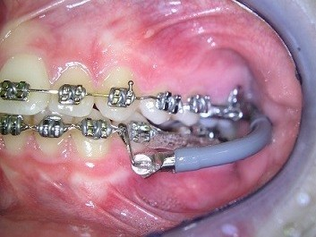
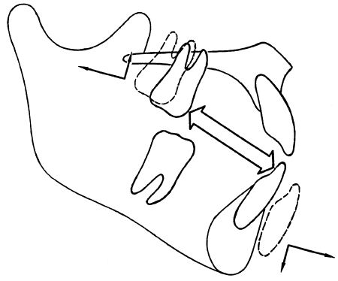
Figure (27) Dental effects produced by the Herbst appliance. (Franchi et al , 1999)

Figure (28) jasper Jumper aplliance. (Sfondrini MF et al,2002)
1.1.3.1.7 Forsus
Very recently, a new appliance which functions similarly to the Jasper Jumper has been introduced. It consists of two Nitinol springs which are fitted to fully banded upper and lower fixed appliances (Figure 29). The indications and contra-indications for this device are the same mentioned for the Jasper Jumper . To date, no published clinical trials have emerged on this system (Sfondrini MF et al,2002) .
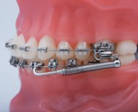

Figure (29) Forsus appliance(Sfondrini MF et al,2002)
1.1.3.1.8 Repelling magnets
In 1988–89 Gianelly et al. (Gianelly et al , 1988) described a new intra-arch method for distalization of first maxillary molars by means of samarium–cobalt repelling magnets (SmCo5). The magnetic force results in a rapid distal movement of the first molars (figure 30). The movement separates the magnets, which must be reactivated by being placed back in contact every 2 weeks. According to Itoh (Itoh et al , 1991) , molar distalization occurs almost entirely as a bodily movement, with slight distal tipping and rotation.

Figure (30) (a,b) Biomechanical force system produced by repelling magnets – sagittal (30a) and occlusal view (30b). (Itoh et al , 1991)

1.1.3.1.9 Jones Jig
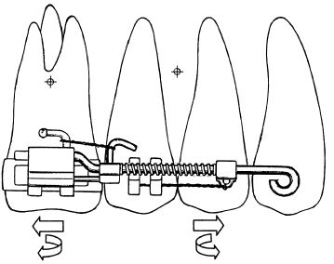
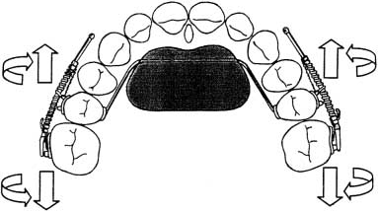
The Jones Jig (Figure 31) is an open Ni–Ti coil spring delivering 70–75 g of force, over a compression range of 1–5 mm,to the molars (Jones, White JM , 1992). A modified Nance appliance is attached to the upper first or second premolars, or the second deciduous molars. the molars will be distally tipped and rotated, whereas the premolars to be mesially tipped. it would be contraindicated in cases of excessive vertical growth. advantages of the Jones Jig include minimal patient compliance and ease of fabrication and use, we recommend to use such appliance in patients with normal or low mandibular plane angle and in cases where mesial movement and protrusion of the anchorage unit during intraoral distalization can be tolerated (Brickman et al , 2000)

Figure (31) Biomechanical force system produced by the Jones Jig-sagittal (31a) and occlusal view (31b). (Brickman et al , 2000)

1.1.3.1.10 Ni–Ti wires
Locatelli (Locatelli et al , 1992) used a 100-g rectangular superelastic Ni–Ti wire (NeoSentalloy) compressed between maxillary first premolar and first molar.(Figure 32) . it can be used in Class II malocclusions, with normally or retroclined upper front teeth. They are contra-indicated in dental and skeletal open bites with high mandibular plane angle, increased lower face height, and proclined upper front teeth. To date, no published clinical trials have emerged on either of those systems (Giancotti A, Cozza p , 1998) .

1.1.3.1.11 Distal - Jet
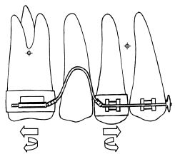
Carano and Testa (Carano, 1993) described the design and use of this appliance. Advantages of the Distal-Jet include improved aesthetics and comfort, simple insertion and activation, better molar bodily movement, and easy conversion into a Nance holding arch after molar distalization (figure 33). As the main disadvantage is represented by a significant anterior anchorage loss, we recommend not to use this appliance in cases presenting maxillary incisor proclination, anterior open-bite and protrusive profile (Ngantung et al , 2001) .
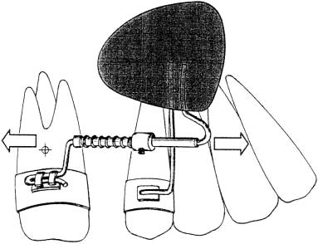
Figure (32) Biomechanical force system produced by Ni–Ti wire. ((Giancotti A, Cozza p , 1998)
Figure (33) Biomechanical force system produced by the Distal-Jet-sagittal view. (Ngantung et al , 2001)

1.1.4 Extraction
The role of extractions in orthodontic treatment has been a controversial subject for over a century. It is fair to say that even today, opinion is divided on whether extractions are used too frequently in the correction of malocclusion. Angle (Angle, 1900) believed that all 32 teeth could be accommodated in the jaws, in an ideal occlusion with the first molars in a Class I occlusion, ie with the mesiobuccal cusp of the upper first molar occluding in the buccal groove of the lower first molar. Extraction was anathema to his ideals, as he believed bone would form around the teeth in their new position, according to Wolff's law (Wolff, 1892) This was criticised by Case who believed extractions were necessary in order to relieve crowding and aid stability of treatment. Recently, the extraction debate has reopened, with some individuals believing that expansion of the jaws and retraining of posture can obviate the need for extractions and produce stable results. These claims are for the most part unsubstantiated.
1.1.4.1 FACTORS AFFECTING THE DECISION TO EXTRACT
It is important to consider the patient as a whole in treatment planning. Medical history, attitude to treatment, oral hygiene, caries rate and the quality of the teeth are important. Patients with cardiac anomalies are at risk of complications during orthodontic treatment and consultation with a cardiologist is important. If necessary, extractions should be covered with appropriate antibiotics and impacted teeth may be best removed rather than aligned as traction to unerupted teeth may pose an increased risk to these patients (Khurana, 1999).
1.1.4.2 Extraction of specfic teeth
1.1.4.2.1 Lower incisors extraction
In general, removal of a lower incisor should be avoided, as the inter-canine width tends to decrease which can result in crowding developing in the upper labial segment or the overjet increasing. However, a number of situations do exist in which a lower incisor may be considered as part of an orthodontic treatment plan and fixed appliances are generally required in these cases. These include situations where a lower incisor is grossly displaced from the arch form or 'ectopic' and space is required to align the teeth. Class III cases at the limit of their growth can be camouflaged with loss of a lower incisor, to allow the lower labial segment to be tipped lingually, correcting the incisor relationship. Treatment of Class I cases with moderate lower labial segment crowding of up to 5 mm (ie the size of a lower incisor) may be treated with loss of a lower incisor. (Canut, 1986)
1.1.4.2.2 Upper Incisors extraction
Upper incisors are rarely the extraction of choice to treat a malocclusion. However, the upper labial segment is particularly at risk from trauma, especially in Class II Division 1 cases with large overjets. In situations where the long-term prognosis of an incisor is poor, for example, the incisor is non vital, root filled, dilacerated or of abnormal form, the tooth should be considered for extraction as part of the orthodontic treatment plan.(Harry, Sandy, 2003)
1.1.4.2.3 Canines extraction
These teeth are rarely considered for extraction unless very ectopic. The loss of a canine makes canine guidance impossible and may compromise a good functional occlusal result. Contact between a premolar and lateral incisor is often poor and canines can act as ideal abutment teeth because of their long root length and resistance to periodontal problems.(Harry, Sandy, 2003)
1.1.4.2.4 Premolars (Harry, Sandy, 2003)
Premolars are often ideal for the relief of both anterior and posterior crowding, the first and second premolars have similar crown forms, which means that an acceptable contact point can be achieved between the remaining premolar and the adjacent molar and canine. The choice between first or second premolar depends on a number of factors: for example, the degree of crowding, the anchorage requirements, the overjet and overbite. In Class I cases where crowding exists and the canines are mesially angulated, loss of first premolars may produce spontaneous improvement in the alignment of the canines (Berg, Gebauer, 1982) .
1.1.4.2.5 First molars
First permanent molars are often the first permanent teeth to erupt into the mouth. Their deep fissure morphology predisposes them to caries and poor tooth brushing combined with a high sugar intake, may result in gross caries. Heavily restored or decayed first molars should be considered for removal over other non-carious teeth. First molars extraction requires careful planning. Their position in the arch means that whilst relief of premolar crowding is achieved the space created is far from the site of any incisor crowding or overjet reduction. The timing of the loss of first molars is also an important consideration. (Sandler et al, 2000).
1.1.4.2.6 Second molars (Thomas,Sandy, 1995)
Thomas provided a succinct summary on the role of loss of second molars in orthodontic treatment. They state that all other teeth should be present with the third molars of normal size, shape and in a good position to erupt. Mild lower labial segment crowding may be effectively treated by loss of second molars, however they should not be considered in the treatment of moderate or severe crowding. Second molar loss may be undertaken under the following circumstances To allow relief of premolar crowding (especially where second premolars are impacted)
- May prevent crowding in a well-aligned lower arch.
However, the potential disadvantages of second molar extraction are:
- Eruption of third molars especially in the lower arch is unpredictable. About 30% of these teeth require uprighting.
- The teeth are remote from the site of crowding making alignment unpredictable.

1.1.5 Uprighting of tipped molar
All teeth are essential, yet in function and influence, some are of greater importance than others, the most important of all being the molars, especially the first permanent molar which according to E. H. Angle is the key to occlusion1. Molars occupy functionally and anatomically a key position in the oral cavity. Functionally they aid in chewing and grinding of food, and anatomically as they are located in the posterior region of the dental arches, responsible for maintaining the vertical dimension of the face.
Loss of a first permanent molar should be immediately addressed by prosthetic replacement or orthodontic space closure as it may lead to functional and anatomical disturbances. The sequelae of events include second and third molars will incline and rotate, canine and premolars will move distally into the molar space, and the opposing first molar will extrude.
The over-all objective in molar uprighting is to optimally position the molars providing the space to restore the lost tooth thereby protecting the teeth against inflammatory periodontal diseases and occlusal traumatism, which together determine the optimal periodontal environment to the molars and improve the masticatory efficiency of the patient. (Souza1 et al , 2013)
1.1.5.1 Differential diagnosis of tipped molars (Souza1 et al, 2013)
Melsen et al remarked that simple appliances for molar uprighting do not take individual patient variation into account. Tipped molars should be differentiated by the type of tooth movement required in all 3 planes of space. For any particular tooth movement there is only one correct force system to be applied. Therefore a differential diagnosis of the tipped molars is important before selecting the optimal force system and appliance design.
- In the transverse planes appropriate balance of vertical forces should be maintained along with uprighting of teeth in crossbites.
- In the sagittal plane the appropriate combination of vertical movement and uprighting must be determined.
- In the vertical plane molar extrusion may be desirable in some early orthodontic treatments when the tipped molar is below the functional occlusal plane.
- In conditions where the distal aspect of the tipped molar is above the functional occlusal plane molar intrusion is required and the biomechanical principles applied become more complicated.
1.1.5.2 Causes of Molar tipping (Santoro , 2009)
- Rotation of a molar forward (mesially) or backward (distally) around its body mass axis called Center of Resistance. (Figure 34)
- Missing teeth due to extensive decay or early loss of deciduous teeth causesa mesial drift of the remaining molars.(Figure 35)
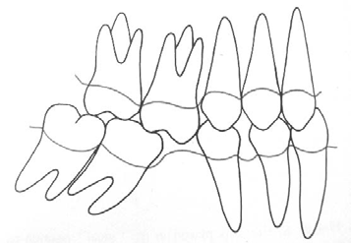
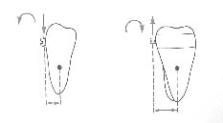

Figure (35) Mesial drift. (Santoro, 2009)
Figure (34) Center of Resistance. (Santoro , 2009)
1.1.5.3 Indications of uprighting (Santoro, 2009)
- Adult patients.
- The dentoalveolar ridge in the edentulous space is very narrow and would not allow movement of the root.
- Slight extrusion must be acceptable and minimized by proper mechanics.
- Bone loss and periodontal pockets on the mesial root of the molar to be uprighted (distal crown movement will usually generate extrusion of the molar with reduction of the depth of the periodontal pockets).
1.1.5.4 appliance design (Santoro, 2009)
- Anchorage: full arch bonding or bonded lingual arch from canine to canine to avoid unwanted tooth movement
- Bands on molars to be uprighted
- Brackets on premolars and canines (figure 36)
- Wires:
– Alignment with braided wires or Nickel-Titanium
– Anchorage with rectangular Stailess Steel size .018 x .025
– Helical uprighting spring size .018 x .025
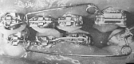

Figure (36) uprighting appliance. (Santoro , 2009)

1.1.6 Derotation of posterior teeth (Proffit et al, 2013)
In patients with Class II malocclusion, the upper molars usually are rotated mesially, and part of the apparent backward movement of the first molar is a distal rotation of the buccal cusps as the tooth rotates around its lingual root. The inner bow of a headgear facebow should be adjusted to produce this type of rotation (Figure 36).
Space tends to open within the maxillary arch when extraoral force to the upper first molars is used and the patient grows well, as in this patient after 12 months of headgear treatment during the adolescent growth spurt (Figure 37).Note that as the molars moved distally, the gingival fiber attachments produced distal movement of the premolars, opening space between these teeth and the canines. When a complete fixed appliance is placed at this stage, one of the first steps is consolidation of the space distal to the canines.

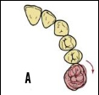
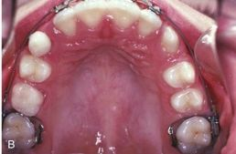

Figure (37)(A,B) Derotation (Proffit et al, 2013)

1.1.7 Proclination of the incisors (Cobourne , Dibiase , 2010)
a deep overbite can also be reduced by incisor proclination and an associated reduction in the inter-incisal angle . As a general rule, lower incisor proclination is unstable and there will be a tendency for these teeth to return to their pre-treatment position, with a potential return of the increased overbite. However, where the lower labial segment is markedly retroclined, such as a class II division 2 malocclusion, some proclination of the lower incisors may be necessary to establish a class I incisor relationship with an acceptable inter-incisal angle .This can effectively be achieved with fixed appliances, especially in the presence of crowding. By engaging the initial aligning archwire fully, the teeth will align by proclination and this can be supplemented further by placing a rectangular stainless steel wire in the lower arch once the teeth are aligned with a reverse curve of Spee. Any significant proclination will invariably require long-term or permanent retention following appliance removal to prevent relapse of the overbite.

References
- Agarwal, Mathur . Maxillary expansion 2010;3(3):139-146
- Angle E H. Treatment of malocclusion of the teeth and fractures of the maxillae, Angle's system. Ed 6, 1900 S.S. Philadelphia: White Dental Manufacturing Co.
- Bell RA. A review of maxillary expansion in relation to rate of expansion and patient’s age. Am J Orthod 1982;81:1:32-7.
- Berg R, Gebauer U. Spontaneous changes in the mandibular arch following first premolar extractions. Eur J Orthod 1982;4: 93-98.
- Bishara SE, Staley RN. Maxillary expansion: Clinical implications. Am J Orthod Dentofacial Orthop 1987;91:3-14.
- Brickman CD, Sinha PK, Nanda RS. Evaluation of the Jones Jig appliance for distal molar movement. Am J Orthod Dentofac Orthop 2000;118:526–34.
- Canut J A. Mandibular incisor extraction: indications and long-term evaluation. Eur J Orthod 1986; 18: 485-489.
- Carano A. Distalizzazione dei molari con magneti: considerazioni biomeccaniche. Mondo Ortod 1991;16:305–9.
- Chudasama D, Sheridan JJ. Guidelines for contemporary air rotor stripping. J Clin Orthod 2007;41:315-20.
- Cleall JF, Bayne DI, Posen JM, Subtelny JD. Expansion of the midpalatal suture in the monkey. Angle Orthod 1965;35:23-35.
- Cobourne, Andrew T DiBiase. Handbook of orthodontics 2010. p191-195.
- Ficarelli JP. A brief review of maxillary expansion. J Pedod 1978;3:1:29-35.
- Franchi L, Baccetti T, McNamara JA. Treatment and posttreatment effects of acrylic splint Herbst appliance therapy. Am J Orthod Dentofac Orthop 1999;115:429–38.
- Frindel C. Clear thinking about interproximal stripping. J Dentofacial Anom Orthod 2010;13:187-99.
- Giancotti A, Cozza P. Nickel–titanium double-loop system for simultaneous distalization of first and second molars. J Clin Orthod 1998;32:255–60.
- Gianelly AA, Vaitas AS, Thomas WM, Berger DG. Distalization of molars with repelling magnets. J Clin Orthod 1988;22:40–4.
- Gill D, Naini F, M Mc Nallyand Jones. The management of transverse maxillary deficiency, Dent Update 2004;31:516-23.
- Haas AJ. The treatment of maxillary deficiency by opening the midpalatal suture. Angle Orthod 1965;35:200-17.
- Haas SE, Cisneros GJ. The Goshgarian transpalatal bar: a clinical and an experimental investigation. Semin Orthod 2000;6:98–105.
- Harry, Sandy . British Dental Journal 2003; 195:433–437
- Itoh T, Tokuda T, Kiyosue S, Hirose T, Matsumoto M, Chaconas S. Molar distalization with repelling magnets. J Clin Orthod 1991;25:611–7.
- Jones RD, White JM. Rapid class II molar correction with an opencoil jig. J Clin Orthod 1992;26:661–4.
- Khurana M, Martin M V. Orthodontics and infective endocarditis. Br J Orthod 1999; 26: 295-298.
- Kloehn SJ. Guiding alveolar growth and eruption of teeth to reduce treatment time and produce a more balanced denture and face. Angle Orthod 1947;17:10–33.
- Lai M. Molar distalization with the Herbst appliance. Semin Orthod 2000;6:119–28.
- Lapenaite, Lopatiene . Interproximal enamel reduction as a part of orthodontic treatment 2014 . p19-23.
- Locatelli R, Bednar J, Dietz VS, Gianelly AA. Molar distalization with superelastic Ni–Ti wire. J Clin Orthod 1992;26:277–9.
- McNamara J. An orthopedic approach to the treatment of Class III malocclusion in young patients. JCO 1987;21(9):598-608.
- Melsen B. Effects of cervical anchorage during and after treatment: an implant study. Am J Orthod 1978;73:526–40.
- Ngantung V, Nanda RS, Bowman SJ. Posttreatment evaluation of the distal jet appliance. Am J Orthod Dentofac Orthop 2001;120:178–85.
- Pancherz H. Treatment of Class II malocclusion by jumping the bite with the Herbst appliance. A cephalometric investigation. Am J Orthod 1979;76:423–42.
- Phulari BS. Orthodontics - Principles and practice. In: Phulari BS. Methods of gaining space. New Delhi: Ajanta Offset and Packagings Ltd.; 2011. p. 303-5.
- Proffit, Henry W. Fields, David m. Sarver . Contemporary Orthodontics 5th 2013;p310
- Radlanski RJ, Jäger A, Schwestka R, Bertzbach F. Plaque accumulations caused by interdental stripping. Am J Orthod Dentofacial Orthop 1988; 94(5):416–20.
- Rebellato J. Two-couple orthodontic appliance systems: transpalatal arches. Semin Orthod 1995;1:44–54.
- Ricketts RM, Bench RW, Gungino CF, Hilgers JJ, Schulhof RJ. Bioprogressive therapy, Rocky Mt Orthod 1979;1:255-58.
- Rossouw, Tortorella. Enamel Reduction Procedures ; June 2003, Vol. 69, No. 6
- Santoro . molar uprighting 2009;p1-10
- Sarver. Skeletal changes in vertical anterior displacement of maxilla with bonded rapid palatal expander appliances. Am J Orthod Dentofacial Orthop 1989;462-66.
- Sfondrini, Vittorio Cacciafesta, Giuseppe Sfondrini. Upper molar distalization: a critical analysis 2002 :115-125
- Singh G. Textbook of orthodontics. In: Singh G, Juneja T. Methods of gaining space. 2nd edition. New Delhi: Ajanta Offset and Packagings Ltd.; 2007. p.230
- Souzal, kumar, shetty. Uprighting of Molars- A Clinical Challenge 2013;p1
- Thomas P, Sandy J R. Should second molars be extracted?Dent Update 1995; 22: 150-156.
- Timms. The Dawn of Rapid Maxillary Expansion. The Angle Orthodontist 1999;69:3:247-50.
- Tuverson D L. Anterior interocclusal relations. Part II. Am JOrthod 1980; 78: 371-393.
- Tuverson DL. Anterior interocclusion relations. Part I. Am J Orthod 1980; 78(4):361–70.
- Vardimon AD, Graber. Magnetic versus mechanical expansion with different force thresholds and points of force application. Am J Orthod Dentofacial Orthop 1987;92:455-66.
- Wendell. Nickel titanium palatal expander. JCO 1993;27(3): 129-37.
- Wieslander L. The effect of orthodontic treatment on the concurrent development of the craniofacial complex. Am J Orthod 1963;49:15–27.
- Wilson WL. Modular orthodontic systems. Part 1. J Clin Orthod 1978;12:259-78.
- Wolff J. Das Gesetz der Transformation der Knochen. Berlin: Hirschwald, 1892. Case C S. The question of extraction in orthdontia. Am J Orthod 1964; 50: 658-691.
- Zachrisson BU, Minster L, Ogaard B, Birkhed D. Dental health assessed after interproximal enamel reduction: Caries risk in posterior teeth. Am J Orthod Dentofacial Orthop 2011;139:90-8.
- Zachrisson BU, Nyoygaard L, Mobarak K. Dental health assessed more than 10 years after interproximal enamel reduction of mandibular anterior teeth. Am J Orthod Denotafacial Orthop 2007;131:162-9.

