Republic of Iraq
Ministry of Higher Education
And scientific Research
University of Baghdad
College of Dentistry

Perception of Smile Esthetics by Dental Students

A project Submitted to the
Council of the College of Dentistry/University of Baghdad,
Department of Orthodontics, in partial fulfillments of
requirements for B.D.S Degree

Prepared by
Ahmed Emad Habib

Supervised by
Prof. Dr. Akram Faisal Alhuwaizi

2017
Baghdad – Iraq

بِسْمِ اللهِ الرَّحْمنِ الرَّحِيمِ

وَعَلَّمَكَ مَا لَمْ تَكُنْ تَعْلَمُ وَكَان فَضْلُ اللّهِ عَلَيْكَ عَظِيم ) (

صدق الله العظيم
سورة النساء 113

ACKNOWLEDGMENT

In the name of Allah, most gracious, most merciful. And the Peace and blessings of Allah be upon His Prophet.
All praises and glory to Allah who gives me the patience to accomplish this project.
My deep appreciation and my thank goes to my supervisor Prof. Dr. Akram Faisal Alhuwaizi for his strong supporting, I hope from Allah that will bring him all the aspirations and help him. My special thanks to Orthodontics department.
I owe my heartfelt gratitude and love to the most dearest thing in my life (my parents) for their encouragement, prayers and supplication, really no word to describe how much they mean to me, I hope from Allah to protect and give them good healthy.

LIST OF CONTENTS
Page No. | Subject
1 | Abstract
2 | Introduction
 | Chapter 1
3-4 | Factor affecting smile attractiveness
4-6 | Gingival Display
6-8 | Smile Arc
8-9 | Buccal Corridor
 | Chapter 2
10 | Material & Subject
10 | Method
10 | Statistical Analysis
 | Chapter 3
12 | Descriptive Statistics
12 | Gender Difference
13 | Educational Level
 | Chapter 4
18 | Most Common
18 | Extremes
19 | Gender Difference
19 | Educational Leve
20 | Conclusion
21-24 | References

LIST OF FIGURES
Page No | Title | Fig. No
6 | Consonant smile arc | 1
7 | Straight smile arc | 2
8 | Reverse smile arc | 3
12 | Gingival appearance (aesthetic value) | 4
15 | Frequency distribution of the sample according to their preferred gingival display | 5
16 | Mean preferred gingival display of first year males and | 6
16 | Mean preferred gingival display of third year males and | 7
16 | Mean preferred gingival display of fifth year males and females | 8
17 | Mean preferred gingival display with gender difference | 9
18 | Mean preferred gingival display among first, third and fifth year students | 10

LIST OF TABLES
Page No | Title | Table No
15 | Frequency distribution of the sample according to their preferred gingival display | 1
17 | Mean and standard deviation of the preferred gingival display with gender difference by | 2
18 | ANOVA test of the preferred gingival display among first, third and fifth year students | 3

ABSTRACT

The aim of this study was to evaluate the influence of the amount of gingival display on smile attractiveness.
An image of a smile was digitally processed to create a series of ten copies with different gingival exposure ranging between -5mm (partly covered crown surfaces of the teeth) to 5mm gingival display. Two hundred and seventy-three randomly selected dental students (from first, third and fifth grades) were shown the picture and asked to select the most attractive picture. The data was cross-tabulated. T-test and ANOVA tests were used to examine any differences.
It was found that, smiles with 0 to -2 mm gingival display were considered to be the most attractive by the most of students (67.4%). While, only 8.4% of the sample preferred smiles with 1mm to 3mm gingival display. No significant gender difference was found among first and third grade students but was significant for fifth graders with female students favouring more gingival display. Educational level showed no significant effect on the choice of the most attractive gingival display.

AIMS OF THE STUDY

The presented study was aimed to evaluate the effect of different amounts of gingival display on the perception of smile attractiveness among first, third and fifth year dental college students.

INTRODUCTION

The smile is one of the most effective means by which people convey their emotions. It is defined as ‘a change of facial expression involving brightening of the eyes, an upward curving of the corners of the mouth with no sound and less muscular distortion of the features than in laugh that may express amusement, pleasure, tender, affection, approval, restrained mirth, irony, derision or any of various other emotions (Hulsey, 1970).
Dental help is most often sought because people want better smiles, occasionally in comparison to movie stars. When an ugly smile is improved by orthodontic intervention, the person feels better and more confident. Out of eight components of a balanced smile, the smile arc and buccal corridors have been the concern of the orthodontist in recent years (Sabri, 2005).

CHAPTER ONE

REVIEW OF LITERATURE

1.1 Smile Attractiveness:
Smile attractiveness is an important topic in orthodontics and is frequently a greater motivational factor than functional improvement and dental health (Gochman,1975, Margolis,1997).
Facial attractiveness plays a key role in social interaction. It influences mating success, kinship opportunities, personality evaluations, performance, and employment prospects (Dion et.al; 1972; Bull and Ramsey, 1988; Flanary, 1992).
Furthermore, attractiveness is suggested to influence personality development and social interaction. Empirical evidence for this relationship is given by a meta-analysis of facial-attractiveness studies (Langlois et al; 2000). These showed that attractive children and adults are judged and treated more positively than unattractive children and adults, even by those who know them .
Attractive children and adults also exhibited more positive behaviours and traits. Facial attractiveness correlated with extraversion and self-confidence/self-esteem. In most domains, attractiveness was found to be equally important for men and women. Other studies showed correlations between self-reported attractiveness and personality traits such as dominance, emotional stability, and self-esteem (Feingold, 1992). or with inhibition, health anxiety, and self-esteem (Greitemeyer et al; 2000).
Facial attractiveness and smile attractiveness appear strongly connected to each other. The fact is that in social interaction, one’s attention is mainly directed toward the mouth and eyes of the speaker’s face (Thompson et al; 2004).
The smile plays an important role in facial expression and appearance This has been demonstrated in studies with photographs, where higher intellectual and social abilities were attributed to individuals with aesthetic smiles. They were also judged to be more attractive than the same individuals on photographs with modified lower-level esthetic smiles (Eli et al; 2001; Newton et al; 2003).

1.2 Factor Affecting Smile Attractiveness:
Several parameters are available to assess smile attractiveness, such as amount of gingival display, midline buccal corridor, incisor width/height ratio, incisor crown inclination, gingival contour and smile arch appearance, among others (Kokich et al; 1999; Patnaik et al; 2003).

1.2.1 Gingival Display:
Gingival display it has related to several factors, such as vertical maxillary excess, upper lip hyperactivity and length, and height of the clinical crowns of maxillary incisors (Mondelli, 2003).
The literature comprises classifications for different types of smiles based on the relationship between the upper lip and the anterosuperior teeth. Smiles fall into five different categories: Class I, when the edge of the lip lies above the cervical portion of the incisor crowns (“gummy smile); class II, when the edge of the lip is located at the cervical third of the incisor surfaces; class III, when the edge of the lip lies in the middle third of the incisor surfaces; class IV, when the edge of the lip is located at the incisal third of the incisors; and class V, when the edge of the lip covers the entire incisor surfaces. The authors concluded that more than 98% of the sample was in classes I and II (Teo, 1981).
Another method of smile classification employs degrees of dental crown exposure and gingival tissue display, which fall into three categories: High, medium and low. In the high smile there is total exposure of the clinical crowns of anterosuperior teeth and a continuous strip of gingival The medium smile reveals most (75%) or all (100%) of the clinical crowns of anterosuperior teeth and the interdental or interproximal papillae only. The low smile shows less than 75% of the clinical crowns of anterosuperior teeth and no display of gingival tissue (Montini et al; 2007, Tjan et al; 1984).
The appropriate relationship is one in which the upper lip rests on the gingival margin of the central maxillary incisors (Ahmad, 1998; . Hulsey, 2002; Mackley, 1993).
Likewise, in the so-called ideal smile the upper lip should be positioned so as to expose the entire crown of the maxillary incisors and up to 1 mm of gingiva (Ackerman et al; 2004; Câmara, 2004; Geron S, 2005).
Several authors agree that women have a higher smile line with greater gingival display while men have a lower smile line (Arnett and Bergman, 1993; Camara, 2004).
The “gummy” smile is not necessarily anaesthetic to the public’s eye. Some movie stars and models, especially women, display some gingival tissue on smiling but their smile is nevertheless still considered pleasant (Mondelli, 2003).
Moreover, the smile pattern varies with patient age, with children displaying a greater amount of gingiva than adults. It is noteworthy that with advancing age, loss of tissue tone causes the upper lip to stretch and upper teeth to overlap, thereby reducing gingival display (Arnett and Bergman, 1993).

1.2.2 Smile Arc:
The smile arc is defined as the relationship of the contour of the incisal edges of the maxillary anterior teeth relative to the curvature of lower lip during a social smile (Tjan et al; 1994, Dong et al; 1999, Sarver, 2001).
On the basis of this relationship, smile lines are of three types. Consonant smile arc has the curvature of incisal edges of the maxillary anterior teeth parallel to the upper border of the lower lip (Sarver and Ackerman, 2003).

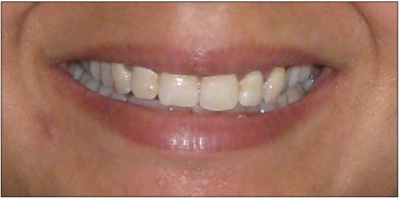
Figure 1: Consonant Smile Arc.

It has been suggested that for consonant smile arc, the centrals should appear slightly longer or, at least, not any shorter than the canines along the incisal plane (Tjan et al; 1984).
Straight smile arc is that in which the incisal edges of the maxillary anterior teeth are in a straight line to the upper border of the lower lip (Singla and Lehi, 2014).

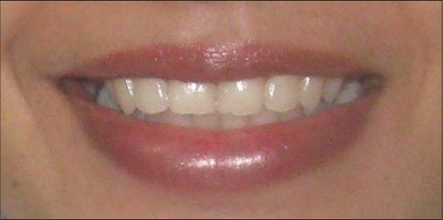
Figure 2: Straight Smile Arc.

Reverse or non-consonant smile arc is the one in which the incisal edges of the maxillary anterior teeth are curved in reverse to the upper border of the lower lip. Reverse smile arc occurs when the centrals are shorter than the canines along the incisal plane which can be due to occlusal malfunction or loss of vertical dimension. (Frush and Fisher 1958, Sarver, 2001).

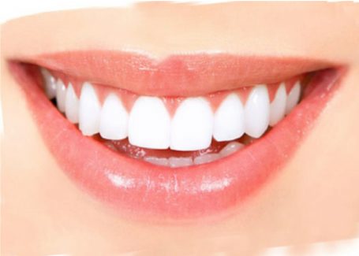
Figure 3: Reverse Smile Arc.

Since the smile arc depends upon occlusal plane inclination and second order crown angulations in the upper anterior teeth, there are some limitations to the achievement of this ideal smile arc on every patient. A reasonable objective is to prevent a flat or reverse smile arc and to obtain some degree of curvature that resembles, one found in the lower lip (Nanda, 2005).

1.2.3 Buccal Corridor:
Buccal corridor refers to dark space (negative space) visible during smile formation between the corners of the mouth and the buccal surfaces of the maxillary teeth and is measured from the mesial line angle of the maxillary first premolar to the interior portion of the commissure of lips. It is represented by a ratio of the inter-commissure width divided by the distance from the first premolar to first premolar (Graber et al; 2005).
It is represented by a ratio of the inter-commissure width divided by the distance from the first premolar to first premolar. Its appearance is influenced by the following factors: (Bhuvaneswaran, 2010).
* The width of the smile and the maxillary arch.
* The tone of the facial muscles.
* The positioning of the labial surface of the upper premolars.
*The prominence of the canines particularly at the distal facial line angle and any discrepancy between the value of the premolars and the six anterior teeth anteroposterior position of maxilla.
Buccal corridor is directly influenced by arch form (Rufenacht, 1990). The ideal arch is broad and conforms to a U shape and is more likely to fill the buccal corridors than narrow and constricted arch and. This negative space should be kept to a minimum as it is unattractive, but at the same the buccal corridor should not be completely eliminated because a hint of negative space imparts to the smile a suggestion of depth (Bhuvaneswaran, 2010).
In addition, buccal corridors are heavily influenced by the anteroposterior position of the maxilla relative to the lip drape. Moving the maxilla forward will reduce the negative space because a wider portion of the arch will come forward to fill the intercommissure space (Benson and Laskin, 2001; Sarver and Ackerman, 2010).
Hulsey examined the influence of buccal corridors on the smile attractiveness and concluded that variation in buccal corridors seemed have no significance (Hulsey, 1970).
Hulsey considered only six anterior teeth for measuring the buccal corridors. Since buccal corridors as defined by Frush and Fisher are the distance from the posterior teeth to the corners of the lips, thus a smile typically includes not only the six anterior teeth but also the first and sometimes second premolars. Fullness of the smile is one of the important feature that determines smile attractiveness. The effect of buccal corridor on smile esthetics has been studied extensively in the recent years. Moore recommended that having minimal buccal corridors is a preferred esthetic feature in both men and women, and large buccal corridors should be included in the problem list during orthodontic diagnosis and treatment planning (Moore et al; 2005).

CHAPTER TWO

MATERIALS AND METHODS

2.1 Material and Subjects:
Two hundred and seventy-three randomly selected dental students from the College of Dentistry, University of Baghdad were involved in the study, taking in consideration for the gender equality in sample selection as much as we can. Ninety four students were taken from first grade, 95 students were taken from third grade and 84 students was taken from fifth grade.

2.2 Method:
An image of a smile was digitally processed to create a series of ten copies with different gingival exposure ranging between -5mm (partly covered crown surfaces of the teeth) to 5mm ginigival display. The pictures were coded from A to H (Figure 4). The students were shown the picture and asked to select the most attractive picture. After collection of data, it was arranged in tables then statistical analysis was done to reach the final result.

2.3 Statistical Analysis:
Data was collected and analyzed by using statistical package of social science program (SPSS, Chicago, Illinois, USA). The data was cross-tabulated. T-test was used to examine any gender difference and ANOVA test was used to examine any difference between the 3 groups. In the statistical evaluation, p values greater than 0.05 were regarded as statically non-significant.
.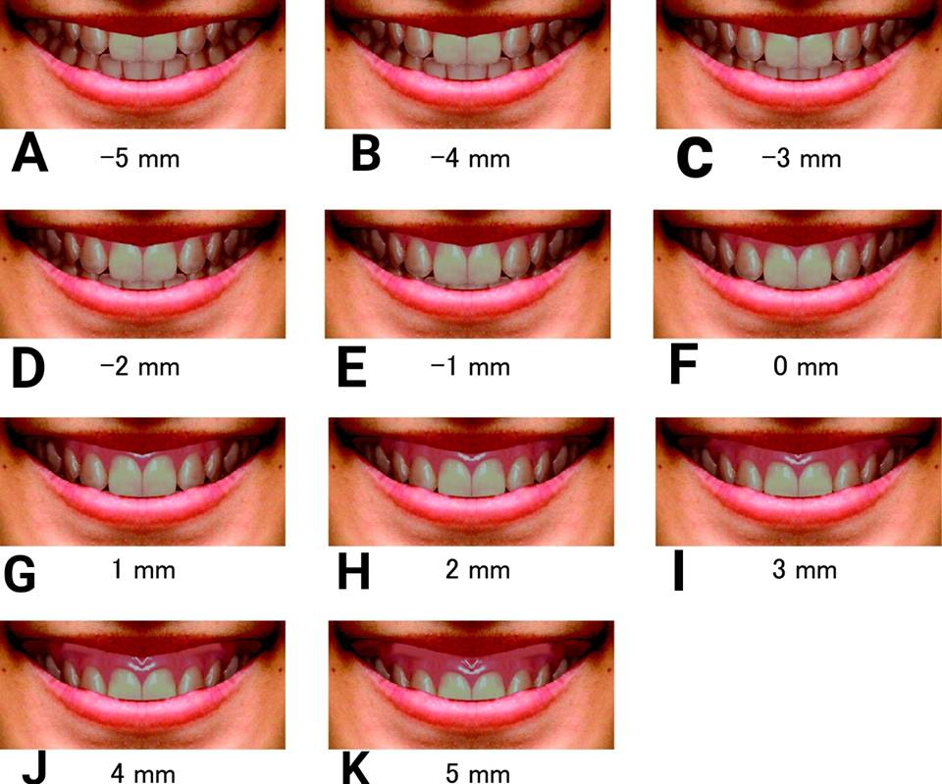
Figure 4: Gingival Appearance (Aesthetic Value). (Hideki et al; 2010).
CHAPTER THREE
RESULT

3.1 Descriptive statistics:
The most attractive smile chosen by the sample was -2 mm gingival display. It was selected by 27.7% of the first year students, 34.7% of the third year students and 27.4% of the fifth year students (Table 1 and Figure 5).
The 0 mm gingival display came in the second place, as it was chosen by 22.3% of the first year students and 25.0% of the fifth year students, while the -1 mm gingival display came in the second place for third year students (23.2%).
Only 7.4% of the first year students, 2.1% of the third year students and 2.4% of the fifth year students chose the least score (-5 mm of gingival display).
The 2 mm of gingival display it was chosen by 3.2% of the first year students and 2.4% of the fifth year students and no one from the third year students. The 3 mm of gingival display was selected only by 2.4% of the fifth year students and no one from first and third year students. Also, no one chose the 4 mm and 5 mm of gingival display from all the sample.

3.2 Gender difference:
Figure 6, 7 and 8 show the distribution of the sample according to the preferred gingival display for males and females. No significant gender difference was shown between males and females among the first and third graders for the mean gingival display, while female fifth year students showed a significant difference from males, where they favoured more gingival display (Table 2 and Figure 9).

3.3 Educational level:
ANOVA test for the mean gingival display showed a non-significant statistical difference between the first, third and fifth graders (Table 3 and Figure 10).

Table 1: Frequency distribution of the sample according to their preferred gingival display.
 | First Year |  |  |  |  |  | Third Year |  |  |  |  |  | Fifth Year
 | Male |  | Female |  | Total |  | Male |  | Female |  | Total |  | Male |  | Female |  | Total
-5 | 2 | 5.3% | 5 | 8.9% | 7 | 7.4% | 2 | 4.8% | 0 | 0.0% | 2 | 2.1% | 1 | 2.4% | 1 | 2.4% | 2 | 2.4%
-4 | 4 | 10.5% | 1 | 1.8% | 5 | 5.3% | 6 | 14.3% | 1 | 1.9% | 7 | 7.4% | 5 | 11.9% | 2 | 4.8% | 7 | 8.3%
-3 | 4 | 10.5% | 9 | 16.1% | 13 | 13.8% | 7 | 16.7% | 10 | 18.9% | 17 | 17.9% | 2 | 4.8% | 4 | 9.5% | 6 | 7.1%
-2 | 11 | 28.9% | 15 | 26.8% | 26 | 27.7% | 13 | 31.0% | 20 | 37.7% | 33 | 34.7% | 14 | 33.3% | 9 | 21.4% | 23 | 27.4%
-1 | 4 | 10.5% | 9 | 16.1% | 13 | 13.8% | 7 | 16.7% | 15 | 28.3% | 22 | 23.2% | 9 | 21.4% | 7 | 16.7% | 16 | 19.0%
0 | 11 | 28.9% | 10 | 17.9% | 21 | 22.3% | 5 | 11.9% | 4 | 7.5% | 9 | 9.5% | 10 | 23.8% | 11 | 26.2% | 21 | 25.0%
1 | 1 | 2.6% | 5 | 8.9% | 6 | 6.4% | 2 | 4.8% | 3 | 5.7% | 5 | 5.3% | 1 | 2.4% | 4 | 9.5% | 5 | 6.0%
2 | 1 | 2.6% | 2 | 3.6% | 3 | 3.2% | 0 | 0.0% | 0 | 0.0% | 0 | 0.0% | 0 | 0.0% | 2 | 4.8% | 2 | 2.4%
3 | 0 | 0.0% | 0 | 0.0% | 0 | 0.0% | 0 | 0.0% | 0 | 0.0% | 0 | 0.0% | 0 | 0.0% | 2 | 4.8% | 2 | 2.4%
Total | 38 | 100.0% | 56 | 100.0% | 94 | 100.0% | 42 | 100.0% | 53 | 100.0% | 95 | 100.0% | 42 | 100.0% | 42 | 100.0% | 84 | 100.0%

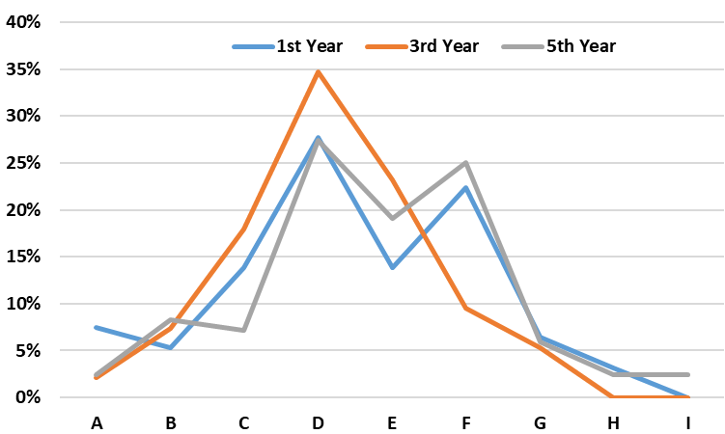
Figure 5: Frequency distribution of the sample according to their preferred gingival display.
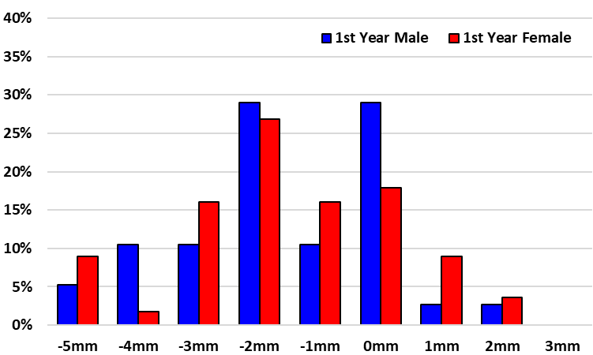
Figure 6: Mean preferred gingival display of first year males and females.

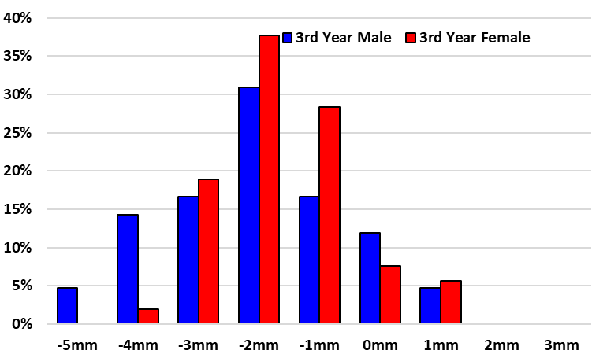
Figure 7: Mean preferred gingival display of third year males and females.

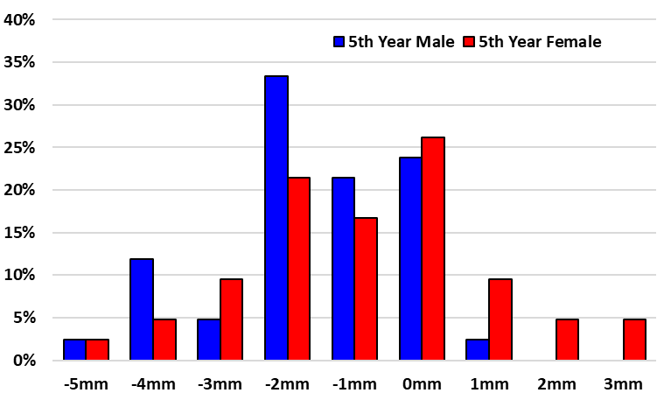
Figure 8: Mean preferred gingival display of fifth year males and females.
Table 2: Mean and standard deviation of the preferred gingival display with gender difference by t-test.

 | First Year |  |  | Third Year |  |  | Fifth Year
 | Male | Female | Total | Male | Female | Total | Male | Female | Total
Mean | -1.605 | -1.536 | -1.564 | -2.048 | -1.623 | -1.811 | -1.595 | -0.857 | -1.226
SD | 1.685 | 1.768 | 1.726 | 1.513 | 1.113 | 1.315 | 1.415 | 1.816 | 1.660
t value | -0.192 |  |  | -1.522 |  |  | -2.078
d.f. | 92 |  |  | 93 |  |  | 82
p value | 0.848 (NS) |  |  | 0.131 (NS) |  |  | 0.041 (p<0.05)

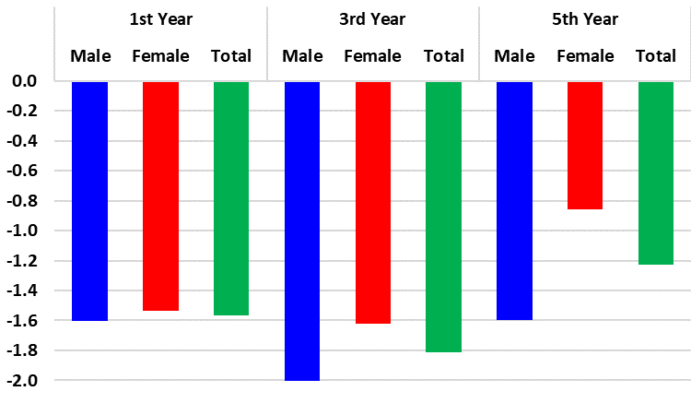
Figure 9: Mean preferred gingival display with gender difference.
Table 3: ANOVA test of the preferred gingival display among first, third and fifth year students.
 | Male | Female | Total
F value | 0.029 | 0.198 | 0.045
d.f. | 26 | 26 | 26
p value | 0.993 (NS) | 0.897 (NS) | 0.987 (NS)
- NS = Non-significant

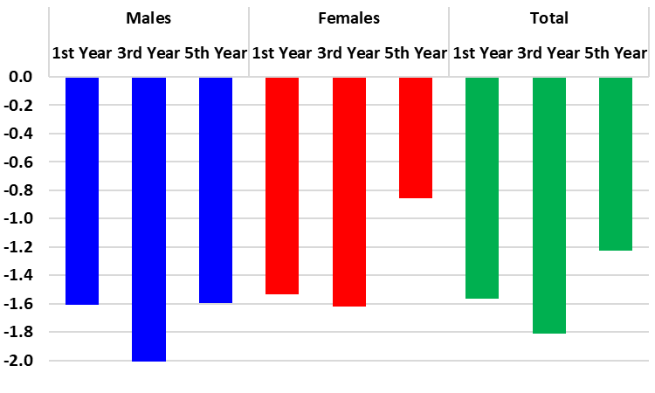
Figure 10: Mean preferred gingival display among first, third and fifth year students.

CHAPTER FOUR
DISCUSSION AND CONCLUSION

4.1 Most Common:
Most of the students chose -2 mm gingival display as the most attractive smile followed by -1mm and 0 mm of gingival display. These results correspond with the findings of Geron and Atalia (2005) and Pausch and Katsoulis (2017) who concluded that lip coverage of the upper incisors between 0–2 mm was found to be the most pleasing esthetically.
In contrast, other studies disagree with our results, two millimeters of gingival display was found in the most attractive smile in other studies (Kokich et al; 1999; Hunt et al; 2002; Kokich et al; 2006; Jornung and Fardal, 2007). This difference could be attributed to cultural differences and differences in sample properties (age, occupation, gender ….etc.).

4.2 Extremes:
From all the sample (273 students), only 9 students chose the -5 mm gingival display, 20 chose the -4 mm gingival display, 5 chose 2 mm gingival display and 2 chose the 3 mm gingival display. Also, no student chose the 4 and 5 mm gingival display. This is in accordance with the findings of several researchers (Pausch and Katsoulis, 2017).

4.3 Gender Difference:
In comparison between males and females, no significant difference was shown between them in the first and third grade while female seniors showed a significant difference in the choice with females favouring more gingival display. This agrees with the findings of Pausch and Katsoulis (2017).
This finding suggests that the female students are becoming more aware of the current trend to favour more gingival display and this awareness may be related to their dental education. In the absence of any similar study it is difficult to compare with any previous study.

4.4 Educational level:
The expectation was the education level of students in advance grades would affect their choices for the most attractive smile, but the results show no significant difference between the samples. Moreover, although the female senior students did favour more gingival display than their male counterparts but this was only weakly statistically significant.
This finding indicates that this change in perception towards smile perception is only marginal and further studies are needed on post graduate dentists to shed light on the effect of practicing dentistry on smile attractiveness perception.

4.5 Conclusion:
1. Smiles with 0 to -2 mm gingival display were considered to be the most attractive by the most of students (67.4%).
2. Only 8.4% of the sample preferred smiles with 1mm to 3mm gingival display.
3. No significant gender difference was found among first and third grade students but was significant for fifth graders with female students favouring more gingival display.
4. Educational level showed no significant effect on the choice of the most attractive gingival display.

REFERENCES
Ackerman MB, Brensinger C, Landis JR. An evaluation of dynamic lip-tooth characteristics during speech and smile in adolescents. Angle Orthod. 2004;74(1):43-50.
Ahmad I. Geometric considerations in anterior dental aesthetics: restorative principles. Pract Periodontics Aesthet Dent. 1998;10(7):813-22; quiz 824.
Arnett GW, Bergman RT. Facial keys to orthodontic diagnosis and treatment planning: Part II. Am J Orthod Dentofacial Orthop. 1993;103(5):395-411.
Benson KJ, Laskin DM. Upper lip asymmetry in adults during smiling. J Oral Maxillofac Surg 2001; 59: 396-8.
Bhuvaneswaran M. Principles of smile design. J Conserv Dent 2010; 13: 225-32.
Bull R, Rumsey N. The Social Psychology of Facial Appearance. New York, NY: Springer Verlag; 1988.
Câmara CALP. Estética em Ortodontia. Parte I: diagrama de referências estéticas dentais (DRED). Rev Dental Press Estét. 2004;1(1):40-57.
Dion K, Berscheid E, Walster E. What is beautiful is good J Pers Soc Psychol. 1972; 24: 285–290
Dong JK, Jin TH, Cho HW, Oh SC. The esthetics of the smile: A review of some recent studies. Int J Prosthodont 1999; 12: 9-19.
Eli I, Bar-Tal Y, Kostovetzki I. At first glance: social meanings of dental appearance. J Public Health Dent. 2001; 61: 150–154.
Feingold A. Good-looking people are not what we think. Psychol Bull. 1992: 111: 304-41.
Flanary C. The psychology of appearance and psychological impact of surgical alteration of the face. In: Bell WH, ed Modern Practice in Orthognathic and Reconstructive Surgery. Philadelphia, Pa: Saunders; 1992: 3–21.
Frush JP, Fisher RD. The dynesthetic interpretation of the dentogenic concept. J Prosthet Dent 1958; 8: 558-81.
Geron S, Atalia W. Influence of sex on the perception of oral and smile esthetics with different gingival display and incisal plane inclination. Angle Orthod. 2005; 75(5): 778-84.
Graber TM, Vanarasdall RL, Vig KW. Orthodontics: Current Principles and Techniques. 4 th ed. St. Louis, Mo: Mosby Year Book; 2005. p. 46-47.
Greitemeyer T, Brodbeck F. Wer scho ¨n ist, ‘‘wird’’ auch gut Z Sozialpsychol. 2000; 31: 73–86.
Geron S, Atalia W. Influence of sex on the perception of oral and smile esthetics with different gingival display and incisal plane inclination. Angle Orthod. 2005; 75(5): 778–784.
Gochman D S 1975 The measurement and development of dentally
relevant motives. Journal of Public Health Dentistry 35: 160-4.
Hideki Ioi, Shunsuke Nakata, Amy L. Counts 2010 Influence of gingival display on smile aesthetics in Japanese. Eur J Orthod 32: 633–7.
Hunt O, Johnston C, Hepper P, Burden D, Stevenson M. The influence of maxillary gingival exposure on dental attractiveness ratings. Eur J Orthod. 2002;24(2):199–204.
Hulsey CM. An esthetic evaluation of lip-teeth relationships present in the smile. Am J Orthod 1970; 57: 132-44.
Hunt O, Johnston C, Hepper P, Burden D, Stevenson M. The influence of maxillary gingival exposure on dental attractiveness ratings. Eur J Orthod. 2002; 24(2): 199–204.
Jornung J, Fardal O. Perceptions of patients’ smiles: a comparison of patients’ and dentists’ opinions. J Am Dent Assoc. 2007;138(12): 1544–1553; quiz 1613–1614.
Kokich VO Jr, Kiyak HA, Shapiro PA. Comparing the perception of dentists and lay people to altered dental esthetics. J Esthet Dent. 1999;11(6):311-24.
Kokich VO, Kokich VG, Kiyak HA. Perceptions of dental professionals and laypersons to altered dental esthetics: asymmetric and symmetric situations. Am J Orthod Dentofacial Orthop. 2006; 130(2): 141-51.
Langlois J, Kalakanis L, Rubenstein A, Larson A, Hallam M,
Smoot M. Maxims or myths of beauty? A meta-analytic and
theoretical review. Psychol Bull. 2000; 126: 390–423.
Mackley RJ. An evaluation of smiles before and after orthodontic treatment. Angle Orthod. 1993;63(3):183-9; discussion 190.
Margolis M J 1997 Esthetic considerations in orthodontic treatment of
adults. Dent Clin North Amer 41: 29-48.
Mondelli J. Estética e cosmética em clínica integrada restauradora. 1ª ed. São Paulo: Ed. Santos; 2003.
Montini RW, McGorray SP, Wheeler TT, Dolce C. Perceptions of orthognathic surgery patient’s change in profile. A five-year follow-up. Angle Orthod. 2007; 77(1): 5-11.
Moore T, Southard KA, Casko JS, Qian F, Southard TE. Buccal corridors and smile esthetics. Am J Orthod Dentofacial Orthop 2005; 127: 208-13.
Nanda R. Biomechanics and esthetic strategies in clinical orthodontics. (Chicago): Elsevier Inc.; 2005.
Newton JT, Prabhu N, Robinson PG. The impact of dental appearance on the appraisal of personal characteristics. Int J Prosthodont. 2003; 16: 429–34.
Patnaik VVG, Rajan S, Sanju B. Anatomy of a beautiful face and smile. J Anat Soc India. 2003;52(1):74-80. Psychol Bull. 1992; 111: 304–41.
Pausch NC, Katsoulis D. Gender-specific evaluation of variation of maxillary exposure when smiling. J Craniomaxillofac Surg. 2017 Mar 27. pii: S1010-5182(17)30097-5. doi: 10.1016/j.jcms.2017.03.002. [Epub ahead of print]
Rufenacht CR. Fundamentals of Esthetics. Carol Stream, III: Quintessence; 1990.
Sabri R. Overview: The eight components of a balanced smile. J Clin Orthod. 2005; 39(3): 155-67.
Sarver DM, Ackerman MB. Dynamic smile visualization and quantification: Part 2. Smile analysis and treatment strategies. Am J Orthod Dentofacial Orthop 2003; 124: 116-27.
Sarver DM. The importance of incisor positioning in the esthetic smile: The smile arc. Am J Orthod Dentofacial Orthop 2001; 120: 98-111.
Singla S, Lehi G. Smile analysis in orthodontics. Indian J Oral Sci 2014:5:49-54.
Teo CS. An evaluation of the smiling lip-line. Singapore Dent J. 1981; 6(1): 27-30.
Thompson L, Malmberg J, Goodell N, Boring R. The distribution of attention across a talker’s face. Discourse Process. 2004; 38: 145–68.
Tjan AH, Miller GD, The JG. Some esthetic factors in a smile. J Prosthet Dent. 1984; 51(1): 24-8.

