Republic of Iraq
Ministry of Higher Education
And Scientific Research
University of Baghdad
College of Dentistry

A survey on Orthodontic Retention Protocols Among Iraqi Orthodontists
A Graduation Project Submitted to College of Dentistry, University of Baghdad, In Partial Fulfillment of the Requirement for B.D.S.
By Tuqa Sahib Rasheed
5th year Dental Student

Supervised by:

Assist. Prof. Dr. Mustafa M. Al-Khatieeb
(B.D.S, M.Sc)

2016-2017

Declaration

Certification of the Supervisor

I certify that this project prepared under my supervision at the university of Baghdad in partial fulfillment of requirements for the Bachelor Degree in Dental science .

Signature:

Assis. Prof. Dr. Mustafa M. Al-Khatieeb

(B.D.S, M.Sc)

Orthodontic Department.

The Supervisor.

Dedication

To my beloved......

Mother & Father

Brother & Sisters

Acknoledgment

First of all, I thank “Allah” almighty for granting me the will and strength to accomplish this project, and pray that his blessings upon me may continue throughout my life.

I offer my project gratitude to Prof. Dr. Hussain Al-Huwaizi, the Dean of college of Dentistry, University of Baghdad, for continuously supporting the pregraduate students ..

My great thanks to Prof. Dr. Dhiaa Jaafar, the Chairman of Orthodontic Department , for his help and support during our study.

I’m greatly indebted to my supervisor Assist. Prof. Mustafa M. Al-Khatieeb for his help, advice and efforts in supervising this work.

Finally, I would like to express my great thanks and appreciation to my family for their support and encouragement during the whole study period.

I

Abstract
The aim of this study was to evaluate retention practices commonly employed by orthodontists. The objectives were to identify the types of retainer frequently used and to investigate the variations in retention practice.

A total of 67 orthodontists were randomly selected, and a questionnaire consisting of 8 multiple-choice questions sent to them . Upon receiving of the completed questionnaires, the data were statistically analyzed.

A responses were received; among these, (40.2%) of orthodontists' practiced was at the University of Baghdad , Collage of Dentistry, and( 60.8%) were in private practice. An Essix retainer was the most commonly used removable retainer for maxillary arch (35.82%) , followed by a Hawley retainer( 26.86%) ; a bounded lingual retainer( 22.38%) , and combination retainer( 14.92 %) , while in the mandible the the combination retainers are about (17.91%) and the mostly used retainer are removable( 50.74% )followed by BLR (31.34%) ; Of the responding orthodontists,( 74.62%) prescribed full-time wear (more than 20 h per day) for a duration of 1 year for a maxillary arch, compared to (71.64%) for the mandibular arch. Only( 13.43%) of the orthodontists prescribed part-time (less than 20 hours) of the UDA and (19.40%) for LDA .
Essix are the most commonly used retainers among orthodontists. The majority of orthodontists prescribed full-time wear for more than 20 h per day with a duration of one year.

II

List of contents
subjects | page
Acknowledgment | I
Abstract | II
List of content | III
List of tables | IV
List of figures | V
Introduction | VI
Aim of study  III |  | IX
Chapter one
Review of literature |  | PAGE
1.1 History | 1
1.2 Retention | 5
1.3 Types of mechanical retention | 6
1.3.1 Removable retention | 7
1.3.1. A- The traditional hawley – type appliance | 7
1.3.1. B- Vacuum, formed retainers | 9
1.3.1. C- positioner | 11
1.3.2- Fixed retention | 13
1.3.2- A- Fixed Bonded Lingual retainer | 13
1.3.2- B_Mandibular Canine To Canine Fixed retainer | 14
1.3.3- Active retainer | 18
1.3.3- A-Spring retainers | 19
1.3.3- B-Modified functional appliance as an active retainer | 19
1.3.4- Hybrid retainer | 21

Chapter two
Materials and methods | 22

Chapter three
Results | 23

Chapter four
Discussion |  | 26

Chapter five
`Conclusion and suggestion |  |  | 29
References |  |  | 30

Appendix

III

table | Title | Page
1 | Types of retainers commonly used | 23
2 | period of retention protocol and check up | 24
3 | period of retention per day | 24
4 | follow up the retainer check up | 25
5 | Assumption of retention protocol | 25
List of tables

IV

Figure | Title | Page
1 | Controlling of eruption of posterior teeth |  | 7
2 | Canine To canine anterior bow and clasp on Molars |  | 8
3 | Fabrication of the vacuum_formed retainers |  | 9
4 | Upper vacuum _formed retainer |  | 10
5 | Postioner and elastomeric positioned |  | 13
6 | Fixed bonded lingual retainer |  | 16
7 | Fixed retainer |  | 17
8 | Spring retainer |  | 19
9 | Modified functional appliance |  | 21
10 | Hybrid retainer |  | 21

List of figures

V

Introduction

Almost every patient who had comprehensive orthodontic treatment is given some type of retainer . Studies on the type of retainer used by orthodontists have been published by Keim et al⁽¹⁾. ,Wong ⁽²⁾,. And Freer ⁽³⁾. The study of Keim et al. Among orthodontics specialist in the United States of America showed that , although decreasing popularity , the Hawley retainer still the used retainer further more invisible retainer is becoming a widely used retainer, while the use of bounded lingual retainers were increasing , with one third of orthodontists using them routinely in the lower dental arch ⁽¹⁾.

While in Australia and New Zealand, an upper invisible retainer and lower canine to canine bounded lingual retainer are commenly used ^{(2,3)} . A study by Renkema etal ⁽⁴⁾ . Showed that factors such as pretreatment conditions, post treatment occlusion , the end result , and oral hygien determine the choice of retainer used .Some orthodontists suggest that fixed retention is the only way of ensuring a stable result ^{(5,6)} .While others contend that removable appliances are required to enable the supporting tissues to adapt the functional demands placed on them ^{(7,8)}

VI

Aims of the Study

1- Evaluate the retention practices commonly employed by orthodontists in Iraq .

2- Types of retainers & which type is more preferable among orthodontists .

3- Evaluate the period of retention check ups .

4-The importance of the period that the patients have been instructed to wear the retainer .

5- Determine the fact behind the assumption of such retention protocol , and by the whom the follow up will be done .

IX

Chapter one

Review of literature
1.1 History
Retention is the phase of orthodontic treatment which maintains the teeth in their orthodontically corrected positions following the cessation of active orthodontic tooth movement. Orthodontic retainers resist the tendency of teeth to return to their pre-treatment positions under the influence of periodontal, occlusal and soft tissue forces, and continuing dentofacial growth. Early clinicians recognized changes in the dentition following treatment, Evens in 1854 seems to be the first to mention the need for some type of retention⁽⁹⁾ . Emerson Angell in 1860 likewise recognized a need for retention following the expansion of the maxillary median suture, Alfred Coleman (1865) was the first to describe the effects of muscular pressure on the dentition, in essence relapse, and one year later, C. A. Marvin described the physiologic reasons for retention^{(9, 10)}.
It was the opinion of Edward H. Angle in 1907 that achieving a normal occlusion as a result of orthodontic treatment was the most crucial component necessary in achieving long-term stability, even at the expense of an expanded dental arch, problems of retention are often taken too lightly and are greater than the problems encountered during active treatment ⁽¹¹⁾. perhaps during a time of extreme frustration, Hawley in 1919 proclaimed that he would give half of his fee to anyone who would be responsible for the retention of his results when the active appliance was removed⁽¹²⁾.
The intent of orthodontic treatment is the correction and prevention of malocclusion of the teeth, but the maintenance of the corrections has plagued orthodontists possibly since the inception of the specialty⁽¹³⁾. In contrast, McCauley in 1944 promoted maintaining inter-canine and inter- molar widths of the original malocclusion⁽¹⁴⁾.

1
In accordance with McCauley, 1944 also recognized the lack of stability in cases where arch expansion had occurred ⁽¹⁴⁾, and Tweed went on to advocate the extraction of teeth in order to prevent this. Tweed, 1945 also proposed that the most stable position for mandibular incisors was upright over their supporting basal bone ⁽¹⁵⁾.
Strang in 1952 claimed that the primary causes of malocclusion lie hidden in the mysterious processes of growth and development, which are beyond our power to control, and Strang recommended overcoreection as a means of reducing the incidence of post-treatment relapse⁽¹⁶⁾. Reitan in l959 noted the potential effects that the periodontium and supporting structures could have on tooth position⁽¹⁷⁾.
Levin (1972) stated that, It is the obligation of the clinician to plan the retentive phase of orthodontic therapy for all adult patients before active treatment is begun ⁽¹⁸⁾.
No other issue in orthodontics, with the possible exception of extractions, seems to receive as much attention as retention. Retention, as it pertains to orthodontics, has been defined as the holding of teeth following orthodontic treatment in the treated position for the period of time necessary for the maintenance of the result⁽¹⁹⁾ .
Joondeph and Riedel in 1994 defined orthodontic retention as the holding of teeth in ideal esthetic and functional positions. The goal of retention is to counteract forces that might affect the teeth as a result of their new positions in the oral environment until such time as the teeth and supporting tissues have become reoriented to the new position.
2
The standard hawley retainer and the fixed mandibular canine to canine retainer have remained popular methods to help achieve these goals and are in routine use by many orthodontists today⁽²⁰⁾ .
Graber in 1994 noted that, retention depends on what is acomplished during treatment. This requires careful consideration of the factors that have the potential to affect post treatment outcomes and stability⁽²¹⁾.
Boley and coworkers in 2003 showed optimism that long-term stability is not hopeless and that, satisfactory long-term results can be achieved for most patients for whom evidence-based treatment objectives including minimal alteration of the mandibular arch form and the retraction and uprighting or maintenance of mandibular incisors in their original position have been met ⁽²²⁾ . Based on his review of the literature on post retention stability of mandibular incisors, Littlewood, 2004 defined retention as the phase of orthodontic treatment that attempts to keep teeth in their corrected position following orthodontic braces, and is thus a very integral part of the treatment⁽²³⁾.
Boley in 2007 also supported the contention of Little and coworkers (1990) who looked at retention of early treatment cases involving arch length increases, and concluded that decisions made during active treatment, such as lateral arch expansion and advancement of the mandibular incisors, make a difference in long-term stability⁽²⁴⁾ .
3
Relapse is the tendency of teeth, which were moved orthodontically to new positions during treatment that may not be well stabilized by the musculature, periodontium and other supporting structures, to return towards their more stable, pretreatment positions ⁽²⁰⁾, Whether or not individual cases can be viewed as successful or not needs to be evaluated by the stability of treatment results. Rationale and methods of retention following orthodontic treatment continue to be a popular, It is widely accepted that the mandibular incisors are the teeth most commonly affected by relapse ^{(22,24)}.

5

4

2rrrrer
5

1.2 Retention
Retention can be achieved by placing appliances known as retainers. There are different types of retainers, broadly divided into either removable or fixed ⁽²⁵⁾.The type of retainer used and the duration of retention is highly variable from one patient to another, mostly depending on the orthodontist’s selection. However, it is an accepted theory that the time of retention must be at least the amount of time necessary for the periodontal fibers around the teeth to reorganize into their new positions ⁽²⁴⁾ .
Unfortunately, even in patients who wear retainers for at least a year, the long term post-retention stability has still shown to be poor, indicating relapse in approximately half of the cases. Recognizing the vast parameters of retention, this report attempts to explore the different types of retainers available to maintain tooth position ⁽²³⁾.
When choosing the retention regimen, the following factors should be considered ⁽²⁵⁾:
1• Likely stability of the result .
2• Initial malocclusion .
3• Type of appliances used .
4•Oral hygiene .
5• Quality of the result (is any settling-in of the occlusion required?) .
6• Compliance of patient .
7• patient expectations .
8• Patient preference .

1.3 Types of Mechanical Retention
The purpose of post treatment retention, according to Angle is that after malposed teeth have been moved into the desired position, they must be mechanically supported until all the tissues involved in their support and maintenance in their new positions shall have become thoroughly modified, both in structure and in function, to meet the new requirements.
Proffit in 1993 has described various forms of mechanical retention as removable, fixed, passive, or active, mechanical retention can generally be broadly classified based on whether or not the retainer is intended to be taken in and out of the mouth by the patient. Both fixed and removable forms of retention continue to be popular means of maintaining post orthodontic treatment results ⁽²⁵⁾.
Since 1925, the standard maxillary retaining device has been the removable Hawley retainer, while in the lower arch, the cemented canine-to- canine retainer has been popular for possibly a longer period of time ⁽¹⁰⁾.
6

1.3 Types Of Mechanical Retention

1.3.1-Removable Retention

1.3.1.A-The traditional Hawley-type appliance
This removable appliance developed 1920, can be fabricated for both the maxillary and mandibular arches and consists of an acrylic base that typically fits against the lingual surfaces of the teeth with round 0.028” or 0.030” stainless steel wire that is incorporated into the base and fits over the occlusal aspect of certain teeth for retention, then continues as a labial bow that follows the post treatment facial contour of the anterior teeth in an effort to maintain the orthodontic result. Patients are typically advised to wear their Hawley retainers full time or as much as possible during the first six months post treatment, followed by indefinite night time only wear after this time, as shown in Figure 1 ⁽²⁶⁾ .
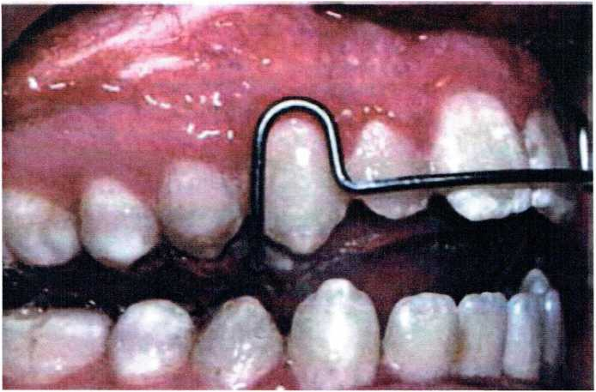
Figure 1: Controlling the eruption of posterior teeth during late vertical growth is the key to preventing open-bite relapse ⁽²⁷⁾.
7
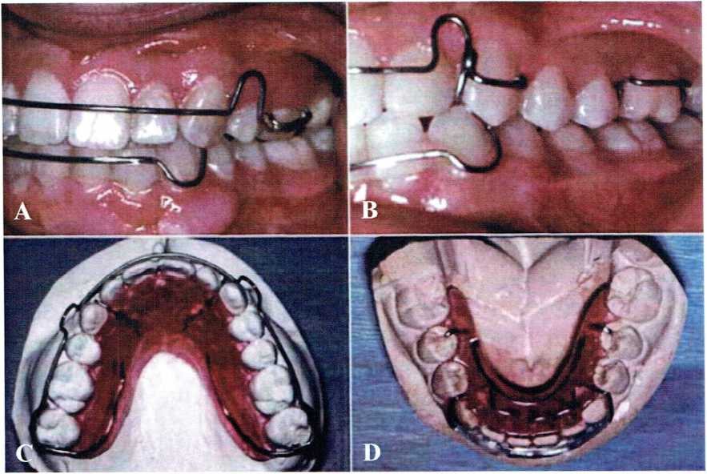
Figure 2: Canine-to-canine anterior bow and clasps on molars ⁽²²⁾.
We have many variations in Hawley retainers design as demonstrated
in Figure 2. They are the characteristic features of the Hawley retainer design. A, A Hawley retainer for a patient with maxillary premolar extractions, with the anterior bow soldered to Adams clasps on the first molars so that the extraction site is held closed. B, The adjustment loop of the Hawley anterior bow keeps the wire from having full contact with the canines. If this is needed, as in this patient whose canines were facially positioned before treatment, a wire that extends across the canines can be soldered to the anterior bow. C, In a patient whose second molars have erupted, a wraparound outer bow soldered to C-clasps on the second molars provides a way to avoid interference as the retainer wire crosses the occlusion. D, For a mandibular retainer, the wire Hawley bow is less effective than a wire-reinforced acrylic bar that tightly contacts the lower incisors⁽²⁷⁾.

8
1.3.1.B-Vacuum-formed retainers “Essix retainer”⁽²⁸⁾: (Figure 3)
Are another common type of appliance used for retention developed in 1993. These acrylic retainers are fashioned out of clear 0.030”acrylic coping material that is heated and then vacuum-formed onto plaster casts of the patients’ treated dentition. The resultant trays are then trimmed to provide 1 to 2 mm buccal and 3 to 4 mm lingual extensions past the gingival margin such that they fit over the occlusal surfaces of the teeth, including the most distal tooth; these are commonly clear and can be fabricated for the maxillary and mandibular arches.
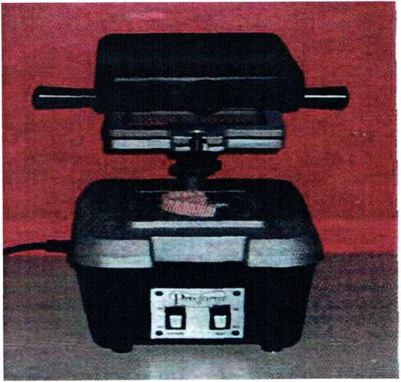
Figure 3: Fabrication of the vacuum-formed retainer ⁽²⁸⁾.
9
The advantage of this retainer⁽²¹⁾:
1-Esthetic.
2-Patient is more likely to wear.
3-Inexpensive.
4-Quick fabrication.
5-Minimal bulk.
6-High strength.
7-No adjustments.
8-does not interfere with speech or function.
-Studies have determined that essix retainer are as efficient as Hawley type or bonded retainers ⁽²⁹⁾.
The benefits of removable retainers that they are ⁽²¹⁾:
- Easier for oral hygiene (they can be removed by the patient for cleaning)
٠ Capable of being worn part-time if required.
٠ The responsibility of the patient, not the orthodontist.
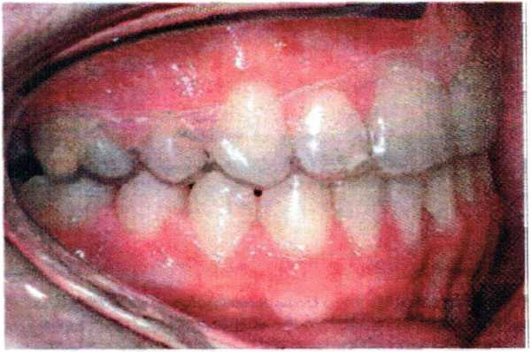
Figure 4: Upper vacuum-formed retainer ⁽²⁷ ⁾
10
The upper vacuum-formed retainer has been trimmed to finish 1-2 mm above the gingival margin. The exception is the area cut away over the canine to make it simpler for the patient to remove the retainer⁽²⁷⁾.
It is important that the patient is instructed never to drink with the vacuum-formed retainer in situ, particularly with cariogenic drinks.Vacuum- formed retainers are contraindicated in patients with poor oral hygiene. This is because these types of retainers are retained by the plastic engaging the undercut gingival to the contact point. If the oral hygiene is poor, then hyperplastic gingivae can obliterate these areas of undercut ⁽²⁸⁾.
The upper Vacuum-formed retainer can act as a reservoir holding the drink in Contact with the tips of the teeth with a severe risk of décalcification ⁽²⁷⁾.
1.4.1.C- positioner:(figure 5)
Immediately following comprehensive orthodontic treatment in an effort to achieve three-dimensional control of post treatment tooth position. Kessling in 1945 described an elastomeric positioner to allow for minor tooth movements, space closure, and overbite coreection if worn coreectly by patients following orthodontic treatment ⁽³⁰⁾.
Nowadays, this rubber-based appliance is custom made to the patient’s post treatment occlusion and centric relation, but adjusted to fine- tune the occlusion by allowing minor changes to occur as the patient fonctions in it. This type of control helps the teeth settle into the most ideal functional and aesthetic relationships without losing the centric relation position of the mandible ⁽²⁹⁾.
11
Following this “settling” of the teeth, the positioner can continue to serve as a traditional removable retainer if worn on a limited basis ⁽³⁰⁾.
The logic of removable retention is that it allows functional integration of teeth into their new positions and does not totally protect them from the post treatment forces, that they will be influenced by the remainder of their service. Waldron in 1942 further suggested that because such forces are natural forces, their effect is not only enduring, but functionally essential, and he suggested that a removable retainer that permits maximum functional freedom to the dentition, while providing minimal retentive restraint, is the best form of appliance⁽³¹⁾.
The primary advantage of a removable retainer is that the patient and orthodontist maintain the ability to easily remove it for cleaning and adjustment, if necessary. This ability to be removed also serves as the primary disadvantage as well. The ability of the removable retainer to maintain tooth position is completely dependent on patient compliance and wear. Lack of patient compliance regarding instructions for use can result in compromised post treatment stability⁽³¹⁾.
12
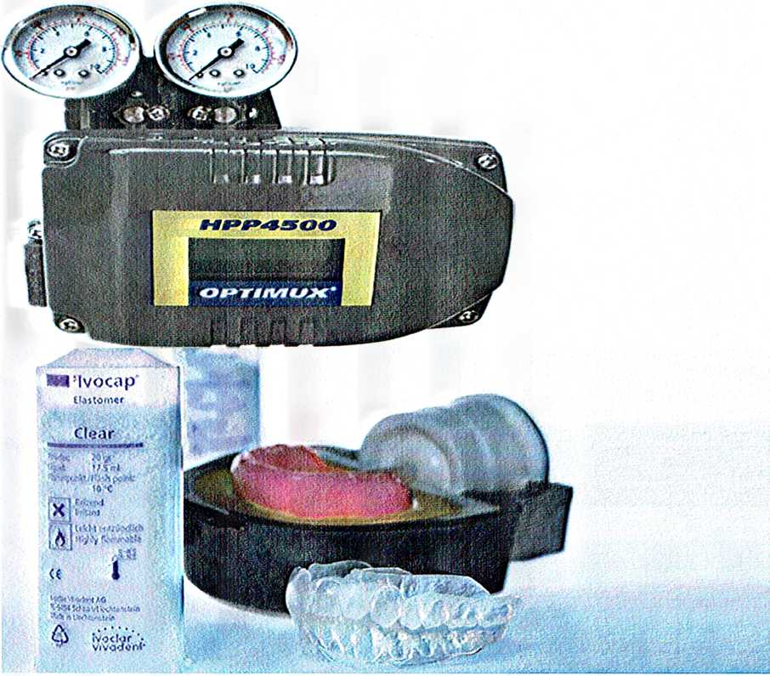

1.3.2 Fixed Retention: (Figure 6 , and 7)
The most commonly used form of fixed retention is:
1.4.2-A-Fixed bonded lingual have some variant of a round archwire that is bonded to the lingual surfaces of the maxillary central incisors or the lingual surfaces of the mandibular anterior teeth, typically from canine to canine ⁽³²⁾.
Occasionally, the first and second premolar teeth are included if these teeth had been extremely malpositioned at pretreatment or to prevent mesial tipping of these teeth or the opening of spaces in extraction cases.
Figure 5: Positioner and elastomeric positioned ⁽³⁰⁾.
13
A nother type of fixed retainer is:
1.3.2.B- mandibular cnine-to-canine fixed retention, the purpose is: (1) To prevent incisor recrowding, (2) To hold the achieved lower incisor position in space, and (3) To keep the rotation center in the incisor area when amandibular anterior growth rotation tendency is present⁽⁵⁾.
Wires typically used are either a braided or a solid section of wire. Currently, the most commonly used solid wires are either a round 0.032 inch stainless steel or 0.030 inch gold-coated wire, bent and sandblasted on the ends for improved retention for bonding. These solid wires are usually bonded only to the lingual surfaces of the canines with light cured composite. This form of retention allows rigid fixation of the teeth, thus prohibiting the potential physiologic response of the teeth to extraneous forces exerted on them ⁽³²⁾.
The use of a braided wire for bonded retention has recently become popular. Proponents of the braided type wire claim that its flexibility allows for some physiologic tooth movement in response to the surrounding forces, while tooth position is maintained. Typically, because of the added flexibility of these wires, clinicians are able to bond all anterior teeth to it, including the canines ⁽³³⁾.
Atack et al in 2007 analyzed two groups of 29 patients at least one year post debonding. One group had bonded lower canine to canine multistrand retainers placed following debonding, while the other group received lower Hawley-type retainers. Based on Little’s irregularity index, relapse was seen in both groups, but no statistical difference was found in the rate of relapse between fixed braided archwire retainers and standard Hawley-type removable retainers ⁽³⁴⁾.
14
The logic of fixed retention is to provide a constant, rigid fixation of the mandibular anterior teeth until the supporting structures are able to adapt to the treatment changes, independent of patient compliance. Angle (1907) stated that the post treatment dentition should be placed in rigid fixed retention for as long as possible. Contrary to Angle’s perspective was the opinion of Markus (1938) who assumed from his search of the literature that teeth must not be fixed following active treatment because this implies that occlusion is static. The positions of the teeth may change immediately, or long after the mechanical retentive appliances are removed.The primary advantage for using fixed means of retention is that it cannot be removed by the patient, which obviates any patient compliance issues⁽⁷⁾.
However, use of fixed retention requires periodic observation, maintenance and accountability for presence of the appliance. Placement of fixed retainers has been considered by some to be time-consuming and technique sensitive and for some individuals, they can be difficult to manage and maintain, encouraging unwanted tooth movement and accumulation of plaque and calculus ⁽³⁴⁾.
Issues have also arisen as to whose responsibility it is to manage the long-term monitoring of the fixed retainer: the orthodontist, general dentist, or hygienist.
15
Figure 6: Fixed bonded lingual retainer⁽²⁶⁾
The potential advantages of fixed retainers include the fact that⁽³⁵⁾:
٠ Patients do not need to remember to wear them.
- They are useful when the result is very unstable.
There are certain cases where the final result will be extremely unstable.
In these cases it is essential that a retainer is in situ full-time, otherwise relapse could occur. In these cases a fixed retainer is recommended, examples include (Figure 7):
closure of spaced dentition (including median diastema).
- following correction of severely rotated teeth.
- where there has been a substantial movement of the lower labial segment.
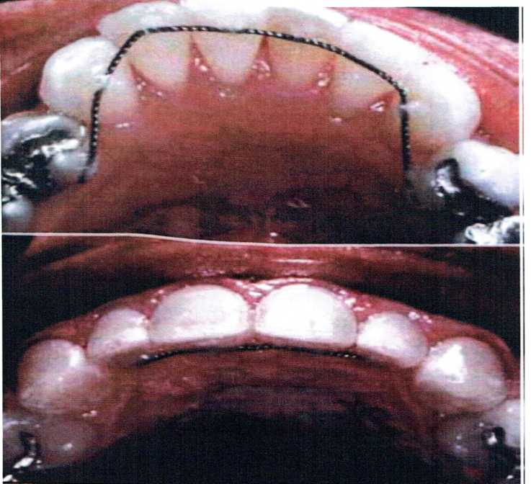
16
٠ combined periodontal and orthodontic cases, where reduced periodontal support makes relapse more likely.

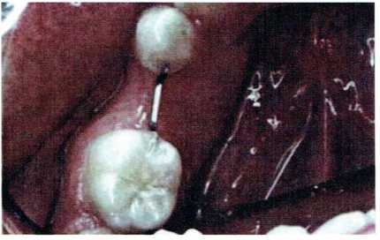
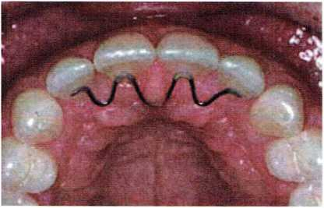
Figure 7:Fixed retainers ⁽²⁶⁾.
17
Current indications for the use of mandibular canine-to-canine fix retention include⁽²⁵⁾:
- Non-extraction cases in which slight increase in arch length or mandibular intercanine width have been produced.
- patients with pretreatment diastemas or severe incisor crowding or rotations.
- patients with a pretreatment flat functional occlusal plane or open bite.
- Class II patients with a rotation center in the premolar area (Bjork’s anterior rotation Type III), and
- patients with a ClassIII growth tendency ⁽³³⁾.
Riedel in 1976 stated that mandibular fixed retention successfully stabilizes the lower anterior segment until one has resolved the problem of the third molar and resolved problems related to growth changes⁽³⁵⁾.

1.3.3 Active Retainer
A contradiction in terms, since a device cannot be actively moving teeth and serving as a retainer at the same time. It does happen; however, that relapse or growth changes after orthodontic treatment lead to a need for some tooth movement during retention. This usually is accomplished with a removable appliance that continues as a retainer after it has repositioned the teeth, hence the name. A typical Hawley retainer, if used initially to close a small amount of band space, can be considered an active retainer, but the term usually is reserved for two specific situations realignment of irregular incisors with spring retainers, and management of Class II or Class III relapse tendencies with modified functional appliances⁽²⁶⁾.
18

Types of Active Retainer

1.3.3-A Spring Retainers; (Figure 8)
Re-crowding of lower incisors is the major indication for an active retainer to correct incisor position. The shape of the incisor crowns can contribute to re-crowding, but the cause of the problem in these cases usually is late mandibular growth that uprighted the incisors. If late crowding has developed, it often is necessary to reduce the interproximal width of lower incisors before realigning them, so that the crowns do not tip labially into an obviously unstable position ⁽²⁵⁾.
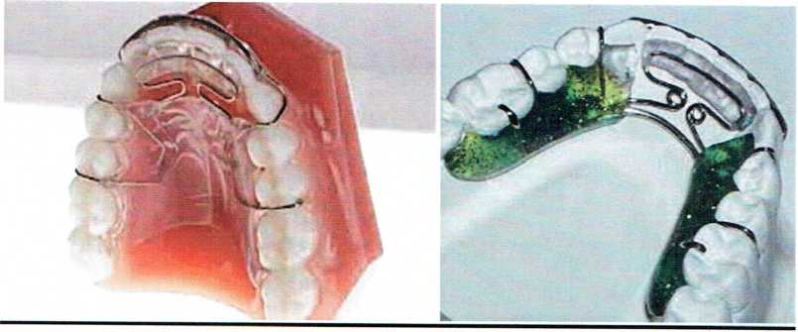
Figure 8: Spring retainer ⁽²⁵⁾.
1.3.3-B Modified functional appliance as active retainer: (Figure 9)

It possible to desicribe an activator as consisting of maxillary and mandibular retainers joined by an aninterocclusal bite block. Although even the simplest activator is more complex than that, The desicription does illustrate the potential of a modified functional appliance to simultaneously maintain the position of teeth within the arches while altering, at least minimally, the occlusal relationships.
19
Atypical use for an activator or bionator as an active retainer would be a male adolescent who had slipped back 2to 3 mm toward a Class II relationship after early correction If he still is experiencing some vertical growth (almost all male adolescents fall into this category, at least to age 17 or l8 and often beyond), it may be possible to recover the proper occlusal position of the teeth. Differential anteroposterior growth is not necessary to correct a small occlusal discrepancy—tooth movement is adequate—but some vertical growth is required to prevent downward and backward rotation of the mandible. For all practical purposes, this means that a functional appliance as an active retainer can be used in teenagers but is of no value in adults.
Stimulating skeletal growth with a device of this type simply does not happen in adults, at least to a clinically useful extent⁽²⁶⁾.
The use of a functional appliance as an active retainer differs from its use as a pure retainer. As a retainer, the object is to control growth, and tooth movement is large lying in undesirable side effect. In contrast, an active retainer is expected primarily to move teeth—no significant skeletal change is expected. An activator or bionator as an active retainer is indicated if not more than 3 mm of occlusal correction is sought. Over this distance, tooth movement as a means of correction is a possibility. The correction is achieved by restraining the eruption of maxillary teeth posteriorly and directing the erupting mandibular teeth anteriorly⁽²⁵⁾.
20
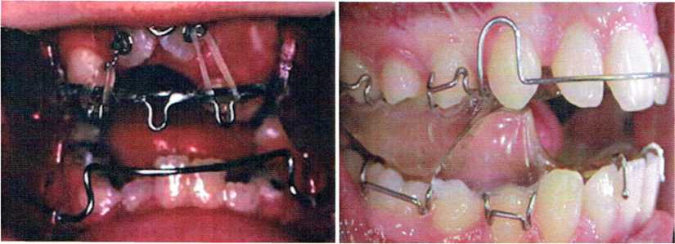
Figure 9؛ Modified functional appliance ⁽²⁶⁾.
1.3.4-Hybrid retainer(Figure 10):
Best choice of post orthodontic retention and when used as transitional dentition, take best feature of the Hawley and invisible retainers and combine them all in to anew appliance, the result is a clear, Invisible appliance, comfortable to wear , Hybrid retainer is wireless appliance suitable for long term retention.
Following conventional or aligner orthodontic treatment, they can be custom Made from models, in a full spectrum of transparent colors The appliance is designed to combine the comfort and aesthetic of invisible retainers and strength and effectiveness of the Hawley-type retainers, these retainers have not distorted over time and have done a wonderful job of keeping the teeth in perfect alignment⁽¹²⁾.

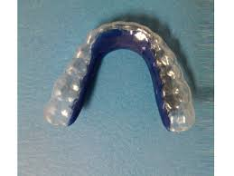

Figure 10: Hybrid retainer⁽²⁶⁾
21

Chapter two

Materials And Methods
This study was conducted via a questionnaire consisting of 8 multiple-choice questions modified from Pratt et al.⁽³⁶⁾ and Valiathan and Hughes.⁽³⁷⁾ The questionnaire was divided into three parts. Several identifiers were included in order to classify the respondents into subgroups. The first part consisted of questions involving the types of retainers that were commonly prescribed, and why does it depend on such type of practice. The second part involved questions about retention practice and period of check-up intervals, and retention check-ups. The third part involved the assumption of retention protocol and by whom the follow up would be done This questionnaire was first distributed to post graduated students of Orthodontic Department from patients finished orthodontics appliances before conducting the final surveyin Baghdad city.
67 samples were conducted for this survey. A simple random sampling method was used . A total of 67 registered orthodontists were included in this study. The study participants were orthodontists registered with the Iraqi Association of Orthodontists who are currently practicing in Baghdad city.
The questionnaire was sent to the selected orthodontists in December 2016. The survey was concluded after 2 months , whereby any response after that period was not included. Confidentially of the information provided was assured and participation was voluntary.
All statistical analyses were performed using the Statistical Package for Social Sciences (SPSS) software version 22.0 (IBM Co., Armonk, NY, USA) to derive descriptive statistics. The items were all described in number and percentages.

22

Chapter three

Results
A total of 67 respondents sent completed questioner within two months after the initial collection from clincian ( spcialized dentist , student of orthodontic brunch , students in orthodontic clincls), the result were as follows :-
40.2% of orthodontists' practiced at the University of Baghdad , Collage of Dentistry and 60.8 were in private practice. Table1 showed that an Essix retainer was the most commonly used removable retainer for maxillary arch( 35.82%), followed by a Hawley retainer (26.86%); a bounded lingual retainer( 22.38%) and combination retainer (14.92%) while in the mandible the combination retainers are about (17.91%) the mostly used retainer are removable( 50.74%) (ESSIX retainer 22.38% and Hawley retainer 11.94% ) followed by BLR( 31.34% ) ; Of the responding orthodontists.

Table 1: types of retainers commonly used
Arch | Types of retainer | Orthodontists who use spesific type of retainer
Maxillary | Hawley retainer | 18 (26.86)
 | Essix retainer | 24 (35.82)
 | Bounded lingual retainer | 15 (22.38)
 | Combination(Hawley&BLR) | 10 (14.92)
Mandibular | Hawley retainer | 8 (11.94)
 | Essix retainer | 15 (22.38)
 | Bounded lingual retainer | 21 (31.34)
 | Combination | 12 (17.91)
Values are presented in number and (%)

23

Table 2 showed the period of retention protocol and check up , It was found that most of orthodontists prescribed 1 year or more to wear the retainers for maxillary arch the percentage was (70.14 % ) and for the mandibular arch the percentage was( 62.68%) followed by period of more han 5 years 13.43% for maxillary arch and 3_6 months 19.40% for mandibular arch .

Table 2 period of retention protocol and check up.
variable | Maxillary retainer | Mandibular retainer
3_6 months | 6 (8.95) | 13 (19.40)
9 months | 5 (7.46) | 5 (7.46)
1 year | 47 (70.14) | 42 (62.68)
2_3 years | 0 | 0
3_5 years | 0 | 0
More than 5 year | 9 (13.43) | 7 (19.40)
Values are presented in number and (%)

Table 3 showed the period of retention per day most of orthodontics in Baghdad instructed the patient to wear the retainer for 20_24 hours per day ,( 74.62 %) for maxillary arch and ( 71.64 %) for mandibular arch followed by period of 12_16 hours per day( 13.43 %) for maxillary arch and (19.40 %)for mandibular arch . None of the orthodontists allowed the patient to decide the amount of time the retainer should be worn .

Table 3 period of retention per day .
variable | Maxillary retainer | Mandibular retainer
8 hours | 0 | 0
8_12 hours | 2 (2.98) | 0
12_16 hours | 9 (13.43) | 13 (19.40)
16_20 hours | 6 (8.95) | 6 (8.95)
20_24 hours | 50 (74.62) | 48 (71.64)
Values are presented in number and (%)

24
Table 4 showed the follow up retainer’s check ups in our survey, most of checked up was done by orthodontists themselfs( 79.10 %) , followed by check up was done by the patient( 16.41% ) , and only( 4.47 %) of patient are reffered to general physition .

Table 4 follow up the retainer check up.
Patient | 11 (16.41)
Self ( orthodontic) | 53 (79.10)
Refer to Gp | 3 (4.47)
Values are presented in number and (%)

Table 5 showed the assumption of retentin protocol in this survey , most assumption was based on what did he learn from the collage (52.23 %) , followed by what did he read from literatures (26.86 %), followed by clinical experience( 20.89 %) .

Table 5 Assumption of retention protocol .
Clinical experience | 14 (20.89)
What does he learn from collage | 35 (52.23)
What does he read from literatures | 18 (26.86)
Values are presented in number and(%)

25

Chapter four
Discussion
Only about one-third (55%) of the randomly selected orthodontists responded to the questionnaire. The response rate in this study was similar to the study by Valiathan and Hughes in 2010⁽³⁷⁾ , that survey was based on a study aimed to identifying a common retention practices in the United State.The response rate in this present study was markedly better than that in a study conducted by Pratt et al,⁽³⁶⁾ whose objective was to evaluate protocols and trends in orthodontic retention involving practicing members of the American Association of Orthodontists in the United States. In that study, the response rate obtained was 18%, which was lower than our response rate.
The results of this study showed that Essix retainers were the most commonly prescribed maxillary and mandibular retainers. This finding was in agreement with the study conducted by Meade and Millett,⁽³⁸⁾ that study aimed to evaluate retention protocols and the use of vacuum-formed retainers among specialist orthodontists in the Republic of Ireland, which involved 123 eligible Members of the Dental Council of Ireland specialist register of orthodontists and/or the Orthodontic Society of Ireland. They found that vacuum-formed retainers were the most commonly chosen retainers, prescribed by 53% of respondents for the maxilla and 33% for the mandible. Moreover, our study findings were also in line with those of a study conducted by Singh et al⁽⁴⁰⁾ in 2009 on the orthodontic retention pattern in the United Kingdom, which showed that vacuum-formed retainers were the most commonly used in the National Health Services and hospital practice. However, our results were in contrast to those obtained in other studies conducted in the Netherlands⁽⁴⁾ Australia⁽²⁾, New Zealand,⁽²⁾ Norway,⁽⁴¹⁾ and Switzerland.⁽⁴²⁾ In Netherlands and Switzerland, the most commonly used retainers for both types of arches were bonded retainers. Maxillary invisible retainers and mandibular canine-to-canine bonded retainers were the retainer of choice of orthodontists in Australia and New Zealand. Norwegian orthodontists preferred to use a combination of fixed and removable retainers (clear thermoplastic retainer) for the maxillary arch and fixed retainers for the mandibular arch during the retention phase after active orthodontic treatment.
26
It is worth mentioning that the results we obtained showed that the prescription of the Hawley retainer did not differ much from that of the Essix retainer. We found that the use of the Hawley retainer was the second most popular among orthodontists in this country. Based on a survey done by Keim et al.⁽¹⁾ in the United States of America, the Hawley retainer remained the most commonly used retainer, although the trend was decreasing. Another survey by Pratt et al.⁽³⁶⁾ also showed that for the maxillary arch, the Hawley retainer was most frequently used (47%), followed closely by the vacuum-formed retainer (41%). Valiathan and Hughes⁽³⁷⁾ . also concluded that the Hawley retainer is the most commonly retainer used for the upper arch.
A very small number of orthodontists still used fixed retainers in their practice and the use of a mandibular fixed retainer⁽¹⁾ was higher than for a maxillary fixed retainer. A survey carried out by Wong and Freer⁽³⁾. showed that the fixed retainer was used by a small number of orthodontists (maxillary,22.38 %; mandibular,31.34 %), which was simillar to the results of the present study. The findings from the studies by Keim et al⁽¹⁾. and Pratt et al⁽³⁶⁾ were in contrast to the results obtained in this study, indicating that there was a variation in the use of the retention appliances in different countries. The choice of retention appliances used by orthodontists may be based on the ease of fabrication, aesthetics, pattern of extractions, oral hygiene⁽⁴⁾, compliance of the patient, durability, pre-treatment occlusion, situation,^{(38,4)}, post-treatment occlusion⁽⁴⁾ , orthodontists personal preference^{(3,42 )} ,clinical experiances⁽⁴¹⁾ , specialist status^{(44,45)} , as well as the cost, rather than popularity.
Orthodontists in Iraq differed in their opinions on the length of time that retainers should be worn and on the duration of the retention phase⁽⁴⁴⁾ Patients were advised to wear the removable retainers for an average of 20_24 h per day, 7 days a week, after which part-time wear was advised for 8_12 h a day. Similar to their first retention phase, we found that two-thirds of the orthodontists prescribed full-time maxillary retainer wear, for more than 20 h per day, for at least 3–6 months. The majority of orthodontists in this country practiced a retention period of 1 year or more, generally preferred their patients to wear the retainers for a lifetime, this was in agreement with the recent study by Meade and Millett⁽³⁸⁾, who found that lifetime wear of retainers was advised by 67–78% of orthodontists in Ireland , high percentage of Iraqi orthodontists (62.68%) told their patients that they could stop wearing removable retainers 1 year after debonding. Overall, most of the orthodontists scheduled the first retention appointment at 3_6 months after debonding and followed their patients closely for a maximum of 2–4 years. The timing of the scheduled retention appointments varied among clinicians, and depended on their number of years in practice, the volume of patients debonded, and the type of retainer prescribed.⁽³⁷⁾
27
Histological studies have shown that reorganization of the periodontal ligament occurs over a 3–4-month period after cessation of orthodontic tooth movement, reorganization of the gingival tissue occurs over a 5– month post-treatment period, and the gingival collagen fiber network typically takes 4–6 months to remodel, while the supracrestal periodontal fibers remained stretched and displaced for more than 232 days after cessation of orthodontic tooth movement.^{(44,45)}, this suggests that the retention period should generally last at least 7 months⁽⁴³⁾, in this respect, results from our study showed that the retention practice among orthodontists in this country was in line with the suggestion by Johnston et al⁽⁴⁶⁾ ,in order to minimize relapse and to enhance stability.

28

Chapter five

Conclusion & Suggestions
This survey provides insight into the retention practice among orthodontists in Iraq. Within the limitations of the present study, the following conclusions can be drawn:
- Essix retainers are the most commonly used retainer among orthodontists in Iraq, followed by the Hawley and fixed retainers.

- Most orthodontists prescribed full-time wear of more than 20 h per day for a duration of 1 year and none of the orthodontists allowed the patient to decide the length of time the retainer should be worn.
- Orthodontists in Iraq practiced a retention period of 1 year and more, and preferred that the retainer to be worn indefinitely.
- Most of the patients returned for retainer-checking appointments for up to 4 years.

The main short come in the present study is that the fact that sample size was small. So We suggest broadening in the future studies to include larger samples and select a rural and urban area in order to make compassion between their results.

29

References

1- Keim RG, Gottlieb EL, Nelson AH, Vogels DS., 3rd 2002 JCO study of orthodontic diagnosis and treatment procedures. Part 1. Results and trends. J Clin Orthod. 2002;36:553–568.

2- Wong PM, Freer TJ. A comprehensive survey of retention procedures in Australia and New Zealand. Aust Orthod J. 2004;20:99–106.

3- Wong PM, Freer TJ. A comprehensive survey of retention procedures in Australia and New Zealand. Aust Orthod J. 2004;20:99–106.

4- Renkema AM, Sips ET, Bronkhorst E, Kuijpers-Jagtman AM. A survey on orthodontic retention procedures in The Netherlands. Eur J Orthod. 2009;31:432–437.

5- Angle EH. Treatment of malocclusion of the teeth, 7th ed. Philadelphia: The
ss White Dental Manufacturing Company; 1907.
6_ Little RM, Riedel RA, Artun j. An evaluation of changes in mandibular anterior alignment from 10 to 20 years post retention. Am j Orthod Dentofacial Orthop 1988; 93:423-8.
7_ Markus MB. A review and consideration of the problem of retention. Am j Orthod Oral Surg 1938; 24:203-12.
8_ Waldron R. Reviewing the problem of retention. Am j Orthod Oral Surgl942; 28:770-91.
9_ Alfred Coleman; manual of orthodontics, search for singapor dental surgeon 1865;10:581-500.
10_ Waldron R. Reviewing the problem of retention. Am j Orthod Oral Surgl942; 28:770-91.
11_ Angle EH. Treatment of malocclusion of the teeth, 7th ed. Philadelphia: The
ss White Dental Manufacturing Company; 1907.
12_ Hawley CA. A removable retainer. Int j Orthod 1919; 2:291-8.
13_ Tweed CH. The application of the principles of the edge-wise arch in the
treatment of malocclusions: Angle Orthod 1941; 11: 5-11.

30

14_ McCauley DR. The cuspid and its fonction in retention. Am j Orthod 1944;30:196-205.
15_ Tweed CH.A philosophy of orthodontic treatment. Am j Orthod 1945; 31:74-103.
16_ Strang R. Factors associated with successful orthodontic treatment. Am j Orthodl952; 38:790-800
17_ Reitan K. Tissue rearrangement during retention of orthodontically rotated teeth. Angle Orthod 1959; 29:105-13.
18_ Kaplan H. The logic of modem retention procedures. Am j Orthod Dento facial Orthop 1988; 93:325-40
19_ Moyers RE.Temporomandibular muscle contraction patterns in Angle Class
- Division 1 malocclusion: An elecfromyographic analysis. Am j Orthod 1949;35:837-57.

20_ Joondeph DR, Riedel RA. Retention and relapse. In: Graber TM, VanarsdallRL,Vig KWL. Orthodontics: Current Principles and Techniques, 2nd ed. St.Louis: Elsevier; 1994. p. 908-50.
21_ Graber TM, Vanarsdall RL. Orthodontics: current principles and techniques, 2nd ed. St. Louis: cv Mosby; 1994.
22_ Boley JC, Mark JA, Sachdeva RCL, Buschang PH. Long-term stability of Class I premolar extraction treatment. Am j Orthod Dcntofacial Orthop 2003; 124:277-87.
23_ Littlewood SJ, Millett DT, Doubleday B, Beam DR, Worthington HV.Orthodontic retention: A systematic review, j Orthod 200633:205؛-12.
24_ Boley JC. Review of the literature on post retention stability of mandibular incisors. CH Tweed Int Found Orthod Res Edu 2007; 6:13-6.
25_ Proffit WR. Retention. In: Contemporary orthodontics, 2nd ed. St Louis: cv Mosby; 1993.534-5.
26_ Proffit WR, Fields HW ,Sarver DM.Contemporary orthodotics Edition:text with continually updated online refrence : Elsevier Science Health Science Division, 2007.

31

27_ White TC,Gardiner JH, Leighton BC, Orthodontics for dental student,Macmillan, 1976.
28_ Laura Mitchell, An introduction to orthodontics, OUP Oxfort, 2007.
29_ Katsaros c, Livas c, Renkema AM. Unexpected complications of bonded
mandibular lingual retainers. Am j Orthod Dentofacial 0rthop2007; 132:838-41.
30_ Kessling HD. The philosophy of the tooth positioning appliance. Am J Orthod Oral Surg 1945;31:297_304.
31_ Waldon R. Reviewing the proplem of retention. Am J . Orthod oral surg 1942;28:770.91.
32_ Zachrission BU. Improving orthodontic resulting in cases with maxillary inciisor missing. Am J. Orthod 1978;73:274-84.
33_ Zachrission BU, BuyukwilmizT. Bonding orthodontics.In:GrberTM,vanarsdall RL, vigKwL.Orthodontics:current.principles and techniques,Uthed.st.louis:ElseuerInc:2005.p.579-659.
34_ Atack N,HarradineN, sandyJR,Ireland AJ. Which way for word fixed or removable lower retainers.Angle orthod 2007;77:954-9.b
35_ Riedel RA, Brandt S. Dr.Richard Riedel on retention and relapse. J Clin Orthod 1976;10:454-72.
36_ Pratt MC, Kuemper GT, Hartsfield JK JR, Fardo D, Nash DA. Evaluation of retention protocols among members of the American Association of orthodontists in U S A ,AM J Orthod Dentenofacial 2011;140:520-6
37_ Valiathan M,Hughes E. Result of survey based study to identify common retention practices the United States, AM J Orthod Dentenofacial Orthod 2010;137:170-7.

38_ Meade MJ, Millett D. Retention protocols and use of vacuum-formed retainers among specialist orthodontists. J Orthod. 2013;40:318–325.

39_ Singh P, Grammati S, Kirschen R. Orthodontic retention patterns in the United Kingdom. J Orthod. 2009;36:115–121.

40_ -. Lai CS, Grossen JM, Renkema AM, Bronkhorst E, Fudalej PS, Katsaros C. Orthodontic retention procedures in Switzerland. Swiss Dent J. 2014;124:655–661.

32

41_ Vandevska-Radunovic V, Espeland L, Stenvik A. Retention: type, duration and need for common guidelines. A survey of Norwegian orthodontists. Orthodontics (Chic.) 2013;14:e110–e117.

42_ Lai CS, Grossen JM, Renkema AM, Bronkhorst E, Fudalej PS, Katsaros C. Orthodontic retention procedures in Switzerland. Swiss Dent J. 2014;124:655–661.

43_ Arnold SN, Pandis N, Patcas R. Factors influencing fixed retention practices in German-speaking Switzerland: A survey. J Orofac Orthop. 2014;75:446–458.

44_ Reitan K. Clinical and histologic observations on tooth movement during and after orthodontic treatment. Am J Orthod. 1967;53:721–745.

45_ Edwards JG. A study of the periodontium during orthodontic rotation of teeth .AM J Orthod 1968;54:441-61
46_ Johnston C, Burden D, Morris D. Clinical guidelines: Orthodontic retention. London: Royal College of Surgeons; 2008. Revised November 2008.

33

الخلاصه
ان دراسه انواع المثبتات التقويميه اهميه كبيرة في علم تقويم الاسنان اذ انه ليس من الممكن تطبيق نفس المثبتات لاشخاص ذوي حالات مختلفه .

ان هدف هذه الدراسه هو تحديد انواع المثبتات المستعمله بصورة شائعه لدى اطباء الاسنان في العراق بصورة عامه وفي كليه طب الاسنان بصورة خاصه واي المثبتات افضل في الاستعمال .

العينة تتكون من سبعة و ستون ورقه جمعت فيها اسئله تحتوي على عدة اختيارات ارسلت الى سبع وستون طبيب اسنان منهم 40.2% طلاب دراسات عليا في اختصاص تقويم الاسنان و 60.8% في عيادات خاصه .

ابتدأنا تجميع العينات وبعد مدة شهرين بدأنا عمليه اجراء المتوسط الحسابي للعينات حيث كانت اعلى نسبه للمثبتات المستخدمه هو لل (ESSIX retainer (بسبب القيمه الجماليه بالاضافه الى انه من اكثر المثبتات التي يفضلها المرضى.

اغلبيه اطباء الاسنان وصفو بلبس المثبتات مدة لا تقل عن 20 ساعه خلال اليوم الواحد مع مدة 9_3 اشهر .

Appendix: a copy of questionnaire submitted to orthodontists for the current study .
