**Ministry of Higher Education**

**And Scientific Research**

**University of Baghdad**

**College of Dentistry**

**Prevalence of mouth breather in different malocclusions**

Research project

Submitted in partial fulfillment of the requirement for the degree of B.D.S.  In the college of dentistry/ Department of orthodontic Dentistry

By:

**Julnar Abd Al-Satar Sabbih**

Supervised by:

**Assist. Prof. Dr. Reem Atta Raffiq**

2016 - 2017



Dedication

*To my mother for her patience,*

*To my father for his support,*

*To my brothers and friends for their encouragement,*

*For my big family.*

**Acknowledgments**

I would like to express grateful thanks to dean of collage of dentistry University of Baghdad Prof. Dr. Hussein Alhuwaizi.

Grateful thanks are expressed to Prof. Dr. Deiaa gaffer AL dabaagh Head of the Department of orthodontics, for his scientific support and advice.

To my supervisor Dr.Reem Atta Raffiq I would like to express gratitude to the scientific care and to the encouragement especially her advices which light my way.

Great thanks to all members of orthodontic department for high ethics and for standing help.

Thank everyone who helped me in the completion of the search for scientific truth.

**Abstract**

The nasal airway may be compromised partially or completely obstructed. Such individuals may find it difficult or impossible to breathe through their nose alone. In about 85% of cases, mouth breathing is an adaptation to nasal obstruction. The purpose of this study is to evaluate the effect of airway obstruction on craniofacial morphology in mouth breather subjects. The selection of 52 Iraqi patient subjects, included 47 subjects who were mouth breathers, which comprised of 20males and 27 females. The ages of the samples ranged between 9 -35years. Retrospective analysis of mouth breather of patients visiting ENT clinic was done from October to March and it involved information about patients gender; age, history, crowding and type of malocclusion. most of mouth breather pacient has obstructed nose due to adenoids ,fracture in the nose, chronic allergic rhinitis .The collected data after analysis showed higher percentage of mouth breather childs with skeletal cl II malocclusion, openbite arch but the collected data for adults showing normal cl I malocclusion.

**Table of content**

|  |  |
| --- | --- |
| Subjects | Page No. |
| Chapter one: Introduction | **1** |
| Chapter two: literature review | **3** |
| 2.1 Occlusion | 3 |
| 2.2 Growth of nasomaxillary complex | 4 |
| 2.3 Oral cavity | 5 |
| 2.4 Function of nose | 5 |
| 2.5 Mouth breather | 6 |
| 2.6 Signs and symptoms | 7 |
| 2.7 Etiology of mouth breathing | 8 |
| 2.8 The effect of mouth breathing on head posture and crainiofacial morphology | 12 |
| 2.9 The effect of mouth breathing on development of occlusion | 14 |
| 2.10 Clinical consideration in mouth breather | 15 |
| 2.11 Role of ENT specialist in mouth breather detection | 16 |
| 2.12 Test of nasal and mouth breather | 16 |
| 2.13 Diagnosis of mouth breathing | 17 |
| Chapter three: Material and methods | **24** |
| 3.1 Material | 24 |
| 3.1.1. The sample | 24 |
| 3.1.2. The patient sample group | 24 |
| 3.1.3. Examination material | 24 |
| 3.2 The method | 25 |
| 3.2.1. Clinical examination | 25 |
| 3.2.2. Case sheet | 25 |
| 3.2.3. Clinical dental examination | 25 |
| Chapter Four: Results | 27 |
| Chapter Five: Conclusion | 29 |
| References | 30 |

# Chapter one:

# Introduction

Normal breathing is nasal, making it possible for inhaled air to be purified, filtered, warmed and humidified before reaching the lungs. Nose breathing protects the upper airways .Mouth breathing may result from upper airway obstruction or from habit wherein air flows through the mouth.

Although there is substantial evidence that impaired nasal respirationresults in mouth breathing, its effects on dentofacial growth is still unclear. Mostclinicians now believe that aberrant growth of the dentofacial complex is the result of both genetic and environmental factors. One current of the relationship between impaired nasal respiration and dentofacial growth is that nasal airway inadequacy resulting in mouth breathing yields postural changes that may alter facial growth.

After more than a century of conjecture and heated argument the orthodontic relevance of nasal obstruction and its assumed effect on facial growth continues to be debated. Oral respiration disrupts those muscle forces exerted by tongue, cheek and lips upon the maxillary arch. The main characteristics of the respiratory obstruction syndrome are presence of hypertrophied tonsils or adenoids, mouth breathing, open-bite, cross-bite, excessive anterior face height, incompetent lip posture, excessive appearance maxillary anterior teeth, narrow external nares, "V" shaped maxillary arch. (Lo Patiene&Babarskas, 2002).

According to the literature, breathing may change the growth pattern of the face and lead to morphological and functional alterations in the whole organism. Certain, authors have defined mouth breathers as those persons with half-open, dry and cracked lips an anteriorized tongue, weak mandibular elevator muscles, a deep and narrow palate, dental alterations and predominantly vertical face growth .

# 

# Chapter two:

# Literature review

**2.1. Occlusion**

Occlusion is the way the maxillary and mandibular teeth articulate. In reality dental occlusion is a much more complex relationship because it involves the study of the teeth, their morphology and angulations, muscles of mastication, skeletal structures, tempromandibular joint, and the functional jaw movements. In addition, it involves the relationship of the teeth in centric occlusion, in centric relation, and during function **(Bishara,2001).**

**I-Normal Occlusion**

Normal occlusion is commonly described as “an occlusion within the accepted deviation of the ideal” **(Jones and Oliver, 2000).**

**II-Malocclusion**

Malocclusion is an irregularity in the occlusion beyond the accepted range of normal **(Jones and Oliver, 2000)**.

**Skeletal sagittal jaws relationships**

Anteroposterior positional relationship of the basal parts of the upper and the lower jaws to each other with the teeth in occlusion is known as the skeletal relationship **(Foster, 1990).**

**I-Skeletal Class I**

In which the jaws are in their ideal anteroposterior relationship in occlusion.

Point **B** lies a few millimeters behind point **A (2°≤ ANB ≤ 4°)**.

**II-Skeletal Class II**

In which the lower jaw in occlusion is positioned further back in relation to the upper jaw than in skeletal class I, or the maxilla gains more prognathism relative to the mandible **(ANB > 4°)**.

**III-Skeletal Class III**

In which the lower jaw in occlusion is positioned further forward in relation to the upper jaw than in skeletal class I, or the maxilla is retruded relative to mandible **(ANB < 2°)**.A classification of the skeletal relationships according to **(Houston, 1983; Rani ,1995 and Mitchell et al ,2004):**

**2.2 Growth of Nasomaxillary Complex**

Growth of nasomaxillary area is produced by two basic mechanisms

(1) Passive displacement created by growth in the cranial base that pushes the maxilla forward.

(2) Active growth of maxillary structure and nose.

The passive displacement of maxilla is important during primary dentition years. Therefore during the entire period between age 7 and 15 years, about one third of total forward movement of maxilla can be accounted for on basis of passive displacement while the rest of active growth of maxillary sutures (Proffit, et al, 2000 and Bishara, 2001).

The maxilla will grow in posterior aspect at maxillary tuberosities to accommodate for eruption of permanent molars. **(Bishara,2001)** however the maxilla is thrust downward and forward by growing eyeballs and nasal septum **(Scott and Symons,1982),** but this forward movement of maxilla also allows for enlargement of nasal and oral pharynx to accommodate for the increased respiratory functional demand of the growing child **(Bishara,2001),** that is why any patient who has undergone orthodontic therapy including rapid maxillary expansion will usually notice from slight to marked improvement in nasal respiration depending on the severity of nasal stenosis **(Hass,1961, Schu1hof,1978, Bell, 1982 and Timms, 1986).**

**2.3The Oral Cavity**

The mouth is the first part of the digestive tube. It is separated by teeth and gums into the smaller, external, vestibule, deep to the lips and cheeks. The mouth bounded by lips anteriorly, muscle of cheek laterally, maxilla and palatine bone superiorly and tongue and body of mandible and muscle of floor of mouth inferiorly, while posterior boundaries by ramus of mandible and the oropharynx (**Cunningham's,1979**) in patient with nasal obstruction the breathing pattern will be by oral rout. So the lower jaw is dropped, the lips are parted and the tongue is depressed from its normal position. In mouth breathing the air is received directly into lungs without being cleaned, warmed and moistened and it tends to lift the palate high. So it has a serious effect on the development of facial skeleton and occlusion of teeth. Because with the time this problem may influence the bone to modify and bring the lower teeth distal to normal, once distal relationship of molars is established the permanent teeth will also assume a similar mal relation), (**Esmile et al, 1952**; **Linder-Aronson and Backstrom,1960; Paul and Nanda,1973; Preston,1979; Kerr, 1985).**

**2.4 Function of the nose**

The organs of the respiratory system include the nose and nasal cavity, the pharynx, the larynx, the trachea, the bronchi, and their smaller branches, and the lungs that contains the terminal air sacs, or alveoli **(Saladin and Porth, 1998).**

Respiration provides **O2** for metabolism and remove **CO2** from the body. Most of transfer takes place in the alveoli of the lungs and it is the function of the nose tomodify air **(Gleeson and Kerr, 1997).**

The nose serves two main functions respiration and olfaction. As an organ of respiration the nasal cavity prepares the inspired air for entrance into alveoli of the lung in the following ways: -

**I- Cleaning the Air:**

When the air first enters the nose, the coarse hairs just inside the anterior nares prevent the entrance of gross matter such as leaves, twigs or insect (proetz).The nasal passages are narrow, thin and long ducts so that the partially cleaned air is drawn through the nasal passages and over nasal mucosa in a thin laminated stream instead of in a wide stream as would occur along a cylindrical passage way, this is help bycone-shaped turbinate lying within this thin narrow corridor so the thin layer of air is caused to come intimate contact with nasal mucosa so the air will be clean from dust, pollen, bacteria **(Saladin &Porth, 1998).**

**II- Warming the Air**

In addition to its cleaning action the mucous membrane of nose acts as radiator to warm and moisten the air while it cleans it (**Morrison, 1931**; **Emslie et al, 1952; Cunningham's,1979)**.

**2.5 Mouth breathing**

The habit of breathing primarily through the oral cavity, which traditionally has been associated with some detrimental dentofacial changes and associated malocclusion. Specifically, the theory is that breathing through the mouth, rather than the nose, could bring about some postural changes, namely tipping of head back and lowering of mandible and tongue, in order to facilitate respiration. If these postural changes are maintained, face height may increase and the posterior teeth may overerupt, with resulting downward and backward rotation of mandible, steep mandibular plane and open bite tendency. As well, the change in equailibrium between soft tissue and jaws and teeth could result in compensatory dental changes, such as constricted maxillary arch, tendency to cross bite (due to impairment in balance between external muscle and tongue) and upright mandibular incisors in addition, mouth breathing creates xerostomia, which can predispose to gingival hyperplasia and inflammation, as well as caries at least in the anterior aspect of dental arches, because it is dry and expose to outer environment all the time. The possible association of mouth breathing and the above described craniofacial pattern as well as its relationship to nasal airway obstruction, is yet another controversial issue, which led to many referrals of orthodontic patients for adenoidectomy over the years **(Daskalogiannakis, 2005).**

## 2.6 Signs and symptoms of mouth breathing

* Crowded teeth – can be a long term side-effect if left untreated
* Dry mouth
* Digestive upset
* 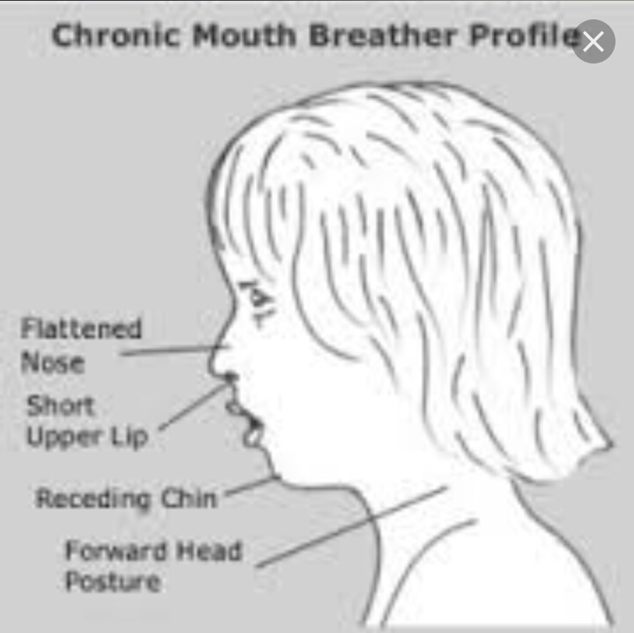Poor sleep – even though you got all 8 hours. Can cause chronic fatigue
* Snoring
* Morning headaches
* Red or inflamed guns
* Dry lips
* Cavities – raises you risk of getting cavities.
* Bad breath
* Frequent airway infections
* Soar throat
* Cold symptoms

**Health Issues Caused by Mouth Breathing**

**Improper Facial Growth & Skeletal Deformities**

Mouth breathing can alter child face shape and jaw position. This is most often seen in children because of their continued and generally rapid growth. Facial growth due to mouth breathing often leads to long, narrow faces with regressed cheekbones, lower jaw, and chin. Because of this, teeth may become crooked, while smiles may appear gummier.Even posture can be affected due to the facial and skeletal issues connected to mouth breathing. In order to breathe more easily, the airway must be open. Hunched shoulders and a forward-leaning head help to open the airways while negatively influencing posture.

**Mouth Breathing & Speech Impediments**

Many mouth-breathing children between the ages of 4 and 12 have speech alterations and impediments such as sound omissions, lisps, and articulatory disorders. Mouth breathing can change the way the tongue works, known as a tongue “thrust.” This negatively affects speech, swallowing, and chewing. This could lead to a child feeling self-conscious. Depending on the severity of the speech impediment(s), a speech pathologist may be necessary to correct speech alterations and slurs

**2.7Etiology of mouth breathing**

The causes of mouth breathing are undoubtedly multiple. It seems that two factors a combination of anatomic predisposition (narrow airway) plus nasal obstruction must be present to cause mouth breathing to be established on a habitual basis **(Emslie et al,1952).** Inflammatory conditions such as allergy and infection cause the nasal mucosa, that is lining to nasal cavity to swell the area available through which air can pass is diminished. Allergy is the most common and important cause of nasal obstruction, but infection, either by viruses such as the common cold or bacteria as often found insinusitis, may cause nasal obstruction **(Moses,1989 and Davidson et al, 1996)**. Regarding anatomical predisposition (narrow airway) ,the more recent studies acknowledge that growth control is likely the result of combined influences of heredity and function **(Graber et al ,2005).**

**I- Predisposing Factor (Narrow AirWay)**

The upper air-way consists from two portions' the nasal passages and nasopharynx. These connect with lower air-way (tracheobronchial tree and terminal alveoli of the lungs) via the larynx. The narrow nasal passages are more easily occluded by nasal obstruction like engorged turbinates than wide passage ways. Also the narrow nasopharynx is more easily occluded by large pharyngeal tonsil than wide nasopharynx. **(Emsileetal, 1952)**

**II- Exciting Factor (Nasal or Pharyngeal Obstruction)**

Obstruction to nasal breathing may occur from a variety of causes. The

most common are:

1- Engorgement of turbinates in nasal passages.

2- Engorgement of lymphoid masses in pharyngeal air-way.

**I- Rhinitis (Runny nose)**

An inflammation of the nose but is used by most of us to connote a runny nose. Many individuals exposed to cold air or to smoke will have nasal discharge and this is an irrelative rhinitis. Treatment of allergic rhinitis involves identification and avoidance of provoking allergens and the use of topical corticosteroid nasal sprays and oral antihistamines. Surgery should be complementary to medical treatment of allergic rhinitis when this is complicated by structural problem such as deflected septum or nasal polyp **(Mackay et al,1997).** Many researches were made on allergic Rhinitis such as in a study done by(**Trask et al , 1987),** in which they found that allergic rhinitis may be associated with altered facial growth.

Also **(Bresolin et al, 1983)** found that mouth breathing in allergic children had longer faces with narrower maxillae and retrognathic jaws. This supports previous claims that nasal airway obstruction is associated with aberrant facial growth.

**II- Chronic sinusitis**

According to **(Murray, 1988)** Chronic sinusitis is a condition in which the sinuses become inflamed, which means the mucosa has swollen and the mucociliary transport system is impaired. As a result, bacteria within the sinus grow continuously.

**III- Engorged turbinate**

Engorged turbinate, especially the middle turbinate, commonly obstruct thenasal passage way especially if a pronounced deviation of the septum is also present **(Groves et al, 1985)**.

**IV- Nasal Septal deviation**

Deviated nasal septum may cause mouth breathing, a slightly deviated nasal septum is usually normal and developmental in origin, and such minor deviations are rarely obstructive. But the deviation of nasal septum is one of mechanical problems which cause nasal airway obstruction and subsequently accepting the easier oral rout for respiration (**Emslie, et al, 1952 and Timms, 1988**). It is worth mentioning that nasal septal deviation play a role in the growth of crania facial skeleton (**Al Mudhaffar, 1995**).

**V- Adenoids and tonsils**

Adenoid tissue arises from the junction of roof and posterior wall of the nasopharynx, and is composed of vertical ridge of lymphoid tissue separated by deep cleft (**Maran, 1988).** The adenoids are part of **Waldeyer’s ring**, which is ring of lymphoid tissue consisting of the adenoid, the tonsils on each side and the lingual tonsil on each side **(Hall and Colman’s, 1992).**The enlargement of the pharyngeal tonsils, or adenoids has for years been blamed a chief cause of mouth breathing **(Emslie et al, 1952).** Because hyperplasia of all the lymphoid tissues of body normal lyoccurs in children between 2 and 6 years of age, this period of physiologic lymphoid hyperplasia, the pharyngeal and plalatin masses (tonsil and adenoids) are normally large in children 2-6 year of age, they slowly diminish in size thereafter so that some less obstructive. The terms “**adenoid faces**” used to describe the dentofacial changes associated with chronic nasal airway obstruction (**Schreiner et al, 1996).**An increase in total anterior face height which is mostly contributed to by a more vertical development of lower anterior face "adenoid face" **(Falih, 1990; Zainulabedin, 1999; Kesso 2003 and Graber et al, 2005).**

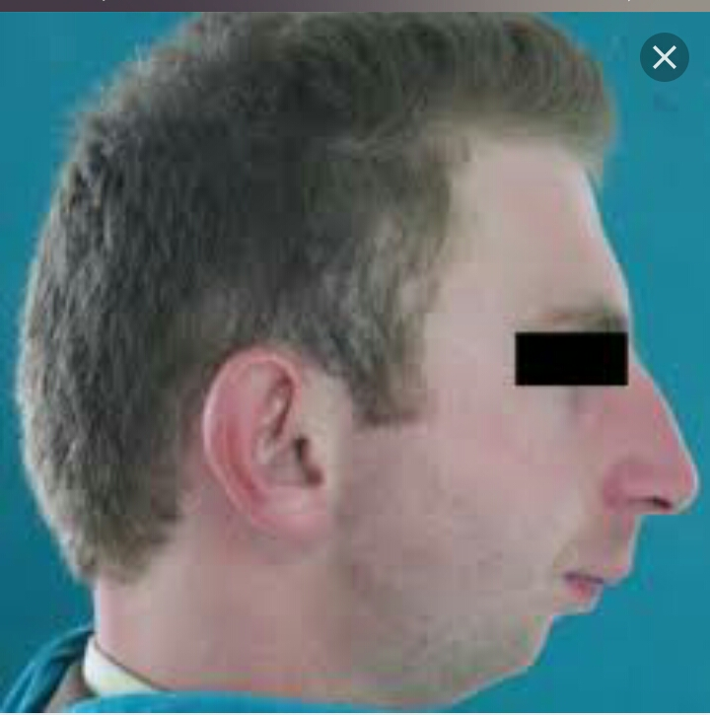

**VI-Nasal polyps**

Nasal polyps are the common mass lesions encountered in the nose and are an easily recognizable clinical as multiple, soft smooth, semi translucent, pale bags, yellow-gray structures that result from a prolapsed lining of the ethmoidal sinuses through the middle meatus and obstructing the nose **(Gerald,1983).**

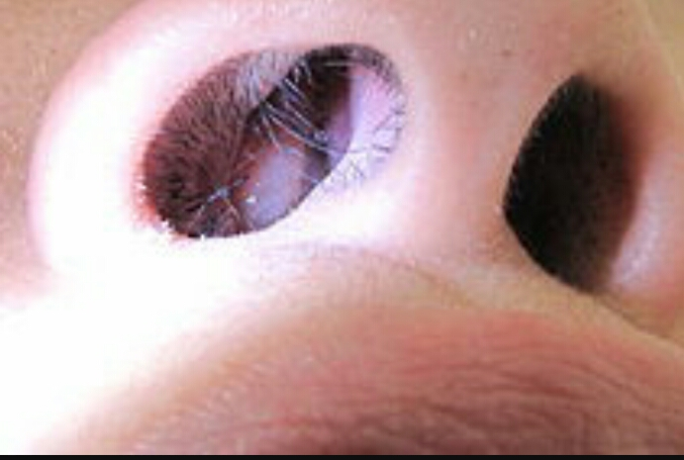

**VII- Choanal atresia**

Choana is derived from a Greek word-meaning fannel. The chonae are, by definition, the posterior apertures of the nose it is one of the more commonly observed congenital abnormalities of the nose, although its true incidence isuncertain. Choanal atresia may be bony (90%) or membranous (10%) and is general lysited just in front of the posterior end of the nasal septum **(Adams et al, 1997).**

**VIII- Tumors and cysts of the nose, paranasal sinuses**

Tumors and cysts of the nose, paranasal sinuses may cause nasal obstruction such as papilloma in the nasal fossae and paranasal Adenoma (**Groves et al, 1985).**

**IX- Habit**

Also mouth breathing could be Habitual. It may persists even after the nasal obstruction is removed, Nocturnal mouth breathing, in particular may continue even after the obstructing adenoids have been removed **(Emslie et al, 1952).**

**2.8 The Effect of Mouth Breathing on Head Posture and Craniofacial Morphology**

Mouth breather category exhibited a higher frequency of distal occlusion (tendency to class II) open bite, crossbite, and crowding (**Melson, et al, 1987**) but the effect of mouth breathing is not restricted to the development of malocclusion but also there is a positive correlation is found between craniocervical angulation and nasal respiratory resistance, which is a measure of airway obstruction. So in mouth breathing, there is increase in craniocervical angulation about 2degree in comparatism with control, this increase is due to hyperextension of head posture relative to cervical column but this increase in craniocervical angulation will disappear if causative factor is treated. But if it stays as it is it will affect craniofacial morphology and this will affect adversely the air way adequacy (**Solow, etal 1984**). Natural head posture can be measured by mean of cephalogram in term of angle between the sella-nasion line and the posterior tangent line to the odontoid process (**Seija Kylamarkula and Janhuggare, 1985**) so as a result of the above, the switch from a nasal to an oronasal breathing pattern induces function adaptations that have been associated with a deviant craniofacial growth pattern and can be summarized as follows: an increase in total anterior face height which is mostly contributed to by a more vertical development of lower anterior face. Concomitantly, an increase in mandibular plane and gonail angles and tipping of the palate can be found. Facial prognathism is reported to be decreased. The typical morphology of the so called "adenoid facies" (**Woodside, and Linder-aronson, 1979**; **Subtelny, 1980; Hannuksela, 1981; Bresolin et al, 1983; Trask,etal,1987; Travonen and Koski, 1987; HassanFalih,1990, Zainulabedin,1999; Kesso,2003; and Grabber et al, 2005).**

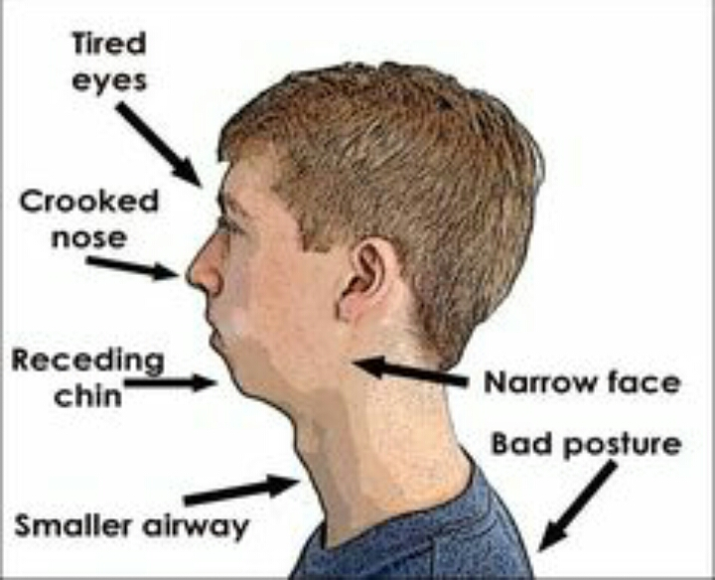

**2.9 The Effect of Mouth Breathing on the Development of Occlusion**

Mouth breathing and continued exposure and drying of the facial gingival of maxillary anterior teeth often lead to mouth breather's gingivitis, there is hyperplastic gingivitis associated with such chronic irritation which tends to follow the line of upper lip in, some instances, the effect of mouth breathing involve the palatal gingiva. It is usually associated with short upper lip and malocclusion (**Ash and Ward, 1992**), and finally the reduced nasal respiration often happen to people who suffer from poor and general health (**Linder- Aronson, 1978).**

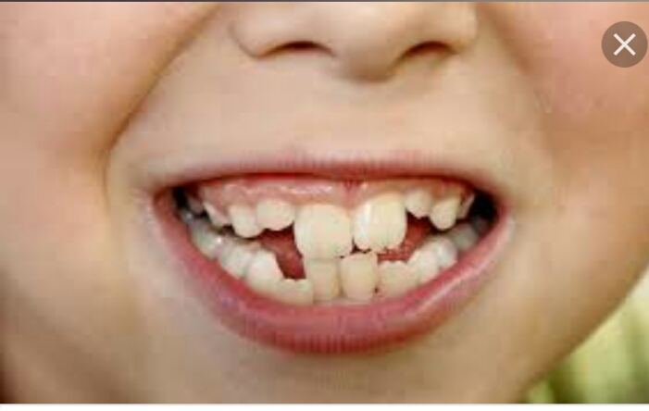

**2.10 Clinical Consideration of Mouth Breathing**

Common in childhood, mouth breathing is the habit of using the mouth instead of nose for respiration regardless of whether the nose is obstructed or not. However there are often specific reasons for mouth breathing, such as allergies, asthma the prevailing Hypothesis that prolong mouth breathing during certain critical growth periods in childhood causes a sequence of event that results in dental and skeletal changes (**Gold stein and Haywood, 2002**) although (**Harvold et al, 1981**). The human mouth breather may also present a variety of symptoms, ranging from normal appearance to sever skeletal and dental irregularities. The excessive eruption of the molar is almost always a constant feature of chronic mouth breathing. This molar eruption causes clockwise rotation mandible during growth with a resultant increase of lower facial height. The increased lower facial height is often associated with retrognathia and anterior open bite, low tongue posture is seen (**Subtelny 1954; Graber 1966; Horowitz and Hixon 1966; Ricketts 1968; Linder-Aronson 1970; Harvold 1972, Harvold 1973; Linder-Aronson1973; Koskiand Lahdemaki 1975; Quinn 1978).**

Also in mouth breathing there is impeding the lateral expansion and anterior development of maxilla. The dentofacial effect that develop in children persist into adulthood, and mouth-breathing and tongue thrusting behavior may continue. It has been found that mouth breathing can lead to dryness and irritation of throat, mouth and lips as well as chronic marginal gingivitis strongly associated with both lip- biting and lip wetting habits, it may be necessary to treat the mouth- breathing habit prior to or in conjunction with treatment of lip habit (**Goldstein and Haywood, 2002**).

**2.11 Role of ENT Specialist in Mouth Breathing Detection**

The diagnosis and treatment of such condition require first of all comprehensive history from patient then clinical examination by ENT specialist to seek for causative factor.

**2.12 Testing for Nasal and Oral Breathing**

The ordinary involuntary type of breathing which is quiet and rather shallow should be distinguished from the voluntary forceful breathing which the child performs or demands. Involuntary or ordinary breathing is tested first. This should be done on a relaxed patient who is uninformed of purpose of test, whose eyes are closed and whose respiration are of normal, shallow type. The test forthe excursion of air is performed with thin, long strip of tissue paper about 3/8 by 1.5 inches. (Thin wisp of cotton, or a chilled mirror also may be used) the movement of paper stripe held in front of nose and lips will demonstrate the excursion of air. The vigor of movement of test strip is a measure of amount of respired air. It is important to note the difference between the inspiratory and expiratory efforts. Many patients inhale through the mouth and exhale through the nose, especially when the nasal passages are only partially obstructed, this is still mouth breathing. A narrow airway is obstructed easily. This factor must always condition the critical judgment of clinician who is seeking the cause for habitual mouth breathing. **(massler- zwemer,1953)** the method used to select mouth breathers was demonstrated by (**Paul And Nanda,1973**) a small cotton wisp was held alternatively in front of each nostril and the mouth of all the individuals. No movement of cotton wisp when held in front of the nose, but evidence of its movement infront of mouth indicated mouth breathing. Individual showing movement of cotton wisp when placed before the nose and no movement in front of the mouth indicated normal applying this test in so for as the patient was not under apprehension or made conscious of this test.

**2.13 Diagnosis of Mouth Breathing**

There are certain difficulties involved in the differential diagnosis of nose and mouth breathers, due to the fact that mouth breathers have some capacity of nasal ventilation **(Linder-Aronson, 1979 and Ung et al, 1990).**It is only when a total blockage or stenosis of the nasal airway has occurred that isolated mouth breathing can be found **(Linder-Aronson, 1979).**The diagnosis of mouth breathing accomplished by the following methods:

**I- History**

The severity of airway obstruction is judged by the degree of disturbance of sleep, feeding and growth. These parameters distinguish children with significant nasal obstruction from many children whose nasal obstruction and rhinorrhea is benign. Parents can often accurately describe waking, apneas and the intensity of snoring. With children aged more than four years, it is important to ask if they can effectively blow their noses. However, during the day mouth breathing due to nasal obstruction may concern parents and teachers more than child **(Albert, 1997).**

**II- Examination**

The ordinary involuntary type of breathing which is quiet and rather shallow should be distinguished from the voluntary forceful breathing which the child performs or demands. Involuntary or ordinary breathing is tested first. This should be done on a relaxed patient who is uninformed of purpose of test. The test for the excursion of air is performed with thin, long strip of tissue paper about 3/8 by 1.5 inches. The movement of paper stripe held in front of nose and lips will demonstrate excursion of air, It is important to note the difference between the Inspiratory and expiratory efforts **(Massler and Zwemer, 1953).**

The method used to select mouth breathers was used by **(Paul and Nanda, 1973)** a small cotton wisp was held alternatively in front of each nostril and the mouth of all the individuals. No movement of cotton wisp when held in front of the nose, but evidence of its movement in front of mouth indicated mouth breathing. Individual showing movement of cotton wisp when placed before the nose and no movement in front of the mouth indicated normal nasal breathing.

**A- Nasal Examination**

Either before or after the actual testing for mouth breathing the examiner should look directly into the nasal opening in order to note the character of nasal mucosa, the condition of inferior and middle turbinate, the position of septum. The size and form of nasal passages can be viewed easily by such direct inspection, in broad faced (brachy facial) type the nasal passages usually are ovoid and wide, a considerable space being apparent between the middle turbinate and septum. In narrow faced individual (dolicho- facial), **(Massler & Zwemer 1953).**

**B- Pharyngeal Examination**

For a thorough examination, it is not enough to inspect for obstruction of nasal passage ways alone. A careful clinician should inspect the nasopharynx and note the condition of pharyngeal tonsils **(Massler and Zwemer, 1953).**

**C- Facial Examination**

The character of faces sometimes is indicative of mouth breathing. While it is true that not all mouth breather have adenoid face, the presence of such should make one suspicious of mouth breathing **(Kim et al, 1987).**

The long-faced individual is more disposed to mouth breathing than the round faced person because of his narrow nasal and pharyngeal air passages which areeasily obstructed by hypertrophied lymphoid tissues (adenoids), engorged turbinateand septal deviations **(Massler and Zwemer, 1953).**

**D- Oral Examination**

A class II division I, malocclusion may represent a typical characteristic in along narrow faced individual or it may be the result of dental changes accompanying mouth open habit **(Kim, et al, 1987) .**

The open mouth habit should not be confused with actual mouth breathing. Anopen-mouth habit does not necessarily prove mouth breathing, many childrenhabitually keep their lips apart, especially those with a characteristic familial shortupper lip. Most of these children breathe normally through their nose. On the otherhand a closed mouth at the time of inspection does not exclude the possibility ofintermittent mouth breathing particularly during sleep. The mouth breathing andopen-mouth habit occur much less frequently in adults. In many instances, the mouth breathing habit is self-corrected after puberty **(Miller and vergervik, 1980; Warren,et al, 1984 ; Lampasso and Lampasso, 2004).**

**III-Investigations**

**A- Fiberopticnasopharyngoscopy**

Direct visualization of the upper airway from the nose to the larynx aids in theidentification of potential areas of airway collapse. The nasal airway is evaluated fornasal pathology. The nasopharynx is then examined to rule out obstruction Fromadenoids, polyp, masses, or cysts .The Fiberoptic examination proceeds to the level of the oropharynx, and the base of the tongue is evaluated along with the tonsillar tissues. Since most obstruction during sleep occurs at the retropalatal and retroglossal areas, this portion of the examination is important. The patient is asked to perform another Muller’s maneuver as the endoscope is passed into the hypopharynx. The position of the base of tongue to the epiglottis and posterior pharyngeal wall is observed. The larynx and vocal cords are also evaluated to rule out any supraglottic, glottic, or subglottic pathology **(Eugene and Renaud ,2010).**



**B- Rhinomanometry:**

It is defined as the study of nasal obstruction and nasal airflow characteristics. Rhinometry provides a mean to quantify the nasal airway in term of its conductive efficiency by use of the inverse or resistance to airflow **(Timmes and Trenouth, 1988; Albert, 1997).**

**C- Cephalometric:**

Measuring the size of the airway on the profile cephalograms **(Thuer et al, 1989).**

**D- CT scan:**

By taking CT scan, one can establish the amount of space of nasopharyngeal and also to find the skeletal patterns of patients **(Kyung et al, 2011).**



**IV. Treatment**

**Intra oral devices for the management of mouth breathing:**

The current first choice therapy is continuous positive airway pressure **(CPAP)**, which keeps the upper airway patent during sleep; alternatively, several surgical procedures have been proposed and described in the literature **(Riley et al., 1997; Engleman et al., 2002)**.

Unfortunately, both approaches may be associated with some undesired side effects, low compliance by some patients and uncertain positive effects; thus, intraoral appliances are becoming a popular alternative option. The use of such devices is based on the assumption that they may produce positive changes in the position and morphology of upper airways, in order to avoid their collapse **(Schmidt et al., 1995)**

Oral appliances have been introduced in 1980 and at present, more than fifty types of devices are available on the market **(Lowe, 2000).**

On the basis of their supposed mechanism of action, intraoral devices can be divided into three groups:

Tongue Retaining Devices (**TRD**).

Mandibular Repositioning Appliances (**MRA**).

Others (Palatal lifting, Labial shields, Tongue posture trainers).

Tongue Retaining Devices (**TRD**) and Mandibular Repositioning Appliances

(**MRA**) have emerged as the most effective and widely used types of devices.

**I- Tounge retaining device**

**TRD** are one-piece plastic or acrylic appliances that are anchored to the maxillary teeth and aim at repositioning the tongue in a more anterior position to an incorporated cavity into which the patient is forced to keep the tongue. Severalversions of devices acting as tongue retainers or stabilizers have been designed **(Cartwright and Samelson, 1982).**

**II- Mandibular repositioning appliance**

Mandibular advancement allows forward repositioning of the tongue, Such advancements are likely to allow enlarging the upper airways. such devices simply allow increasing the diameter of the upper airways, thus preventing them from collapsing during the inspiratory phase of the breathing cycle. Nonetheless, it has also been hypothesized a more complex action on the pharynx motor system, which should be activated by an appliance induced muscle stretching **(Clark et al., 2000).**



**III – MRA** may be manufactured either as a single-block appliance or a two-piece device, and may be custom-made or pre-fabricated **(Eckhart, 1998)** There are many types of appliances are widely diffused among practitioners without any apparent evidence of superiority or specificity of indications over the others **(Loube and Strauss, 1997)**

**Chapter Three**

**Material and Method**

**3.1 Material**

**3.1.1 The Sample**

**3.1.2. The patient sample Group**

Out of 52 Iraqi subjects 47 individuals (20 male and 27 female), with an age ranged between (9-35) years, were randomly selected from patients attending the center of ENT, in Al-murganhospital in Babil.

Those individual were examined by ENT specialist as having

A-nasal obstruction from prepubertalpriode. They form about 36 subjects from the total mouth breathers. The nasal obstruction was due to

**1)** septal deviation, it may be as a result of trauma or developmental anomaly **(Gray, 1978; Brain, 1979; Alpini et al, 1986; Weimert, 1986; Sorri, et al,1990, Huygen, et al, 1992).**

2) Turbinathyperatrophy (**Weimert, 1986**).

3) Allergic rhinitis chronic rhinitis (**Turner, 1988**).

4) Nasal polypy (**Turner, 1988**).

5) Adenoid, sometime persists in adulthood (**Weimert,1986**).

6) Nasal trauma during delivery and in childhood (**Rock And Brain, 1983**) (**Weimert, 1986**).

B- Habitual mouth breather. Those subjects were examined by ENT specialist and clinical examination revealed nothing but they give history of mouth breathing (**Linder- Aronson, 1960**).The habitual mouth breathers form about 10 subjects from the total mouth breathers.

**3.1.3. Examination Material**

1) A set of 7 plane mouth mirrors.

2) Two kidney dishes one for mirrors and other for cottons.

3) Disinfectant solution.

4) Gloves.

5) Cheeck retractor.

**3.2 The Method**

**3.2.1. Clinical Examination**

Every subject should pass several steps of clinical examination with comprehensive history and case sheet fulfillment.

**3.2.2. Case Sheet**

The researcher examined each subject about the following information:

1-(a)name (b) age (c) sex (d) educational level (e) weight (f) height (g) past medical history (h) past dental history(j)socioeconomic (**Row and William’s, 1994**) after clinical dental and ENT examination :

2- Breathing pattern.

3- The cause and history of mouth breathing (**Kesso, 2003**).

4- Snoring: a noise generated from upper airway due to partial upper airway obstruction (**Mackay, etal, 1997**), this was taken as history from the family if the patient snors during sleeping (**Kesso, 2003**).

**3.2.3. Clinical Dental Examination**

It included :-

**1. Intra Oral Examination.**

Examination of oral cavity includes general look to the oral soft and hard tissue (**AlZubair,2002, Muhi eldeen,2004, AL-Azzawi, 2005**).

Molar Occlusion relationship (**Angle,1899**), and canine occlusion relationship according to (**Foster, 1972**).

**2. Extra Oral Examination**

Examination on facial component like eyes, nose, mouth and for bilateral symmetry, a small degree of bilateral facial asymmetry exists in essentially in allnormal individual (**Proffit, etal, 2000**).

**3. Examination of class by direct measurement**

The pacient has examined by two finger method to determine the type of class and by the overjet and overbite measurement.

**Chapter Four**

**Results**

The analysis of the dental record showed 30(57%) person with class 1 ,15 (28%)with class II, 3(5%) with class III and 4 (7%) person with open bite .most of them mouth breather due to chronic rhinitis, adiniod, envirmental allergic rhinitis and chronic obstructed nose. which comprised of 20(42%)males and 27 (57%) females. The ages of the samples ranged between 9 -35years. Retrospective analysis of mouth breather of patients visiting ENT clinic was done from October to March.

**Table 4.1: number of mouth breather according to maloclussion**

|  |  |  |  |
| --- | --- | --- | --- |
| Cl 1 | Cl II | Cl III | Openbite |
| 30 | 15 | 3 | 4 |

Figure 4.1: factors lead to mouth breathing

Figure 4.2: gender difference and mouth breathing

Figure 4.3: age difference and mouth breathing

**Chapter Five**

**Conclusion**

1- Generally, studies has shown that mouth breathing subjects have nasopharyngeal airway obstruction and narrowing and exhibit changes in dentofacial morphology and pharyngeal volume when compared to controls.

2- Mouth breather subjects had tendency to possess skeletal Class II pattern, but also found in Class I and Class III skeletal class.

3- Mouth breather subjects had tendency to possess skeletal Class II pattern with retruded mandible, more retrognathic facial type and more vertical growth since they exhibited larger anterior facial height and lower facial height, and higher man. P angle, man max angle. and sum angles, this was more prominent in females than males.

**References**

**(A)**

* AL- Azzawi, R.A.W. Assessment of dental arch crowding by use of tow methods in Iraqi youngster sample. A master thesis orthodontic department , Baghdad University, (2005).
* Al- Zubair, N. M. Maxillary and mandibular dental arch dimensionsand forms in a sample of Yemeni population aged 18-26 years with class 1 normal occlusion. A master thesis, orthodontic department, University of Baghdad. (2002).
* Albert, B.: Nasal obstruction and Rhinorrhoea in infants and children. [in: Adams D., Cinnamond M. (eds.). Scott Brown's Otolargngology.Vol. 6. Pead. Otolaryngology London: Butterwoth , 1997 ; 17/1 – 17/4.
* Al-Mudhaffar N M J. :The effect of nasal septal deviation on the cranio-facial form:A posters–Anterior cephalometric study. A master thesis, college of dentistry, University of Baghdad,1995
* Ana Paula BianchiniI; ZelitaCaldeira Ferreira GuedesII; Marilena Manno Vieira III,A study on the relationship between mouth breathing and facial morphological pattern.vol.73 no.4 São Paulo July/ Aug. 2007).
* Angle, E. H. Classification of malocclusion. Dental cosmos. (1899); 41: 248-264.
* Ash, M.M, ward, M.L. Oral pathology, an introduction to general and oral pathology for hygienists. (1992) 6th Ed. Lea and febiger.

**(B)**

* Bishara SE, Ferguson D. : Introduction to the growth of the face. Textbook of orthodontics. Philadelphia: W.B. Saunders company,2001
* Bresolin D, Shapiro P A, Shapiro G G, Chapko M K, Dassel S. :Mouth breathing in allergic children Its relationship to dentofacial development. Am. J. Orthod. ,1983; 334-340
* Bresolin D; Shapiro G. G., chapko, M. K and dassel, S. mouth breathing in allergic children. Its relation ship to dentofacial development (1983); Am. J. orthod. (334-340).

**(C)**

* Cartwright RD, Samelson CF. : The effects of a nonsurgical treatment for obstructive sleep apnea. The tongue-retaining device. J. Am. Med. Assoc.,1982; 248: 705-709.
* Clark DE, Danforth RA, Bames RW, Burtch ML. :Radiation absorbed from dental implant radiology: a comparision of linear tomography, CT scan, and panoramic and intra oral techniques. J oral Implantol1990; 16(3): 156-64.
* Coleman EL et al. : Randomized crossover trial of two treatments for sleep apnea/hypopnea syndrome: continuous positive airway pressure and mandibular repositioning splint. Am. J. Respir.Crit. Care Med., 2002; 166: 855-859.

**(D)**

* Daskalogiannakis, J. Glossary of orthodontic terms. Quintessence publishing co. (2005). P 176.

**(E)**

* Eckhart JE. : Comparisons of oral devices for snoring. J. Calif. Dent. Assoc. 1998; 26: 611-623.
* Emslie R D, Massler M,Z wemer J D. Mouth breathing: I. Etiology and effects ( a review ). J. Am. dental association ,1952;44:506-521
* Engleman HM, McDonald JP, Graham D, Lello GE, Kingshott RN,
* Eugene Lefebvre and Renaud Moreau : Snoring; Causes, Diagnosis and Treatment, 2010.

**(F)**

* Foster T D.A: text of Orthodontics, Oxford, Blackwell Scientific publications,1990.
* Foster, T. D.; Grundy, Mc and lavelle C. L. B. A longitudinal study of dental arch growth. AM. J. orthod (1977); 72(3): 309- 314.

**(G)**

* Glesson M, Kerr A G. :Basic Sciences. In Scott-Brown's Otolaryngology,6 th.ed,1997.
* Graber; Vanarsdall. Vig. :Orthodontics current principles &tedhniques. 4P thPed,Mosby com, 2005; P 117-140.
* Gray, L.P.Deviated nasal septum: incidence and etiology. Ann otolRhinolaryngol, (1978); 87:3-20.
* Groves J,Gray R F,DowntonD,Blau J N. : A synopsis of Otoloaryngology. 4th.ed,1985
* Gruenbaum, Tamar. Famous Figures in Dentistry Mouth – JASDA 2010; 30(1):18.

**(H)**

* Haas, A. Rapid expansion of maxillary dental arch and nasal cavity by opening the mid palatal suture. Angle orthod. J (1961); 31: 73-90.
* Hall and Colman's. :Diseases of the nose,Throat and Ear, and head and neck, A handbook for students and2practitioners.14th.ed,1992
* Harvold, E.P., tomer, B.S., vargervik, K., chierici, G. Primate experiments on oral respiration AM. J. orthod, (1981); 79:359-72.
* Harvold, EP., chierici, G., Vargervik, K. Experiments on the development of dental malocclusions. AM. J. orthod; (1972); 61:38-44.
* Hassan, F. The relationship between nasopharyngeal airway and dentofacial structure a cephalometric study. Amaster thesis, orthodontic department, University of Baghdad. (1990).
* Horowitz, S. and Hixon, E.H., The nature of orthodontic diagnosis. P. 138. Mosby, Stlouis. (1966).
* Houston WJB. :Walther's orthodontic notes. 4th ed. Wright. PSG, 1983.

**(J)**

* Jones ML, Oliver RG. :Walter and Houston's orthodontic notes, 6th ed. Reed Educational and Professional Publishing Ltd, 2000.

**(K)**

* Kim H.Y. :Anterior openbite and its treatmeut with multiloop edgewise Archwire. Angle, orthod, 1987; (4): 290-321.
* Kyung-Min Oh, Ji-Suk Hong, Yoon-Ji Kim, Lucia S.H. Cevidanes, Yang-Ho Park,: Three-dimensional analysis of pharyngeal airway form in children withanteroposterior facial patterns,2011.

**(L)**

* Lampasso, J.D., lampasso, J.G. :Allergy nasal obstruction and occlusion. Seminorthod, 2004 ; (10): 39-44.
* Linder-Aronson S. :Respiratory function in relation to facial morphology and the dentition. British J Orthod,1979;6: 59-71.
* Linder-Aronson, S. Effect of adenoidectomy on dentition and facial skeleton over period of 5 years. Trans Eurorthodsoc; (1973); 177- 86.
* Linder-Aronson, S. Rispiratory function in relation to facial morphology and dentition British J. orthod, (1979); 6: 59-71.
* Linder-Aronson, S., Bakstrom, A. Acomparison between mouth breathers and nose breathers with respect to occlusal and Facial Dimension. Odontol Revy, (1960); 11.343-376.
* Loube MDI, Strauss AM. : Survey of oral appliance practice among dentists treating obstructive sleep apnea patients. Chest ,1997; 111: 382-386.
* Lowe AA. : The durability of intraoral devices for snoring and sleep apnea: another view. J Can. Dent. Assoc., 2000; 66: 486-487.

**(M)**

* Mackay, I.S., Bull, T.R., and kerr, A.G.: scott- Browm’s otolaryngology (4) Rhinology sixth ED, 1997.
* Maran A G D. :Diseases of the nose, throat and ear. 10th. ed, 1988
* Massler M, Zwemer I D. :Mouth breathing II. Diagnosis and treatment. JADA 1953;46:658-70.
* Melson, B., Attina, L., Santuarim, and attin, A. Relation ships between swallowing pattern, mode of respiration and development of Malocclusion. Angle orthod. (1987); 57 (2): 113-120.
* Miller, A.J., verger vik, K.: Neuromuscular adaptation in experimentally induced oral respiration in the rhesus monkey (muccacamulatta). Arch oral boil , 1980; 25:579-89.
* Mitchell L, Carter NE. :An introduction to orthodontics, London, Oxford,2004
* Morrison, W. W. The inter relation ship between nasal obstruction and oral deformities. I Nt. J. orthod, 1931; 17:453-8.
* Moses A.J: The official publication of the Chicago dental society, Airways and appliances, 1989;82(2).
* Muhieldeen, A. A. M. Dental arch dimension in sample of Iraqi thalassemic patients aged 12-16 years with class I normal occlusion. A master thesis, orthodontic department. University of Baghdad 2004.
* Murray J A M. :Chronic sinusitis. Logan Turner's disease of the nose, throat and ear.10th.ed ,1988; 42-50.

**(P)**

* Paul, J. L. and Nanda, R.S. :Effect of mouth breathing on dental occlusion. Angle orthod,1973; 43: 201-206.
* Profit, willam, R., fields, Henry, W. Contemporary orthodontics. 3rd ed. Mosby comp. 2000.

**(Q)**

* Quinen, G.W. Air way interferance and its effect upon the growth and development of the face, Jaws, dentition and associated parts NC. Dent. J. 1978; 60: 28-31.

**(R)**

* Rani MS.: Synopsis of orthodontics, India, Laxman Chand Arya, A.I.T.B.S. Publishers and Distributors, 1995

**(S)**

* Saladin K S,Porth C M. :Anatomy and physiology,1998
* Schmidt-Nowara W, Lowe A, Wiegand L, Cartwright R, Perez-Guerra F, Menn S. : Oral appliances for treatment of snoring and obstructive sleepapnea: a review. Sleep , 1995; 18:501-510.
* Seijakylamarkula and janhaggar. Head posture and the morphology of first cervical vertebra European. J. orthod. 1985; 7: 151-156.
* Solow, B., siersbs, Niclesenk, and Greve, E. :Air way adequacy, head posture and craniofacial morphology, Am. J. orthod, 1984; 86(3): 214-223.
* Subtelny, J.D. the Significant of a devoid tissue in orthodotics. Angle orthod. 1954; 24:59-69.

**(T)**

* Thilander B, Pena L, Infante C, Parada SS, de Mayorga C (2001). "Prevalence of malocclusion and orthodontic treatment need in children and adolescents in Bogota, Colombia. An epidemiological study related to different stages of dental development.". Eur J Orthod. 23 (2): 153–167. doi:10.1093/ejo/23.2.153. PMID 11398553
* Thuer, U., Kuster, R., Ingervall, B. : A comparison between anamnestic, rhinomanometric and radiological methods of diagnosing mouth breathing. Eur. J. Orthod. , 1989; 11: 161-8.
* Timms D J,Trenoth M J. :A quantified comparison of craniofacial form with nasal respiratory function.Am J orthod ,1988;94(3):211-216.
* Trask G M,Shapiro G G,Shapiro PA. :The effect of perennial allergic rhinitis on dental and skeletal development: A comparison of siblling pairs. Am J orthod, 1987;92(4) 286-293
* Travonen, P., koski, K. Cranio facial skeleton of seven-year-old children with enlarged adenoids. Am. J. orthod. Dento fac. orthod, 1987; 91: 300-04.

**(W)**

* Warren, D.E., Malcolm, D.L., Virginia, A.H. :Analysis of simulat upper airway breathing, Am. J. orthod, 1984 ; 86. (3): 197-206.
* Weimert, T. On airway obstruction in orthodontic practice. J. C. orthod, 1986; 96-104.
* Wood side, D.G., linder-Aronson, S. The chanalization of upper and lower anterior face heights compared to population standard in males between ages 6 to 20 years. Eur. J. orthod, 1979; 1: 25-40.

**(Z)**

* Zain ul Al bedim, Y. W. :Dantofacial morphology of patients with naso - pharyngeal air way inadequacy due to enlargement adenoid. A master thesis, orthodontic department, university of Baghdad 1999.