Ministry of Higher Education

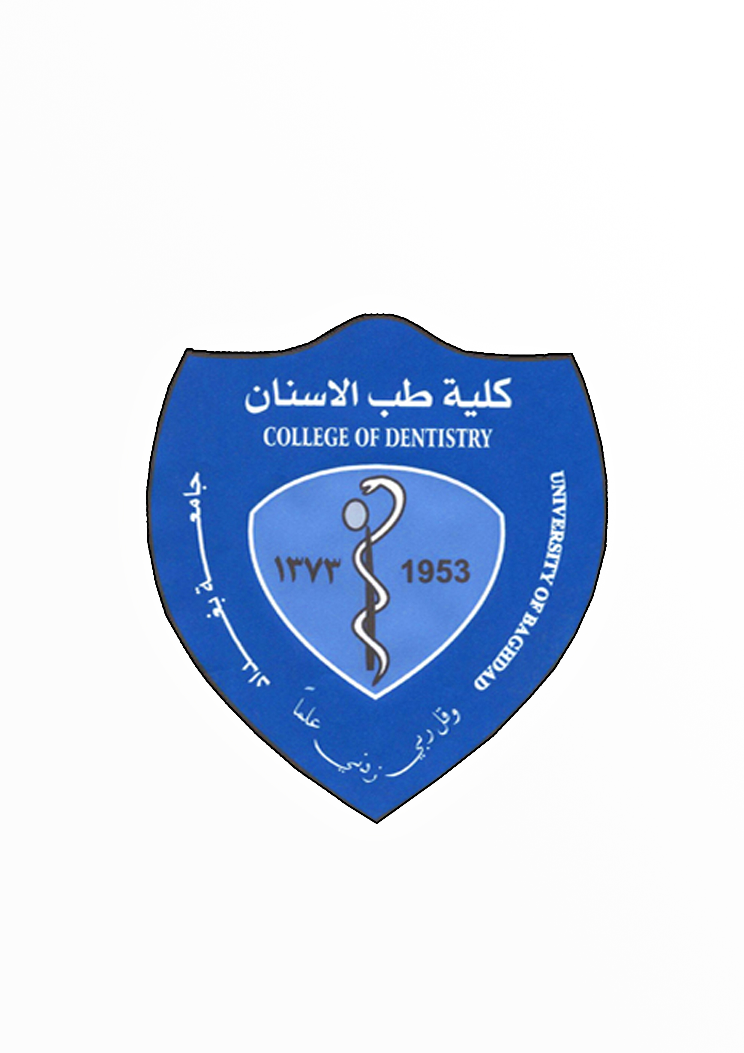

& Scientific Research

University of baghdad

college of dentistry

Self-Ligating bracket

Done By:

Mohannad A. Hameed Joodi

Supervised by:

Dr. Yasser R. Al-Labban

*April 2017*

**ACKNOWLEDGMENTS**

I would like to express grateful thanks to the dean of college of dentistry, university of baghdad Prof. Dr. Hussain Al-huwaizi.

Grateful thanks are expressed to Prof. Dhiaa Al-dabagh head of the department of orthodontic dentistry, for his scientific support and advise.

I would like to heartily thank Dr.yasser al-laban who has supervised my study and helped me in various respect. For his instructive siggestion, continuing encouragement, and fatherly care I am deeply grateful.

I am especially indebted to my family and my fiancee for their sincere help in carrying out this work.

Much gratitude is also due to all my colleagues who have helped me in this study.

|  |  |  |
| --- | --- | --- |
| **Table of contents:** | | |
| **Chapter 1** | 1 | |
| 1.1 Introduction | | 1 |
| 1.2 Defintion of self-ligating bracket | | 2 |
| 1.3 Philosophy of self-ligating bracket | | 2 |
| 1.4 Properties of ideal orthodontic appliance | | 3 |
| 1.4.1. Secure and robust ligation | | 3 |
| 1.4.2. Full bracket engagement | | 3 |
| 1.4.3. Quick and easy ligation | | 4 |
| 1.4.4. Low friction | | 4 |
| 1.4.5. Improves patient comfort and hygiene | | 4 |
| **Chapter 2** | 5 | |
| 2.1 Classification of self-ligating bracket | | 5 |
| 2.2 Active VS Passive self-ligating bracket | | 5 |
| 2.3 Interactive treatment | | 6 |
| 2.4 Active treatment with self-ligating bracket | | 7 |
| 2.4.1 Leveling and alignment. | | 7 |
| 2.4.2 Space closure and finishing | | 8 |
| **Chapter 3** | 9 | |
| 3.1 History and development of self- ligating bracket | | 9 |
| **Chapter 4** | 12 | |
| 4.1 Passive system | | 12 |
| 4.1.1 Damon 3 bracket | | 12 |
| 4.1.2 Opal (ultradent) bracket | | 13 |
| 4.1.3 Opal M bracket | | 13 |
| 4.1.4 Smartclip bracket | | 14 |
| 4.1.5 Clarity bracket | | 15 |
| 4.2 Active system | | 16 |
| 4.2.1 Speed bracket | | 16 |
| 4.2.2 Ovation R bracket | | 17 |
| 4.2.3 Ovation C bracket | | 17 |
| 4.2.4 Time 2 bracket | | 19 |
| 4.3 Interactive system | | 20 |
| 4.3.1 Fully interactive system | | 20 |
| 4.3.2 Dual activation Hybrid interactive\passive system  ( two bracket design in one coordinated system ) | | 21 |
| **Chapter 5** | 22 | |
| Friction in conventional bracket with elastic ligature and loose stainless steel ligature compared with self-ligating bracket | | 22 |
| Conventional bracket VS Self-ligating wire | | 23 |
| **Discussion** | | 24 |
| **Conclusion** | 25 | |
| **References** | 26 | |

**List of figures:**

|  |  |  |
| --- | --- | --- |
| **Number of figure** | **Name of figure** | **Page** |
| (1-1) | General Design of Self-ligating bracket | 2 |
| (1-2) | Comparision between conventional and  self-ligating bracket | 3 |
| (2-1) | Passive VS Active Self-ligating bracket | 6 |
| (2-2) | Working principle of interactive bracket during insertion various type of acrhwire | 6 |
| (3-1) | Russell attachment when opened and closed | 9 |
| (3-2) | Edgelock bracket | 9 |
| (3-3) | Speed bracket | 10 |
| (3-4) | Activa bracket | 10 |
| (3-5) | Time bracket | 10 |
| (3-6) | InOvation R and InOvation C bracket | 11 |
| (3-7) | Smartclip bracket | 11 |
| (4-1) | Damon 3 bracket | 12 |
| (4-2) | Opal (ultradent) bracket | 13 |
| (4-3) | Opal M | 14 |
| (4-4) | special pliers for smartclip bracket | 14 |
| (4-5) | smartclip bracket | 14 |
| (4-6) | clarity bracket | 15 |
| (4-7) | Speed bracket | 16 |
| (4-8) | Openning of speed bracket | 16 |
| (4-9) | Ovation R bracket | 17 |
| (4-10) | Ovation C bracket | 18 |
| (4-11) | Special instrument for opening of Ovation system | 18-19 |
| (4-12) | Time bracket | 19 |
| (4-13) | Empower clear bracket | 20 |
| (4-14) | Empower Metal bracket | 20 |
| (4-15) | Initial leveling and aligment stage | 21 |
| (4-16) | Working and finishing stage | 21 |
| (4-17) | Dual activation Hybrid interactive\passive system | 21 |

**List of Tables:**

|  |  |  |
| --- | --- | --- |
| **Number of table** | **Name of table** | **page** |
| (2-1) | Passive Vs Active self-ligating bracket | 7 |
| (5-1) | comparision between self-ligating bracket and conventional bracket | 23 |

**Chapter 1**

**1.1 Introduction**

“Open the door, insert the archwire, close the door!” That is how simple the use of an Self-ligating bracket should be. However, this may be more wishful thinking than reality. There are two main factors that affect the use of self-ligation in orthodontics, the ligating mechanism itself and the operator who uses it. Self-ligating brackets are difficult to manufacture. The materials used, particularly for the locking mechanism, have to be able to withstand masticatory forces as well as the stress that normally occurs during orthodontic treatment. The mechanism needs to be manufactured to extremely high standards, and this is particularly difficult because different materials are used for the bracket base and the locking mechanism, and by default their respective tolerances differ. The resulting bracket is a delicate device that requires careful and diligent handling. ( Ludwig et al., 2012.)

One of the factors affecting prospective tooth movement and hence the amount of force required is the degree of friction that exists between the archwire and bracket; this frictional resistance being influenced primarily by the physical characteristics of the archwire and bracket materials (Ireland et al., 1991), archwire dimensions (Taylor & Ison, 1996), and the method of archwire ligation (Ireland et al., 1991) (Shivapuja & Berger, 1994).

Iatrogenic decalcification of tooth enamel and the development of visible white spot lesions are undesirable and unfortunate consequences of fixed orthodontic therapy, potentially undermining the esthetic benefits often achieved through correction of the malocclusion. It is well documented that fixed appliances increase bacterial plaque accumulation and the risk for white spot lesions when the elastomeric ligature are used (Gorelick et al., 1982; Geiger et al., 1983)

when using the elastomeric ligature, the short life of this ligature need more number of clinical appointment and short interval between visit. The coventional orthodontic bracket use heavy force to overcome the friction, so the tooth movement is slow. So, the manufacture attend to produce a new bracket that can overcome of problem associated with conventional bracket with elastic ligation.

**1.2 Definition of self-ligating bracket**

Self-ligating brackets are ligatureless bracket systems that have a mechanical device built into the bracket to close off the edgewise slot. The cap holds the archwire in the bracket slot and replaces the steel/elastomeric ligature. (Braun and Thomas, 2015)

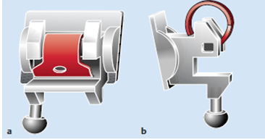

Figure (1-1) General Design of Self-ligating bracket

**1.3 Philosophy of self-ligating bracket proponents**

Classical histological studies suggest that light forces that cause the tooth movement ( below the threshold of cementoclast activation) are more biologically efficient and less traumatic during orthodontic tooth movement (Chan etal.,2005).Therefore, the use of increased force levels might be expected to be associated with increased discomfort.

Light forces are the key to self-ligation. Proponents suggest that low force, low-friction systems allow teeth to travel to their physiologic position because they do not overpower the musculature or compromise the periodontal tissues. Ischemia is not induced in the surrounding periodontal tissues because the forces generated by the small dimension archwires are too low to completely occlude the periodontal vascular supply. so the root resorption ratio may decrease when we use self-ligating bracket (pandias et al., 2008).

Self-ligating brackets place enough force on the teeth to stimulate tooth

movement without completely disrupting the vascular supply and therefore, tooth movement is more effective and physiologic. Moreover, the design in passive self-ligating bracket also enables teeth to move in the path of least resistance. When the gate is in its closed position, the bracket essentially becomes a tube in which the flexible nickel-titanium archwire can move freely. By greatly reducing the amount of friction with passive self-ligating brackets, low force archwires can work to peak expression and stimulate teeth to move in a more biologically compatible method .Teeth movement is also more efficient when they are allowed to move individually, and passive self-ligating brackets offer more freedom for teeth to move to their natural position even though they are still interconnected because the archwire is never tightly engaged with the bracket slot (Damon, 1998).

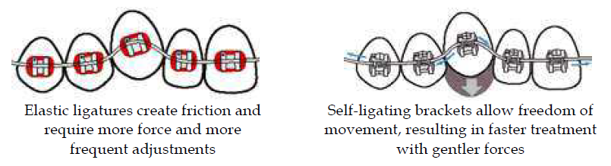

Fig. (1-2) Comparision between conventional and self-ligating bracket

**1.4 Properties of an Ideal orthodontic ligation system**

Regardless of the type of bracket and ligation used, there are several desirable properties for an ideal orthodontic ligation system.

**1.4.1. Secure and robust ligation**

Secure , full archwire engagement maximizes the potential long range of action of modern low modulus wires and minimizes the need to regain control of teeth where full engagement is lost during treatment. Once a wire is ligated, it is desirable that it is resistant

to inadvertent loss of ligation. Wire ligatures are good in this respect while elastic ligatures are more easily lost. Elastic ligatures also experience significant force decay over time.

(Taloumis et al., 1997).

**1.4.2. Full bracket engagement**

Full archwire engagement into the bracket slot is desirable to attain full expression of torque particularly at finishing stages of treatment. Wire ligation can maintain adequate archwire engagement between office visits (Braun and Thomas 2014).

**1.4.3. Quick and easy ligation**

Wire ligation is a lengthy procedure and this is the main reason they are not frequently used. Elastic ligatures are much faster to remove and replace (Türkkahraman et al., 2005)

**1.4.4. Low friction**

For sliding mechanics, brackets that experience low friction are the most desirable. Low friction is important during the leveling and aligning stages of orthodontic treatment. It will allow a more efficient force delivery, less force dissipation and thus a faster expression of the wire. *(*Pizzoni et al., 1998)

Friction is determined by number of factor:

1- the type and size of the archwire

2- type of bracket

3- the method of ligation ( Burrow, 2009 )

**1.4.5. Improves patient comfort and hygiene**

Wire ligatures can cause tissue laceration if the cut ends are exposed but they are very hygienic. Elastic ligatures are more comfortable than wire ligatures but have the side effect of being less hygienic. (Ehsani et al., 2009)

**Chapter 2**

**2.1 Classification of self ligating bracket**

Two types of self-ligation bracket:

1- Active bracket

2- Passive bracket

It is depend on:

1- the design of the locking mechanism

2- the dimensions of the slot

3- the dimensions of the archwires

(Braun and Thomas, 2015)

**2.2 Active VS Passive self-ligating bracket**

**(**Stefanos et al., 2010)

***In active system,***  it made from either chrome-cobalt or nickel titanium.

the locking mechanism generally consists of a flexible mechanism that constrains the archwire in slot and has the ability to make a pressure on the wire. It can force the archwire into the bracket slot in a spring-like fashion. (Pandis et al.,2010)

Proponents of an active clip claim that it provides a “homing action” on the wire when deflected, providing more control with the appliance (Hanson, 1980). Such brackets have a flexible clip that creates a slot depth of 0.0175” to 0.020”.

***In passive systems,*** the slot is locked or shut with a rigid lid or bolt-like locking mechanism. No active force is exerted by the locking mechanism on the archwire itself. the Advantegous of passive system is reduced frictional resistance of the archwire. (Gandini et al., 2008)

Passive self-ligating brackets have a slot depth of 0.028” and do not exert an active force on the wire. Those who advocate a passive clip state that there is less friction in the appliance during sliding mechanics because the slot provides more room for the archwire and they provide no active seating force (Damon, 1998).



fig.(2-1) Passive VS Active Self-ligating bracket

Some manufacturers market their clips as ***semiactive or interactive bracket,*** In these cases, the clip becomes active only once the archwire reaches a certain size. *Before that*, there is no active contact between the wire and the clip. Interactive clips are identical to passive clips for small arch wire sizes. ( Ludwig et al., 2012)

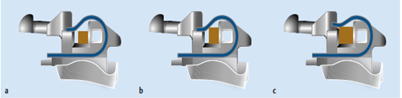

Fig.(2-2) Working principle of interactive bracket during insertion various type of acrhwire

**2.3 Interactive Treatment**

1- **Passive Phase:** Initial Clip does not interact with the wire, allowing for less friction during early treatment.

**2- Transitional Phase:** Intermediate Clip lightly interacts with the wire, allowing the bracket wire interface to control tooth movement.

**3- Active Phase:** Finishing Clip fully engages the wire into the bracket slot for precise finishing. (Fuck et al., 2007)

Less friction can be obtained by:

1- passive SL Bracket

2- Active SL Bracket with small arch wire ([Berger, 1990](http://www.ncbi.nlm.nih.gov/pubmed/2309669))

When studying the effect on torque expression between PSL and ASL, research comparing different PSL and ASL brackets has shown that better torque expression and control was demonstrated by ASL systems due to their active “forcing” of the archwire into the slot, thus their *clinically applicable range of torque activation was greater than PSL systems*([Badawi et al., 2008](http://www.ncbi.nlm.nih.gov/pubmed/18456146" \t "_blank))..

In terms of speed of treatment, no measurable differences between these systems were demonstrated when comparing the times required for alignment of comparable maxillary anterior crowding ([Pandis et al., 2010](http://www.ncbi.nlm.nih.gov/pubmed/20122421" \t "_blank))

|  |  |  |
| --- | --- | --- |
|  | passive | Active |
| Design | Rigid sliding door | Flexible active clip |
| Force application | No active force applied on archwire | Apply active force on arch wire |
| Friction | less friction | Slightly more |
| Speed | No advantage | No advantage |
| Torque expression | Less torque | More torque |

Table (2-1) Passive VS Active bracket system

**2.4 Active treatment with self-ligating bracket**

The active treatment is often subdivided into the following

categories:

• Leveling and alignment

• Space closure and correction of molar relationship

• Detailing and finishing

(Alzergawi,2014.)

we have an advantegous in self-ligation bracket during leveling and alignment phase only.

**2.4.1 Leveling and alignment.**

Self-ligating systems showed significantly faster tooth movement during the leveling and aligning phase. The reason for this is probably he reduced friction of the self-ligating system in comparison with conventional ligation. One of the fastest and most efficient movements in orthodontics is the extrusion of teeth, but tipping of teeth can also be achieved quickly and efficiently. With conventional ligation, elastomeric or metal ligatures prevent free sliding of the archwire through the bracket slot, which is essential for efficient tooth movement. This is generally not observed with self-ligating brackets. It is worth remembering, however, that similar results can be obtained by using conventional brackets with loosely tie steel ligatures. (Eberting et al., 2001)

**2.4.2 Space closure and finishing**

During this phase, horizontal and vertical dentoalveolar correction are made. Thus overbite and overjet are reduced. (Alzergawi,2014.)

we did not observe any advantage for self-ligating brackets for either of the above treatment phases. (Miles, 2007.)

**Chapter 3**

**3.1 History and development of self-ligating brackets**

(Ludwig et al., 2012)

Self-ligating brackets were first introduced in the mid-1930s in the form of the ***Russell attachment*** by Stolzenberg. The bracket had a flat-head screw seated snugly in a circular, threaded opening in the face of the bracket that allows for quick and simple archwire changes. Loosening the screw made the system passive while tightening it made it active and. The bracket system was more comfortable for the patient and resulted in shorter office visits as well. Unfortunately, the Russell attachment did not gain much popularity and virtually disappeared from the market.

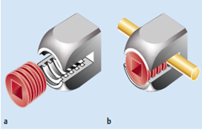

fig.(3-1) Russell attachment when opened and closed

In 1972, Wildman introduced the passive ***EdgeLok bracket*,** which in its earlier incarnations had a round bracket body as well as a labial sliding

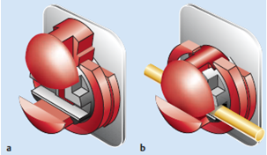

fig.(3-2) Edgelock bracket (a) open (b) closed with sliding mechanism

In the 1980s, Hanson developed a completely new approach to self-ligation**: *the SPEED bracket*** was the first active self-ligating bracket. The locking mechanism is formed by a flexible clip. the Bracket still used today but has some modifacation such as the locking meschanism made from nickel titanium rather than stainless steel.

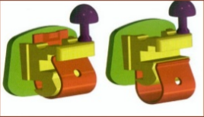

fig.(3-3) Speed bracket

In 1986s, a number of very different designs for self-ligating brackets have entered the market and Plechtner introduced the ***Activa bracket.***

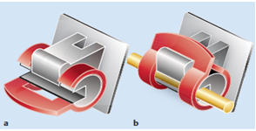

fig.(3-4) Activa bracket

[

Another self-ligating bracket model, ***Time bracket*** entered the marketplace in 1995. The Time bracket features a rigid, curved arm that wraps occlusogingivally around the labial aspect of the bracket body. The stiffness of the bracket arm prevents any substantial interaction with the archwire, thereby rendering Time a passive bracket (Berger & Byloff,

2001).)

In 1996, ***Damon Bracket*** was introduced as Damon SL1 Bracket. A.J. Wildman introduced another bracket called Twinlock bracket. This bracket was named as Damon 2 bracket. In 2004, Damon 3 bracket was intrdouced which was a hybrid of metal and composite material.

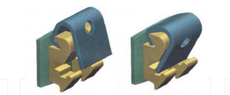

fig.(3-5) Time bracket

In 2002, the ***In-Ovation R™*** by GAC was introduced. This bracket features an interactive clip because it can provide both passive and active control depending on the archwires used.

Round leveling wires can freely move to correct rotations during the initial leveling and aligning phase, while full size rectangular wires are fully engaged into the base of the bracket by the clip in the later stages of treatment for better torque control.

In 2006, ***In- Ovation C™*** is now available which has a partial ceramic face for better esthetics

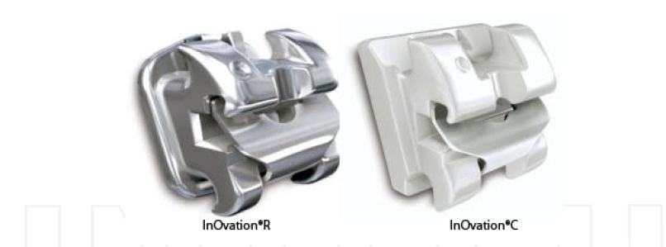

fig. (3-6) InOvation R and InOvation C bracket

In 2004, 3M Unitek introduced the SmartClip™ self-ligating bracket, which is different from other self-ligating brackets in that it does not have a slide or clip to hold the wires.Instead it contains a nickel-titanium clip on each side of the twin bracket that locks in the wire. The archwire is inserted by using finger pressure to push it past the flexible clip. Remove requires a special instrument from 3M Unitek™.

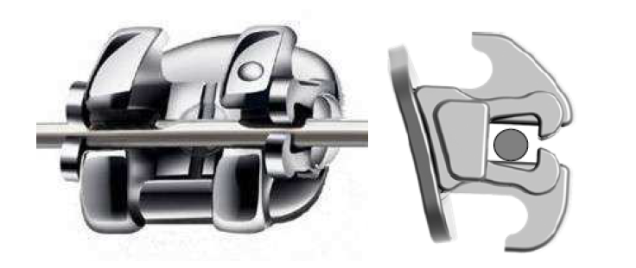

Fig. (3-7) Smartclip bracket

**Chapter 4**

**4.1 Passive system:**  (Chen et al., 2009; Ludwig et al., 2012)

**4.1.1 Damon 3 bracket:**

The Damon 3 bracket  **is a passive** system. The locking mechanism consists of a rigid sliding door with guiding grooves or rails.

The bracket base and part of the body consist of acrylic.

**Opening of the bracket** requires a special instrument and is in a caudal direction (i.e., occlusal for the upper jaw and gingival in the lower jaw).

**Advantage:**

1- Maintain esthetic for long time with few discoloration.

2- short time for positioning.

3- rotational and torque is sufficient.

**Disadvantage:**

1- Most of composite bonding stay on tooth

2- long time for Debonding.

3- oral hygiene is difficult.

**Indication**

1- patient with good oral hygiene

2- patient with esthetic requirement

**Contraindication:**

1- not indicated for severely rotated tooth

2- not use with chlorhexidine mouth rinse or coffee or tea

3- not indicated for patient with poor oral hygiene

**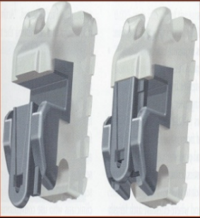**

fig. (4-1) Damon 3 bracket

**4.1.2 Opal (Ultradent) bracket:**

is a passive bracket. It consists of a translucent fiber-reinforced composite polymer.

**Openning:**

With special instrument from the incisal direction similar to the probe

**Advantage:**

1- Highly esthetic

2- very smooth and gentle on soft tissue

**Disadvantage**

1- need professional cleaning

2- poor torque and rotational control

3- Bracket discoloration is easy

**Indication**

1- correction of small rotation and mild crowdinig

2- highly esthetic requirement in the initial treatment phase

**Contraindication:**

1- not indicated for severely rotated tooth or sever crowdinig

2- not indicated for patient with poor oral hygiene and smoker patient

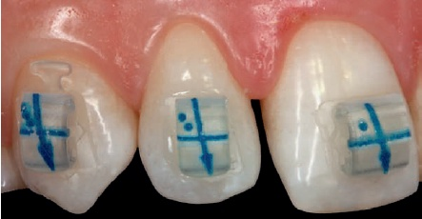

fig.(4-2) Opal (ultradent) bracket

**4.1.3 opal M bracket:**

Made from Metal

**Openning :** special instrument from incisal direction similar to the dental probe .

**Advantage:** smooth and gentle on soft tissue

**Disadvantage:** non esthetic due to it made from metal

**Indication:** for all cases of crowdining, torque and rotational control due to the good clinical properties

**contraindication:** not use in patient concern with esthetic requirement

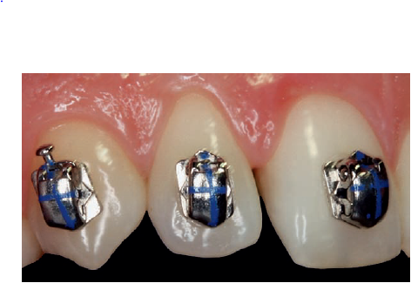

fig.(4-3) opal M bracket

**4.1.4 Smartclip bracket:**

The bracket has two clips laser-welded to it, which are mesial and distal to the tie-wings. There are no movable parts such as lids or locks. The mechanism itself consists of two nickel–titanium clips that open automatically once the arch wire is dislodged in the buccal–lingual direction with special pliers.

**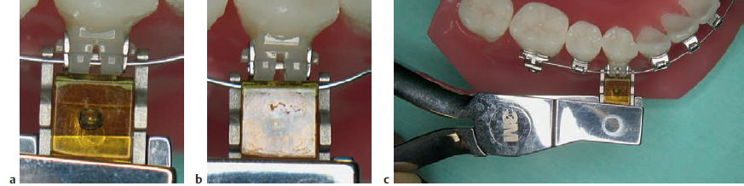**

fig.(4-4) special pliers for smatrclip bracket

**Advantage:**

1- can convert them to active bracket

2- oral hygiene is easy to keep

**Disadvantage**

The main disadvantage of this bracket that is debonding of bracket during insertion and removal of wire, so cause discomfort to patient.

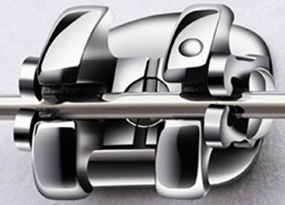

fig.(4-5) smartclip bracket

**4.1.5 Clarity bracket:**

This has a metal slot incorporated in the ceramic base to improve Reduce friction. As in the SmartClip bracket, the self ligating mechanism consists of a NiTi clip that is fixed to the mesial and distal aspects of the twin bracket. special tools are required to insert and remove archwire.

**Advantage:**

1- Cleaning is easy for the patient because of there

2- Ceramic Brackets offer trusted strength in a small size and lowest profiles in the

3- good esthetic due to the metal part is hidden behind the arch wire.

**Disadvantage:**

1- uncomfort to the patient due to debonding of bracket during insertion and removal of archwire

2- - it is non esthetic in rotated tooth due to presence of metal at the mesial and distal side. possibility of debonding during insertion and removal of wire

**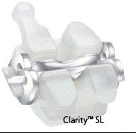**

fig.(4-6) clarity bracket

**4.2 Active system** (Chen et al., 2009 ; Ludwig et al., 2012)

**4.2.1. speed bracket:**

The Speed bracket was the first active self-ligating bracket on the market. The bracket base is well contoured. It is welded to the body.

The nameis derived from the descriptive term ***Spring-loaded, Precision, Edgewise, Energy, and Delivery.***

**Opening**

occurs from gingival to occlusal for both upper and lower arches,

and a customized tool is recommended for this.

**Advantage:**

1- small size bracket that can be use in severely crowded teeth

2- has an auxiliary slot which is useful.

3- provide less friction and full control.

**Disadvantage**

1- non esthetic

**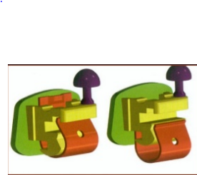**

fig.(4-7) Speed Bracket

**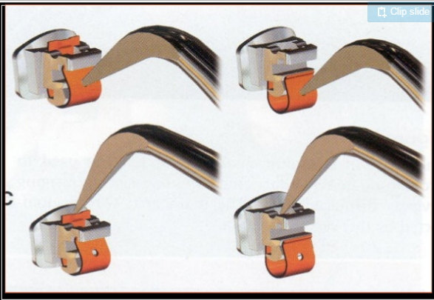**

fig.(4-8) opening of speed Bracket

**4.2.2 Ovation R bracket:**

It made from chromium Molybdenum alloy

**Opening of bracket:**

Use special instrument similar To the explorer from gingival to occlusal direction.

**Advantage:**

1- easy to place

2- good torque and rotational control

3- easy to open and close the bracket

**Disadvantage:**

1- has no esthetic requirement for the patient

2- may cause allergy to the patient.

**Indication**

1- severely crowded teeth

2- good torque and rotational control is needed

**Contraindication:**

1- patient with highly esthetic requirement

2- patient with allergy to chromium molybdenum or nickel.

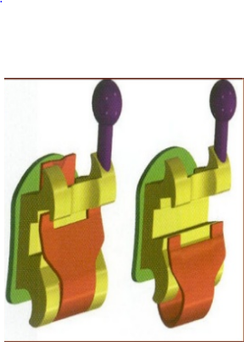

fig.(4-9) ovation R bracket

**4.2.3 Ovation C bracket:**

Active bracket that made from ceramic.

**Opening:**

From gingival direction toward occlussal direction with special instrument

**Advantage:**

1- better torque and rotational control than ovation R

2- highly esthetic

3- it is possible to reuse of the bracket for the same patient after cleaning of bracket base

**Disadvantage:**

1- debonding procedure is difficult and time consuming.

2- Fracture of bracket may occur

3- Enamel damage can occur.

**Indication**

In cases that require good torque control

**contraindication:**

Cases with severely crowded tooth due to large size of bracket.

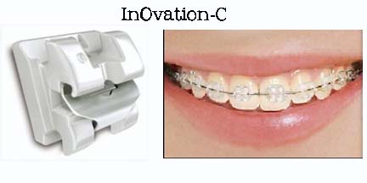

fig. (4-10) Ovation C bracket

**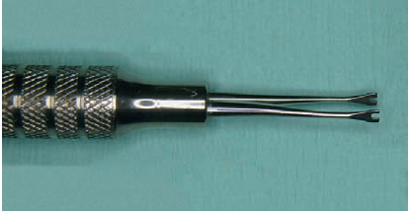**

A

**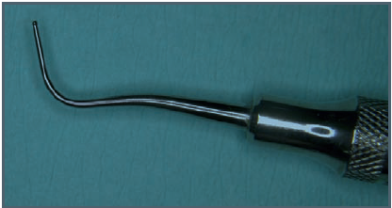**

B

fig. (4-11) Special instrument for opening of Ovation system

**4.2.4 Time 2 bracket:**

The bracket can be opened with a special in the gingival direction.

The bracket has large size so :

**Advantage:** good rotational and torque movement

**Disadvantage:** poor esthetic and not indicated for patient with severely crowded or small teeth

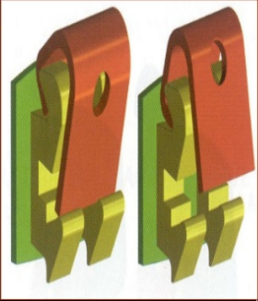

fig.(4-12)Time bracket

**4.3 Interactive system (empower bracket )**

**(**Chen et al., 2010; Ludwig et al., 2012)

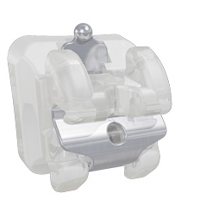

fig.(4-13) Empower clear bracket

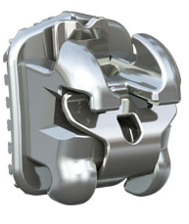

fig. (4-14) Empower metal bracket

Introducing the industry’s first self ligating bracket system that empowers the orthodontist with the versatility of both passive and interactive ligation clips - all in one unified system. Empower uses strong, heat treated chromium cobolt clips

Two option we have:

**4.3.1 Fully interactive system**

Empower’s interactive self ligating system offers the benefits of :

• Low friction sliding mechanics during initial leveling and alignment stages.

• Increased control of torque and rotations using larger wires delivers exceptional finishing precision.

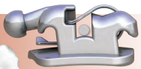

fig.(4-15) Initial leveling and alignment stage

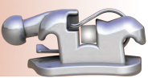

fig.(4-16) working and finishing stage

**4.3.2 Dual activation Hybrid interactive\passive system ( two bracket design in one coordinated system )**

Empower’s Dual Activation system offers the unprecedented versatility of a combination interactive anterior / passive posterior system.

• Anterior teeth - low friction, low force during initial leveling and alignment stages, increased torque and rotational control during finishing • Posterior teeth - low friction mechanics throughout treatment

**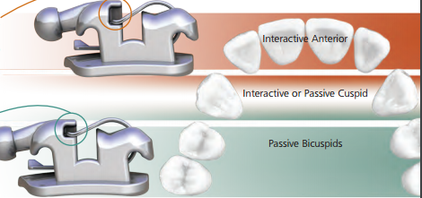**

fig.(4-17) Dual activation Hybrid interactive\passive system

**Anterior teeth - interactive Clips**

Empower’s Selective EngagementTM clip allows smaller wires to slide with reduced friction and actively engages larger wires for increased torque and rotation control mid to late treatment.

**posterior teeth - passive clips**

Passive clips on posterior teeth allow low friction, low force mechanics throughout treatment. No wire sizes are actively engaged by the clip.

**Chapter 5**

**5.1 Friction in Self-ligation bracket and conventional bracket with elastomeric ligature or loose stainless steel ligature**

Some studies compared the frictional characteristics of a number of self-ligating brackets and compared them with conventional brackets, which had archwires tied either using elastomeric or stainless steel ligatures.

It was found that self-ligating brackets have reduced frictional characteristics in comparison with classic brackets with elastomeric ligatures. However, the investigations also demonstrated that the frictional characteristics of self-ligating brackets were similar to those of conventional brackets using loose steel ties for ligation.

from the study, we conclude that we can achieve frictional charactarisic and effectivity in conventional Bracket similar to that in self ligating bracket by using loose steel ligature rather than elastomeric ligature.

(Fuck et al.,2007; Leite et al., 2014)

**5.2 Comparision between self-ligating bracket and conventional bracket** (Read et al., 1997)

|  |  |  |
| --- | --- | --- |
| **Conventional** | **Self ligation** |  |
| Difficult due to elastomeric chain | Easy to maintain | Oral hygiene |
| High force | Low force | Force level |
| More resorption due to high force | it is less due to light force | Root resorption |
| Long chair side time | Short chair side time | Chair side time |
| Short time due to elastomeric chain loss | Long interval time | Interval time |
| More number of appointment | Less number of appointment | Number of appointment |
| Loses initial shape and tightness | Retain oroginal throughout the treatment | Ligation stability |
| More friction | Less friction | Friction |
| At the elastomeric chain | At specific area in locking mechanism | Plaque accumulation |
| Slow tooth movement due to the the bracket prevent free movement of wire and more friction occur | Fast tooth movement due to the free wire movement in slot and less friction | Tooth movement |
| Slightly longer | May be short | Overall treatment time |
| Less expensive | More expensive | Cost |

Table (5-1) comparision between self-ligating bracket and conventional bracket

**Discussion**

Self-ligating brackets (SLBs) are not new conceptually, having been pioneered in the 1930s. They have undergone a revival over the past 30 years with a variety of new appliances being developed.

The key of work of self-ligating bracket is the light force that applied so it permit the free movement of archwire in slot of bracket and produce less frictional resistance.

Pandias in 2008 said that the self-ligating bracket cause less resorption of root during clinical trials when compared the root resorption that associated with conventional bracket with elastomeric ligature because the force that applied is too small to occlude the periodental vascular supply.

Damon in 1998 said that the design in passive self-ligating bracket enables teeth to move in the path of least resistance.. By greatly reducing the amount of friction with passive self-ligating brackets, low force archwires can work to peak expression and stimulate teeth to move in a more biologically compatible method . passive self-ligating brackets offer more freedom for teeth to move to their natural position even though they are still interconnected because the archwire is never tightly engaged with the bracket slot.

Some studies show that the active treatment with Self-ligating bracket is better during leveling and alignment, and there is no advantage in any another stage of treatment.

Studies shown that we can obtain a conventional bracket with frictional features similar to that in self-ligating bracket by replacement of elastomeric ligature with loose stainless ligature.

The general advantages of self-ligating bracket is less friction and full arch wire engagement that allow the tooth to travel to its physiological position more effiecient, long interval between visit, easy to keep clean and make less chance to cause root resorption during orthodontic treatment.

**Conclusion**

There is insufficient evidence to support the use of self-ligating fixed orthodontic appliances over conventional appliance systems or vice versa. Self-ligating bracket do not confer particular advantage with regard to subjective pain experience. There is insufficient evidence suggesting that orthodontic treatment is more or less efficient with SLBs.

Self-ligating brackets (SLBs) are divided into 2 main categories, active and passive, according to the mechanism in which they interact with the archwire (encroaching on the slot lumen or not). Self-ligating bracket systems were built on the philosophy of delivering light forces on a low-friction basis, thus insuring more physiologic tooth movement. clinical trial claim that low-friction SL brackets coupled with light forces enhance the treatment efficiency and address the clinical superiority of self-ligating brackets.

In the last years, some manufacture produce new bracket that called interactive bracket which has two type either fully interactive bracket or dual bracket which is anterior interactive and posterior passive.

We can approach a conventional bracket with physical properties similar to that in self-ligating bracket by using loose stainless steel ligature rather than use elastomeric ligature.

we have an advantage during treatment in the step of leveling and alignment that is better by using self-ligating bracket because of less friction formed that result from freely movement of archwire in the bracket slot.

Friction was influenced not only by the type of wire, but also the bracket type. Self-ligating brackets showed lower means of friction.

Low friction is an advantage during initial leveling and alignment stage, but it is disadvantage during finishing stage.

**REFERENCES**

**A**

\* Alzergawi H, 2014. *fixed appliance* . College of Dentistry, University of al-Kuffa.(Lecture on.7/4l2014) pp. 5-6.

**B**

\* Badawi, H. M.,Toogood, R.W., Carey, J. P.,Heo, G. and Major, P. W. (2008). 'Torque expression of self-ligating brackets'.*American Journal of Orthodontics and DentofacialOrthopedics*, Vol. 133, No. 5, pp. 721-728. ISSN 1147-5540.

\* Braun, Thomas (February 25, 2014). ['Static Self-Ligating Orthodontic Bracket'](https://www.google.com/patents/WO2014137654A1?cl=en&dq=US2014/018150&hl=en&sa=X&ved=0ahUKEwjOu-_P4tTKAhVENz4KHSV8DKMQ6AEIHDAA)

\* Berger, J .L. 1990.'The influence of the SPEED bracket's self-ligating design on force levels in tooth movement: a comparative in vitro study'.*American Journal of Orthodontics and Dentofacial Orthopedics*.Vo. 97, No. 3. March 1990. PP.219-228

\* Berger, J. L. andByloff, F. K. (2001).'The clinical efficiency of self-ligated brackets'.*Journal of Clinical Orthodontics*, Vol. 35, No. 5, pp. 304–308, ISSN 1147-5540.

\* Burrow SJ. Friction and resistance to sliding in orthodontics: a critical review. Am J Orthod Dentofacial Orthop. 2009;135(4):442-7

**C**

\* Chan E, Darendeliler, M.A. 2005. 'Physical properties of root cementum: Part 5. Volumetric analysis of root resorption craters afterapplication of light and heavy orthodontic forces'. Am J Orthod DentofacialOrthop. Vol., No. 2127.PP.186–195

\* Chen, Stephanie Shih-Hsuan, Greenlee, Geoffrey Michael,Kim, Jihyun-Elizabeth, Smith, Craig L.and Huang, Greg J. (2010). 'Systematic review of self-ligating brackets'. *American Journal of Orthodontics and Dentofacial Orthopedic*137 (6):726.e1. doi:10.1016/j.ajodo.2009.11.009 .PMID 20685517.

**D**

\* Damon, D.H. (1998). 'The Damon low-friction bracket: A biologically compatible straight-wire system'. *Journal of Clinical Orthodontics*, Vol. 32, No. 11, pp. 670-680, ISSN 1038-8398.

**E**

\* Eberting, J. J.; Straja, S. R. &Tuncay, O. C. (2001).'Treatment time, outcome, and patient satisfactioncomparisons of Damon and conventional brackets'. *ClinOrthod Res*, Vol. 4, No. 4, pp. 228-234, ISSN 1168-3812.

\* Ehsani, Sayeh, Mandich, Marie-Alice, El-Bialy, Tarek H. and Flores-Mir, Carlos (2009-06-29). "Frictional Resistance in Self-Ligating Orthodontic Brackets and Conventionally Ligated Brackets". The Angle Orthodontist. 79 (3): 592–601. doi:10.2319/060208-288.1

**F**

\* Fuck LM, Wilmes B, Gürler G, Hِnscheid R, Drescher D. Friktions verhalten selbstligierender und konventioneller Bracket systeme. InfOrthodKieferorthop 2007;39:6–17

**G**

\* Gandini P, Orsi L, Bertoncini C, Massironi S, Franchi L. In vitro frictional forces generated by three different ligation methods. Angle Orthod. 2008;78(5):917-21

\* Gorelick, L.; Geiger, A. M. & Gwinnett, A. J. (1982).Incidence of white spot formation after bonding and banding.*American Journal of Orthodontics*, Vol. 81, No. 2, pp. 93-98, ISSN 0675-8594.

\* Geiger, A. M.; Gorelick, J. &, Gwinnett, A. J. (1983).'Bond failure rates of facial and lingual attachments'. *Journal of Clinical Orthodontics*, Vol. 17, No. 3, pp.165-169, ISSN 0635-0356.

**I**

\* Ireland, A. J., Sherriff, M. and McDonald, F. (1991).'Effect of bracket and wire composition on frictional forces' .*European Journal of Orthodontics*, Vol. 13, No. 4, pp. 322-328, ISSN 0191-5622.

**L**

\* Leite VV, Lopes MB, Gonini Júnior A, Almeida MR, Moura SK, Almeida RR. (2014)' Comparison of frictional resistance between self-ligating and conventional brackets tied with elastomeric and metal ligature in orthodontic archwires' . *Dental Press J Orthod. 2014 May-Jun*;19(3):114-9. PMID: 25162575

\* Ludwig B, Bister D, and Baumgaertel S. (2012).Self-ligating brackets in Orthodontics. www.thieme.com/media/samples/pubid1270036187.pdf

**M**

\* Miles P.G. 2007.'Self-ligating vs conventional twin brackets during en-massespace closure with sliding mechanics'. *Am J Orthod Dentofacial Orthop*.132(2):223–225

**P**

\* Pandis, N., Polychronopoulou, A., and Eliades, T. (2010).'Active or passive self ligating brackets? A randomized controlled trial of comparative efficiency inresolving maxillary anterior crowding in adolescents'.*American Journal of Orthodontics and Dentofacial Orthopedics*, Vol. 137, No.1, pp. 12-16, ISSN 0889-5406.

\* Pandis N, Nasika M, Polychronopoulou A, Eliades T. 2008. 'External apical root resorption in patients treated with conventional and self-ligating brackets'. *Am J OrthodDentofacialOrthop*. 134(5):646-51.

\* Pizzoni, L.,Ravnholt, G., and Melsen, B. (1998). 'Frictional forces related to self-ligating brackets'. *The European Journal of Orthodontics*.  20 (3): 283–291. doi:10.1093/ejo/20.3.283. ISSN 0141-5387. PMID 9699406. (1998-06-01)

**R**

\* Reitan, K. (1956). 'Selecting forces in orthodontics'.*Transactions of the European Orthodontic Society*, Vol. 32, pp. 108-125.

\* 21. Read-Ward GE, Jones SP, Davies EH. A comparison of self-ligating and conventional orthodontic bracket systems. *Br J Orthod*. 1997;24(4):309-17.

**S**

\* Shivapuja, P. K. and Berger, J. (1994).'A comparative study of conventional ligation and selfligation bracket systems'.*American Journal of Orthodontics and Dentofacial Orthopedics*, Vol. 106, No. 5, pp. 472–480, ISSN 0797-7187.

\* Stefanos, Sennay,Secchi, Antonino G., Coby, Guy,Tanna, Nipul andMante, Francis K. (2010).'Friction betweenvarious self-ligating brackets and archwire couples during sliding mechanics'.American Journal of Orthodontics and Dentofacial Orthopedics.138(4): 463–467.(2010-10-01).*.*

**T**

\* Taloumis, L. J.; Smith, T. M., Hondrum, S. O. & Lorton, L. (1997). Force decay and deformation of orthodontic elastomeric ligatures. *American Journal of* *Orthodontics and Dentofacial Orthopedics*, Vol. 111, No. 1, pp. 1-11, ISSN 0900- 9917.

\* Taylor, N. G. &Ison, K. (1996).'Frictional resistance between orthodontic brackets andarchwires in the buccal segments'. *Angle Orthodontist*, Vol. 66, No. 3, pp. 215–222. ISSN 0880-5917.

\*Türkkahraman, H., Sayin, M. O., Bozkurt, F. Y.,Yetkin, Z., Kaya, S. andOnal, S. (2005).'Archwire ligation techniques, microbial colonization, and periodontal status inorthodontically treated patients.'*Angle Orthodontist*, Vol. 75, No. 2, pp. 231-236,ISSN 1582-5788.