Preventive Dentistry
Prevention and controlling of Dental caries
Lec.3
أ.د.عذراء مصطفى
Fluorides in Dentistry
The caries-preventive effect of fluoride has been known since the 1930s, when the differences in caries prevalence between communities were attributed to naturally occurring fluoride levels in the drinking water. Some studies have been proven that water fluoridation has reduce dental caries by about 50%.
Due to its safety, efficacy and cost-effectiveness in preventing caries the fluorides are widely used in different forms thus remains cornerstone of most caries prevention programs.
It is well documented that fluoride can have both beneficial and detrimental effects on the dentition. As a basic principle, the beneficial effects on dental caries are due primarily to the topical effect of fluoride after the teeth have erupted into the oral cavity. In contrast, the detrimental effects of fluoride are due to its systemic absorption during tooth development, resulting in dental fluorosis. By maximizing topical exposure throughout life and minimizing systemic absorption during the period when the dentition is developing, fluoride can be used to maximize the anticaries benefits while minimizing the risk of fluorosis.
Fluoride in Environment
- Fluorine is one of 118 chemical atomic elements in the periodic system. In its pure form, it is a poisonous pale yellowish brown gas. Fluorine is placed as number 9 in the periodic table, as it has 2 electrons in the inner shell and 7 electrons in the outer shell.
- Fluorine belongs to the group of chemical elements called halogens, which refers to their ability to form salts in union with a metal. Halogens, and in particular fluorine, are highly reactive being one electron short of a full outer shell.
- This electron can be gained by reacting with, for example, calcium, forming calcium fluoride (CaF2). Thus, fluoride is the term used when fluorine is combined with a positively charged counterpart. The complexes often consist of crystalline ionic salts such as fluorapatite (Ca10[PO4]6F2).
- Fluoride content is commonly expressed in parts per million
- (ppm) which is equivalent to 1mg fluoride per kilogram or liter of water. Thus,1ppm fluoride equal to 1mg fluoride per liter of water
Fluoride in Our Surroundings
Fluoride occurs in nature as a constituent of natural minerals in the soil and more than 150 fluoride-containing minerals have been described. For example :
cryolite contains aluminum fluoride
fluorspar contains calcium fluoride.
As many of the minerals in the soil are soluble in water, fluoride is found in varying concentrations in the groundwater.
Fluoride in water and atmosphere
All water contains fluorides in varying concentrations. Sea water contains significant quantities of fluoride at levels 0.8–1.4 mg/lt.
In water from lakes, rivers, and artesian wells the fluoride content is usually below 0.5 mg /L although concentrations as high as 95 mg /L have been recorded in Tanzania. The highest natural fluoride concentration ever found in water was 2800 mg/L, recorded in Lake in Kenya.
Additional fluoride is widely distributed in the atmosphere, originating from dust of fluoride-containing soils from gaseous industrial waste, the burning of coal fires in populated areas and from gases emitted in areas of volcanic activity in nature.
The principal source of pollution are industries and mining of phosphate and fluorspar, where fluoride rich dust travel long distances by wind and enter food chain by depositing on plants. Pesticides containing fluoride can have a similar effect.
In food the uptake of fluoride varies among plant species, being influenced by soil, use of fertilizer, age of the leaf, irrigation and other factors. Tea plant has a fluoride concentration ranging from 3.2 to 400g/kg. Vegetation grown in near of industrial facilities may show elevated fluoride concentrations because of the absorption of particulate and gaseous fluoride impinging on leafy surfaces. Also fluoride can be found in fishes and shell fishes.
In countries with water fluoridation programs, fluoridated water may raise the fluoride content of the processed food if fluoridated water is used for food processing more than that of the products for which non-fluoridated water has been used.
Other sources of fluoride are drugs like diuretics and anesthetics drugs, and in dental products e.g. dentifrices, mouth rinses and some restorative materials.
Fluoride Metabolism
1-Fluoride Absorption
Approximately 75 to 90 percent of the fluoride ingested each day is absorped from the alimentary tract. Fluoride may also be inhaled from air borne fluoride. Readily soluble fluoride compounds such as NaF tablets or aqueous solution of NaF are completely absorped where as compound with solubility such as CaF₂, MgF and A1F_{3 ,} are less completely absorbed. So the presence of Ca may lead to formation of insoluble salts with fluoride and absorption reduced to 70% and in food rich with Ca to 60%. The ingestion of fluoride with food retards its absorption . Absorption from stomach occurs readily and is inversely related to the pH of the gastric content. The absorption process occurs by passive diffusion. The absorption of fluoride is unusual in that it can occur from the stomach to a considerable extent. The rate of gastric absorption is directly related to the acidity of the contents so that, for any given dose, the peak plasma level is higher and occurs sooner when the contents are more acidic Most of the fluoride that escapes absorption from the stomach will be absorbed from the proximal small intestine.
2-Distribution of Fluoride in the Body
About 90% of fluoride intake is absorbed in blood from stomach and to lesser extent from small intestine and 10% excreted by feces.
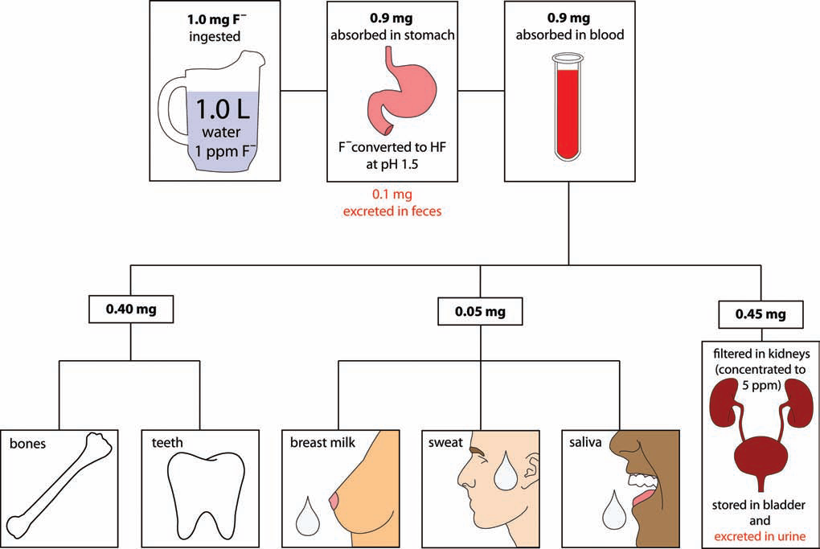
Fluoride in Plasma
Plasma is the biological fluid into which and from which fluoride must pass for its distribution elsewhere in the body and for its elimination from the body. There are two general forms of fluoride in human the ionic form (also called as inorganic fluoride or free and the non-ionic or bound fluoride). Ionic form is of significance in dentistry and public health and is detected by ion-specific electrode together the ionic and non-ionic fraction is a "total" plasma fluoride. Ionic fluoride is not bound to proteins, to other components of plasma or to soft tissue. The concentration of ionic fluoride in soft and hard tissue is directly related to the amount of ionic fluoride intake. The peak plasma concentration usually occurs within 30-60 minutes, then decreased within a few minutes after its distribution into body tissues through extracellular fluid .in pregnant women fluoride passes placenta and found in fetal blood in about 70% of mother blood.

B-Soft Tissues
It depends on the extra cellular pH of cell, increase acidity increase the fluoride exchange through the tissue plasma. The fluoride distributed rapidly to heart, kidney, liver and slowly distributed to skeletal muscles and adipose tissues. So it is suggested that alkalization of the body fluid is a useful adjunct in the treatment of fluoride toxicity.

C- Calcified Tissues
Approximately 99 percent of the body burden of fluoride is associated with calcified tissues. The fluoride concentration in bone is not uniform. In long bones, for example, the concentrations are highest in the periosteal region. They decline sharply within a few millimeters of the periosteal surface and increase slightly as the endosteal region is approached. Cancellous bone has higher fluoride concentrations than compact bone. Dentine and bone appear to have similar fluoride concentrations which increase with age. while that of enamel is markedly lower.
Approximately 50% of fluoride in plasma is from daily intake in young adult is associated with calcified tissues and the remainder is excreted by the kidneys and this percentage is increased in young children because of increased retention of fluoride in large surface area of developing bone crystallites.
Surface enamel fluoride concentrations tend to decrease with age in areas subjected to tooth wear but increase in areas that accumulate plaque. Dentine fluoride levels decline progressively from the pulpal surface to the dentine-enamel junction (DEJ). Enamel fluoride concentrations are highest at the surface and decline progressively toward the DEJ. Bulk enamel fluoride concentrations mainly reflect the level of fluoride exposure during tooth formation, while dentine and bone fluoride concentrations are generally proportional to the long-term level of intake.
3-Fluoride Excretion
a-Urine
Fluoride is excreted primarily via urine . The percentage of the filtered fluoride reabsorbed from the renal tubules can range from about 10 to 90 percent. The degree of reabsorption depends largely on the pH of the tubular fluid, urinary flow and renal function . Urinary fluoride clearance increases with urine pH due to a decrease in the concentration of HF.
Numerous factors (e.g. diet and drugs) can affect urine pH and thus affect fluoride clearance and retention. The renal clearance of fluoride in the adult typically ranges from 30 to 50 ml/min. whereas clearance rates of the other halogens (chloride, iodide and bromide) are usually less than 1.0 ml/min. The excretion of fluoride in urine is reduced in individuals with impaired renal function.
b-Feces
It is generally accepted that most of the fluoride in the feces is not absorbed. Fluoride present in feces results from two sources: the ingested fluoride that is not absorbed and the absorbed fluoride that is re excreted into the gastrointestinal tract .Fecal fluoride usually accounts for less than 10 percent of the amount ingested each day.
c- Sweat
Usually, only a few percent of the fluoride intake is excreted in the sweat. However, under excessive sweating as much as 50 percent of the total fluoride excreted may be lost via perspiration.
d- Breast milk
The average fluoride level is 0.019±0.004 ppm in breast milk, fluoride intake of infants is not very high.
e-Saliva
Less than 1 percent of absorbed fluoride is reported to appear in the saliva. The concentration of fluoride in saliva is about two-thirds of the plasma fluoride concentration and seems to be independent of flow rate, in contrast to the situation for most electrolytes. Fluoride presents in saliva in low concentration 1-2µmol/L which is from toothpaste , water, and food.
In fact, saliva does not represent true excretion, because most of the fluoride will be recycled in the body. However, the fluoride content of the saliva is of major importance for maintaining a fluoride level in the oral cavity.

