

Systemic Fluoridation

Fluoride Supplements

Lec.6

أ.د.عذراء مصطفى

Fluoride tablets, Lozenges and drops

* Fluoride supplements were originally designed to provide the systemic fluoride that a child would not consume living in a non-fluoridated area.
* Supplements contain a measured amount of fluoride typically 0.25mg, 0.5mg, and 1mg usually as sodium fluoride
* An early study by Bibby et al. (1955) a 1-year caries trial with 242 children comparing fluoride lozenges that were sucked and swallowed with fluoride tablets that were swallowed right away, he found only four new caries in the children who consumed the lozenges versus 6.6 new caries in the children who swallowed the tablets.
* Fluoride supplements should only be prescribed by dentists where there is

clear evidence for high risk of caries and non-compliance with using other fluoridated products; and the parents must be cooperative.

Indications: children living in area with non or low level of fluoride in water

1. To children with high risk to dental caries.
2. To children with chronic systemic disease.
3. To handicapped children.

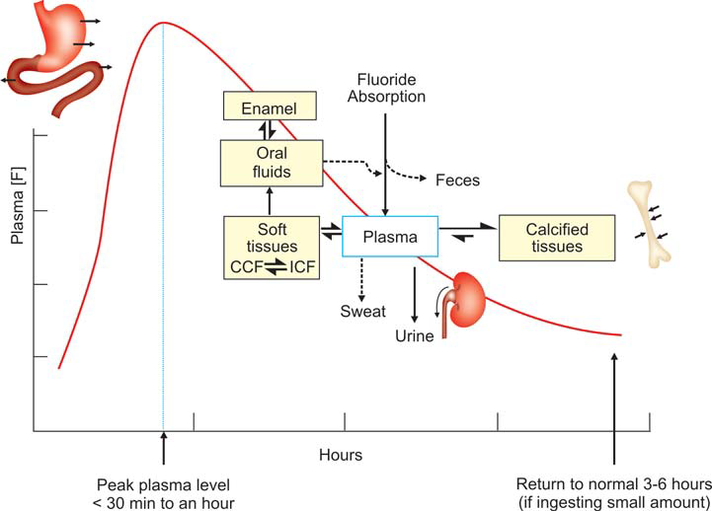

Fluoride supplement dosage schedule according to F concentration in drinking water Approved by American Dental Association

Fluoride Level in Drinking Water

Age <0.3ppm 0.3–0.6ppm >0.6ppm

Birth- 6 months None None None

6months-3 years 0.25 mg/day None None

3-6years 0.5 mg/day 0.25 mg/day None

6-16 years 1.0 mg/day 0.5 mg/day None

2.2 mg sodiumfluoride tablet gives 1mg ion fluoride

1.1 mg sodiumfluoride tablet gives 0.5mg ion fluoride

To maximize the topical effect of fluoride, tablets and lozenges are intended to be chewed or sucked for 1–2 minutes before being swallowed.

It is daily used from 6months to 16 years to give their maximum effect.

Should not be given with milk

Effective on:

primary teeth: The studies concluded that a caries preventive effect of about 40-50% was found when entail age was 2 years or younger.

Permanent teeth :In studies taken tablets from 1 to 7 years give reduction 39-80%percent and the show that sucking tablets ,for as long as possible gives better results in caries prevention.

Prenatal: results from few studies found caries reduction in children their mothers received fluoride tablets during pregnancy is greater than others.

Fluoride may be supplemented during pregnancy until dental formation is completed through pharmaceutical products, i.e. tablets or drops, according to variable doses (0.25 and 1 mg). During pregnancy and breast feeding, mothers should take 1 mg a day. In fact, theoretically, during intrauterine life, the fluoride taken by the mother may work in the pre-eruptive phase, during the amelogenesis of deciduous teeth with a consequent beneficial effect on the newborn’s deciduous teeth .

Fluoride passes through the placenta freely, until it reaches excessively high levels in the mother’s blood, and thus triggers this passage (barrier effect) to protect the foetus from excessive doses. The threshold concentration that pushes the placenta to trigger this function is 0.4 ppm of fluoride in maternal blood . Some Authors consider the systemic administration of fluoride as a further supplement during pregnancy, as it is identified as the first step to caries prevention

Fluoride Drops ; they are available as 0.125mg,0.25mg,0.50mg drops .The drops are prescribed to the children until they are old enough to swallow.10 drops equal to 1mg,if 10 drops placed in a liter of water the result concentration of 1ppm of fluoride.

It may be given with multivitamins drops for young children.

Fluoridated Salt

Where water fluoridation could not be initiated, some countries have introduced salt fluoridation. Caries remain a significant problem in some Latin America countries, as well as some countries in the Caribbean, and some of these countries have converted their salt supplies to fluoridated salt. Switzerland started the practice in 1955.

Salt is usually fluoridated at 250 ppm (which is 250 mg F/kg salt, or 0.25 mg/gm salt). Table salt in the kitchen can contribute 1 to 4 g of the daily salt intake. Thus, a person could potentially ingest 1 mg of fluoride a day at a salt intake of 4 grams a day. The evidence that fluoridated salt effective is weak.

Advantages:

1. Wide coverage
2. Need little action by the individual
3. Low coast
4. Freedom for the consumers as both fluoridated and non-fluoridated salt is available
5. It is safe
6. Minimum possibilities of fluorosis.

Disadvantages:

1. Salt fluoridation need community education and promotion.
2. International efforts to reduce sodium intake to help control hypertension.
3. Consumption of fluoridated salt is lowered during early life when the need for fluoride is the maximum.

Fluoridated Milk

Milk fluoridation is the addition of a measured quantity of fluoride to bottled or packaged milk to be drunk by children .both bovine and human milk contain low level of fluoride about 0.03ppmF. Milk fluoridation is suggested instead of water fluoridation.

* Concentration of 2.5 ppm fluoride to 6 ppm
* In a study done in UK: The children generally consumed one typical serving (200 mL) at level 5mg/L(5ppm) of the beverage (test and control milk). In the trial by Stephen (1984) it took about 5 years to achieve a 31.2% reduction in DMFT. No correction was made for delay in tooth eruption.
* A high concentration of fluoride is needed for two reasons:

(1) the children did not drink the beverage throughout the day.

(2) calcium in the milk complexes with fluoride, which would reduce its availability for topical benefits.

Some studies could not show any benefit of fluoridated milk.

Disadvantages:

1. Consumption of milk varies between different socioeconomic groups .
2. Consumption decrease with age so long term benefit is less than water fluoridation
3. Require high level of technical expertise
4. Procedure can be relatively coast.

In warm climates fluoridated fruit juices may be alternative to Milk fluoridation .