C.V
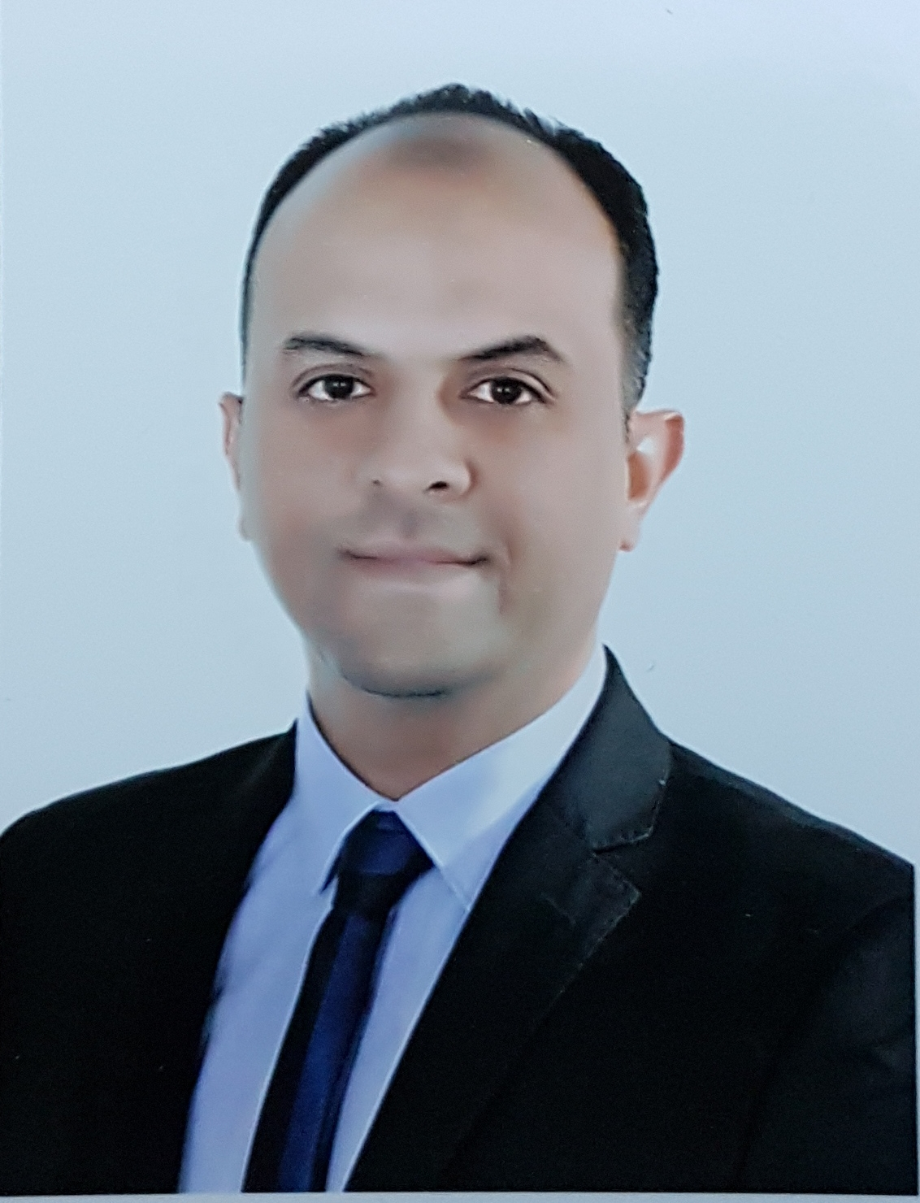

Photo

Name: Anas Falah Mahdee
Date of Birth: 05/ 07/ 1975
Religion: Muslim
Martial statues: Married
No. of children: Three
Specialization: BDS, MSc, PhD
Position: Teaching staff member in Department of Aesthetic and Restorative Dentistry
Scientific Degree: Assistant Professor
Work Address: College of Dentistry University of Baghdad
Work Phone:
Mobile: 00964781776569
E-mail: a.f.mahde@codental.uobaghdad.edu.iq
a.f.mahdee@gmail.com

- First, Scientific Certification:

Date | College | University | Degree science
1998 | College of Dentistry | University of Baghdad | B.Sc.
2002 | College of Dentistry | University of Baghdad | M.Sc.
2017 | Dental School | Newcastle University UK | Ph.D.
 |  |  | Any other
From -To | Workplace | Career | No.
16/11/1998 to 18/03/2002 | College of Dentistry/ University of Baghdad | Dentist | 1
18/03/2002 to 24/06/2006 | College of Dentistry/ University of Baghdad | Assistant Lecturer | 2
24/06/2006 to 06\10\2010 | College of Dentistry/ University of Baghdad | Lecturer | 3
06\10\2010 till now | College of Dentistry/ University of Baghdad | Assistant Professor | 4
- Second, Career:

- Third, University Teaching.
From -To | The (Institute / College) | University | No.
From 1998 till now | College of Dentistry | University of Baghdad | 1

- Fourth, Courses Which You Teach:
Year | Subject | Department | No.
From 2002 till now | Restorative Dentistry | Restorative and Aesthetic Dentistry | 1
From 2002 till now | Endodontic | Restorative and Aesthetic Dentistry | 2
From 2002 till now | Crowns and Bridges | Restorative and Aesthetic Dentistry | 3
2017-2018 | Medical terminology | Basic sciences | 4
2018 till now | Plagiarism and academic writing | Postgraduate | 5

- Fifth, Thesis which was supervised by :

Year | Department | Thesis Title | No.
In progressing | Restorative and Aesthetic Dentistry | The preventive efficacy of three dentinal tubule occlusion methods against tooth discoloration caused by triple-antibiotic paste and gray MTA | 1
In progressing | Restorative and Aesthetic Dentistry | Intracanal adaptation, intratubular penetration, and Push-Out Bond Strength of different root canal sealers | 2

- Sixth, Conferences which you participated:
Type of Participation | Place | Year | Conferences Title | No.  ( بحث / بوستر حضور)
Attendance | Baghdad | 1998, 1999, 2000 | IAD annual conference | 1
Attendance | College of Dentistry/ University of Baghdad | 2009, 2010, 2011 | Postgraduate dental conferences | 2
Attendance | Erbil- Iraq | March 30-31 2012 | IAD annual conference | 3
Attendance | Najaf- Iraq | Feb 24-25 2012 | Al-Najaf Dental Conference | 4
Attendance | Baghdad Iraq | April 24-26 2012 | First National Conference for Iraqi dental colleges | 5
Attendance | Amman- Jordon | May 30-31 2012 | 5th Conference School of Dentistry | 6
Attendance | Japan | June 18-24 2012 | Course of Dental Simulation in Nissin Company | 7
Attendance | Dubai UAE | Feb 5-7 2013 | UAE International Dental Conference | 8
Attendance | Newcastle University UK | 2015 | Postgraduate Day | 9
Presenter (Lecture) | Newcastle University UK | 2016 | Postgraduate Day | 10
Presenter (Poster) | Boston USA | March 11-13 2015 | International Association of dental research conference (IADR) | 11
Presenter (lecture) | Barcelona Spain | Sep 17-19 2015 | European Society of Endodontology Congress (ESE) | 12
Attendance | London UK | March 12 2016 | British Endodontic Society Scientific Meeting | 13
Presenter (Poster) | Cape town, South Africa | June 3-6 2016 | 10th World Endodontic Congress | 14
Presenter (Poster) | London UK | March 11 2017 | British Endodontic Society Scientific Meeting | 15
Presenter (lecture) | College of Dentistry/ University of Baghdad | Dec 20-21 2017 | 12th Postgraduate Dental Conference | 16
Presenter (lecture) | College of Dentistry/ University of Baghdad | March 19-20 2018 | 19th Annual Scientific Dental Conference | 17
Attendance | Baghdad | 2018 | 5th Baghdad Endodontic Conference | 18
Presenter (Poster) | Baghdad | Sep 7-8 2018 | Rafi Aljobory 3rd International Conference | 19
Attendance | University of Wasit | Jan 22-23 2019 | International Conference for Civic University | 20
Attendance | College of Dentistry/ University of Baghdad | March 2019 | 13th Postgraduate Dental Conference | 21
Attendance | College of Dentistry/ University of Baghdad | March 2019 | 20th Annual Scientific Dental Conference | 22

- Seventh, Scientific Activities:
Outside the College | Within the College
Continuous education programs of Iraqi Dental Association and British society of endodontics (BDS) | Continuous education programs in college of Dentistry University of Baghdad
Skill training courses, Good clinical practice, and skill development courses in language, scientific writing and statistics in UK. In addition to special training courses in biological tissue preparation, molecular and cellular work and light and confocal microscopy training | Workshops and symposium in the college of dentistry/ University of Baghdad

- Eighth, Research Projects in The Felid of Specialization to The Environment and Society or the Development of Education:
No. | Research Title | Place of Publication | Year
1 | Computer measurement of image shift of intracoronal pins viewed on bite-wing and panoramic radiographs | Journal of Baghdad College of Dentistry | 2005, 17 (3):17-22
2 | Effect of beveling with different grid size diamond fissure bur on resin bond strength | Journal of Baghdad College of Dentistry | 2006, 18 (3): 6-9
3 | The Effect of Pepsi Cola Beverage on Surface | Mustansiriya Dental Journal | 2010, 7(1): 9-14
4 | Roughness of Two Composite Resins (In Vitro study) | Journal of Baghdad College of Dentistry | 2010, 22(2): 12-16
5 | The effect of Pepsi cola beverage on microhardness of composite resin polymerized with different curing lights (in vitro study) | Journal of Baghdad College of Dentistry | 2010, 22(3): 34-38
6 | Effect of EDTA on apical leakage of resin based root canal sealer | Journal of Baghdad College of Dentistry | 2010, 22(4): 10-13
7 | Evaluation of the effect of ER: YAG laser on apical microleakage (in vitro study) | Journal of Baghdad College of Dentistry | 2013, 25(4): 66-71
8 | Complex cellular responses to tooth wear in rodent molar | Archives of Oral Biology | 2016, 61: 106-114
9 | Complexity of Odontoblast and Subodontoblast Cell Layers in Rat Incisor | Journal of dental sciences | 2016, 4(2): 68-74
10 | Evidence For Complex Physiological Processes In The Enamel Organ of The Rodent Mandibular Incisor Throughout Amelogenesis | Medical Journal of Babylon | 2017, 14(1): 68-82
11 | Evidence for programmed odontoblast process retraction after dentine exposure in the rat incisor | Archives of Oral Biology | 2018, 85: 130-141
12 | Evidence for changing nerve growth factor signalling mechanisms during development, maturation and ageing in the rat molar pulp | International Endodontic Journal | 2019, 52(2): 211-222
- Ninth, Membership:
- Iraqi Dental Association since 1998
- Iraqi Endodontic Society
- British society of Endodontic
- European Society of Endodontology
- International association of Dental Research (IADR)
- Tenth, Awards and Certificates of Appreciation:

Year | Donor | Name of Awards and Certificates | No.
2007-2013 | Dean of college of dentistry university of Baghdad | Several certificate of appreciations | 1
2004 | Head of University of Baghdad | Certificate of appreciation | 2
2017 | Iraqi Education Councilor in London | Certificate of appreciation | 3
2018 | Dean of college of dentistry university of Baghdad | Certificate of appreciation (2) | 4
2018 | Head of University of Baghdad | Certificate of appreciation | 5
2018 | Head of University of Wasit | Certificate of appreciation | 6
2019 | Dean of college of dentistry university of Baghdad | Certificate of appreciation | 7
2019 | Head of University of Wasit | Certificate of appreciation | 8

- Twelfth, languages:
- Arabic
- English

