**Gypsum products**

Products of gypsum are used extensively in dentistry. Gypsum is a mineral mind in various parts of the world .It is an industrial byproduct and it is used, for many centuries for construction purposes.

.

**Application in dentistry:**

1. Impression plaster was used for impressions of the mouth.
2. Casts and dies over which dental prostheses and restorations are made.
3. Mounting to the articulater.
4. Molds for processing dental polymers.
5. Dental investments: when plaster is mixed with silica it is known as dental investment .They are used to form molds into which molten metal is cast.

**Properties of ideal model material**

1. Dimensional stability (no expansion or contraction during or after setting).
2. High compressive strength to withstand the force applied on it.
3. Hardness (soft material can easily scratch).
4. Reproduce the fine details.
5. Produce smooth surface.
6. Resenable setting time.
7. Compatible with impression materials.
8. Can be disinfected without damaging the surface.

**Types of gypsum products**

Type I: impression plaster

Type II: plaster

Type III: stone

Type IV: die stone

Type V: High strength, high expansion dental stone

**Manufacture of gypsum products**

The process of heating gypsum to produce plaster is known as calcinations. Calcium sulfate dihydrate (CaSO4.2H2O),when heated loses part of its water of crystallization and changes to calcium sulphate hemihydrates. They are supplied as powder when mixed with water they form slurry or plaster, which set to form a rigid mass.

**Plaster:** when the gypsum is heated in open container to 110-120C, it gives part of its water to form plaster which is CaSO4.1/2 H2O. The crystals of plaster are irregular in shape and porous and called Beta.

CaSO4.2H2O 110-120C CaSO4.1/2 H2O + evaporation of water

**Stone:** chemically stone is the same as plaster that is CaSO4.1/2 H2O but it is made by heating gypsum in wet condition under super heat steam to 125 C. the crystals are dense regular and have prismatic shape they are called alpha particles.

**Die stone:** it is produced by boiling gypsum with 30% CaCl (calcium chloride). The crystals are also dense regular and have prismatic shape they are called alpha.



**A B C**

Three types of powder particles in gypsum producing products (×400). **A,** Plaster of Paris (β-hemihydrate particles); crystals are spongy and irregular in shape. **B,** Dental stone (α-hemihydrate); crystals are prismatic and more regular in shape than those of plaster. **C,** Improved stone (modified α-hemihydrate); the cube-shaped particles have a reduced surface area that improves the flow of the mixture.

**Setting reaction**

When plaster is mixed with water it takes one and a half molecules of water, i.e it regains its water of crystallization and becomes calcium sulphate dihydrate. They are converted back to gypsum and set to hard mass. The reaction is exothermic and is the same for all gypsum products. Plaster or stone or die stone (CaSO4.1/2 H2O) dissolve in water.

**Theories of setting**: there two theories

1-Crystalline theory.

2-Gel theory.

Crystalline theory is more widely accepted. The setting reaction is explained on the basis of difference in solubility of hemihydrates and dihydydrate . Hemihydrate is four times more soluble than dihydrate.

**Steps of reaction:**

1. It reacts with water to form gypsum (CaSO4. 2 H2O).
2. Gypsum is less soluble in water and the solution becomes super saturated (unstable condition).
3. Gypsum crystallizes allowing more particles to dissolve and to form gypsum. This will continue until all the particles have been converted to gypsum (CaSO4. 2 H2O). Each crystal as it forms becomes nucleus for crystallization. During this process part of gypsum form a gel which acts as a cementing medium between the crystals. Then the rigid mass is formed by the interlocking network formed by the long needle- like gypsum crystals.

**CaSO4.1/2H2O+H2O CaSO4. 2H2O +Heat (exothermic reaction)**

**The microstructure of the set gypsum:**

The set material consists of an entagled aggregate of crystals, having lengths of 5-10 um. Two types of microscopic porosity can be seen the mass:

1. Microporosity caused by residual unreacted water. These voids are spherical and occur between clumps of gypsum crystals.
2. Microporosity resulting from growth of gypsum crystals .These voids are associated with setting expantion and are smaller than the first type.They appear as angular spaces between individual crystals in the aggregate**.**

**Water –powder Ratio:** The W/P ratio is a very important factor in deciding physical and chemical properties of the final product. Example: The higher the w/p ratio, the longer the setting time and weaker gypsum products, there for w/p ratio should be kept as low as possible ,but at the same time sufficient to produce a workable mix**.**

The powder is mixed with water at certain ratio according to the type of gypsum product.W/P ratio for plaster is 0.5 that is 50ml of water for 100gm of plaster powder.

W/P ratio for stone is 0.3

W/P ratio for die stone 0.2

The difference in W/P ratio due to the difference in the bulk volume of the powders. the water is measured and put in a clean rubber bowel then the powder is stiffed on it gradually allow the powder to settle then the mix with clean spatula for 1 min. until creamy mix is obtained.

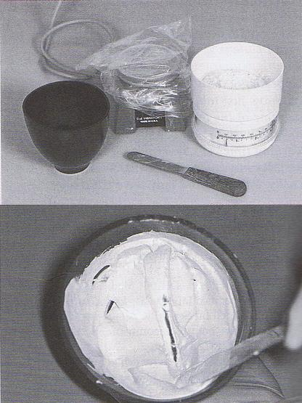

**Setting time**

Setting time is the time from the beginning of mixing the powder with water until the material hardens.

**Mixing time:** is the time from the addition the powder to the water until mixing is complete.

**Working time**: is the time available to make a workable mix.

**Initial setting time:** As thereaction proceeds, however, more hemihydrates crystals react to form dihydrate crystals . the viscosity of the mass is increased, and it can no longer be poured .The material becomes rigid (but not hard).It can carved but not moulded.

**Final setting time** :the time at which the material can be separated from the impression with out distortion or fracture.

**Measurement of setting time:**

1. **Loss of gloss method** :As reaction proceeds, the gloss disappears from the surface of the plaster mix (sometimes used to indicate initial set).
2. **Exothermic reaction**: The temperature rise of the mass may also be used for measurement of setting time,as the setting reaction is exo thermic.
3. **Penetration tests**: By using penetrometers .(Vicat needle(A), Gillmore needles(B)

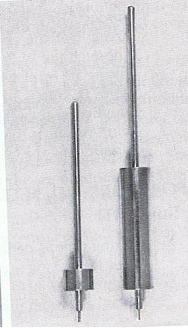 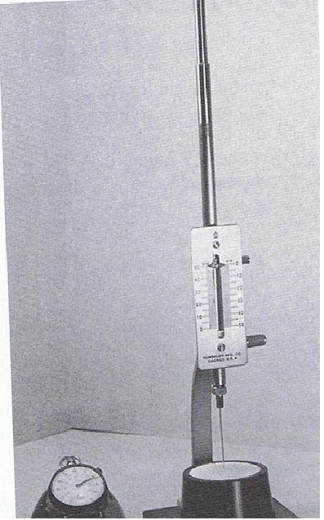

(B) (A)

**Factors effecting the setting time**

1. **W/P ratio:** the more water is used for mixing the fewer nuclei they will be per unit volume consequently the setting will be prolonged.
2. **Fineness:** the finer the particle size of the hemihydrate the faster the mix will harden. The rate of solution of the hemihydrate will be increased, also the gypsum nuclei will be more numerous and therefore a more rapid rate of crystallization will accur.
3. **Mixing:** the longer the plaster is mixed, the shorter is the setting time. When the powder is brought into contact with water some gypsum crystals will be formed as mixing begins more particles will be exposed to water and thus form more crystals at the same time the crystals are broken up by mixing and they are distributed through out the mixture and result in the formation more nuclei for crystallization thus the setting time is decreased.

**Effect of Water/Powder Ratio (W/P) and Mixing Time on the Setting Time of Plaster of Paris**

**W/P Ratio Mixing Time (min) Setting Time (min)**

**0.45 0.5 5.25**

**0.45 1.0 3.25**

**0.60 1.0 7.25**

**0.60 2.0 4.50**

**0.80 1.0 10.50**

**0.80 2.0 7.75**

**0.80 3.0 5.75**

1. **Temperature:** there is little change in the setting time between 0-50C but if the temp. exceeds 50C the setting time will be retarded. As the temp. approaches 100 C no setting will take place.
2. **Impurities:** if the manufactures add gypsum the setting time will be shortened because of the increase in the potential nuclei for crystallization.
3. **Retarders and acceleraters:** the addition of accelerators and retarders are the most effective and practical for control of the setting time.

**Retarder:** is the chemical material added to gypsum product to increase the setting time. ex. glue borax and gum Arabic. It will reduce the dissolution of hemihydrates and might deposit on the nuclei of crystallization and effectively reduce the rate of crystallization so retard the setting time.

**Accelerator:** is the chemical material added to gypsum product to decrease the setting time. ex. Sodium chloride and potassium sulfate in certain concentration. These salts increase the rate of dissolution of hemihydrates and thus the saturation of the solution occur more rapidly and the gypsum formation.