2. Rigid impression material (Impression compound)
It is described as:
1- A rigid, muco-compressive impression material.
2- Reversible impression material which set by physical change.
3-Thermoplastic material (it softens when heated and on cooling it hardens).
4-Making impression of edentulous mouth (primary impression).
- Presentation: present as sheets, sticks, cakes and cones.

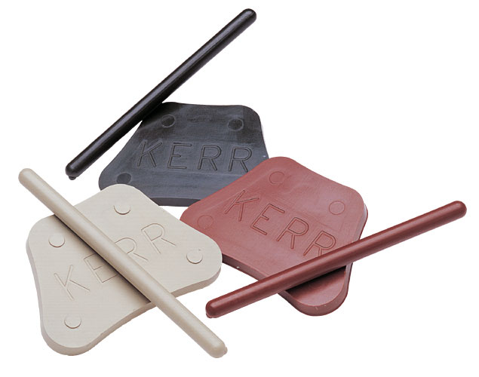
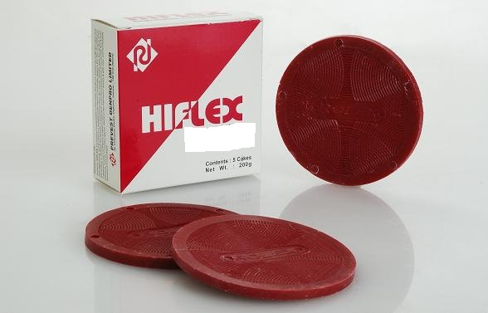

- Composition: in general impression compound is a mixture of:
- Waxes: usually bees wax. This material is brittle and must be soften to be workable (thermoplastic properties).
- Resin: like (shellac, dammar, Rosen) give the thermoplastic properties.
(If resin and waxes are used on their own, tend to produce brittle material with tendency towards tackiness.
- Plasticizers: (Stearic acid) added to overcome brittleness.
- Filler:(calcium carbonate and limestone) added to:
- Overcome tackiness.
- Control degree of flow.
- Minimize shrinkage due to thermal contraction.
- Improve rigidity of impression material.
- Types of impression compound
- Type I impression compound (lower fusing): supplied in sheets, sticks form or cones.
- Sheet form material used to take primary impression for edentulous ridges using stock tray, softened using water bath (55-60) C (found to be ideal for manipulation with fingers in order to obtain plasticity throughout the impression compound). Storage in water should not be so long to prevent leaching out of important constituents such as stearic acid over heating make the compound sticky and difficult to handle.
- Stick form material used for border molding of an acrylic special tray during fitting of the special tray, it's softened over flam. The compound should not allowed boiling, otherwise the plasticizer are volatilized.
- Type II tray compound (higher fusing): it is stiffer and has less flow than regular impression compound. Used to make a special tray (now largely replaced by acrylic tray) into which another impression material is placed in complete edentulous arches.
- The different in fusing temperature between type I and type II reflects a difference in the composition of thermoplastic compound of each (waxes and resins).

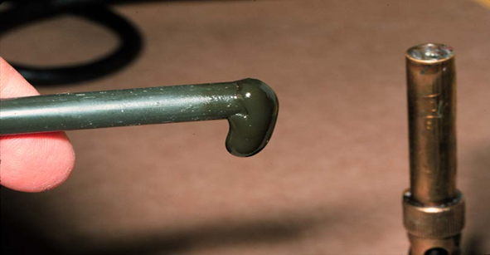

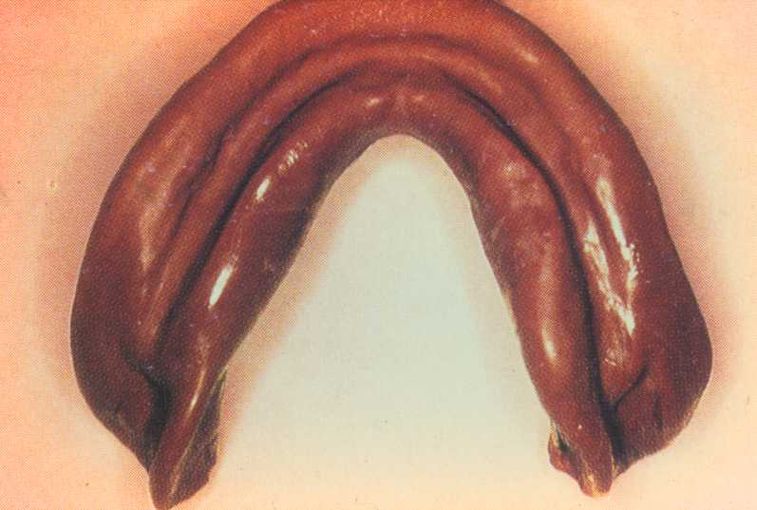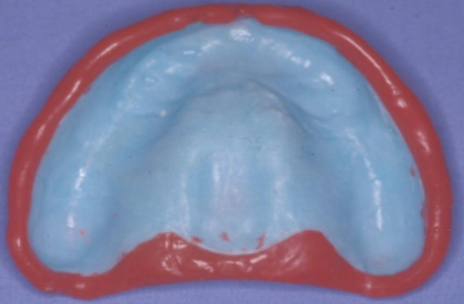

- USES:
- For making a primary impression for edentulous ridges.
- Border molding of special tray.
- Make a special tray.
- Properties:
- It is muco-compressive and it is the most viscous impression materials used (high viscous), therefore the reproduction of surface details is not very good. However, the reproduction can be improved by reheating the surface of the impression material after tacking the first impression and then reseated it in the patient's mouth even this is not good as the other impression materials.
- Rigid once cooled not used to record undercuts (used for primary impression only).
- Poor dimensional stability, the material has high value of coefficient of thermal expansion and undergoes considerable shrinkage on removal from mouth. also because pressure is applied during formation of an impression (muco-compressive) residual stress exists in cool impression the gradual relief of internal stresses may cause distortion of impression(the mould should be poured as soon as possible within 1 hour).
- Low thermal conductivity so it needs thorough heating and a water bath is preferred to soften the impression compound. We should wait for certain time in order that all the material is softened and when we introduce it into the patient mouth we should wait enough time till the outer and the inner portion of the compound is hard before we can remove it from patient mouth.
- It is a physical reaction not chemical reaction so the impression compound can be reused a number of times (for the same patient) in case of error; inaccurate portions can be remade without having to remake the entire impression.

- Advantages:
- Compatible with model material and not need separating medium before pouring the plaster.
- Can be reused a number of times.
- Not need special tray.

- Disadvantages:
- The handling of dental impression material is very technique sensitive. (if it is not prepared properly not softening enough, volatiles can be lost on heating or low molecular weight ingredient can be lost during long immersion in a water bath)
- High coefficient of thermal expansion leading to dimensional changes.
- Muco-compressive material (cause displacement to the soft tissue).
- Low detail reproduction. High viscous, low flow.
- Rigid once set so cannot be used in undercut area.
- Must be poured within one hour.
3. Zinc oxide eugenol impression material:
It's described as a rigid, mucostatic impression material, irreversible impression material which set by chemical reaction. The combination of zinc oxide and eugenol is widely used in dentistry.
- General uses of zinc oxid –eugenol
- Final impression for edentulous arches.
- Occlusal bite registration.
- Temporary relining material for dentures.
- Temporary filling.
- Surgical pack in periodontal surgical procedure.
- Root canal filling.
- Cementation and insulating medium.
- Uses of zinc oxide –eugenol impression material:
- Final impression for edentulous arches.
- Occlusal bite registration.

- Types of Zinc oxide eugenol impression material
- Type I hard.
- Type II soft.

- Presentation:
The impression material is in the form of two pastes (2 tubes):
- Base paste (white color).
- Reactor or accelerator or catalyst paste (red in color).

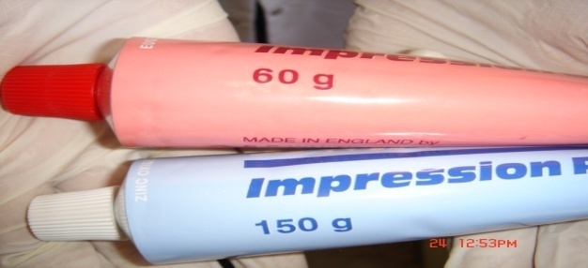
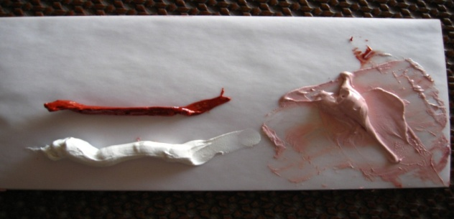
- Composition:
Base paste:
- zinc oxide 87 %.( reactive component take part in setting reaction).
-fixed vegetable or mineral oil 13 %.( act as plasticizer).
-water.
Reactor paste:
-oil of cloves or eugenol 12 %.( reactive component).
-gum or polymerized rosin 50%. (Speed the reaction).
-filler (silica type). 20%
-resinous balsam 10 %.( improve flow and mixing properties).
-lanolin 3%
-accelerator solution CaCl2 and coloring agent 5%.
-water.
- chemical reaction
Zinc oxide +eugenol H2O zinc eugenolate +zinc oxide (unreacted)
The set material consists of a mixture of amorphous zinc eugenolate matrix which holds unreacted zinc oxide particles together.

- Manipulation
Two strips of equal length are squeezed from each tube (base and catalyst) on glass slab or paper pad mixed (mixing time=1 min.) until a uniform color is observed. Then the mixture is filled into fitted special tray. No separating medium is needed before the stone model is pour, and after the stone has set it can be separated from the impression by immersion in hot water (50-60) C for 5 to 10 minutes.
- Properties
- Setting time
- Type I: Initial setting time= (3-6) Min., final setting time=10 Min.
- Type II: Initial setting time= (3-6) Min., final setting time=15 Min.
Factor controlling the setting time:
- By varying the length of the two pastes (not recommended).
- Setting time can be decreased by adding zinc acetate or acetic acid or drop of water.
- Longing the mixing time, short is the setting time.
- High atmospheric temperature and humidity accelerated the setting time.
- Setting time can be delayed by cooling the mixing slab, spatula or by adding small amounts of waxes or oils.
- Accurate registration for surface details due to good flow. The material has mucostatic properties (recording tissue in uncompressed state).
- Rigid non elastic once set and should not be used for partially edentulous arches, or undercut areas it's fractured when removed from undercut area.
- It requires a special tray for impression making.
- It has adequate adhesion to acrylic tray (no need adhesive material).
- It has advantages of being dimensionally stable, a negligible shrinkage (less than 0.1 %) may occur during hardening.
- No separating medium is needed before the stone model is poured because it does not stick to the cast material.
- The paste tends to adhere to skin, so the skin around the lips and the cheek should be protected with petroleum jelly (Vaseline) to make the cleaning process much easier.
- Although the material not toxic, Eugenol can cause burning sensation and tissue irritation.
- It can be checked in mouth repeatedly without deformation.

- Advantage
- Good adapted to the soft tissues without causing displacement of the soft tissue (mucostatic), so it has good reproduction of surface detail.
- Good dimensional stability.
- Well Adhere to the special tray (no need for adhesive).
- Inexpensive.
- Not need separating medium before the stone model is pour.
- It can be checked in the mouth repeatedly without deformation.
- Minor defects can be corrected locally.
- It has enough working time to complete border molding.
- Pour any time.

- Disadvantage
- Messiness
- Non elastic and may fracture if undercuts present.
- Variable setting time due to temperature and humidity.
- May irritate to soft tissue due to the eugenol.
- It need special tray.
- The skin around the lips and the cheek should be protected with petroleum jelly (Vaseline).

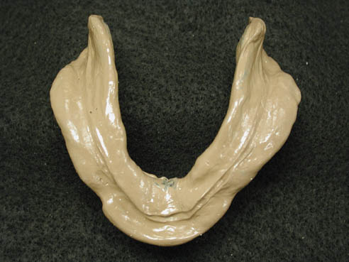

4. Impression waxes:
Impression waxes are rarely used to record complete impression but are used to. These material consist from a mixture of low melting paraffin and bees waxes in ratio about 3:1. Waxes have high and larger coefficient of thermal expansion. So it will distort when removed from undercut area. It's used in ranging consistencies soft, medium, hard and extra hard.

