Etiology of malocclusion

Classification of etiological factors
The final form of the occlusion and position of the teeth exhibits a wide range of variation. The main factors responsible for producing this variation can be divided into two groups:
- The general factors which have general effect on the occlusion and play a part in the development of every occlusion.
- The local factors which do not necessarily appear in everyone but they may be the main cause in producing a malocclusion in an individual.

General factors affecting occlusal development:
- Skeletal factors: the size, shape and relative positions of the upper and lower jaws.
- Muscle factors: the form and function of the muscles which surround the teeth, i.e. the muscles of the lips, cheeks and tongue.
- Dental factors: the size of the dentition in relation to the size of the dental arches.

Skeletal factors:
Excluding any pathological condition, the teeth are supported by the alveolar bone, which in turn is based on the basal bone of the jaws, therefore jaw bone can be subdivided into alveolar bone and basal bone, although both of them are belonged to the same bone.

As the teeth are set in the jaws, the relationship of the jaws to each other will influence the relationship of the dental arches. Jaw relationship can be considered as:
- Jaws in relation to the cranial base:
Jaws are part of the head therefore each jaw may vary in its positional relationship to other structures of the head. Such variation can occur in sagittal, lateral and vertical planes. In orthodontic diagnosis it is usual to relate the position of upper and lower jaws to the anterior cranial base and each jaw can vary independently in its relation to the cranial base.
- Jaws in relation to each other:
The relationship of the jaws to each other can also vary in sagittal, lateral and vertical planes, and variation in any plane can affect the occlusion of the teeth.
The sagittal or antero-posterior relationship of the upper and lower jaws to each other called the skeletal relationship or skeletal pattern which can be:
Skeletal class I: in which the jaws are in ideal antero-posterior relationship in occlusion.
Skeletal class II: in which the lower jaw in occlusion is positioned further back in relation to the upper jaw.
Skeletal class III: in which the lower jaw in occlusion is positioned further forward in relation to the upper jaw.

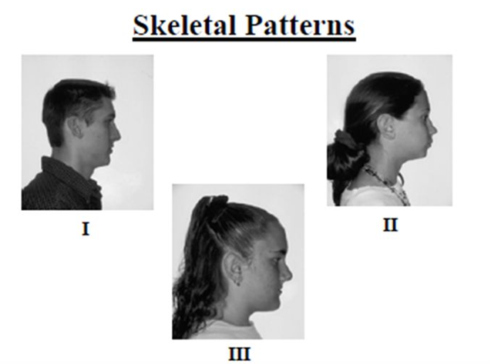

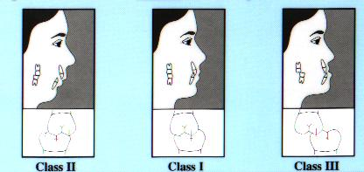

- Variation in the skeletal relationship results from:
  - Variation in the size and position of the jaw: In the sagittal plane if one jaw is excessively small or large in relation to the other in antero-posterior dimension the development of skeletal class II or class III relationship may result.

Also if one jaw is set further back or further forward than the other in relation to the cranial base, again skeletal class II or class III relationship may result.
In lateral plane, if the jaws match in size then the occlusion of buccal teeth in transverse relation is correct. However, if one jaw is wider than the other it may result in buccal cross bite, when lower jaw wider, or scissor bite, when the upper jaw is wider.
In the vertical plane, the effect is mostly seen with the variation in the shape of the lower jaw at the gonial angle. When this angle increased the vertical dimension of the face increased and vice versa.

- Alveolar bone in relation to basal bone: although the alveolar bone is supported by the basal bone, the relationship between the upper and lower bones is not necessarily the same as that between the upper and lower basal bones. The alveolar bone supports the teeth and will therefore match tooth position rather than basal bone position.

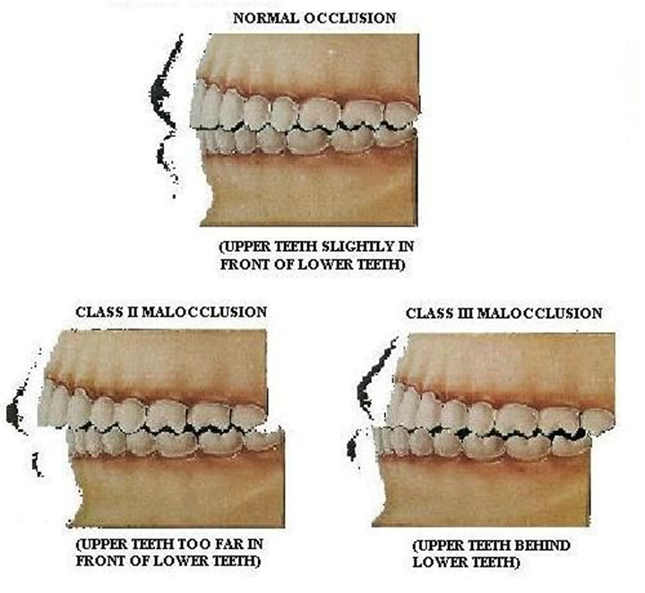
Antero-posterior skeletal relationship

Soft tissue factors:
The teeth erupt into an environment of functional activity governed by the muscles of face, mastication and tongue. The muscles of tongue, lips and cheeks are of particular importance in guiding the teeth into their final position and variation in muscle form and function can affect the position and occlusion of the teeth. All muscles exert their influence by their sites of origin and insertion. Since the origins of these muscles are mainly on the basal bone therefore the position of the jaws must affect the position and action of the muscles which function on the teeth.

- The lips: the several muscles of the lip work as one functional unit; their effect on occlusion development depends on their form, size and function.
Vertical relationship: In the ideal lip form the lips meet together at rest position this condition called lip competence, if the lips do not meet in rest position a condition due to short upper lip and lips seal achieved only by active contraction of the orbicularis oris and mentalis muscles called lip incompetence sometimes lip seal is prevented due to malocclusion for example the protruding maxillary incisors despite normally developed lips called potentially competent lips.

Competent lips
Potentially competent lips
Incompetent lips

Lips are usually brought together during swallowing and speech movements. If they are of sufficient size to be together at rest then lip closure will not place extra force on the teeth. If the lips at rest are apart, then muscular contraction will be required to bring them together during swallowing and speech, which in turn will impose extra forces on the erupting teeth. The effect of these forces on the erupting teeth depends on the sagittal relationship of the lips.

The sagittal relationship: it is determined by the relationship of the basal bone of the jaw to which they are attached. For example the lower lip tends to be further back in class II and further forward in class III, which increase the difficulty to put the lips together and may cause the lower lip to modify the eruptive path of the incisors.
- In skeletal class II the lower lip may function completely or partially behind the upper incisors. For example
  - In not severe case the lower lip may procline the upper incisors resulting in more severe class II than skeletal relationship.
  - In more sever skeletal discrepancy the lower lip may function behind the upper incisors without causing them to be proclined.
- In other skeletal class II the lower lip function entirely in front of upper incisors causing them to be retroclined into the class II division 2 incisor relationship.

- The lower lip may cause retroclination of the lower incisors during swallowing, speech or smiling activities.
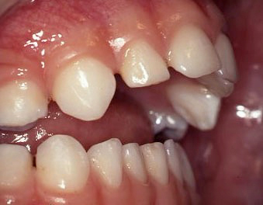

Lip line:
The level at which the lips meet together in normal function. The ideal lip line is approximately at the center of the crowns of the upper incisors with the lower lip in front of the upper incisors. If it is low part of the lower lip may function behind the upper incisors causing proclination, if it is completely behind upper incisors there will be no lip line as in class II. It is high in class II division 2 causing retroclination of upper incisors.

