C.V
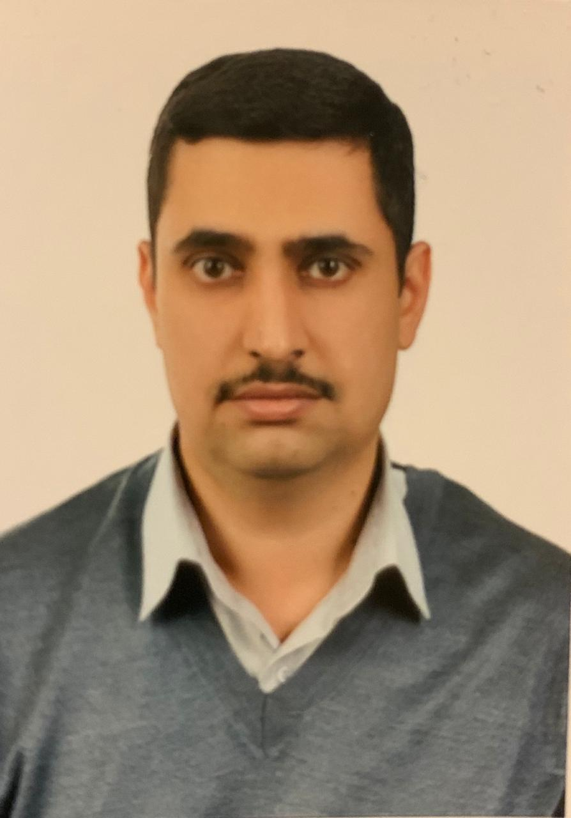

Photo

Name: Omar Shebli Mohammed Ali
Date of Birth: 1981
Religion: Muslim
Martial statues: Married
No. of children: One
Specialization: Oral medicine and oral pathology
Position: Teaching staff
Scientific Degree: Lecturer
Work Address: Collage of Dentistry
Work Phone:
Mobile:
E-mail: omarshebli@codental.uobaghdad.edu.iq

- First, Scientific Certification:

Date | College | University | Degree science
2004 | Dentistry | Baghdad University | B.Sc.
2009 | Dentistry | Jordanian Science and technology | M.Sc.
 |  |  | Ph.D.
 |  |  | Any other
From -To | Workplace | Career | No.
2010-2014 | Collage of Dentistry/ Baghdad university | Assistant lecturer | 1
2014- | Collage of Dentistry/ Baghdad university | Lecturer | 2
 |  |  | 3
 |  |  | 4
 |  |  | 5
 |  |  | 6
- Second, Career:

- Third, University Teaching.
From -To | The (Institute / College) | University | No.
2010- | Collage of Dentistry/ Baghdad university | Teaching staff | 1
 |  |  | 2
 |  |  | 3
 |  |  | 4
 |  |  | 5
 |  |  | 6
 |  |  | 7

- Fourth, Courses Which You Teach:

Year | Subject | Department | No.
2010-2015 | Oral medicine | Oral Diagnosis | 1
2015- | Oral Pathology | Oral Diagnosis | 2
 |  |  | 3
 |  |  | 4
 |  |  | 5
 |  |  | 6
 |  |  | 7
 |  |  | 8
 |  |  | 9

- Fifth, Thesis which was supervised by :

Year | Department | Thesis Title | No.
 |  |  | 1
 |  |  | 2
 |  |  | 3
 |  |  | 4
 |  |  | 5
 |  |  | 6
 |  |  | 7

- Sixth, Conferences which you participated:
Type of Participation | Place | Year | Conferences Title | No.  ( بحث / بوستر حضور)
Lecturer | Al-Bayan University | 2017 | Oral Cancer | 1
Lecturer | Darb Al-Moussawi | 2016 | Medical City conference | 2
Attendance | Darb Al-Moussawi | 2015 | Medical City conference | 3
Attendance | Early Cancer detection center | 2015 | Early cancer detection | 4
Attendance | Darb Al-Moussawi | 2014 | Collages of dentistry Conference | 5
Lecturer /Attendance | Collage of Dentistry | 2010-2018 | Continuous education | 6
 |  |  |  | 7

- Seventh, Scientific Activities:
Outside the College | Within the College

- Eighth, Research Projects in The Felid of Specialization to The Environment and Society or the Development of Education:
No. | Research Title | Place of Publication | Year
1
2
- Ninth, Membership:

- Tenth, Awards and Certificates of Appreciation:

Year | Donor | Name of Awards and Certificates | No.
 |  |  | 1
 |  |  | 2
 |  |  | 3
 |  |  | 4
 |  |  | 5
 |  |  | 6

- Eleventh, Scientific literature:

Year of The Publication | Scientific Literature Title | No.
2010 | Oral Candida flora in a group of Jordanian patients with β-thalassemia major  AM Hazza'a, AMG Darwazeh, OSM Museedi  Oral Surgery, Oral Medicine, Oral Pathology, Oral Radiology, and … | 1
2014 | Oral cancer trends in Iraq from 2000 to 2008  OS Museedi, WH Younis  The Saudi Journal for Dental Research 5 (1), 41-47 | 2
2014 | Oral cancer awareness among group of general dental practitioners in Iraq  OS Museedi  Journal of Baghdad College of Dentistry 325 (2212), 1-4 | 3
2016 | Retrospective analysis of 1286 oral and maxillofacial biopsied lesions of Iraqi children over a 30 years period  BH Abdullah, OAJA Qader, OS Mussedi  Pediatric dental journal 26 (1), 16-20 | 4

- Twelfth, languages:
- Arabic
- English

*Note: - Make a copy on CD.

