Oral Histology
Lec.4 Dr. Nada AL.Ghaban
Dentine development (Dentinogenesis)
Essential epithelial/mesenchymal interactions occur in the developing tooth germ to enable dentine formation start. Dentine formation, like bone and cementum, is a two-phase process, commencing with the secretion of an extracellular connective tissue matrix and its subsequent mineralization. It continues throughout life. The tissue that is produced shows regional variations in structure and well-defined age changes. Dentine formation begins when the tooth germ has reached the bell stage of development. The dentine-forming cells, the odontoblasts, differentiate from the peripheral cells of the underlying dental papilla and are of neural crest origin.
Dentine formation begins, as with enamel, in the region of the cusp (or incisal margin) of the tooth and gradually extends down the slopes of the crown to the cervical margin.
Following crown completion, root dentine then forms as the epithelial root sheath (of Hertwig) extends apically and odontoblasts differentiate from the adjacent dental papilla. Dentin formation continues throughout the life of the tooth, and its formation results in a gradual but progressive reduction in the size of the pulp cavity.
Odontoblasts Differentiation:-
The differentiation of odontoblasts from the dental papilla in normal development is brought about by the expression of signaling molecules and growth factors in the cells of the inner enamel epithelium illustrate the differentiation sequence. The dental papilla cells are small and undifferentiated, and they exhibit a central nucleus and few organelles. At this time they are separated from the inner enamel epithelium by cell free zone that contains some fine collagen fibrils. Almost immediately after cells of the inner enamel epithelium reverse polarity, changes also occur in the adjacent dental papilla.
The ectomesenchymal cells adjoining this zone rapidly enlarge and elongate to become preodontoblasts first and then odontoblasts as their cytoplasm increases in volume to contain increasing amounts of protein-synthesizing organelles. Then this zone gradually is eliminated as the odontoblasts differentiate and increase in size and occupy this zone. These newly differentiated cells are characterized by being highly polarized(40 µm in length and 7 µm in width ), with their nuclei positioned away from the inner enamel epithelium. Thus the dental papilla is the formative organ of dentin and eventually becomes the pulp of the tooth, a change in terminology generally associated with the moment dentin formation begins.
Dentinogenesis occur by odontoblasts in two stages:
1-Formation of dentin matrix( predentin):
The first sign of dentin formation is the appearance of large-diameter collagen fibrils (0.1 to 0.2 mm in diameter) called von Korff’s fibers which formed by newly differentiated odontoblasts . These fibers consist of collagen type III associated with fibronectin. These fibers originate deep among the odontoblasts , and fan out immediately below the IEE cells. As the odontoblasts continue to increase in size, they also produce smaller collagen type I fibrils that orient themselves parallel to the future dentinoenamel junction .The odontoblasts form the main components of the predentin , the collagen fibers and non-collagenous protein.
The main non-collagenous proteins in the predentin are:
1. Bone morphogenic proteis (BMP 2,4 ,7), 2. Dentin phosphoprotein (DPP)
3. Osteocalcin, Osteonectin and Osteopontin , 4. Dentin sialoproteins (DSP).
DPP and DSP represent the major non-collagenous protein in D. because they are important for organization and mineralization of predentin .
Coincident with this deposition of predentin, the odontoblast develops a cell process, the odontoblast process or Tomes’ fiber, which is left behind in the forming dentin matrix as the odontoblast moves away toward the pulp. 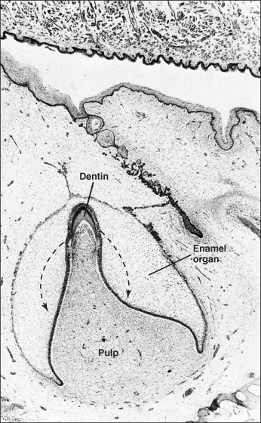 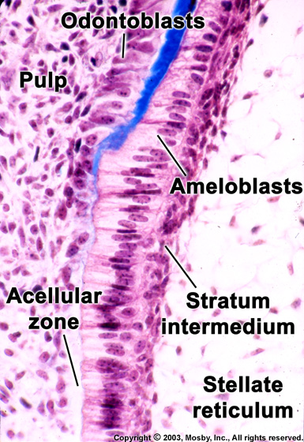
2-Mineralization of the predentin
It occurs parallel to predentin formation. It begins at the tip of the crown and then it proceeds in a rhythmic pattern to gradually complete cervically.
Mineralization of dentine begins when the predentine is approximately 5 µm thick. Spherical zones of hydroxyapatite called calcospherites are formed within the predentine. Mineralization of the dentine matrix starts at random points and eventually these calcospherites fuse together to form mineralized dentine.
Dentinal tubules will form around each odontoblastic process. The first layer of predentin begins its mineralization called primary Mantle dentin is formed in a layer approximately 15 to 20 mm thick onto which then is added the primary Circumpulpal dentin.
Pattern of mineralization in dentin:
Histologically, two patterns of dentin mineralization can be observed during dentinogenesis globular and linear mineralization that seem to depend on the rate of dentin formation.
Globular (or calcospheric) calcification involves the deposition of crystals in several discrete areas of predentin. Mantle dentin mineralization occur in a globular pattern ,where small centers of calcification spread concentrically until they fuse together as calcospherites . This mineralization occur by budds off small matrix vesicles (an electron microscopical budding in cell membrane of odontoblasts contain the first hydroxyapatite crystals and alkaline phosphatase enzyme) which lie superficially near the basement membrane. Mineral phase first appears within the matrix vesicles as single hydroxyapatite crystals. Crystals grow and rupture of matrix vesicle occur and fuse of crystals with adjacent crystals to form a continuous layer of mineralized dentin matrix.
The mineralization goes then in linear or occasionally globular pattern in the remnant or bulk thickness of dentin which is called circumpulpal dentin. The mineralization begins by crystal deposition in form of fine plates of hydroxyapatite crystals on the surface of the collagen fibrils. The long axes of the crystals are paralleling to the collagen fibrils.
If somewhere those globules do not fuse together, areas of uncalcified dentin are known as interglobular dentin.
Root dentin:-
Forms at a slightly later stage of development and requires the proliferation of epithelial cells (Hertwig’s epithelial root sheath) from the cervical loop of the enamel organ to initiate the differentiation of root odontoblasts.
Root dentin form similarly to coronal dentin, but some differences have been reported. The mantle dentin in the root, shows differences in collagen fiber orientation and organization, in part because the collagen fibers from cementum blend with those of dentin .Also it forms at a slower speed, and its degree of mineralization less than that of coronal dentin.
The onset of root formation precedes the onset of tooth eruption, and when the tooth reaches its functional position, about 2/3 of the root dentin will have been formed. Completion of root dentin occur in the deciduous tooth until about 18 months after it erupts and in the permanent tooth until 2 to 3 years after it erupts.

Clinical considerations:
Disturbances in either the secretion of dentin matrix or maturation of this matrix can lead to defects in dentin structure, and as a consequence to the supportive function of dentin. Three different types of inherited defects in dentin matrix are classed under the term dentinogenesis imperfecta. In these individuals, the crowns are found to have a bulbous contour and the pulp chambers become obliterated by poor quality dentin. Clinically, this results in a bluish or brownish cast to the teeth, and shortly after eruption the enamel fractures away leaving the soft inner core of dentin exposed.

