Radiology
Lec 1. Fundamentals of radiography د. اريـج
Introduction
- Radiology is the science that deals with diagnosis , therapeutic and researches application of high energy radiation.
- Dental radiography is a process of production an image for an object through the use of x – radiation.
- Dental radiograph help the dentist to examine the internal tissues like (roots of teeth and alveolar bone) which cannot be seen by the naked eye due to over lying soft tissues.
- X – Ray was discovered by (Roentgen) in 1895, it travels in a form of pure energy and the basic unit is x – ray photon or (quantum).
- X – Ray photons travel with a wave motion called (sine – wave) and the distance between the crests of these waves called (wave – length) which measured by a unit (A˚). The X – ray photons wave length used in diagnostic radiography is ranged between 0.1 – 0.5 A˚ , and the amount of energy contained in each photon called (photon energy) which depend on :
1.Wave length
2.Frequency of x – ray
The high frequency of X – ray the shorter wave length photons this shorter wave length photon has more energy than a low frequency long wave length type of X – ray photons.
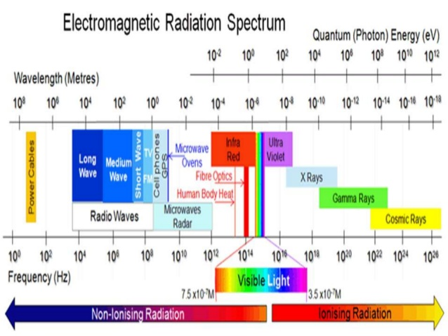
Fig 1. Electromagnetic radiation spectrum
Similarities between x – ray and light
1. Both belong to the same electro – magnetic radiation family.
2. Both travel in straight lines at the same speed which is 186,000 miles per seconds.
3. Both affected the photographic films and made them black.
4. Both not affected by magnetic fields
5. X – ray and light cast the shadows of the objects in the same manner
Differences
1. X – ray has the ability to penetrate objects that the light cannot pass through
2. X– ray has the ability to ionize atoms
3. X – ray has the ability to produce light (blue light) when it hits some objects and this phenomena called (fluorescence).
4. X – ray is invisible

Components of X – ray machine
A dental X– ray machine is used to generate X – ray, this machine composed of:-
1. Step up transformer :- it consist of 2 coils of electrical wire and it used to increase the incoming voltage from 240 Volts to 60 kilovolt or more.
2. Step down transformer :- it used to decrease the incoming voltage to around 10 Volts in order to supply the filament circuit of X – ray tube with low voltage.
3. Autotransformer :- this is made from one coil to do the work of 2 coils. It can be used for making minor change in the voltage.
4. Rheostat :- is a device used to increase the resistance to the passage of electrical current through the wire it reduce the amount of electrical current used in X – ray machine through the circuit to about 10 – 15 milliamper (mA).
5. Timer :- it cause activation of high tension current across the tube and this happened when the timer bottom is pressed.
6. Ammeter and voltmeter :- these two are the same type of instrument since both are operated by magnetic field.

7. X–ray tube :- it consist of external and internal structures. The external structure including the support structure, the protective housing and the glass enclosure, while the internal structures are the anode and cathode.
The x-ray tube should be a vacuum tube so that the electrons are free to travel inside the tube without interaction with air molecules. The glass of the tube is leaded to prevent (the generated X – ray) from escaping in all directions. While the window is of unleaded glass so that X – ray exist out through this window.

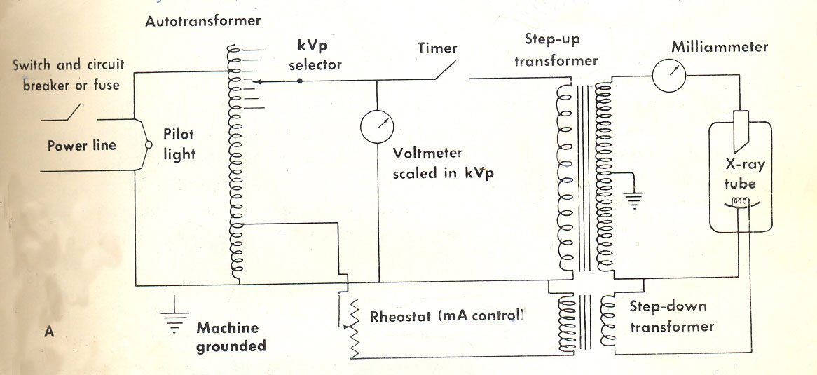
Fig 2. Diagram of X-ray machine showing the components and electrical circuit.

X – ray tube consists of 2 ends:-
- (-ve) electrode (cathode) end.
- (+ve) electrode (anode) end.
Cathode end:-
It consist of focusing cup made of molybdenum in which a tungsten filament is set, this filament is the source of electrons that are used to generate X – ray.
Anode end:-
It consist of thin tungsten button set in a rod of copper , this rod surrounded by an oil bath which used to absorb heat that created during generation of X– ray.
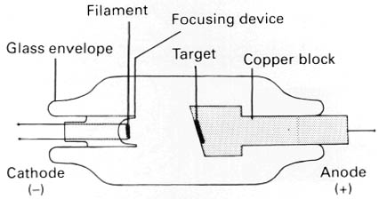
Fig. 3 Diagram of a simple X-ray tube showing the main components.

Generation of X – ray
X – ray photons generated at the surface and within the tungsten button (target) of the anode by bombardment of anode with electrons coming from cathode when the filament is heated electrically.
The speed of these electrons depend on the potential difference (kV) between cathode and anode of the tube.
Electrons impact on (a rectangular area) at the surface of tungsten button of the anode called (focal spot)
The kinetic energy of these electrons will converted to X – radiation and heat in fact there is only 0.2% of this energy will converted to X – ray while the remaining energy goes in form of heat this heat will dissipated with the aid of radiator that attach to the anode.
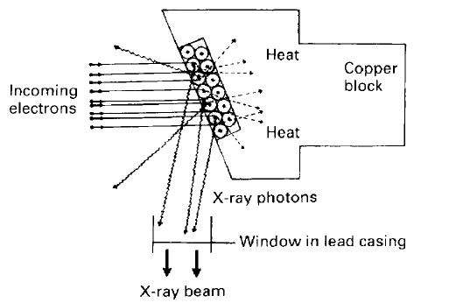
Fig. 4 Diagram of the anode enlarged, showing the target and summarizing the interactions at the target.
Selection of target material
Ideal target material must possess the following qualities:-
- It should have high thermal conductivity
- It should have high atomic number
- It should have high melting point
- It should have low vapor pressure
(Tungsten with copper rods is ideal because copper has high thermal conductivity.)
Focal spot : - it’s a small area on the tungsten surface (target) on which electrons come from cathode are impacted and X – ray photons are produced. Therefore useful X – ray beam emerges from this spot the rectangular focal spot called (actual focal spot) while the projection of this spot when viewed from any point with the X – ray beam appears more or less like a square this square projection called (effective focal spot).
In diagnostic radiography the use of rectangular focal spot which is projected as a square called (Benosn Line focus principle) this will obtained by setting the surface of the target at an appropriate angle (15 – 20)˚ to the cathode.
This principle help to get these benefits:-
1. X – Ray generated over large surface area on the target.
2. Larger actual focal spot for better dissipation of heat.
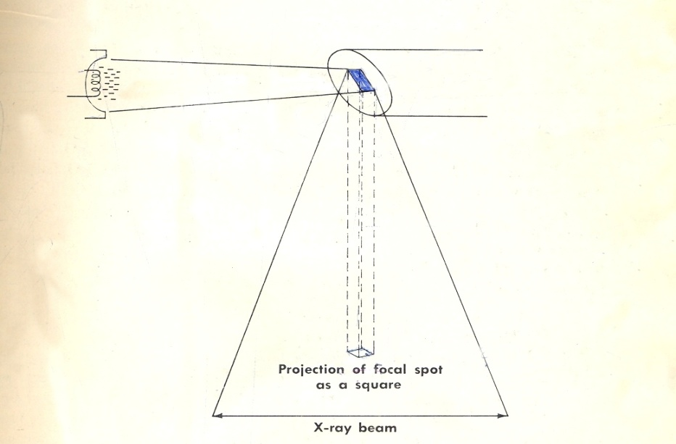
Fig. 5 Actual and effective focal spot

