Radiology
Lec. 3 X – Ray Films د. اريج
Radiograph: Is the image of an object made with use of X- ray instead of light.
Dental x- ray film: Is a recording media on which image of the object was made by exposing this film to X- ray.
Types of X- ray film
a- Intra oral X- ray film.
b- Extra oral X- ray film.

a- Intra oral X- ray film
Chemical composition of X- ray film:
It consist of a sensitized emulsion present on both sides of transparent base.
The base is the foundation of the radiographic film , made from cellulose acetate. Its primary purpose is to provide a rigid structure onto which the emulsion can be coated. Its flexible and fracture resistant to allow easy handling but rigid enough to be placed on the viewer.
The emulsion is the heart of the x-ray film , it’s the material with which the x-ray or light photons interact and forming the image. It consists of homogenous mixture of silver halides crystals (mainly silver bromides) suspended in gelatin. The silver bromide crystals are sensitive to both light and X- ray photons.
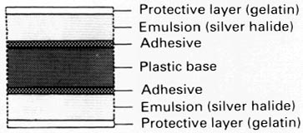
Fig. 1: Diagram showing the cross-sectional structure of double emulsion radiographic film.

The intra oral film is wrapped by opaque material to prevent light from reaching the film because light photons can activate the silver halides crystals. Also a thin sheet of (Lead foil) is usually placed behind the film to prevent most of secondary radiation that originated in the tissue of the patient behind the film from reaching it.
Therefore this lead foil reduces secondary radiation and minimizes film fog. In addition the lead foil absorbs X- ray that have passed through the object and the film so it reduce the exposure of the tissue behind the film. This foil has a design of (herring bone pattern).
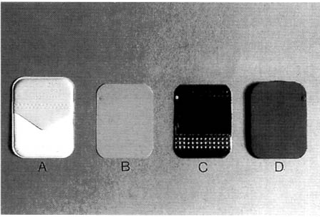
Fig. 2: The contents of a film packet. A The outer wrapper. B The film. C The sheet of lead foil. D The protective black paper.

Intra oral film types
Classified on numerical basis into:
A - Type I
Called periapical film used to examine the apical area of the tooth and the surrounding structures . The size of this type include (1.00, 1.0, 1.1 and 1.2).
B – Type II
Is called bitewing film it used to detect the inter proximal caries and the height of alveolar bone between 2 adjacent teeth.
The size include (2.00, 2.0, 2.1, 2.2 and 2.3)
C – Type III
Is called occlusal film that used to demonstrate area larger in dimension than area appearing in periapical film.
The size is (3.4) only.

Intra oral film speed
Speed means the sensitivity of X- ray film silver bromide crystals (Ag Br) to X- ray photon.
There is direct relation between the speed of the film and the size of the crystals, the larger crystal size the faster film speed. the faster mean it need less amount of radiation to produce radiographic image so less radiation dose absorbed by patient
The classification of film speed based on alphabetical basis so from A to F, film speed A is the slowest while speed F is the faster one.

b- Extra oral film
The purpose of using such film is to make a radiographic image able to examine an area in and around the jaw that can't be seen by intra oral film.
Types of extra oral film
- Screen
- Non screen

  - Non screen film
- Film emulsion is more sensitive to X- ray than to light.
- The film has double emulsion like intra oral film but the emulsion is thicker.
- Increased thickness of emulsion make the non screen film need less amount of radiation so it need less exposure time.
- The size of the film used include: 5×7 and 8×10 inches.

  - Screen film
- Film emulsion is more sensitive to visible light and more specifically to blue light in the visible light spectrum.
- The size include: - 5×7, 8×10 and 10×12 inches.
- Screen film has 3 types:- slow or detail screen, medium or par – speed screen and fast or high – speed screen.
  - The screen film placed between 2 fluorescent screen in cassette. These 2 fluorescent screen made from (tiny calcium tungestate crystals). When these crystals exposed to X- Ray , the result of this exposure is a creation of light , this light in turn exposes the screen film to produce the image.

Size of Image Receptors
- Cephalometric and Skull views 20x25 cm (8x10 inches)
- Lateral Oblique views 13x18 cm (5x7 inches)
- Panoramic views 12.7x30.5 cm (5x12 inches) or 15x30 cm (6x12 inches)

Film properties
These include density, contrast and details or definition.
- Density: Is the degree of blackness present in the processed film it measures in terms of light transmission on a percentage or logarithmic scale.
Film density used in diagnostic radiograph is ranged from 0.25 to 2.
Sensitometry is the study of the relationship between the intensity of exposure of the film and the blackness after film processing.
Film density measured by sensitometer or densitometer, and its relationship with radiation exposure is represented by H & D curve (Hurter and Driffield). the more film exposure to X- ray the blacker it becomes when processed.
The optical density OD of unexposed film are due to base density and fog density (background fog density). The base density is the OD inherent in the film base and its due to the composition of the base and the tint added to it to make the radiograph more pleasing to eye ( it's about 0.1), while fog density is related to the development of silver grains that contain no useful information, it results from exposure of film during storage, undesirable chemical contamination, improper processing (should not exceed 0.2).
Factors affect film density
- Exposure time: increase exposure time increases the film density.
- Milliampere: increase milliampere value (mA) which is usually ranged from 10 – 15mA cause increasing film density.
- Kiolvoltage: increase Kilovoltage value (kV) cause increasing film density.
- Developing time: developing time usually range from 4 – 5 minutes. increase developing time cause increasing film density.
- Distance: increase the distance between x- ray tube and the film during exposure cause decrease film density.

- Contrast: It means the graduation of differences in film density at different areas of a radiograph.
Type of contrast:

- Long – scale or low contrast:- when many different film densities can be seen between totally clear and totally black areas of the radiograph.
- Short – scale or high contrast:- when few different film densities can be seen between totally clear and totally black areas of the radiograph.

The stepwedge or penetrometer: Is an object used to show the radiographic contrast .it's usually made of aluminum and is constructed so that there is a constant increase in thickness of aluminum between the X- ray tube and the film.

- Factors affect contrast
  - Kilovoltage: increase kilovoltage cause increase the contrast scale
  - Processing solution temperature: increase the temperature cause decrease of contrast scale.
- Details or definition: Is the ability to reproduce sharp outlines of the object.
Factors affect details
- Focal spot size: size of focal spot must be as small as possible in order to produce sharp image.
- film grain size (film crystals): increase the size of film grain produce less sharp image.
- Movement of patient head or X- ray tube or the film during exposure causes unsharp image .
- Target object distance: which should be as great as possible, otherwise the image will be unsharp.
- Object film distance: should be as small as possible to produce sharp image.
- Screen – film contacts: poor contact cause un sharp image.

Film latitude: is the measurements of exposure range that produce a distinguishable differences in OD. (film latitude is inversely proportional with contrast).
Gamma of the film: is the measurements of both contrast and latitude (decrease gamma mean shallow slope with poor contrast and wide latitude).

- What will happened during exposure of X- ray film exposure to radiation?
x- ray photons interact with electrons of the atoms of the chemical emulsion in the X- ray film so the result is analog image, analog means the image appears identical to the original.

Latent image formation
The Ag Br crystals in the film emulsion are changed whenever they absorb X- ray photons, the result of absorption is precipitation of speck of silver in each exposed Ag Br crystal to X- ray, collectively these specks are called Latent image which is invisible and in order to convert to visible image X- ray film must be processed.

Film processing
Its either manual or automatic processing.
Processing cycle include: Developing, rising, fixing, washing and drying.
- Developing: is the stage of processing during which the latent image is converted to a visible image.
X- ray film is placed in developer solution (alkaline , temperature is 20c˚for 4 – 5 minutes) the action of developing agents are on exposed Ag Br crystals to continue the process of precipitating the specks of silver until all silver is deposit at the site of crystal and the bromine is released into the developing solution causing softening of the X- ray film emulsion .
- Rinsing: by water for 30s to terminates the developer action and remove chemicals from emulsion.

- Fixing: by using a fixer solution for 10 – 15 minutes its action is:
  - Re harden the film emulsion
  - Removed all the unexposed or undeveloped crystals.

After fixing washed the film in running water for 20 – 30 minutes & finally drying.
Unexposed x-ray film that has been processed appears like frosted window glass it's easily transmit light but not image. On the other hand, exposed processed film can be quite opaque. Properly exposed film appears with various shades of gray and heavily exposed film appears black.
Dark Room
The darkroom or processing room is a place where the necessary handling and processing of radiographic films can be carried out safely and efficiently without hazard of producing film fog by accidental exposure to light or x-ray. It may exclude all outside light and provides the artificial safelight only.
Size and location of darkroom
Whenever possible oral radiography darkroom should be designed when the dental office is planned and should be convenient and easy to work with.
The size of the darkroom depends on the followings:
1.Type & amount of the films to be processed , the greater workload need larger darkroom . Large films need large processing tanks , so it takes more space in the darkroom.
2.Extra space must be provided if more than one person works with ,9sq.ft. for one person is enough but it is advisable to have at least 20 sq. ft. of floor space for average dental office.
While for the location of darkroom, Many requirements should be taken in consideration:
1.It can be conveniently reached from the rooms where the films are to be exposed & examined.
2.Darkroom should be located where room temperature fluctuates as little as possible because the temperature of the processing solution must kept constant .It should be located in cool part of the clinic .
3.Humidity retards drying of the processed films and damages unused films stored in 1` opened films boxes .
4.The darkroom should be accessible to plumbing & power lines.

- Illumination of dark room
1. A ceiling light to provide ordinary illumination in the darkroom , its switch must be placed high enough on the wall to prevent the operator from accidentally turning it on during processing .
2. Safelight , it consist of a filtered light beam .this light is safe only when the correct watt-bulb is used and the fixture is placed at or beyond the recommended distance from the work area.
3. Red warning light which is placed outside the entrance to the room , it should be wired so that it is illuminated whenever the safelight is turned on
Film storage
1.Film must be stored away from excessive heat and humidity.
2.Chemicals must not be allowed to come in contact with stored films.
3.Objects should not be placed on top of stored films because pressure can cause film artifacts.
4.The boxes of stored films should be lead lined or made of steel to prevent stray radiation from fogging the films.
Testing for safe lighting (Penny Test)
1.Turn off all the lights including the safe light, wait for 5 minutes to obtain a fair degree of dark adaptation of the eyes; then look for any light leak that should be obliterated.
2. A film exposed in a normal manner , taken from its wrapper in a total darkness and placed on a work bench directly under the safe light. A small coin is placed on it, and then safe lights are turned on. The film is left in this condition for a length of time equal to the maximum time that any unwrapped film of this type may be left in a darkroom before being processed. The film then processed, if the image of the coin is seen, the darkroom is not light safe so the safe light must be rectified.

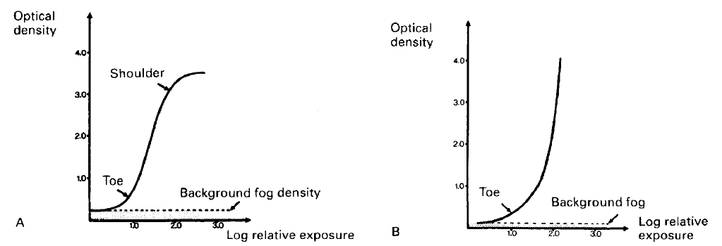
Fig. 5: A - typical characteristic curve of indirect-action radiographic film, showing the main regions of the curve including background fog density, toe and shoulder. B - typical characteristic curve for direct-action film.
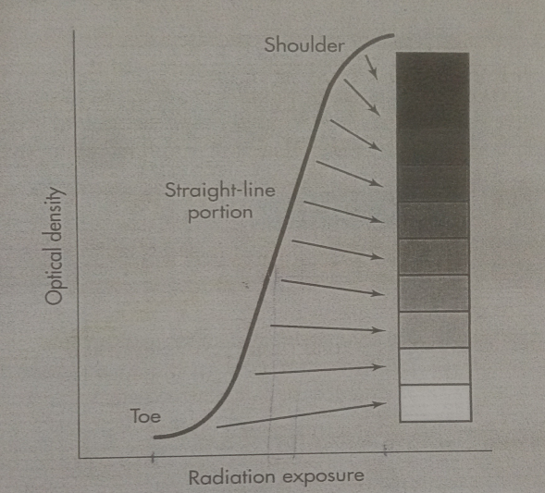
Fig. 6: characteristic curve of radiographic film is the graphic relationship between optical density (OD) and exposure.

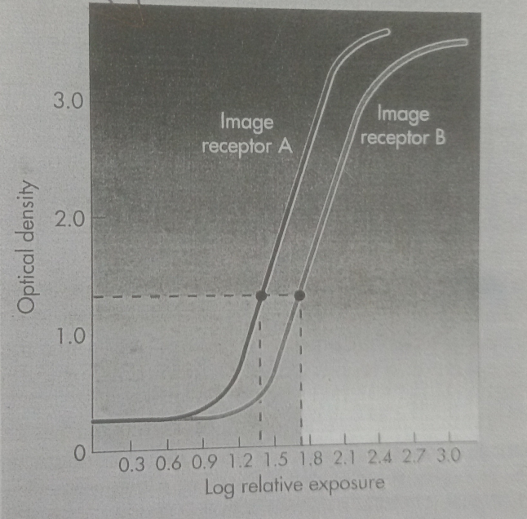
Fig. 7: comparison of speed between film A and B. film A is faster than film B.
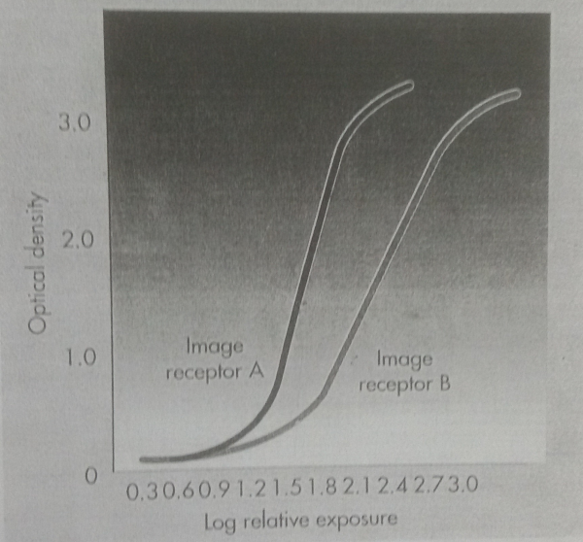
Fig. 8: comparison of contrast between film A and B. film A is higher contrast than film B (straight-line portion is greater for A).
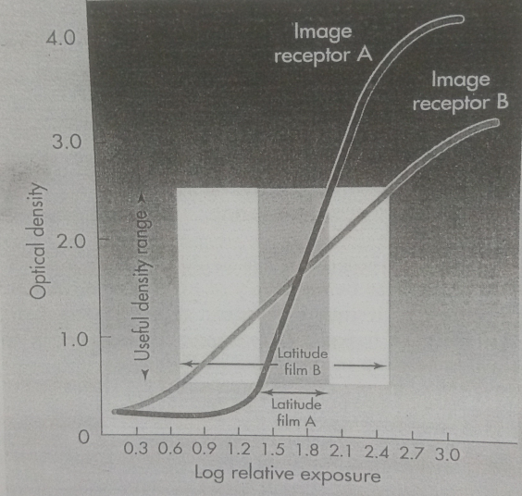
Fig. 9: comparison of latitude between film A and B. film B have wider latitude than film B.

