Oral Histology
Lec.6 Dr. Nada AL-Ghaban
Enamel structures and Amelogenesis:
Enamel (E.) is the hardest calcified tissue in the human body, because of its high content of mineral salts and their crystalline arrangement, The function of the enamel is to form a resistant covering of the teeth, rendering them suitable for mastication.
Chemical composition of E.: Highly mineralized structure, 96% by weight inorganic materials hydroxyapatite (HA), 4% by weight organic content and water. Enamel HA crystals are the largest HA crystals of all the calcified tissues in the body. These crystals are susceptible to dissolution by acids and hence provides the basis for dental caries. The organic matrix of enamel is made from non-collagenous proteins and enzymes. Of the enamel proteins 90% are amelogenins and 10% are non-amelogenins (ameloblastin, enamelin and tuftelin). The primary function of the organic material is to direct the growth of enamel crystals
Physical Properties of E.:
The E. is the hardest substance of human body,but its brittle and low tensile strength (like ceramics), therefore enamel requires base of dentin to withstand forces during mastications.
Enamel is translucent and varies in color from light yellow to whitish and It varies in thickness, with maximum over cusps (2.5 mm) to a knife at the cervical line. Thickness of enamel in primary teeth is nearly half than that in permanent teeth
It is partially permeable to some fluids, bacteria and other products of the oral cavity. The permeability of enamel is due to the presence of cracks and microscopic spaces on the surface of enamel which allows penetration of fluids.
Also its unlike other calcified structures in the body enamel is unique as it is totally acellular .
Unsupported enamel is subject to easily fracture or cleave along rod boundaries (organic sheath). This is an important concept in dental preparations which has to do specifically with tooth microstructure.
Structure and Organization of E.:
Enamel is made up of 3 structures: 1-E. rods or prisms, 2- E.rod sheaths ,3-Cementing inter-rod substance. Each Rod is made up of millions of crystallites, and each rod is formed by four ameloblasts.
E. rods run from Dentino Enamel Junction (DEJ) to the external surface of the tooth. Rods are formed nearly perpendicular to DEJ and curve slightly towards the cusp tip. The follow a wavy course as the traverse from the DEJ to the surface of the crown. The length of most rods is much longer than the thickness of enamel.
The diameter of the rod at the outer surface is double the diameter at DEJ. Crystals that surround each rod are called inter-rod enamel. Rod and inter-rod enamel is formed from the Tomes process of Ameloblasts.
The crystals making up the rod and inter-rod enamel have same composition but are oriented in different direction . The boundary between rod and inter-rod enamel is marked by a narrow space filled with organic materials known as rod sheath.
In cross section, the E. rods have a rounded head or body and a tail (look like keyholes), rounded head of each prism lies between the narrow tail portions of 2 adjacent prisms; usually the rounded head is oriented incisally or occlusally, and the tail oriented cervically. 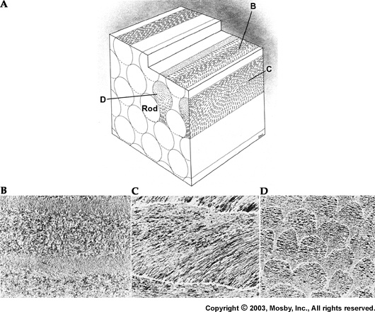
Cross-section of rod-interrod area appearance compared to “keyhole”
Histological features of E.:
Gnarled enamel: Most enamel rods follow an undulating pathway from DEJ to the tooth surface. But in the cusps tips of molars groups of enamel rods twist about one another. This twisting pattern of enamel rod is known as Gnarled enamel. Gnarled enamel makes the enamel strong and more resistant to fracture.
Hunter-Schreger bands:- Are an optical phenomena and are seen in reflected light. They can be seen in ground longitudinal sections as alternating dark and light bands . The dark bands correspond to the cross sectional enamel rods and the light bands represent the longitudnally sectioned inter-rod enamel.
Enamel spindles: It originate from odontoblastic process which cross the DEJ. Before enamel forms, some developing odontoblastic process extend into the ameloblast layer, and when enamel formation begins become trapped to form enamel spindles (which represent the only ectomesenchymal structure present in the E.
Enamel tufts: It also originate from the DEJ, run a short distance in the enamel or sometimes to one half of the E. thickness. They represent protein (enamelin) rich areas in the enamel matrix that fail to mature. They are formed during the formative stages of enamel. They are considered to be ‘faults’ by some researchers while others consider them to be necessary to anchor dentine to enamel.
Surface structures of E.
1-Perikymata: They are transverse, wave like grooves, believed to be the external manifestations of the striae of retzius. They are continuous around a tooth & usually lie parallel to each other & to the cementoenamel junction(CEJ). Their course is usually fairly regular, but irregular near the cervical region .
2-E. cuticle: It covers the entire crown of the newly erupted tooth , has wavy course and it of no major clinical significance . Is secreted by the ameloblasts when enamel formation is completed. probably soon removed by mastication and its remnants called Nasmyth’s membrane .`
3-E.Pellicle:- Formed after the tooth is in the oral cavity, acquired from saliva and the oral flora. May contain factors which hinder the attachment of bacteria to tooth surfaces.
4-E. Lamllae:-Thin leaf like structures that extend from the enamel surface toward the DEJ and may extend to dentin. Consist of organic material, with little mineral content. E. lamellae usually developed in planes of tension.
Incremental lines of E:
1-Cross striations: Are periodic bands that appear along the full length of enamel rod . Because of this the enamel rod appears like a ladder with cross striations being the rungs of the ladder. They appear at regular intervals that is in agreement with the rate of enamel deposition (which is approximately 4 μ m per day).

2-Striae of Retzuis:
Striae of Retzuis also represent incremental growth. In ground cross sections they appear like concentric growth rings similar to those found in trees. In ground longitudinal sections they appear to be dark line extending from the DEJ to the tooth surface . Along the Retzuis striae fewer enamel crystals are found and this is related to physiologic disturbances in the body. Striae of Retzuis often extend from the DEJ to the outer surface of the enamel, where they end in shallow furrows know as perikymata .
3- Neonatal line : Is a Striae of Retzuis that forms at birth, because it reflects the great physiologic changes occur at birth. So these lines demarcating the boundary between E. formed before and after birth.
Amelogenesis (Enamel formation)
Amelogenesis begins at cusp tips and the incisal edges of the E. organ and then it separated down the cusp slopes until all the cells of IEE differentiate into ameloblasts. The delicate basement membrane between IEE and odontoblasts will disintegrate after dentinogenesis and before amelogenesis. It should be emphasized that once the IEE has fully differentiated into ameloblasts there is no more proliferation as these highly differentiated cells do not divide.
Amelogenesis is a complex process, it involves 2 stages which are:
1- E. matrix deposition. 2- Mineralization of the E. matrix.
E. matrix deposition:
The freshly secreted E. matrix by ameloblasts contain 30% minerals as hydroxy apatite crystals and 70% waters and E. proteins which include 90% amelogenine protein and 10% nonamelogenins protein( enameline, ameloblastin &tuftalin). These E. proteins are responsible for creating an environment favorable to mineral deposition. When the first layer of E. is laid down, the ameloblasts will begins to retreat from DEJ towards E. surface and begins to secrete the next layer of E. Enamel matrix appear as a deep in the H. and E. staining sections. The ameloblasts usually secrete the E. in rods or prisms. The initial and last secreted E. matrix is described as Rodless or prismless E.
Mineralization or maturation of the E.:
When the full thickness of E. matrix has been deposited, mineralization will be started, This process involved additional minerals with the removal of organic material and water to reach 96% mineral content. This minerals makes the initial E. crystals that formed in first stage to grow wider and thicker due to the deposition of large amount of hydroxy apatite crystals.
The source of minerals during maturation are from the:
I- Ameloblast itself and other cells of E. organ like stratum intermedium.
2- Capillaries which are approach to the outer E. epith. and its very close to the E.
Life cycle of the ameloblasts:
Ameloblasts show different morphological features and organelle content during different stages of enamel formation which include the following stages:
1- Presecretory stage:
A -Morphogenic stage: During this stage the IEE begins its differentiation first into pre-ameloblasts which induce adjacent dental papilla cells to differentiate into odontoblasts which form dentin. At this stage the IEE consists of cuboidal cells with centrally located nuclei.
B -Differentiating stage: The IEE cells grow into columnar cells with more organelles mostly protein synthesizing organelles in distal end.
2 -Secretory stage:
When the first layer of dentin is formed, it induces the adjacent pre-ameloblasts to complete their differentiation into ameloblasts which secrete enamel. Secretory ameloblasts are polarized tall columnar cells with Tomes' processes (conical shaped processes) at their distal ends. Tomes' processes interdigitate with the surface of the forming enamel giving it a picket fence appearance. Tomes' processes determine the orientation of the newly formed (nucleated) enamel hydroxyapatite crystals. The organelle content of secretory ameloblasts is mainly protein synthesizing organelles i.e. Golgi complex and granular endoplasmic reticulum. Numerous mitochondria and secretory granules are also present. Junctional complexes, tight junctions and desmosomes are present at the distal and proximal ends of ameloblasts. Also, desmosomes and gap junctions are present along their lateral surfaces. As the secretory stage is end, the Tomes' processes are lost and accordingly the last formed layers of enamel are prismless.
3 -Transitional stage:
When enamel reaches its full thickness the ameloblasts height is decreased and protein synthesizing organelles are reduced. Many lysosomes and autophagic vacuoles are also present. The overall number of ameloblasts is reduced by programmed cell death(apoptosis) and it is estimated that by the end of this stage the ameloblast population is reduced by 25- 50%.
4 -Maturation stage:
During maturation massive influx of calcium and phosphates occurs and at the same time there is selective loss of enamel proteins, mainly amelogenin and water. The ameloblasts modulate between two phenotypes depending on the morphology of their distal ends. The ameloblasts either have numerous microvilli forming a ruffled border or their distal ends are even straight, thus forming two morphologically different types, namely Ruffled-ended ameloblasts which add calcium and phosphates to E. matrix ( 80 % of maturation ameloblasts) and Smooth-ended ameloblasts by removal of amelogenin and water from E. matrix (20 % of maturation ameloblasts), respectively.
Thus maturation ameloblasts modulate i.e. change their morphology from one type to the other and back.
5 -Protective stage:
At this stage the ameloblasts lose their differentiation and become short cuboidal cells which together with the remnants of the other layers of the E. organ form a multilayered structure, namely the reduced enamel epithelium. This structure remains on the surface of fully formed enamel until the tooth erupts. It separates the enamel from the dental sac and thus protect it from being in contact with ectomesenchymal cells in the dental sac. If this contact accidentally happens, either enamel is resorbed resulting in pitting or dental sac cells in the contact area differentiate into cementoblasts and lay down cementum on the enamel surface. Then the reduced enamel epithelium and the oral epithelium jointly form the dentogingival junction of the erupting tooth.
Age changes in enamel:
- With age enamel becomes worn out because of masticatory attrition.
- Age also causes a decrease in the permeability of enamel.
- Other characteristics of aging of enamel are discoloration and a change in the surface layer .
Defects of enamel formation:
Disturbances in either the secretion or maturation of the enamel matrix can lead to defects in enamel structure.
Enamel hypoplasia is due to a decrease in the amount of matrix synthesized by the ameloblasts
Enamel hypomineralization/maturation is caused by a lack of sufficient mineral incorporated .
Generally three conditions affect enamel during its formative stages. 1- Defects caused by febrile disease, 2- Defects caused by tetracycline, Finally 3- defects caused by excess fluoride, Dental Fluorosis (mottled enamel).
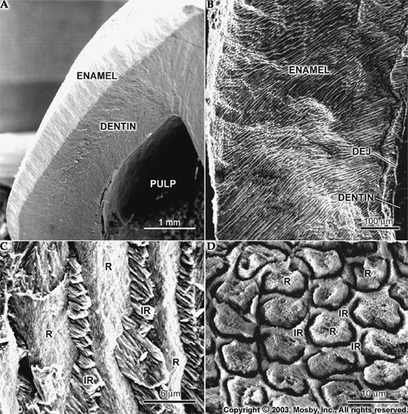
Electrone microscopic of E. rods: R=E. rods, IR= inter rod substance

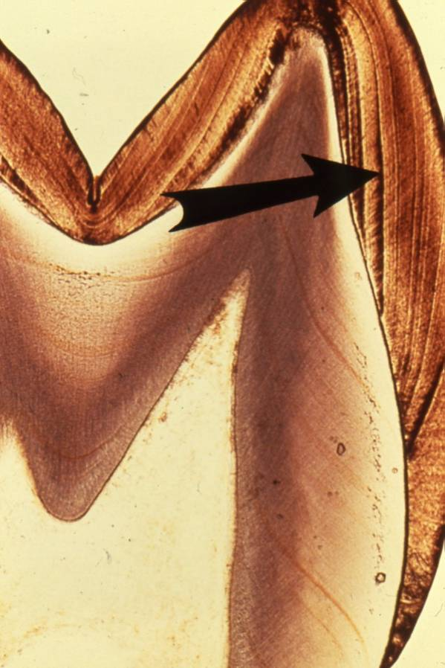

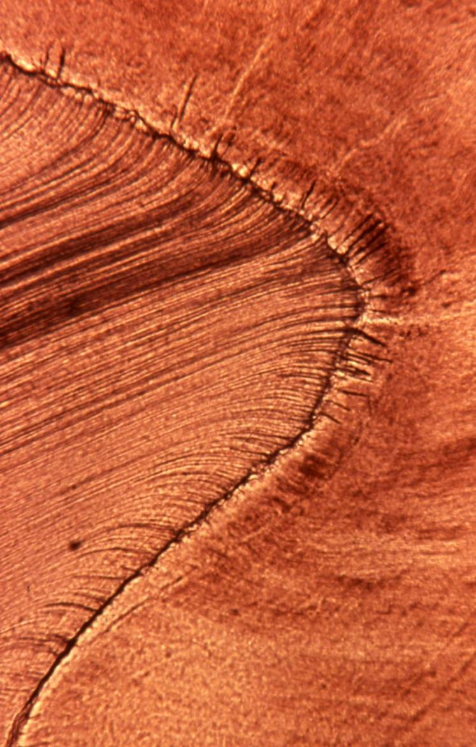
E.spindle

