Dental materials : The advancement of dentistry and the quality of dental treatment are dependent on knowledge of the basic sciences .Certainly no basic science could be more relevant to dentistry and dental treatment than materials used in dentistry ,so, It is the science which deals with materials used in dentistry ,their physical and mechanical properties and their manipulation as such properties are related to the proper selection and use by the dentist .In the past the gold bands and wires were used for the construction of partial dentures .In the middle of the nineteenth century, research studies on amalgam were done by G.V. black .After that the American dental association determined the physical and chemical properties of dental materials and the development of new dental materials instruments and test methods.
The primary objective of it is to formulate standards or specification for dental materials and to certify the products which meet those requirements. The study of dental material enables the dentist to understand the behavior of these materials and how to use them to their best advantage .The service that a restoration or appliance gives to the patient is largely determined by the proper selection and use by the dentist .The objective for this course is to learn the physical ,chemical and mechanical properties of some of dental materials and their manipulation.
Biological requirements of dental material: A dental material should be :
1-Be non toxic to the body.
2-Be non- irritant to the oral or other tissues.
3-Not produce allergic reactions and ,not be mutagenic or carcinogenic.
General properties of dental materials :there two main types of properties1- physical 2-mechanical,physical properties like color ,solubility ,density dimensional stability and others .Mechanical properties like hardness ,strength and others .There is no material until now have ideal properties which is either mechanical or physical, so the property which is good in one material may be bad in another material.
Physical properties: the following properties which are important in the study of dental material:
1-Color : Esthetics is critically important in dealing with dental material .For good esthetics ,the interaction of light with restorative materials must mimic the interaction of light with natural teeth. The dental restorative materials should be translucent in order to look like a natural teeth, and also should not be stained or changed the color by time ;ex anterior filling and artificial teeth.
Translucence :is the optical property that allows the light to go short way in the material before being reflected out again .Also should look like natural tooth substance at different light conditions ,such as day light and artificial light ,ex .an artificial tooth may be acceptable in ordinary light but may be discovered the relative darkness of the material in fluorescent light .For dentures ,the material should have the same appearance of natural gum .Acrylic material can be made with various shades of pink to look as normal gum.
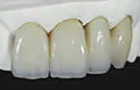

2-linear coefficient of thermal expansion and contraction: Thermal expansion of the material occurs after increasing the temperature is due to increase the kinetic energy of the atoms and increase the vibration lead to increase the inter atomic spacing ,as a result the material expand grossly .After cooling the material contract, these changes measured by the linear coefficient of thermal expansion and contraction which is the change in length per unit length for 1 C⁰ temperature change. a=final length- original length/original length*temp change (cm/cm .C ⁰).Hard tooth structure has the smallest coefficient, metals are intermediate ,and polymers have the largest .Tooth : 11*10⁻⁶ cm/cm.C⁰ ,Gold: 14*10⁻⁶ cm/cm.C⁰ ,impression compound :250*10⁻⁶cm /cm. C⁰, Acrylic resin: 76*10⁻⁶ cm/cm.C⁰, Composits : 14-50*10⁻⁶ cm/cm .C⁰. Filling materials should have the same coefficient as the tooth, if it does not, it will press too hard against the cavity wall on expansion and may cause pressure on the pulp, or pull away from the wall when chilled by cold water. The later effect will cause the filling to leak temporarily ,which may lead to further caries .
Gold alloy is used to cast crown or bridge .After cooling of the gold from the melting temperature ,it will contract and so the crown will be smaller. To compensate for this contraction ,we use certain type of investment, which expand in the same amount.
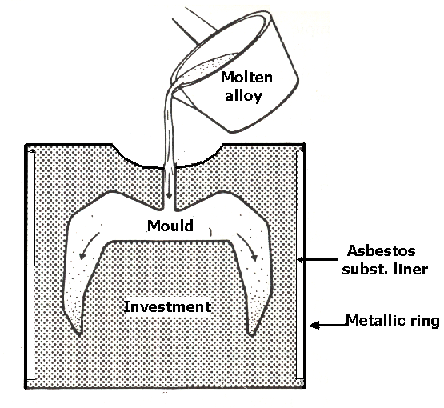
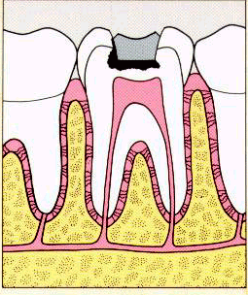
3-Dimensional stability: many material change shapes when they set or harden. Impression materials should not change dimensions when set .Also , dental materials should have no dimensional changes after setting .Amalgam is filling material for posterior teeth ; it may expand or contract, depending on its manipulation .Ideally, dimensional changes should be small. Excessive contraction can lead to micro leakage and secondary caries .Excessive expansion can produce pressure on the pulp and post operative sensitivity. On the other hand , the investment material that forms the mold for casting should expand for certain amount to compensate for the contraction of the molten metal after it is cooled from the molten stage .Expansion of investment is about 1-2%, contraction of alginate is about 3%.

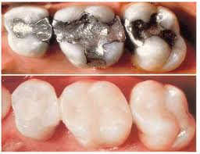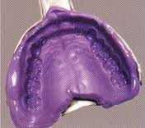

4-Density :Lightness is nearly always an advantage in restorative materials, but sometimes tin or lead is used inside full lower denture to make it heavy to control its mobility .Density of gold:14 gm/cm³. Acrylic :1.2 gm/cm³. Chromium / cobalt: 8.3 gm/cm³. Water : 1gm/cm³. 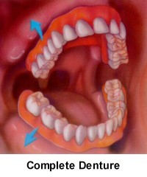

5-Solubility :Restorative materials should not dissolve in the mouth, and if it dissolves, it should not release toxic substances .Its measured in Mg/mm². Solubility of composite: 0.01Mg/mm². Solubility of resin cement maximum :7.5 Mg/mm².
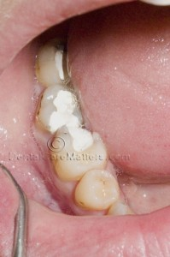

6- Absorption of fluids : Some materials will absorb water or other fluids. If it is too much or continued for long time ,this will result in serious dimensional changes and the material would also be unhygienic .On the other , some materials like acrylic will absorb water for a day and stops after that , so it is acceptable .Water absorption of composites 40Mg/mm²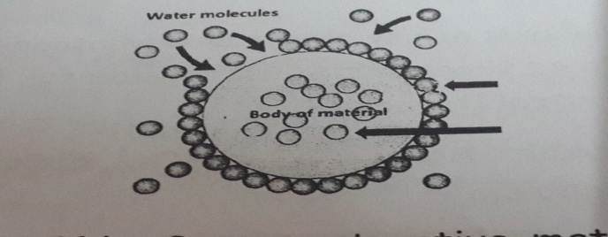
7- Tissue reaction :some restorative materials are damaging to the living tissue which is in contact with ,like silicate filling and zinc phosphate cement which is acid and may kill the dental pulp unless a protective lining is used .Dental material should not show any allergic reaction to the tissue and also should not provide good culture to the growth of bacteria and Candida albican to grow and cause infection, like soft lining materials.
8- Thermal conductivity :Is the physical property that deals with heat transfer through a material by conductive flow .It is defined as the quantity of heat in calories per second passing through a material 1 cm thick with cross section of 1cm² having a temperature difference of 1C⁰.Generally, metals are better heat conductors than non- metals. Metal filling material like amalgam, sometimes cause pulp pain by transmitting heat or cold more than natural tooth especially in deep cavities .Thus they require heat insulating layer between the filling and the pulp , here it is un desirable property. On the other hand, the thermal conductivity of metallic denture base material is an advantage as it gives feeling closer to the normal condition and the patient will feel normal also it will protect him from drinking very hot drinks which may burn his mouth.Silver:1cal/sec/cm ².Amalgam: 0.055 Cal/sec/cm² .Zinc oxide eugenol :0.011 Cal/sec/cm² .Enamel:0.0022Cal/sec/cm².
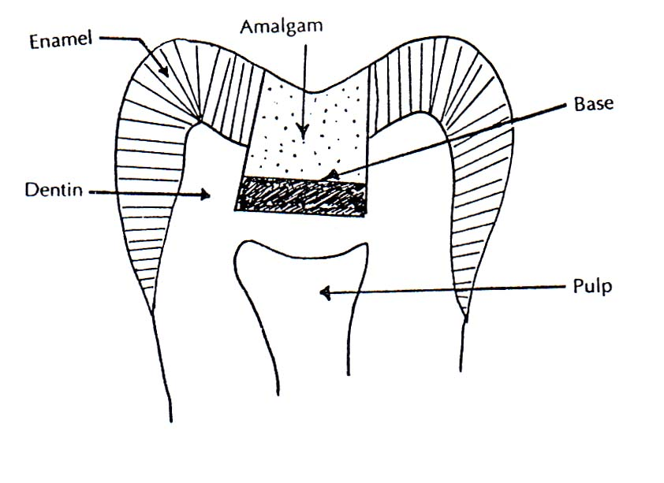

9-Thermal diffusivity :is the measure of the speed with which a temperature change will spread through an object when one surface is heated. It is calculated from the thermal conductivity divided by the product of density and heat capacity: h=K/C_{P}*

10-Electrical Activity : It is the ability of metals to ionize by losing electrons .If there is a high difference in the electrode potentials of two metals in contact with the same solution like gold and aluminum, an electrolytic cell may develop and the patient may feel discomfort.Enamel:2.9*10⁶ Ohm.cm. Zinc oxide eugenol :10⁹-10¹⁰Ohm.cm

Electrochemical properties: The use of wide variety of metals for restorations and prosthetic devices the successful clinical performance and long term durability which require adequate corrosion resistance in the oral environment .
Corrosion :is the electrochemical process and is dependent on the ability to conduct electrical current either by means of free electrons in metals or via ions in solutions.
Tarnish: is a surface discoloration on a metal or a slight loss or alteration of the surface finish or luster.
11-Adhesion and cohesion :Adhesion is the force which causes two or more different substances to attach when they are brought in contact with one another .When the molecules of the same substances hold together ,the forces are said to be cohesion.
Biocompatibility: is formally defined as the ability of a material to elicit an appropriate biological response in a given application in the body .Inherent in this definition is the idea that a single material may not be biologically acceptable in all applications. For example, a material that is acceptable as a full cast crown may not be acceptable as a dental implant. Also implicit in this definition is an expectation for the biological performance of the material. In a bone implant, the expectation is that the material will allow the bone to integrate with the implant. Thus an appropriate biological response for the implant is osseointegration.
In a full cast crown, the expectation is that the material will not cause inflammation of pulpal or periodontal tissues, but osseointegration is not an expectation. Whether or not a material is biocompatible therefore depends on the physical function for which the material will be used and the biological response that will be required from it.

