1. *Anomalies of tooth shape*

Anomalies of tooth shape include dilacerations, true fusion, gemination, concrescence, talon cusp, and ‘dens in dente’.

* Dilaceration is an anomaly of the tooth shape in which there is a sharp bend or curve in the root or crown. It generally does not affect orthodontic treatment planning but may complicate the extraction of the affected tooth.

 

Dilacerated roots might also create problems when they have to be aligned

Dilacerated roots of a maxillary first pre-molar

* True fusion is seen when the tooth arises through the union of two normally separated tooth germs. It might lead to spacing or sometimes it might complicate its movement by orthodontic means.

  

Fusion

True fusion

A larger bracket is required to attain proper rotational control of the tooth

* Geminated teeth are anomalies, which arise from division of a single germ by an invagination, leading to the formation of two incomplete teeth.

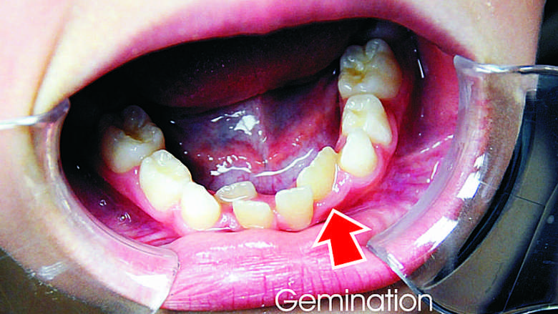 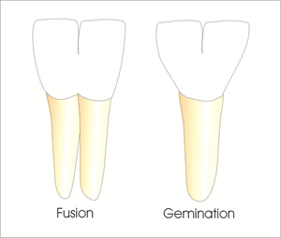

* The term ‘twinning’ has been used to designate the production of equivalent structures.

 

Twinning

Two near equal sized teeth in place of the maxillary left lateral incisor

* Concrescence refers to fusion of cementum of teeth which occurs after root formation has been completed.

 

Concrescence

Concresence following root completion

* The talon cusp is an anomalous structure projecting lingually from the cingulum area of a maxillary or mandibular permanent incisor. It might interfere in proper occlusion. It’s grinding invariably leads to pulpal exposure necessitating root canal treatment.

The term ‘Dens in Dente’ is used to denote a developmental variation which radiographically may resemble a tooth within a tooth.



Talon’s cusp as seen on the maxillary lateral incisor

 

Talon’s cusp on the right lateral incisor preventing its ideal alignment in the arch, it appears to be rotates mesiopalatally.

1. *Abnormal labial frenum*

At birth the labial frenum is attached to the alveolar ridge with some fibers crossing over and attaching with the lingual dental papilla. As the teeth erupt, bone is deposited and the frenal attachment migrates superiorly with respect to the alveolar ridge. Some fibers may persist between the maxillary central incisors. These fibers which persist between these teeth are capable of preventing the two contralateral central incisors from coming into close approximation. This space called a midline diastema which may occur due to various causes:

1. Deciduous dentition

2. Ugly duckling stage

3. Racial predisposition, Negroids

4. Microdontia

5. Congenital absence of lateral incisors

6. Supernumerary tooth in the midline

7. Abnormal frenal attachment

8. Abnormal pressure habits (digit sucking and tongue thrust habit)

9. Trauma

10. Impacted tooth in the midline

A specific test used to determine the role of frenum as a causative factor called the ‘blanch test’ which can be done as follow:

Step 1: The lip is pulled superiorly and anteriorly

Step 2: Any blanching in the interdental region is indicative of the fibers of the frenum crossing the alveolar ridge

Step 3: The blanch test can be collaborated with an IOPA of the region which shows a slight radiolucent wedging/notching in the interdental alveolar ridge region

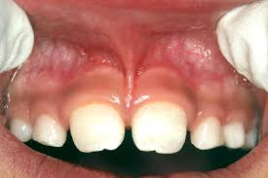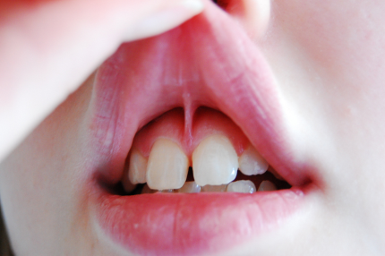

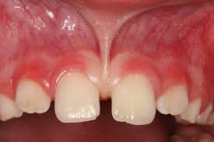 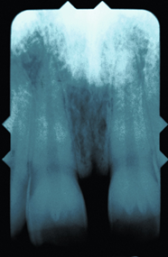

Labial frenum, blanch test, intraoral periapical radiograph

1. *Premature loss of deciduous teeth*

The premature loss of a deciduous tooth can lead to malocclusion only if the succedaneous tooth is not close enough to the point of eruption.

When the permanent tooth does not erupt following the loss of the deciduous tooth, the adjacent teeth get time to migrate in its space. This can lead to the mesial migration of the posterior teeth result in a decrease in the overall arch length. This might cause the permanent successor to erupt malpositioned or get impacted or cause a shift in the midline (in case of anterior teeth).

In case an anterior deciduous is lost prematurely; there is a tendency for spacing to occur between the erupted anterior teeth. It might also lead to a shift in the midline, towards the side where the deciduous tooth has been lost.

If one of the posterior deciduous teeth is lost, especially the deciduous second molars, the first permanent molars erupt mesially. This might lead to a loss in the arch length. This is seemed most commonly in the maxillary arch where there is lesser space for the canine to erupt; therefore it may erupt labially.

Mesially tilting of the erupted mandibular first molars may cause the second premolars to remain impacted



Mesial tilting of the mandibular 1st permanent molars leading to a decreased space for the eruption of the 2nd premolars

1. *Prolonged retention of deciduous teeth*

Any deciduous tooth may be retained beyond the usual eruption age of their permanent successor, this may cause:

i. Buccal/labial or palatal/lingual deflection in its path of eruption;

ii. Impaction of the permanent tooth.

 

Left maxillary central incisor deflected palatally into cross-bite

Lingually erupting mandibular lateral incisors, due to over retained deciduous teeth

Most commonly impacted tooth is the maxillary canine (third molars not taken into account). The reasons for this include:

1. It is the last anterior tooth to erupt
2. Space occupied by the deciduous canine is less than the mesiodistal width of the permanent canines
3. The premolars might migrate mesially leaving limited space for the canines to erupt
4. It has the longest path of eruption
5. Controversially, as it may seem, it is the only tooth to erupt after root completion.