Tongue:

The tongue functioning, in conjunction with the lips and cheeks, in guiding the erupting teeth, and this affected by its size, its resting posture and its function.

The size of the tongue is mainly related to the size of the lower jaw. If the lower jaw is larger than the upper jaw, the tongue is too large to fit within the upper arch, therefore tongue finds space between upper and lower arches and prevents full vertical development of the dentoalveolar structures resulting in open bite.

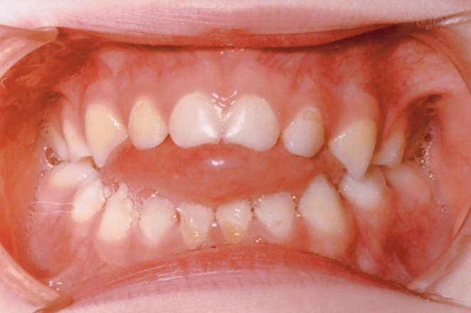

The resting position of the tongue is ideally within the dental arches, filling the space enclosed by the teeth. Sometimes the tongue takes up an adaptive postural position, slightly protruded between teeth to touch the lower lip which will prevent the full vertical development of the incisal segment resulting in incomplete over bite. This is produced to seal the front of the mouth to allow nasal breathing (tongue lower lip anterior oral seal instead of lips oral seal) when there is difficulty to hold the lips together due to vertical or sagittal lip discrepancy.

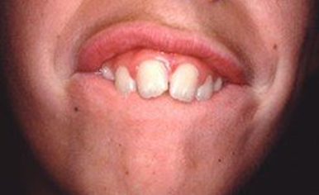

The function of the tongue is concerned with mastication, swallowing and speech. Its effect on the dentition is mostly related to swallowing. After the food mastication is completed, the swallowing of food and saliva take place in sequence as: a) closure of the lips; b) teeth in light occlusal contact; c) tongue elevated to the palate, and d) momentary clenching of the teeth as food pass into the pharynx.

Variation of normal swallowing are also seen which may be described as:

1. Adaptive swallowing: involves positioning of the tongue between teeth during swallowing and may be carried out with the buccal teeth apart (tongue positioned between teeth, reduce the muscle and air pressures within the upper arch lead to narrow arch and buccal cross bite also prevents the full vertical development of the anterior dento-alveolar segment result in incomplete over bite), or buccal teeth together (lead to incomplete overbite or anterior open bite due to forward position of tongue)
2. Swallowing with endogenous tongue thrust: swallowing activity is accomplished by an anterior thrust of the tongue which is a basic neuromuscular mechanism. It sometimes associated with anterior lisp

during speech. It prevents the full vertical development of the anterior dento-alveolar segments resulting in an incomplete over bite or anterior open bite.

These two variations have somewhat similar effects on developing occlusion however, they respond differently to orthodontic treatment designed to reposition the teeth. The adaptive tongue will be changed if the teeth are moved but the endogenous tongue not and will reproduce the original tooth position if these are altered.

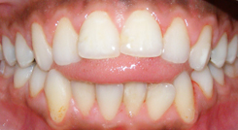

**Neutral zone**

The fact that the lips and cheeks function outside and the tongue within the dental arches has led to the concept of a neutral zone existing between the inner and outer perimeters of the dental arches, where the forces of lips and cheeks on one hand and of the tongue on the other are balanced and within which the teeth are positioned.

This zone should be considered not only in relation to muscle forces but also in relation to intra oral air pressures which are induced by mandibular positions and movements, and to occlusal contacts and the periodontal ligament.

It is important to keep the teeth in the neutral zone at the end of the orthodontic treatment otherwise they will move to take up other positions.

**Dental factors:**

The third general factor affecting the occlusion of the teeth is the relationship between the size of the dentition and the size of the jaws. Ideally, there should be adequate space for the teeth to erupt into the mouth without crowding or spacing. In primary dentition the ideal situation exists when there is spacing between the anterior teeth that will give better chance for permanent incisors to erupt without overlapping. The disproportion between teeth size and arch size can be:

* Excessive dentition size in relation to dental arch size which can have:
  + Overlapping and displacement: when the dental arch is too small for the dentition or teeth too large for the dental arch or both, the teeth will be displaced. The most affected teeth are the last teeth in each group i.e. lateral incisors, second premolars, canines and third molars.
  + Impaction of the teeth: occurs when eruption of teeth is completely blocked by other teeth due to crowding, also it affects the last tooth in each segment.
  + Mesial movement of the teeth: either associated with alveolar growth as part of dentoalveolar forward development also called mesial migration, or movement of individual tooth into space created by interproximal attrition or loss of the teeth, this can occur any time during or after growth period.
* Excessive dental arch size in relation to dentition size: it is less common, occur when there is too small teeth in relation to the size of the dental arch or too large dental arch in relation to the size of the dentition or both which will result in spacing.

The size of the dental arch may not be the same as the size of the basal bone because skeletal relationship and muscular factors can produce a dental arch which is larger or smaller than the basal bone; therefore dentition size should be considered in relation to dental arch rather than jaw size.

**Local factors:**

Local factors can be classified as follow:

1. *Anomalies of number*

Each jaw is designed to hold only a specific number of teeth at a particular age. The anomalies in the number of teeth can be of two types:

1. Increased number of teeth or supernumerary teeth:

Supernumerary teeth can vary remarkably in size, shape and location. They may be:

* Supplemental teeth: which bear a close resemblance to a particular group of teeth and erupt close to the original sight of these teeth, i.e. incisors, premolars or molars, etc.

 

Supplemental tooth in the maxillary lateral incisor region

Supplemental teeth in the mandibular pre-molar region

* Mesiodens: it is the most commonly seen supernumerary tooth. It is usually conical in shape with a short root and crown, situated between the maxillary central incisors and can vary considerably in shape. It can be seen erupted or impacted, singular or in parts. It can occur in the maxilla or in mandible.

 

An impacted inverted maxillary

mesiodens

Erupted mesiodens

 

An inverted mesiodens preventing the eruption of the left maxillary central incisor

A mandibular mesiodense

Supernumerary teeth can cause

**a.** Non-eruption of adjacent teeth.

**b.** Delay the eruption of adjacent teeth.

**c.** Deflect the erupting adjacent teeth into abnormal locations.



Supernumerary tooth on the maxillary molar region has deflected the second permanent molar

**d.** Increase the arch perimeter (increasing the over jet if in the maxillary arch or decreasing the over jet if seen in the mandibular arch.

**e.** Crowding in the dental arch.

**(ii)** Less number of teeth or missing teeth

Congenitally missing teeth are more commonly seen in comparison to supernumerary teeth. It can be anodontia or hypodontia or oligodontia.

Anadontia: characterized by the congenital absence of all primary or permanent teeth. It is divided into 2 subsections, complete absence of teeth or partial absence of teeth

Hypodontia, usually missing 1 or 2 permanent teeth,

Oligodontia is the congenital absence of 6 or more teeth.

The most commonly congenitally missing teeth are the third molars, followed by the maxillary lateral incisors.

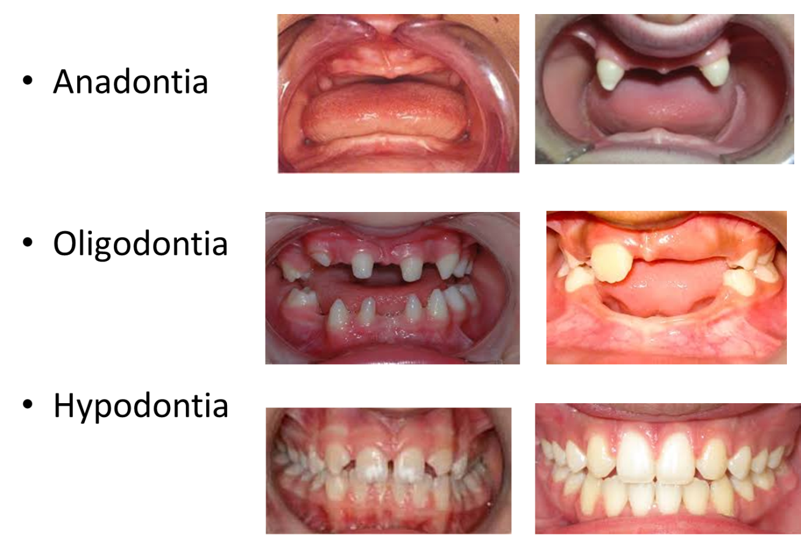

Congenitally missing teeth can lead to:

a. Gaps between teeth.

b. Aberrant swallowing patterns.

c. Abnormal tilting/axial inclination or location of adjacent teeth.

d. Multiple missing teeth can cause a multitude of problems.

  

Spacing between teeth due to missing maxillary lateral incisors

Abnormal position of the maxillary right central incisor in contact with the right canine due to the absence of the right lateral incisor

Tongue thrust habit developing due to the congenital absence of the maxillary lateral incisors



Multitude of problems caused due to missing mandibular central incisors. Retrognathic mandible, convex profile, anterior deep bite, maxillary anterior crowding and end-on molar relationship

1. *Anomalies of tooth size*

It includes macrodontia and microdontia, which can be localized or generalized.

* The true generalized macrodontia, where all the teeth are larger than normal is seen in cases of pituitary gigantism.
* The true generalized form of microdontia, where all the teeth are small is rarely seen. It is usually associated with cases of pituitary dwarfism.

The most commonly seen *localized microdontia* involves the maxillary lateral incisors. The tooth is called a ‘peg lateral” and exhibits a peg shaped crown with the mesial and distal sides converging incisally. The root may be shorter and more cylindrical than normally seen. *Relative generalized microdontia* may also be seen, but should be considered as an illusion of the true condition.

 

Relative generalized microdontia. Here the jaws are too big for normal sized teeth

Peg-shaped maxillary lateral incisors