Lec: Prosthodontic
د.حكمت جميل

Pre-prosthetic Surgical Considerations
Soft Tissue Procedures
With loss of teeth, bony resorption, and remodelling, soft tissue relationships that existed with teeth and were not problematic may become concerns. With reduction of ridge height and contour, soft tissue and muscular attachments change. These muscular and soft tissue changes are often deleterious to prosthesis stability and function, and require removal or alteration. Additionally, with the potential trauma and chronic irritation caused by ill-fitting prostheses, the development of hyperplasic tissues in the denture bearing and peripheral tissue areas may occur. These hyperplasic tissues contribute to lack of denture fit and stability, and can contribute to patient discomfort. Because it is very difficult to replace oral mucosa after it has been removed, the treatment plan must detail the sequence in which the soft tissue abnormalities will be addressed. Treatment will usually address the bony abnormalities first, to achieve normal bone healing with good soft tissue coverage. Additionally, if implant placement is part of the treatment plan, bone augmentation may be required. Preserving redundant soft tissue to provide coverage for bone augmentation should be considered. The soft tissue issues may be addressed after the grafting and or implants have healed. In general, excised, redundant hyperplasic soft tissues are the result of chronic irritation from an ill-fitting prosthesis. However, because of the chronic irritation, pathologic changes within the tissues can occur. Therefore, as a rule, a portion of all excised hyperplasic tissues should be submitted for histopathologic examination.

Maxillary Soft Tissue Tuberosity Reduction
Interarch distance is a critical element for proper fabrication of denture bases, and hyperplasic maxillary tuberosity tissues often impinge on adequate interarch distance. To determine if the reduction will be primarily bone or soft tissue, a panoramic radiograph that can discriminate the soft tissue shadow from bone is required. If not available, sounding of the soft tissue with the anaesthesia needle after the region is anesthetized will provide the clinician with detail of the tissue thickness. If a great deal of tissue removal is anticipated, a surgical guide is recommended.
A midline elliptical incision is made sharply to bone with the widest part of the ellipse directly over the area where the most tissue is to be removed. The anterior and posterior portions of the ellipse should taper into the normal portions of the ridge anteriorly and to the posterior tuberosity posteriorly. The ellipsed portion is elevated and removed. The clinician can now look into the area made by the removed section of tissue and evaluate the tissue height above the bone. Once the excess tissue has been removed and there is a uniform thickness of mucosa, digital pressure will approximate the buccal and palatal flap margins to evaluate the amount of vertical reduction that has been accomplished. Having the patient close down gently on theclinician's fingers will allow for evaluation of the change in interarch distance. If the vertical reduction is acceptable, the wound margins are approximated and trimmed to get a tension-free butt Joint closure. The wound is closed with an interrupted or continuous suture technique.

Maxillary Labial Frenectomy
Labial frenal attachments are thin bands of fibrous tissue/muscle covered with mucosa that extend from the lip or cheek and attach into the periosteum on the sides of, or the crest of, the alveolar ridge.
Except for frenal attachments, which attach at the incisive Papillae and contribute to the midline diastema, most frenal attachments—like other soft tissue structures—are of little consequence when teeth are present. On the edentulous ridge, which has experienced résorption and remodelling, the muscular and soft tissue attachments may directly affect the seating, stabilization, and construction of the prosthesis, as well as subject the patient to reduced function and discomfort. Although this is a simple technique, it yields great benefit. Although other techniques exist, the following is recommended for a simple frenectomy. Infiltration anaesthesia to the lip around the frenum is usually adequate. Injecting directly into the frenum may distort the anatomy. After achieving good anaesthesia, two small, curved haemostats are placed with the curved sides against the tissues over the superior aspect of the frenum and the inferior aspect of the frenum.
The clinician will use a surgical blade and follow the curvature of the upper hemostat, cutting through the upper aspect of the frenum, This is repeated for the lower hemostat. The frenum will now be excised, leaving a diamond-shaped wound.Exploring the wound, any frenal remnants should be excised directly to periosteum. A suture is

placed through the wound margin engaging the periosteum in the depth of the vestibule right below the anterior nasal spine. If the frenum extended to the crest of the ridge and was excised thorough attached tissue, all parts of the wound will close primarily except that part in the attached tissue. No attempt should be made to close that area and it should be left to granulate and heal by secondary intention

.

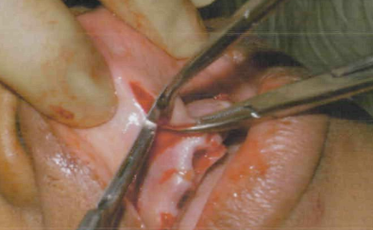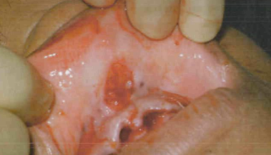

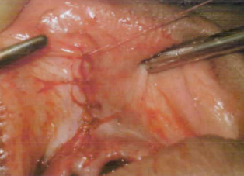

Excision of Redundant/Hyper mobile Tissue Overlying the Tuberosities
Redundant hypermobile tissue is often the result of ill-fitting dentures, ridge resorption, or both. After identifying the area to be excised, parallel incisions on the buccal and lingual or palatal aspects of the tissue are made sharply to bone. The excised piece of tissue will be dissected from the bone and removed. Digital pressure is applied to check for primary closure of the wound margins. The wound is irrigated and closed primarily. Care should be taken to avoid significant undermining of the buccal/facial aspects of the flaps, and loss of vestibular depth when closing the wound.

Excision of inflammatory Fibrous Hyperplasia (Epulis Fissuratum)
Inflammatory fibrous hyperplasia is a generalized hyperplasic enlargement of the mucosa and fibrous tissue in the alveolar ridge and vestibular area. The etiology is most closely associated with chronic trauma to the involved areas from ill-fitting prosthesis. Inflammatory fibrous hyperplasia progresses in stages, and the surgical procedure indicated varies with the stage. For those lesions in the early stages, there is not a significant degree of fibrosis of the involved tissues, and nonsurgical therapies may be effective. In the later stages where there is significant fibrosis and hyperplasic changes, excision of the hyperplasic mass of tissue is the treatment of choice.

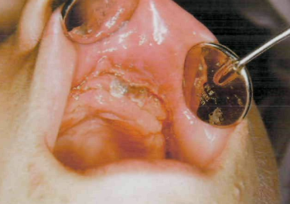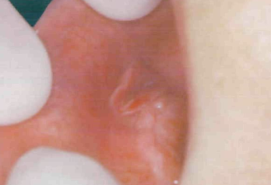

Several treatment options exist based on the size of the hyperplasic mass of tissue to be removed. If the tissue mass is not extensive, use of lasers or electrosurgery techniques provides good results for tissue excision. For more extensive tissue masses, the margins of the tissue mass are elevated using tissue forceps, and an incision is made at the base of the mass, but not through the periosteum. A dissection is made under the entire mass of the hyperplasic tissue, and the mass is removed.
The normal mucosal margins are sutured in place, and the superior margins are sutured to the depth of the vestibule. In order to minimize soft tissue creeping and loss of vestibular height with secondary intension healing, a surgical stent with an extended anterior flange lined with soft tissue conditioner, or the existing denture with the flange extended to engage the height of the vestibule. A soft tissue conditioner should be placed, and the prosthesis should only be removed for wound care and rinsing, and cleansing of the interior surface of the prosthesis. Secondary epithelialization will take four to six weeks.

Inflammatory Papillary Hyperplasia of the Palate
Inflammatory- papillary hyperplasia of the palate is a condition affecting the palatal mucosa, thought to be caused by ill-fitting prosthesis, poor hygiene, or fungal infections and the associated inflammation.
Its clinical presentation appears as multiple nodular projections in the palatal mucosa. The lesions may be erythematous or may have normal palatal mucosal coloration.

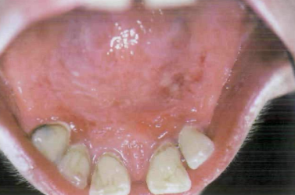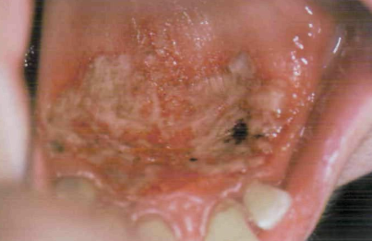

Early treatment consists of prosthesis adjustments, tissue conditioner, and proper oral hygiene. In more advanced presentations, several treatment options have been suggested. Because this is primarily an inflammatory disorder, there is no need to excise the full thickness of the palatal tissue. In any of the described treatment options, the superficial inflamed layers of the palatal mucosa are removed leaving the palatal periosteum intact to heal by secondary intension. These techniques include removal of the inflamed mucosa with electrosurgery loops, laser ablation of the superficial layers, sharp dissection, use of coarse fluted burs, or cryotherapy. The palate is covered with a surgical stent or denture with a soft tissue conditioner to assist with patient comfort and provide coverage while secondary epithelialization takes place in the following four to six weeks.

