Radiology
Lec. 2 X-ray beam shape and position Dr. Areej

Electron - Target interaction
The x-ray tube current crossing from cathode to anode. When the current increase , the filament becomes hotter and more electrons are released by thermionic emission . the number of electrons emitted is determined by temperature of filament.
The electrons travelling from cathode to anode are called projectile electrons. When these electrons hit the heavy metal atoms of anode target, they transfer their kinetic energy to the target atoms. They interact with either orbital electrons or nuclear field of target atoms and result in conversion of electron kinetic energy in to thermal energy (heat) and electromagnetic energy in the form of infrared radiation (also heat ) and x- radiation.
Conversion of projectile electrons kinetic energy into X – ray photon energy occurred by 2 ways:
First:-
Electrons can be brought to stop on the surface of the anode (target) through collision with tungsten atoms of the target giving up all of their kinetic energy to X – ray photons such photons will be of high energy (short wave length photons).
Some of cathode electrons giving up only part of their energy and the resultant X – ray photons have low energy (long wave length photons) and most of X – ray photons are created by this manner.
Second:-
When cathode electrons able to dislodge one or more orbital electrons of tungsten atom. For example cathode electron must possess more than 69,000 electron volts to dislodge K orbital electron of tungsten atom and this is only occurred when X – ray machine set at 70 Kilovolts or more. Then after the dislodgment of K electron from its shell, an electron from L shell falls into the empty place of K shell.
X – Ray spectrum
X – Ray beam consist of many photons of different wave length because:
A - Electrons don’t give up all their kinetic energy in identical fashion.
B – Potential voltage across the X – ray tube changes constantly as the AC voltage varies to DC.
That’s why X – ray beam is poly- different wave length.
Note: - X – ray photon wave length can calculated from this formula:-
12.35
KV
=
Minimum photon wavelength in A˚

Voltage Rectification
The current from common wall plug is 60Hz. The currenet direction changed 120 times each second. The main supply to the X – ray machine of 240 volts has 2 functions:
A – Generate the high potential difference (kV) to accelerate the electrons across the X – ray tube via the step up transformer.
B – Provide the low – voltage current to heat the filament via the step – down transformer.
However, the incoming 240 volts is an alternating current with typical wave form as shown:-
Voltage
+
-
Time

Fig 1:sine –wave of the AC current

Half of cycle is (+) and other half is (-) but for production of X – ray only the positive half of the cycle can be used because x-ray produced by acclereation of electrons from cathode to anode and cannot be produced by electrons flowing in the reverse direction from anode to cathode(x-ray tube require a DC currenet). Therefore, a certain electrical device called Rectifier must be provided for converting AC to DC by elimination of the negative half of the cycle.
Rectification is accomplished with diodes which is an electronic device containaing two electrodes that allow electrons movment from cathode to anode in one direction only . so the x-ray tube designed to be self rectified.
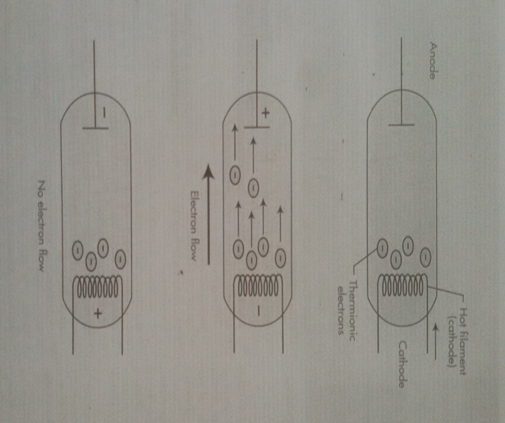
Fig 2: Schematic diagram of diode which conduct electrones in only one direction
Filtration
X – ray used in dentistry must be able to penetrate dental hard tissues (teeth and bone). The longer wave length X – ray (soft X – ray) are not useful in diagnostic radiology thus removal of these long wave length photons from the beam by passing the beam through a filter made from Aluminum which absorb most of long wave length photons (soft X – ray), the resulting X – ray beam will consist mainly of X – ray photons with short wave length, high energy photons and high penetrating power that’s why they named (hard X – ray beam).
Types of filtration:
- Inherent filtration: done by filter built-in to the X – ray machine by manufacturer (as glass wall , the insulating oil and the metal housing of the tube). The inherent filtration tends to increase with age because some of tungsten metal of both target and filament is vaporized and deposited on the inside of the tube window.
- Added filtration : done by using aluminum sheet as extra filter.
*[total filtration = inherent filtration + added filtration]
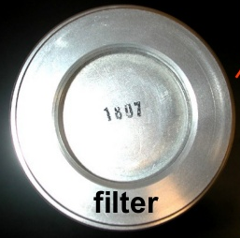 fig 3: aluminum filter attached to the tube head

Collimation
Is a process used to control the size and shape of X – ray beam. In diagnostic radiography its essential to get the diameter of circular X – ray beam at patients skin surface is not great than 2.75 inches, while for Rectangular X – ray beam the dimensions at the skin should be approximately 1½ × 2 inches.
Types of collimators:
- diaphragms (round or rectangular shape).
- metal cylinders, cones and rectangular tubes.

Diaphragm Consists of a metal plate or disk made from lead with a hole in the center of the disk which allow the beam to pass through it only.
The shape of X – ray beam determine by the shape of the diaphragm hole such diaphragm is placed over the opening in the head of X – ray machine.

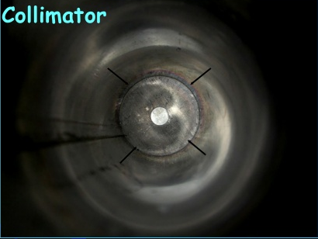 fig 4: collimator attached to the end of tube head

a b

X- ray Film
X- ray Film
exposed
tissues

Fig 5: comparison between exposed tissues with round and rectangular collimators

Half – value layer:
It’s a method of monitoring the penetration quality of the X – ray beam. Determination of half – value layer is done by placing thin filtering material such as aluminum filter in front of the beam so we continue increase the thickness of filtering material until we have a thickness that reduce the number of X – ray photons in the beam passing through it to (one half) this will representing a half – value layer for such beam of radiation.
High half value layer the high penetrating ability of the beam. In oral diagnosis the acceptable value is approximately 2 mm of aluminum

Types of radiation

- Central ray: is X– ray photons that traveling in very center of the cone of radiation (radiation beam), and its commonly used to fix and locate the position of X – ray beam.
- Bremsstrahlung radiation: radiation produced when projectile electron is slowed by the electric field of target atom nucleus.
- Characteristic radiation: radiation produced when an outer shell electron fills an inner shell void (empty orbital).
- Primary radiation: Radiation emerging from the X – ray machine in form of collimated useful X – ray beam
- Secondary radiation: Radiation result from interaction of primary beam with matter
- Leakage radiation: x-ray that escape through the protective housing and result in unnecessary exposure of the patient and radiologic technologist and have no value in diagnostic radiology.

Definition of terms used in X – ray interaction:-
- Scattering: - change in direction of photon with or without a loss of energy.
- Absorption: - deposition of energy i.e. removal of energy from the beam.
- Attenuation: - reduction in the intensity of X – ray beam caused by absorption and scattering attenuation = absorption + scattering.
- Ionization: - removal of an electron from neutral atom.

X-ray interaction with matter (Absorption of X – ray)
x – Ray are absorbed by any form of matter (solid, liquid, and gas) when photons reach an atom, different types of interaction may occur depend on photon energy:
- X – Ray photons can pass through the atom without any change occurred to both of them.
- Coherent scattering sometimes called classical scattering or Thompson scattering occur by interaction of low energy x-ray photon and atom . there is no lose of photon energy only changes in direction (photon of scattered radiation) .
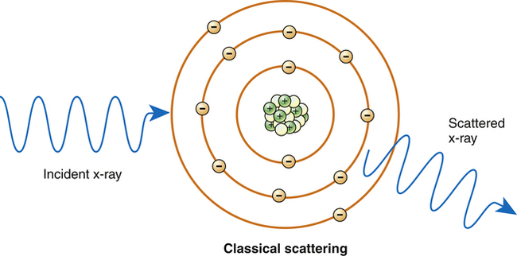

- Compton effect: occur between moderate energy x-ray photon and free or loosely bound outer shell electron of atom. It result in ionization of atom (ejection of Compton recoil electron) , reduction of photon energy (there is some absorption of photon energy by ejected electron which undergoes further ionization interaction within the tissue) , and change in x-ray direction (scattered radiation ).
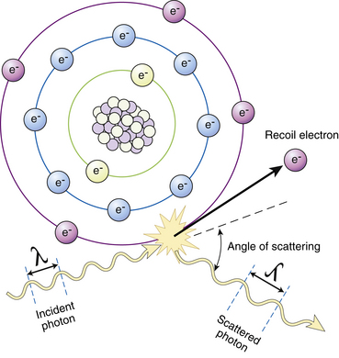
- Photoelectric effect: occur by X – Ray photon interaction with inner – shell electron of the tissue atom (ex. From k shell) , the X – ray photon disappears and deposits all its energy this process is pure absorption. Now the inner – shell electron is ejected with considerable energy (now called a photo – electron) in to the tissue for further interaction with other electrons of other tissue atoms. So this high – energy ejected photo electron behaves like the original high energy X – ray photons interact and eject other electrons as it passes through the tissues, these ejected electrons are responsible for the majority of ionization interactions within the tissue and the possible resulting damage attributable to the X – rays.

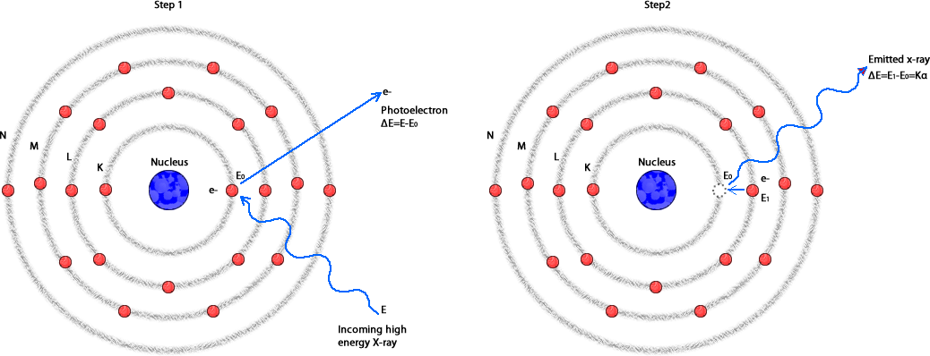
When k electron removed out of its orbital, an electron from L shell falls in to k shell and release energy in the form of x-ray photon. This photon has definite wavelength of a particular element, this phenomena is used to identify elements and the radiation is called characteristic radiation.
There are two other types of interaction Pair production ( between high energy x-ray photon and nuclear force field ) and photodisintegration (between high energy photon and nucleus) but both of them not occur in diagnostic radiology.
X-ray measuring units:
- Traditional Units
- Roentgen ( R) is the basic unit of radiation exposure for the amount of X-radiation or gamma radiation which will produced in one cc of air ions carrying one electrostatic unit of either sign.
- rad ( roentgens absorbed dose ) is a measure of the amount of energy absorbed by an organ or tissue.
- rem ( roentgens equivalent man ) is a measure of the degree of damage caused to different organs or tissues.
- Curie (Ci) : is the unit of quantity of radioactive material and not the radiation emitted by that material.
- RBE: is a relative biological effectiveness dose.

- International system of units SI Units
- Coulomb per kilogram (C\kg) : 1 C\kg = 3876 R
- Gray (Gy) : 1 Gy = 100 rad
- Sievert (Sv) : 1 Sv = 100 rem
- Becquerel (Bq) : 1 Bq=2.7 x 10*11 Ci

