Lec.1
Periodontics
Treatment planning for patients With Periodontal Diseases
The ultimate goal for every patient is to bring his or her mouth to a state of health and maintain it long term.This begins with educating the patient on the problems in his or her mouth and the etiologies,treatment,and prevention of these problems.A properly formulated treatment plan is paramount to achieving this goal.A treatment plan is a plan for therapy formulated only after a thorough examination has been completed,diagnosis and prognosis have been determined and the needs and desires of the patient have been taken into consideration.It must be recognized that as diagnosis and prognosis will change with treatment,therapeutic needs may also change.As such,the treatment plan must be changed accordingly.
The treatment plane for patients with periodontal disease include the following phases :
- Phase I therapy ( initial, cause related therapy , non surgical therapy )
- Phase II therapy ( surgical therapy )
- Phase III therapy ( restorative therapy)
- Phase IV therapy ( maintenance therapy )
The aim of the treatment plan is total treatment that is,coordination of all the immediate,intermediate,and long-term goals for the purpose of creating a well-functioning dentition in a healthy periodontal environment.
The Immediate goals are the elimination of all infections and inflammatory processes that cause periodontal and other oral problems that may hinder the patient’s general health.Basically,the immediate goals are to bring the oral cavity to a state of health.This may require patient education on infectious oral diseases and disease prevention,periodontal procedures,endodontics,caries control,oral surgery,and treatment of oral mucous membrane pathologies.Referral to other dental and medical specialities may be necessary.
The intermediate goals are the reconstruction of a healthy dentition that not only fulfils all functional and aesthetic requirements but lasts many years.Restoration of health,function,aesthetic and longevity involves endodontic,orthodontic,periodontal,and prosthodontic considerations as well as the age,health,and desires of the patient
The long-term goal is maintenance of health through prevention and professional supportive therapy.The long-term goal is set,and both the patient and the clinician work toward it from the very first visit.Once active disease has been controlled,all infectious and inflammatory processes have been eliminated and health has been attained,health should be maintainable for the rest of the patient’s life.
Maintenance of health requires patient education on disease prevention and oral hygiene at the onset of treatment,meticulous daily home care by the patient,and patient adherence to professional recall maintenance at a regular interval.
The treatment plane is the blueprint for case management.It includes all procedures required for the establishment and maintenance of oral health and involves decisions regarding the following:
- Emergency treatment(pain,acute infections)
- Removal of nonfunctional and diseased teeth,and possibly strategic extraction of healthy teeth to facilitate the prosthetic reconstruction of the patient
- Treatment of periodontal diseases(surgical or nonsurgical,regenerative or resective)
- Endodontic therapy(necessary and intentional)
- Caries removal and placement of temporary and final restorations
- Occlusal adjustment and orthodontic therapy
- Replacement of missing teeth with removable or fixed dental prostheses or dental implants
- Aesthetic demands
- Sequence of therapy
Extracting or Preserving a Tooth
Removal,retention,or temporary(interim)retention of one or more teeth is an important part of the overall treatment plan.A tooth should be extracted under the following conditions:
- It is so mobile that function becomes painful.
- It can cause acute abscesses during therapy.
- There is no use for it in the overall treatment plan.
In some cases,a tooth can be retained temporarily,postponing the decision to extract until after treatment is completed.A tooth in this category can be retained under the following conditions:
- It maintains posterior stops; the tooth can be removed after treatment,when it can be replaced by an implant or another type of prosthesis.
- It maintains posterior stops and may be functional after implant placement in adjacent areas.When the implant is restored, these teeth can be extracted.
- In the anterior aesthetic zone,a tooth can be retained during periodontal therapy and removed when treatment is completed and a permanent restorative procedure can be performed.The retention of this tooth should be not jeopardize the adjacent teeth.This approach avoids the need for temporary appliances during therapy.
- Extraction of hopeless teeth can also be performed during periodontal surgery of the adjacent teeth.This approach reduces the number of appointments needed for surgery in the same area.
Sequence of Therapy
The periodontal treatment sequence is presented in the following figures .Immediately after completion of phase I therapy, the patient should be placed on the maintenance phase IV to preserve the results obtained and prevent any further deterioration and recurrence of disease. While on the maintenance phase, with its periodic evaluation, the patient enters into the surgical phase II and the restorative phase III of treatment .
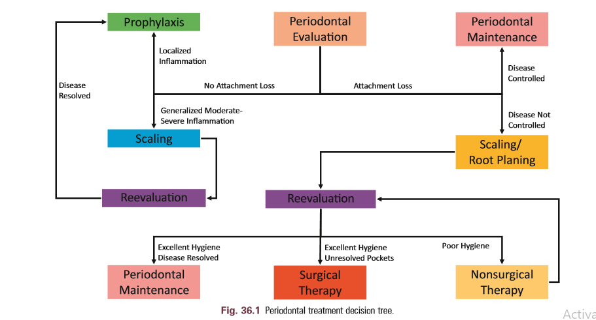

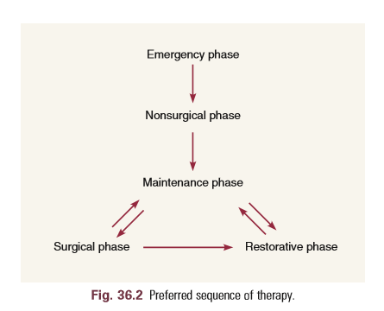

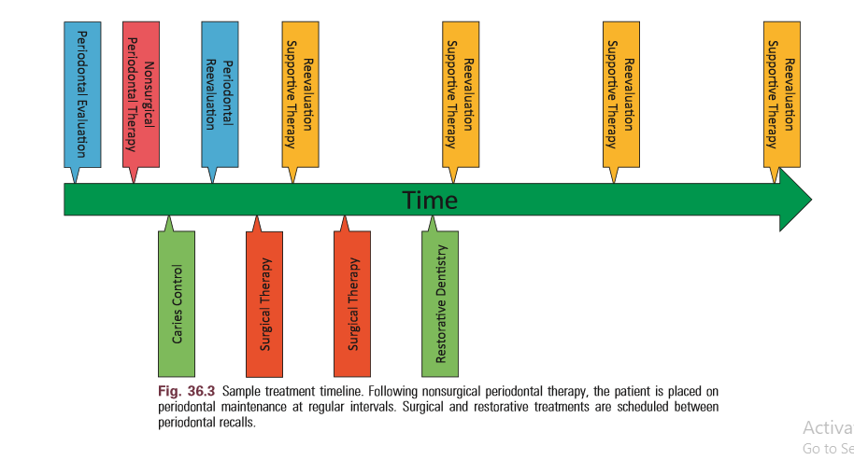

Phase I Therapy
Objectives of initial phase I (cause – related therapy):
The objective is to alter or eliminate the microbial etiology and factors that contribute to gingival and periodontal diseases to the greatest extent possible,thereby halting the progression of disease and returning the dentition to a state of health and comfort.The phase I therapy aimed at removal of pathogenic biofilms, toxins and calculus and the reestablishment of a biologically acceptable root surface . This is accomplished by:
1) patient education and oral hygiene instruction for plaque or biofilm control.
2)Complete removal of supragingival and subgingival plaque or biofilm and calculus ( Scaling & root planing).
- Possible use of Antimicrobial agents (local or systemic).
- Correction or replacement of poorly fitting restorations and other prosthetic devices
- Restoration or temporization of carious lesions.
- Treatment of Occlusal trauma .
- Treatment of food impaction areas
- Orthodontic tooth movement treatment.
- Extraction of hopeless teeth
Motivation: Detailed information must be given to the
patient regarding his/her periodontal disease, its etiological
factors, symptoms, consequences, prognosis and the
relationship between the presence of dental plaque and
calculus in the mouth and the location of sites showing dental
disease by using plaque disclosing agents. These information
are aimed at motivating the patient to cooperate in the
treatment hence without compliance (which has been
described as the degree to which a patient follows a regimen
prescribed by a dental professional), a good treatment
outcome will not be achieved.
Mechanical plaque control demands active participation of
the individual subject and the establishment of proper oral
homecare habits is a process that depends on the behavioral
changes, thus the patient's positive attitude to treatment may
have a positive long-term effect on his/her tooth cleaning
efforts. In addition, dental professionals should try to
emphasize on the role of the patient personal oral hygiene
procedures in the prevention of dental diseases &they should
encourage the patient to take responsibility for his/her own
oral health. Finally, if the clinician can establish the link
between oral health & general health for the patient, this
individual may be more willing to establish proper hygiene
measures as part of his/her lifestyle.
Disclosing agent: Since dental plaque is white, sometimes
it cannot easily be identified, particularly if it is not thick
enough and/or the observer is not well trained. A disclosing
agent is a chemical compound (tablets or solution) that stains dental plaque such as erythrosine, fuschsine or a fluorescein.
These agents should be used to demonstrate the presence and
location of plaque in addition to the evaluation of the efficacy
of the patient's homecare technique thus they should be
applied after tooth brushing and interdental cleaning.
Self-Performed Plaque Control:
Dental plaque is a bacterial biofilm that resides on tooth
surfaces or soft tissues and is not easily removed from the
surfaces of teeth. Supragingival plaque is exposed to saliva and
to the natural self-cleansing mechanisms existing in the oral
cavity, but such mechanisms do not adequately remove plaque.
Therefore, the regular use of personal oral hygiene measures
(refer to the efforts of the patient to remove suragingival
plaque) is essential to the dental and periodontal health
because plaque is the major etiological factor in periodontal
disease thus plaque removal reduce symptoms of inflammation
(bleeding, redness, swelling), inhibit the progression of the
disease & inhibit the formation of supra & subgingival calculus
which is a plaque retentive factor.
Furthermore, meticulous, long-term self-performed plaque
removal measures can modify both the quantity & composition
of subgingival plaque therefore, prevention of gingivitis,
periodontitis and loss of attachment are based on the
achievement of sufficient plaque removal. These practices
require not only the appropriate motivation and instruction of
the patient, but also the adequate tools.
Brushing: Although different cleaning devices have been
used in different cultures (toothbrushes, chewing sticks,
chewing sponges … etc.), the most widespread means of
actively removing plaque at home is tooth brushing, The
efficacy of brushing with regard to plaque removal is dependent on:
- The design of the brush.
- The skill of the individual using the brush.
- Frequency & duration of brushing.
Therefore, oral hygiene instructions should include
components such as self-assessment, self-examination, self-
monitoring and self-instruction. For this purpose, plaque
disclosing solution is applied before brushing, and with the aid
of a mirror, the patient can identify the amount of plaque
formed after the last brushing episode thus receiving
information about his/her cleaning performance. Later on, the
disclosing agent should be applied after brushing, which allows
the patient to identify areas needing additional cleaning efforts.
Methods of tooth brushing:
Tooth brushing instruction should involve a description of
specific brushing methods, the grasp of the brush, the
sequence & amount of brushing, the area of limited access, and supplementary brushing of the occlusal surfaces and the
tongue.
However, the design of brushes or a specific brushing method
are of secondary importance to the skills of the individual in
using the brush. Thus the simplest, least time consuming
procedures that will effectively remove plaque without causing any damage to the tissues and use of the technique
on a regular basis should be recommended.
If a patient prefers a specific method the clinician can
evaluate & modify the technique to maximize the effectiveness
rather than changing it. However, there is no single method
that is correct for all patients. The morphology of the dentition
(crowding, spacing, gingiva phonotype… etc.), the type and
severity of the periodontal tissue destruction, the patient's own
manual dexterity (= skill), as well as morphologic situation
(longer teeth, Open interdental spaces, exposed dentin) during
the course of periodontitis therapy determine what kind of
hygiene aids and methods are to be used. Different tooth
brushing methods have been recommended. Such methods can
be classified based on the position & motion of the brush.
- Horizontal brushing (scrub): Most individuals use such
method since it is simple. The head of the brush is
positioned at a 90° angle to the tooth surface and then a
horizontal movement is applied. The occlusal, lingual &
palatal surfaces of the teeth are brushed with open mouth and the vestibular surfaces are cleaned with the mouth closed.
- Vertical brushing (Leonard technique): lt is similar to the horizontal brushing technique, but the movement is applied in a vertical direction using up & down motion.
- Circular brushing (Fones Technique): with the teeth closed, a circular motion is applied that extends from the maxillary gingiva to the mandibular gingiva. Horizontal movements are used on the lingual and palatal tooth surfaces.
- Vibratory technique (Stillman technique):The head of the brush is positioned in an oblique direction toward the apex, with the bristles placed partly on the gingival margin and partly on the tooth surface. Light pressure with a vibratory movement is then applied to the handle without moving the brush from its original position.
- Roll technique (Modified Stillman technique): The brush is positioned in a similar manner to the vibratory technique, but after applying a small vibratory pressure, the head of the brush is rolled in an occlusal direction.
- Charters Technique: The head of the brush is positioned in an oblique direction with the bristles directed towards the occlusal surface. A vibratory (rotary) movement is then applied without moving the brush from its position. This method is effective in cases with receded interdental papilla because the bristles can penetrate the interdental space.
- Sulcular technique(Bass technique) The head of the brush is positioned in an oblique direction towards the apex and bristles are directed into the sulcus at 45° to the long axis of the tooth. The brush is moved in a back & forth direction using short strokes. On the lingual surfaces in the anterior regions the brush head is kept in the vertical direction. This method is effective in removing plaque not only at the gingival margin, but also could reach a depth of about 1mm subgingivally.
- Modified Bass technique: The brush is positioned similarly to the Bass/Stillman technique, but after applying a back and forth movement, the head of the brush is rolled in an occlusal direction. It is a combination of the Bass & the modified Stillman techniques.
Tooth brushes requirements:
The features of a manual toothbrush in periodontics must be
Nylon, Soft-medium strength, rounded ends filaments. A
smaller head is easier to reach all areas of the oral cavity and
should be trimmed flat and be multi-tufted with all tufts being
of the same length.
The 3 brush heads clean vestibular, occlusal & oral tooth
surfaces thus this design was superior to other brushes.
Frequency: Brushing twice a day is recommended, especially
at night, just before going to bed.
Duration: Brush for a minimum of 2 minutes, covering all
areas of the oral cavity.
* lt is recommended that the toothbrush is to be replaced
every 2-3 months, because a worn toothbrush with frayed
filaments loses resilience and is less effective in removing
plaque than a new brush.
Electric toothbrushes: Studies have shown that efficiency
in plaque removal with the electric toothbrushes is at least as
good as correctly used manual toothbrush, but there are added
benefits for those with limited manual dexterity, that includes
the elderly, those with arthritis in their hands and wrists,
children, hospitalized individuals, physically or mentally
handicapped & patients with neurological disorders. Electric
brushes has also been recommended to non-compliant patients as they are easier and faster than manual.
Dentifrices: A dentifrice is usually used in combination with
tooth-brushing with the purpose of facilitating plaque removal
and applying agents to the tooth surfaces for therapeutic or
preventive reasons. The most important active ingredient in
toothpaste:
- Fluoride: prevent caries,
- Desensitizing agent: alleviate sensitivity of exposed dentin.
- Anti-plaque agents:
- Triclosan: antibacterial agent.
- Stannous fluoride.
- Chlorhexidine: plaque inhibiting agent.
- Anti- Calculus agent: reduces the formation of supragingival calculus.
- Bicarbonate: reduce the acidity of dental plaque.
- Cleaning + Polishing agents: these abrasive agents should
have particle size and shape which facilitate plaque & stain removal without producing hard & soft tissue damage
- Whitening agents: whiten stained teeth.
- Detergents: sodium Iauryl sulfate has antimicrobial & plaque inhibitory properties
Interdental Cleaning
Since interproximal areas are
1) The worst for food & plaque stagnation
2) Earliest areas to be affected.
3) The tooth brush does not reach the interproximal spaces efficiently as they are difficult to access.
Thus, gingivitis & periodontitis are usually more pronounced
in these areas. Caries also occur more frequently in the
interdental region; therefore, interdental plaque removal,
which cannot be achieved with toothbrush, is of critical
importance for most patients. A number of interdental cleaning
methods have been used for this purpose however, all these
devices are effective but not all of them suit all patients or all
types of dentitions.
Factors we need to consider when selecting the appropriate
interdental cleaning method are:
- The contour & consistency of the gingival tissues.
- The size & shape of the interproximal space.
- The morphology of the proximal tooth surface.
- Tooth position & alignment.
- The manual dexterity & motivation of the patient.
- Fixed dentures & orthodontic appliances.
- Restorations.
Dental floss & tape:
Flossing is the most universally applicable method. Clinical
studies show that when tooth brushing is used together with
flossing more plaque is removed from the proximal surfaces
than by brushing alone. Flossing removes up to 80% of proximal
plaque. Even subgingival plaque can be removed since dental
floss can be introduced 2-3.5 mm below the tip of the papilla.
Dental floss is most useful where the interdental papilla
completely fill the embrasure space in healthy patients. Several
types of floss are available:
- Unwaxed is used in normal tooth contacts because it slides easily.
- Waxed is used in tight proximal tooth contacts & after
brushing because the wax deposits prevent fluoride from the toothpaste to precipitate on teeth. However, no difference in the effectiveness between both types was demonstrated.
- A floss holder to facilitate flossing might be used.
- Tape: a type of broaded dental floss used for cleaning
bridge pontics.
- Super floss used for patients with crowns, bridges &
orthodontic.appliances.
Recently, powered flossing devices have been introduced.
Floss is used in a vertical direction. If it is used in a horizontal motion, the teeth can develop a grooved surface. Finally, flossing is a difficult & time consuming method.
Wood sticks:
They are indicated for plaque removal, if the interdental
spaces are slightly open (recession) and even in cases of poor
manual dexterity since they are easy to use. Wood sticks are
usually made of soft wood & have a triangular shape. Recently,
brush sticks have been introduced they are elastic with tiny
hair-like bristles and fine plastic files. Concavities can be
cleaned very well with these devices.
Interdental brushes:
These are the aid of choice for:
- Widely open interdental spaces.
- When root surfaces with concavities or grooves have
been exposed.
- In through-and-through furcation defects in
periodontitis patients.They are manufactured in different sizes & forms. The most common forms are cylindrical or conical shaped head. It is believed that the most efficient cleaning results are achieved if the brush selected slightly larger than the interdental space. They are easy to use & can also be used as a carrier to apply fluoride or chlorhexidine gel into the interdental space. When brushes are not properly used, they may cause dentin hypersensitivity, thus interdental brushes should be used without dentifrices except in special cases and for short term.
Single tufted brushes:
They are ideal for cleansing areas which cannot be reached
with other devices. They are designed to improve access to
distal surfaces of posterior molars, tipped & rotated teeth, to
clean around & under fixed appliances, pontic, orthodontic
appliances and teeth affected by gingival recession & furcation
involvement.
Adjunctive aids:
Dental water jet: The daily use of oral irrigation has been
shown to reduce gingivitis & bleeding. The pulsating
hydrodynamic forces produced by irrigators can rinse away
food debris from interdental spaces & plaque retentive areas.
Irrigation is not however, a monotherapy but used as an
adjunct to brushing & flossing. They may be used with water or
with chlorhexidine that lead to improved plaque inhibition and
had an anti-inflammatory effect. With specially designed tips
the fluid may penetrate deeply into the pocket.
Tongue cleaners: The dorsum of the tongue harbors a great
number of microorganisms. These bacteria may serve as a
source of bacterial dissemination to other parts of the oral
cavity (e.g. Tooth surfaces) and may contribute to dental plaque formation & halitosis. Therefore, tongue brushing or scraping has been advocated as part of daily home oral hygiene, together with tooth brushing & flossing to remove
microorganisms & debris from the tongue. Patients should be informed t0 clean particularly the posterior portion of the dorsum.
Effects & sequelae of the incorrect use of mechanical plaque
removal devices:
Tooth brushing can cause damage both to soft & hard tissues.
Trauma to the soft tissues results in gingival erosion & gingival
recession. Trauma to hard tissues leads to cervical abrasion of
the tooth surface which is mainly caused by the abrasives in the
dentifrice. These lesions have been associated with toothbrush
stiffness, the method of brushing, brushing frequency/time,
excessive brushing force, and improper use of both manual and
powered tooth brushing.
The use of dental floss, interproximal brushes & wood sticks
may also induce soft tissue damage; however, in most cases
this damage is limited to acute lesions, such as lacerations and
gingival erosions.

