**General pathology Dr. Layla Sabri**

|  |
| --- |
| **Diseases of the Immune System** |

|  |
| --- |
| **Immunity**:  It is protection against infections. The immune system is the collection of cells and molecules that are responsible for:   1. Defending our body against pathogenic microbes in our environment. 2. Prevent the proliferation of cancer cells. 3. Mediate the healing of damaged tissue. |
| Defense against microbes consists of two types of reactions:  **1- Innate immunity** (natural or native immunity): It is mediated by cells and proteins that are always present and act immediately against any infection. The major components of innate immunity are:   1. Epithelial barriers of the skin, gastrointestinal tract, and respiratory tract, which prevent microbe entry. 2. Phagocytic leukocytes (neutrophils and macrophages). 3. A specialized cell type called the natural killer (NK) cell. 4. Several circulating plasma proteins, the most important of which are the proteins of the complement system. | |

|  |
| --- |
|  |

|  |
| --- |
| **2- Adaptive immunity** (acquired or specific immunity). It is normally silent and responds (or "adapts") to the presence of an infectious microbes by becoming active for neutralizing and eliminating the microbes. The components of the adaptive immunity are lymphocytes and their products. The terms "immune system" and "immune response" refer to adaptive immunity. |

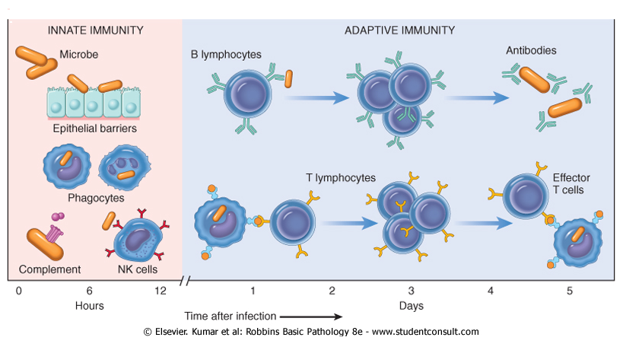

|  |  |  |  |
| --- | --- | --- | --- |
| |  | | --- | | **Types of adaptive immunity:**  **1-Humoral immunity***:* Mediated by soluble **antibody** proteins  that are produced by **B lymphocytes** (B cells).Antibodies provide  protection against extracellular microbes in the blood, mucosal  secretions, and tissues.  **2-Cell-mediated (or cellular) immunity***:* Mediated by **T lymphocyte**(T cells) which are important in defense against intracellular microbes. They work by either directly killing infected cells (by cytotoxic T lymphocytes) or by activating phagocytes to kill ingested microbes, via the production of soluble protein mediators called cytokines (made by helper T cells). |  |  | | --- | |  |  |  | | --- | | When the immune system is inappropriately triggered or not properly controlled, the same mechanisms that are involved in host defense will cause tissue injury and disease.  The reaction of the cells of innate and adaptive immunity may be manifested as **inflammation** which is a beneficial process, but it is also the basis of many human diseases. |   C:\Users\Dell\Desktop\hu imm.png  **Cells and tissues of the immune system:** |

|  |
| --- |
|  |

|  |
| --- |
| 1-Lymphocytes, which are the mediators of adaptive immunity.  2-Specialized antigen-presenting cells (APCs), which capture and  display microbial and other antigens to the lymphocytes.  3-Various effector cells, that eliminating the antigens (microbes). |

|  |
| --- |
|  |

|  |
| --- |
| **Lymphocytes:** |

|  |
| --- |
| Lymphocytes are present in the circulation and in various lymphoid organs as two types:  **Tlymphocytes**(mature in the thymus).  **Blymphocytes**(mature in the bone marrow).  Each T or B lymphocyte expresses receptors for a single antigen, and the total population of lymphocytes (numbering about 1012 in humans) is capable of recognizing tens or hundreds of millions of antigens*.* |

|  |
| --- |
|  |

|  |
| --- |
| **T Lymphocytes:** |

|  |
| --- |
| They are the effector cells of cellular immunity and provide important stimuli for antibody responses to protein antigens. T cells do not detect free or circulating antigens. Instead, the vast majority (>95%) of T cells recognize only protein antigens that are displayed on other cells bound to proteins of the major histocompatibility complex (MHC; or human leukocyte antigen [HLA] complex).  The normal function of MHC molecules is to display protein for recognition by T lymphocytes thus perform their function of killing infected cells or activating phagocytes or B lymphocytes that have ingested protein antigens. |

|  |
| --- |
|  |

|  |
| --- |
|  |

|  |
| --- |
| **B Lymphocytes** |

|  |
| --- |
| B cells synthesize antibodies or immunoglobulins=Ig = five classes: IgG, IgM, IgA, IgE and IgD.After stimulation, B cell will be differentiated into **plasma cells** which secrete large amounts of antibodies, which are the mediators of humoral immunity. |

|  |
| --- |
|  |

|  |
| --- |
| **Natural Killer Cells** |

|  |
| --- |
| They are lymphocytes of innate immunity which have limited set of activating receptors so they do not have specificities as diverse as do T cells or B cells. They can recognize molecules expressed on stressed or infected cells or cells with DNA damage, and then kill these cells.  NK cells express inhibitory receptors that recognize self class I MHC molecules, which are expressed on all healthy cells; so theyavoid attacking normal host cells. Infections (especially viral infections) and stress are associated with loss of expression of class I MHC molecules so NK cells are released from their inhibition and destroy the unhealthy host cells. |

|  |
| --- |
|  |

|  |
| --- |
| **Antigen-Presenting Cells** |

|  |
| --- |
| These cells are specialized to capture microbial antigens and display them to lymphocytes. These APCs are dendritic cells (DCs) and macrophage. |

|  |
| --- |
|  |

|  |
| --- |
| **1-Dendritic Cells** |

|  |
| --- |
| Cells with fine dendritic cytoplasmic processes occur as two functionally distinct types. **InterdigitatingDCs**, are non-phagocytic cells that express high levels of class II MHC and T-cell co stimulatory molecules.  Immature DCs reside in epithelia, where they are located to capture entering microbes; an example is the Langerhans cell of the epidermis.  Mature DCs are present in the T-cell zones of lymphoid tissues, where they present antigens to T cells circulating through these tissues. DCs are also present in the interstitium of many non-lymphoid organs, such as the heart and lungs, where they can capture the antigens of microbes that have invaded the tissues. |

|  |
| --- |
|  |

|  |
| --- |
| **Follicular dendritic cells**(FDCs), located in the germinal centers of lymphoid follicles in the spleen and lymph nodes. These cells bear receptors for the Fc tails of IgG and for complement proteins, and hence efficiently trap antigen bound to antibodies and complement. |

|  |
| --- |
|  |

|  |
| --- |
|  |

|  |
| --- |
| **2- Macrophages**:  Ingest microbes and other particulate antigens and display them for recognition by T lymphocytes which in turn activate the macrophages to kill the microbes, the central reaction of cell-mediated immunity. |

|  |
| --- |
|  |

|  |
| --- |
| **Effector Cells** |

|  |
| --- |
| Many different types of leukocytes perform the adaptive immune response, which is to eliminate infections. These include **NK cells**,  **Antibody-secreting plasma cells**,**T lymphocytes**, **Macrophages**  .  T lymphocytes secrete **cytokines** that recruit and activate other leukocytes, such as neutrophils and eosinophils, which will function in defense against various pathogens. |

|  |
| --- |
|  |

|  |
| --- |
| **Lymphoid Tissues:**  Divided into**:** |

|  |
| --- |
| 1. Generative (primary) organs, where lymphocytes express antigen receptors and mature. These include the thymus and bone marrow. 2. Peripheral (secondary) lymphoid organs, where adaptive immune responses develop. The peripheral organs are the lymph nodes, spleen, and mucosal and cutaneous lymphoid tissues. |

|  |
| --- |
| Cells **and Tissues of Immune the System**:**Summary**  **Lymphocytes** are the mediators of adaptive immunity and the only cells that produce specific and diverse receptors for antigens.  **T (Thymus-derived) lymphocytes** express antigen receptors called T cell receptors (TCRs) that recognize protein antigens that are displayed by MHC molecules on the surface of antigen-presenting cells.  **B (Bone marrow-derived) lymphocytes** express membrane-bound antibodies that recognize a wide variety of antigens. B cells are activated to become plasma cells, which secrete antibodies or immunoglobulines.  **Natural killer (NK) cells** kill cells that are infected by some microbes, or are stressed and damaged beyond repair. NK cells express inhibitory receptors that recognize MHC molecules that are normally expressed on healthy cells, and are thus prevented from killing normal cells.  **Antigen-presenting cells (APCs)** capture microbes and other antigens, transport them to lymphoid organs, and display them for recognition by lymphocytes. The most efficient APCs are:  **dendritic cells**, which live in epithelia and most tissues and **macrophages** which ingest microbes and other particulate antigens and display them for recognition by T lymphocytes. |

Under normal conditions, the immune response prevents disease, but occasionally, the inappropriate activation of the immune system can lead to debilitating or life-threatening illnesses, like:

1. Allergic or hypersensitivity reactions.
2. Transplantation immunopathology.
3. Autoimmune disorders.
4. Immunodeficiency states.

**Allergic orhypersensitivitydisorders:**

**Hypersensitivity:** itis defined as an exaggerated immune response to a foreign agent resulting in injury to the host. It is caused by immune responses to environmental antigens called **allergens** that produce inflammation and cause tissue injury.

**Allergens:** Any foreign substances capable of inducing an immune response. Many different chemicals of natural and synthetic origin are known as allergens.

Complex natural organic chemicals, especially proteins, are more likely to cause an immediate hypersensitivity response, whereas simple organic compounds, inorganic chemicals, and metals more commonly cause delayed hypersensitivity reactions. Exposure to the allergen can be through inhalation, ingestion, injection, or skin contact.

**Hypersensitivity disorders are of four types:**

Type I: IgE-mediated disorders.

Type II: Antibody-mediated (cytotoxic) disorders.

Type III, Immune-Complex Disorders

Type IV: Cell-mediated hypersensitivity reactions.

**Type I, IgE-Mediated Disorders (Immediate type):**

They are immediate-type of hypersensitivity reactions that are triggered by binding of an allergen to a specific IgE found on the surface of mast cells or basophils.

Mast cells, (tissue cells), and basophils, (blood cells), are derived from blood precursor cells. Mast cells are distributed throughout connective tissue, near surfaces that are exposed to environmental antigens especially in areas beneath the skin and mucous membranes of the respiratory, gastrointestinal, and genitourinary tracts, and adjacent to blood and lymph vessels.

Basophils are similar to mast cell in many aspects but its role in this type of hypersensitivity is not well established because it is not present in the tissues but circulating in the blood.

Mast cells and basophil shave granules that contain potent mediators of allergic reactions. During the sensitization, the allergen-specific IgE antibodies attach to receptors on the surface of these cells triggers a series of events that lead to degranulation of the sensitized cells, causing release of their allergy-producing mediators which include:

**Histamine**, a potent vasodilator that increases the permeability of capillaries and venules, causes bronchoconstriction and increasedsecretion of mucus.

**Acetylcholine** produces bronchialsmooth muscle contraction and dilation of small blood vessels.

**Proteases** generate kinins and cleave complement components

to produce additional chemotactic and inflammatory mediators.

**Leukotrienes** and **prostaglandins** produce responses similar to those of histamine and acetylcholine, although their effects are delayed and prolonged by comparison.

**Platelet-activating factor** result in platelet aggregation ,histamine release,and bronchospasm. It also acts as a chemotactic factor for neutrophils and eosinophils.

**Cytokines** recruit and activate a variety of inflammatory cells.



Type I hypersensitivity reactions may present as a systemic disorder (anaphylaxis) or a localized reaction (atopy).

**Systemic Anaphylactic Reactions:**

Result from injected allergens (*e.g.,* **penicillin**, **radiographic contrast dyes, and bee or wasp stings**).

More rarely, they may result from ingested allergens (seafood, nuts, and legumes).

**Sign and symptoms**: Anaphylaxis has a rapid onset, often within minutes, there will be:

1. Itching.
2. Urticaria.
3. Gastrointestinal cramps.
4. Difficultyin breathing caused by bronchospasm.
5. Angioedema (swelling of face and throat) may develop, causing upper airway obstruction.
6. Massive vasodilation may lead to peripheral pooling of blood, a profound drop in blood pressure, and life-threatening circulatory shock.

**Localized Atopic Disorders:**

Occur when the antigen is confined to a particular site, usually related to the route of exposure. It is genetically determined and the term **atopy is** often used to imply a hereditary predisposition to such reactions.

They have high serum levels of IgE and increased numbers of basophils and mast cells and they are also responsive to the chemical mediators of allergic reactions.

Atopic disorders include **food allergies**, **allergic rhinitis** (hay fever), **allergic dermatitis**, and certain forms of **bronchial asthma.**

**Type II, Antibody-MediatedCytotoxic Disorders:**

They are the end result of direct interaction between IgG and IgM class antibodies and tissue or cell surface antigens, with subsequent activation of complement- or antibody-dependent cell-mediated cytotoxicity.

Examples of type II reactions include **mismatched blood transfusions,hemolytic disease of thenewborn** caused by ABO or Rh incompatibility, and **certain drug reactions**. In the latter, the binding of certain drugs to the surface of red or white blood cells elicits an antibody and complement response that lyses the drug-coated cell. Lytic drug reactions can produce transient anemia, leukopenia, or thrombocytopenia, which are corrected by the removal of the offending drug.

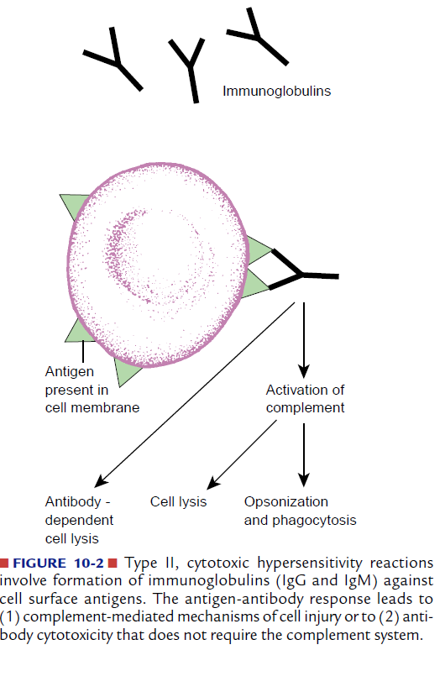

**Type III, Immune-Complex Disorders:**

They are mediated by the formation of insoluble antigen-antibody complexes that activate complement which will generates chemotactic and vasoactive mediators that cause tissue damage by a variety of mechanisms, including alterations in blood flow, increased vascular permeability, and the destructive action of inflammatory cells.

The reaction occurs when the antigen combines with antibody, whether in the circulation (circulating immune complexes) or at extravascular sites where antigen may have been deposited.

Immune complexes formed in the circulation produce damage when they come in contact with the vessel lining or are deposited in tissues,including the renal glomerulus, skin venules, lung, and joint synovium.

There are two general types of antigens that cause immune complex mediated injury:

1. Exogenous antigens such as viral and bacterial proteins.
2. Endogenous antigens such as self-antigens associated with autoimmune disorders.

Type III reactions are responsible for the **acute glomerulonephritis** that follows a streptococcal infection and the manifestations of **autoimmune disorders** such as systemic lupus erythematosus(SLE).

Unlike type II reactions, in which the damage is caused by binding of antibody to body cells, the harmful effects of type III reactions are indirect (*i.e.,* secondary to the inflammatory response induced by activated complement).

**Acute serum sickness** is the type of a systemic immune complex disease.Serum sickness is asyndrome consisting of rash, lymphadenopathy, arthralgias, and occasionally neurologic disorders that appeared 7 or more days after injections of horse antisera for prevention of tetanus. Although this therapy is not used today, the name remains.

The most common causes of this allergic disorder include: **antibiotics** (especially penicillin), **various foods, drugs**, and **insect venoms**. Serum sickness is triggered by the deposition of insoluble antigen-antibody(IgM and IgG) complexes in blood vessels, joints, heart, and kidney tissue.

The deposited complexes activate complement, increase vascular permeability, and recruit phagocytic cells, all of which can promote focal tissue damage and edema.

The signs and symptoms include:

1-Urticaria. 2- Patchy or generalized rash.

1. Extensive edema (face, neck, and joints). 4- fever.



**Type IV, Cell-MediatedHypersensitivity Disorders:**

It is mediated by cells, **not antibodies**; occur 24 to 72 hours after exposure of a sensitized individual to the offending antigen.They are mediated by helper T lymphocytes that are directly cytotoxic or that secrete inflammatory mediators like cytokines that cause tissue changes. Cytokines will attract T or B lymphocytes as well as monocytes, neutrophils, eosinophils, and basophils. Some of the cytokines promote differentiation and activation of macrophages that function as phagocytic and antigen-presenting cells(APCs).

The best-known type of delayed hypersensitivity response is the **reaction to the tuberculin test**, in which inactivated tuberculin or purified protein derivative is injected under the skin. In a previously sensitized person, redness and indurations of the area develop within 8 to 12 hours, reaching a peak in 24 to 72 hours. A positive tuberculin test indicates that a person has had sufficient exposure to the M. tuberculosis organismto incite a hypersensitivity reaction.

Certain types of antigens induce cellmediated immunity with an especially pronounced macrophage response. This type of delayed hypersensitivity commonly develops in response to particulate antigens that are **large, insoluble,** and difficult to eliminate. The accumulated macrophages are often transformed into so-called **epithelioidcells** because they resemble epithelium. A microscopic aggregation of epithelioid cells, which usually are surrounded by a layer of lymphocytes, is called **a granuloma***.* Inflammation that is characterized by type IV hypersensitivity is called **granulomatous inflammation.**

Direct T-cell–mediated cytotoxicity, will cause necrosis of antigen-bearing cells. It is important in the eradication of virus infected cells, autoimmune diseases such as Hashimoto’s thyroiditis, and host-versus-graft or graft-versus host transplant rejection.Allergic **contact dermatitis**and hypersensitivity **pneumonitis** are presented as examples of cellmediated hypersensitivity reactions.

