Periodontics
Lec.4
Mucogingival surgery
Periodontal treatment involving procedures for correction of defects in morphology,position and/or the amount of soft tissue (gingiva and alveolar mucosa) and underlying bone support at teeth and implants.
These procedures are varied from simple *gingivectomies or *crown lengthening procedures ( e.g. To increase the clinical crown length if there is a gummy smile with
a high lip line), to complex gingival grafting procedures. In patients with bone defects *GTR and *bone grafting (Guided bone regeneration, GBR) may also be employed to increase the bulk of available alveolar bone, grafting procedures generally aim Io cover exposed roots, to increase the bulk of the width of keratinized gingiva and to prevent further gingival recession.
Grafting procedures include
- Free gingival graft (epithelium + connective tissue)
- The pedicle sliding graft (Lateral repositioned graft)
- The sub epithelial connective tissue graft (connective tissue)
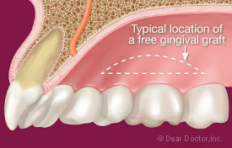
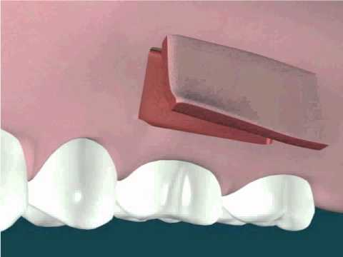

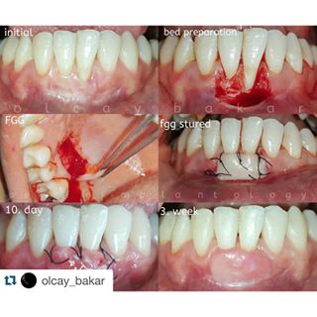Free gingival graft
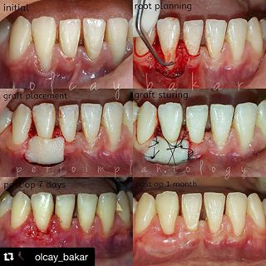
Free gingival graft
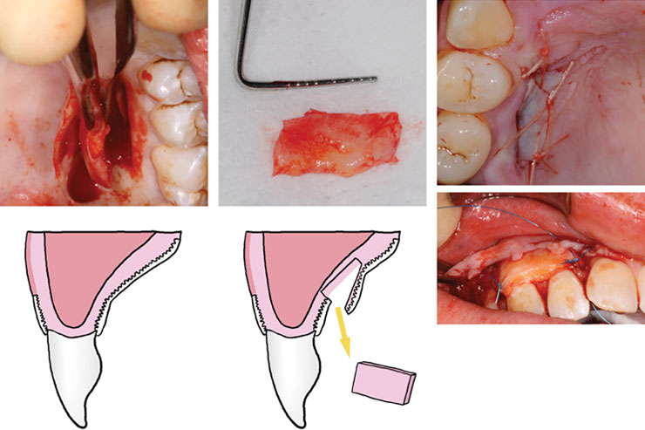
Sub epithelial connective tissue graft
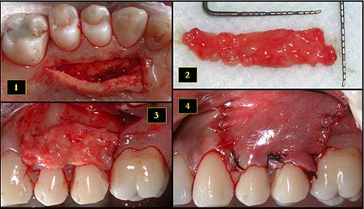
Sub epithelial connective tissue graft

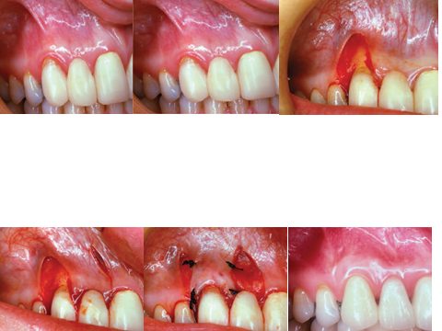
Lateral repositioned graft
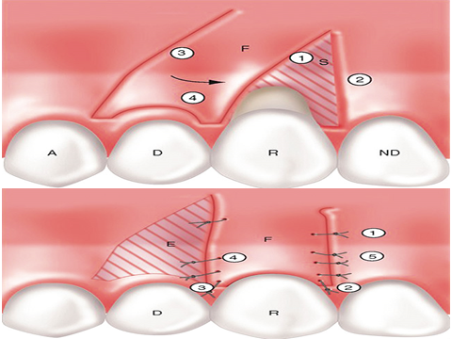
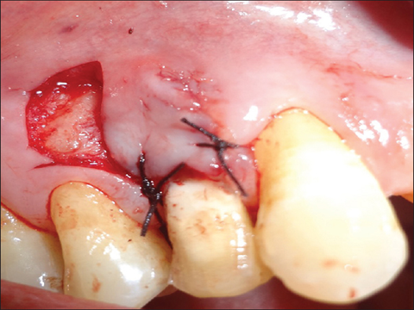
Lateral repositioned graft
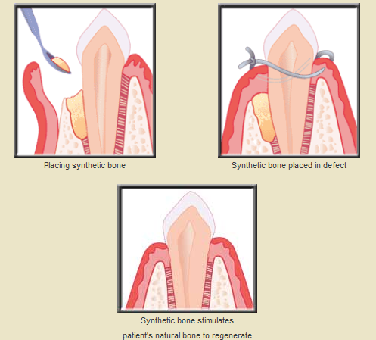
Bone graft (GBR)

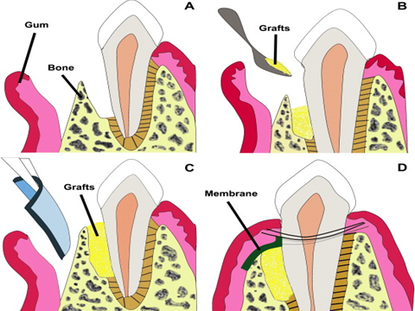
GTR + GBR graft

Guided tissue regeneration GTR
Following periodontal surgery, the instrumented root surface is colonized by gingival epithelial cells to form a long junctional epithelium which prevent the formation of new connective tissue attachment to the root surfaces, thus GTR is achieved by placing barrier membrane over periodontal defect to exclude gingival epithelium and connective tissues cells, and to create a space into which the proliferating cells from periodontal ligament and bone can migrate into healing area. These cells have the
capability to differentiate into fibroblast, cementoblast and osteoblast and thus can produce new periodontal ligament fibers, cementum and bone to regenerate the lost connective tissue attachment to the root surface. Membranes are either non-
resorbable which require removal 4-6 weeks after placement or resorbable which biodegrade within the tissue over 12 months
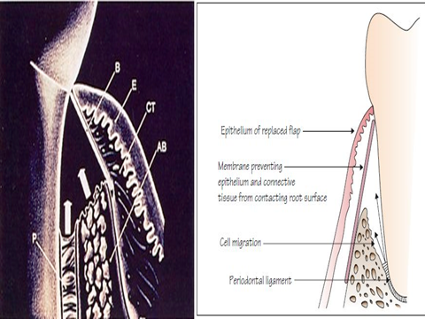
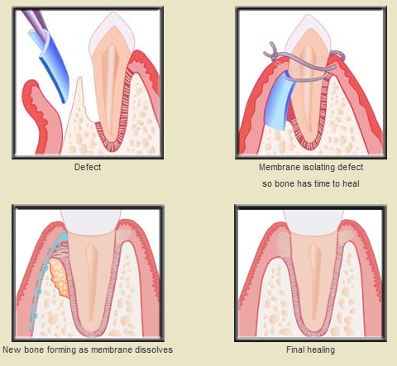
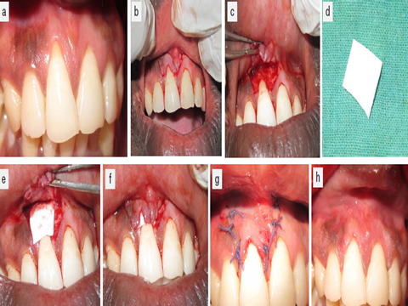
Crown lengthening
Indication
1-Short clinical crown require increased retention for placement of full coronal restoration (including cases of gross tooth wear requiring full mouth rehabilitation)
2-Deep subgingivally located crown preparation margins, resulting in difficulty finishing margins and taking impressions also encroachment on the biologic width
3-Sub gingival caries
4-Root fractures or root resorption in the cervical third of the tooth root
5-Aesthetic improvement of anterior teeth with short clinical crowns and high lip line
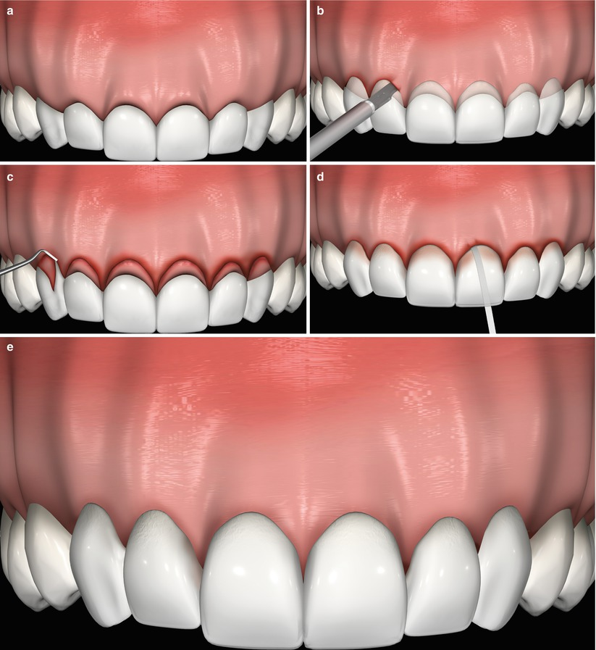
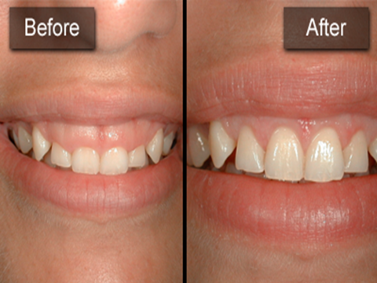
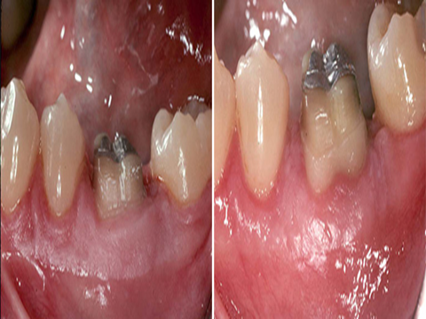

Distal wedge procedures
In many cases the treatment of periodontal pockets on the distal surface of distal molars is complicated by the presence of bulbous tissue over the tuberosity or by a prominent retromolar pad. The direct aproach to pocket elimination in the maxillary
jaw is the gingivectomy, however when limited amount of keratinized gingiva are present, or not at all, or a distal angular bony defect has been diagnosed,the bulbous tissue should be reduced in size rather than being removed, this may be accomplished by the distal wedge procedure which facilitate access to the osseous defect,eliminating the deep pocket and preserve sufficient amount of gingiva and mucosa to achieve soft tissue coverage of the remaining periodontium.
Retro molar flap operation: This can be used distally to last molar near to an edentulous area to gain access for RP and pocket reduction or elimination. Initial incision is done buccally and palatally/lingually (distal wedge) .Tissues between the two incisions(triangular –shaped wedge exicision) are removed & the flap is reflected as much as possible for better visualization of the root surface .The second incisions serve to undermine and thin the buccal and palatal/lingual tissue flaps overlying the alveolar bone. Repositioning the flaps with sutures.

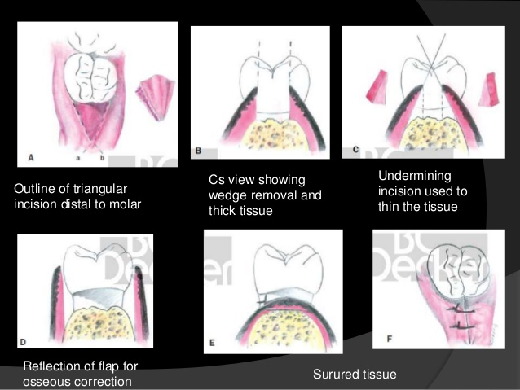
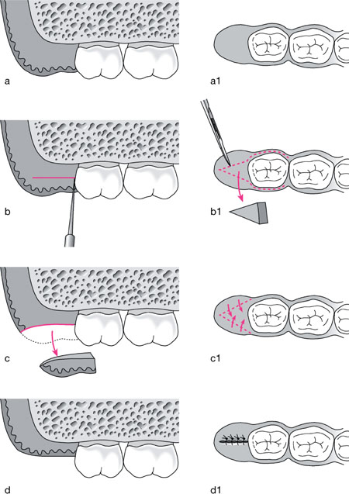
Techniques for the removal of the frenum
A frenum is a fold of mucous membrane, usually with enclosed muscle fibers, that attaches the lips and cheeks to the alveolar mucosa and/or gingiva and underlying periosteum.A frenum becomes a problem if the attachment is too close to the marginal gingiva.Tension on the frenum may pull the gingival margin away from the tooth.This condition may be conducive to plaque accumulation and inhibit proper brushing of the teeth with pocket formation.Also may tend to open the sulcus and gingival recession.
Frenectomy or Frenotomy
The term frenectomy is complete removal of the frenum,including its attachment to underlying bone and may be required in the correction of an abnormal diastema between maxillary central incisors.
Frenotomy is the incision of the frenum and relocating the frenal attachment.
Frenal problems occur most often on the facial surface between maxillary and mandibular central incisors and in the canine and premolar areas.They occur less often on the lingual surface of the mandible.
The technique for the removal of the frenum accomplished as follows:
1.After anesthetizing the area, engage the frenum with a hemostat inserted to the depth of the vestibule.
2.Incise along the upper surface of the hemostat,extending beyond the tip.
3.Make a similar incision along the undersurface of the hemostat.
4.Remove the triangular resected portion of the frenum with the hemostat.This exposes the underlying brushlike fibrous attachment to the bone.
5.Make a horizontal incision, separating the fibers,and bluntly dissect to the bone.
6.Undermining the incision to approximate the border of incisions for suturing.
7.Clean the field of operation and pack with gauze sponges until bleeding stops.
8.Cover the area with periodontal pack.
9.Remove the pack after 1 week.One month is usually required for the formation of an intact mucosa with the frenum attached in its new position. 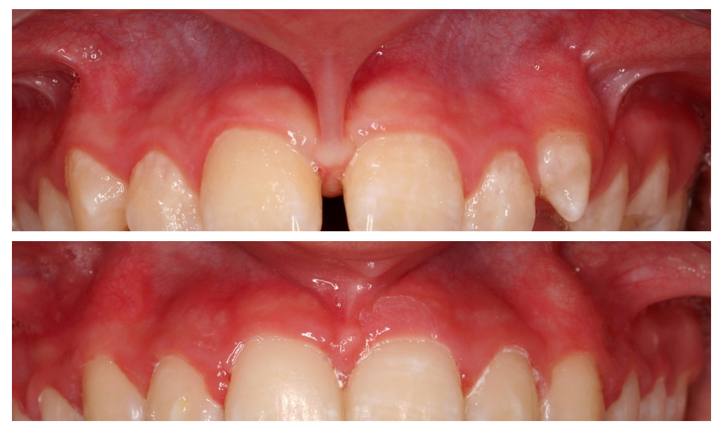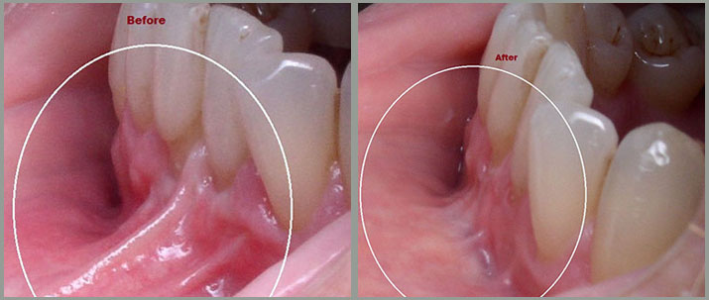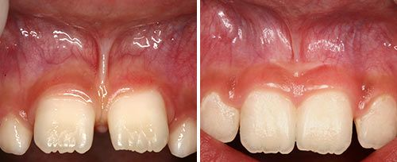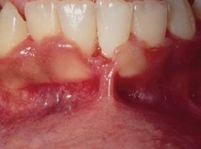

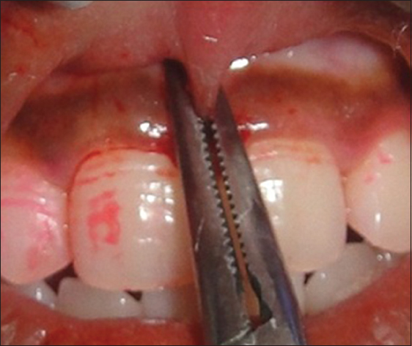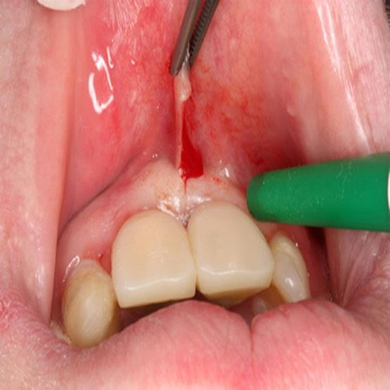

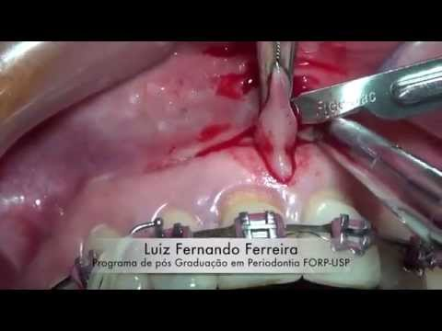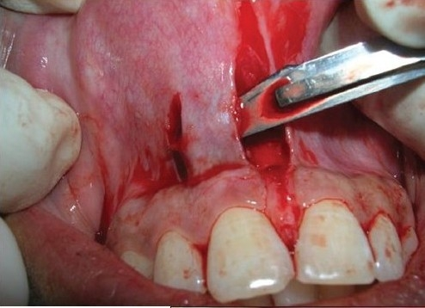
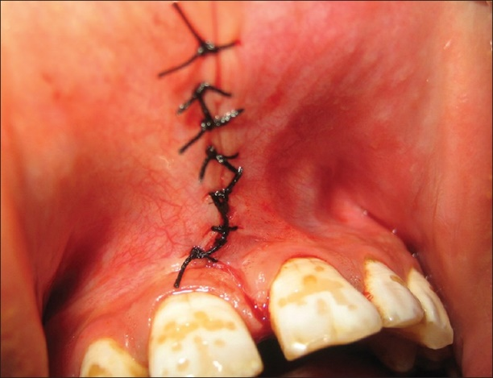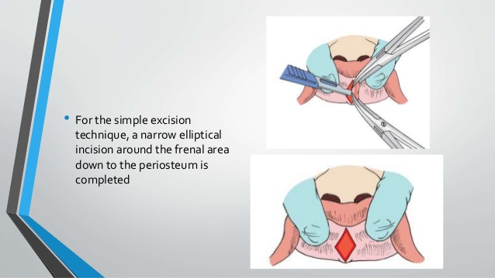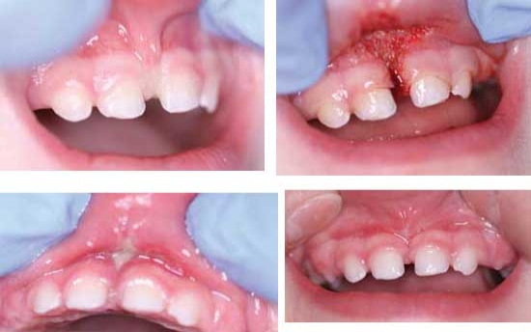

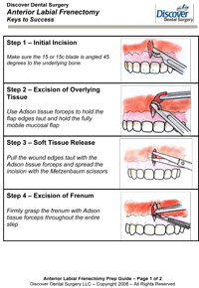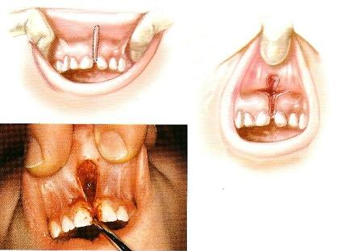
Periodontal dressing: are mainly used :
I· To protect the wound post surgically
2-To obtain and maintain a close adaptation of the mucosal flaps to the underlying bone (especially when a flap has been repositioned apically)
3-For the comfort of the patient
4-Prevent post operative bleeding during the initial phase of healing
5-Prevent the formation of excessive granulation tissue
Periodontal dressing should have the following properties:
1-Should be soft but still have enough plasticity and flexibility to facilitate its placement in the operated area and to allow proper adaptation.
2-Should harden within a reasonable time
3-After setting should be sufficiently rigid Io prevent fracture and dislocation.
4-Should have a smooth surface after setting to prevent irritation to the check and lips
5-Should preferably have bactericidal properties to prevent excessive plaque formation
6-Not detrimentally interfere with healing
Types of dressing
I-Zinc-oxide eugenol pack: eugenol in this type may induce an allergic reaction
2-Non eugenol pack: e.g. Coe pack; one tube contain zinc oxide and lorothidol (Fungicidal) and the second tube contain non ionizing carboxilic acids and chlorothymol (bacteriostatic agent)
3-Light cured dressing
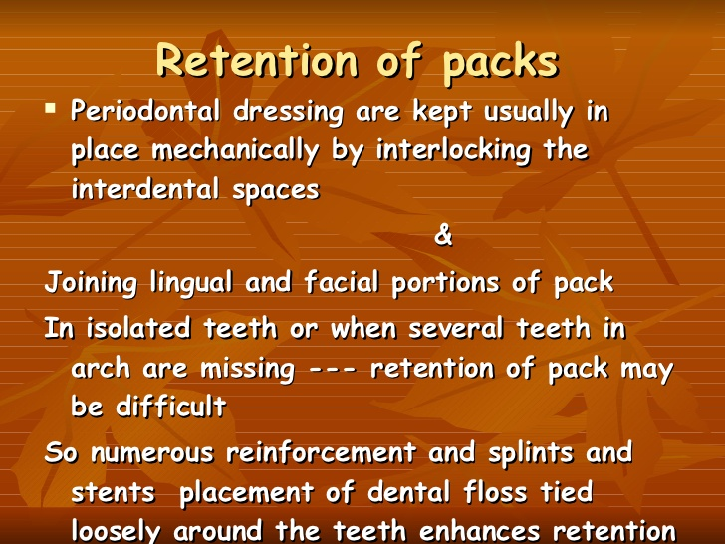
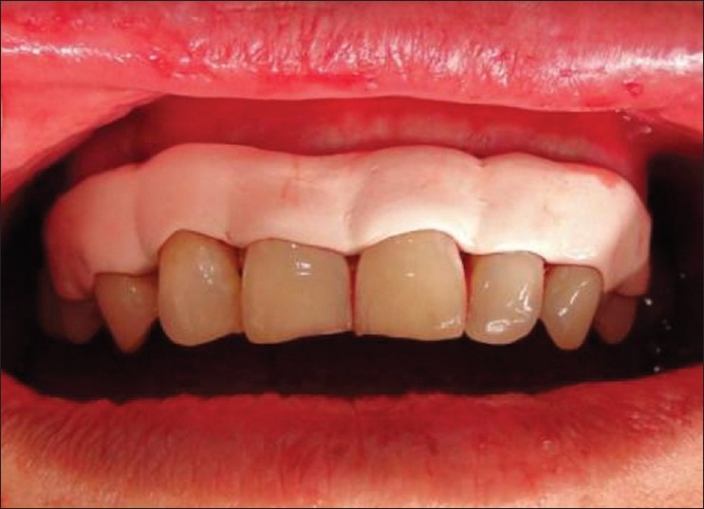
Maintenance phase(supportive periodontal therapy SPT)
Preservation of the periodontal health of the treated patient requires a supportive program that is just as important as the therapy used to treat the periodontal disease.The maintenance phase of periodontal treatment starts immediately after the completion of phase I therapy.While the patient is in the maintenance phase,the necessary surgical and restorative procedure are performed.This insures that all areas of the mouth retain the degree of health attained after phase I therapy.
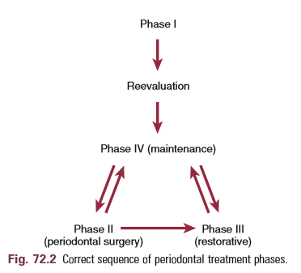
The primary goal of maintenance therapy include
I-Maintenance of oral health (cancer screening)
2-Prevention of new infection
3-Prevention of re-infection and disease recurrence
The time interval between the recall appointments should be based on a periodontal risk assessment(type and severity of periodontitis, systemic and local risk factors, degree of motivation, compliance, manual dexterity and the patient success to maintain a proper personal oral hygiene standard.
It is important to emphasize that the recall program must be designed to meet the individual need of the patient, some patients should be recall every month while other may have to be checked only once a year
Findings From long-term clinical trials have suggested that recall appointments, once every three month is effective in preventing disease recurrence.
There are three parts to an SPT appointment:
1.examination
2.treatment
3.report,clean up and scheduling
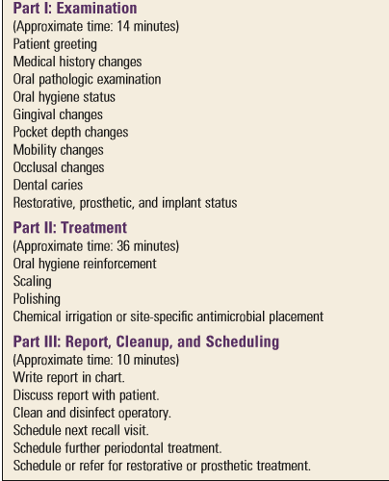
The time required for a recall visit for patients with multiple teeth in both arches is approximately 1 hour.
Recurrence of Periodontal Disease
Occasionally, lesions may recur, which is often due to inadequate plaque/biofilm control on the part of the patient or failure to comply with recommended SPT schedules. It should be understood, however, that it is the responsibility of the dentist to educate and motivate patients to improve their oral hygiene techniques. Surgery should not be undertaken unless the patient participates in disease prevention and demonstrates proficiency in plaque/biofilm control.
Other causes for recurrence include the following:
1.Inadequate or insufficient treatment that has failed to remove all of the potential factors favoring biofilm accumulation. Incomplete calculus removal in areas of difficult access is a common source of problems.
2. Inadequate restorations placed after the periodontal treatment was completed.
3. Failure of the patient to return for periodic maintenance care . This may be a result of the patient’s conscious or unconscious decision not to continue treatment or the failure of the dentist and staff to emphasize the need for periodic supportive therapy.
4. Presence of some systemic diseases that may affect host resistance to previously acceptable levels of biofilm.
A failing case can be recognized by the following:
1. Recurring inflammation revealed by gingival changes and bleeding of the sulcus on probing.
2. Increasing depth of sulci, leading to the recurrence of pocket formation.
3. Gradual increases in bone loss, as determined by radiographs.
4. Gradual increases in tooth mobility, as ascertained by clinical examination.
The decision to retreat a periodontal patient should not be made at the preventive maintenance appointment but should be postponed for 1 to 2 weeks. Often, the mouth appears improved at that time because of the resolution of edema and the resulting improved tone of the gingiva. Table summarizes the symptoms of the recurrence of periodontal disease and their probable causes.

